Truck Parking Availability System Design Guidance

Introduction
The purpose of this document is to provide guidance that should be consider in the design and evaluation of Intelligent Transportation System (ITS) Truck Parking Availability System (TPAS) projects. It is intended to assist on the design of key TPAS project elements including video detection sensors, Dynamic Message Signs (DMS), and Closed-Caption Television (CCTV) cameras, amongst others.
The intent of this guidance document is to augment information found in the Florida Department of Transportation (FDOT) Design Standards, Standard Specifications for Road and Bridge Construction, Florida Design Manual (FDM), and the Manual on Uniform Traffic Control Devices (MUTCD). This document is not intended to replace sound engineering judgment, nor is it intended to provide all of the information required to produce TPAS ITS plans.
The intended audience for this document includes transportation professionals involved in the planning, design, and review of TPAS projects. Engineers of Record should have a sufficient understanding of ITS design principles to develop a detailed TPAS design and deployment consistent with this document and other applicable FDOT standards and guidelines.

System Purpose & Design Flow
Truck parking shortages have been identified as a safety concern both locally and nationally. Several studies have identified that there is an inadequate supply of truck parking spaces which results in negative consequences for truck drivers. The lack of parking requires drivers to start searching for truck parking early to ensure they do not exceed their federally mandated Hours-of-Service (HOS) requirements which results in time lost that could be spent traveling to their next delivery destination. The American Trucking Association found that it takes truckers an average of fifty-six minutes to find a parking spot.
To assist truck drivers with locating safe and available truck parking at FDOT welcome centers, rest areas, and weigh stations the FDOT developed TPAS. During the initial deployments of TPAS it was determined that presence detection was the system of choice.
As technology has improved, video detection is now being considered for new projects and deployment upgrades. This system involves capturing images of parking areas through video detection sensors and sending these images to a cloud-based server computer algorithm that processes the images to determine occupied and available spaces. The information is then sent to the state’s SunGuide® system and is transmitted by sending alerts to commercial truck drivers via DMS, in-truck devices, third-party feeds, and mobile apps. Other detection system methods include utilizing magnetometer, radar, or infrared wireless detection systems that are embedded in the pavement of truck parking spaces. The embedded sensors, however, are being phased out and will no longer be deployed on new TPAS projects to leverage new technologies (i.e., video detection sensors) which offer increased accuracy with reduced maintenance.
Figure 2-1 below provides an illustration of the FDOT TPAS Interconnect Diagram as identified in the Florida Statewide and Regional ITS Architecture (RITSA). This service package shows how the information flows between each other and can be found here: Florida's Statewide Architecture (fdot.gov). Figure 2-2 provides a more illustrative overview of how the TPAS works in real-time.
Figure 2-1 FDOT TPAS Interconnect Diagram
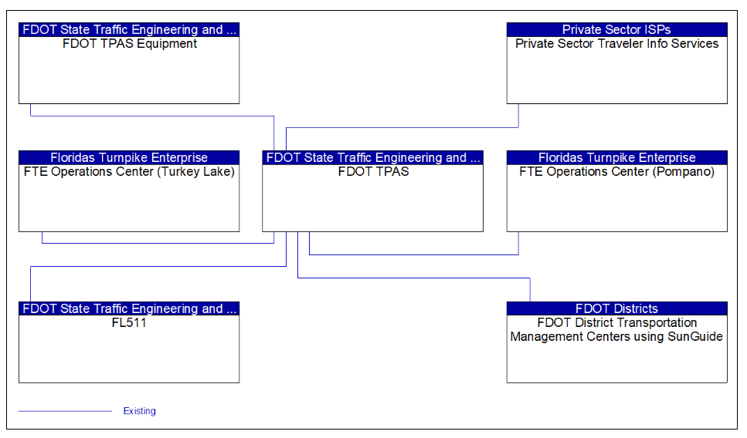
Figure 2-2 High Level TPAS Overview
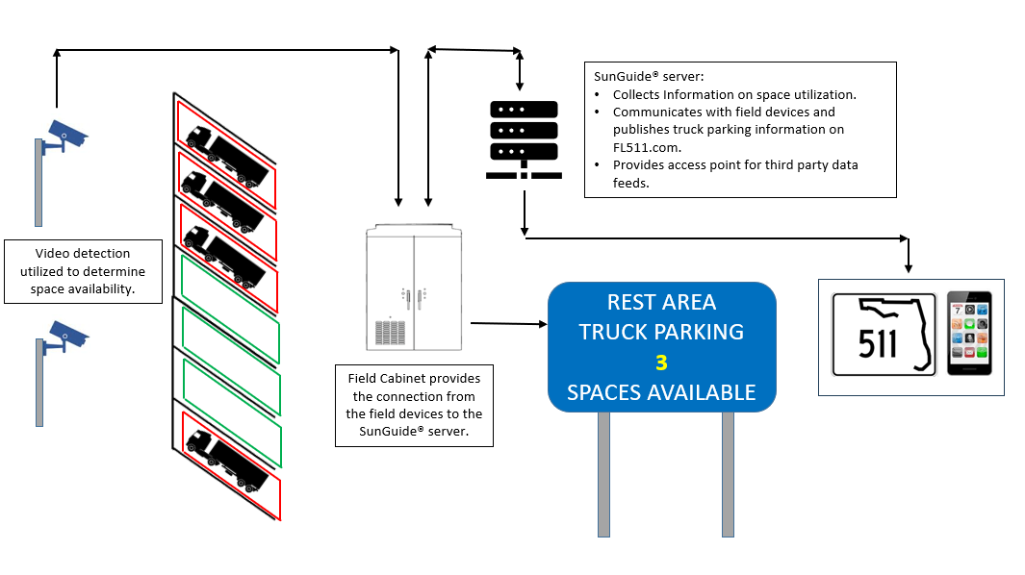

Truck Parking Video Detection Sensors

Purpose
TPAS video detection sensors are used to capture images of parking areas where they are then sent to a secure cloud-based server that is accessible via the Traffic Management Center (TMC) and uses real-time analytics to determine occupied and available spaces.

Video Detection Sensor Placement
The Engineer may encounter a number of truck parking space types, even within the same truck parking facility. Thus, the best placement for video detection sensors will depend on the truck parking facility’s size, layout, and obstructions. The detection range will also vary depending on the sensor’s focal length or resolution, which dictates how much of the scene will be captured. The longer the focal length, the narrower the angle of view and the higher the magnification. The shorter the focal length, the wider the angle of view and the lower the magnification.
The primary factors that the Engineer will have to consider when determining video detection sensor locations are its height, distance from the target parking spot, and angle. The Engineer will need to take into account that the higher the video detection sensor is installed, the larger it’s field of view away from its location. However, this does create a potential for blind spots closer to the pole. Thus, the Engineer should carefully consider for video detection sensor locations that can detect as many parking spots as possible to help limit their number needed at each truck parking facility.
The figure below is taken from a sensor that is mounted on a light pole approximately 20 feet above the ground. It’s tasked with detecting six (6) truck parking spots that are between two medians. This is the type of sensor view that the Engineer should aim to obtain when examining for the most appropriate locations.
Figure 3-1 Video Detection Sensor Image Example
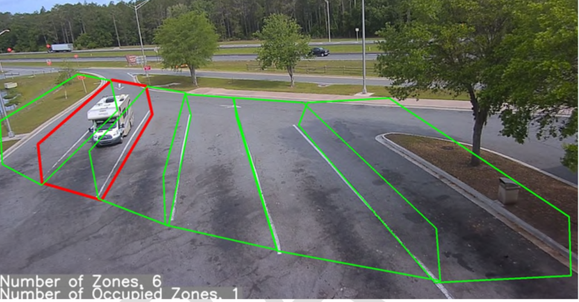
In other instances, it may be necessary to install sensors for one (1) or two (2) spots only, due to the configuration of the parking area. As seen in the figure below, in order to grab a full view of the parking spot (as the software requires), the sensor offset from its target is minimal (less than five feet) and it is angled nearly perpendicular to the ground.
Figure 3-2 Video Detection Sensor Image Example
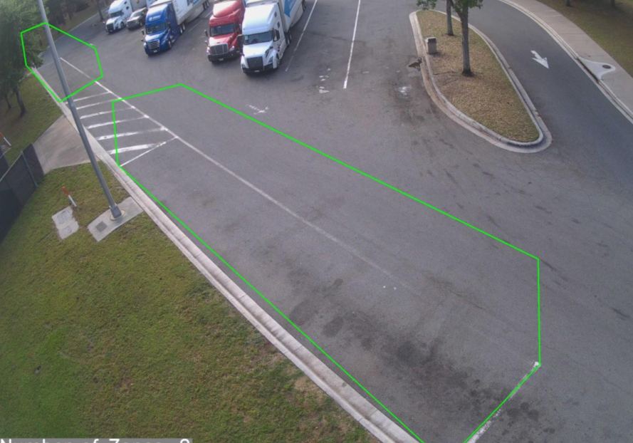

As the above figures illustrate, the Engineer will have to carefully design each sensor’s location to ensure proper detection of all truck parking spots.

General Guidelines
- Truck parking video detection sensors shall provide unobstructed coverage of each truck parking spot, using the least number of sensors possible.
- Truck parking detection video detection sensors shall be of the fixed static, IP high-definition type only.
- When determining video detection sensor placement, the Engineer shall assume that each parking spot is occupied (to account for potential occlusion) and that all trucks are 72 feet long, 13.5 feet tall, and 8.5 feet wide.
- The Engineer shall assume a minimum video detection sensor resolution of 720 pixels x 480 pixels when calculating for video detection sensor coverage. Assuming worst case scenario (resolution meets Standard Specifications requirement) ensures that the design will have room for error when determining sensor coverage.
- The Engineer shall perform a viewshed analysis of proposed overview truck parking video detection sensor locations to the District in order to demonstrate that it will allow a truck in any parking space to be uniquely identified if the lot is full and landscaping is fully grown with full foliage. It is recommended that the Engineer make use of online resources that can assist with this task such as the following website: https://www.jvsg.com/calculators/cctv-lens-calculator/.
- Co-location of CCTV cameras and truck parking vehicle detection sensors is strongly preferred for ease of maintenance and cost saving purposes. They shall be combined on common poles and cabinets whenever possible, while adhering to the individual requirements of each device.
- The Engineer shall design sensor locations to overlap parking spots to the best extent possible.
- Maximum mounting height of any video detection sensor shall not exceed 40 feet.
- The Engineer shall clearly denote on the plans the mounting height of each video detection sensor along its mounting structure, and the angle that it should be installed at relative to the ground.

Existing Truck Parking Facility Placement Guidelines
- Video detection sensors may be mounted to existing light poles that are not directly behind truck parking spots. Light poles at truck rest areas are often struck by trucks and thus the Engineer shall carefully select a light pole that runs little risk of being struck to the best extent possible.
- Video detection sensor coverage can be affected by the growth of vegetation around the truck parking facility. The Engineer shall factor in types of plant and anticipated growth. Unless unavoidable, the Engineer shall coordinate with the District in regard to any necessary trimming.

Proposed Truck Parking Facility Placement Guidelines
- When a TPAS is being designed as part of a new truck parking facility, the Engineer shall closely coordinate with lighting to strategically locate light poles that will also serve as mounting structures for the video detection sensors in accordance with of that in Section 4.3.
- The Engineer shall also coordinate closely with landscaping when designing a TPAS as part of a new truck parking facility, in order to eliminate potential visual obstructions that will prevent proper detection.

