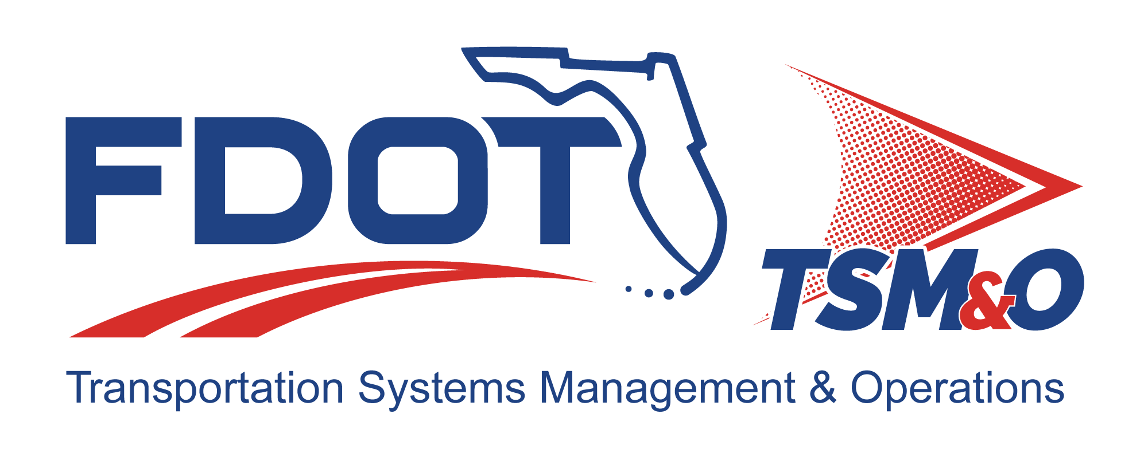

Test Report for: insert project name

Version: insert version number

Approval date: insert approval date

DOCUMENT CONTROL PANEL
File Name:
File Location:
Version Number:
Name |  | Date
Created By:
Reviewed By:
Modified By:
Approved By:
Table of Contents

1 Test Objective 1
2 Test Results 1
2.1 Requirements Verified or Failed 1
2.2 Comments and Recommendations 1
2.2.1 Critical Failures 1
2.2.2 Serious Failures 1
2.2.3 Minor Failures 2
3 Detailed Test Results 2
3.1 Integration (or Test) Case 1 2
3.1.1 Test Log 2
3.1.2 Test Documentation 2
3.1.3 Test Data Sheets 2
3.1.4 Analysis and Conclusions 2
3.2 Integration (or Test) Case 2 3
3.2.1 Test Log 3
3.2.2 Test Documentation 3
3.2.3 Test Data Sheets 3
3.2.4 Analysis and Conclusions 3
4 Raw Test Data Files 3
5 User Definitions 3

List of Tables

Table 1: Title 3

List of Figures

Figure 1: Title 3

List of Acronyms and Abbreviations

FDOT Florida Department of Transportation
IC Integration Case
TC Test Case

Test Objective
Describe the test objective. This can be copied from the test plan.

Test Results
This section provides the executive summary of the test, and should provide a quick summary of the test results and the recommended actions to be taken.

Requirements Verified or Failed
Explain that requirements can either pass or fail the test. There are three types of failure categories: 1) Fail-Repair, which requires retesting; 2) Fail-Deviation Required; and 3) Fail-Waiver Required. This explanation is followed by a summary table listing the number of requirements in each category.

Comments and Recommendations
To help the Florida Department of Transportation (FDOT) management decide how to proceed, the test engineer will group the failures by how critical they are to the deployment and operation of the system.

Critical Failures
Critical failures must be fixed before further testing of the system can continue. The system cannot be deployed or operated with a critical failure. These are sometimes referred to as “show stoppers.” This section explains what a critical failure means and is followed by a three-column table identifying the requirements, the text of the requirement, the reason it failed, and why it is critical that it be fixed before continued testing or operation takes place.

Serious Failures
Serious failures are those that need to be fixed, but an interim solution exists that can be used to operate the system. Usually, an interim solution is a manual operation, such as entering data into a database directly or selecting certain system output configurations instead of letting the software do it. These failures can be listed as Failure-Deviation Required. The work-around solution is described, and a recommendation is made to implement the work-around and have the contractor fix the failure before the final release of the system. If it is determined that it is not cost effective to fix the failure and retest, and if the work-around solution is adequate for the long term, the failure may be listed as Failure-Waiver Required, meaning the FDOT will grant the contractor a waiver for that requirement. Usually, a waiver is granted in return for some form of consideration from the contractor, such as a reduced fee or other additional functionality that wasn’t specified but later desired.

Minor Failures
Minor failures do not materially effect the operation of the system, and can be fixed at a later date or ignored. An example might be a user interface display that has a misspelling in it or the wrong color used for an icon on the display. These failures can be listed as Failure-Deviation Required or Failure-Waiver Required.

Detailed Test Results
This section presents the test documentation that supports the conclusions and recommendations in Section 2 of this template. There is a one-to-one correlation between the integration cases (IC) and subcases (or test case [TC] and test subcases) described in the test procedures document and the test report.

Integration (or Test) Case 1

Test Log
A copy of the test engineer’s log is provided that chronologically lists what steps were taken when. The timing is important when comparing the actions against test data produced by the system under test.

Test Documentation
Test files and system reports that support the test conclusions and recommendations for the particular integration (or test) case are included in this section. If dummy test data was inserted into the system as a part of the test, the actual test data file is listed here.

Test Data Sheets
Include a copy of the test procedure with the pass/fail box filled here. Usually, this is a marked up copy of the test procedures and it is photocopied into the document. There should be no attempt to clean up the test data sheets.

Analysis and Conclusions
Provide a detailed analysis of each failure, explaining why the system failed to meet the requirement (if known) or what the failure may be related to. It is acceptable to conclude that the requirement as stated cannot be met by the system without a major redesign of the system or that the requirement was not correctly stated. Specific recommendations and the rationale for the recommendations complete this section.

Integration (or Test) Case 2
This section is in the same format as IC 1 (or TC 1) above. Continue until all the ICs or TCs described in the test procedures have been addressed.

Test Log

Test Documentation

Test Data Sheets

Analysis and Conclusions

Raw Test Data Files
This section contains a list of the raw data extracted from the system that was used to analyze the system’s performance. This may be a separate document if large amounts of data were produced.

Table 1: Title

Figure 1: Title

User Definitions

DOCUMENT REVISION HISTORY
Version Number | Approved Date | Description of Change(s) | Created/  Modified By

