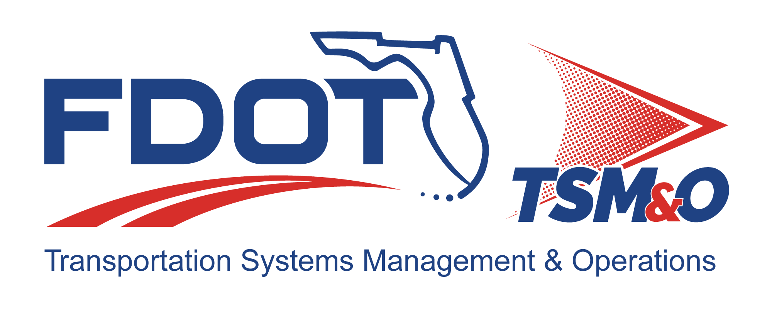

System Test Plan for: insert project name

Version: insert version number

Approval date: insert approval date

DOCUMENT CONTROL PANEL
File Name:
File Location:
Version Number:
Name |  | Date
Created By:
Reviewed By:
Modified By:
Approved By:
Table of Contents

1 Introduction 1
1.1 Purpose 1
1.2 Overview 1
1.2.1 Integration Case 1 1
1.2.2 Integration Case 2 1
1.2.3 Integration Case n 1
1.2.4 Test Case 1 1
1.2.5 Test Case 2 1
1.3 Milestone Demonstrations 2
1.3.1 Milestone Demonstration 1 2
1.3.2 Milestone Demonstration 2 2
1.4 System Configurations 2
1.4.1 Milestone Demonstration 1 Configuration 2
1.4.2 Milestone Demonstration 2 Configuration 2
1.5 Definitions 2
1.6 Glossary of Terms 2
2 References 2
3 Integration and Testing 3
3.1 Integration Cases 3
3.1.1 Integration Case 1 3
3.1.2 Integration Case 2 3
3.1.2.1 Integration Subcase 2.2 3
3.1.3 Integration Case n 3
3.2 Test Cases 3
3.2.1 Test Case 1 3
3.2.2 Test Case 2 3
3.3 Milestone Demonstration Test Scripts 3
3.3.1 Milestone Demonstration 1 4
3.3.2 Milestone Demonstration 2 4
4 Functional Requirements 4
4.1 Test Methods 4
4.1.1 Inspection 4
4.1.2 Analysis 4
4.1.3 Demonstration 5
4.1.4 Testing 5
4.2 Requirements Traceability Verification Matrix 5
5 Notes 5

List of Tables

Table 1: Title 6

List of Figures

Figure 1: Title 6

List of Acronyms and Abbreviations

IC Integration Case
TC Test Case

Introduction
Provide an introduction to the document and the project and a high-level system that includes a description of its major parts.

Purpose
Describe the purpose of the document, how it will be used, and the objective(s) of the testing.

Overview
Provide a brief description of the testing that is planned. If phased integration is being done on the project, provide a paragraph or two describing the general approach to the phased integration and identify the functional parts of the system that are being integrated. The following subparagraphs provide more detail .If no phased integration testing is being done, skip the integration case (IC) descriptions and describe the test cases (TCs).

Integration Case 1
Briefly describe what parts are being integrated and tested.

Integration Case 2
Briefly describe what parts are being integrated and tested.

Integration Case n
Continue describing the ICs, where integration case “n” is the last one and “n” is a number. There should be a maximum of four or five IC descriptions.

Test Case 1
The contractor uses TCs to sell the system to the FDOT. Test cases may be designed and written by an independent verification and validation contractor; FDOT personnel; or the contractor’s engineers. The test plan and test procedures need to be approved by the FDOT before they can be used. Provides a brief description of the first TC.

Test Case 2
Provide a brief description of the second TC. Continue describing the TCs until finished.

Milestone Demonstrations
Identify the functional threads in the system and the major functions they provide. Also identify the number of milestone demonstrations that will be performed by the contractor.

Milestone Demonstration 1
Identify the purpose of the first milestone demonstration and what key functionality it provides.

Milestone Demonstration 2
Identify the purpose of the second milestone demonstration and what key functionality it provides. Continue to describe the milestone demonstrations until finished. There should be a minimum of two, and a maximum five or six, depending on the size of the project and the its complexity.

System Configurations
Describe the test configurations of the system for each milestone demonstration.

Milestone Demonstration 1 Configuration

Milestone Demonstration 2 Configuration

Definitions
Define any special definitions required to understand the test plan

Glossary of Terms
List all acronyms used in the test plan and their explanation.

References
List all reference material that is used in the integration and testing plan. Do not list any documents not specifically referenced in the body of the document. The references are typically listed as a two-column table without showing the borders. The first column has the document title and the publishing date, while the second column has the name and contact information of the document publisher. This section always starts with the caveat:

The following documents are referenced in or were used in preparation of this document to the extent specified herein. If a referenced document conflicts with this document, this document shall take precedence.

Integration and Testing
Provides the details of the planned integration and acceptance testing. It is permissible to make two separate documents, one for integration testing and one for acceptance testing, or they may be combined, as this template suggests.

Integration Cases
Describe the integrations cases based on functional threads through the system. A functional thread is a string of system components (i.e., hardware, firmware, and software) that can demonstrate key functions of the system.

Integration Case 1
Provide the following:

- List the equipment needed.
- State the objective(s) of this test.
- List the requirements that will be verified by this test.
- Provide a brief description of the test procedure. A separate test procedure document will provide detailed step-by-step procedures.

Integration Case 2
If an IC is further subdivided, then provide the above listed information for each subcase instead. Integration Subcase 2.1

Integration Subcase 2.2

Integration Case n

Test Cases

Test Case 1

Test Case 2

Milestone Demonstration Test Scripts
A script is a document that the test engineer follows to execute a test. Often a script is automated through software control of the system under test. In the test plan, a general description is given of the steps taken to result in the desired demonstration of functionality.

Milestone Demonstration 1
Describe the objective of the demonstration and the specific functions being demonstrated. Discuss what happens after the demonstrations, such as whether the partial system will be left in place to be operated in the interim until final delivery and acceptance. Discuss issues of system ownership until final system acceptance. Discuss whether a site survey is required before the demonstration and what the purpose of such a site survey would be. Discuss any specific interfaces to legacy equipment and how those interfaces will be verified before the demonstration. Discuss the plan for setting up the demonstration, how dry runs of the demonstration will be performed, what process to follow if something doesn’t work right; whether vendor/contractor training is required, and what amount of system documentation is required to support the milestone demonstration. Ideally, the milestone demonstration should be a concluding IC test so that ICs leading up to the demonstration build confidence in the success of the project.

Milestone Demonstration 2
Continue describing the plan for the milestone demonstrations until finished.

Functional Requirements
This section identifies the requirements and relates them to the tests described in the plan. It does not restate the requirements.

Test Methods
This is a standard explanation of the four test methods already described in Section 3.2.1. Repeat the text below in the test plan as stated below.

Inspection
The acceptance test procedures review and/or inspect the end item, including its drawings and characteristics, during the actual performance of the acceptance test.

Analysis
Analysis is an element of verification in the form of a statistical study of previously collected data resulting in calculated data intended to verify a requirement when an examination, test, or demonstration cannot feasibly be used to verify the requirement. Such data, collected during a tightly controlled test setup, may be composed of a compilation of acceptance test data, design solutions, or data derived from lower-level tests. Satisfaction of the requirement is performed by statistical analysis of the test data.

Demonstration
Demonstration is an element of verification that differs from testing in that it verifies only the specific situation demonstrated but not the total requirement. Demonstration is used in lieu of testing where system parameters are not sufficiently controllable to provide a test that verifies the stated requirement explicitly. In such cases, performance within the stated requirements will be demonstrated for the specific case or cases. The capability to conform to the requirement must be inferred from the successful completion of the specific demonstration. The bulk of system testing should be demonstration tests because they are relatively easy to set up and execute. The data requirements for a demonstration test are minimal compared to a test type method.

Testing
Testing is an element of verification denoting the determination of the properties and characteristics of equipment or components by technical means, including functional operation, and the application of established test principles and procedures. The analysis of data derived from a test is an integral part of this verification element and should not be confused with analysis.

Requirements Traceability Verification Matrix
Provide a table listing identifying the requirements, the parent-child relationships, the test method(s), and where the requirement is tested (i.e., IC or TC number). Refer to Figure 4.13 in Chapter 4.

Notes
This section contains any special explanations or additional amplifying information required to understand the test plan. This section should be included even if it contains no information in early drafts.

Table 1: Title

Figure 1: Title

DOCUMENT REVISION HISTORY
Version Number | Approved Date | Description of Change(s) | Created/  Modified By

