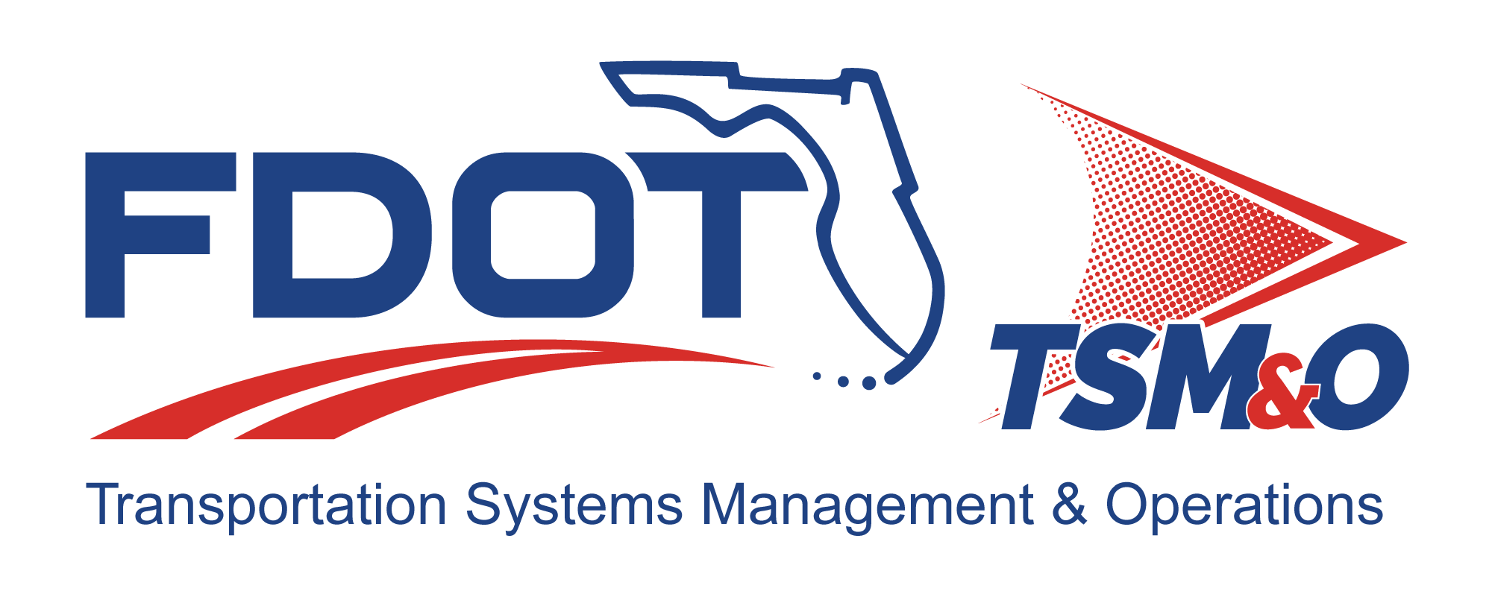

System and Subsystem Requirements for: insert project name

Version: insert version number

Approval date: insert approval date

DOCUMENT CONTROL PANEL
File Name:
File Location:
Version Number:
Name |  | Date
Created By:
Reviewed By:
Modified By:
Approved By:
Table of Contents

1 Overview 1
1.1 Identification 1
2 Reference Documents 1
2.1 Government Documents 1
2.2 Nongovernment Documents 1
3 Requirements 2
3.1 System Definition 2
3.1.1 Operational Assumptions 2
3.1.2 System Interface Requirements 3
3.1.2.1 System External Interfaces 3
3.1.2.2 System Internal Interface 3
3.2 System Requirements 3
3.2.1 Performance 4
3.2.2 Physical Characteristics 4
3.2.3 Reliability 5
3.2.4 Maintainability 5
3.2.5 Environmental Requirements 5
3.3 Design and Construction 5
3.3.1 Electromagnetic Radiation 6
3.3.2 Workmanship 6
3.3.3 Interoperability 6
3.3.4 Safety and Security Requirements 6
3.4 Human Factor Requirements 6
3.5 Documentation 7
3.6 Personnel and Training 7
3.7 Subsystem Requirements 7
3.7.1 Subsystem A Requirements 7
3.7.1.1 Subsystem A Definition 7
3.7.1.2 Interfaces 7
3.7.1.3 Subsystem A Requirements 7
3.7.1.3.1 Component 1 Requirements 7
3.7.1.3.2 Component 2 Requirements 7
3.7.2 Subsystem B Requirements 8
3.7.2.1 Subsystem B Definition 8
3.7.2.2 Interfaces 8
3.7.2.3 Subsystem B Requirements 8
3.7.3 Subsystem C Requirements 8
3.7.3.1 Subsystem C Definition 8
3.8 Precedence 8
3.9 Quality Assurance Provisions 8
3.10 General 9
3.10.1 Responsibility for Tests 9
3.10.2 Special Tests and Examinations 9
3.11 Quality Conformance Inspections 9
3.11.1 Inspection 9
3.11.2 Analysis 9
3.11.3 Demonstration 9
3.11.4 Testing 9
3.12 Software Quality Assurance 9
3.13 Requirements Traceability Matrix 9
3.14 Notes 9
4 User Definitions 10

List of Tables

Table 1: Title 9

List of Figures

Figure G.1 – [System Name] System Functional Block Diagram 2
Figure G.2 – Example of the Requirements Hierarchy 4

List of Acronyms and Abbreviations

FDOT Florida Department of Transportation
LRU Lowest Replaceable Unit

Overview
The System/Subsystem Requirements Specification establishes the functional, performance, design, development, and verification requirements for this project. This document contains requirements gathered from the contractual elements typically consisting of the contract document, scope of work, concept of operations document, request for proposals, etc. The System/Subsystem Requirements Specification defines the set of requirements to be verified as part of the acceptance of the ITS project.

Identification
This section contains a full identification of the system to which this document applies, including identification number(s), title(s), abbreviation(s), version number(s), and release number(s), as applicable.

Reference Documents
Always insert the following disclaimer:

The following documents, of the exact issue shown, form a part of this document to the extent specified herein. In the event of a conflict between the documents referenced herein and the contents of this document, this document shall be considered the superseding requirement.

When listing references, it is recommended that a two-column table be used. In the first column, provide the complete title of the document and the date it was published. In the second column, name the enterprise that published the document, the address of the publisher and a contact name, telephone number, electronic mail address, or Web site Uniform Resource Locator where copies of the referenced document can be obtained.

Government Documents
This section lists the number, title, revision, and date of all documents referenced in the specification. This section also identifies the source for all documents not available through normal government stocking activities. List the number, title, revision, and date of all documents referenced in this plan, including:

- Florida Department of Transportation (FDOT) specifications
- FDOT standards
- FDOT drawings
- Other FDOT publications (i.e., manuals, regulations, handbooks, bulletins, etc.)

Nongovernment Documents
Nongovernment documents may include:

- Institute of Electrical and Electronics Engineers standards
- Other documentation

Requirements
This section specifies the system requirements – that is, those system characteristics of that are conditions for its acceptance. This section of the document may be replaced with output from a tool used for requirements traceability. Each requirement will be assigned a project-unique identifier to support testing and traceability, and will be stated in such a way that an objective test can be defined for it. Each requirement will be annotated with associated qualification method(s) and, for subsystems, traceability to system requirements.

The degree of detail to be provided will be guided by the following rules:

- Include those characteristics of the system that are conditions for system acceptance
- Defer to design descriptions those characteristics that the acquirer is willing to leave up to the developer
- If there are no requirements in a given paragraph, the paragraph will so state.
- If a given requirement fits into more than one paragraph, it may be stated once and referenced in the other paragraphs.

System Definition
Provide an overview description of the system. Briefly mention the subsystems and state that they will be specified in detail in Section 3.7 of this specification.

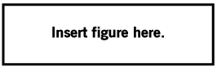
Figure G.1 – [System Name] System Functional Block Diagram

Operational Assumptions
State what assumptions have been made regarding the operation of the system (i.e., there will be a mix of legacy and new systems, and a long-term plan to transition to an all new system; state what assumptions apply, etc.)

System Interface Requirements
This section specifies the requirements for the system's external interfaces. This paragraph may reference one or more interface requirement specifications, or other documents containing these requirements.

System External Interfaces
This section identifies the required external interfaces of the system. The identification of each interface will include a project-unique identifier and will designate the interfacing entities (i.e., systems, configuration items, users, etc.) by name, number, version, and documentation references, as applicable. The identification will state which entities have fixed interface characteristics and, therefore, impose interface requirements on interfacing entities, and which are being developed or modified, thus having interface requirements imposed on them. One or more interface diagrams will be provided to depict the interfaces.

System Internal Interface
This section specifies the requirements, if any, imposed on interfaces internal to the system. If all internal interfaces are left to the design or to requirement specifications for system components, this fact will be stated.

System Requirements
This section itemizes the requirements associated with each of the system’s capabilities. A “function” is defined as a group of related requirements. Discuss the requirements hierarchy relative to a diagram of the functional hierarchy. (An example for a toll collection system is provided.)

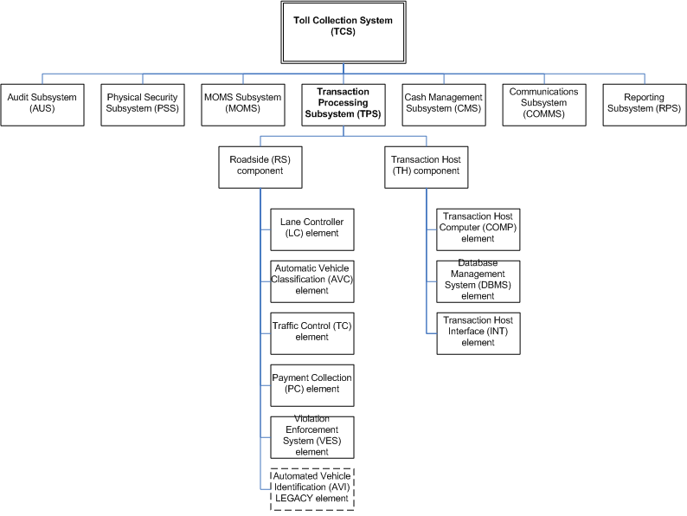
Figure G.2 – Example of the Requirements Hierarchy

Performance
This section identifies a required system capability and itemizes the requirements associated with the capability. The requirements specify the required behavior of the system and include applicable parameters, such as response times, throughput times, other timing constraints, sequencing, accuracy, capacities (i.e., how much/how many), priorities, continuous operation requirements, and allowable deviations based on operating conditions. The requirements will include, as applicable, required behavior under unexpected, unallowed, or “out-of-bounds conditions; requirements for error handling; and any provisions to be incorporated into the system to provide continuity of operations in the event of emergencies.

Physical Characteristics
Includes height, weight, volume or physical dimensions. State only ones that matter. For example, a unit to be installed in a small confined space must not exceed certain dimensions or a unit to be lifted by one person shall not exceed a certain weight.

Reliability
How reliable must the system be? This is often determined by its availability requirement and system availability may be stated instead. Let the contractor determine the necessary reliability metric (for example, the mean time between failures).

Maintainability
This section describes the requirements for built-in testing and diagnostic capabilities necessary for maintaining the system, and the logistical requirements that pertain to defining the lowest replaceable unit (LRU). State how a failure will be isolated to the LRU or the isolation to the maximum number of LRUs, and how the LRU will be repaired (i.e., whether it will be sent back to the factory for repair or will the vendor be required to train FDOT personnel in the repair of LRUs at the board level).

Environmental Requirements
This section specifies the requirements, if any, regarding the environment in which the system must operate. Examples for a software system are the computer hardware and operating system on which the software must run. Examples for a hardware-software system include the environmental conditions that the system must withstand during transportation, storage, and operation, such as conditions in the natural environment (i.e., wind, rain, temperature, geographic location), induced environment (i.e., motion, shock, noise, electromagnetic radiation), and environments due to enemy action (i.e., explosions, radiation).

Design and Construction
This section specifies the requirements, if any, that constrain the design and construction of the system. For hardware-software systems, this paragraph will include the physical requirements imposed on the system. These requirements may be specified by reference to appropriate commercial or military standards and specifications. Examples include requirements concerning:

- Use of a particular system architecture or requirements on the architecture, such as required subsystems; use of standard, military, or existing components; or use of government/acquirer-furnished property (i.e., equipment, information, or software)
- Use of particular design or construction standards; use of particular data standards; use of a particular programming language; workmanship requirements; and production techniques
- Physical characteristics of the system, such as weight limits, dimensional limits, color, or protective coating requirements; interchangeability of parts; ability to be transported from one location to another; ability to be carried or set up by one, or a given number of, persons
- Materials that can and cannot be used; requirements on the handling of toxic materials; and limits on the electromagnetic radiation that the system is permitted to generate
- Use of nameplates; part marking; serial and lot number markings, and other identifying markings
- Flexibility and expandability that must be provided to support anticipated areas of growth or changes in technology or mission

Electromagnetic Radiation
State any sensitivity the system has to interference from other radio transmissions, such as a strong radar at a nearby airport.

Workmanship
Usually, state the “best commercial practices,” unless there is a specific standard you can reference.

Interoperability
The extent to which the system has to exchange data and operate with other systems.

Safety and Security Requirements
This section specifies the system requirements, if any, concerned with preventing or minimizing unintended hazards to personnel, property, and the physical environment. Examples include restricting the use of dangerous materials; classifying explosives for purposes of shipping, handling, and storing; abort/escape provisions from enclosures; gas detection and warning devices; grounding of electrical systems; decontamination; and explosion proofing. This section includes the system requirements, if any, for nuclear components, including, as applicable, requirements for component design, prevention of inadvertent detonation, and compliance with nuclear safety rules.

Human Factor Requirements
This section specifies the system requirements, if any, included to accommodate the number, skill levels, duty cycles, training needs, or other information about the personnel who will use or support the system. Examples include requirements for the number of workstations to be provided, and for built-in help and training features. Also included will be the human factors engineering requirements, if any, imposed on the system. These requirements will include, as applicable, considerations for the capabilities and limitations of humans; foreseeable human errors under both normal and extreme conditions; and specific areas where the effects of human error would be particularly serious. Examples include the requirements for adjustable-height workstations; color and duration of error messages; physical placement of critical indicators or buttons; and use of auditory signals.

Documentation
List what documents are required. These are usually specified in a contract deliverable requirements list that is formatted in a table in this section. If a particular format or document organization is desired, reference a data item description and supply it in an appendix of this specification.

Personnel and Training
This section specifies the system requirements, if any, pertaining to training. Examples include training devices and training materials to be included in the system.

Subsystem Requirements
This section identifies a required system capability and will itemize the requirements associated with the capability. The requirements will specify the required behavior of the system and will include applicable parameters, such as response times, throughput times, other timing constraints, sequencing, accuracy, capacities (i.e., how much/how many), priorities, continuous operation requirements, and allowable deviations based on operating conditions. The requirements will include, as applicable, required behavior under unexpected, unallowed, or out-of-bounds conditions; requirements for error handling; and any provisions to be incorporated into the system to provide continuity of operations in the event of emergencies.

Subsystem A Requirements

Subsystem A Definition
Insert a functional block diagram of this subsystem and describe how it functions.

Interfaces

Subsystem A Requirements

Component 1 Requirements
- Component 1, Element 1 requirements
- Component 1, Element 2 requirements
- Component 1, Element 3 requirements
- Component 1, Element 4 requirements

Component 2 Requirements
- Component 2, Element 1 requirements
- Component 2, Element 2 requirements
- Component 2, Element 3 requirements
- Component 2, Element 4 requirements

Subsystem B Requirements

Subsystem B Definition
Insert a functional block diagram of this subsystem and describe how it functions.

Interfaces

Subsystem B Requirements

Subsystem C Requirements

Subsystem C Definition
Repeat the above for all the subsystems identified.

Precedence
Discuss the precedence for the requirements. Usually, the executed contract governs first in the event of a conflict between this specification and other contract documents. The system specification follows, then the statement of work, and then the test documents.

Quality Assurance Provisions
This section specifies the requirements, if any, pertaining to system quality factors. Examples include quantitative requirements concerning system functionality (i.e., the ability to perform all required functions), reliability (i.e., the ability to perform with correct, consistent results – such as equipment mean time between failures requirements), maintainability (i.e., the ability to be easily serviced, repaired, or corrected), availability (i.e., the ability to be accessed and operated when needed), flexibility (i.e., the ability to be easily adapted to changing requirements), portability of software (i.e., the ability to be easily modified for a new environment), reusability (i.e., the ability to be used in multiple applications), testability (i.e., the ability to be easily and thoroughly tested), usability (i.e., the ability to be easily learned and used), and other attributes.

General

Responsibility for Tests

Special Tests and Examinations

Quality Conformance Inspections

Inspection
This section includes information pertaining to the visual examination of system components, documentation, etc.

Analysis
This section contains information on the processing of accumulated data obtained from other qualification methods. Examples are reduction, interpolation, or extrapolation of test results.

Demonstration
This pertains to the operation of the system, or part of the system, that relies on observable functional operation not requiring the use of instrumentation, special test equipment, or subsequent analysis.

Testing
This specifies requirements for testing the operation of the system, or a part of the system, using instrumentation or other special test equipment to collect data for later analysis.

Software Quality Assurance

Requirements Traceability Matrix

Notes
This section contains any general information that aids in understanding this document (e.g., background information, glossary, rationale, etc.). This section will contain an alphabetical listing of all acronyms and abbreviations, and their meanings as used in this document, and a list of any terms and definitions needed to understand this document.

Table 1: Title

User Definitions

DOCUMENT REVISION HISTORY
Version Number | Approved Date | Description of Change(s) | Created/  Modified By

