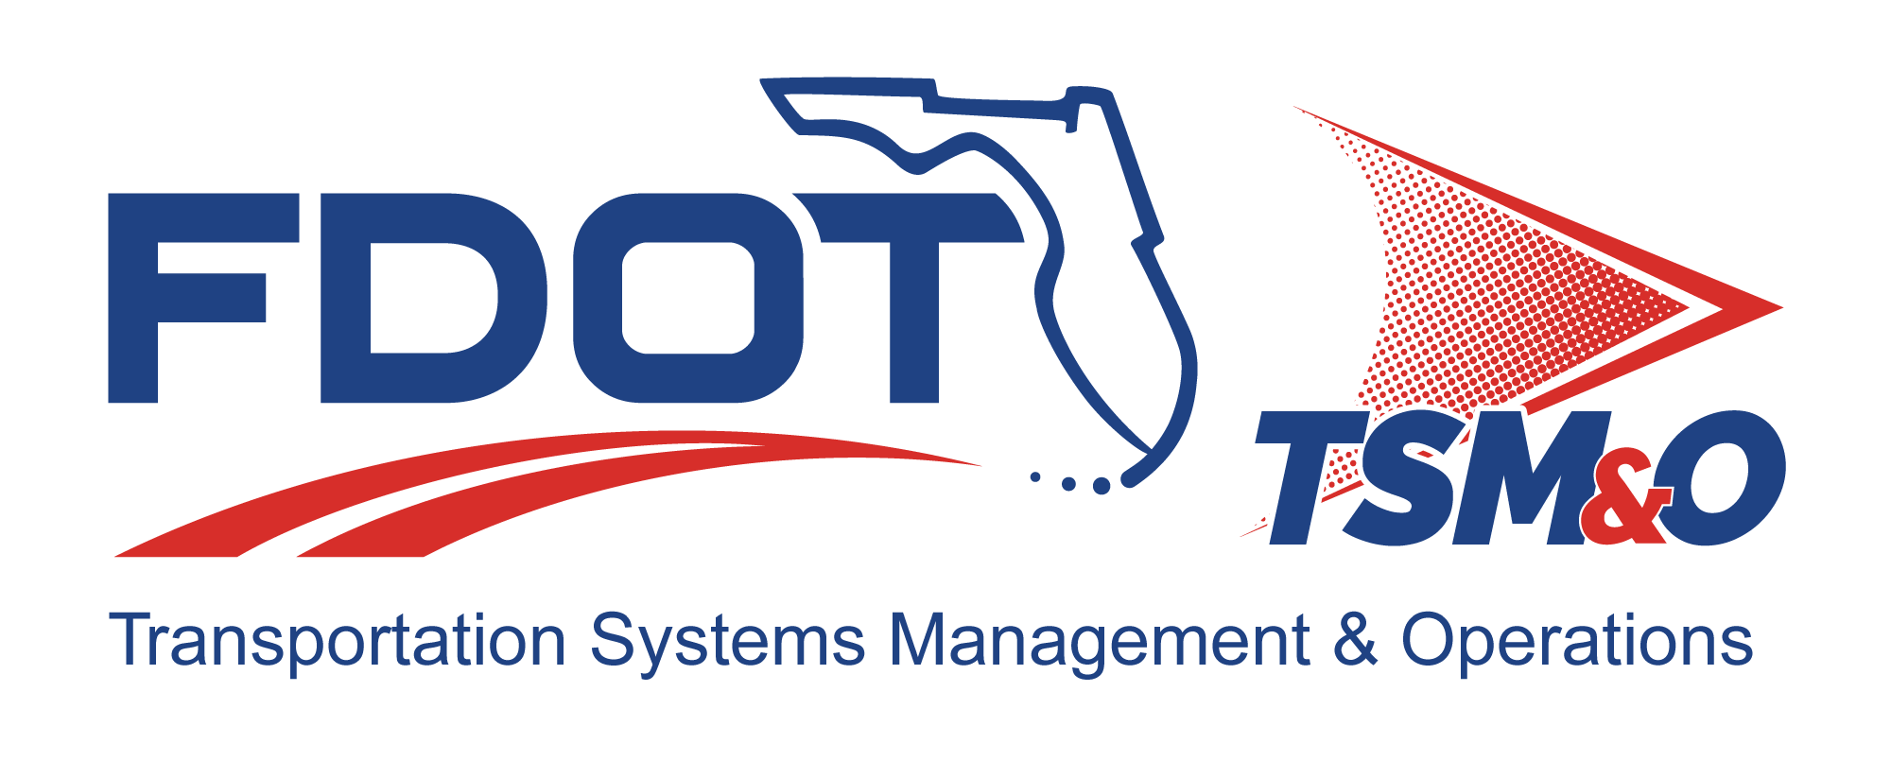

Subcontract Management Plan for: insert project name

Version: insert version number

Approval date: insert approval date

DOCUMENT CONTROL PANEL
File Name:
File Location:
Version Number:
Name |  | Date
Created By:
Reviewed By:
Modified By:
Approved By:
Table of Contents

1 Overview 1
1.1 Scope 1
2 Organization and Responsibilities 1
3 Subcontracting Plan / Subcontractor Work Distribution 2
4 Task Work Order Management Process 2
5 Quality Assurance 2
6 Staffing 2
7 Financial 2
8 Technical 2
9 Management 2
9.1 Risk Management 2
9.2 Change Management 3
9.3 Subcontract Closeout Management 3
10 Invoice and Financial Status Reporting 3
10.1 Receipt 3
11 Communications and Problem Resolution 3
12 User Definitions 3

List of Tables

Table 1: Title 3

List of Figures

Figure 1: Title 3

List of Acronyms and Abbreviations

FDOT Florida Department of Transportation
ITS Intelligent Transportation Systems
SMP Subcontract Management Plan

Overview
The Subcontract Management Plan (SMP) describes the process used by the Florida Department of Transportation (FDOT) to select qualified intelligent transportation systems (ITS) subcontractors and manage them efficiently. The SMP combines the concerns of requirements management, project planning, project tracking, and project oversight for basic management control, along with necessary coordination of quality assurance and configuration management, and applies this control to the subcontractor as appropriate.

Scope
The SMP sets forth the processes for managing and integrating project activities, and provides methods and guidance for the selection and management of subcontractors using proven processes and methods that assure successful program execution. The SMP shall be updated annually or as required to reflect changes in subcontractor management functions and/or processes.

The scope of the SMP begins at the preproposal stage and continues through subcontract execution, performance management, and closeout. It provides guidance for subcontract management activities, including:

- Organization, roles, and responsibilities
- Methods and processes for subcontractor management
- Management oversight for all subcontractors to minimize program impacts due to cost, schedule, or technical performance
- Distribution of work
- Subcontract task work order allocation
- Quality assurance of deliverables/products
- Status reporting and invoice procedures
- Ongoing communications

Organization and Responsibilities
This section describes the organization and responsibilities associated with the subcontract management process, including:

- Project management
- Business management
- Contracts and subcontract administration
- Engineering
- Environmental; health and safety; and security
- Quality assurance

Subcontracting Plan / Subcontractor Work Distribution
This section describes the allocation/distribution of work among the project’s subcontractor team.

Task Work Order Management Process
This section provides the management process for task work order responsibilities, including:

- Subcontractor task work order management:
- Task work order staffing process

Quality Assurance
This section describes the key areas that may be utilized for measuring teammate performance, including the staffing, financial, technical, and management areas.

Staffing
This section describes staffing performance and how it is measured. The performance may be measured by performing an analysis of the open/filled ratio, and the timeframe required to fill open or vacant positions.

Financial
This section describes the key financial elements that are monitored for ongoing analysis.

Technical
This section describes the key factors monitored for subcontractor technical performance, including:

- Delivery of excellent performance
- Customer support

Management

Risk Management
This section describes the process where performance problems are reported to the project management. It further establishes the process in which the project manager responds to problems and develops an action plan to ensure problem resolution.

Change Management
This section describes the control and exercise of all subcontract change or modification actions.

Subcontract Closeout Management
This section describes the procedure for how closeout of the subcontract will be managed.

Invoice and Financial Status Reporting

Receipt
This section describes the process for receipt of services and how invoices are processed for payment.

Communications and Problem Resolution
This section establishes the key methods for subcontractor communications and how all issues/concerns are resolved when they arise.

Table 1: Title

Figure 1: Title

User Definitions

DOCUMENT REVISION HISTORY
Version Number | Approved Date | Description of Change(s) | Created/  Modified By

