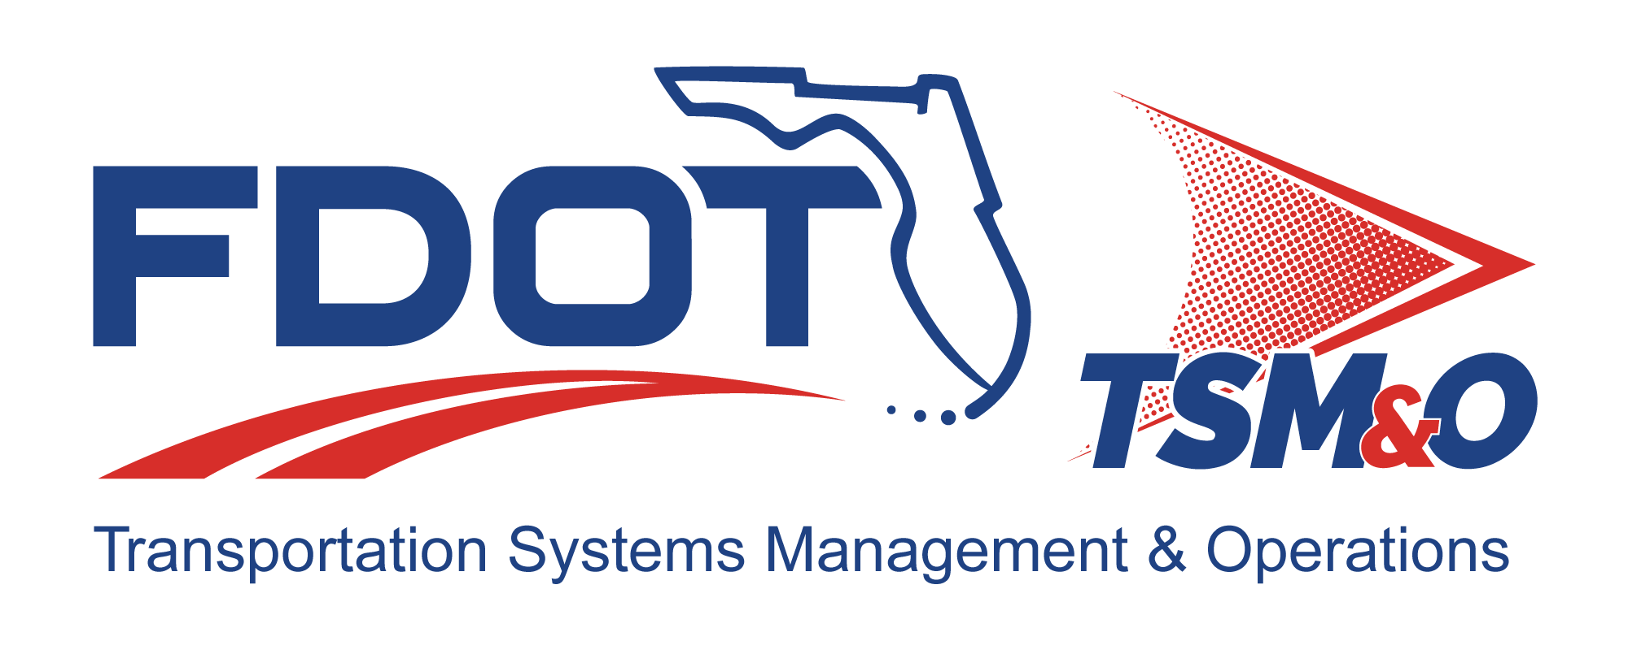

Software Development Plan for: insert project name

Version: insert version number

Approval date: insert approval date

DOCUMENT CONTROL PANEL
File Name:
File Location:
Version Number:
Name |  | Date
Created By:
Reviewed By:
Modified By:
Approved By:
Table of Contents

1 Overview 1
1.1 Scope 1
1.2 Identification 1
1.3 System Overview 1
1.3.1 Operational Concept 1
1.3.2 Computer Software Configuration Items 1
1.4 Relationship to Other Plans 1
2 Reference Documents 2
3 Overview of Software Development Planning 2
3.1 Requirements and Development 2
3.2 Project Documentation 2
3.3 System Life Cycle 2
3.4 Schedules and Resources 3
3.5 Training Requirements 3
4 General Software Development Activities 3
4.1 Development Process 3
4.2 Development Methods 3
4.3 Product Standards 3
4.4 Reusable Products 3
4.4.1 Incorporating Reusable Products 3
4.4.2 Developing Reusable Products 3
4.5 Critical Requirements 3
4.6 Computer Hardware Resource Utilization 4
5 Detailed Software Development Activities 4
5.1 Project Planning and Oversight 4
5.2 Establishing a Software Development Environment 4
5.3 System Requirements Analysis 4
5.4 System Design 5
5.5 Software Requirements Analysis 5
5.6 Software Design 5
5.7 Software Implementation and Test/Code and Unit Test 5
5.8 Software Integration and Testing 5
5.9 System Integration and Testing 6
5.10 System Acceptance Test 6
5.11 Preparing for Software Use 6
5.11.1 Preparing for Software Transition 7
5.12 Software Configuration Management 7
5.13 Software Product Evaluation 7
5.14 Software Quality Assurance 7
5.15 Corrective Action 8
5.16 Technical and Management Reviews 8
5.17 Other Software Development Activities 8
6 Schedules and Activity Network 8
7 Program Organization and Resources 8
8 User Definitions 9

List of Tables

Table 1: Title 8

List of Figures

Figure 1: Title 8

List of Acronyms and Abbreviations

CDMP Configuration and Data Management Plan
CM Configuration Management
CSCI Computer Software Configuration Item
FDOT Florida Department of Transportation
ITS Intelligent Transportation Systems
QA Quality Assurance
SDP Software Development Plan
SEMP Systems Engineering Management Plan
SIT Systems Integration and Testing

Overview
The Software Development Plan (SDP) establishes the software development approach, methodologies, tools, and procedures to be used during the analysis, design, development, testing, integration, deployment, and maintenance of the software for each Florida Department of Transportation (FDOT) intelligent transportation systems (ITS) project. This SDP is a dynamic document and shall be updated on a periodic basis to reflect organizational changes, lessons learned, new tools, and advances in methodologies. The SDP will not be directly applicable to the FDOT ITS engineer, since typical FDOT activities do not usually include software development. However, the SDP should be a requirement for the project subcontractors responsible for developing and submitting the SDP document for a software development effort.

Scope
The SDP provides the means to coordinate schedules, control resources, initiate actions, and monitor progress of the development effort. The purpose of the document is to provide a detailed plan for the use of resources, methodologies, and techniques that provide for the development of all software that comprise the product line.

Identification
This section contains a full identification of the system to which this document applies, including, as applicable, identification number(s), title(s), abbreviation(s), version number(s), and release number(s). The project SDP is managed and controlled in accordance with the FDOT’s configuration management (CM) practices.

System Overview
This section provides a brief description of the operational concepts and products that will be developed using this SDP.

Operational Concept

Computer Software Configuration Items

Relationship to Other Plans
This section describes the relationship of the SDP to the other project management plans, including:

- Program management plans
- Systems engineering management plans (SEMP)
- Hardware development plans
- Configuration and data management plans (CDMP)
- Quality management plans
- Quantitative management plans

Reference Documents
This section lists the number, title, revision, and date of all documents referenced in this plan.

- FDOT documents
- Project plans
- Operational procedures
- Engineering instructions

Overview of Software Development Planning
This section establishes the context for the planning described in later sections. Include an overview of:

- Requirements and constraints on the system and software
- Requirements and constraints on project documentation
- Position of the project in the system life cycle
- Selected program/acquisition strategy or any requirement constraints on it
- Requirements and constraints on project schedules and resources
- Training required for project engineers, both initial and ongoing
- Other requirements and constraints, such as project security, privacy, methods, and standards, etc.

Requirements and Development
System and software requirements will be documented in the requirements database. Software requirements will be derived from the system requirements and allocated to computer software configuration items (CSCIs). Any additional system constraints are documented in the project’s SEMP.

Project Documentation
This section defines the tool(s) used to produce the project documentation (i.e., Microsoft Word, Microsoft Excel, etc.) and how document configuration will be controlled.

System Life Cycle
This section describes the life-cycle model used across FDOT ITS projects. The model encompasses the entire development process from requirements analysis through deployment.

Schedules and Resources
This section provides the detailed schedule for the project. The schedule depicts the assigned personnel as well as the critical path and any critical dependencies.

Training Requirements
This section defines the software development training requirements for the project software engineers.

General Software Development Activities

Development Process
This section describes the software development process to be used. It also identifies planned software builds, their objectives, and the software development activities to be performed in each build.

Development Methods
This section identifies the software development methods (e.g., object-oriented methodology, etc.) to be used. It includes descriptions of the manual, automated tools, and procedures to be used in support of these methods.

Product Standards
This section provides reference to the standards to be followed for representing requirements, design, code, test cases, test procedures, and test results.

Reusable Products

Incorporating Reusable Products
This section describes the approach to be followed for identifying, evaluating, and incorporating reusable software products, including the scope of the search for such products and the criteria to be used for their evaluation.

Developing Reusable Products
This section describes the approach to be followed for identifying, evaluating, and reporting opportunities for developing reusable software products.

Critical Requirements
This section describes the approach to be followed for handling requirements designated critical. For example:

- Safety assurance
- Security assurance
- Privacy assurance
- Assurance of other critical requirements

Computer Hardware Resource Utilization
This section describes the approach to be followed for allocating computer hardware resources and monitoring their utilization.

Detailed Software Development Activities
This section provides the plans for performing detailed software development activities, including the approach (i.e., methods, procedures, and tools).

Project Planning and Oversight
This section describes the approach to be followed for project planning and oversight.

- Software development planning
- Computer software configuration item test planning
- System test planning
- Software installation planning
- Software transition planning
- Following and updating plans, including the intervals for management review

Establishing a Software Development Environment
This section describes the approach to be followed for establishing, controlling, and maintaining a software development environment.

- Software engineering environment
- Software test environment
- Software development library
- Software development files

System Requirements Analysis
This section describes the approach to be followed in system requirement analyses. System requirements analysis processes will be performed as described in the project SEMP.

- Analysis of user input
- Operational concept
- System requirements

System Design
This section describes the approach to be followed for participating in system design.

- Systemwide design decisions
- System architectural design

Software Requirements Analysis
This section describes the approach to be followed for software requirements analysis. It also defines the entrance and exit criteria for the software development process.

Software Design
This section describes the approach to be followed for software design. It also defines the entrance and exit criteria for the software design process.

- Software architecture/preliminary design
- Software detailed design

Software Implementation and Test/Code and Unit Test
This section describes the approach to be followed for software code and unit testing. It also defines the entrance and exit criteria for the software code and unit test processes.

- Software code
- Unit testing preparations
- Performing unit testing
- Revision and retesting
- Analyzing and recording unit test results

Software Integration and Testing
This section describes the software integration activities that focus on integrating all the software components into a software element that will be further integrated with the other elements to form the systems.

- Preparing for integration and testing
- Performing integration and testing
- Revision and retesting
- Analyzing and recording integration and test results

System Integration and Testing
This section describes the approach to be followed for participating in system integration and testing (SIT). System integration testing will be conducted in accordance with the project SEMP. The software engineer(s) will be responsible for supporting the testing activities. These activities will include assisting with the debugging process as problems are uncovered and correcting any software related problems. Subtopics to be addressed include:

- Independence in SIT
- Testing on the target computer system
- Preparing for SIT
- Performing SIT dry runs
- Performing SIT
- Revision and retesting
- Analyzing and recording SIT results

System Acceptance Test
This section describes the approach to be followed for participating in system qualification testing. System acceptance testing will be conducted in accordance with the project SEMP. The software engineer(s) will be responsible for supporting the testing activities. These activities will include assisting with the debugging process as problems are uncovered and correcting any software related problems. Subtopics to be addressed include:

- Independence in system acceptance testing
- Testing on the target computer system
- System acceptance test preparation
- Performing system acceptance test dry runs
- Performing system acceptance testing
- Revision and retesting
- Analyzing and recording system acceptance test results

Preparing for Software Use
This section describes the approach to be followed for preparing for software use.

- Preparing the executable software
- Preparing version descriptions for user sites
- Preparing user manuals
- Installing at user sites

Preparing for Software Transition
This section describes the approach to be followed for preparing for software transition. Software transition consists of the preparation of all software files, including source and executables, for delivery, and updating the final version descriptions. All files will be identified and verified via recompilation and/or reference checking after that component has successfully passed the required testing and been placed into controlled libraries for inclusion in the software build.

- Preparing the executable software
- Preparing source files
- Preparing version descriptions for the support site
- Preparing the “as-built” CSCI design and other software support information
- Updating the system design description
- Preparing support manuals
- Transitioning to the designated support site

Software Configuration Management
This section describes the approach to be followed for software CM. The CM processes and procedures are described in the CDMP.

- Configuration identification
- Configuration control
- Configuration status accounting
- Configuration audits
- Packaging, storage, handling, and delivery

Software Product Evaluation
This section describes the approach to be followed for software product evaluation. Software product evaluation will be accomplished according to the program schedules established for the project.

- In-process and final software product evaluations
- Software product evaluation records, including items to be recorded
- Independence in software product evaluation

Software Quality Assurance
This section describes the approach to be followed for software quality assurance (QA).

- Software QA process and product evaluations
- Software QA records, including items to be recorded
- Independence in software QA

Corrective Action
This section describes the approach to be followed for corrective actions (i.e., problem/change reports, etc.).

Technical and Management Reviews
This section describes the approach to be followed for technical and management reviews.

Other Software Development Activities
This section describes the approach to be followed for other software development activities.

- Risk management, including known risks and corresponding strategies
- Software management indicators, including indicators to be used (i.e., metrics)
- Security and privacy
- Subcontractor management
- Interface with software independent verification and validation agents
- Coordination with associate developers
- Improvement of project processes

Schedules and Activity Network
This section presents the schedule information or refers to detailed software schedules published for the project, including:

- Schedule(s) identifying the activities in each build and showing initiation of each activity
- Availability of draft and final deliverables, and other milestones; and completion of each activity
- An activity network, depicting sequential relationships and dependencies among activities and identifying those activities that impose the greatest time restrictions on the project

Program Organization and Resources
This section describes the project organization and resources to be applied in each software build, increment, iteration, or prototype.

Table 1: Title

Figure 1: Title

User Definitions

DOCUMENT REVISION HISTORY
Version Number | Approved Date | Description of Change(s) | Created/  Modified By

