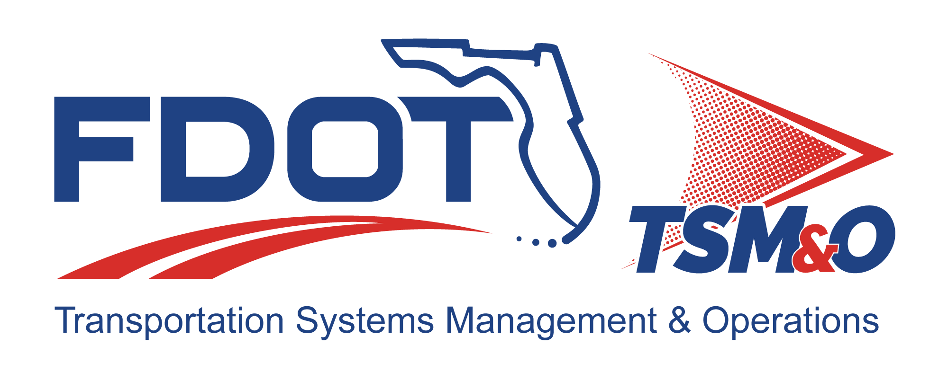

Quality Management Plan for: insert project name

Version: insert version number

Approval date: insert approval date

DOCUMENT CONTROL PANEL
File Name:
File Location:
Version Number:
Name |  | Date
Created By:
Reviewed By:
Modified By:
Approved By:
Table of Contents

1. Introduction 1
1.1 Purpose 1
1.2 Scope 1
1.3 Background 1
1.4 References 1
1.5 Quality Checkpoints 1
2. Staffing 1
2.1 Roles and Responsibilities 1
2.2 Required Skills 1
3. Reviews 1
3.1 Methodologies and Standards 1
3.2 Quality Assessments and Reviews 2
4. Quality Assurance Milestones 2
5. Resource Estimates 2
6. Contractor Controls 2
7. Corrective Actions 2
7.1 Processes 2
7.2 Products 2
7.3 Preventive Measures 2
7.4 Quality Assurance Checklists 3
8. User Definitions 4

List of Tables

Table N.1 – Quality Assurance Management Plan Checklist 3
Table N.2 – Configuration Management Plan Checklist 3

List of Figures

Figure 1: Title 3

List of Acronyms and Abbreviations

CMP Configuration Management Plan
QA Quality Assurance
QMP Quality Management Plan

Introduction

Purpose
The purpose of the Quality Management Plan (QMP) is to identify the program’s quality-related objectives, to describe how achievement of these objectives will be measured, and to describe the quality-related processes that will be used to assure that the objectives are achieved.

Scope
The scope of the objectives, measures, and processes described in this section should apply to the entire project.

Background
This section of the QMP must provide a brief, general description of the project to provide the context for the QMP.

References
This section must cite the applicable reference material used in developing the QMP.

Quality Checkpoints
This section must describe in detail the quality assurance (QA) processes to be used and when they will be used. For each checkpoint, provide a high-level overview of who will be involved, the criteria to be used for evaluation, and who will review/approve the results.

Staffing

Roles and Responsibilities
This section must identify the overall responsibilities of the QA team and the project team, as well as their individual responsibilities at the various quality checkpoints.

Required Skills
This section must identify the knowledge, skills, and experience needed to perform QA activities.

Reviews

Methodologies and Standards
This section must identify the project and product QA methodologies to be used, and standards to be applied.

Quality Assessments and Reviews
This section must describe the review procedures for project work processes and products that will be used to verify quality. It must include details on assessment or review; when they will be conducted; who will conduct them; the scope of review; success criteria; QMP reporting formats; and review processes.

Quality Assurance Milestones
This section must identify the QMP deliverables and the timeliness associated with those deliverables. For each checkpoint, information such as checkpoint name; lead QMP resource; QMP deliverable; and planned start and end dates must be included.

Resource Estimates
This section must include an estimate of the resources required to perform QMP activities, such as the number of staff, hours of effort, direct expenses, etc.

Contractor Controls
If using contracted QMP resources, a section must be included that describes the controls and processes for monitoring contractor work products and deliverables against agreed to timelines and levels of quality.

Corrective Actions

Processes
This section must provide a high-level description of the planned tracking and resolution procedures for problems or issues identified in project processes detected in QMP reviews.

Products
This section must provide a high-level description of the planned tracking and resolution procedures for problems or defects identified in project products detected in QMP reviews.

Preventive Measures
Any processes or measures designed to prevent the detection of errors or problems in QMP activities must be described. Reviewing lessons learned from prior projects may provide a way to avoid repeating prior errors.

Quality Assurance Checklists
Table N.1 – Quality Assurance Management Plan Checklist

YES | NO | Check List Description
 |  | Are project tracking activities evident?
 |  | Are project tracking and oversight being conducted?
 |  | Are all plan reviews conducted according to plan checklists?
 |  | Are all issues arising from peer reviews addressed and closed?
 |  | Are status and review meetings conducted according to the schedule?
 |  | Has a contract work breakdown structure that supports all deliverables and long-term tasks been developed?
 |  | Are changes managed according to the configuration management plan (CMP)?
 |  | Have all deviations from standards and procedures documentation been approved?
 |  | Are project roles and responsibilities defined?

Table N.2 – Configuration Management Plan Checklist

YES | NO | Check List Description
 |  | Does a CMP exist?
 |  | Is the CMP being used?
 |  | Does the CMP contain a list of configuration items (CI) to be managed?
 |  | Does the CMP contain change control procedures?
 |  | Does the CMP contain the process to evaluate changes, including estimates and impacts?
 |  | Does the CMP identify the person or group who has the authority to approve changes to the CMP?
 |  | Has the CMP been added to the configuration management baseline?

Figure 1: Title

User Definitions

DOCUMENT REVISION HISTORY
Version Number | Approved Date | Description of Change(s) | Created/  Modified By

