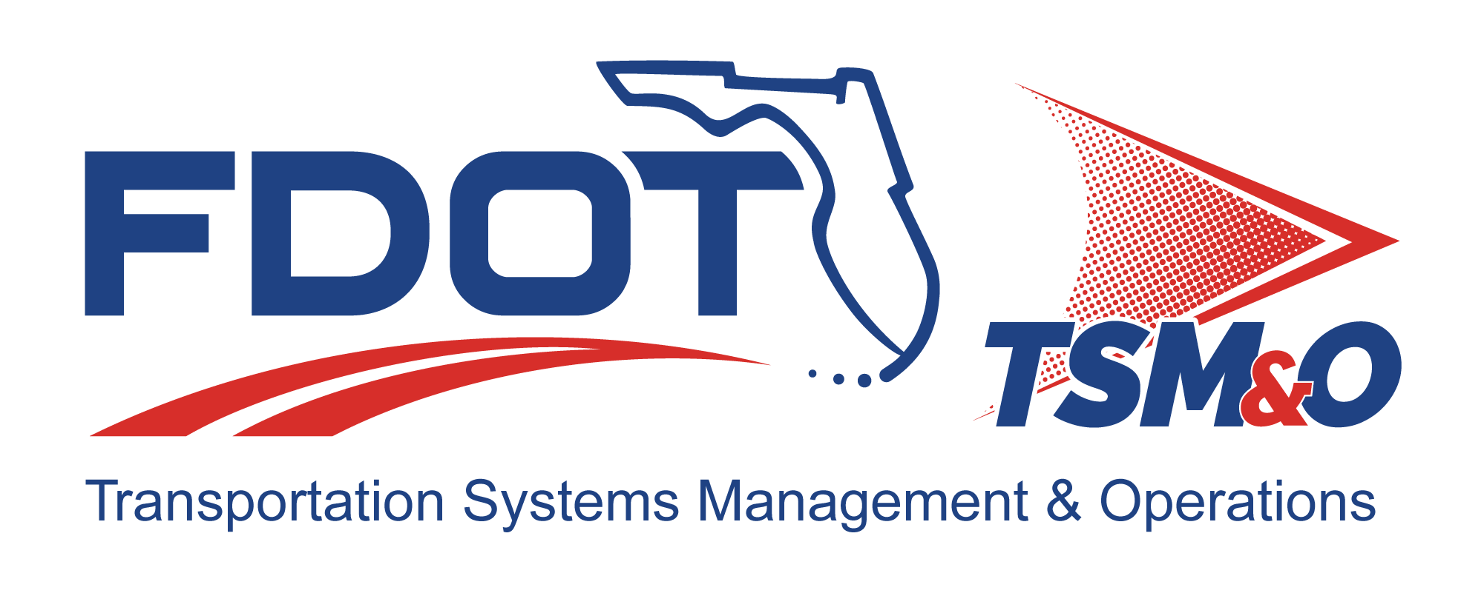

Project Systems Engineering Management Plan for: insert project name

Version: insert version number

Approval date: insert approval date

DOCUMENT CONTROL PANEL
File Name:
File Location:
Version Number:
Name |  | Date
Created By:
Reviewed By:
Modified By:
Approved By:
Table of Contents

Introduction 6
1.1 Document Overview 8
1.2 Need for a Project Systems Engineering Management Plan 8
1.2.1 Project Identification 8
1.2.2 Purpose and Scope 8
1.2.3 Technical Project Summary Schedule 9
1.2.4 Relationship to Other Plans 9
1.2.4.1 Relationship to Florida’s Ten-Year ITS Cost Feasible Plan 9
1.2.4.2 Relationship to Florida’s Statewide ITS Architecture 10
1.2.4.3 Relationship to Other “On-project” Plans 10
1.3 Applicable Documents 10
1.4 Systems Engineering Processes 10
1.4.1 Developing the Project Intelligent Transportation System Architecture 11
1.4.2 Creating High-Level Functional Requirements 11
1.4.3 Creating Detailed Requirements 11
1.4.4 Performing Trade-off Studies, Gap Analyses, or Technology Assessments 12
1.4.5 Performing Technical Reviews 12
1.4.6 Identifying, Assessing and Mitigating Risk 13
1.4.7 Creating the Requirements Traceability Verification Matrix 13
1.4.8 Creating Performance Measure Metrics 13
1.4.9 Conducting System Testing, Integration, Verification, Validation, and Acceptance Planning 14
1.5 Project Management and Control 15
1.5.1 Organization Structure 16
1.5.2 Managing the Schedule with the Project Evaluation and Review Technique and the Critical Path Method 17
1.5.3 Procurement Management 19
1.5.4 Risk Management 19
1.5.5 Subcontractor Management 19
1.5.6 Engineering Specialty Integration 20
1.5.6.1 Integrated Logistics Support and Maintenance Engineering 20
1.5.7 Monthly Project Status Reviews 20
1.5.8 Change Management 21
1.5.9 Quality Management 21
1.5.10 Systems Acceptance 21
1.5.11 Operations and Maintenance, Upgrade, and Retirement 22
1.5.12 Lessons Learned 22
2. User Definitions 22

List of Tables

Table A.1 – Insert Table Name A.1

List of Figures

Figure 1.1 – Simplified Systems Engineering Approach – the “V” Diagram 2
Figure 1.2 – Intelligent Transportation System Project Stages 12
Figure 1.3 – Sample Project Evaluation and Review Technique Chart 15
List of Acronyms and Abbreviations

CEI Construction, Engineering, and Inspection
CFP Cost Feasible Plan
ConOps Concept of Operations
CPM Critical Path Method
FDOT Florida Department of Transportation
ITS Intelligent Transportation System
MOE Measure of Effectiveness
MOP Measure of Performance
MTR Minimum Technical Requirement
O&M Operations and Maintenance
PERT Project Evaluation and Review Technique
PITSA Project Intelligent Transportation System (ITS) Architecture
PSEMP Project Systems Engineering Management Plan
QA Quality Assurance
QC Quality Control
QM Quality Management
RITSA Regional Intelligent Transportation System (ITS) Architecture
RTVM Requirements Traceability Verification Matrix
SEMP (Florida’s Statewide) Systems Engineering Management Plan
SEP Systems Engineering Process
SITSA Statewide Intelligent Transportation System (ITS) Architecture
TSP Technical Special Provision

Developing a Project Systems Engineering Management Plan

Introduction
This document is both a tutorial and a template for your project systems engineering management plan (PSEMP). If you remove the entire introduction section, you will have the correctly numbered outline for your PSEMP starting with Section 1.1 – Document Overview. Tutorial text is in italics or underlined italics. Boilerplate text is presented in normal text and can be used as is.
Consultants and suppliers in the service/product development process will do the majority of the systems engineering work for Florida Department of Transportation intelligent transportation systems (ITS) projects. Systems engineering processes (SEP) vary depending on the nature of the project. For software development projects and complicated product development projects, SEPs are very extensive. But for projects where existing products are procured and installed based on user-defined requirements, SEPs are not that extensive. Florida’s Statewide Systems Engineering Management Plan (SEMP), referred to herein as Florida’s Statewide SEMP, provides an extensive description of SEPs and management control that can be used in software/hardware development projects to design/build or procure/install projects. Hence, Florida’s Statewide SEMP is used as a general reference while embarking on a new ITS project. It is available on-line at: http://www.dot.state.fl.us/trafficoperations/ITS/Projects_Deploy/SEMP.shtm.
This document is an extraction from Florida’s Statewide SEMP in that it documents some basic SEPs that should be followed in all ITS projects that primarily deal with procurement and installation of equipment. The PSEMP will enable the Overall Project Manager to manage a project using systems engineering principles and methods. Systems engineering is a discipline that organizes work in a systematic way. By doing so, it eliminates the need to correct errors during later stages of the project. Figure 1.1 shows a simplified approach that systems engineering adheres to. This diagram is also known as the “V” diagram.
Figure 0.1 – Simplified Systems Engineering Approach – the “V” Diagram
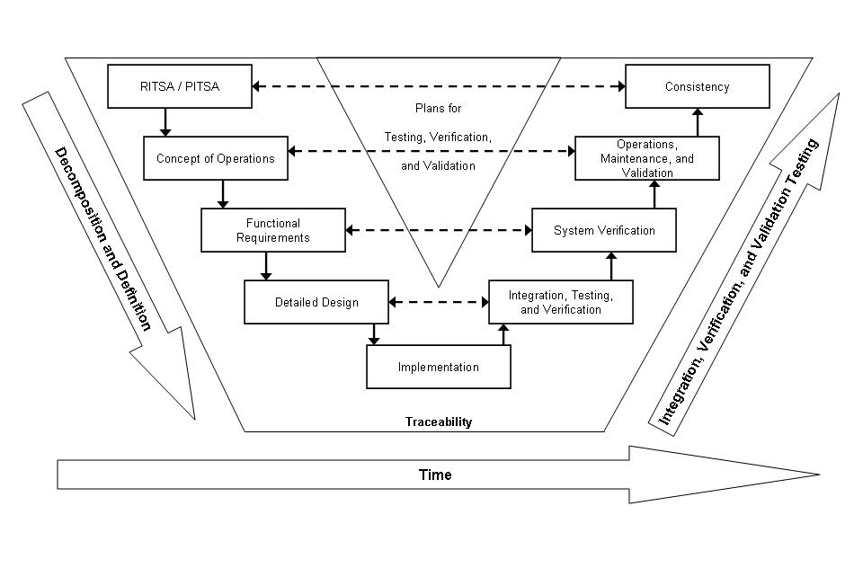
Following SEPs maximizes the quality of the system being implemented while minimizing the budget and time required for its completion. Hence it is the responsibility of the Overall Project Manager to instruct his/her staff as well as consultants and suppliers to adhere to pertinent SEPs as described in Florida’s Statewide SEMP or this document, as the case may be.
Although the PSEMP has been created to satisfy a Federal Highway Administration requirement, the main purpose of the document is to guide the Overall Project Manager from project conception to the operations and maintenance phases in a systematic way following systems engineering principles. The PSEMP is a living document in that it is updated continuously as various project steps are completed. The document revision history panel located at the end of the template should be used to document all approved versions.
The template to use for your ITS project starts immediately below. Delete all above text including this entire line.

Document Overview
This document is the Project Systems Engineering Management Plan (PSEMP) for the insert project name. A PSEMP is a plan that helps manage and control a project utilizing systems engineering processes (SEP). The PSEMP identifies what items are to be developed, delivered, integrated, installed, verified, and supported.
The document is organized as follows:
- Section 1.2 – Need for a PSEMP
- Section 1.3 – Applicable Documents
- Section 1.4 – Systems Engineering Processes
- Section 1.5 – Project Management and Control

Need for a Project Systems Engineering Management Plan
The Florida Department of Transportation (FDOT) requires high-risk intelligent transportation systems (ITS) projects using federal funds to use a SEP. The PSEMP documents how systems engineering will be used for ITS project management.
Florida’s Statewide Systems Engineering Management Plan (SEMP) is used as a reference guide in the creation of this PSEMP.

Project Identification
Project Name: Insert the official project name.
Financial Project Identification: Insert the financial project identification code.
Federal Aid Project Number: Insert the federal aid project number.

Purpose and Scope
This document serves as the PSEMP for the insert project name of FDOT District insert District number, if appropriate, or delete the word “District.” It provides planning guidance for the technical management, procurement, installation, and acceptance of the project, which includes provide a general description of the project scope, such as install and maintain roadway surveillance and roadway information dissemination devices, etc.
Further details of the project can be obtained by reviewing other documents, such as the project concept of operations (ConOps), quality assurance (QA) plan, operations and maintenance (O&M) plan, etc.

Technical Project Summary Schedule
Provide an overview of the project’s schedule. For example:

- Advertisement February 2006
- Letting / Notice to Proceed March 2006
- Construction July 2006 to January 2007
- Fiber / Conduit Install July 2006 to October 2006
- Poles / Cameras Install October 2006 to January 2007
- Pole / Remote Traffic Microwave Sensor Install October 2006 to January 2007
- Dynamic Message Sign Structure Install October 2006 to January 2007
- Unit / Subsystem Tests July 2007 to October 2006
- System Acceptance Tests January 2007 to March 2007
Avoid providing a detailed schedule in this section – just an overview of the major events to give a general time perspective for the project should be included. The detailed schedule will be available once the project evaluation and review technique (PERT) chart is prepared as described in Section 1.5.2.

Relationship to Other Plans
Describe where this project fits into the funding organization’s strategic plan in this section. At a minimum, refer to the FDOT Ten-Year ITS Cost Feasible Plan (CFP) if the project is identified in that document. Another reference plan includes the regional ITS architecture (RITSA). Specifically identify what part of the RITSA is being implemented. It is desirable, at this stage, that you mention what other project-specific plans, such as the quality assurance (QA) plan, the O&M plan, etc., are being prepared for this project.

Relationship to Florida’s Ten-Year ITS Cost Feasible Plan
The Ten-Year ITS Cost Feasible Plan (CFP) is a ten-year program and resource plan that identifies ITS projects in the overall context of Florida’s ITS Corridor Implementation Plans. It represents a commitment of state- and District-managed ITS funds to provide a coordinated statewide program to develop ITS infrastructure on Florida’s major intrastate highways. The insert project name project is included in the Ten-Year ITS CFP.
The FDOT’s current Ten-Year ITS CFP is available online at http://www.dot.state.fl.us/trafficoperations/ITS/Projects_Deploy/Ten-Year_CFP.shtm.

Relationship to Florida’s Statewide ITS Architecture
The insert project name project is included in the District insert District number (if applicable) regional ITS architecture (RITSA), which was developed as part of the Statewide ITS Architecture (SITSA). More information on the current SITSA is available online at http://www.consystec.com/florida/default.htm.

Relationship to Other “On-project” Plans
Describe other “on-project” plans in this section, such as the project QA plan, O&M plan, etc., that this PSEMP relates to.

Applicable Documents
The following documents, of the exact issue shown, form a part of this document to the extent specified herein. In the event of a conflict between the contents of the documents referenced herein and the contents of this document, this document shall be considered the superseding document.
Document #1, including the title, version, and date published | Provide the name of the publisher or organization that controls document distribution and contact information so a copy can be obtained.
Document #2, including the title, version, and date published | Provide the name of the publisher or organization that controls document distribution and contact information so a copy can be obtained.
Et cetera | Et cetera

Systems Engineering Processes
Describe the SEPs that are typically followed in ITS projects in this section of the PSEMP. All processes may not be required for every project. Conversely, other processes may be required, depending on the nature of each project. Tailor each PSEMP accordingly. Refer to Chapter 3 of Florida’s Statewide SEMP for more details on SEPs.

Developing the Project Intelligent Transportation System Architecture
Each project will most likely be identified in the RITSA. If that is the case, mention the service packages selected from the RITSA to develop the PITSA in this section.
If for some reason a project architecture is not identified in the RITSA, a Turbo Architecture needs to be created for the project. Define the process used to create that architecture. Verify that all interfaces are defined and that interface control documents exist for all interfaces. If the interface control documents do not exist, create those documents separately and refer to them here.

Creating High-Level Functional Requirements
The concept of operations (ConOps) document describes high-level project requirements from a customer and stakeholder perspective. This document is a must for all projects. A feasibility study or something similar that was done prior to the project kick-off may exist. The project ConOps is created as a separate document at this stage and referred to here.
For most ITS projects, the ConOps can serve as high-level functional requirements for the system; however, for complicated ITS projects, another stage of functional requirements — the system/subsystem requirements — needs to be developed based on the ConOps.

Creating Detailed Requirements
For 30 or 60 percent design/build projects, detailed requirements are referred to as minimum technical requirements (MTR). MTRs are developed based on high-level requirements as mentioned in Section 1.4.2 herein during the normal design/build process. The Design/Build Consultant develops detailed specifications based on the MTRs. Mention the MTR document that was created.
For low-bid projects, the detailed requirements are referred to as the specifications and/or technical special provisions (TSP). Specifications and/or TSPs are developed based on high-level requirements as mentioned in Section 1.4.2 herein for low-bid projects. Mention the specifications and/or the TSP document that has been created

Performing Trade-off Studies, Gap Analyses, or Technology Assessments
As a formal decision analysis method, trade-off studies are used in situations where more than one alternative exists for a given product, system, or technology. For example, there are multiple detection units available to detect vehicle presence and measure traffic parameters. Choosing the best detector in a given situation will require a trade-off study. Trade-off studies can be done at several levels and at different times during the project.
A gap analysis focuses on determining the gap that exists between existing system capabilities and the desired system to be implemented.
When the same product or system can be built using different technologies, a technology assessment is completed to determine the right technology to use to build the product in the given situation.
If the trade-off study, gap analysis, or technology assessment processes are very involved, create a separate document and refer to that document here; however, if the processes are simple, document the information in this section itself.
Some of these studies may have been completed prior to the project kick-off date. If that is the case, mention those documents here.

Performing Technical Reviews
A SEP requires several reviews to properly accomplish the various work items that are to be completed in a project. Section 4.6.1.1 of Florida’s Statewide SEMP describes various reviews that can be performed for a project. Not all reviews are needed for all projects. Depending on the scope of the project, only a few reviews may be necessary. The Overall Project Manager should follow the District’s design review process for design/build and low-bid projects. System engineers attend these reviews and document changes, which could be applicable to requirements and schedules. A requirement change that modifies stakeholder requirements is reported to the Overall Project Manager for a decision. Schedule changes are reported at the monthly project status review meetings as described in Section 1.5.7 herein.
Document planned project reviews in this section.

Identifying, Assessing and Mitigating Risk
Describe how various project risks will be identified and document them in this section. Risks are assessed as low, medium, or high. Begin with high-risk items and describe the measures that can be taken to mitigate the risks. Completion of these tasks will yield a risk matrix. Risks are evaluated throughout a project’s life cycle, as risks may change during the course of the project. The following areas are specifically considered for risk identification:
- Known problems in the existing system,
- Operational danger,
- Current technology,
- Critical path tasks in the project schedule, etc.

Creating the Requirements Traceability Verification Matrix
Once stakeholder needs and requirements have been defined, create the requirements traceability verification matrix (RTVM). Among other items, the matrix references all stakeholder needs typically identified in a ConOps document (and any other potential requirements sources). System requirements are then referenced in the matrix. Such requirements specify what the system will do; they are derived from and are directly traceable to stakeholder needs. Depending on project-type (for example, design/build, low-bid), system requirements may include minimum technical requirements, specifications, or technical special provisions.
System requirements must be verifiable and a method to verify compliancy to each requirement is also referenced in the RTVM in addition to compliancy results. The purpose of this early assignment of a verification method, long before the system requirements will actually be verified, is to make sure there is thought given to how the requirement will be verified from the very start.
Subsystem requirements and high-level design components may also be referenced in the RTVM, depending on project needs.
The matrix will provide backward and forward traceability, at a minimum, between stakeholder needs, system requirements, and verification test cases. The matrix can be maintained directly in a database or spreadsheet for small projects or generated and maintained with a requirements management tool for more complex projects. The Test Manager will use the RTVM to ensure that each requirement is properly tested. The organization that defines the detailed requirements also creates the RTVM.

Creating Performance Measure Metrics
The systems engineering team must define system effectiveness measures that reflect overall stakeholder expectations and satisfactions. Relate the measures to project stakeholder goals and objectives.
The performance measures can be categorized as follows:
- Safety measures
- Protection of public investment measures
- Interconnected transportation measures
- Travel choice measures
There are two ways to evaluate how well a system design meets its requirements. One is by defining MOEs and the other is by defining MOPs.
Customers or stakeholders will use MOEs to measure satisfaction with products produced by the technical effort.
The MOPs are the engineering performance measures that provide the design requirements needed to satisfy the MOEs. There could be several MOPs, which are sometimes referred to as technical performance measures, for each MOE.
After functional system requirements are defined and low-level requirements are allocated by the Systems Engineer to the subsystems, components, and elements of the system, the Systems Engineer will select or specify the requirements that are testable. Testable requirements are MOPs that can be traced to stakeholder requirements and their MOEs.
The RTVM prepared in the previous section will already include some of the MOPs, depending on the depth of requirement included.
Describe the MOEs and MOPs that will be used during the project in this section, or create a separate document and refer to it here. The Test Manager will use these during system acceptance.
For construction projects, a separate set of performance parameters are developed as described in Section 13.1 of the Construction Project Administration Manual (Topic Number 700-000-000), online at http://www.dot.state.fl.us/proceduraldocuments/formsandprocedures.shtm.

Conducting System Testing, Integration, Verification, Validation, and Acceptance Planning
Describe the system test and evaluation methodology in this section. Also, include the system integration testing methodology here. It is recommended that a phased integration approach be used. Refer to Section 3.3.10.3 of Florida’s Statewide SEMP for details on this subject.
Describe the process that will be used for FDOT to accept the system. If FDOT is the Systems Integrator, then describe how FDOT will accept the subsystems.
Typically, this section includes the following:
- Test approach
- Test schedules
- Test tools
- Test facility
- In-process test plans
- System integration test plan
- System verification and validation plan
- System acceptance criteria
- Integration and testing organizational responsibilities
The Construction Consultant will provide the test plan. The Construction, Engineering, and Inspection (CEI) Consultant will use the RTVM and test plan to determine if a test should be accepted or rejected based on results.

Project Management and Control
Describe the project management and control needed to successfully complete the project in this section. Also, identify the tasks that need to be performed to achieve these goals and define the organizational responsibilities required for accountability in the project.
The successful completion of SEPs described in Section 1.4 herein form the backbone for project success. The Overall Project Manager’s responsibility is to ensure that tasks are completed on schedule and at cost. Hence, the Overall Project Manager’s responsibility is to put proper controls in place that help achieve this goal.
Figure 1.2 shows stages for an ITS project. The Overall Project Manager’s responsibility starts with project kick off and ends with O&M. There will be various people and organizations that help throughout this process. The Systems Engineer will typically select the RITSA service packages to define the PITSA. The Consultant will typically perform duties including, but not limited to, the high-level requirements analysis for publication of the MTRs/TSPs. The District office will be responsible for the procurement process, and selection and award of the contract. A Consultant will perform construction/installation, which will be supervised by the Construction Project Manager on behalf of the Overall Project Manager. System acceptance will be supervised by the District office or an independent verification and validation team. The maintenance department will take over after the system has been accepted.
Figure 0.2 – Intelligent Transportation System Project Stages
The following areas will be covered in this section:
- Organization structure
- Managing the schedule with a project evaluation and review technique (PERT) chart, and the critical path method (CPM)
- Procurement management
- Risk management
- Subcontractor management
- Engineering specialty integration
- Monthly project status reviews
- Change management
- Quality management (QM)
- Systems acceptance
- O&M / upgrade / retirement
- Lessons learned

Organization Structure
Describe project organization and responsibilities as they relate to the specific tasks to be performed in this section. List the names of functional managers and delineate their responsibilities in this section. Provide a description and diagram of the interaction between functional organizations, including the structure of the systems engineering organization and the responsibilities of all organizations. The Overall Project Manager is in charge of the entire project, and may designate other people from time to time to manage certain aspects of the project on his behalf, but the responsibility still lies with the Overall Project Manager.
Describe the organizational structure of the project here and clearly define responsibilities. Include items such as:
- Who will get environmental permits
- Who will perform surveying and geotechnical investigation
- Who will get roadway permits, etc.

Managing the Schedule with the Project Evaluation and Review Technique and the Critical Path Method
The PERT/CPM is one of the most efficient methods available for managing a project schedule. Before a schedule can be prepared, high-level task items or product elements are broken down into smaller manageable units in a hierarchical fashion. Breaking down tasks in this fashion is sometimes called the work breakdown structure.
Prepare a PERT chart that shows all project tasks and task dependencies. It is critical that these dependencies are identified accurately and that no task is left open ended. It is the Overall Project Manager’s responsibility to prepare this chart after receiving task details (either in the form of a segment of the PERT chart, or as start and end dates for individual tasks, staffing requirements, and task dependencies) from each responsible member of the project team, including consultants and contractors. The Overall Project Manager may delegate the creation of the PERT chart to the District Scheduling Engineer or a Consultant. Figure 1.3 shows a sample PERT chart. Further details on how to create a PERT chart are provided in Section 4.6.1.2.1 of Florida’s Statewide SEMP.
The way a project schedule is managed is referred to as the CPM. A critical path is the longest path in the PERT chart from start to finish. It is called the critical path because any delay in the activities on this path pushes forward the project completion date. The tasks on the critical path have no slacks. This means that their early/late start dates are the same and so are the early/late finish dates. In Figure 1.3, this path is indicated by bold lines and shadowed task boxes. All tasks are reviewed in the project review process and any date changes are entered in the PERT chart. Any time there is a delay in any task on the critical path, a flag is raised indicating this issue needs to be addressed immediately because this signals a delay in the project completion date. For this reason, the tasks on the critical path are reviewed more frequently than other tasks that have slacks — in other words, tasks that are not on the critical path.
Create your project PERT chart as soon as possible. Refer to the document where this chart can be found or attach the chart to this document if it is not very elaborate.

Figure 0.3 – Sample Project Evaluation and Review Technique Chart

Prepare ITN Package
2/4/06 0 d 2/24/06
2/4/06 20 d 2/24/06
Early Start
Duration
Early Finish
Late Start
Slack Time
Late Finish
Gather Stakeholder Requirements
1/2/06 0 d 1/12/06
1/2/06 10 d 1/12/06
Prepare System Requirements
1/13/06 0 d 2/4/06
1/13/06 23 d 2/4/06
Prepare Scope of Services Document
1/20/06 7 d 2/4/06
1/13/06 15 d 1/28/06
Prepare Contract Terms and Conditions
1/23/06 10 d 2/4/06
1/13/06 10 d 1/23/06
Prepare Project SEMP
1/22/06 20 d 2/24/06
1/2/06 32 d 2/4/06
Project Start 1/2/2006
Release ITN 2/24/2006

Procurement Management
FDOT does not perform software/hardware development or construction. For most projects, FDOT will procure products or services from outside vendors and consultants. Therefore, the procurement process is very critical to overall project success. Section 4.4 of Florida’s Statewide SEMP describes this procurement process in detail. The process varies depending on the nature of the products/services to be procured.
Describe the planned management process for procurement of systems, products, and services in this section.

Risk Management
The preliminary risk identification, assessment, and mitigation strategies have been completed by the Systems Engineer as described in Section 1.4.6 herein. The Overall Project Manager reviews the matrix created by the Systems Engineer, and adds some project-level or external risks that he may think are important. This provides a new risk matrix. The new risk matrix is evaluated by the Overall Project Manager and the Systems Engineer on a regular basis, especially during or after major reviews.
Document the project’s risk matrix in this section.

Subcontractor Management
Describe how the Overall Project Manager will manage the Subcontractor’s technical work to ensure product control in this section. In most instances, a Prime Consultant or a Systems Integrator, and not FDOT, will manage Subcontractor activities. The Systems Integrator or Prime Consultant assigns appropriate people to coordinate with the Subcontractor working teams. These people will oversee design reviews, system testing, etc. The Overall Project Manager requests PERT charts for the major tasks to be completed, either from the Prime Consultant or the Systems Integrator, and uses them to better oversee the processes.
Document who will manage the project’s Subcontractor activities in this section, as well as the scheduled reviews and how often the reviews are planned.

Engineering Specialty Integration
Engineering specialties are the highly specialized engineering disciplines needed in projects because the Overall Project Manager may not be an expert in all disciplines of a project or in successfully maintaining the system throughout its life cycle. The idea is to get members from different specialties involved in the project at an early stage and make them aware of their project responsibilities. There are various specialty engineering disciplines that may be required, depending on the complexity and nature of the project. Section 6.1 of Florida’s Statewide SEMP details these specialties. Most of the specialties described in Section 6.1 are needed in system/product/process development phases, so they are the responsibility of the Systems Integrator or Consultant. Only one essential specialty is described here. If a project requires the involvement of more disciplines, more information is available in Section 6.1 of Florida’s Statewide SEMP.

Integrated Logistics Support and Maintenance Engineering
This engineering specialty is responsible for determining the total support required for a system to ensure operational readiness and sustainability throughout its life cycle.
This specialty provides the following project input:
- Defines support requirements – for example, the mean time to repair
- Supports considerations that influence requirements and design
- Provides the necessary support package
- Provides operational support at a minimum cost
Mention the engineering specialties that will be used by a project in this section.

Monthly Project Status Reviews
The Overall Project Manager assesses project health, based on technical progress, budget, and schedule performances as well as risk status, at monthly project status reviews. Information from Systems Engineers, Systems Integrators, and/or Consultants is gathered, depending on the nature of a project. Various issues may be discussed at these meetings, but the following items must be discussed in detail:
- Action item reviews and resolution
- Critical path item status reviews
- Major risk item reviews
After each review, the schedule should be updated to reflect the project’s latest status. Keep minutes from the reviews and the PERT chart in a separate document.
Describe how monthly reviews are conducted in this section. Refer to the document containing the review minutes and the PERT chart.

Change Management
The Overall Project Manager addresses changes in schedule and the subsequent impacts by adjusting the PERT chart and cost metrics. Sometimes changes in task durations give rise to a new critical path for the project, which must be monitored as the project proceeds.
Changes in some basic requirements need careful review. The Overall Project Manager informs stakeholders of changes to basic requirements and the subsequent outcomes. The Overall Project Manager decides if design changes will be accepted and the Construction Project Manager generally makes a decision regarding construction changes. If there are substantial construction changes, the Overall Project Manager, the CEI Consultant, and the Construction Project Manager generally make a decision regarding acceptance.
When dealing with a software project or other standard-related issues that will have statewide impact, the Overall Project Manager presents the issue to the Change Management Board for resolution.
Follow the normal change order process for all changes on construction projects.

Quality Management
The Overall Project Manager must establish a quality management (QM) plan not only for internal project processes, but also for quality systems from vendors and consultants. A QM plan should contain both a plan to implement quality control (QC), and a plan to monitor and verify that quality standards are being achieved. QC is the process whereby quality is engineered into the products being deployed using inspection, testing, and audits of documentation. QA is the process of verifying that the product meets the quality standards established by the QM plan.
Describe the project’s QM plan in this section. For construction projects, follow the statewide and District-specific QC/QA process that has already been established.

Systems Acceptance
The systems acceptance process is critical because this is where FDOT becomes responsible for the continued maintenance and management of the systems, products, and processes delivered.
The Overall Project Manager must assign a Test Manager right after the requirements have been written. For construction projects, the Test Manager is part of the CEI team. The Test Manager uses the plans described in Section 1.4.9; the RTVM created in Section 1.4.7; and the MOEs and MOPs discussed in Section 1.4.8 to supervise the entire testing process. The Test Manager provides the status of all tests in report form to the Overall Project Manager, who carefully reviews the reports and decides on the final system acceptance.
Document the process included in the project for FDOT to accept the system in this section. Describe in detail where the system developer or supplier obligation ends, and the system transitions to maintenance mode by FDOT.

Operations and Maintenance, Upgrade, and Retirement
Once a system has been through the acceptance testing process and has been accepted, it moves into the O&M phase. In this phase, system problems could be resolved in one of many ways. An FDOT employee trained on the system could repair it. The manufacturer’s warranty could be used to get it fixed. In some cases, FDOT could contract with an outside agency to maintain the system. In any case an O&M plan should be written to spell out the details of how the system will be maintained and operated.
Once a system has been in operation for some years, it may be upgraded. The need for upgrade could be due to the availability of new technology that makes the existing system function better and extends its life. Refer to Section 7.2.5 of Florida’s Statewide SEMP for more details on this subject.
Finally, there comes a time when the system is no longer able to function as it was intended to. This could be caused by normal wear and tear on the system; system maintenance has become too costly; and technological obsolescence due to better and cheaper systems have become available, or because the equipment is no longer supported by the manufacturer. The time has come for the system to be retired. There are expenses involved in retiring a system that need to be considered during the project planning stage. Refer to Section 7.2.6 of Florida’s Statewide SEMP for more details on this subject.
Mention the O&M plan that has been created for the project to support system operations, maintenance, upgrade, and retirement here.

Lessons Learned
In every project, there are lessons to be learned. Document the lessons learned for future guidance. Sometimes, it is feasible to have lessons learned from the project applied to the same project, but, usually, lessons learned during a project will be valuable guidance for future projects.
Mention the lessons learned depository that has been created for the project.

User Definitions

DOCUMENT REVISION HISTORY
Version Number | Approved Date | Description of Change(s) | Created/  Modified By

FDOT Procedure titled Systems Engineering and ITS Architecture (Topic No 750-040-003). Available online at http://www.dot.state.fl.us/proceduraldocuments/procedures.shtm.
The FDOT’s ITS Corridor Implementation Plans are available online at http://www.dot.state.fl.us/trafficoperations/ITS/Projects_Deploy/CFP/CFP_Legacy.shtm .

