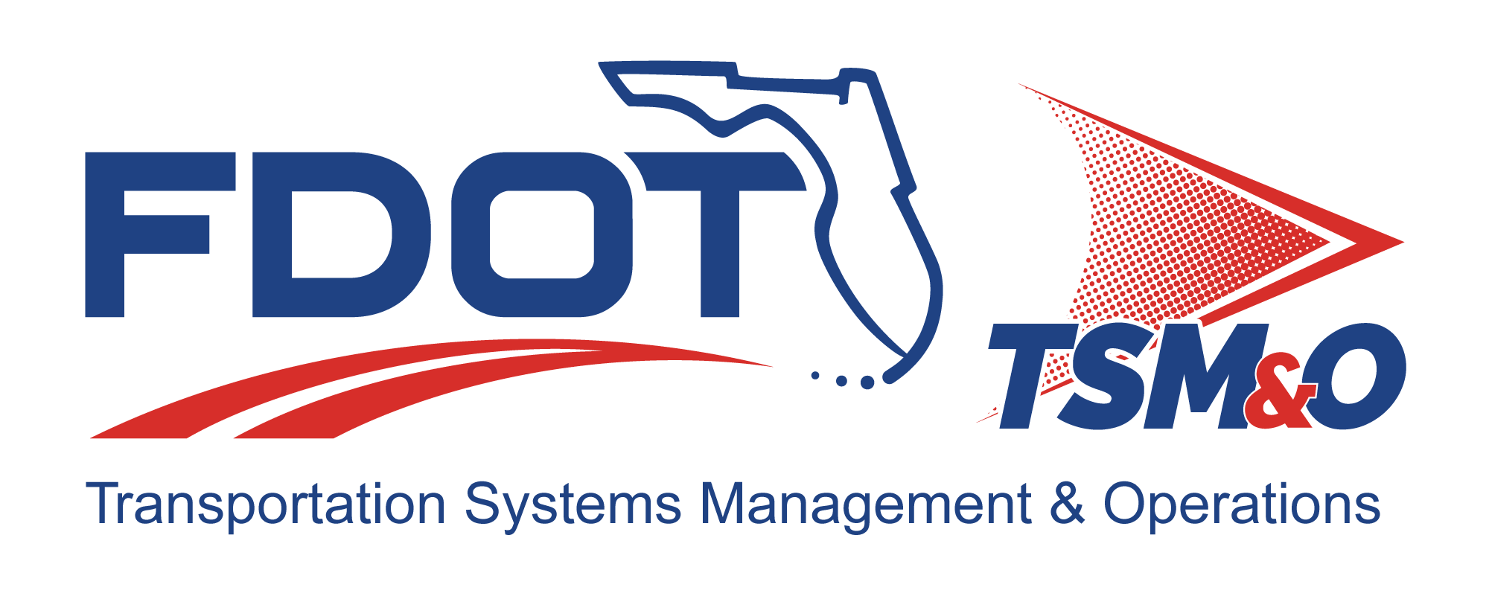

Project Performance Management Plan for: insert project name

Version: insert version number

Approval date: insert approval date

DOCUMENT CONTROL PANEL
File Name:
File Location:
Version Number:
Name |  | Date
Created By:
Reviewed By:
Modified By:
Approved By:
Table of Contents

1. Overview 1
1.1 Scope 1
1.2 Identification 1
2. Organizational Metrics 1
3. Project Objectives 1
3.1 Project Analysis 1
3.2 Process Goals 2
3.3 Product Quality Goals 2
3.4 Program Measurements and Metrics 2
4. Engineering Process 2
5. Quantitative Management 3
5.1 Data Collection and Verification 3
5.2 Measurement Analysis 3
5.3 Causal Analysis 3
5.4 Management Reporting 3
6. Responsibilities 3
7. Training 3
8. User Definitions 4

List of Tables

Table 1: Title 3

List of Figures

Figure 1: Title 3

List of Acronyms and Abbreviations

FDOT Florida Department of Transportation
PMP Program Performance Management Plan

Overview
The Project Performance Management Plan (PPMP) describes the methods used by the Florida Department of Transportation (FDOT) engineering and management, or its subcontractors, to quantitatively manage the performance of the processes. The PPMP establishes the engineering process goals and product quality goals as well as the methods used for collecting, analyzing, quantitatively controlling, and reporting performance data in terms of project goals. The PPMP also describes the project’s management process, using project management measurements for progress and status.

Scope
The PPMP describes the goals and measurements for management of systems, hardware, and software engineering processes. The PPMP is applicable to project managers for the use of measurements, analyses, and reports.

Identification
This section contains a full identification of the system to which this document applies, including, identification number(s), title(s), abbreviation(s), version number(s), and release number(s), as applicable. The PPMP is managed and controlled in accordance with FDOT configuration management practices.

Organizational Metrics
This section establishes project goals and associated measurements (i.e., metrics) for systems, hardware, and software engineering at the organizational level. The organizational metrics serve as a resource to use when deriving the process performance baseline for a project. The FDOT metrics are collected from each project and retained in a central metrics database. The project measurements are used for periodic risk analysis. The metrics are used to define the FDOT process capability baseline; assess process stability and control; and identify opportunities for process improvements.

Project Objectives
The project goals are defined for FDOT to use in meeting the project’s customer expectations. The process and product quality measurements (i.e., quantitative management metrics) are used to manage program process and product quality. Project measurements are used to determine program status and identify program risks that will be managed and mitigated in accordance with the program risk management process.

Project Analysis
This section includes project plans for decomposition and analysis of FDOT goals and customer goals. The project’s plan for defining the goals must also identify the critical processes and measurements that most directly impact the project goals. The project identifies all the processes and associated measurements that will support tracking and management control. The project prioritizes these processes and measurements, and compares the proposed project measurements against the FDOT’s project tracking and quantitative measurements to select a specific set of project metrics to be used for managing project performance.

Process Goals
This section lists the project process goals related to FDOT goals, and customer goals that are specific to the project. An example of a project-specific process goal is:

- Meet 100 percent on-time customer document deliveries

- All FDOT and project process goals are passed to subcontractors in their statements of work.

Product Quality Goals
This section lists the product quality goals related to FDOT goals and customer product quality goals that are specific to the project. An example of a project specific goal is:

- Meet project reliability requirements (i.e., project contractual requirements)

- All FDOT and project product quality goals are passed to subcontractors in their statements of work.

Program Measurements and Metrics
This section provides the list of metrics that are used for quality management of the project. An example of a project specific goal and its associated metrics is:

Goal: Delivery 100 percent of the system documents on time

Metrics: Planned delivery date
Actual delivery date

Engineering Process
This section describes any special or tailored project processes (e.g., the systems engineering management plan, software development plan, hardware development plan, etc.) that require unique metrics or measurements, or that cause project modification of any FDOT organizational measurements or their interpretation.

Quantitative Management

Data Collection and Verification
This section identifies the project resources and describes tools used to collect and verify measurement data. Data collected for project performance management purposes is collected at least monthly and analyzed to support timely management of both project processes and product quality.

Measurement Analysis
This section describes the analytical techniques for measurement analysis of the metrics associated with each project goal. One of the typical metrics is productivity (e.g., hardware, software, systems, etc.) and the associated units of measure (e.g., labor hours spent per system).

Causal Analysis
This section describes the causal analysis (i.e., analysis of both the data and the process) used to determine root cause and corrective action.

Management Reporting
Quality measurements are presented to the appropriate levels of management. The project metrics coordinator compiles and distributes the quality management report to project and engineering management on a monthly basis. This report will track performance for process and product quality against the goals defined in the quality management plan.

Responsibilities
This section lists the personnel responsible for managing the performance of the processes.

- Project metrics coordinator (include responsibilities)
- Project manager (include responsibilities)
- Project engineer (include responsibilities)
- Quality assurance manager (include responsibilities)

Training
This section describes any available training related to management of ITS process performances.

Table 1: Title

Figure 1: Title

User Definitions

DOCUMENT REVISION HISTORY
Version Number | Approved Date | Description of Change(s) | Created/  Modified By

