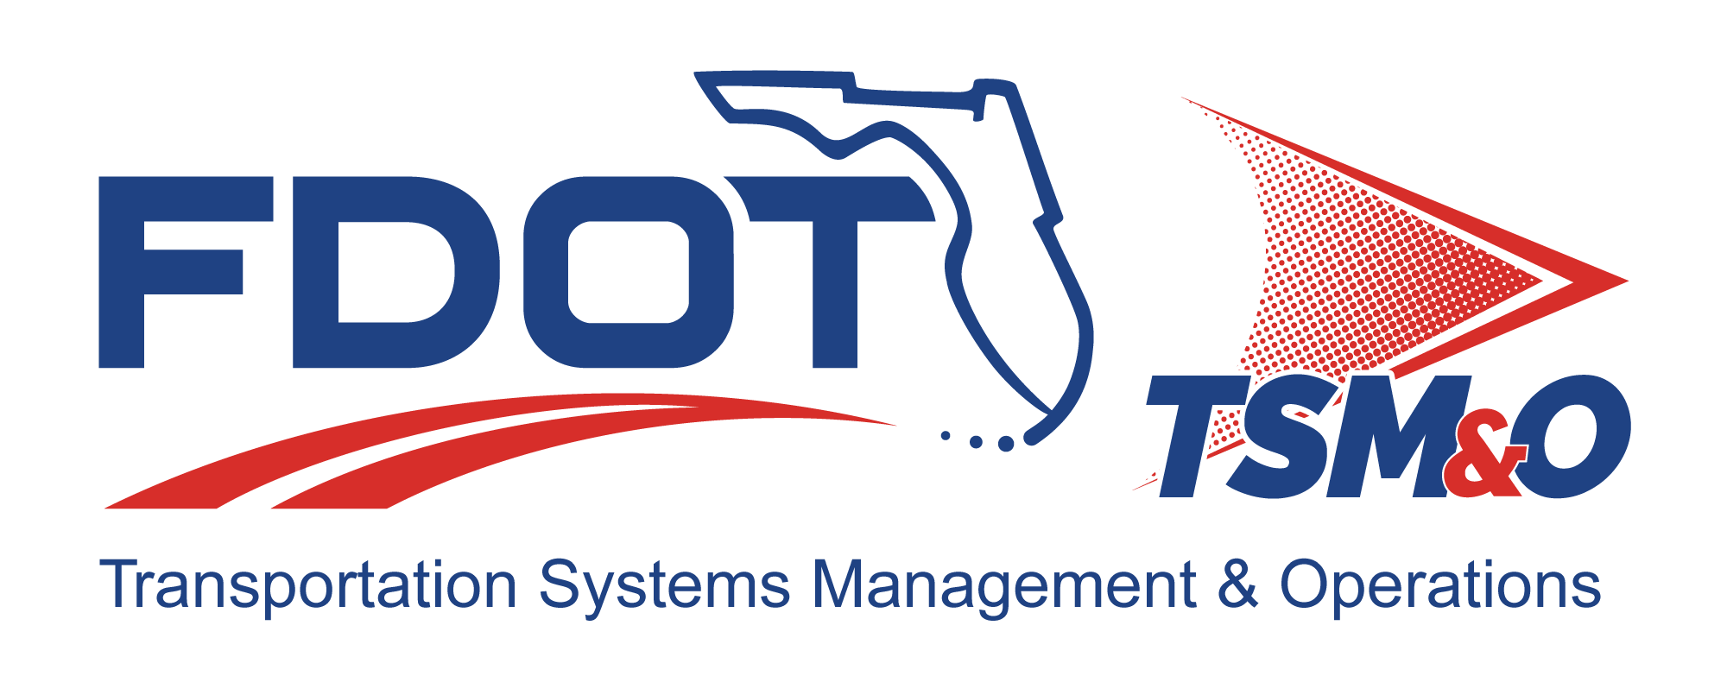

Program Management Plan for: insert project name

Version: insert version number

Approval date: insert approval date

DOCUMENT CONTROL PANEL
File Name:
File Location:
Version Number:
Name |  | Date
Created By:
Reviewed By:
Modified By:
Approved By:
Table of Contents

1. Introduction 1
1.1 Project Information 1
1.2 Deliverables 1
1.2.1 System Description 1
1.2.2 Products and Services 1
1.3 Key Project Events 1
1.4 Goals 2
1.5 Vision and Charter 2
2. Organization Structure 2
2.1 Responsibilities 2
3. Management Plans 2
3.1 Statement of Work 2
3.2 Cost Management 2
3.3 Schedule Management 3
3.4 Technical Management 3
3.5 Resource Management 3
3.6 Risk Management 3
3.7 Subcontract Management 4
3.8 Configuration and Data Management 4
3.9 Quality Management 4
3.10 Monitoring and Control 4
4. Statusing 4
4.1 Reviews 5
4.2 Metrics 5
5. User Definitions 6

List of Tables

Table 1: Title 6

List of Figures

Figure 1: Title 6

List of Acronyms and Abbreviations

FDOT Florida Department of Transportation
CDMP Configuration Data Management Plan
HDP Hardware Development Plan
ITS Intelligent Transportation Systems
PMP Program Management Plan
SDP Software Development Plan
SEMP Systems Engineering Management Plan
SOW Statement of Work

Introduction
The Program Management Plan (PMP) establishes the management approach used on a Florida Department of Transportation (FDOT) intelligent transportation systems (ITS) project that is consistent with the approach used on all FDOT ITS programs. The PMP describes the overall program structure; deliverables; related management plans and procedures; and the methods used to plan, monitor, control, and improve the project development efforts. The PMP is a dynamic document and is updated on a periodic basis to reflect all organizational changes, lessons learned, and advances in methodologies that occur throughout a project’s life cycle.

Project Information
This section provides a brief summary of the program and includes:

- Project Name
- Contract Number
- Period of Performance
- Contract Type (i.e., firm fixed price, cost plus, etc.)
- Contract Value
- Delivery Date
- Project Manager
- Contact Information

Deliverables

System Description
This section provides a brief description of the system being developed and managed.

Products and Services
This section describes what products are being supplied to the FDOT under the contract. It also provides a list of products and services that will be produced by an ITS project.

Key Project Events
This section describes the key milestone events for an ITS project. For example, functional assessment events, acceptance/approval events, key technical demonstrations/collaborative events, etc.

Goals
This section briefly describes any strategic and/or tactical goals a project is to achieve. These may include cost, schedule, or technical goals.

Vision and Charter
This section briefly describes the project’s vision and charter. The purpose of a shared vision is to provide a statement of an envisioned future, and to establish a common understanding of the aspirations and governing ideals of the project. The charter is the contract among the project members for the expected work effort and level of performance.

Organization Structure
This section describes the organizational structure of the project. The organization includes FDOT personnel, subcontractors, customers, and users. The description includes the role and involvement of each entity in the project.

Responsibilities
This section describes the roles and responsibilities of project personnel, including the:

- Project Manager
- Subcontracts Manager
- Project Engineer
- Finance Manager
- Planning
- Operation
- Procurement
- Configuration Management
- Quality Assurance

Management Plans

Statement of Work
The statement of work (SOW) defines the planning and management activities that will be expected by the customer. The SOW is mutually agreed to by the customer and FDOT project management. The SOW resides in the project library and is maintained by the project manager

Cost Management
This section describes internal cost management policies that provide a set of operating procedures for planning, directing, monitoring, and measuring work. These policies provide controls for accurate decision-making data for the project management team to analyze, capture variances, and plan revisions to the baseline costs.

Schedule Management
The integrated master schedule outlines the program plan in sufficient detail to define resource requirements, material timing, and integration requirements with existing plans and schedules. The integrated master schedule, built around the contract work breakdown structure, is the top level of the scheduling system, and is supported by a hierarchy of intermediate and detailed schedules. All critical dependencies, resources needed, and critical path items are clearly identified on the integrated master schedule.

Technical Management
The technical management strategy for the program is documented in three key management plans, including the:

- Systems Engineering Management Plan (SEMP) – This plan describes the overall plans for the engineering and manufacturing development of each program. The SEMP should also describe how the technical baselines (e.g., requirement specifications, etc.) for the program will be documented, traced to other engineering work products, and maintained.
- Software Development Plan (SDP) – The SDP establishes the software development approach, methodologies, tools, and procedures to be used during the analysis, design, development, testing, integration, deployment, and maintenance of the software for each FDOT project.
- Hardware Development Plan (HDP) – The HDP establishes the hardware development approach, methodologies, tools, and procedures to be used during the analysis, design, fabrication, testing, integration, deployment, and maintenance of the hardware for each FDOT program.

The SEMP, SDP, and HDP serve as the program’s implementation of the tailored FDOT standard organizational Systems Engineering Process. These documents reside in the project library and are maintained by the project engineer.

Resource Management
Resource management (i.e., staffing) on the project is handled by the FDOT project manager and subcontract manager, as applicable. The FDOT ITS project staffing needs will be reviewed on a monthly basis and subcontractor staffing will be statused through monthly progress reviews conducted by the subcontract manager.

Risk Management
Risk management is designed to reduce the impact of programmatic and technical uncertainties to acceptable and manageable levels. Risks are inherent in every endeavor, especially during the development phases of a program’s life cycle. Each person on the program is responsible for overall risk management, and uses the same process to identify and control risks.

Subcontract Management
If the project utilizes subcontracted services and products, it is essential to have an experienced subcontract manager, subcontractor SOW, and a subcontract management plan. The objective of these documents and personnel is to ensure purchase orders are properly executed, providing the appropriate controls to meet the program schedule, budgets, and technically compliant services and products to review the progress of the subcontractor and subcontract management activities.

Configuration and Data Management
The configuration and data management activities for the program are documented in the configuration data management plan (CDMP). The CDMP describes the procedures to be used on the program to assure the integrity and control of the products being developed (e.g., configuration identification and methods; formal release configuration data management controls; development of library controls; the engineering change proposal process; change control process; program problem reporting; configuration control board establishment; configuration audits; and the storage, handling, and delivery of project media).

Quality Management
The quality management activities for the program are documented in the quality management plan. The quality management plan describes the procedures to be used on the program to implement a quality program and provide FDOT management personnel with visibility into the quality of the products (e.g., process and product evaluations; record keeping; nonconformance tracking; and reporting channels).

Monitoring and Control
Monitoring and control activities are used to monitor the project’s performance. These include the uses of periodic status reviews; informal and formal reviews; milestone reviews; and metrics analysis to determine the health of the program.

Statusing
This section describes the progress reviews, scheduled as periodic occurrences or on an as-needed basis, used on the project to status the program’s performance. These reviews include the results and analyses of reviewing internal and external commitments, risks, management of project data, and stakeholder involvement. These reviews are performed at various project levels and may include both project and senior management representation.

Results, documented as meeting minutes, include a minimum of the decisions made during the meeting, attendance, issues, risks, and action items.

Reviews
This section describes the typical mechanisms employed on the project that are initiated from either internal or external needs.

- Initial Baseline Reviews are used to assess the project’s technical, cost, and schedule baselines. Initial baseline reviews provide an independent mechanism to assure project management that the project has the infrastructure in place to meet its performance commitments for the project to remain on schedule and under budget. An example of an initial baseline review is the project kickoff meeting where the project plan is reviewed.
- Independent Technical Assessments are used to assess proposed technical, cost, schedule, and staffing objectives for new business opportunities or enhancements. Independent technical assessments are used to identify risks prior to the establishment of a contractual commitment. These assessments provide an independent review mechanism to assure project management that the proposed commitment is complete, meets FDOT policy, and is well thought out. An independent technical assessment may be conducted by an FDOT contractor that has no relationship to the development contractor or by a separate FDOT committee.
- Performance Assessment Reviews are used to assess the project technical, cost, and schedule performance against the baseline plans. Performance assessment reviews provide an independent mechanism to assure project management that the project performance commitments are met in order for the project to maintain a “GREEN” status. Performance assessment reviews help identify weaknesses in the project’s implementation of the baseline plans and help foster an atmosphere of continuous improvement. Examples of performance assessment reviews are the monthly progress reviews; the system requirements review; the system design review; software and hardware design reviews; etc.
- Milestone Reviews are typically formal reviews. Reviews are conducted at meaningful points in the project’s schedule, such as the completion of selected stages (or phases), with relevant stakeholders (i.e., managers, staff members, customers, end users, suppliers etc.). Project commitments, plans, status, and risks are reviewed. Significant issues and their impact are identified and documented. Results of the review, such as action items and decisions, are documented as review minutes. Action items are tracked to closure. Examples of milestone reviews include the system requirements review, system design review, software specification review, preliminary design review, critical design review, test readiness review, etc.

Metrics
This section describes the metrics used to provide adequate quantitative visibility into the development progress so that project management can take effective actions when a project’s performance deviates from its plans. Actual performance metrics are tracked against documented estimates, commitments, and plans, and the appropriate action is taken when plans and actuals deviate.

The project has identified a set of project metrics to be used for project progress management, project quantitative management, and the associated analysis activities (e.g., sourcing, delivery performance, and other project metrics). These metrics, along with the project’s quantitative objectives, are documented in the project’s program performance management plan. Refer to Appendix O for a template to use in creating this plan.

In addition, the project produces a monthly program performance management report that describes the quantitative analysis performed on selected processes in accordance with defined project goals. Together with other FDOT projects, these metrics are used in the planning and costing of future activities as well as to support ongoing process evaluations.

Table 1: Title

Figure 1: Title

User Definitions

DOCUMENT REVISION HISTORY
Version Number | Approved Date | Description of Change(s) | Created/  Modified By

