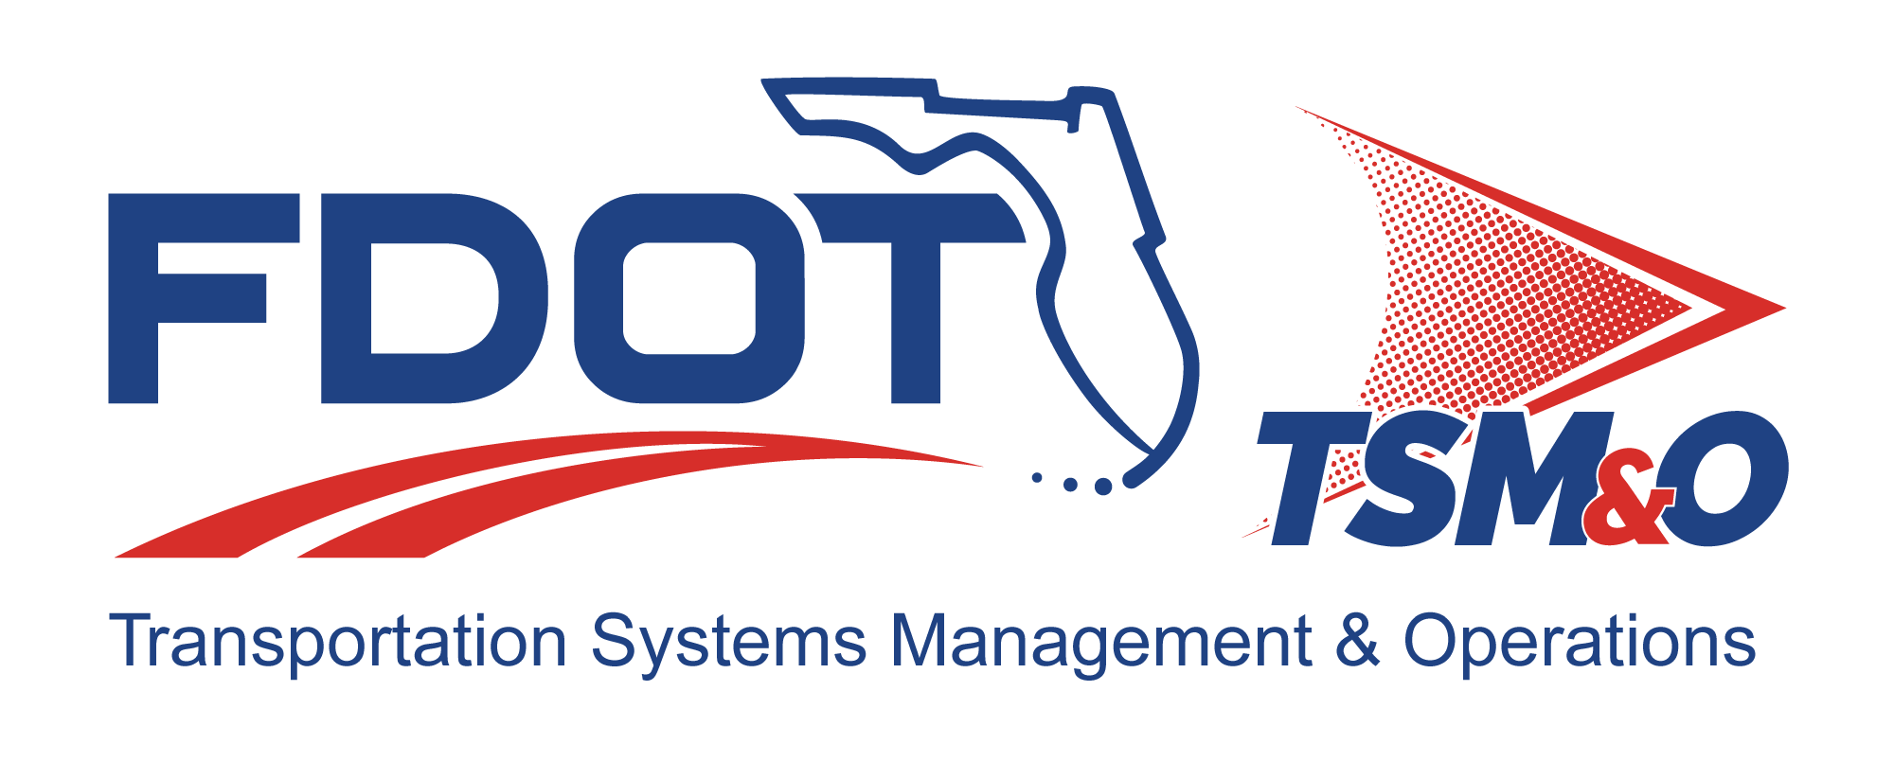

Operational Development Plan for: insert project name

Version: insert version number

Approval date: insert approval date

DOCUMENT CONTROL PANEL
File Name:
File Location:
Version Number:
Name |  | Date
Created By:
Reviewed By:
Modified By:
Approved By:
Table of Contents

1. Overview 1
1.1 Scope 1
2. Reference Documents 1
3. System Description 1
3.1 System Requirements 2
3.2 System Milestones 2
3.3 Manpower 2
3.4 Constraints and Risks 2
3.5 Future System Improvement Efforts 2
3.6 Lessons Learned 2
3.7 Supporting Plans and Work Instructions 3
4. User Definitions 3

List of Tables

Table 1: Title 3

List of Figures

Figure 1: Title 3

List of Acronyms and Abbreviations

FDOT Florida Department of Transportation
ITS Intelligent Transportation Systems
ODP Operational Development Plan

Overview
The Operational Development Plan (ODP) describes the necessary tasks, responsibilities, and controls that will be implemented by the Florida Department of Transportation (FDOT) and the intelligent transportation systems (ITS) project subcontractors. Its primary objective is to assure that the FDOT ITS project has sufficient and significant resources to support the project objectives. The ODP provides sufficient details to cover the top-level operating concepts. The details of operation should be defined during the subsequent analysis, design, and development phases.

Scope
The ODP covers the following elements:

- Project summary
- Description of the overall mission of the system
- Description of the overall system requirements
- System milestones
- Definition of current project resources
- Constraints and risks
- Future system improvement efforts
- Lessons learned
- Supporting plans and work instructions

Reference Documents
Always insert the following disclaimer:

The following documents, of the exact issue shown, form a part of this document to the extent specified herein. In the event of a conflict between the documents referenced herein and the contents of this document, this document shall be considered the superseding requirement.

Include references to project-specific FDOT standards and procedures used in the development of the requirements.

System Description
Describe the system and mission for the ITS project. This will include title, nomenclature, and program elements for budget, security classification, and principal agencies. It will identify the customer, contracting agencies, and users/stakeholders. The FDOT will reference other plans and documents that support the systems operation process.

System Requirements
This section describes how manpower, personnel, training, security, safety, human factors engineering, and health hazard considerations are applied to the design and development of the ITS product to reduce costs and enhance capabilities.

System Milestones
This section identifies the schedules and milestones for the ITS project.

Manpower
This section identifies total resource requirements to operate the ITS product throughout its life cycle. Included are recommended tradeoffs to support the system and the impacts of not funding or procuring desired operational capability. Manpower categories to be addressed include:

- Contractor
- Subcontractor
- Customer

Constraints and Risks
This section describes all potential limitations that will or may affect timely implementation of the ITS project and prevent it from being maintained at full capability. It describes all operational constraints for the ITS project. Items to be considered include manpower/personnel and resource availability; safety; security; cost; and environmental considerations. The FDOT will identify risks and assign risk levels that may affect schedules or other milestones. The FDOT will identify the system work-a-rounds, dollar costs for alternative operation, and increased use of the system.

Future System Improvement Efforts
This section describes future studies, and analyses and cost/benefit analyses that may support upgrades to the systems or alternative methodologies to close any operational gaps or accomplish the operational objectives with fewer resources.

Lessons Learned
This section addresses how the ITS project will benefit from previous or other ongoing projects, and should include:

- Lessons learned, usually based previous projects
- Identification of problem areas common with other projects and potential solutions
- Document fixes, work-a-rounds, or changes to requirements based on lessons learned
- Impacts on system costs, effectiveness, and operational capability
- Best practices that were used for successful projects

Supporting Plans and Work Instructions
This section describes the supporting operating plan and work instructions required to operate the system, and includes:

- Training and certification plan
- Instructional development plan
- Quality management plan
- Security plan
- Safety plan

Table 1: Title

Figure 1: Title

User Definitions

DOCUMENT REVISION HISTORY
Version Number | Approved Date | Description of Change(s) | Created/  Modified By

