FISCAL YEAR (FY)
$69M
$74M
$79M
$41M
$47M
$65M
$58M
$61M
$29M 1051051M
$105M
7%
93%
IMPROVEMENTS
Where does the funding go?
ACTUAL FY 2019–2023 PROJECTED FY 2024–2028
How much does FDOT fund each year?
INVESTMENTS
FROM
2019 TO 2028
$628M⁺
PRODUCT SUPPORT
- Planning
- Financial Analysis
- Design / Inspection
CAPITAL IMPROVEMENTS
- Launch complexes
- Facilities
- Manufacturing
$318 MILLION $310 MILLION
2019 2020 2021 2022 2023 2024 2025 2026 2027 2028
2026

2025

2025

2022
2020 2021 2022 2022 2023 2024 2025
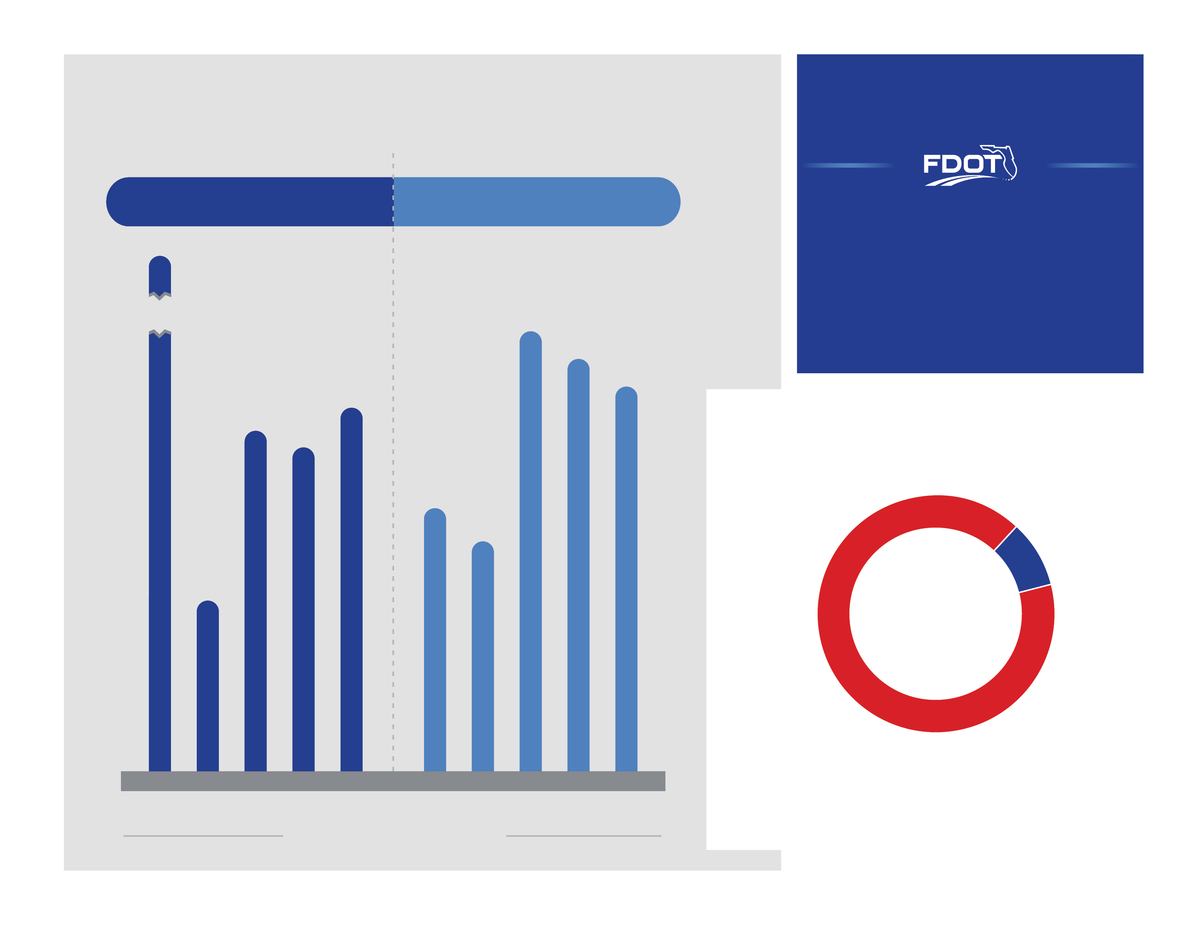
FDOT’S SPACEPORT IMPROVEMENT PROGRAM
Florida Department of Transportation (FDOT) is committed to the successful implementation of Florida’s Spaceport Improvement Program.
This information presents FDOT’s actual and projected yearly spaceport funding from 2019 to 2028.

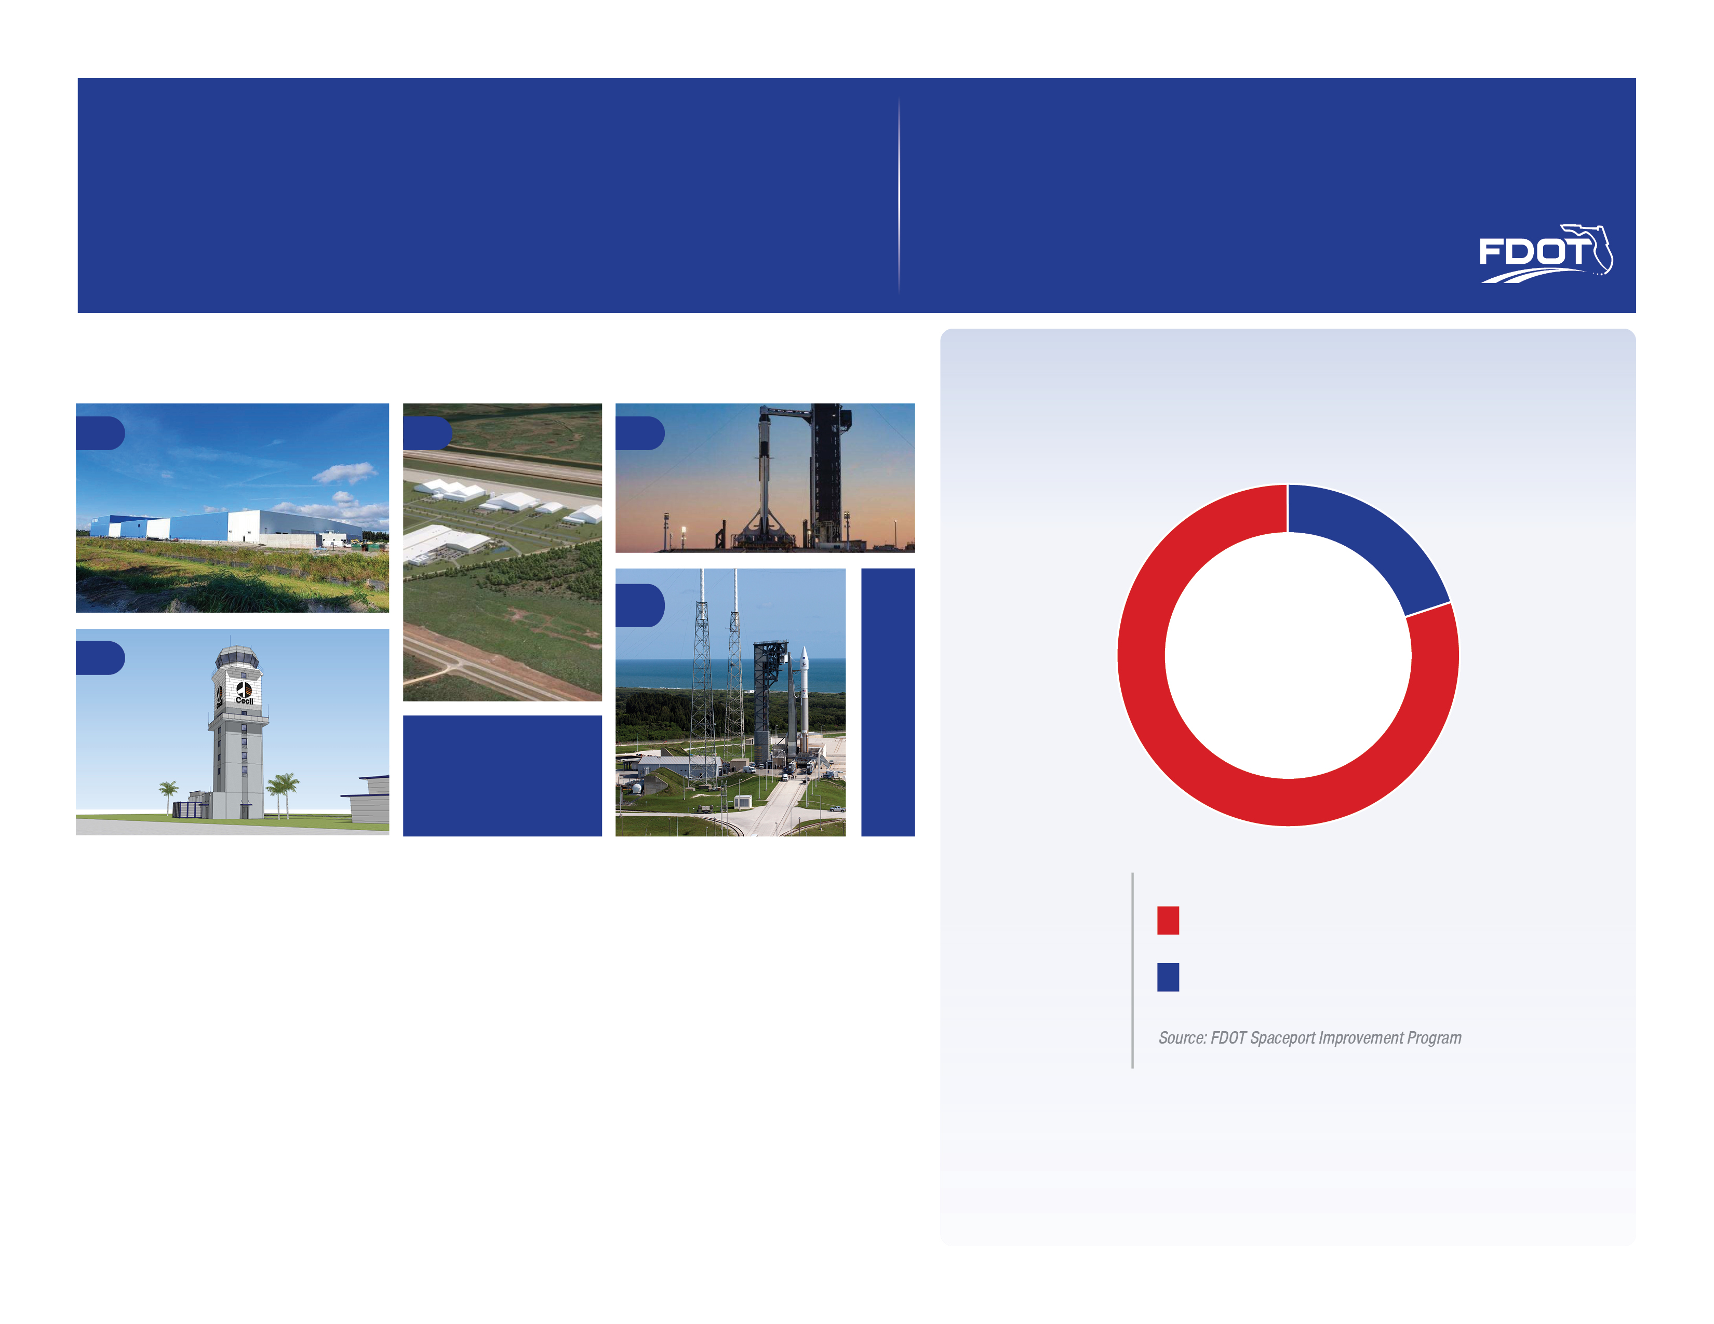
3 SPACEX – LAUNCH COMPLEX 39A – EXPANDS SPACE LAUNCH VEHICLE SYSTEMS Supports launch of New Starship and Human Transportation in Space
1 BLUE ORIGIN – COMPOSITES ASSEMBLY FACILITY
Supports heavy lift launch and operations for customer payloads. and test support commercial aerospace development for multi-users and launch vehicles
SUPPORTS LAUNCH OPERATIONS AND TEST SUPPORT HEAVY LIFT ORBITAL LAUNCH FACILITIES Provides Launch Capabilities for the New Glenn Heavy Lift Vehicle
5
2 3
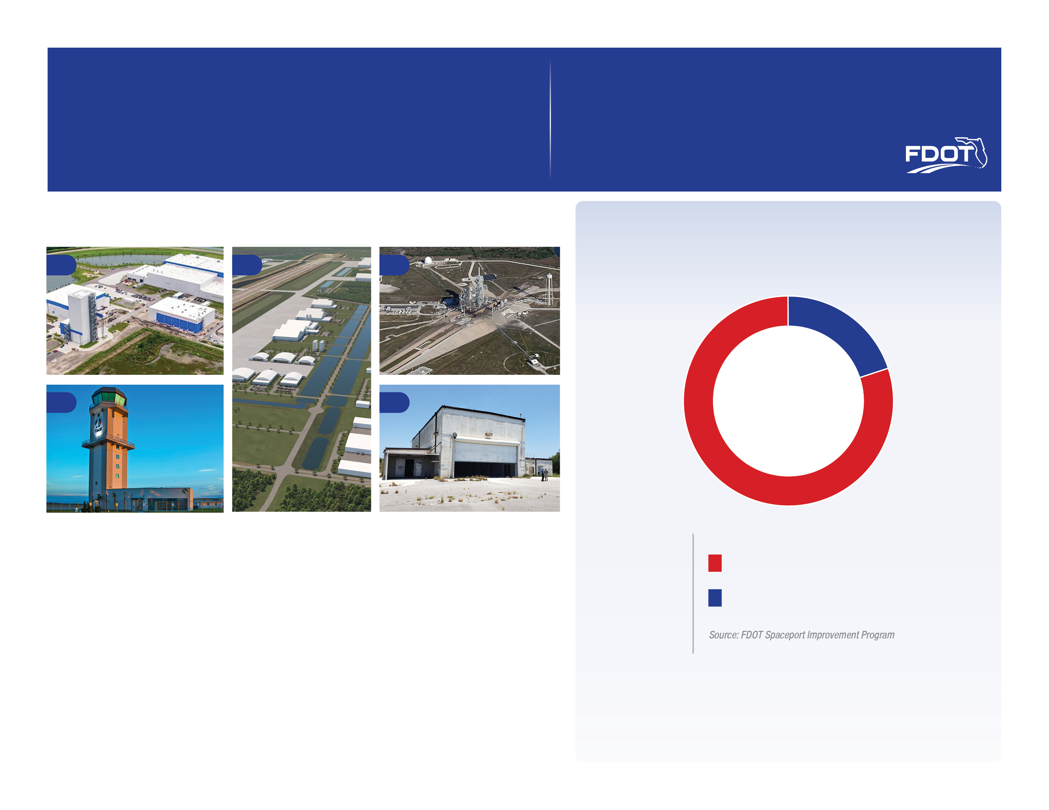
4 CECIL SPACEPORT – COMPLETION OF SPACEPORT HANGAR AND UTILITY CORRIDOR
Enables commercial launch operations at the Jacksonville Aviation Authority – Cecil Spaceport
FDOT Participation
Aerospace Partner
20%
80%
2012–2027
$2.2 Billion⁺
4
1
SPACEPORT PROJECTS
MODERNIZATION & GROWTH INVESTMENTS

2 SPACE FLORIDA – SPACEPORT LAUNCH AND LANDING FACILITY
Supports commercial aerospace development for multi-users and launch vehicles
5 AREA 57 IMPROVEMENTS – REFURBISHES PROCESSING FACILITIES
Enhances launch operations for medium vehicles at the Cape Canaveral Spaceport
COMMERCIAL MARKET-DRIVEN SPACEPORT
FLORIDA—THE GLOBAL DESTINATION FOR
SPACE TRANSPORTATION &
AEROSPACE COMMERCE
FDOT and Space Florida stimulate private sector investments and commercial spaceport development. Below are selected ongoing Spaceport Projects that have been integrated within
the state’s transportation system. State funds have been leveraged to yield significant results.

