SPACEPORT OFFICE

Spaceport Facilities
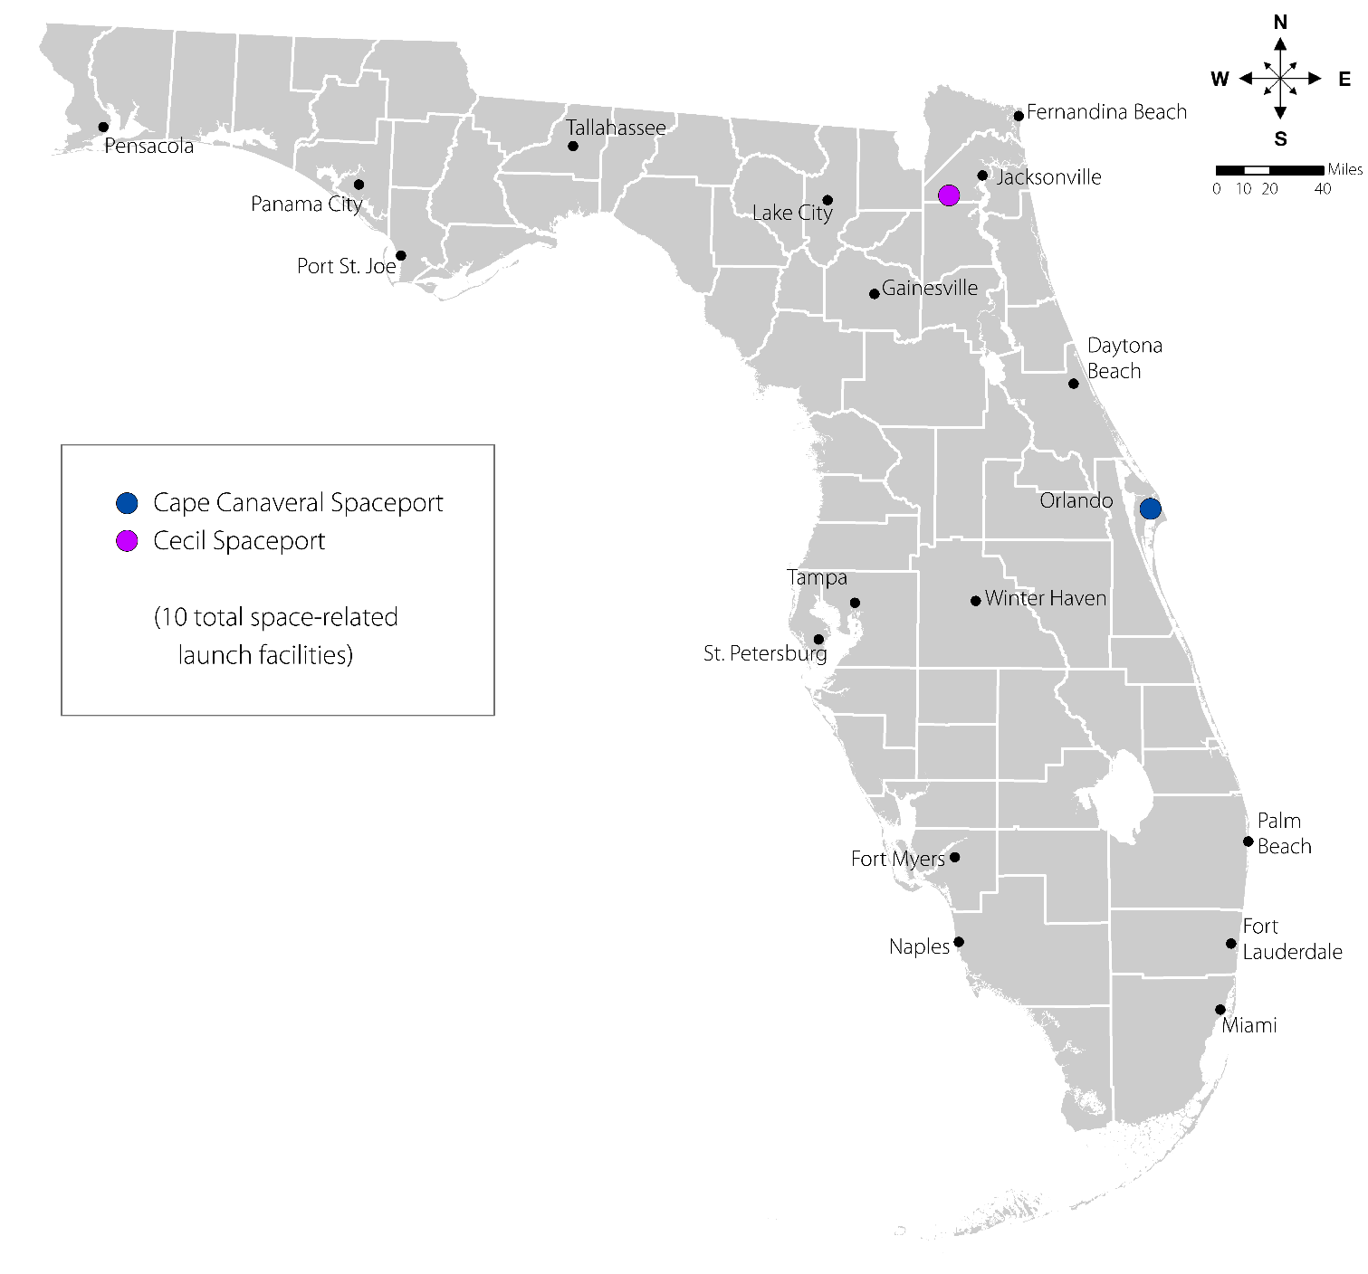
Cape Canaveral Spaceport
Cecil Spaceport
Spacecoast Regional Spaceport

SPACEPORTS Staff

SPACEPORT Staff Responsibilities
Spaceport Office | - Provides critical review and dissemination of analyses of significant aerospace issues.  - Analyzes the effects of new requirements, and suggestions to meet them, to key FDOT central and district office leadership and management.  - Promotes development and improvement of aerospace transportation facilities.  - Coordinates the development of spaceports.  - Provides input related to infrastructure and related transportation facilities contained in the Strategic Intermodal System Plan (SIS).  - Addresses intermodal requirements and impacts of space transportation facilities.
(District Modal Contacts located in each district section)

FDOT and Spaceports
Florida has one of the most dynamic transportation systems in the world. Besides roads, bridges, seaports, rail, and airports, the state also has a leadership role in America’s space program. Substantial public benefits gained from the space program, such as global positioning systems (GPS), weather forecasting, disaster response, smartphones, and NextGen rely on satellites to enhance our transportation system and improve our quality of life.
The Florida Department of Transportation (FDOT) uniquely includes support for spaceports as part of the transportation network. FDOT and Space Florida work together to provide space transportation services and infrastructure in the State.
FDOT, through its Spaceport Improvement Program (SIP), provides funding assistance for projects that:
- Improve space transportation facilities,
- Encourage coordination between airports and spaceports, and
- Foster interagency efforts to improve space transportation capacity and efficiency.
Since the beginning of the US space program, Florida has been at the forefront of all aspects of the space industry. As the center of National Aeronautics and Space Administration (NASA). the United States Air Force (USAF) and now the United States Space Force (USSF) space launch infrastructure since the 1950’s, space transportation has had a major effect on Florida’s economy and its multi-modal transportation system. Though accommodating this mission has always been a significant role of FDOT, space was not previously considered by the State as a separate mode of transportation to be planned or programmed. This view began to change as space transportation technology continued to mature and the prospect of commercial spaceflight became a greater reality.
In 1999, Florida designated space as an official mode of transportation and spaceports as the associated transportation facilities. This official designation provided space equal standing within FDOT, similar to other the long-established modes of roads, bridges, rail, airports, and seaports. With this designation, spaceports and space transportation were aligned to help FDOT achieve its primary mission.
Most importantly, Florida law establishes a process for incorporating spaceport and aerospace industry related needs into the Florida Transportation Plan (FTP) and the Strategic Intermodal System (SIS), the primary drivers for delivering state transportation products in Florida.
The FTP provides the policy framework for allocating FDOT’s funding to meet the transportation needs of residents, tourists, and businesses. The FTP identifies goals and objectives for the next several decades and addresses the needs of the state transportation system as a whole. One FTP stated goals is to strengthen coordination among seaports, airports, spaceports, railroads and other modal partners. The SIS is a statewide system of transportation facilities playing a critical role in moving people and goods within Florida and to or from other states and nations. The SIS serves as the state’s highest priority for statewide mobility. Incorporating space and aerospace related needs into the FTP and the SIS is a significant commitment by the state to support a major sector of Florida’s economy.
Space Florida, an independent special district of the State of Florida, serves as the state’s lead entity for state aerospace-related activities with federal, military, and state agencies as well as the private sector. Space Florida promotes and assists Florida’s aerospace business sector by providing access to space transportation facilities, financing, support services, and innovative education programs. Created as an Independent Special District pursuant to Chapter 331, Part II, Florida Statutes, Space Florida is charged with fostering the growth and development of a sustainable and world-leading space industry in Florida.
Vision
Mission
Deploy the FDOT work program to attract and support long-term commercial aerospace industry through the Spaceport Improvement Program, advance the Department’s Mission and Vision, and collaborate with Space Florida to make Florida the “Place for Space”.
Vision
Partnering with Space Florida, to allocate available funding to serve the people of Florida by providing a world class space transportation network that is well planned and conscientiously executed, supports economic growth, and is in concert with the mission and vision of FDOT.

Space Florida is required under state statute to “develop a spaceport master plan for the expansion and modernization of space transportation facilities within spaceport territories”. The Florida Spaceport System Plan functions in this role, incorporating the various individual spaceport master plans across the state, including the Cape Canaveral Spaceport Master Plan. Within this System Plan, Space Florida maintains a list of recommended capital projects eligible to be funded through FDOT.

FDOT & Space Florida Collaboration
FDOT and Space Florida work closely together to provide space transportation services on spaceport properties throughout the State. With the Federal Aviation Administration’s (FAA) licensure of commercial spaceports at Cape Canaveral in 1999, Cecil Spaceport in 2010, and Space Coast Regional Spaceport (Titusville) in 2020, coupled with the potential for more in the future, Florida is in the unique position of having an expanding system of spaceports capabilities. Further, due to the programmatic changes associated with the retirement of the NASA Shuttle Program, access to an increasing number of unused federal space launch facilities led Space Florida, in partnership with FDOT, to take a more active role in the planning and funding of spaceport infrastructure. This expanding role has led to the Spaceport Improvement Program and significant milestones securing Florida’s place as a global space transportation leader.
As Florida’s aerospace industry development organization, Space Florida fosters bold economic development activities to expand and diversify domestic and international space opportunities. These efforts support talent development, enhance infrastructure, and support government and commercial organizations in improving Florida’s competitive business climate. Space Florida leverages this development by supporting, assisting, facilitating, and consulting regarding space industry-related needs to attract, retain, and expand aerospace or related supply chain businesses (aerospace partners) that create economic opportunities in Florida.
Recent collaboration efforts include:
- Provided funding assistance to Space Florida for improvements to Launch Complex-46 at Cape Canaveral Spaceport. The improvements provide for rocket engine testing, launching, and other development at the complex.

- Continued to support Space Florida’s efforts to obtain an FAA commercial launch site operator license for the Shuttle Landing Facility and the proposed Shiloh launch complex, both at the Cape Canaveral Spaceport.

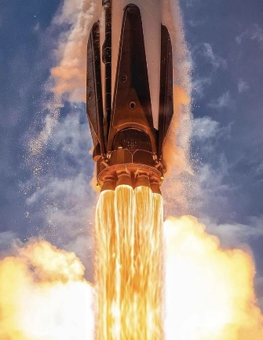
- Provided Space Florida with engineering technical expertise for facility assessments of the Shuttle Landing Facility, Launch Complex-46, solid propellant processing areas, and future launch pad sites.

Future of Spaceports
As the commercial space sector develops, Florida will face new challenges to provide a safe aerospace environment while simultaneously promoting strong and resilient economic development. Going forward, the challenge for FDOT is to identify, balance, and incorporate various regulatory and economic aspects of evolving commercial space activities with its core mission to attract and support the long-term growth and development of Florida’s space industry.

Resources
Florida Statutes – Chap. 331Aviation and Aerospace Facilities and Commerce: http://www.leg.state.fl.us/statutes/index.cfm?App_mode=Display_Statute&Search_String=&URL=0300-0399/0331/Sections/0331.360.html
FDOT Spaceport Office Home Page: https://www.fdot.gov/spaceport
Space Florida: https://www.spaceflorida.gov/
Florida Spaceport System Plan 2018: https://www.spaceflorida.gov/wp-content/uploads/2018/12/FSSP18_FINAL__03-06-2018__Low-Res.pdf
Cape Canaveral Spaceport Master Plan: https://www.spaceflorida.gov/wp-content/uploads/2018/12/sf-bod-approved-ccs-master-plan-02-01-17.pdf
Cape Canaveral Spaceport Development Manual v 1.3: https://www.spaceflorida.gov/wp-content/uploads/2023/01/CCS-Development-Manual-January-2023-version-1.3-signed-220112.pdf
Cecil Spaceport – Spaceport Development Area Plan 12/2021: https://www.spaceflorida.gov/wp-content/uploads/2022/01/Cecil-Spaceport-Area-Development-Plan.pdf

