Highway Safety Concept Paper Instructions

Fiscal Year (FY) 2020

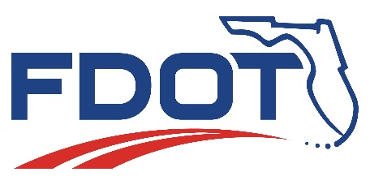

Florida Department of Transportation
State Safety Office
Highway Safety Subgrant Program

Revised 12/2018

Table of Contents
Table of Contents 2
Subgrant Overview 4
Subgrant Timeline 4
Funding 5
Agencies Eligible to Receive Funding 5
Funding Restrictions 5
Funding Cycle 5
Selection Criteria 6
Notification 6
Submission Deadline 7
Examples 7
Traffic Safety Priority Areas 8
Highway Traffic Safety Subgrant Management System 12
Getting Registered in the System 12
System Roles 14
Subrecipient Viewer Role 14
Subrecipient System Administrator Role 14
Subrecipient Editor Role 14
Getting Started 15
Creating a New Concept Paper 15
Concept Paper Forms 16
Form Field Limitations 18
Types of Forms 18
Applicant Information 19
Project Details 22
Statement of the Problem 23
Supporting Data 23
Proposed Solution 24
Sustainability 25
Project Objectives 25
Evaluation 26
Additional Questions for Traffic Records Coordinating Committee (TRCC) Priority Area 27
Concept Paper Budget 29
Personnel Services 30
Contractual Services 31
Expenses 32
Equipment Costing $5,000 or More 33
Indirect Costs 34
Concept Paper and Concept Budget Summary Pages 35
Final Submission 36
Printing a Copy of the Concept Paper 36
Additional Required Documents 36
Submitting the Concept Paper 38

Subgrant Overview
The Florida Department of Transportation (FDOT) State Safety Office awards subgrants to traffic safety partners to undertake priority area programs and activities to improve traffic safety and reduce crashes, serious injuries, and fatalities. A list of traffic safety priority areas along with descriptions is provided on page 8 of this document. Subgrants may be awarded for assisting in addressing traffic safety deficiencies, expansion of an ongoing activity, or development of a new program.

Subgrant Timeline
Subgrants are awarded on a federal fiscal year (FY) basis (October 1–September 30). Below is a timeline of the subgrant process.
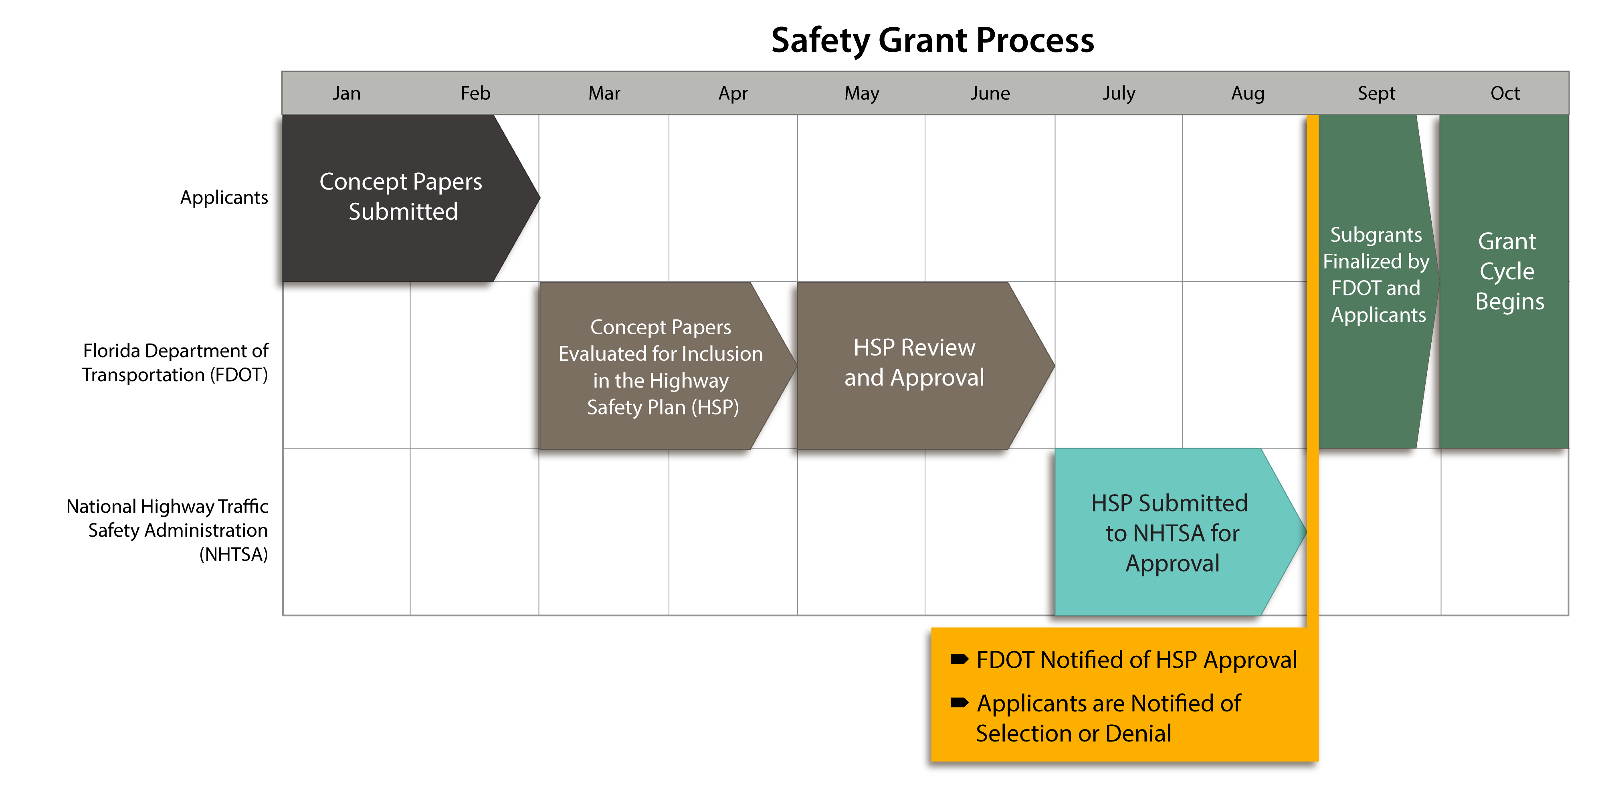
- January 1 – Last day of February — Entities interested in applying for funding submit concept papers describing their proposed efforts for the next award cycle beginning October 1.
- August – September — Entities are notified as to whether or not their concept paper has been selected and additional information on how to complete the Subgrant for Highway Safety Funds application.
- October 1 — Subgrant fiscal year begins
- September 30 — Subgrant fiscal year ends

Funding

Agencies Eligible to Receive Funding
Many types of organizations are eligible to receive traffic safety subgrant funding: government agencies, political subdivisions of state, local, city and county government agencies, law enforcement agencies, state colleges and state universities, school districts, fire departments, public emergency service providers, and certain qualified non-profit organizations (e.g., MADD, SADD, foundations, etc.).
Qualified Non-Profit Organizations must provide their “Certificate of Status” from the Florida Department of State, Division of Corporations, verifying their not-for-profit status when submitting their concept paper. The “Consumer’s Certificate of Exemption” from the Florida Department of Revenue or a letter from the Department of the Treasury confirming Section 501(c)(3) status is not sufficient to meet this requirement.
If the non-profit organization’s project is selected for funding, it must provide a financial statement showing available funds equal to or greater than the amount of the subgrant award, at the time of award.

Funding Restrictions
Replacement/supplanting of existing program expenditures and/or items are not allowable costs. Examples of unallowable costs include but are not limited to: replacement of vehicles purchased through previous subgrants, program maintenance, rehabilitation, and construction. Other unallowable costs are dealt with on a project-by-project basis.

Funding Cycle
Subgrants are administered and funded on a federal fiscal year basis (October 1 – September 30), however the start date is always contingent upon allocation schedules of the federal dollars. Funding is approved on a yearly basis.
Local subgrants are usually not funded for more than three consecutive years in a given priority area, however evaluation and selection is done on an annual basis, so there is no guarantee that a local subgrant will be funded consecutively or for more than one year. Projects deemed as statewide activities or deemed necessary based on data available by the FDOT State Safety Office may be funded for a longer period of time if funds are available.
Subgrants are intended to provide “seed” money to start new local programs. Projects should become self-sufficient when subgrant funding terminates. To promote self-sufficiency, agencies are expected to provide a local match when funding for personnel (other than overtime) is included in second and third year projects. The local match is normally 25% for second year projects and 50% for third year projects.

Selection Criteria
The FDOT State Safety Office reviews all concept papers for compliance with state and federal regulations. Concept papers that comply with these regulations are prioritized using the following criteria:
- Does the concept paper satisfy a specific traffic safety need identified by the FDOT Safety Office?
- Does the applicant agency serve a city/county ranked in the top 25% of its population group for the priority area in which funds are being requested according to the Florida Highway Safety Matrices?
- Does the crash and/or citation data supplied in the concept paper’s “Statement of the Problem” document an existing traffic safety problem?
- Does the concept paper support the Strategic Highway Safety Plan goals and objectivities?
- If the agency was funded in the past, did it submit reports, invoices, and financial paperwork on a timely basis and implement the activities that were detailed in the subgrant agreement?
- Does the indirect cost rate requested significantly affect the proposed project’s ability to adequately address the traffic safety need?
The FDOT State Safety Office is required by the National Highway Traffic Safety Administration (NHTSA) to evaluate and document the risk for each entity applying for federal subgrant funds prior to making an award. Each applicant is assessed for risk of noncompliance with federal and state statutes, federal and state regulations, terms and conditions of the subgrant as well as the applicant’s financial stability, quality of management systems, history of performance, single audit compliance, and prior audit findings, if applicable. This information is used to determine the appropriate level of monitoring if a subgrant is awarded. If the applicant does pose a risk, but the proposal has merit, the FDOT State Safety Office may, as a condition of awarding subgrant funds, impose specific terms or conditions.
Projects that are ultimately selected should provide the greatest impact to the high crash, high fatality, and/or high injury challenges that Florida faces. If concept papers are not received from those areas identified as high crash, high fatality, and/or high injury, the FDOT State Safety Office may directly solicit concepts from agencies within targeted high-risk areas.

Notification
Notification as to whether a concept paper has been selected is sent to the head of each agency between August and September. Agencies that are selected will receive further instructions on how to complete the subgrant application highway safety funds at that time.

Submission Deadline
Concept papers are accepted from January 1 through the last day of February for the next funding cycle. (E.g. Concept papers submitted January 1, 2019 will be for the October 2019 – September 2020 funding cycle.) Concept papers must be submitted through the Florida Highway Traffic Safety Subgrant Management System.
Concept papers cannot be submitted in the system after the last day of February.

Examples
Beginning with FY 2020, concept papers will no longer be submitted in paper form; however, example concept papers from previous years are available on the FDOT State Safety Office website. The format of the example concept papers mimics the online concept paper application.

Traffic Safety Priority Areas
Aging Road Users – Includes traffic safety programs designed to improve aging road user safety awareness, access to alternative transportation, and education. Concept papers can address areas such as education, training, surveys and public information efforts. Items eligible for funding under this category may include but are not limited to: overtime for education, equipment for training, and public information and education materials. Funding for equipment is contingent upon an evidence of need clearly defined in the problem statement and a comprehensive plan that requires the use of the requested equipment. Subgrants for equipment only are not allowable.
Community Traffic Safety Outreach – Includes traffic safety programs identified by local communities that address crash problems, establish priorities, and develop appropriate intervention techniques. Concept papers can address areas such as education, surveys or public information efforts. Items eligible for funding under this category may include but are not limited to: public information and education materials. Subgrants for equipment only are not allowable.
Distracted Driving – Includes traffic safety programs to increase safety awareness, prevention, and education. Concept papers can address areas such as education, training or public information efforts. Items eligible for funding under this category may include but are not limited to: overtime for education, equipment for training, and public information and education materials. Funding for equipment is contingent upon an evidence of need clearly defined within the problem statement and a comprehensive plan that requires the use of the requested equipment. Subgrants for equipment only are not allowable.
Impaired Driving – Includes high visibility enforcement (HVE), youth alcohol programs, community prevention/intervention programs and driving under the influence (DUI) courts. Concept papers can address areas such as specialized enforcement, education, training or public information efforts. Items eligible for funding under this category may include but are not limited to: overtime, alcohol testing equipment, in-car video systems, public information and education materials and DUI checkpoint equipment (including trailers, light towers, traffic cones, arrow boards, and generators). Funding for equipment is contingent upon an evidence of need clearly defined in the problem statement and a comprehensive plan that requires the use of the requested equipment. Subgrants for equipment only are not allowable.
Motorcycle Safety – Includes programs to increase safety awareness and skills among motorcyclists. Concept papers can address areas such as specialized enforcement, education, training and public information efforts. Items eligible for funding under this category may include but are not limited to: overtime, equipment for training and public information and education materials. Funding for equipment is contingent upon an evidence of need clearly defined in the problem statement and a comprehensive plan that requires the use of the requested equipment. Subgrants for equipment only are not allowable.

Occupant Protection and Child Passenger Safety – Includes safety belt use awareness, safety belt and child restraint enforcement, expanding child passenger safety fitting stations, and other occupant protection educational programs. Concept papers can address areas such as training, enforcement, surveys and public information and education materials. Funding for equipment is contingent upon an evidence of need clearly defined in the problem statement and a comprehensive plan that requires the use of the requested equipment. Subgrants for equipment only are not allowable.
Pedestrian and Bicycle Safety – Includes programs to increase safety awareness and skills among pedestrians, bicyclists and motorists sharing the road. Concept papers can address areas such as education, training, enforcement, surveys and public information efforts. Items eligible for funding under this category may include but are not limited to: overtime, public information and education materials, bicycle skills courses and training for professionals involved with all aspects of pedestrian and bicycle safety. Funding for equipment is contingent upon an evidence of need clearly defined in the problem statement and a comprehensive plan that requires the use of the requested equipment. Subgrants for equipment only are not allowable.
Police Traffic Services – Includes programs related to traffic enforcement, crash investigation equipment and general traffic safety equipment. It may also include comprehensive traffic programs (a combination of multiple priority areas in one subgrant). Concept papers should address traffic safety needs. Funding for equipment is contingent upon an evidence of need clearly defined in the problem statement and a comprehensive plan that requires the use of the requested equipment. Subgrants for equipment only are not allowable.
Public Traffic Safety Professionals Training – Includes training for public safety traffic enforcement officers and applicable support staff in the areas such as traffic homicide investigation, traffic crash reconstruction and DUI enforcement detection. Training classes should be designed to improve the skills and abilities of Traffic Enforcement Professionals as well as Crash Investigation personnel and acquaint them with the new technology, theories, and techniques in their areas of practice. Items eligible for funding under this category may include but are not limited to: overtime, registration fees and equipment for training. Subgrants for equipment only are not allowable.
Speed/Aggressive Driving – Includes speeding, aggressive driving, red light running, and other traffic enforcement activities. Concept papers can address areas such as specialized enforcement, education and public information efforts. Items eligible for funding under this category may include but are not limited to: overtime, speed measuring devices, radar display trailers and public information and education materials. Funding for equipment is contingent upon an evidence of need clearly defined within the problem statement and a comprehensive plan that requires the use of the requested equipment. Subgrants for equipment only are not allowable.

Teen Driver Safety – Includes traffic safety programs to increase teen driver safety awareness, prevention, and education. Concept papers can address areas such as specialized enforcement, education, training or public information efforts. Items eligible for funding under this category may include but are not limited to: overtime for education, equipment for training and public information and education materials. Funding for equipment is contingent upon an evidence of need clearly defined within the problem statement and a comprehensive plan that requires the use of the requested equipment. Subgrants for equipment only are not allowable.
Traffic Records – Includes the addition of crash, citation, roadway, and Emergency Medical Service (EMS) data into electronic record management systems, the development of comprehensive highway safety information systems and the automation of analytical processes. Items eligible for funding under this category may include but are not limited to: computer software (other than citation and crash form software) and hardware needed to implement TraCS or traffic records management systems. Support for proprietary crash and citation software activities are not funded because the state provides software that includes the uniform citation form, DUI citation form, DUIPak, long and short form crash reports and the update/continuation form is available at no charge to all Florida law enforcement agencies. However, comprehensive data system updates can be considered.
Traffic Records Coordinating Committee (TRCC) – The National Highway Traffic Safety Association (NHTSA) awards additional funding that can only be used for Traffic Records with the conditions that the distribution of these funds must be made by a Traffic Records Coordinating Committee (TRCC). The review and approval of these subgrants goes through a separate process but everything else is similar to the above Traffic Records priority area.
The funding can be used for projects that improve the accuracy, completeness, timeliness, and uniformity of the state’s six traffic records systems (citation/adjudication, crash, driver, EMS/Injury Surveillance system, roadway and vehicle) or that advance the goals and objectives of Florida’s TRCC as documented in the Florida Traffic Safety Information System Strategic Plan 2017–2021. Subgrant funding can no longer be used to help purchase hardware/equipment/peripherals needed to use electronic reporting software. Clerk of Court Offices are allowed to use TRCC subgrant funding to purchase third party software to provide an interface with law enforcement agencies. If the funding will be used to purchase a Records Management System, Case Management System, or other type of overall document management system, only the portion of the system related to traffic records (e-crash or e-citation data) can be funded.
Law enforcement agencies that applied and received subgrant funding through the Department of Highway Safety and Motor Vehicles (DHSMV) Safety Data Improvement Project (SaDIP) Subgrant to purchase laptops and mounting hardware to support electronic reporting of commercial motor vehicle crashes to the State, are still eligible to apply for TRCC funding. The DHSMV subgrant funding was specific to commercial motor vehicle crash data improvements.
Agencies are encouraged to apply for both the Traffic Records and TRCC priority areas. Please note: this requires the submission of two separate concept papers!
Work Zone Safety – Includes traffic safety programs to increase work zone awareness, enforcement, and education. Concept papers can address areas such as specialized enforcement, education, training, and/or public information efforts. Items eligible for funding under this category may include but are not limited to: overtime for education, equipment for training, and public information and education materials. Subgrants for equipment only are not allowable.

Highway Traffic Safety Subgrant Management System

Getting Registered in the System
Applying for Federal Highway Safety funds begins with registration in the Highway Traffic Safety Subgrant Management System.
The system link is: https://fdot.intelligrants.com
There are two ways to register:
- On the home page, click on the “New User” link located in the “Login” box on the right side of the page. This will take you to the registration page.
- Contact your agency System Administrator to request access.
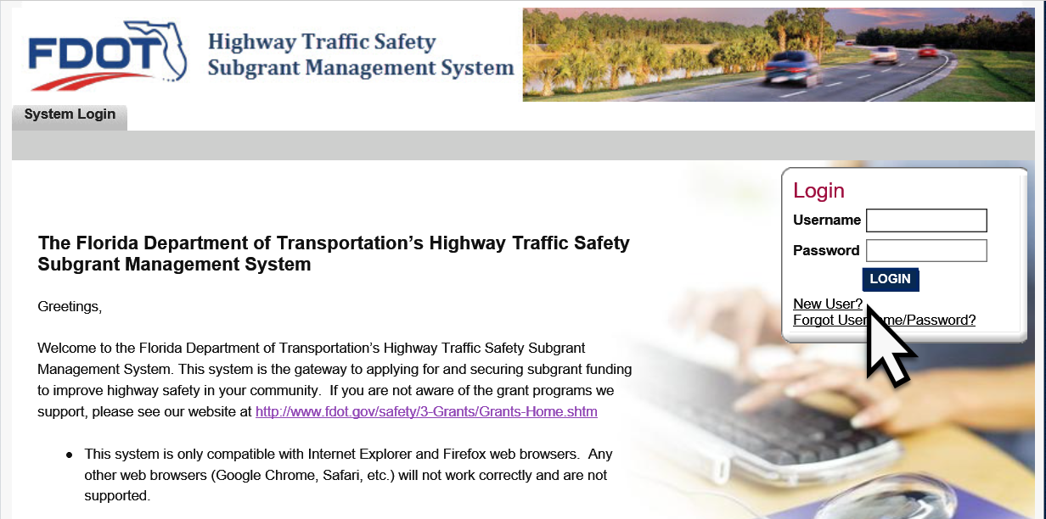

On the Registration page, complete all required information fields and click on the “Save” button located at the top right side of the page.
Note: Please be sure to spell out the entire name of your organization!
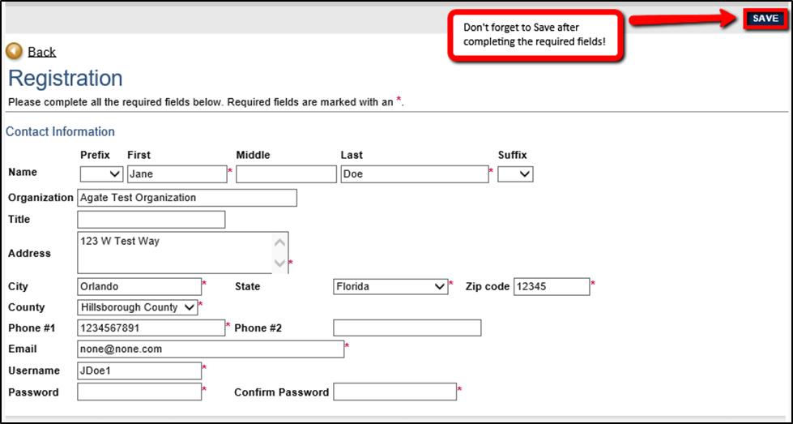
Once the Registration form is saved, FDOT will be notified of the request. Upon approval of the request, the user will receive an email message that user access has been approved. Requests will only be processed during normal business hours, Monday through Friday, 8:00 am to 5:00 pm.
All registration requests will be added to the system as a “Subrecipient Viewer” and may access the system but may make no changes until a Subrecipient System Administrator is delegated by their organization.Each organization must assign, at least one, with a maximum of two, Subrecipient System Administrators to coordinate access to the system and submit documents to the FDOT State Safety Office, on behalf of the agency. Subrecipient System Administrators may add access for other agency individuals to edit or view and/or submit documents. concept papers
A “Subrecipient System Admin Request Form” must be completed and signed by the agency head or delegate (copy of the delegation letter must be provided), to grant authority to allow completion and submission of concept papers. Completed forms should be sent to Danielle King at Danielle.King@dot.state.fl.us for processing.

System Roles

Subrecipient Viewer Role
Authority: “Viewer” has the authority to access the system and view all documents for the agency; however, this role cannot edit or upload anything within the system.
All user requests will be added to the system as a “Subrecipient Viewer” and may access the system but may make no changes until a Subrecipient System Administrator is delegated by their organization. Editor Roles are assigned by the System Administrator.

Subrecipient System Administrator Role
Authority: The “System Admin” Role has the authority to:
- Access the system on behalf of the organization
- Add and delete other user access for the organization
- Edit documents within the system
- Submit final documents to the FDOT State Safety Office via the Highway Traffic Safety Subgrant Management System, on behalf of the organization.
The system allows a maximum of two “System Admin” roles to be assigned to each organization.
System Administrator privilege is assigned by the FDOT State Safety Office upon email receipt of the Subrecipient System Administrator Request Form, signed by the Agency Head. System Administrator(s) will receive instructions on how to add and delete other users to the system and projects with edit capabilities.
Note: If an agency is small and/or one person is handling all aspects of FDOT subgrant programs, that person should be given the “System Admin” role, which will allow every function within the system.

Subrecipient Editor Role
Authority: The “Editor” Role has the authority to:
- Access the system on behalf of the organization
- Edit documents within the system
- Submit final documents to the FDOT State Safety Office via the Highway Traffic Safety Subgrant Management System, on behalf of the organization.
The FDOT State Safety Office will not provide “Editor” access to the system through registration requests submitted in the system.

Getting Started

Creating a New Concept Paper
From the home screen, click the “View Available Concept Papers to Initiate” to create a new concept paper. Then Select “Apply Now” from the next screen
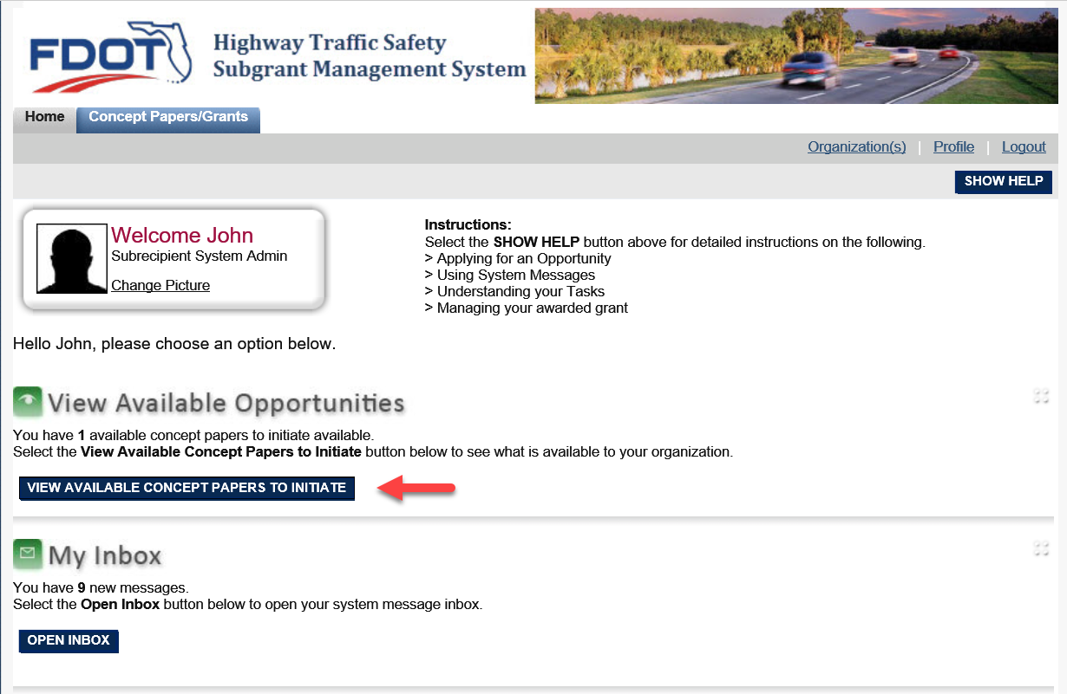
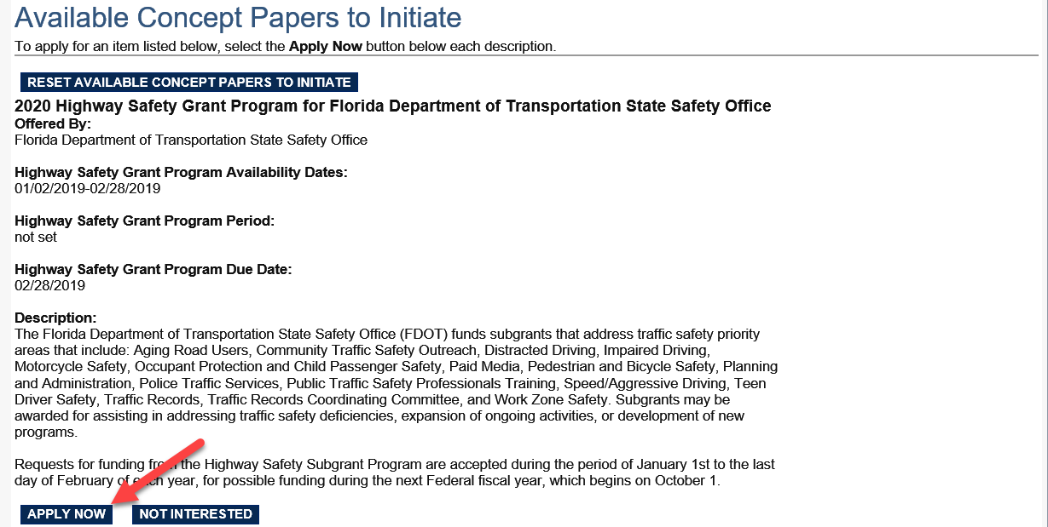

Concept Paper Forms
There are two options for accessing the forms of the concept paper.
- Scroll down on the first screen to review the forms overview and to access each form of the concept paper.
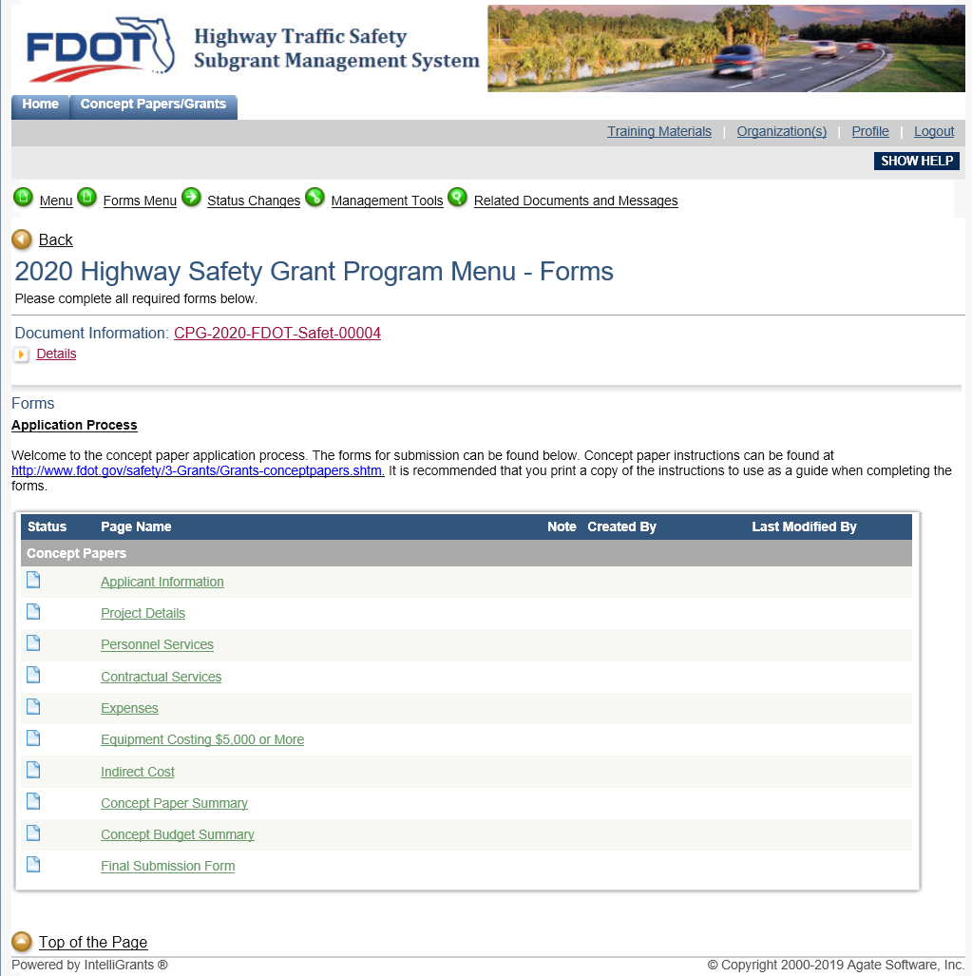

- Select the “Forms Menu” link from the Document Navigation Menu, at the top of the screen. Individual forms can be selected from the pop-up menu.
The Document Navigation Menu is accessible from any screen within the system.
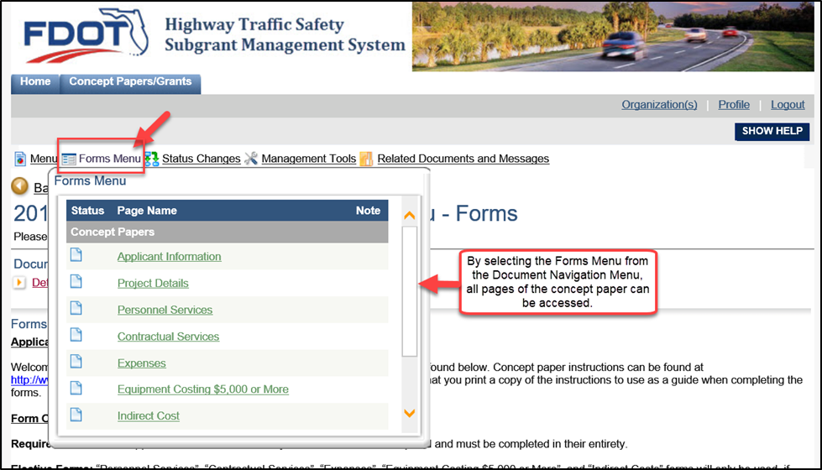
The name of the form you are working in can be found at the top of each form.
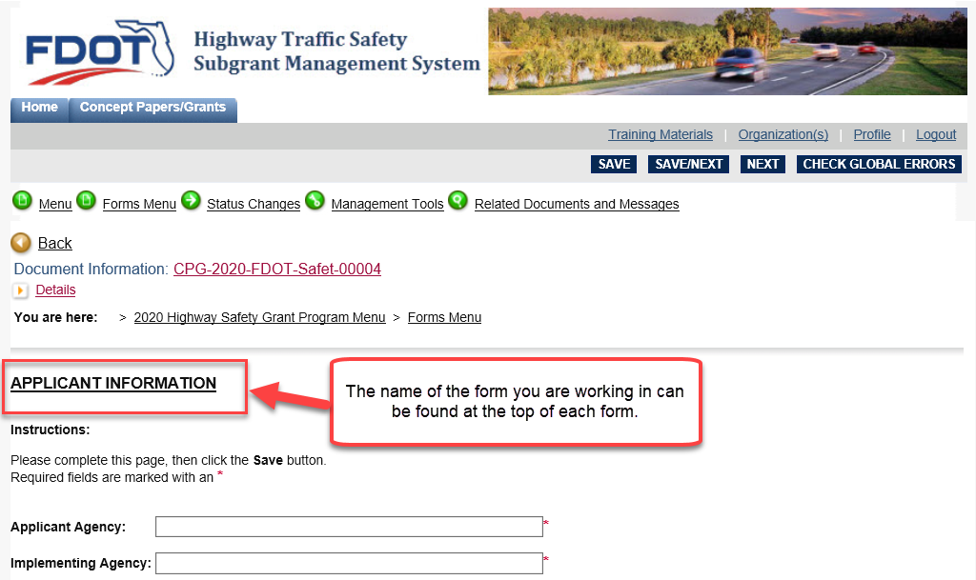

Form Field Limitations
The system does not recognize formatted text properly. If you are copying and pasting information into form fields, formatting must be removed by first pasting content into Windows Notepad. Windows Notepad will remove all formatting allowing you to copy this text into the system form field.
Images and graphs cannot be inserted into form fields.

Types of Forms
- REQUIRED FORMS: The “Applicant Information” and “Project Details” forms are required for all concept papers and must be completed in their entirety.
- ELECTIVE FORMS: “Personnel Services”, “Contractual Services”, “Expenses”, “Equipment Costing $5,000 or More” and “Indirect Costs” forms will only be completed, if needed. (E.g. if you are not requesting contractual services funding, then you would not complete the “Contractual Services” form).
- FINAL SUBMISSION FORM: This form will allow the upload of additional required documents (e.g. the letter of support and non-profit certification) if applicable. This is also where a PDF version can be printed for internal circulation and approval, prior to submission in the system. Final submission of the concept paper to the FDOT State Safety Office is executed through this form.
Note: The Concept Paper Summary and Concept Paper Budget Summary forms are system generated to combine the individual concept paper forms for ease of comparison and review. These forms are not manually updated but are updated based on changes to the preceding forms.

Applicant Information
The first form in your concept paper is the “Applicant Information” form. The following explains what you should put in each field of this form.
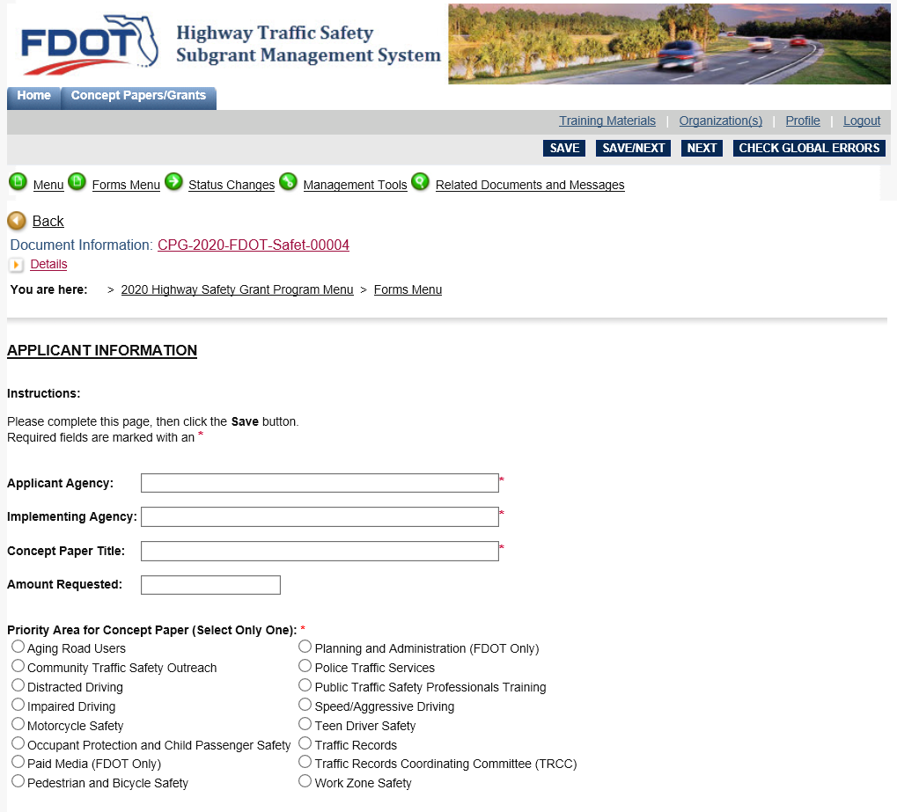
Applicant Agency | The agency that will receive the subgrant funds. (E.g. City of Tallahassee)
Implementing Agency | The agency that will execute the subgrant tasks and objectives. (E.g. Tallahassee Police Department)
Concept Paper Title | The title for the project. Please do not use acronyms.
Amount Requested | Total funding amount requested for the proposed project.
Priority Area for Concept Paper | You may only select one priority area per concept paper. Agencies applying for multiple subgrants must submit a concept paper for each priority area. An overview of each priority area is provided on page 8 of this document.
Type of Project | Identify if the proposed project is local or statewide.
Type of Request | Identify if the proposed project is new (initial) or if it has been funded in previous years (continuation).  For continuation requests, please include the year that the project is in (e.g. Year 1, Year 2 or Year 3) and the previous year’s project number.
Ranking | Local projects must provide their city or county ranking according to the Highway Safety Data Matrices or identify if the proposed project is to address an otherwise identified, data-driven need (must provide detailed data to support the need in the “Supporting Data” section of the “Project Details” form).
Head of Agency | Contact information for the head of the applicant agency. Must include a valid email address to receive electronic submission and selection decision notifications.
Project Contact | Contact information for the primary project contact. Must include a valid email address to receive electronic submission and selection decision notifications.

Once you’ve completed all fields in the “Applicant Information” form, click the “Save/Next” button to move onto the next concept paper form. Selecting “Save” will save progress within the form without advancing to the next form.
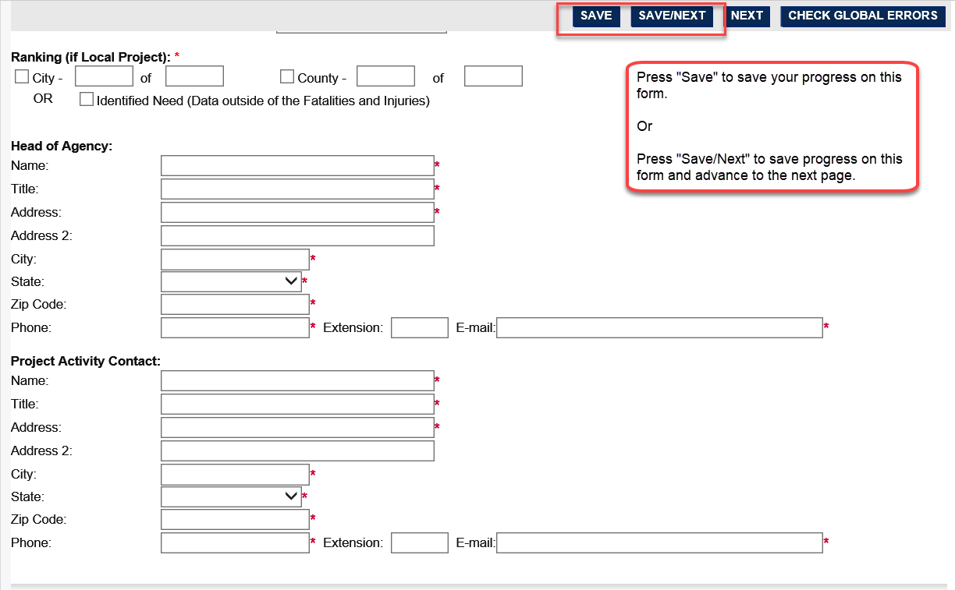
Every time a form is saved, the system will check for errors. If errors are found, the system will list the errors at the top of the form and as an orange stop icon in the Forms Menu.
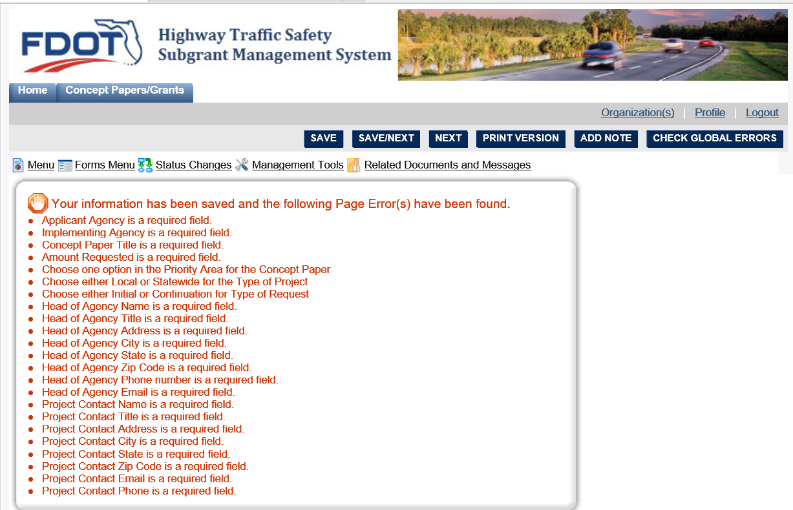
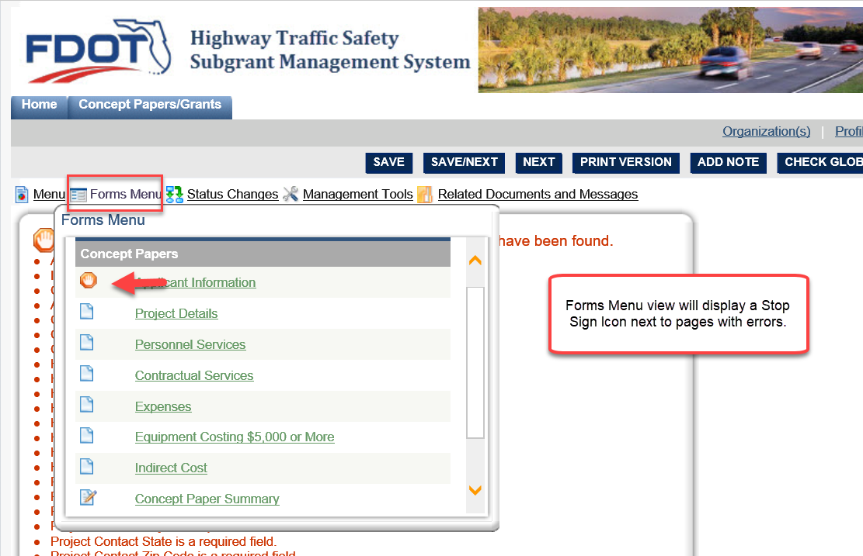

Project Details
The second form in the Forms Menu is “Project Details”.
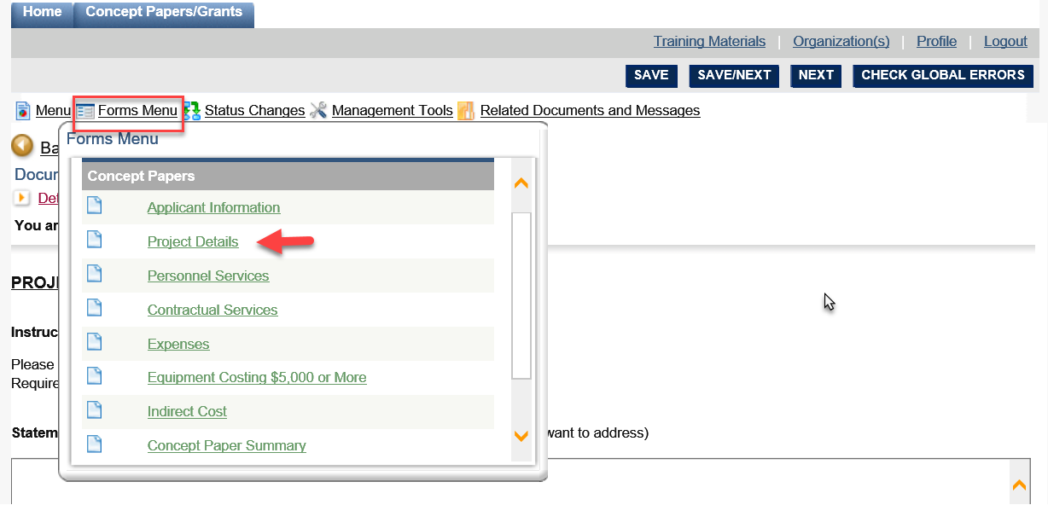
This form has several large fields to complete. You will need to scroll down to see all fields on this form. The following describes what information should be included in each field of this form.
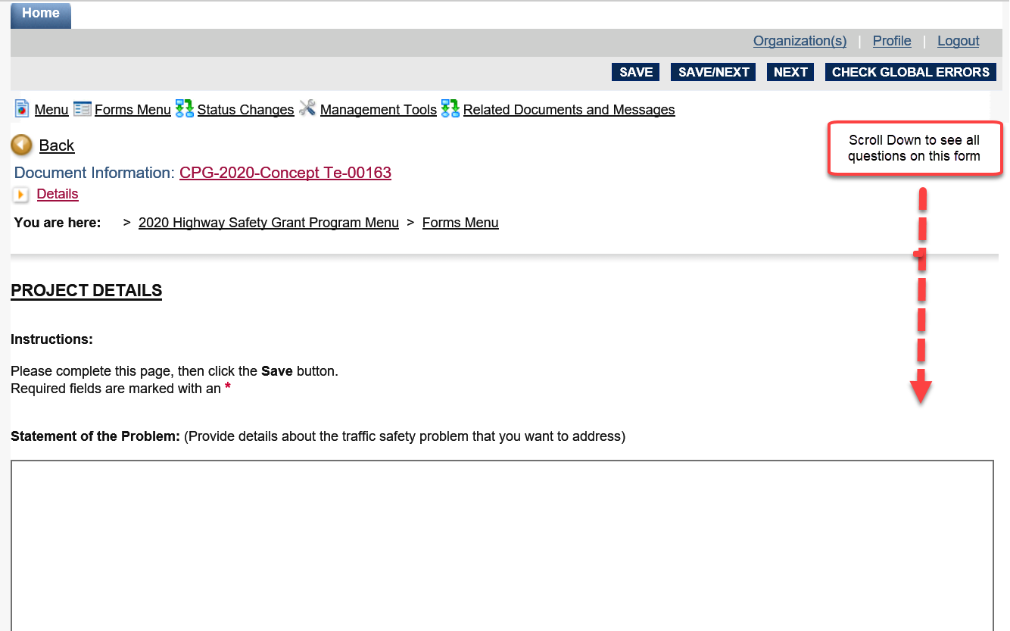

Statement of the Problem
Identify the specific traffic safety-related problem or deficiency that the proposed project is intended to address. Please identify the associated emphasis area of the Strategic Highway Safety Plan (SHSP).
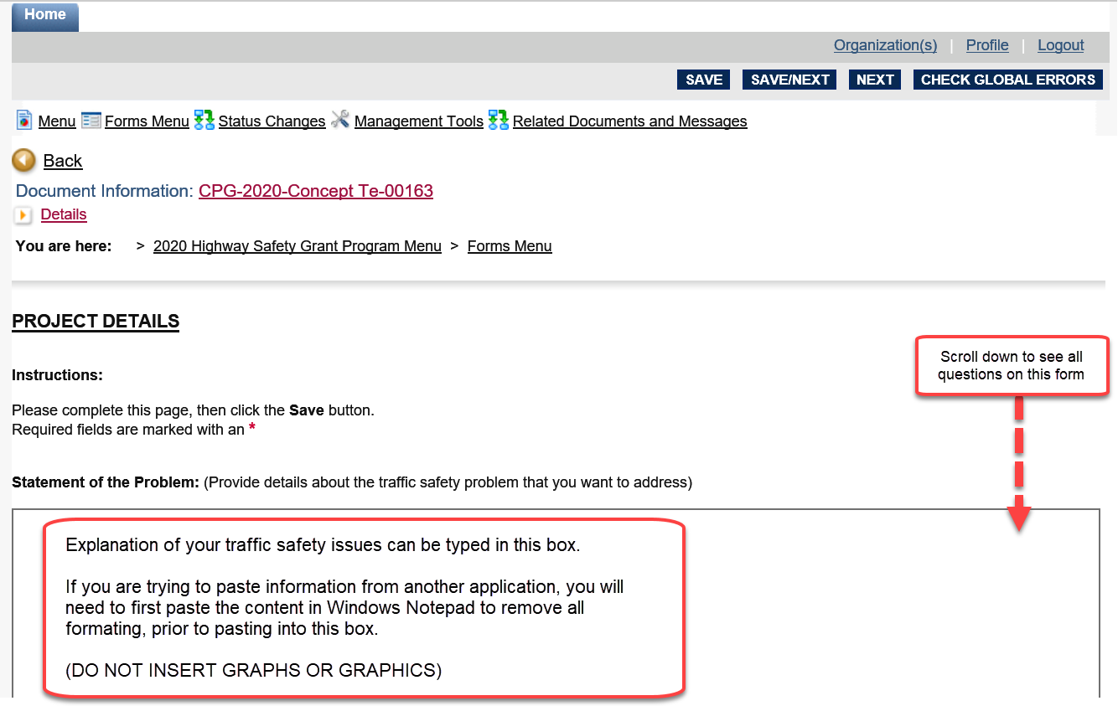

Supporting Data
Include at least three (3) years of local crash, injury, fatality, and citation data, to show the extent of the problem the proposed project will address. If the city or county is ranked lower than the top 25% in the most recent Highway Safety Data Matrices, provide further details to document the otherwise identified data-driven need. Take into consideration changes or projected changes in population, traffic patterns and other demographic dynamics that may affect traffic safety. Survey data can also be included in this section.
Examples:
- Provide city or county alcohol-related crash statistics (crashes, injuries, and deaths) for the past three (3) years.
- Compare local safety belt use rates to statewide rates.
- Provide three (3) years of enforcement data that reflect the problem. (E.g. show the number of citations, arrests, and special operations for your jurisdiction that reflect the problem.)
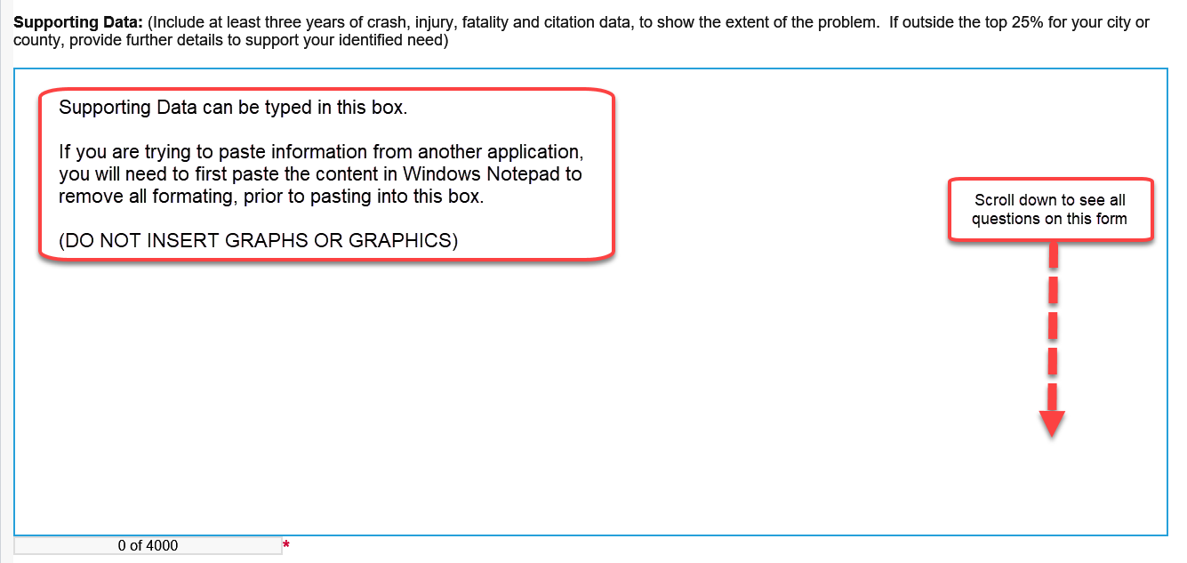

Proposed Solution
Provide the specific countermeasure(s), chapter, and section from the Countermeasures That Work guide that the proposed program will implement. Explain how each countermeasure will address the problem and how the requested funding will be used to support those countermeasure(s). If no countermeasure(s) exist, explain the basis of the proposed program strategy and how it will be effective.
Proposed solutions must show a logical relationship to the identified problem. Items listed in the concept paper budget must correlate to the Statement of the Problem and the Proposed Solution. Proposed budget and purchases must also directly relate to solving the identified problem and implementation of the solution.
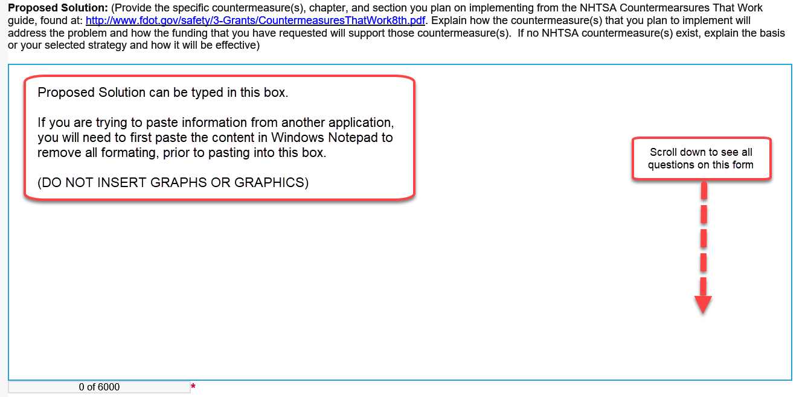

Sustainability
Clearly describe how the traffic safety efforts will be continued after the funding period has ended. If you cannot continue the safety efforts, provide details about what will prevent you from continuing.
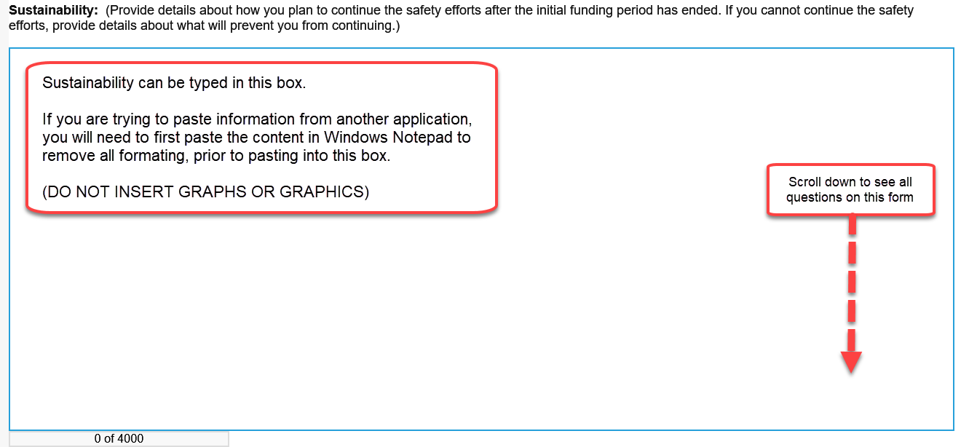

Project Objectives
List the short-term objectives that you have for the project. All objectives must be quantifiable and correlate to the Statement of the Problem and the Proposed Solution. Baseline data should be provided for all objectives.
Examples:
- To reduce the number of crashes by 5% compared to the 3-year average of the most recent data by conducting 12 sobriety checkpoints during the subgrant period.
- To reduce the number of alcohol-related crashes by 5% in 2019 compared to 206 crashes recorded in 2017 through high visibility enforcement.
- To reduce bicycle and pedestrian injuries and fatalities in the city by 5% during 2019 as compared to the 128 injuries reported in 2017 by conducting public awareness programs at local high schools, colleges, and businesses.
- To provide 12 public education outreach events in the community during the subgrant period.
- To conduct at least 60 child passenger fitting station appointments by September 30, 2019.
- To increase the number of speed-related overtime enforcement contacts by 5% compared to the same period in the previous three years.
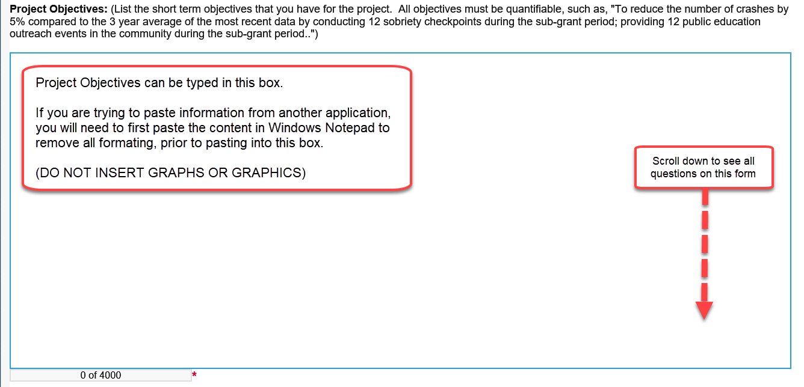

Evaluation
For each objective listed above, provide an explanation describing the method that will be used to determine if/how the objective was met at the end of the subgrant period.
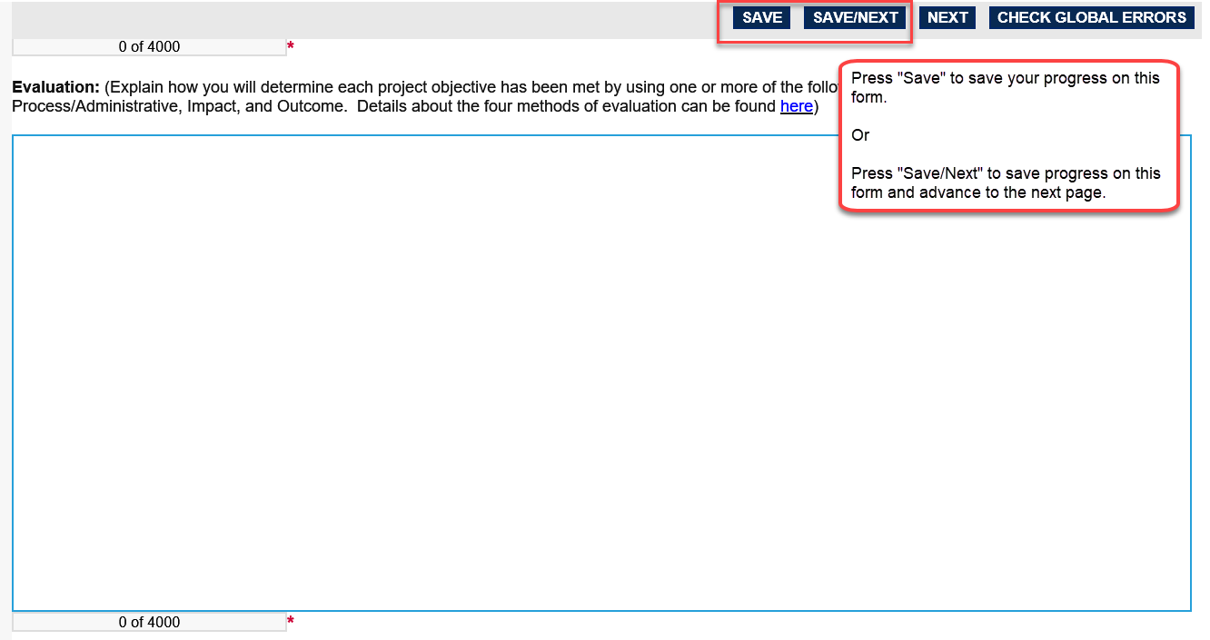

Additional Questions for Traffic Records Coordinating Committee (TRCC) Priority Area
This section is only required to be completed if requesting funding from the Traffic Records Coordinating Committee by selecting “Traffic Records Coordinating Committee” in the “Applicant Information” section of the concept paper.
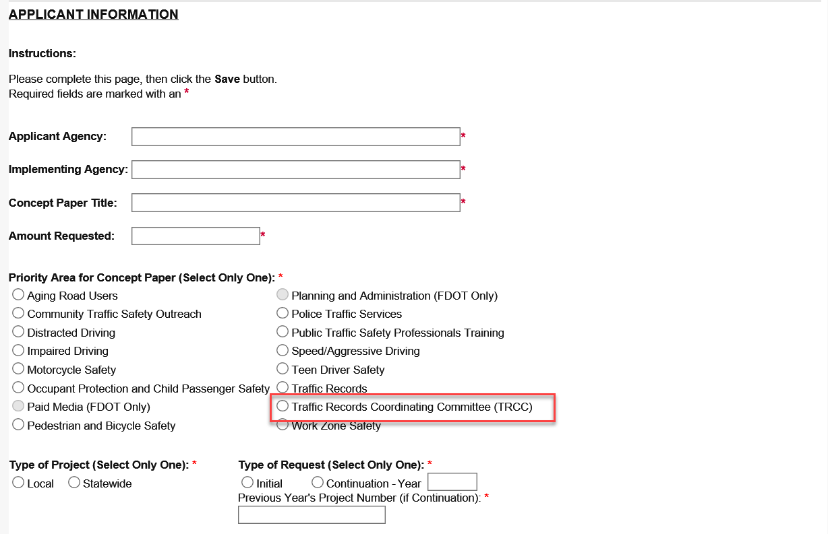
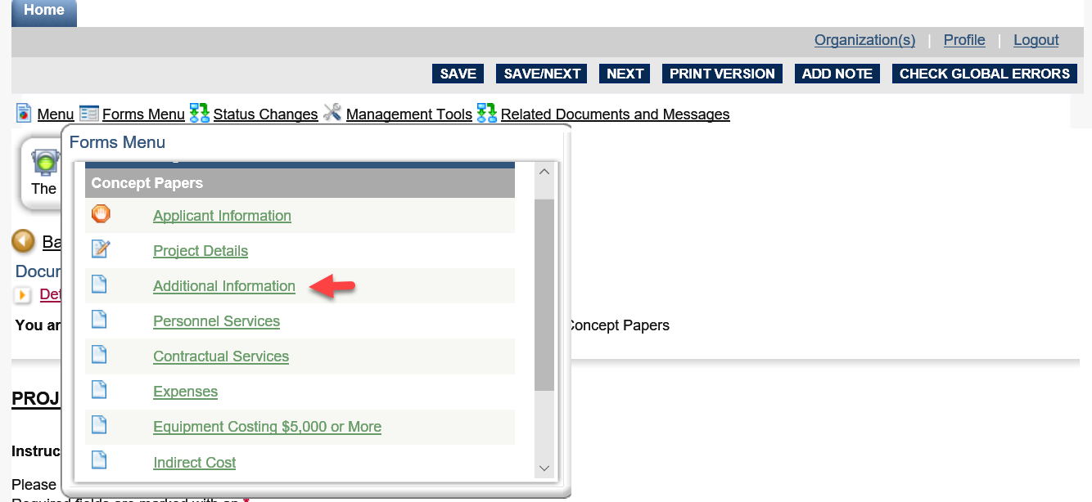
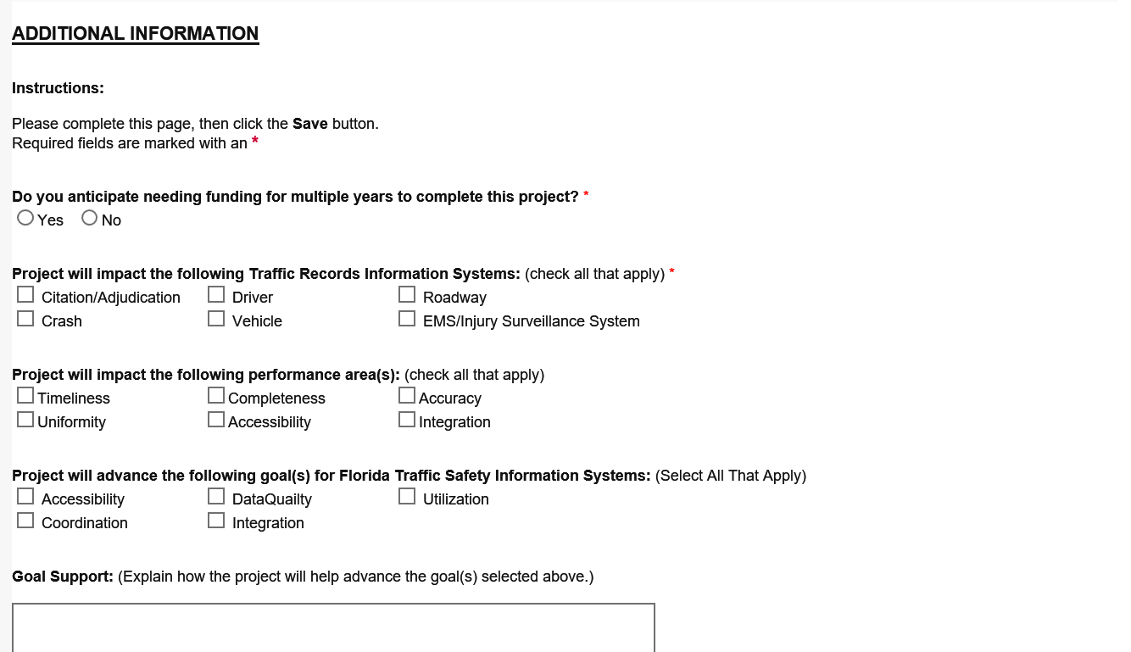
Do you anticipate needing funding for multiple years to complete this project? – Select “Yes” if you anticipate needing funding for multiple years to complete the project. Please provide a projection of how much is expected to be spent in current and each future year(s) to allow a full understanding of the funding needs required.
Project will impact the following Traffic Records Information System(s) – Select which of the state’s six traffic records systems (Citation/Adjudication, Crash, Driver, EMS/Injury Surveillance system, Roadway, and Vehicle) the project will impact.
Project will impact the following performance area(s) – Select which of the six performance areas the project will impact.
Project will advance the following goal(s) for Florida’s Traffic Safety Information Systems – Select which of the state’s five goals of Florida’s TRCC as documented in the Florida Traffic Safety Information System Strategic Plan 2017–2021 the project will impact. The goals are:
Goal 1: Coordination - Provide ongoing coordination in support of multi-agency initiatives and projects which improve traffic records information systems.
Goal 2: Data Quality - Develop and maintain complete, accurate, uniform, and timely traffic records data.
Goal 3: Integration - Provide the ability to link traffic records data.
Goal 4: Accessibility - Facilitate access to traffic records data.
Goal 5: Utilization - Promote the use of traffic records data.
Goal Support – Explain how the project will help advance the goal(s) selected above

Concept Paper Budget
The concept paper budget is entered by completing the “Personnel Services”, “Contractual Services”, “Expenses”, “Equipment Costing $5,000 or More” and “Indirect Costs” forms. Forms should only be completed, if needed. (E.g. if you are not requesting contractual services funding, then you would not complete the “Contractual Services” form).
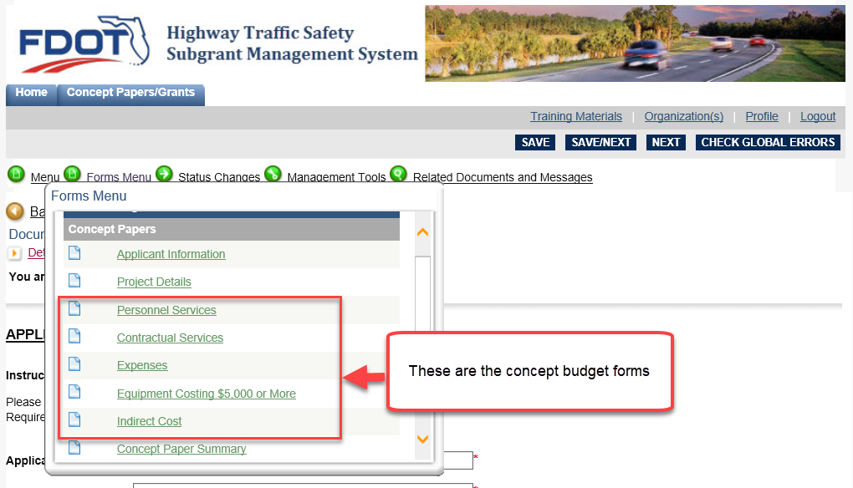
On all budget forms, the “Federal Funding” column is used to indicate the funding being requested in the concept paper. “State or Local” match is used to identify the amount of funding the agency is also contributing toward the concept effort, if applicable.
Note: The Total column is automatically calculated from the sum of Federal Funding and Match column amounts.
Care should be taken in estimating costs. Include tax, delivery, shipping, and set-up costs. Attempt to anticipate increases in costs that may occur between the time the subgrant is proposed and the subgrant start date.
Subgrant costs must be reasonable, allowable, and necessary and be directly related to the stated problem and proposed solution.
Equipment purchases should be clearly defined in the problem statement and proposed solution, and describe a clear need for the equipment and how it will be used in the project.

Personnel Services
The Personnel Services Column should include position title and any benefits that will be reimbursed. Do not list an individual’s name. Use descriptive titles such as “Law Enforcement Overtime”, “Program Coordinator”, “Administrative Staff”, etc.
If this concept paper is for the “Traffic Records Coordinating Committee (TRCC) priority area, the percentage of time worked on the project should also be included under the Personnel Services Column.
Note: The entire line must be completed. If you have no Match funds, enter “0” in those columns to prevent error.
Ten lines are provided, if you need additional lines, complete the first 10 lines, then press “SAVE”. One additional line will be provided each time you save.
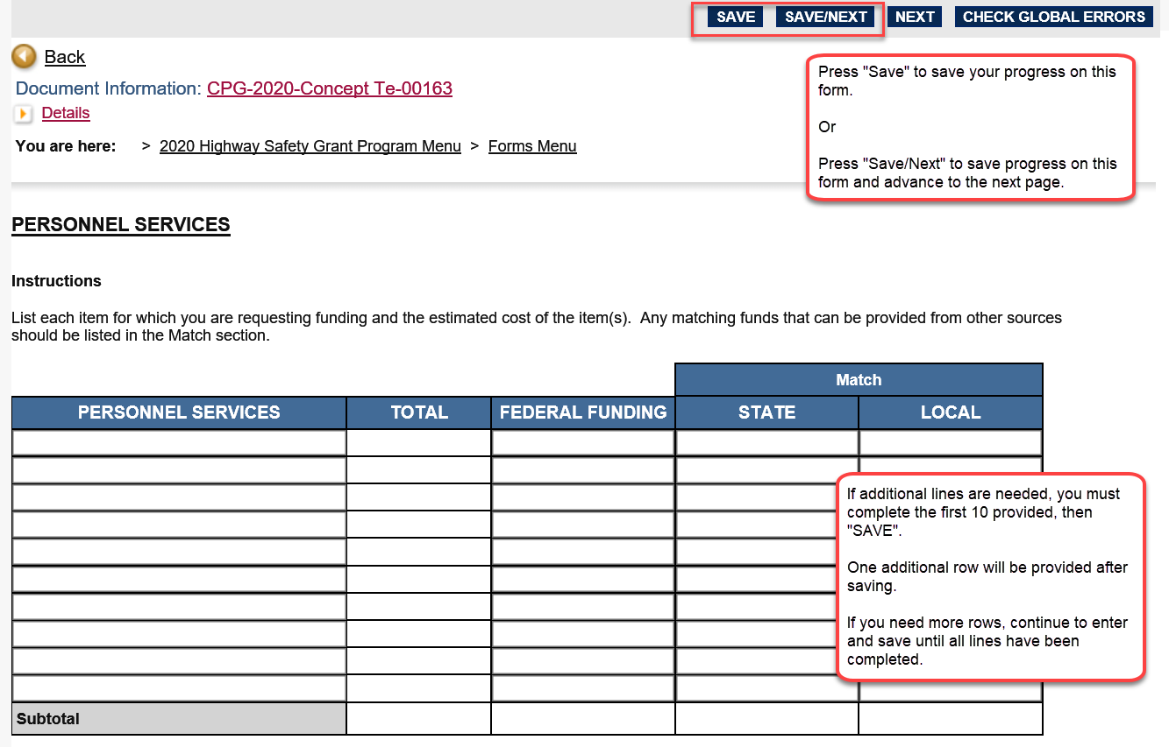

Contractual Services
Contractual Services costs include services to be performed via a subcontract agreement and correlates to the Statement of the Problem and the Proposed Solution. Do not list a specific consultant firm, agency, or individual’s name. Use descriptive titles to describe the services such as “Data Consulting” or “Evaluation Services.”
Note: The entire line must be completed. If you have no Match funds, enter “0” in those columns to prevent error.
Ten lines are provided, if you need additional lines, complete the first 10 lines, then press “SAVE”. One additional line will be provided each time you save.
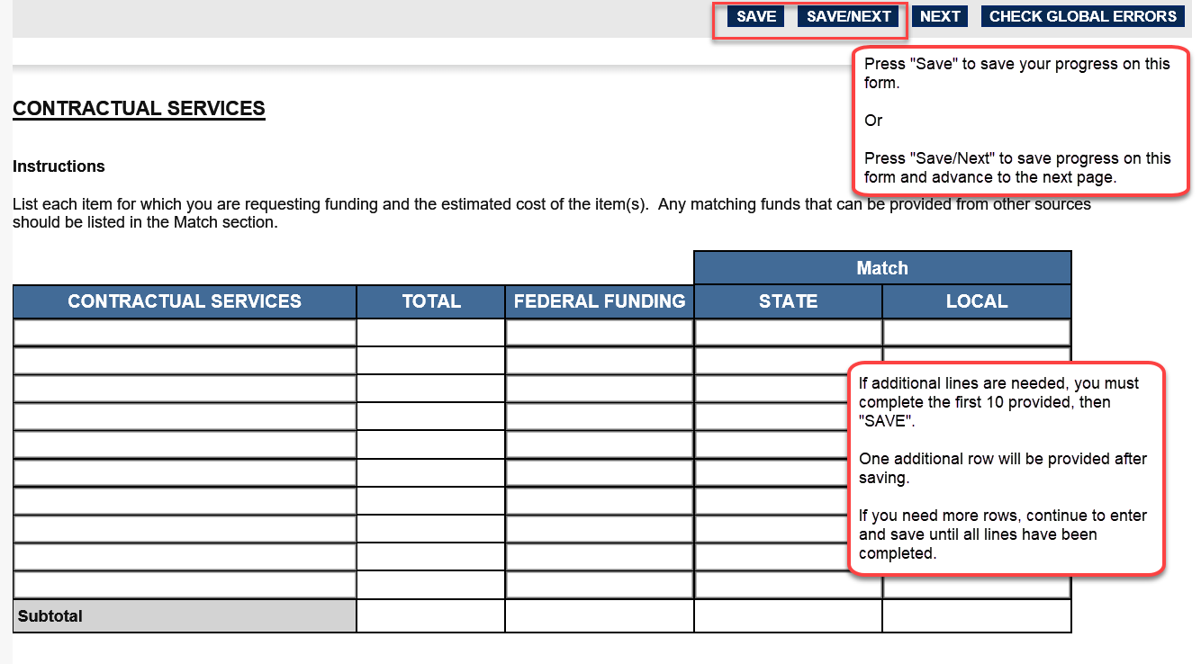

Expenses
Costs may include direct expenditures such as: public information and education materials, printing, travel, and portable breath test devices. Enter only items that are less than $5,000 per item.
Note: The entire line must be completed. If you have no Match funds, enter “0” in those columns to prevent error.
Ten lines are provided, if you need additional lines, complete the first 10 lines, then press “SAVE”. One additional line will be provided each time you save.
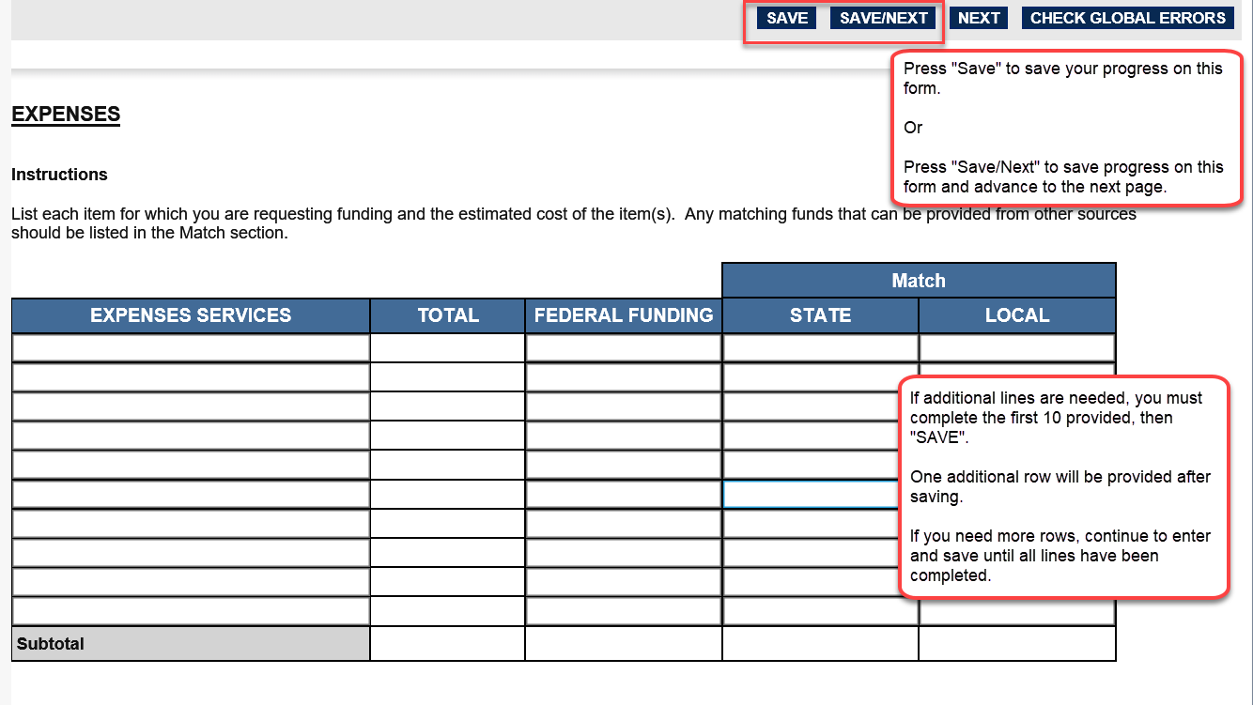

Equipment Costing $5,000 or More
This section is for equipment costing more than $5,000 per item.
Costs may include items such as: speed monitoring trailers, light towers, laser units and computers. Include a quantity for each piece of equipment. Items that exceed $5,000 are considered “non-expendable property”.
Note: The entire line must be completed. If you have no Match funds, enter “0” in those columns to prevent error.
Ten lines are provided, if you need additional lines, complete the first 10 lines, then press “SAVE”. One additional line will be provided each time you save.
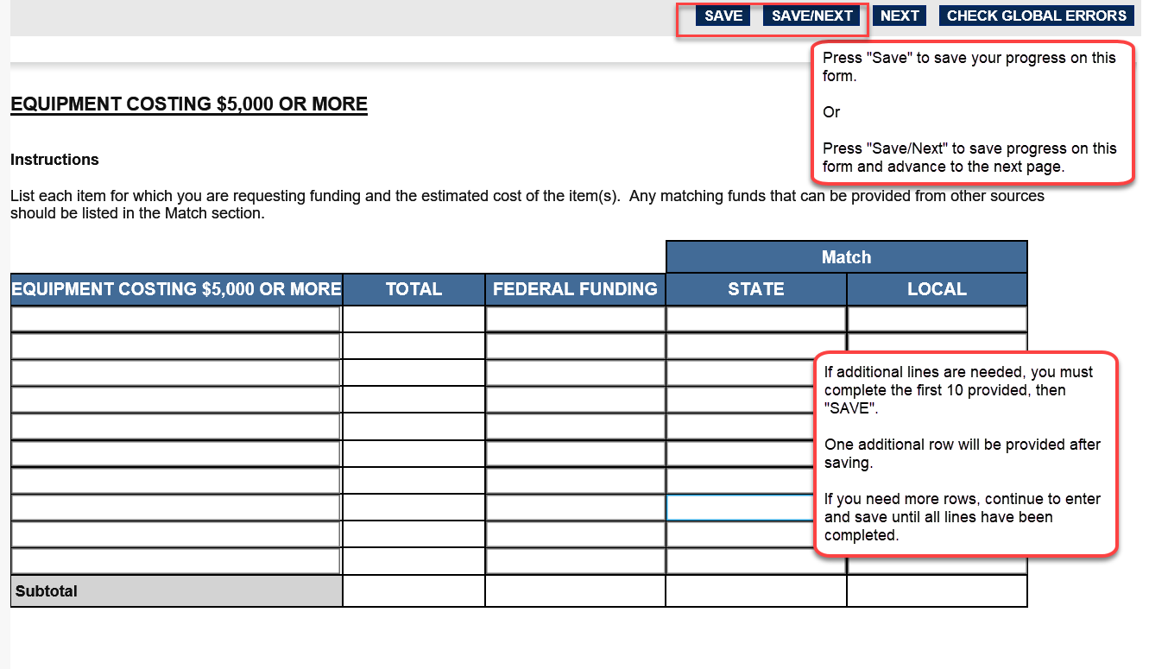

Indirect Costs
Indirect costs are costs that cannot be charged directly to a project. If a subrecipient has a federally negotiated indirect cost rate, it may be applied to the subgrant. If a subrecipient does not have a federally negotiated indirect cost rate, a rate up to the de minimis indirect cost rate of 10% of modified total direct costs may be applied. A subrecipient may opt to request a lower or no indirect costs rate, even if it has a federally negotiated indirect cost rate. Concept papers requesting indirect costs will be awarded based on cost benefit, available funding, and if the indirect cost rate requested significantly affects the proposed project’s ability to adequately address the traffic safety need. The FDOT State Safety Office has historically not awarded indirect costs for local projects, law enforcement agencies for enforcement activities, or rates over 10%.
Note: The entire line must be completed. If you have no Match funds, enter “0” in those columns to prevent error.
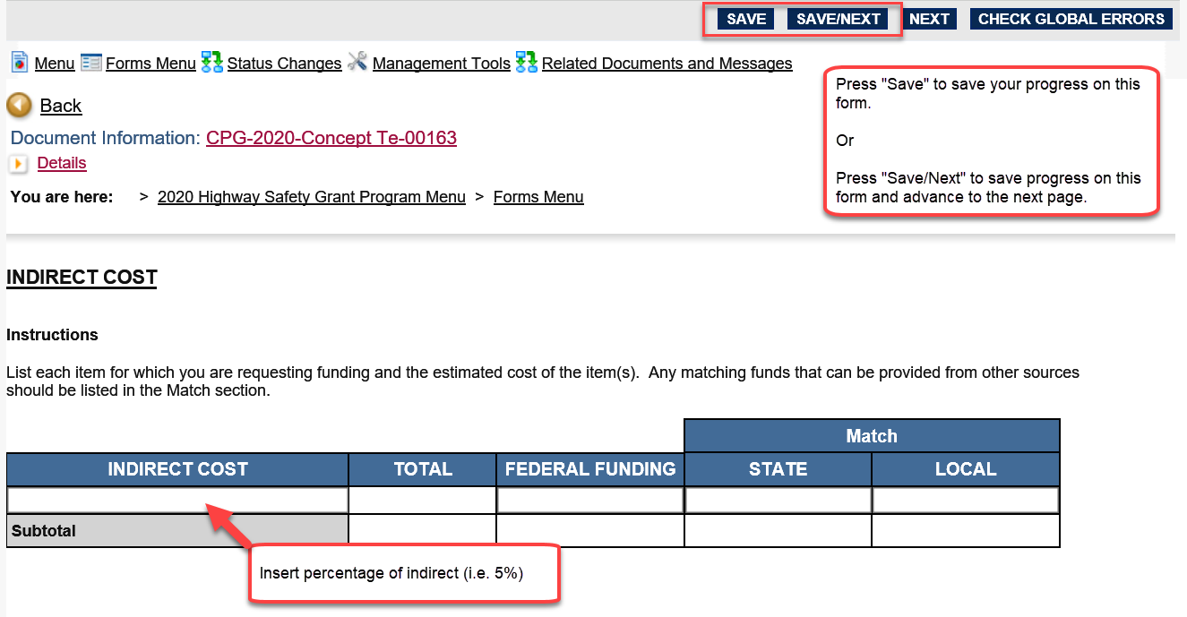

Concept Paper and Concept Budget Summary Pages
The “Concept Paper Summary” and “Concept Budget Summary” forms are system generated for ease of review and system edit checks. You can advance past these forms, by clicking the “Next” button, or selecting the “Final Submission” form from the Forms Menu pop-up.
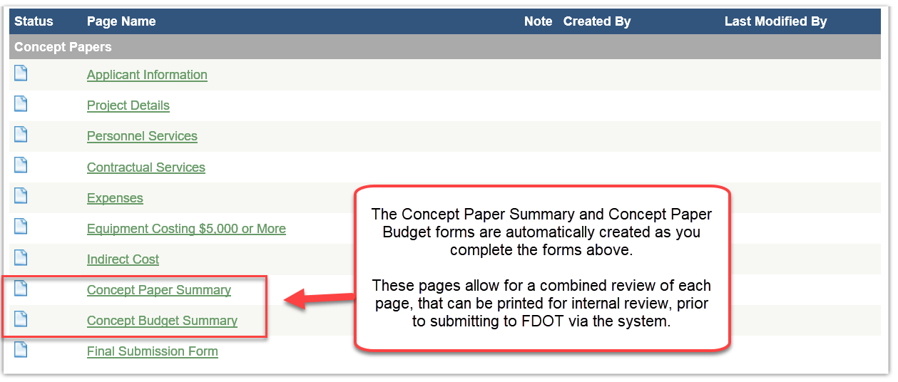

Final Submission

Printing a Copy of the Concept Paper
A final combined PDF version of the concept paper can be created by clicking the “Print a PDF Copy of Entire Concept Paper” hyperlink. It is recommended that you print a copy for your records. The PDF can be used to circulate for internal agency approvals prior to submission.
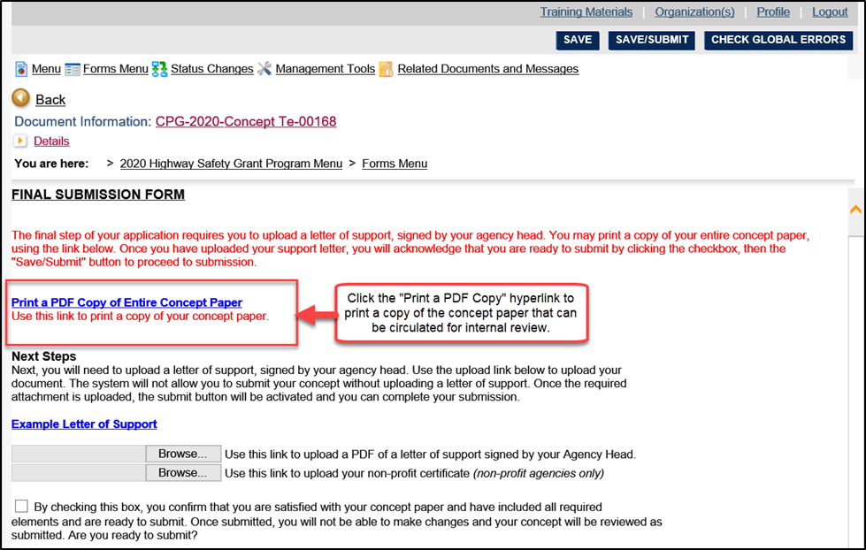

Additional Required Documents
- A cover letter signed by the head of the agency or their authorized signatory is required. The cover letter must be typed on agency letterhead and state that the agency head fully supports the proposed project.
Examples of an agency head or their authorized signatory includes but is not limited to: Sheriff, Chief of Police, Fire Chief, University President, County Commission Chairperson, Mayor, City Manager, Chief of Staff, or Health Department Director.
- Not-for-profit agencies must include their “Certificate of Status” from the Florida Department of State with their Highway Safety Concept Paper.
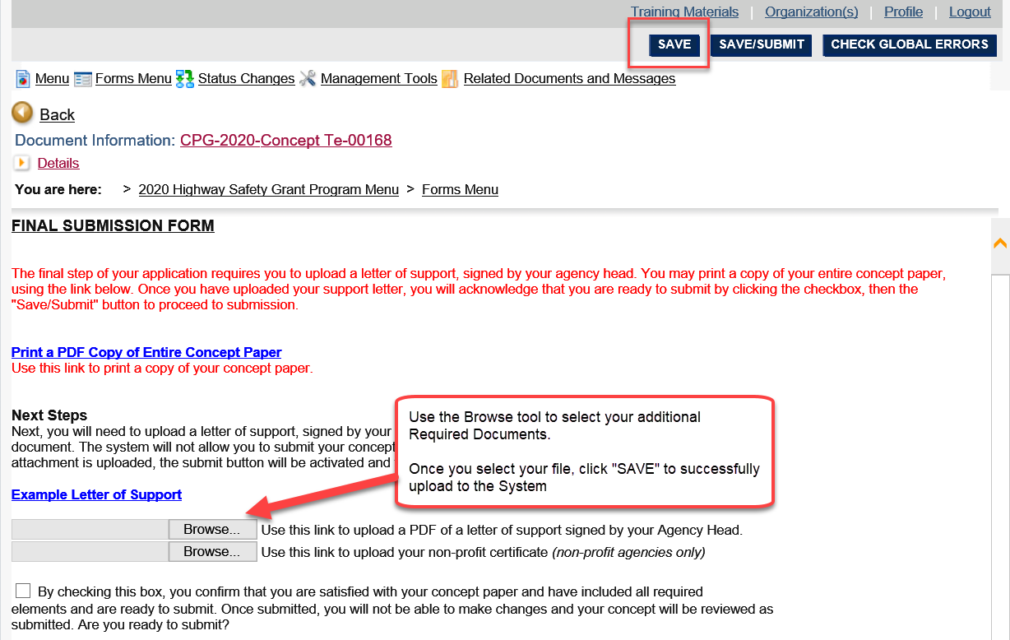
To upload additional required documents, use the Browse link to select and upload the documents. Once you select your file, click the “Save” button at the top of the form page. Uploaded files will appear below the upload tool.
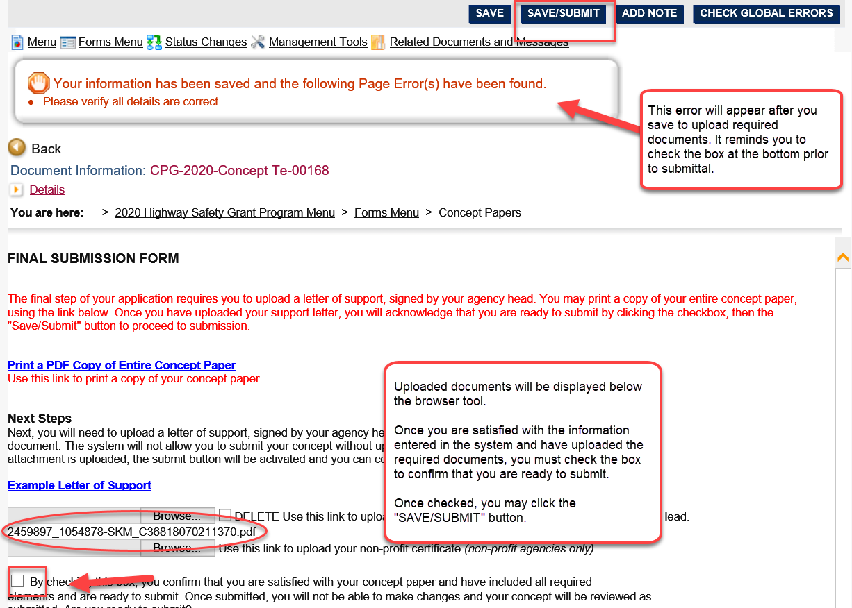

Submitting the Concept Paper
Once you save the form to upload the additional required documents, you will get an error that advises you to verify all details prior to submittal.
Take one last opportunity to ensure that all information has been entered correctly in all previous forms and additional required documents have been uploaded.
Once you have confirmed all information is complete, check the confirmation box at the bottom of the page, then select “SAVE AND SUBMIT” at the top of the form page.
You will receive a system message and email that your concept has been submitted to the FDOT State Safety Office for review.

