SIGNING AND MARKING
A INTRODUCTION 18-1
B BACKGROUND 18-1
C SIGNS 18-2
C.1 Advance Street Name Signs 18-2
C.1.a Standards 18-2
C.1.b Installation 18-2
C.1.c Sign Design 18-3
C.2 Advance Traffic Control Signs 18-5
C.3 Overhead Street Name Signs 18-5
C.3.a Standards 18-5
C.3.b Installation 18-6
C.3.c Sign Design 18-6
C.3.d Internally Illuminated Overhead Street Name Signs 18-6
C.4 Community Wayfinding Guidance 18-7
C.5 DMS Overview 18-7
C.6 Design Details for Signs 18-7
D PAVEMENT MARKINGS 18-8
D.1 Pavement Markings 18-8
D.2 Reflective Pavement Markers 18-8
E AUDIBLE AND VIBRATORY TREATMENTS 18-8
E.1 Longitudinal Audible Vibratory Treatments 18-8
E.2 Transverse Rumble Strips 18-9
F RAILROAD DYNAMIC ENVELOPE PAVEMENT MARKING AND SIGNAGE 18-9

TABLES
Table 18 – 1 Design Guidelines for Advance Street Name Signs 18-3

FIGURES
Figure 18 – 1 Examples of Advance Street Name Signs 18-4

CHAPTER 18

SIGNING AND MARKING

A INTRODUCTION
Signing and pavement markings help improve highway safety by providing guidance information to road users. Both signs and pavement markings should provide sufficient visibility to meet the user’s needs. The design of signs and pavement markings should complement the basic highway design. Designers and engineers should also be aware of the capabilities and needs of seniors, and consider appropriate measures to better meet their needs and capabilities.
Sections C and D of this chapter specifically discuss traffic control devices for both signing and pavement marking that accommodate not only the needs of all types of road users, but also the special needs of seniors.

B BACKGROUND
Section 316.0745, F.S., requires the FDOT to compile and publish a manual of uniform traffic control devices for use on the streets and highways of the state. To comply with this statute, the Federal Highway Administration’s (FHWA) Manual on Uniform Traffic Control Devices (MUTCD) has been adopted for use in Rule 14-15.010, F.A.C.: All references in this chapter are in conformance with the MUTCD:
The Manual on Speed Zoning for Highways, Roads, and Streets in Florida (2019), is adopted for use by the State of Florida under Rule 14-15.012, F.A.C. This manual is prepared by the FDOT in compliance with Chapter 316, F.S., to promote uniformity in the establishment of state, municipal, and county speed and school zones throughout the State.

C SIGNS

C.1 Advance Street Name Signs
The use of advance street name signs provides advance notification to road users to assist them in making safe roadway decisions. Signs should be used for signalized or non-signalized intersections that are classified as a minor arterial or higher, or a cross street that provides access to a traffic generator or possesses other comparable physical or traffic characteristics deemed to be critical or significant.

C.1.a Standards
The words Street, Boulevard, Avenue, etc., may be abbreviated, deleted, or reduced in size to conserve sign panel length. However, if confusion would result due to similar street names in the area, the deletion should not be made.
Use of the local name is preferred on advance street name signs. When a cross street has a different name on each side of the intersection, both names shall be shown with an arrow beside each name to designate direction. Additional legend such as NEXT SIGNAL or XX FEET may be added.

C.1.b Installation
Advance street name signs should be installed in advance of the intersection in accordance with the distances shown in “Condition A” of Table 2C-4. Guidelines for Advance Placement of Warning Signs of the MUTCD. These distances are to be considered the minimum for a single lane change maneuver, and should be measured from the begin taper point for the longest auxiliary lane designed for the intersection. The degree of traffic congestion and the potential number of lane change maneuvers that may be required should also be considered when determining the advance placement distance.

C.1.c Sign Design
Advance street name signs shall be designed in accordance with Part 2 Signs of the MUTCD. The lettering for the signs shall be composed of a combination of lower case letters with initial upper case letters.
Letter height should conform to Table 18 – 1 Design Guidelines for Advance Street Name Signs. Various layouts for advance street name signs are shown in Figure 18 – 1 Examples of Advance Street Name Signs.

Table 18 – 1 Design Guidelines for Advance Street Name Signs
Posted Speed Limit | Street Name Legend | Next Signal or  Intersection
 | Letter Size (inches)  Series E Modified (EM)  Upper/Lower Case Letters | Letter Size (inches)  Series D (D)  Upper Case Letters
35 mph or less | 8 EM | 6 D
40 mph or greater | 10.67 EM | 8 D

Figure 18 – 1 Examples of Advance Street Name Signs
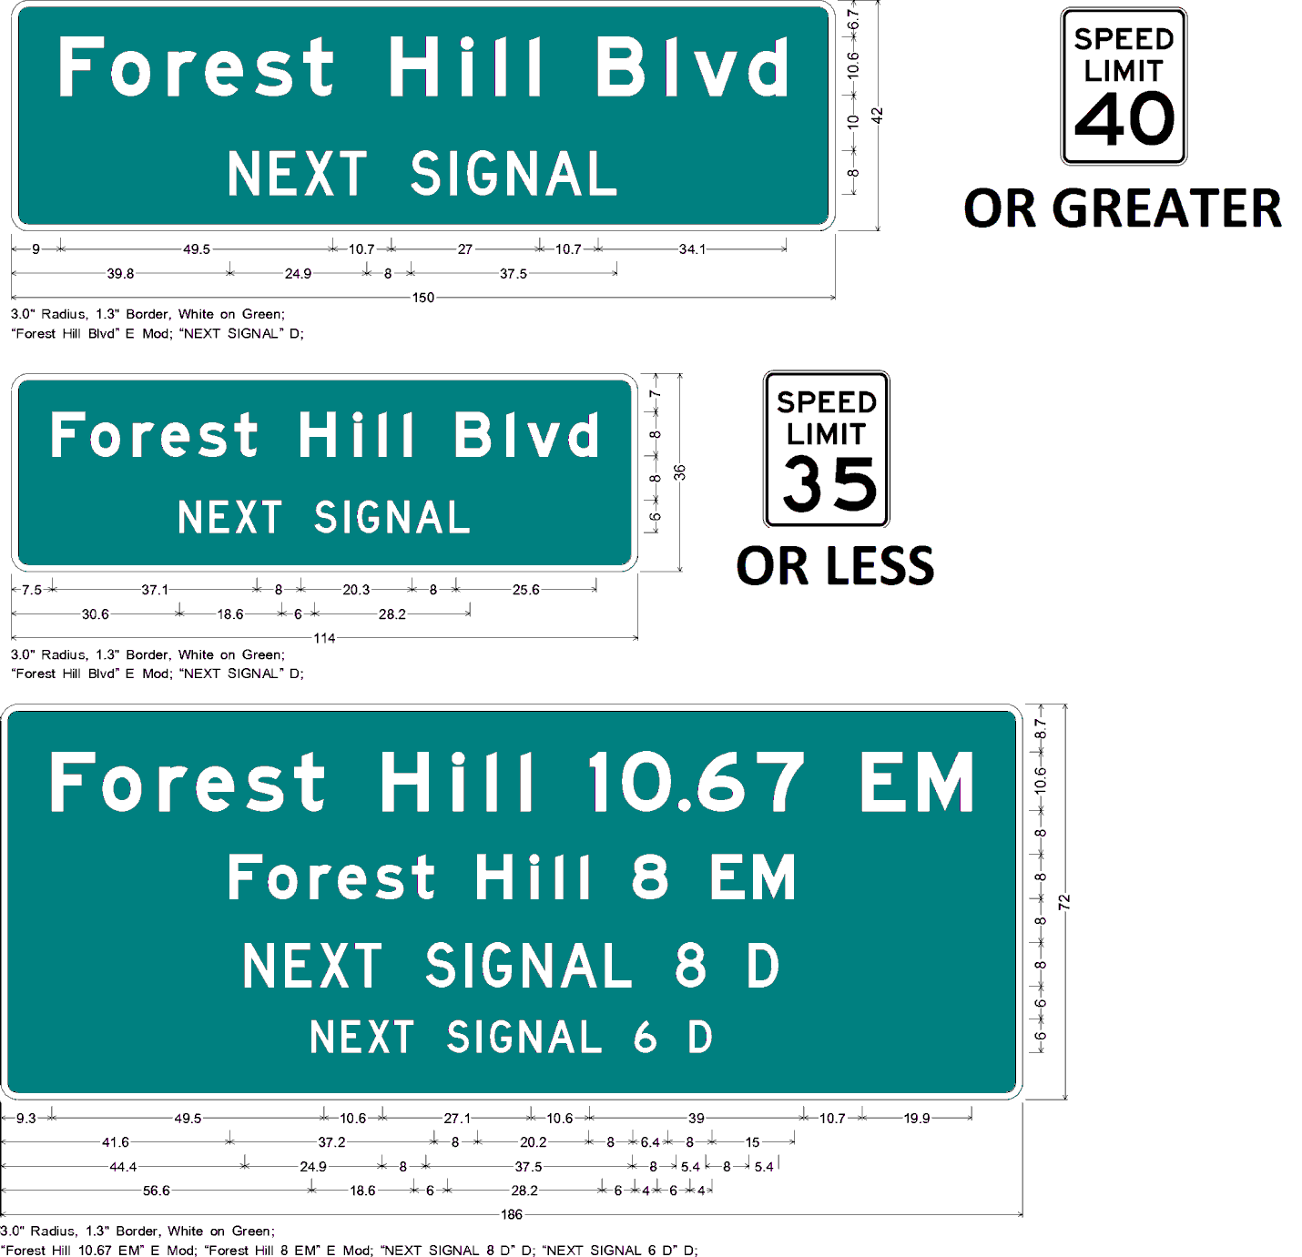

C.2 Advance Traffic Control Signs
Advance Traffic Control signs, i.e., Stop Ahead (W3-1), Yield Ahead (W3-2), and Signal Ahead (W3-3) signs, shall be installed on an approach to a primary traffic control device that is not visible for a sufficient distance to permit the driver to respond to the device. The visibility criteria for traffic signals shall be based on having a continuous view of at least two signal faces for the distance specified in Table 4D-2. Minimum Sight Distance for Signal Visibility of the MUTCD.
An Advance Traffic Control sign may be used for additional emphasis of the primary traffic control device, even when the visibility distance to the device is satisfactory.

C.3 Overhead Street Name Signs
Overhead street name signs with mixed-case lettering should be used at major intersections (with multi-lane approaches) as a supplement to post mounted street name signs.

C.3.a Standards
Overhead street name signs shall only be used to identify cross streets, not destinations such as cities or facilities. To avoid the need for lighting of overhead signs, they should have a minimum maintained retroreflectivity value as shown in Table 2A-3. Minimum Maintained Retroreflectivity Levels, MUTCD. Roadway geometry and forward sight distance will also influence the need for overhead sign lighting.
The words Street, Boulevard, Avenue, etc., may be abbreviated, deleted, or reduced in size to conserve sign panel length. The border should be eliminated on overhead street name signs to minimize sign panel size. When a cross street is known by both a route number and a local name, use of the local name is preferred.
When a cross street has a different name on each side of the intersection, two options are permitted:
- When two sign panels are used, install one sign panel on the left and the other sign panel on the right side of the signal heads; or
- When one sign panel is used, the left name should be displayed over the right name. Arrows should be provided to indicate which side of the intersection the street name applies.

C.3.b Installation
Due to the possibility of hurricane strength winds, overhead street name signs should not be installed on span wire but should be mounted to the strain pole or mast arm.
The location of the overhead street name sign on a signal strain pole and/or mast arm may vary. However, it shall not interfere with the motorist’s view of the signal heads. The preferred location is shown in the FDOT’s Standard Plans. In the case of separate street names on each side of the street, where separate signs are used, one sign should be placed to the right of the signal heads and the other sign to the left of the signal heads.

C.3.c Sign Design
On roadways with speeds of 40 mph or above, the sign panel should be at least 24 inches in height with the length determined by text. At a minimum, use 8-inch upper case and 6-inch lower case lettering for the street name. If block numbering text is included, use 6-inch all upper case lettering on the second line. The preferred font is Series E-Modified; however, Series E may be used to accommodate the amount of legend so as not to exceed the 96-inch maximum length.
Where structurally possible, overhead street name signs should be designed in compliance with the FHWA recommendations for older drivers using a minimum lettering size of 10-inch upper case with 9-inch lower case.

C.3.d Internally Illuminated Overhead Street Name Signs
An internally illuminated overhead street name sign may be used to improve night-time visibility. Internally illuminated overhead street name signs should have a standardized height of 24-inches and a length not to exceed 108-inches (nine feet).
A Series E Modified or Series E font, which may vary to accommodate the amount of text on the panel should be used.

The sign design shall be in accordance with the MUTCD. When possible, the text should utilize the following text attributes in descending order to limit the maximum width:
- 10-inch upper case with 8-inch lower case, Type EM font
- 10-inch upper case with 8-inch lower case, Type E font
- 8-inch upper case with 6-inch lower case, Type EM font
- 8-inch upper case with 6-inch lower case, Type E font
Internally illuminated overhead street name signs shall be on the FDOT’s Approved Products List (APL).

C.4 Community Wayfinding Guidance
Community wayfinding guide signs should be developed and approved through local resolution with criteria for the destinations shown on the community wayfinding guide sign system plan. Any wayfinding guide sign should be used in accordance with Rule 14-51.030, F.A.C. The intent is to provide guidance and navigation information to local cultural, historical, recreational, and tourist activities. No destination should be displayed for the purpose of advertising.

C.5 DMS Overview
The main purpose of dynamic message signs (DMS) is to convey timely and important en-route and roadside information to motorists and travelers. Further information on how DMS signs may be used can be found in the FDOT’s policy on Displaying Messages on Dynamic Message Signs Permanently Mounted on the State Highway System.

C.6 Design Details for Signs
The MUTCD shall govern all sign details. At a minimum, the “Conventional Road” size shall be used on signs intended for motor vehicle operators.
Shared use path sign sizing for traffic control shall follow the “Shared-Use Path” sizing and height shown in the MUTCD. See Chapter 9 – Bicycle Facilities for additional requirements on the signing of shared use paths.

D PAVEMENT MARKINGS

D.1 Pavement Markings
6-inch pavement markings should be used for all pavement center line, lane separation line and edge line markings. The FDOT Design Manual, Chapter 230 provides additional information, including material options.

D.2 Reflective Pavement Markers
To provide greater emphasis and increase visibility to the pavement markings, especially during wet/night conditions, Raised Pavement Markers (RPMs) should be used. More information on RPM configurations is shown in the FDOT’s Standard Plans, Index 76-001.

E AUDIBLE AND VIBRATORY TREATMENTS

E.1 Longitudinal Audible Vibratory Treatments
Longitudinal Audible and Vibratory Treatments (AVTs) are an effective low-cost countermeasure to reduce the severity and frequency of lane departure crashes.
Audible Vibratory Treatments (AVTs) shall be provided for edge lines and center lines on flush-shoulder roadways with a posted speed of 50 mph or greater and lane widths of 11 feet or greater. Sections where advisory speeds are used due to restricted horizontal or vertical geometry shall not be excluded. AVTs shall not be placed within the limits of crosswalks.
More information on these types of treatments are shown in the FDOT’s Standard Plans, Index 546-010 and FDOT Design Manual, Chapter 210 Arterials and Collectors. AVT options include sinusoidal ground-in rumble strips and profiled thermoplastic. The sinusoidal ground-in rumble strip option provides the most economical and durable solution with less noise pollution.

E.2 Transverse Rumble Strips
Transverse rumble strips alert the driver in rural areas to upcoming stop conditions or abrupt changes in alignment. Factors influencing their use include crash history, roadway geometry and surrounding land use (noise pollution). They should not be placed in crosswalks or bicycle facilities. On roadways open to bicycle travel, a minimum clear path of 4 feet on the outside edge should be provided. Sections 3J.02 Transverse Rumble Strip Markings and 6F.87 Rumble Strips, MUTCD provide further information on the use of transverse rumble strips.
See Chapter 11 – Work Zone Safety and Mobility for requirements for installation of short term transverse rumble strips during construction activities.

F RAILROAD DYNAMIC ENVELOPE PAVEMENT MARKING AND SIGNAGE
Railroad Dynamic Envelope pavement markings are used to delineate the area around at-grade railroad crossings where vehicles should not stop. See Chapter 7 – Rail-Highway Crossings for guidance on the design and installation of railroad dynamic envelope pavement markings and signage.

