
-

Supply Chain Innovation Lab

BDV25 TWO 977-72

FDOT Identification of Prospective Solutions for the Florida Trade Imbalance and Empty Backhauls

Deliverable 6A: Draft Final Report

June 2022

PREPARED FOR
Florida Department of Transportation


FDOT Identification of Prospective Solutions for the Florida
Trade Imbalance and Empty Backhauls

Deliverable 6A: Draft Final Report

Submitted to:
Mr. Rickey Fitzgerald
Manager, Freight and Rail Office
Florida Department of Transportation
605 Suwannee Street, MS 25
Tallahassee, Florida 32399-0450
Email: rickey.fitzgerald@dot.state.fl.us
Phone: (850) 414-4702

Prepared by:
Dr. Seckin Ozkul, P.E. (Principal Investigator - PI)
Assistant Professor of Instruction and Director, Supply Chain Innovation Lab
Monica Wooden Center for Supply Chain Management & Sustainability
Muma College of Business, University of South Florida
4202 E. Fowler Ave., BSN 3403 | Tampa, FL 33620-5375 USA
Email: sozkul@usf.edu
Phone: (813) 974-2530

Dr. Robert Hooker (Co-PI)
Associate Professor, Marketing and Supply Chain Management
Muma College of Business, University of South Florida
4202 E. Fowler Ave., BSN 3403 | Tampa, FL 33620-5375 USA
Email: robert75@usf.edu

Ms. Ankita Sharma
Graduate Research Assistant
Email: ankitasharma@usf.edu

Mr. Vishal Honnali Pattanashetty
Graduate Research Assistant
Email: vishalhonnal@usf.edu

June 2022

- DISCLAIMER
The opinions, findings, and conclusions expressed in this publication are those of the authors and not necessarily those of the State and/or Florida Department of Transportation.

- UNIT CONVERSION TABLE
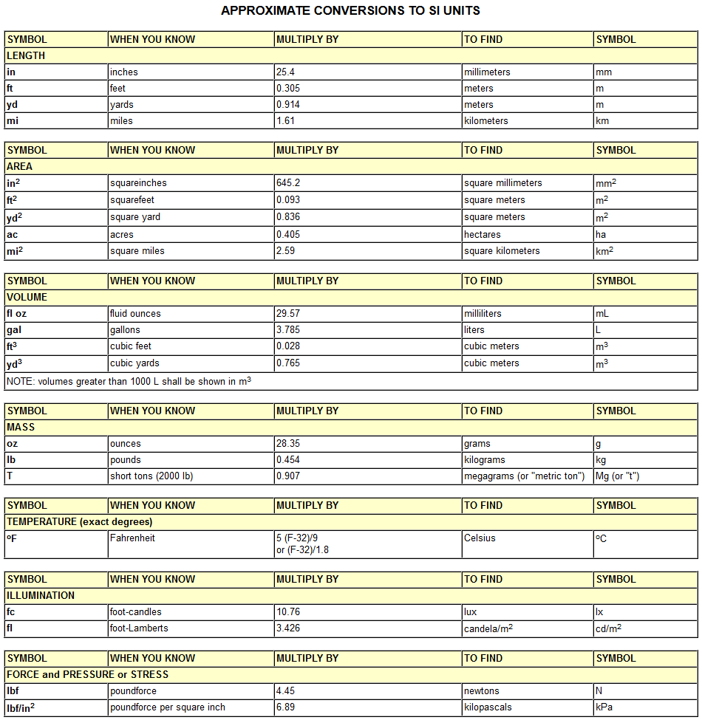

III. TECHNICAL REPORT DOCUMENTATION PAGE
1. Report No. | 2. Government Accession No. |  |  | 3. Recipient’s Catalog No.
4. Title and Subtitle  FDOT Identification of Prospective Solutions for the Florida  Trade Imbalance and Empty Backhauls |  |  |  | 5. Report Date  June 2022
 |  |  |  | 6. Performing Organization Code
7. Author(s)  Seckin Ozkul, Robert Hooker, Ankita Sharma |  |  |  | 8. Performing Organization Report No.
9. Performing Organization Name and Address  Supply Chain Innovation Lab  School of Marketing and Innovation, Muma College of Business  University of South Florida  4202 E. Fowler Avenue, BSN 3403  Tampa FL 33610 |  |  |  | 10. Work Unit No. (TRAIS)
11. Contract or Grant No.
BDV25 TWO 977-72
12. Sponsoring Agency Name and Address  Florida Department of Transportation (FDOT)  605 Suwannee Street, MS 36  Tallahassee, FL 32399-0450 |  |  |  | 13. Type of Report and Period Covered  Final Report, 7/1/2020–9/30/2022
 |  |  |  | 14. Sponsoring Agency Code
15. Supplementary Notes
16. Abstract
Florida struggles with a serious imbalance between inbound and outbound freight. Statistics from the Federal Highway Administration reveal that the total freight tonnage entering Florida is nearly double the tonnage leaving the state. This imbalance suggests that many trucks and other modes of freight transportation leave the state empty or only partially loaded, which raises the cost for shippers and reduces the effectiveness of freight movements. Therefore, trailers coming into the state full end up leaving partially empty or empty, adding to the logistics cost of every trip, and leading to increased costs for the consumer. In this study, the research team analyzed scenarios to determine the prospective solution to the empty backhauling issue Florida faces. The purpose of this research is to identify the locations of empty backhauling in Florida using the Weigh-in-Motion (WIM) data from the Florida Department of Transportation as well as assessing future manufacturing potential by analyzing skilled work force data from major industries to compare the significance of future prospective changes in empty backhauling. In addition, this study also sought to understand shipping practices and factors that influenced shipping mode choice by interviewing experts from industry partners, such as manufacturers, major shippers, and freight forwarders, that operate both in and out of Florida. The findings indicated that time, cost, service, and empty backhauling issues are factors that influence shipping practices, as well as the capacity of goods being shipped, the market, and flexibility of movement that affects their mode choice. In addition, the study also reported on finding work opportunities for truck drivers coming into Florida via a magnitude of online freight platforms as well as via production of commodities in reported emerging manufacturing industries within Florida.
17. Key Words  Freight imbalance, empty backhauling, skilled work force, emerging and high performing manufacturing sectors, shipping practices, work opportunities for truck drivers |  |  | 18. Distribution Statement
19. Security Classif. (of this report) |  | 20. Security Classif. (of this page) |  |  | 21. No. of Pages  180 | 22. Price
Form DOT F 1700.7 (8-72) Reproduction of completed page authorized
- ACKNOWLEDGMENTS
The authors express their sincere appreciation to the Florida Department of Transportation (FDOT) for funding this research project and especially to FDOT Freight and Rail Office Manager, Rickey Fitzgerald, for his full support, excellent guidance and for envisioning and managing this project. The authors would also like to thank Darryll Dockstader, Manager of the FDOT Research Center, as well as Armando Moscoso of the Freight and Rail Office, for their guidance and support throughout this project.

V. EXECUTIVE SUMMARY
Florida struggles with a serious imbalance between inbound and outbound freight. With the third largest population in the U.S., the state offers a large and attractive consumer market. Statistics from the Federal Highway Administration (FHWA) reveal that the total freight tonnage entering the state is nearly double the tonnage leaving the state. This imbalance suggests that many trucks leave the state empty or only partially loaded leading to empty backhauling, which raises the cost for shippers and reduces the effectiveness of freight movements. One solution to this problem is to increase the manufacturing which can lead to more production and hence additional goods for backhauling trucks.
Therefore, the major goal of this project was to evaluate opportunities to reduce the current empty backhauling issue. To achieve this goal, the research team performed a multitude of different tasks in order to come up with an action plan to alleviate Florida’s truck empty-backhauling problem.
The first task that was performed was to conduct a literature review to identify previous research studies that deal with empty backhauling and/or freight inbound/outbound imbalance. In addition, an outside group of freight experts was selected to use their combined knowledge and expertise in the areas of freight shipping, forwarding, and trucking. A review of the literature revealed that Florida is not alone in facing this empty backhauling problem. Indeed, multiple states and countries are concerned about empty backhauling. Within the U.S., Arizona, California, and Nevada are among the top states with an inbound/outbound freight imbalance, with empty backhauling percentages in those states of 41%, 40%, and 39%, respectively (Hanh, 2003; Arizona State Freight Plan, 2014; Michael Gallis and Assoc., 2016). To date, most research has concentrated on optimizing vehicle routing problems with backhauls, whereas strategies to reduce and minimize existing inbound/outbound freight imbalance have received little attention (Ropke and Pisinger, 2006; Wassan et al., 2013). One promising strategy for the empty backhauling problem in Florida is to increase the volume of imports bound for Florida markets through its seaports. Florida has 15 deep-water ports, including PortMiami, which has the capacity to handle Super Post-Panamax vessels (Ozkul et al., 2019).
Once the above-mentioned task was performed, the research team examined the available WIM data for the years 2018 and 2019 for each truck passing through major WIM stations throughout Florida. Based on the empty backhauling truck percentages obtained, the sites, locations, and counties requiring the greatest amount of empty backhauling relief were determined. For previous years, the team examined the percentage of empty backhauling on interstate highways passing through counties with interstate highways. Based on this analysis, 14 counties with highest empty backhauling problem and freight imbalance were identified. Hillsborough and Collier Counties were determined to have the highest truck empty backhauling percentages of 61.60% and 61.33%, respectively.
As a next step, the research team, evaluated the various manufacturing sectors in Florida and identified future manufacturing capacity through the availability of skilled labor to determine whether empty backhauling can be alleviated in the future. Research team identified Florida's high performing, emerging, and legacy manufacturing industries, which could play a key role in alleviating its empty backhaul problem by generating more outbound freight and filling the trucks with cargo on the return trip. After this analysis the research team had a list of high performing, emerging and legacy manufacturing sectors, which could play a crucial role in alleviating this empty backhauling problem.
To better understand and identify the key factors for each company’s current shipping decision making process and for choosing alternative modes of transportation, face-to-face interviews were conducted with major shippers, freight forwarders, and manufacturers that operate both in and out of Florida. Overall, the interviews show that reliability of transportation, capacity of goods being shipped, and flexibility of movement impact their mode choice. Cost, time, and service quality were also found to be important factors to consider for mode choice. Also, the issue of empty backhauling also affects the mode choice of the companies.
Once the interviews were concluded, several work/backhaul load opportunities for the truck drivers in Florida were identified by the research team. The research team analyzed the work-opportunities and manufacturing data to provide recommendations on decreasing empty backhauling through prospective backhaul work opportunities for truckers. The results show that various online platforms and companies are available which can provide work opportunities to truck drivers. Some of the online platforms include, but are not limited to, Uber Freight, Amazon Freight, C.H. Robinson, Shipwell, Convoy, Freightview, etc. Also, the establishment of a prospective unified incoming truck driver's platform by a third party, specifically for Florida, may also assist in reducing empty truck backhauling, but needs a strong champion for a successful outcome.
Overall, the analysis showed that Florida has a significant potential to alleviate the empty backhauling problem highlighted in this study. Along with the findings from all sections of this report, a set of initiatives need to be implemented in the manufacturing sector as it has a direct impact on the Florida’s empty backhauling problem. First, it is important to provide more incentives to emerging sectors since these sectors hold a lot of potential, and they should be encouraged so that they can become high-performing sectors in the future. Also, identification and analysis of formative success factors that will enhance manufacturing growth throughout Florida for the high performing and emerging sectors is highly important as a future research direction. Furthermore, identifying the factors responsible for the historic success and competitiveness of legacy industries in Florida is also important so they can be implemented for future manufacturing sectors.

Contents
I. DISCLAIMER 3
II. UNIT CONVERSION TABLE 4
III. TECHNICAL REPORT DOCUMENTATION PAGE 5
IV. ACKNOWLEDGMENTS 6
V. EXECUTIVE SUMMARY 7
1. Introduction 11
1.1 Background 11
1.2 Project Objectives 11
1.3 Report Organization 12
2. Literature Review 12
2.1 Florida’s Freight Challenges and Backhauling Studies 13
2.2 Backhauling and Freight Imbalance by Selected States and Countries 18
2.3 Backhauling and Freight Imbalance Research by Selected States 19
2.3.1 Arizona 19
2.3.2 Nevada 21
2.3.3 Hawaii 24
2.4 Backhauling and Freight Imbalance Research by Selected Countries 26
2.4.1 European Freight Market 26
2.4.2 China 29
2.4.3 Central America 30
2.5 Enterprise Florida: Industries of Excellence and Strength for Florida 31
2.6 Industries and Sectors with Highest Empty Backhauling 33
2.7 Summary and Recommendations 35
3. Quantification of Truck Empty Backhauling in Florida 36
3.1 WIM Data Collection and Cleaning 36
3.2 WIM Data Analysis 41
3.3 Data Analysis Results and Findings 44
3.3.1 Findings and Maps 44
3.3.2 Empty Backhauling Percentages by Selected Counties 52
4. Future Potential Manufacturing Impact on Empty Backhauling Percentage 54
4.1 Data Collection and Cleaning for Skilled Work Force and Manufacturing in Florida 54
4.2 Analysis Methodology for Skilled Work Force and Manufacturing in Florida 57
4.3 Skilled Work Force and Manufacturing Results and Findings 59
4.3.1 Findings and Maps 59
4.3.2 Major Manufacturing Sector by Selected Geographic Region and Counties 62
4.3.3 Future Manufacturing Impact on Truck Empty Backhauling 70
4.3.4 Potential Manufacturing Sector’s Impact on Empty Backhaul 88
5. Key Factor Identification for Current Shipping Practices to/from Florida 91
5.1 Expert Interviews to Determine Key Factors 91
5.2 Summary of Interviews 91
Interview 1 92
Interview 2 92
Interview 3 93
Interview 4 93
Interview 5 93
5.3 NVivo Analysis on Interviews 94
5.4 Results and Findings for Key Factor Identification for Current Shipping Practices 95
6. Recommended Backhaul Opportunities for Truck Drivers in Florida to Alleviate Empty Truck Backhauling 109
6.1 Available Online Platform for Trucking Backhauls Load Fulfillment 109
6.1.1 Uber Freight 109
6.1.2 Amazon Freight 112
6.1.3 C.H. Robinson 115
6.1.4 Freightview 117
6.1.5 Truckstop.com Load Board 118
6.1.6 Convoy 119
6.1.7 Shipwell 121
6.2 Manufacturing Impact on Backhaul Opportunities for Truck Drivers 122
6.3 Unified Online Platform for Incoming Truck Drivers for Backhaul Opportunities 126
7. Conclusions, Recommendations and Future Research 128
References 131
APPENDIX A – Weigh-in-Motion (WIM) Data Attributes 135
APPENDIX B – FHWA Vehicle Classification 137
APPENDIX C – Truck Percentages by Vehicle Class for All Sites 138
APPENDIX D – Empty and Full Truck Percentages by Direction of Travel 141
APPENDIX E – Empty Truck Percentages by Month 142
APPENDIX F – Empty Truck Percentages by Time of Day 154
APPENDIX G – Florida Labor Force and Manufacturing 166
APPENDIX H – Variation in Labor Force by County for 2019-2021 174

Introduction
Florida is known as a state with high levels of freight mobility and international trade. It is also known to be a consumer state, because of Florida’s growing tourism and historically acknowledged aging population. In addition, statewide industry in general does not produce enough products to keep pace with the high demand for goods, leading to an imbalance in inbound freight versus outbound freight. Therefore, at the logistics end of this freight imbalance, trailers end up getting into the state full and mostly leave partially empty or fully unloaded, adding to the logistics cost of every trip, and leading to increased costs to the consumer.
That said, the mission of the FDOT Freight and Multimodal Operations Office is to develop motor carrier, rail, transit, seaport, waterway, aviation, and spaceport opportunities through program and project management to support FDOT’s comprehensive multimodal transportation system as well as its critical focus area in multi-modal efficiency.
This project was intended to help with FDOT’s ability to ensure goods and products reach their final destination at the lowest possible cost for Florida businesses and residents, via the alleviation of empty backhauling.

Background
This current research project is essential for the state to understand the nature of the empty backhaul shipments in Florida. This study intended to build on the findings of the FDOT funded research study “Evaluation of Florida’s Inbound and Outbound Freight Imbalance”, for which Dr. Seckin Ozkul, P.E. was also the principal investigator. By better understanding the make-up of the industries, modes, and routes most affected, recommendations for solutions both in infrastructure and regulation can be more quickly identified and implemented.
Therefore, this project will also help with FDOT’s ability to ensure goods and products reach their final destination at the lowest possible cost for Florida businesses and residents.

Project Objectives

The major goal of this proposed research project is to identify the locations in Florida with empty backhauling using FDOT Weigh-in-Motion (WIM) data and to also provide recommendations on alternative modes of transportation (i.e. barge, rail, etc.) for specific industries. Florida has high potential for growth to alleviate empty truck backhauling. The specific project objectives include:
- Review/revise the literature on empty backhauling and coordinate with FDOT districts to identify all current and previous research into Florida empty backhauls
- Conduct WIM data analysis to ensure previous studies are up to date
- Determine future manufacturing potential through skilled work force data analysis for major industries as highlighted by Enterprise Florida to compare the significance of future change to empty backhauls balance
- Hold interviews with industry partners to create recommendations on possible industry partnership solutions to improve their shipping practices such as using alternative modes of transportation (i.e., barge, rail, etc.)
- Provide recommendations on how truck drivers coming into Florida, bringing goods that are destined for Florida, can find work to leave the state with less-than-truckload (LTL) or truckload (TL) rather than empty backhauling out of the state

Report Organization

This final project report comprises 7 sections. Section 1, Introduction, provides a brief overview of the whole project. Section 2, Literature Review, reports on the available literature on empty backhauling, such as research papers and reports for various states and countries, as well as reports on different industries in Florida. Section 3, Quantification of Truck Empty Backhauling in Florida, includes analysis of the top 10 counties with the highest empty backhauling percentage in Florida. Section 4, Future Potential Manufacturing Impact on Empty Backhauling Percentage, covers the future potential manufacturing impact on empty backhauling percentages. Section 5, Key Factor Identification for Current Shipping to/from Florida, includes expert interviews and findings. Section 6, Recommended Backhaul Opportunities for Truck Drivers in Florida to Alleviate Empty Truck Backhauling includes recommended backhaul opportunities for truck drivers in Florida to alleviate empty truck backhauling. Finally, Section 7, Conclusions, Recommendations and Future Research includes the conclusions, recommendations and future research direction.

Literature Review

The research team developed the following methodological literature review components for this project.

DOT Reports: Since the study involved having a thorough understanding of backhauling percentages in Florida and other states, DOT reports provide a great deal of information. They include an overview of state’s existing freight system, state’s freight plan as well as details of different commodities flowing in and out of the state. They also give an important information about the freight facts and figures such as import and export tonnages of the state. They also provide the imported and exported freight by value and link how the movement of these goods have contributed to the economy. These freight mobility studies also provide information about backhauling percentages within the state
Academic Papers: Academic papers related to empty backhauling studies were considered to look at the methodologies used to solve empty backhauling. The keywords used to select the academic papers from Scopus databases are as follows:
- Freight + Distribution + Empty + Backhauling
- Commodity + Flow + Florida
- Empty + Backhauling + Solutions
- Florida + Industries + Empty + Backhauling
Filters Utilized:
- Engineering
- Business, Management, Accounting
- Decision Sciences
- Economics, Econometrics, Finances
Other Transportation Reports: Annual reports from transportation departments of different states were studied to look at trends in commodity flows within and around the country. The annual import and export figures were studied to understand whether there is an empty container backhauling problem at certain areas. Some of the reports and studies also included prospective solutions to the problem those areas faced. Some of the important studies found were commodity flow surveys in 2002 and 2007 and freight analysis frameworks.

Florida’s Freight Challenges and Backhauling Studies

An important study highlighting Florida’s freight challenges, the imbalance of trade flows and truck empty backhaul, was conducted by FDOT’s Transportation Data and Analytics Office (2018). The study quantifies the truck empty backhauls in Florida using weigh-in-motion data (WIM) from 2015 through 2017. In this report, researchers use gross vehicle weight (GVW) of a truck as an indicator of it being loaded (full) or unloaded (empty). They also consider axle weight load distribution and analyze the data accordingly to determine if the truck is empty, half empty, or full. Based on the analysis using WIM data, a merged dataset for all the months and for Class 9 trucks on interstate sites only, the following results were found.
Figure 1 shows full class 9 trucks by direction of travel. It depicts that for the three WIM sites near the Florida border, there is a higher percentage of trucks which are full traveling into the state compared to trucks leaving the state. More than 50% of the trucks coming into the state between the years of 2015 and 2017 are full trucks compared to 38% that left the state during the same time span. This provides evidence that there is a trade imbalance between freight coming in and going out of the state in terms of weight of the commodities, which in turn points to empty backhauling.
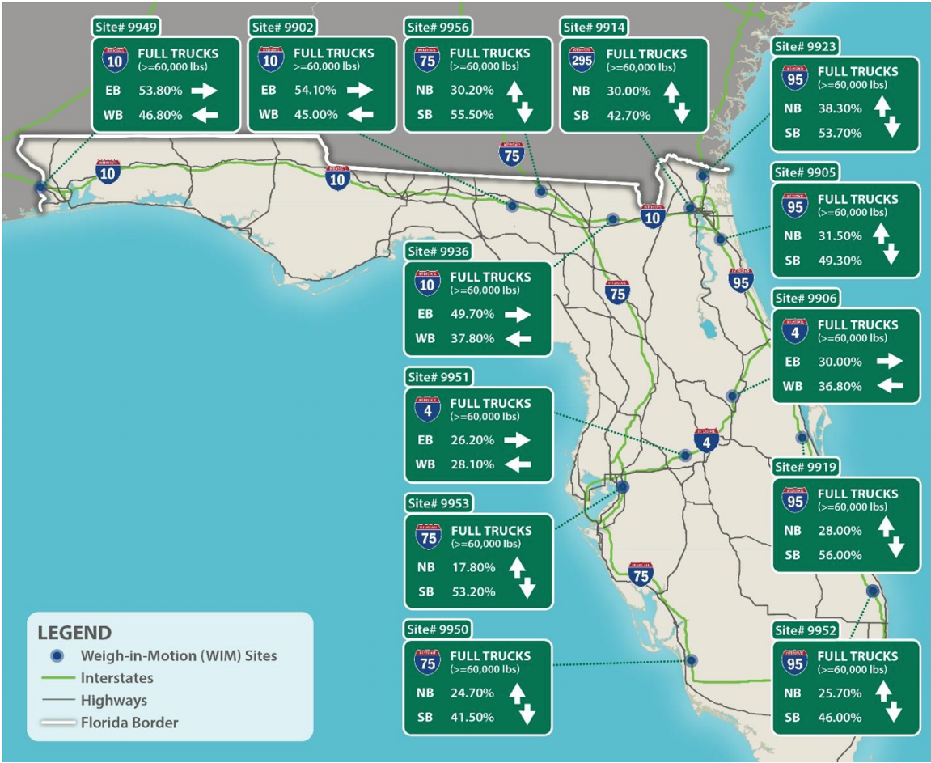
Figure 1. Percentage of Full Class 9 Trucks by Direction of Travel
(Source: Truck Empty Backhaul, 2018)
To determine if there is any seasonality in the empty backhauling percentages in Florida, data were analyzed by the month of the year. Figure 2 illustrates the empty trucks passing through the WIM site on I-95 in Nassau County, south of the state line by month of year.
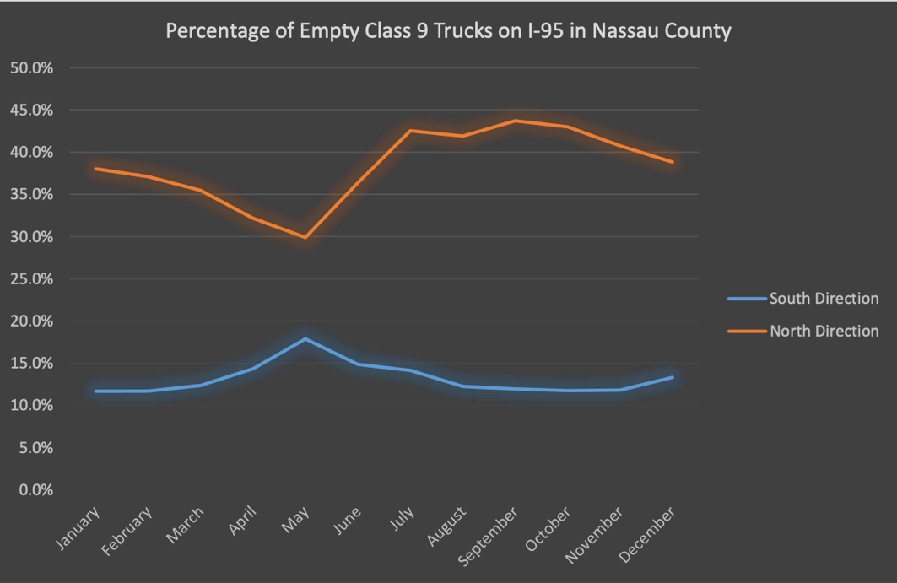
Figure 2. Empty Class 9 Trucks by Month: I-95 in Nassau County
(Source: Truck Empty Backhaul, 2018)
We can see from Figure 2 that trucks coming into Florida show less seasonal variation compared to the trucks going out of Florida. Also, percentage of empty trucks are highest during the month of May in the inbound direction, while percentage of empty trucks are lowest in the outbound direction during the same month. In general, as seen in Figure 3, we can see the percentage values for empties are more in outward (leaving Florida) direction compared to inbound on any given month of the year. This confirms Florida suffers from empty backhauling.
The research also analyzed Transearch data (for the year 2011) which, provides commodity flow information for different counties in the state of Florida.
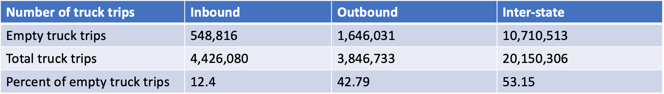
Figure 3. Empty Truck Trips as Per Transearch Data
(Source: Truck Empty Backhaul, 2018)
The outcome of this analysis indicated that 42.79% of the trucks moving out of the state are empty, whereas only 12.40% of the trucks which are coming into Florida are empty. This also confirms the fact that Florida imports more than it exports and provides an overview of nature of the empty backhaul shipments in Florida.
Putting these figures in context, empty backhauling adds to the cost of companies. In a previous study it is estimated that the cost to deadhead an empty truck is approximately $1.60 per mile or $64 an hour (Owusu-Ababio and Schmitt, 2015). The American Transportation Research Institute (ATRI) reports 19.5% of trucking miles provide no revenue, which is a deadhead or empty miles. Private fleets, which represent half of the trucking industry experience 28% empty miles, while for-hire or contract carriers, which represents half of the trucking industry, experience a much lower level of empty miles. Although data are unavailable for the rail industry, it is believed that this industry also experiences imbalances in freight movement in and out of Florida.
Truck Empty Backhaul, 2018 also identifies certain factors influencing empty backhaul in Florida. Florida, with close to 21M population, is the 3rd most populous state in the country. With some unique demographic characteristics, the state’s population tends to consume more than is produced within Florida. Florida is a peninsula with many natural harbors to support maritime freight activities. Product manufacturing and distribution tend to be located in centralized areas of the country and it requires long line haul distance to markets north of Florida. The study identifies that some economic factors, climate/weather factors, along with some industry factors lead to the imbalanced freight flows in Florida. This study also offers some regulatory solutions, partnering solutions, technological solutions and recommendations which may potentially help alleviate the empty backhauling problem in Florida.
Another study which addressed Florida’s empty backhauling problem is the Central Florida Regional Freight Mobility Study (2013). This was conducted by Cambridge Systematics, Inc, prepared for Metroplan Orlando FDOT District 5, Lake‐Sumter MPO, Space Coast TPO, and Volusia TPO. The study explains the connection between economy and rise in demand. It states that goods movement is a derived demand meaning freight volumes grow as population, income, and employment grows.
It reveals the finding that freight moves only if residents consume those goods. The more population and business activities in the region, the greater the demand for freight and goods to be moved in the state’s region. The study presents the key linkages between the region’s freight movement and economy.
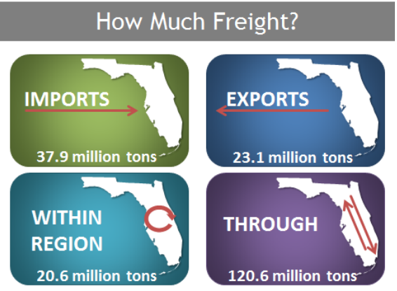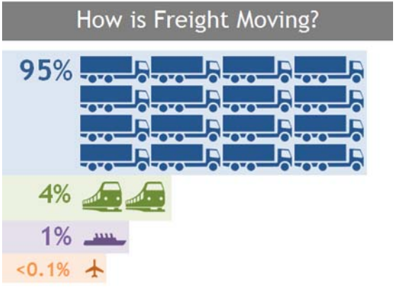
Figure 4. Freight Movement Through Central Florida Region
(Source: Central Florida Regional Freight Mobility Study, 2013)
Of the 202 million tons of imports, exports, intraregional, and through freight moved over the Central Florida study region’s transportation network in 2010, nearly 19% of this traffic were imports, 11% were exports from the region’s and 10% were goods moving within the region representing local business to business sales (Figure 4).
95 percent of the local freight was moved by truck, 4 percent by rail, 1 percent by water, and less than 1 percent through air in 2010, when measured by weight. Over 191 million tons of freight was carried by truck over the region’s roadway infrastructure. The study also predicts future freight demand and economic opportunities. Figure 5 shows the forecasted future regional freight flows.
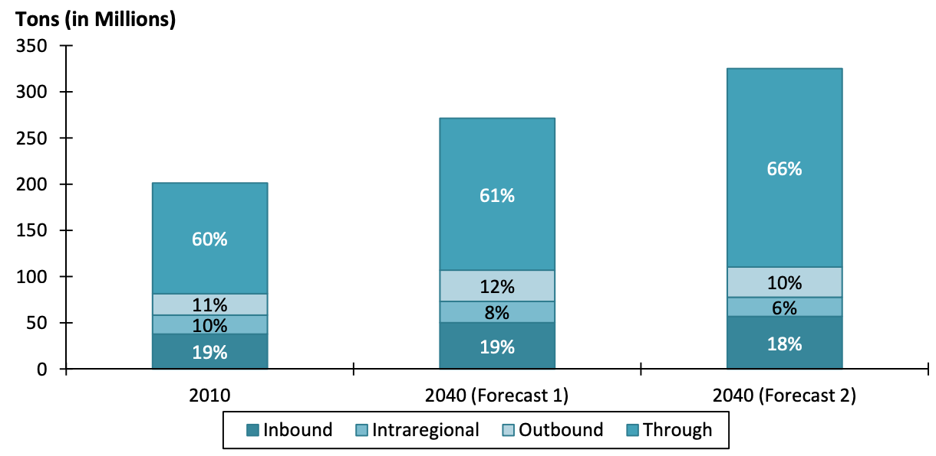
Figure 5. Forecasted Future Regional Freight Flows
(Source: Central Florida Regional Freight Mobility Study, 2013)
According to Florida Trade Logistics Study 2.0 (2013) conducted by the Florida Chamber Foundation and the Florida Made for Trade (2011) study, 146 million tons of freight was imported into Florida whereas only 85 million tons of freight left the state. Forecasts for the year 2040 show a comparable pattern with almost 208 million tons of freight imported into the state while exports amount to around 173 million tons. However, unlike in 2011, 2040 forecasts suggest that the value of exports will be higher than imports with an increase of around $47 million.

2.2 Backhauling and Freight Imbalance by Selected States and Countries
This section provides a review of backhauling and freight imbalance by selected states including Arizona, Nevada, and Hawaii as well as by selected countries including European freight markets, Norway, Thailand, Central America, and China.
Figure 6 shows the ratio of outbound to inbound domestic shipments by value destined for markets within a state (Freight Facts and Figures, 2018). A ratio of outbound to inbound shipments (the “heat key” below the figure) greater than 1.0 suggests that a state ships more goods in other states than it receives goods from other states, on the other hand a ratio less than 1.0 indicates that a state imports more goods from other states than it exports.
North Dakota and Alaska have the highest ratios which are 2.2 and 1.8, respectively, in terms of value, indicating that the value of their goods exported to other states is double the value of the goods they received from other states. Although both states have relatively small populations, they are major producers of energy commodities—oil in North Dakota and coal in Alaska. Hawaii had the lowest ratio of interstate outbound-to-inbound shipments by value at 0.18, because of its isolated geography and its resource dependency. Florida, Arizona, and New Hampshire also exported far less to other states than they imported, partly due to demographics and other factors.
The ratio of outbound to inbound domestic shipments by weight also seems to follow the same trend, with Florida, Arizona, and New Hampshire importing more goods by weight than what they export.

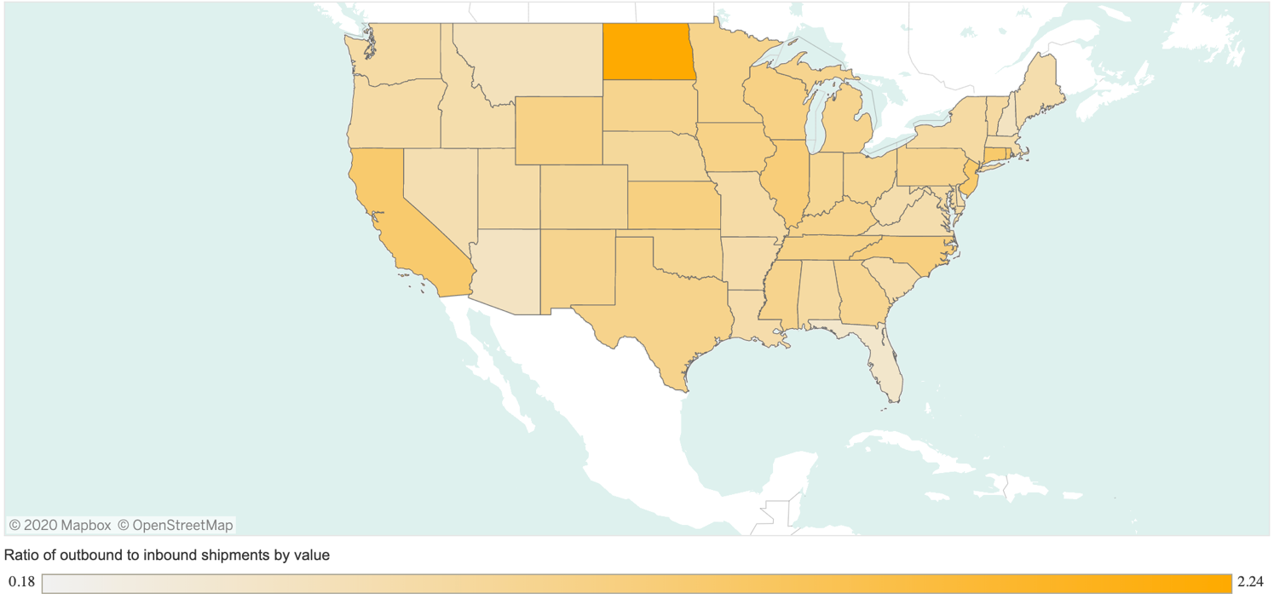
Figure 6. Ratio of Outbound to Inbound Shipments by Value
(Freight Facts and Figures, 2018)

2.3 Backhauling and Freight Imbalance Research by Selected States
This section provides an overview of the literature review for selected states in United States.

2.3.1 Arizona
Over 137 million tons by weight in freight flows are generated by Arizona’s top ten freight industry sectors. Natural resources contribute 49 percent of these flows, by volume (2012).
Arizona’s top freight sectors generate more than $188 billion in freight flows. These freight flows are 41% inbound to Arizona, 21% is outbound from Arizona, and 38% are intrastate flows within the borders of the state. Consumer goods sectors constitute 58 percent of these flows, by value (2012).
As illustrated in Figure 7, Arizona’s transportation and logistics freight movements are predominantly passing through (Intrastate). 63% of the freight are the commodities passing through the state, followed by inbound and outbound movements. 14% of the freight is within, which is the freight moving within the state. In terms of inbound shipments, California is the major state from which Arizona imports 90% of the freight. The other notable state is Texas. New Mexico and Nevada are the major destinations for outbound shipments sector. The transportation and logistics industry in Arizona move a wide variety of commodities.
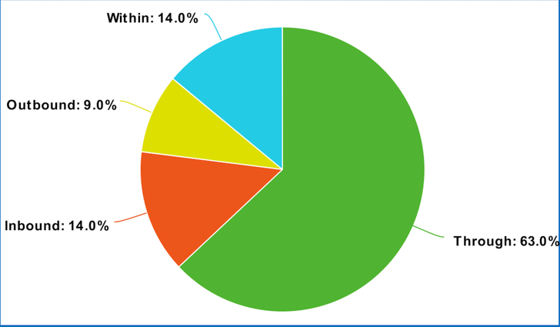
Figure 7. Annual Statewide Freight Flow by Value Using 2013 Data)
(Source: Recreated from Arizona State Freight Plan, 2014)

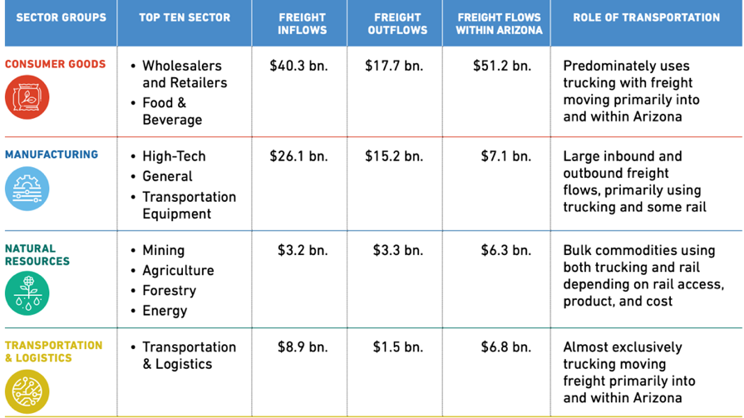
Figure 8. Arizona’s Top Ten Freight Dependent Sectors
(Source: Arizona State Freight Plan, 2014)

In addition, more than 137 million tons in freight flows are generated in Arizona, of which 24.5 million tons are inbound, approximately 10 million tons are outbound, and more than 100 million tons are intrastate flows (Figures 8 and 9). Thus, the empty running of trucks in 2013 was estimated to be 40%.
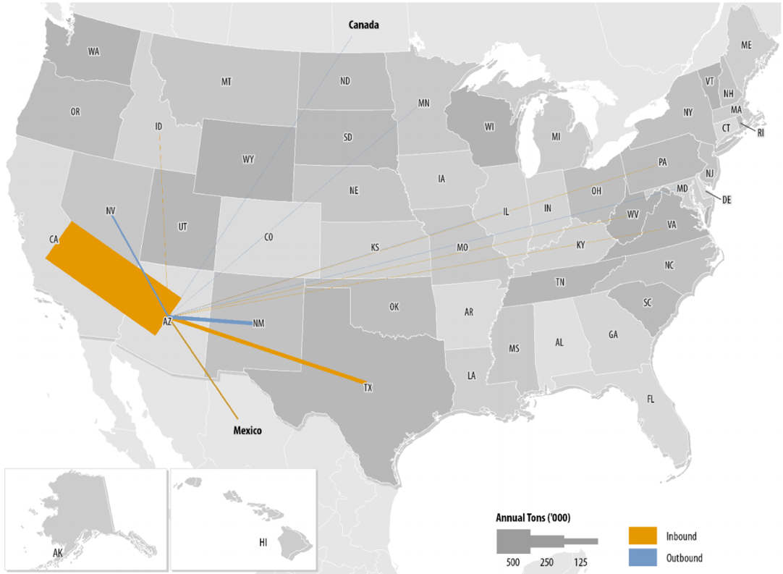
Figure 9. Arizona Transportation and Logistics Sectors Inbound-Outbound Flows
(Source: Arizona State Freight Plan, 2014)

2.3.2 Nevada
One of the important studies which points to the freight imbalance in Nevada is the Nevada Freight Program Assessment (2013). This study addresses the goods moved outbound/exports, inbound/imports, and internally within Nevada by different modes of transportation. It also sheds light on how freight imbalance may affect economic growth and lists the industrial sectors, which face the freight imbalance problem and who have potential for growth in the future. The study includes data from 1997 through 2011 and presents the GDP forecasts for 2022 and 2032. Inbound freight to Nevada from the rest of the US has increased over 30 percent accounting to 42 million tons, as shown in Figure 10.
Demand for freight coming into Nevada has been growing significantly since 1997. While inbound shipments have increased, outbound shipments have dipped by 3-4% as the study mentions. A comparison between inbound and outbound flows reveals the imbalance between the two, with inbound being dominant by both weight and value. In addition, the baseline forecasts using Freight Analysis Framework (FAF) data by this study show that outbound freight will double in tons and triple in value between 2012 and 2040 due to growth in manufacturing.
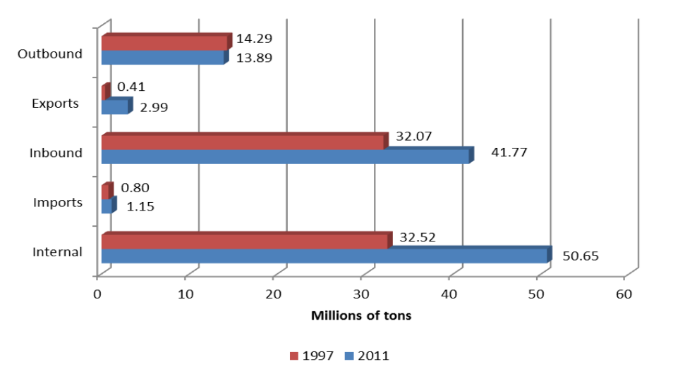
Figure 10. Inbound-Outbound Freight Flows of Nevada
(Source: Nevada Freight Program Assessment, 2013)
Nevada state freight plan’s analysis of commodity flows through Nevada depicts that states’ economy is dependent on the daily distribution of millions of tons of goods shipped by a multimodal network of different modes of transportation. These modes of transportation include highways, railways, airports, ports, and pipelines. Nevada is primarily a consuming economy. Inbound flows which are goods like food, retail, and beverage exceed the output of goods created or distributed (outbound flows) from within Nevada at a ratio of 2:1. Resource based industries like mining and construction consume majority of top commodities by tonnage, which are moved within the state.
Industry dependence on inbound freight is when the state uses goods and raw materials for production process or in providing services in the state. This establishes a link between reliance of sales on inbound freight. As shown in Figure 11, mining, construction, food services, accommodations, and food manufacturing are particularly dependent on inbound materials shipped via trucks as they provide between $783 million and $2.7 billion worth of sales. Figure 11 also provides income associated and value added with this output.
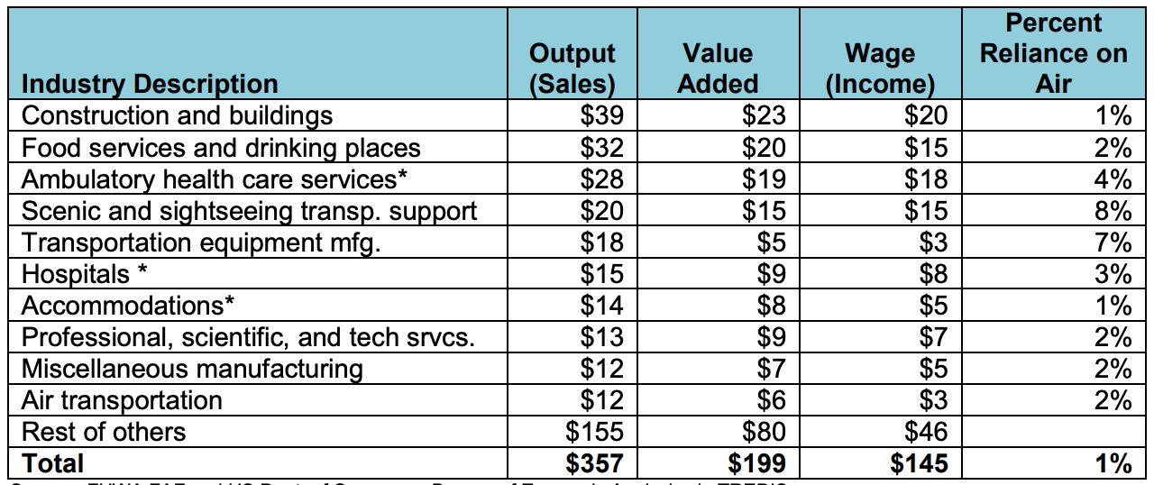
Figure 11. Industry Dependence on Inbound Freight Transported by Truck (in millions $)
(Source: Nevada Freight Program Assessment, 2013)
Industry dependence on outbound freight is when states’ outbound freight enables intermediate or final goods to be delivered to customers outside the state for their use or consumption.
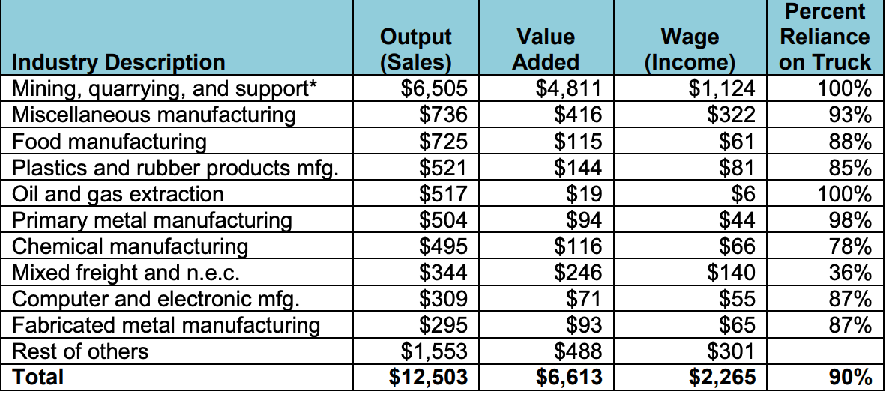
Figure 12. Industry Dependence on Outbound Freight Transported by Truck (in millions $)
(Source: Nevada Freight Program Assessment, 2013)
Using Figure 12, it can be observed that $6.5 billion of mining, quarrying, and support sales are through trucks transporting this industry’s commodities, which represents 99 percent of output compared to dependency on other modes. The truck-dependent portion comprises over $12.5 billion worth of sales. It can be clearly seen that Nevada imports more freight than it exports through these figures.
Nevada Department of Transportation proposed following actions to solve the issue of freight imbalance with the two-to-one inbound-to-outbound ratio causing empty equipment movements.
- Replace the dependence on inbound freight with locally manufactured goods
- Invest in goods producing jobs (e.g., Tesla plant for electric car manufacturing) to ensure an aggressive growth in outbound freight in the state
- Encourage Nevada’s shippers and trucking firms to participate in empty equipment (truck, railcar, etc.) reduction strategies
To strengthen its multimodal and multidirectional services, the state is planning to build a stronger freight infrastructure which is expected to improve its links to western ports and eastern markets that will provide more opportunities.

2.3.3 Hawaii
Hawaii faces problems in transportation and freight management such as poor pavement conditions, development/proposal of policies that overlook freight needs, limited operating hours of shipping operators, lack of alternative routes, inadequate loading zones, shoreline erosion (climate change), rapid growth, and lack of funding for improvements. Figure 13 shows the tonnage by type of trade, and it can observe that the highest commodity flow occurs between the Hawaii islands themselves.
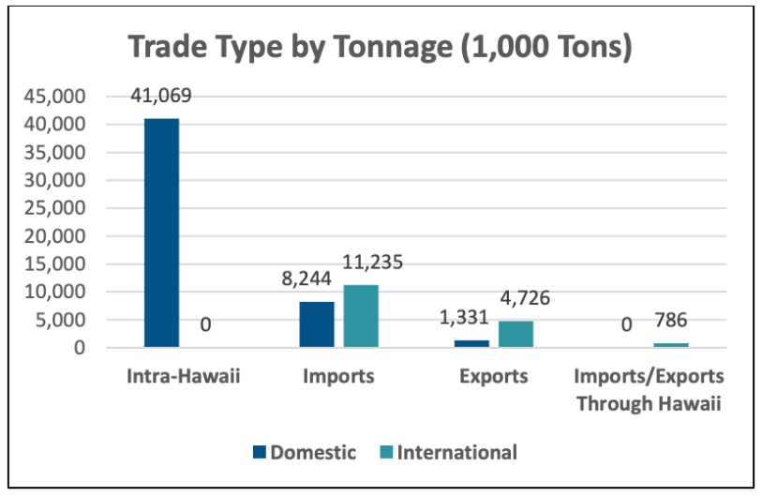
Figure 13. Hawaii Trade Type by Tonnage
(Source: Hawaii Statewide Freight Plan, 2018)
Imports and domestic inbound traffic are half the amount of intra island traffic. Outbound and exports represent less than 10% of the trade overall. Using Figure 13 we can determine that state’s inbound freight is much more than its outbound freight leading to freight imbalance problems. According to Freight Facts and Figures (2018), which details the freight facts by state, Hawaii in 2017 had 1,849 thousand tons of outbound flow compared to 3,324 thousand tons of inbound flow.

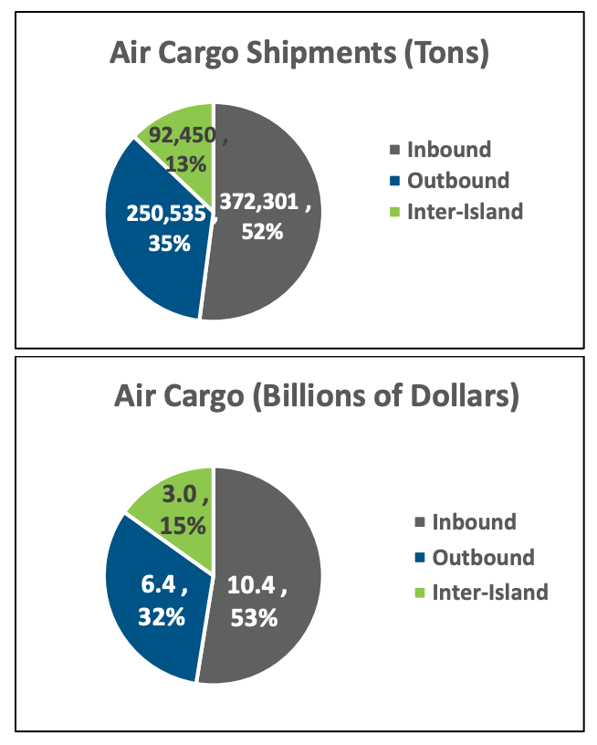
Figure 14. Hawaii Air Cargo Shipments, 2015
(Source: Hawaii Statewide Freight Plan, 2018)
According to 2015 data, just over 715,000 tons of air cargo were transported around Hawaii. Figure 14 shows that 52 percent of these were inbound shipments in tons, 35 percent were outbound shipments, and 13 percent were shipments between the islands. A similar trend can be seen in air cargo shipments of Hawaii. Imbalance in freight is evident from Figure 14, both by value and weight.

2.4 Backhauling and Freight Imbalance Research by Selected Countries
This section provides a review of backhauling and freight imbalance by selected countries/regions, including the European freight market, Norway, Thailand, Central America, and China.

2.4.1 European Freight Market
One of the important studies which identifies freight imbalance problem is ‘Determinants of European freight rates: The role of market power and trade imbalance’ (2014). This paper investigates the determinants of freight rates between six European countries (France, Germany, Netherlands, the UK; Mediterranean: Italy and Spain). It shows that inbound freight rates in these six European countries on average is 23% higher than for outbound rates. This indicates that cost of repositioning empty containers is paid by European importers.
Trade development has several factors which have a high impact such as transportation costs, which is a component of import price. Imbalance in freight moving in and out of the region becomes an important factor on the determination of freight rates. This leads to asymmetric freight rates between the outward and inward trips in order to take into account the cost of empty container repositioning, on the legs where the loading factor is lower. This study controls for the direction of a journey, since the data takes into account both the inward and outward freight rates for each trip, and it also provides a detailed analysis by breaking down the freight rates into two components: the basic freight rates and maritime surcharges. The study identifies that export growth rates are increasing much more for regions, which recently named as production areas than major market consumption areas. This is leading to unequal freight rates between the inward and outward journeys.
According to this study “freight liner shipping connectivity and port infrastructure as determinants of freight rates in the Caribbean (2008)”, when a “country imports 10 times more than what it exports leads to an increase of the freight rate by 8.40 USD”. For many major routes, the trade imbalance can be so large that the freight rates sometimes are twice as high for the head-haul than for the back-haul.
The results of the study are as follows:
- Inward freight rates were, on average, 23% higher than outward rates
- A one-standard-deviation increase in distance lead to an estimated increase of 15% in inward freight rates and only 6% for the outward rates
- The freight rates for return journeys tend to be higher for indirect services than for long journeys
As the UK government’s survey of road freight movement, Continuing Survey of Road Goods Transport (CSRGT) depicts, in the last 30 years the proportion of kilometers run empty by trucks with gross weights over 3.5 ton or more declined from 33.7% in 1973 to 26.5% in 2003 (McKinnon, 1996). A study (McKinnon and Ge, 2006) uses the UK Government’s main road and freight survey and other studies to investigate the causes of the decline in empty running. This study found out that, backloads were found for only 2.4% of the empty journey legs, representing 2% of empty truck-kms.
The authors identified the factors that are constraints in the empty backhauling of trucks in the UK:
- Priority given to outbound delivery service: One of the inhibiting factors is manager unwillingness to risk reduction in the quality of outbound distribution to customers. Backhauling increases the risk that the vehicle will not be re-positioned in time to collect its next outbound load
- Unreliability of collection and delivery operations: The risk of backhauling operations being delayed (and thus disrupting later outbound trips) can be sometimes high
- Inadequate knowledge of available loads: Many possible matches of backhaul capacity with suitable loads are missed because of a lack of transparency in the road haulage market. Most of the time, vehicle operators would not know what loads are available for possible backloading activity. According to one of the surveys, information about 61% of the available backloads comes through “word of mouth”
- Lack of coordination between purchasing and logistics departments: Discussion of physical movement of products as part of the trade negotiation between companies is likely to increase backloading opportunities
- Incompatibility of vehicles and products: Often, a vehicle available to collect a backload is unsuited to the potential backhaul. This can impose a tight constraint on possible backload opportunities
- Resource constraints: It has been predicted that the combined effect of a shortage of truck drivers and the application of the EU Working Time Directive to mobile workers in 2005 will reduce delivery flexibility over the next few years. This may have a negative effect on potential backhaul capabilities by trucks
The study (Angel A. Juan et al., 2011) discusses how horizontal co-operation through backhauling can be an effective strategy in reducing distance-based costs as well as emission costs during distribution activities in transportation of goods. As defined by Bahinipati et al. (2009) horizontal co-operation is “a business agreement between two or more companies at the same level in supply chain or network in order to allow ease of work and co-operation towards achieving a common objective”. The study mentions that the French ministry of Economics and the Spanish Ministry of Transportation encourages the use of practices such as horizontal cooperation to increase profits and reduce empty backhauling.
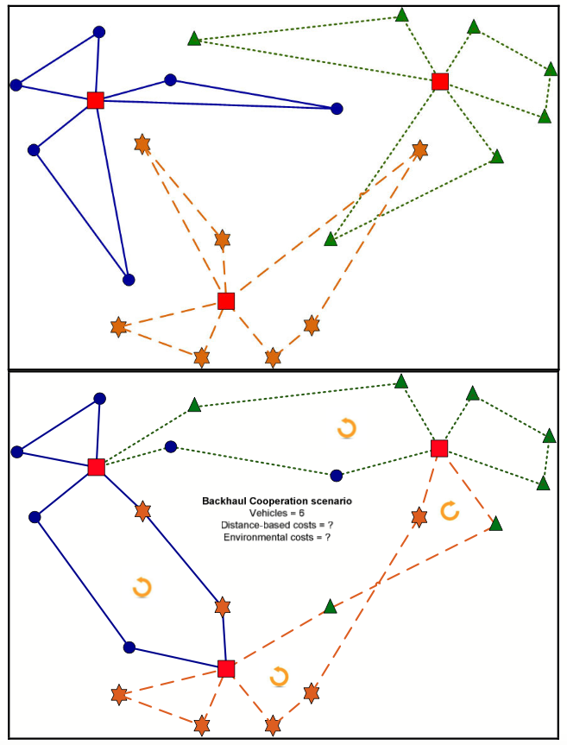
Figure 15. Non-cooperative (above) vs. Cooperative (below) Backhauling Scenarios
(Source: Angel A. Juan et al., 2011)
The top part of Figure 15 shows a non-cooperative scenario where service provider (square nodes) designs its own set of features and routes to transport its customers. On the other hand, the bottom part of the figure shows a co-operative scenario, where backhauling strategies are considered by merging some routes in order to increase the actual utilization of vehicles during the trip. The comparison of figures provides an intuitive idea about the benefits of horizontal co-operation.

2.4.2 China
China is one of the largest producers of goods in the world, with millions of loads leaving the country every day. An average of 50% of China’s road container transportation consists of empty loads due to the prevalence of one-way loads. It should be noted that the fuel consumption rate of an empty load is two-thirds that of a full load (Wang et al., 2011).
A study named “empty container repositioning problems in the context of Eurasian intermodal transportation (2019)” approaches to empty container repositioning problems in the context of Eurasian intermodal transportation found out that majority of transportation on Eurasian routes is through usage of containers. There is a substantial imbalance between Asia and China, which plays a key role in this phenomenon. Higher numbers of full containers coming from China and much smaller numbers of those containers, which are filled and sent back to China, are observed. This imbalance causes lack of availability of empty containers in export regions, while import dominant regions face a problem of getting rid of surplus of empty containers. Due to the repositioning of empty containers, China faces a significant problem.
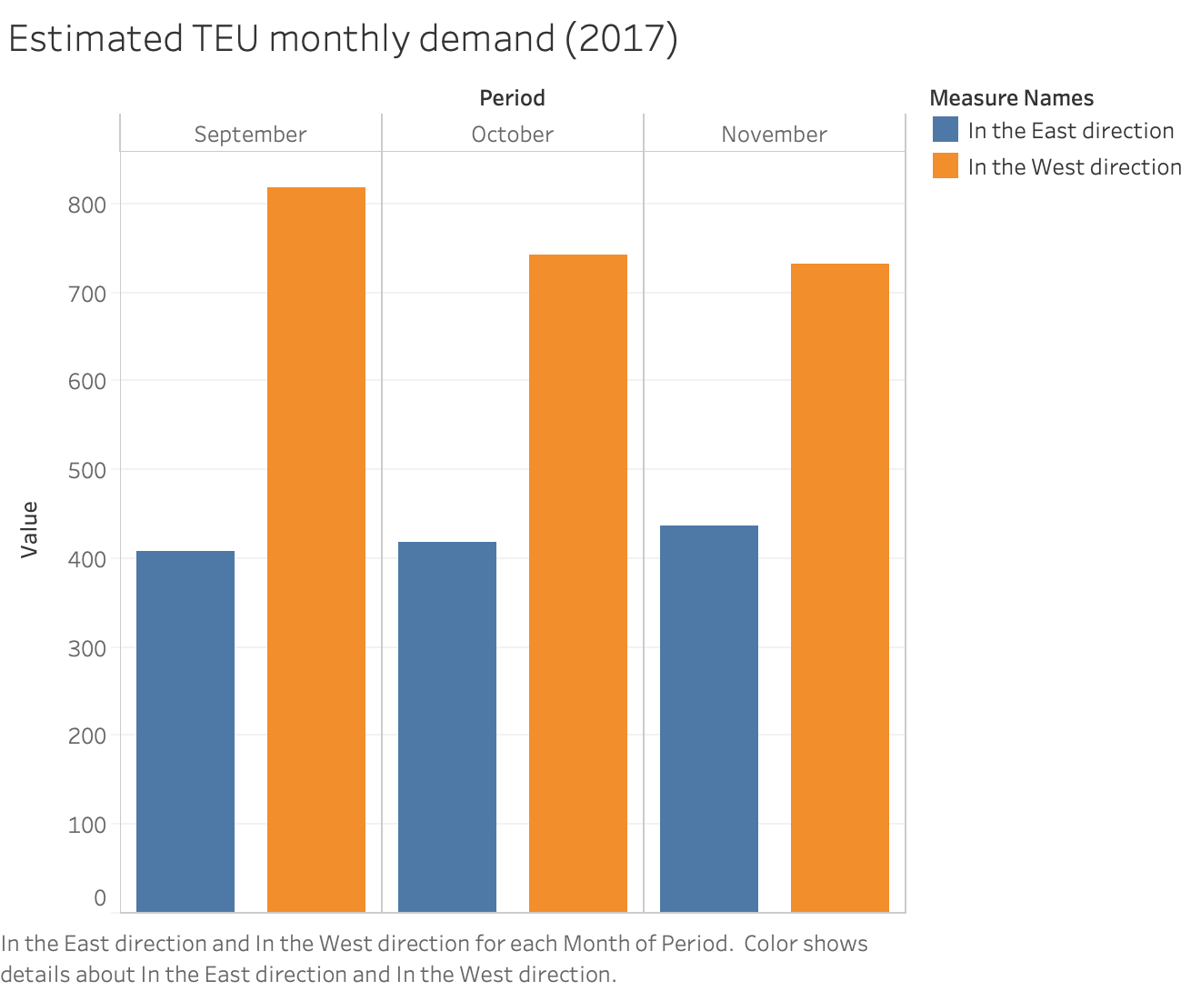
Figure 16. Asia-Northern Europe Estimated TEU Monthly Demand
(Source: Recreated from Approaches to Empty Container Repositioning Problems in the Context of Eurasian Intermodal Transportation, 2019)
The scale of the problem is illustrated in Figure 16, where differences between the monthly demand for 20-foot Equivalent Units (TEUs), a standardized capacity measure of transport units, shipped in both directions between Northern Europe and Asia is presented, resulting in an empty container balancing problem.
The study provides solutions which include technical ones, aiming at reduction of the storage and transportation vehicle space of empty containers. For example, foldable containers or increasing the flexibility of container size adjustments, and changes in container management like container sharing or substitution. It also provides an overview on approaches of modeling empty container repositioning problems based on mathematical programming.
- One of the technical solutions offered in this study is usage of foldable or collapsible containers. This helps in saving repositioning costs as well as storage space. The study estimates that foldable containers can save up to 75% of the space, although purchase cost is one of the barriers which limits the usage of foldable containers
- Container substitution can also be used as a method to relax the problem of empty containers repositioning. One 40-foot container can be used instead of two 20-foot containers if the goods transported can be loaded in a single container
- Container sharing is one of the options to reduce empty backhauling. This concept is a part of collaborative logistics which refers to resource sharing to increase performance. Container sharing is an example of horizontal cooperation performed between shippers who aim at reducing costs, increasing productivity and strengthening market position by sharing capacities and operations
- Internet platforms with up-to-date information about containers which are in demand and in supply can serve as a great tool helping the planning of empty container shipments

2.4.3 Central America
Mexico is presently America’s 3rd largest goods trading partner. IT accounts for $611.5 billion in total (two way) goods traded during 2018. Goods exports totaled $265.4 billion, and goods imports totaled $346.1 billion. The U.S. goods trade deficit with Mexico was $80.7 billion in 2018 per the Office of the United States Trade Representative. U.S. goods and services trade with Mexico totaled an estimated $671.1 billion in 2018. Exports were $299.2 billion; imports were $371.9 billion. The U.S. goods and services trade deficit with Mexico was $72.7 billion in 2018. The U.S. goods trade deficit with Mexico was $80.7 billion in 2018, a 16.4% increase ($11.4 billion) over 2017. Figure 17 depicts the exports vs. imports percentages.

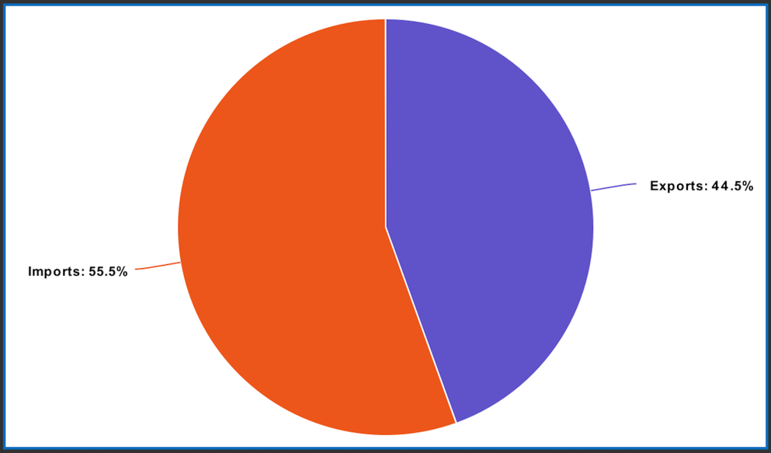
Figure 17. Export and Import Percentages from US to Mexico in 2018
(Source: Recreated from Office of the United States Trade Representative, 2018)
A recent study found out that one of the biggest issues that aggravates supply chain management in Central America is the empty backhaul (Spillan, Virzi, and Garita, 2014). According to the Bureau of Transportation and Statistics study, Freight Facts and Figures, 2018, 230,005 tons of freight traveled from Mexico to the US in 2014, but only 188,905 tons were delivered from the US to Mexico. In addition, in the US, of 5,415 trucks crossing the Mexican border, only 3,779 were loaded with cargo. Thus, the empty backhauling in 2014 was almost 30%.
Guatemala has most empty backhauls, followed by Panama, Nicaragua, and Costa Rica. For example, a representative of the Sea Star Line noted, “There are approximately four full loads moving to Puerto Rico for every full container returning to the US.” For this reason, logistical expenses in Central America are 36% of the total costs based on the final price of the merchandise. As a result, empty containers are stored at US ports and then transported back to Central American countries.

2.5 Enterprise Florida: Industries of Excellence and Strength for Florida

Enterprise Florida is the principal economic development organization for Florida. It is a public-private partnership (PPP) dedicated to job creation in the state for more than 21 million residents. It also conducts studies and promotes Florida as the business destination for various corporates and other companies. Florida’s industry excellence and strength can be divided into the following key areas.
- Aviation and Aerospace: Florida is home to many leading producers of different types of aircrafts and aviation parts. To benefit this industry’s business, the state has a rich supply chain and large talent pool. Many aviation/aerospace companies have significant operations in Florida such as Boeing, Embraer, General Dynamics, Lockheed Martin, Northrop Grumman, Pratt & Whitney, and Sikorsky.

- Life Sciences: Florida has firmly established itself as a hub for life sciences after years of coordinated effort. Today the state is home to more than 1,100 biotech, pharmaceutical and medical devices companies and a foundation of more than 46,000 healthcare establishments - including 720+ hospitals. It is growing its potential in the fields of biotechnology, medical device manufacturing, pharmaceutical manufacturing and healthcare.

- Manufacturing: The state has advanced manufacturing industries ranging from production of plastics to tortillas, to motor vehicles. More than 330,000 workers have been employed in manufacturing sector, who can help manufacturing business ramp up quick in Florida.

- Defense and Homeland Security: The defense and homeland security industry is comprised of various companies who are developing products and solutions to support our military and protect civilian populations from security threats. The state is a host for 20 major military installations and 3 unified combatant commands. Florida’s strength in infotech, photonics, simulation and training, and biotech makes it the favorite spot for companies to start their operations.

- Information Technology: Florida’s industry strengths in information technology are diverse, and range from photonics to mobile technologies, to communications equipment, to modeling and simulation, and beyond. Industries in software and computer system design, microelectronics and computer products, digital media and telecoms are showing high potential for growth.

- Financial & Professional Services: Florida excels in finance. It is evidenced by presence of more than 160 commercial banks with $131 billion in assets. Florida’s 97,000+ professional services establishments are spread across the state and include major firms in legal services, accounting, consulting, architecture, engineering, R&D and related fields.

- Logistics & Distribution: Almost every major global logistics firm has their presence in Florida, including the headquarters for Ryder System, Inc., Landstar System Inc., CEVA Logistics U.S., Inc. and other top logistics companies. Florida has industries in value added logistic services, wholesale trade and transportation, specialized logistics IT, and defense logistics.

- Cleantech: Florida is already home to industry innovators from Mitsubishi Power Systems Americas to Siemens Energy, to Saft, who are building a robust cleantech industry, with strength in energy, efficiency and environment friendly technologies. Floridan companies are leading testers of water, desalination, and remediation technologies.

- Headquarters: Florida offers a pro-business environment, large market, large workforce, and tremendous diversity. Florida also offers world-class business amenities and infrastructure, so products and ideas can travel fast. Florida is particularly well-suited for Latin American headquarters operations through its connection to Latin America.

2.6 Industries and Sectors with Highest Empty Backhauling

A region’s economic viability and livability is dependent on freight movement. In addition, a region’s economy substantially is aided from increased intra- and inter-regional freight flows between different trading partners and logistics activity centers (LACs) such as ports, intermodal logistics centers, etc. This section details empty backhauls by different industries in Florida.

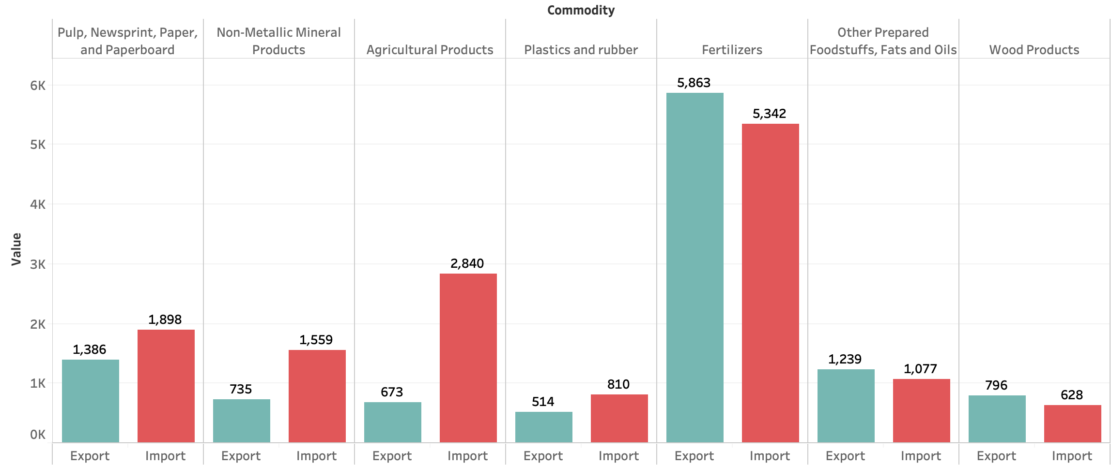
Figure 18. Tonnage by Commodity Type – Imported and Exported in Florida
(Source: Recreated from Freight Data Fusion from Multiple Data Sources for Freight Planning Applications in Florida, 2018)
In Figure 18, the industries which are grouped to the left, import more goods than they export. This leads to a freight imbalance in goods moving in and out of Florida. Florida imports 2,840 thousand tons agricultural products and only exports 673 thousand tons. Similar trend can be observed in Non-metallic Mineral products, Plastic and rubber products and Pulp, Newsprint, Paper, and Paperboard products. These industries have comparatively higher empty backhauling percentages than other industries. Industries which are grouped to the right of Figure 18, such as fertilizers and wood products export more goods than they import.
As mentioned in the previous sub-section, Florida has advanced manufacturing industries which are diverse and include sectors producing intermediate and finished products starting from plastics to motor vehicles. According to the information provided by Enterprise Florida, the state is home to over 19,000 manufacturers employing more than 331,000 workers. These strong industry assets have great potential and help manufacturing business ramp up fast in Florida. Some of the industries with the good potential for growth are advanced manufacturing, including electronic components aerospace and defense products, metal fabrication, and medical equipment. Some of the companies in these sectors are Actavis Inc., Danfoss Turbocor, Embraer, Gerdau Ameristell, Harris, HEICO, Jabil, Johnson & Johnson Vision Care, Lockheed Martin, Mitsubishi Power Systems, Motorola, Siemens Power Systems, Sun Hydraulics.
Considering inbound and outbound freight by different regions of Florida, South Florida (Miami) is the top region receiving 15 million tons of shipment per year, followed by the greater Tampa Bay region, which imports 8.8 million tons of freight per year. This is followed by the remainder of the state, Jacksonville, and Orlando. If we consider the outbound freight for the same regions, Miami tops all regions with 7.9 million tons of freight. Tampa has 5.8 million tons of outbound freight per year followed by Orlando, Jacksonville, and remainder of the state. These figures clearly establish a fact that South Florida (Miami) and the greater Tampa Bay regions have comparatively higher backhauling percentages in Florida than other regions of Florida.

2.7 Summary and Recommendations

After reviewing the available literature on empty backhauling such as the above-mentioned various research papers and reports for several states and countries, and by different industries in Florida, we realize that Florida is not the only state or region, which has empty backhauling problems. Through this literature review, we have identified other states as well as other countries with similar problems. This literature review also looked at the solutions implemented by various transportation departments to alleviate empty backhauling and we have a clear picture on different solutions countries have adopted to alleviate empty backhauling.
Per this literature review, it can be concluded that empty backhauling is an important problem, which affects a state’s economy. Several state DOT reports also provide information about the freight and commodities flowing in and out of these respective states. They also provide tonnage of import and export for these states per different industries.
Some of the important techniques discussed in this literature review to alleviate empty backhauling were using collapsible containers, horizontal co-operation, and container sharing and substitution between different industries.
This literature review also looked at the various industries as highlighted by Enterprise Florida as Florida’s industries for excellence and strength. These industries are highlighted for prospective growth in the coming years. We also compared these industries with the section of industries, which were found to have the highest empty backhauling, so that we have a preliminary idea of which prospective industries suffer from empty backhauling more compared to others.
In the next phase of the project, Section 3, the research team analyzed available Weigh-in-Motion (WIM) data for the years 2018 and 2019. This allowed the research team to obtain the latest empty backhauling truck percentages in Florida per differing WIM station locations within the state.

Quantification of Truck Empty Backhauling in Florida

In Section 3, the empty backhauling percentages for the state of Florida across various WIM sites were calculated and reported for the years 2018 and 2019. This section provides an overview of how the data were collected as well as various attributes of the data. This section also provides the data analysis methodology and their end results and findings.

3.1 WIM Data Collection and Cleaning

Weigh-in-motion or weighing-in-motion (WIM) devices capture and document the axle weights and gross vehicle weights as vehicles drive over a measurement site. Unlike static scales, WIM systems are capable of measuring vehicles traveling at a reduced or normal traffic speed and do not require the vehicle to come to a halt. This makes the weighing process more efficient and, in the case of commercial vehicles, allows trucks under the weight limit to bypass static scales or inspection.

Weigh-in-motion is the process of estimating the motionless (static) weight of a vehicle from measurements of the vertical component of dynamic tire forces applied to a sensor on a smooth, level road surface. The WIM dataset contains individual records of buses/trucks (FHWA Classes 4 to 13) passing through each WIM site in the state. The dataset includes the date, time, travel direction, travel lane, gross vehicle weight, vehicle class, vehicle length, axle spacing, and axle weights for each truck passing through the WIM station (please refer to Appendix A for a complete list of the data attributes). In this analytical study, the research team used WIM data from the years 2018 through 2019, supplied by Joey Gordan of the Florida Department of Transportation (FDOT).

Granularity of the dataset: Granularity is the level of detail at which data are stored in a database. The datasets used for this analysis had the granularity of a single truck passing through the WIM station. That is, when a truck passes through a WIM station, various attributes of the truck such as truck’s gross weight, class of the vehicle, direction, speed, lane, site identification of the WIM station, etc. This is a micro-dataset, composed of individual records, as opposed to aggregate datasets comprised of complied statistics. Micro-datasets are more detailed and inherently flexible. This strengthens the results of the study by allowing analysis of the actual records and not the compiled statistics.

Limitations of the dataset: The WIM data stored in the FDOT database may not include all days/times due to malfunctioning or damage of the sensors. It also does not cover all the travel lanes due to sensor installation practices. If the calibration of the sensors is adjusted to record accurate results, observed weights may slightly vary over time compared to actual weights.

Quality assurance of the dataset: The methods followed in this phase assure that the quality of data is suitable for analysis and processing. As mentioned earlier, this is a micro- dataset; hence, we must perform validation and cross-references to ensure that data are valid, reasonable, and secure. This will ensure achieving accurate conclusions. Range and constraint validation tests performed in achieving the quality assurance of the data are as follows:
- Weight integrity: Since there were many weight variables in the dataset (e.g., gross weights and individual axle weights), we performed tests to ensure that we are not considering false records for that analysis which may alter the results. The typical weights for each class of vehicle were identified through a literature review. The records which failed this test were dropped from the study.
- Classification integrity: Trucks were classified as per the FHWA Vehicle Scheme F code. FDOT produced a classification tree based on length, number of axles, and axle spacing. Trucks that were classified as error records according to the FHWA Vehicle Scheme F code in the data were removed. FHWA Vehicle scheme F code details are supplied in Appendix B.
WIM Data Cleaning
The research team received the raw data files as annual text files from January 2018 through December 2019 for the entire state of Florida. The dataset is large and complex with each year’s data containing over 50 million records for buses/trucks (FHWA Classes 4-13). A snapshot of the data is shown in Figure 19.
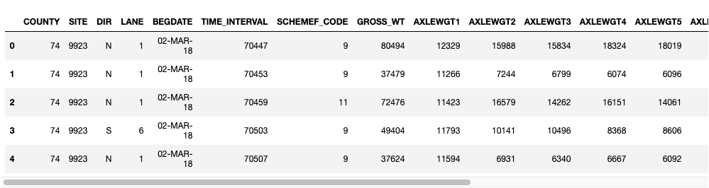Figure 19. The Snapshot of the Data
The data were provided as SITE ids for the locations where WIM stations are installed. The latitude and longitude, county information of the WIM site matching the SITE ID’s was extracted from Florida traffic online website [1]. The WIM stations considered for this study are the ones that are on interstate highways since the majority of long-haul truck movement that occurs between states predominantly occur on the interstate system. For this reason, the analysis is concentrated on the WIM sites in Florida that are on the interstate system. There are 12 sites located on the interstates that provide continuous data. These sites and their corresponding locations are shown in Figure 20.
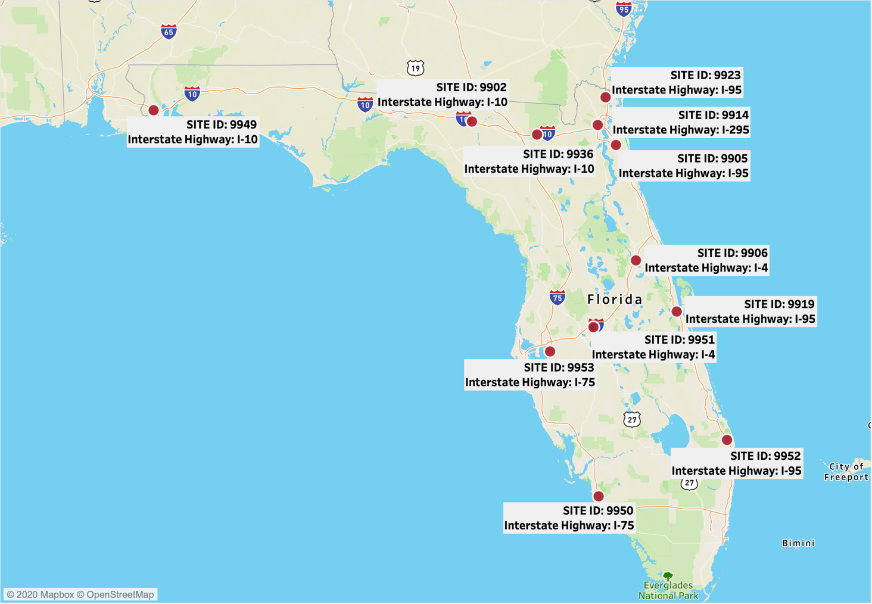
Figure 20. Florida WIM Sites on the Interstate System

The WIM dataset had close to 50 columns detailing various attributes of the vehicle passing the WIM station. For our analysis, we only selected the columns which fall in the scope of the study. Some of the important columns considered in this study are the gross weight of the vehicle, direction in which the vehicle is traveling, date and time at the time of passing the WIM station, individual axle weights, class of the vehicle, and site ID. The details of each field can be found in Appendix A as previously mentioned.

The WIM data had classes of vehicles from FHWA Class 4 through class 13. These vehicles are classified according to the FHWA Vehicle Scheme F code. Appendix B provides information about the FHWA vehicle classification scheme as previously discussed. After conducting the distribution analysis of the classes on the WIM stations on interstate highways shown in Figure 20, we found the following results.

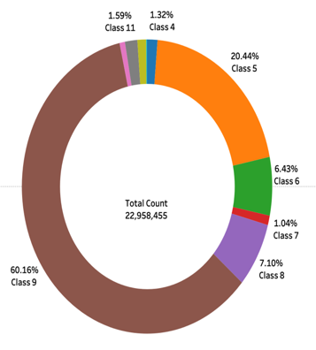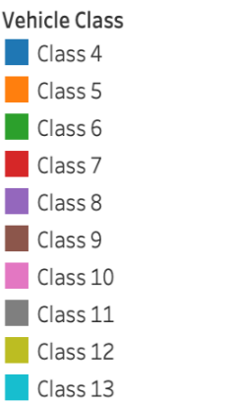
Figure 21. Percentage of Trucks by Different Classes of Vehicles Passing
Through Interstate Highways
We can observe from Figure 21 that nearly 60% of the vehicles passing through the WIM stations belong to Class 9 and 7% percent of them to Class 8. We further checked the distribution of each class over different months in a year. We were able to observe the same trend where more vehicles were falling in Classes 8 and 9. This also confirmed the fact that most of the vehicles traveling through the WIM stations on the interstate highways belong to Classes 8 and 9. In addition, it should be noted that there is a significant amount of Class 5 trucks (single unit truck) in the traffic stream, however it should be noted that these vehicles do not represent interstate freight movement. This shows that Classes 8 and 9, represent 93% of the heavy commercial heavy vehicles transporting freight commodities interstate. For this reason, the data were filtered to contain Classes 8 and 9 for further analysis. Truck percentages by vehicle class for all sites ids by direction can be found in Appendix C.
The gross weight column in the data had values ranging from 0 to 444,658 lbs. According to Florida highway safety and motor vehicles, the highest gross weight allowed for a truck to carry in Florida is 80,000 lbs. We observed 2.8M records in the data which is about roughly 2.5% of the records were showing gross weight above this value. To further add to this value considering heavy load permits, we did a descriptive analysis of the gross weight of trucks above 80,000 lbs. From this study, we could find that 88% of the records which were above 80,000 lbs. were in the range of 80,000-90,000 lbs. 8% of the records above 80,000 lbs. were in the range 90,000-110,000 lbs., and only 4% above 110,000 lbs. Hence, we filtered out the records which had gross weight column value above 110,000 lbs. This was performed to prevent the study from drawing incorrect conclusions from data that may not be correctly recorded.
Some additional data fields were calculated from an existing field to help with the data analysis. These are explained under Section 3, Data Analysis. These calculated fields are as shown in Table 1.
Table 1. Calculated Data Fields
Name of the variable | Formula/Explanation
AX3Perc | (AXLEWGT3 / GROSS_WT) * 100
AX4Perc | (AXLEWGT4 / GROSS_WT) * 100
AxDiff | AX3Perc - AX4Perc
Status | Empty, Full, Partially Empty, Cubed out
Latitude and Longitude | Latitude and Longitude info for the SITE ID of WIM Stations
Where,
- AX3Perc – Percentage of weight carried by axel 3 in the vehicle
- AX3Perc – Percentage of weight carried by axel 4 in the vehicle
- AxDiff – Difference between the percentage of weight carried by Axel 3 and Axel 4
- Status – Status of the vehicle classified as Empty, Full, Partially Empty, and Cubed out
- Latitude and Longitude – This information is collected from the website and added to the dataset to help the visualization of results.

3.2 WIM Data Analysis
This section describes the methodologies adopted for the data analysis. Figure 22 shows the methodology flow chart. The fundamental assumption behind the methodology is that the gross weight of a truck is an indicator of being empty or full. Data is coded to reflect the status of each truck using gross vehicle weight based on the following conditions. This methodology, as it is also described in FDOT Truck Empty Backhaul Study (2018) was reviewed by the research team, agreed on, and adopted in the analysis section for this study.
Based on empirical research, the methodology categorizes that if the gross vehicle weight is greater than 60,000 lbs., the truck is full.
A) Full Truck = Gross vehicle weight > 60,000 lbs.
Similarly, if the gross vehicle weight is less than 40,000 lbs., the truck is considered empty. Trucks with gross vehicle weight between 40,000 lbs. and 60,000 lbs. are either partially empty or cubed out (reached the volume limit of a container).
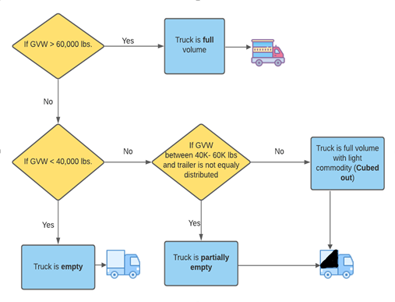Figure 22. Full/Empty Truck Determination Methodology
B) Empty Truck = Gross vehicle weight < 40,000 lbs.
In some cases, space in the trailer does not necessarily mean that the truck has an additional cargo carrying capacity. For example, some cargo cannot be mixed, or high-valuable items may not occupy the entire trailer (cost/per mile is such that additional revenue is not necessary, or allowable given time constraints). In addition, some cargo must be loaded in specific ways not to touch/border other cargo.
In the trucking industry, it is a common practice to push the cargo forward within the box trailer in turn reflecting the greater weight on axel 3 compared to axel 4 and other axels. It is believed that this loading practice improves vehicle stability and safety and allows room for shippers to add additional loads per trip. Accepting this industry practice, we conducted an axle weight load distribution analysis to determine whether a truck with gross vehicle weight between 40,000 lbs. and 60,000 lbs. was partially empty or cubed out.
C) Partially Empty = Unequal Trailer Weight Distribution à If > 5% weight difference (between axles 3 & 4 of a 5-axle vehicle) à Available capacity for additional cargo
A greater than 5% weight difference between axles 3 and 4 of a 5-axle truck, indicates that the truck is carrying a greater load on axle 3 compared to axle 4. By focusing on weight distribution between axle 3 and axle 4, it can be assumed that there is significant space still available for cargo.
D) Cubed Out (Full) = Equal Trailer Weight Distribution à If < 5% weight difference (between axles 3 & 4 of a 5-axle vehicle) à No available capacity.
These trucks might be full by volume but are light by weight. They are identified using the assumption that the weight distribution of the “Lightweight but full” truck follow a similar distribution to “Full weight” trucks. For example, if a truck weighs 50,000 lbs. but the weight distribution is equal over axles 3 & 4, then it can be assumed that the trip is “lightweight but full”, or “cubed out”.
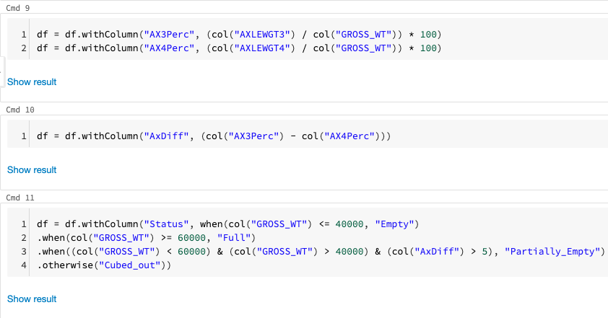Figure 23. Snapshot of the Software Code Developed and Used for Methodology
Figure 23 shows a snippet of Spark code that the research team implemented for analyzing the empty backhauling percentage of various counties.

3.3 Data Analysis Results and Findings

This section includes the results obtained from the previous section, such as empty backhauling percentages for various counties in the state on different interstate highways, through various visualizations and tables.

3.3.1 Findings and Maps
This section provides the details of the analysis. The final dataset was formed after merging data files from the years 2018 and 2019. As mentioned previously, raw data were filtered to reflect only the WIM stations on interstate highways. It was also filtered to include only FHWA classes 8 and 9. The gross weight of each record was analyzed, and bins were created to understand the distribution of weights for Class 8 and 9 trucks across the sites. The percentage of weight distribution over axles was calculated to help identify the uniformly distributed trucks. Statistical distribution analysis was conducted to compare the axle weights between axles 3 and 4.
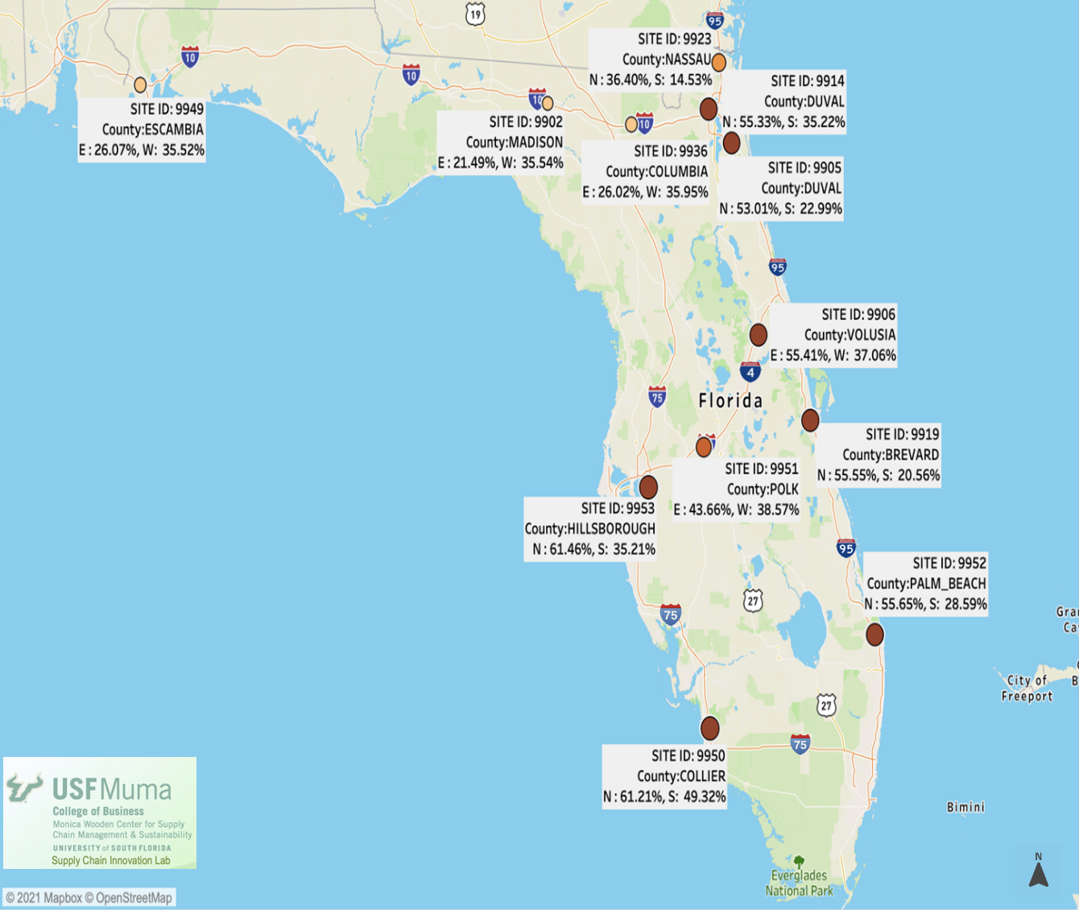
Figure 24. Empty Truck Percentages by Direction on WIM Sites Located on Interstate Highways

Figure 24 shows the empty truck percentages for freight coming in and going out of the state in terms of the weight of the commodity for the years 2018 and 2019. We can observe that compared to the empty trucks entering the state, the percentage of empty trucks leaving the state is significantly higher. A similar trend can be observed in the WIM stations near the border.
This can be further investigated and confirmed by looking at the percentage of full trucks leaving and entering the state during 2018 and 2019. Empty and full truck percentages by the direction of travel for all the site ids are given in Appendix D.

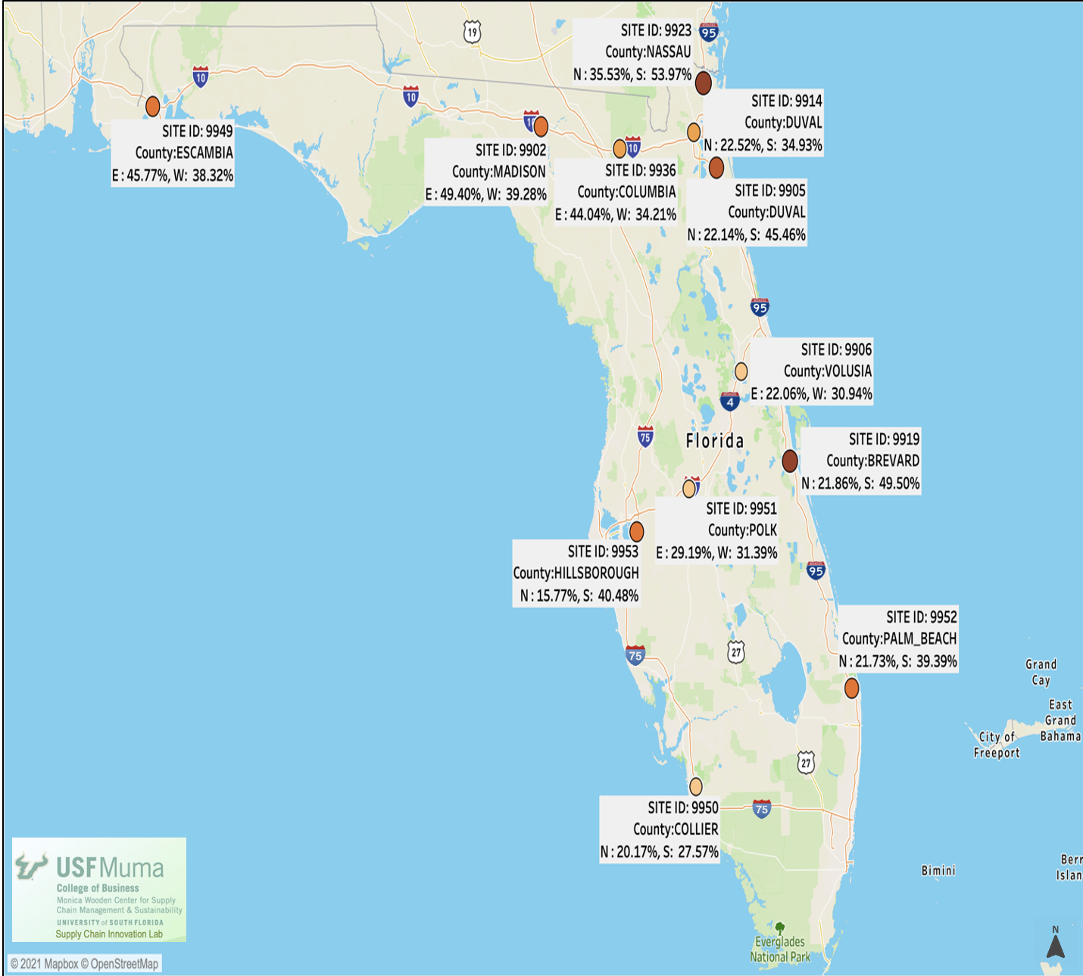
Figure 25. Full Truck Percentages by Direction on WIM Sites Located on Interstate Highways
Figure 25 shows the percentage of full trucks leaving and entering the state. It can be observed that the percentage of full trucks entering the state is higher than the full trucks leaving the state. This together with the empty backhauling percentages, also confirms the trade imbalance and the empty backhauling in Florida for the years 2018 and 2019. More than half (50+ %) of the trucks coming into the state between the years of 2018 and 2019 are full trucks in comparison to nearly 40% that left the state during the same period.
Once the full and empty trucks were identified, what remains are partially empty and cubed out trucks. Figures 26 and 27 show the percentages of trucks that are partially empty and cubed out, respectively.
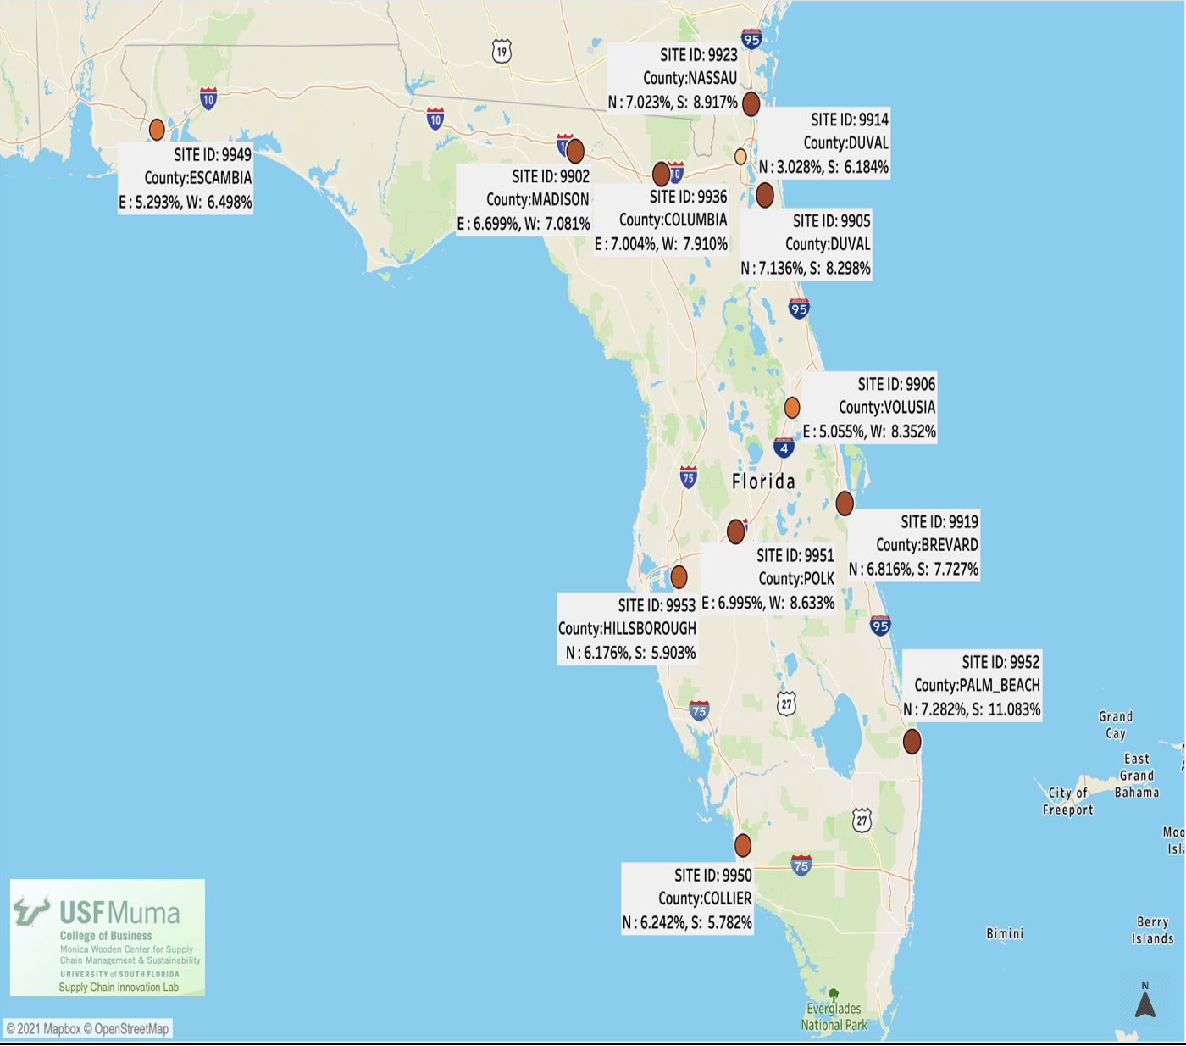
Figure 26. Partially Empty Truck Percentages by Direction on WIM Sites Located on
Interstate Highways
The cubed-out trucks make up nearly 21% of all truck traffic at most sites. These can be potentially incorrectly classified as partially empty due to their lighter gross vehicle weights, yet no additional capacity is available for cargo. It is important to recognize this classification of trucks while quantifying empty backhauls. Partially empty trucks make up nearly 8% of all trucks at most sites.
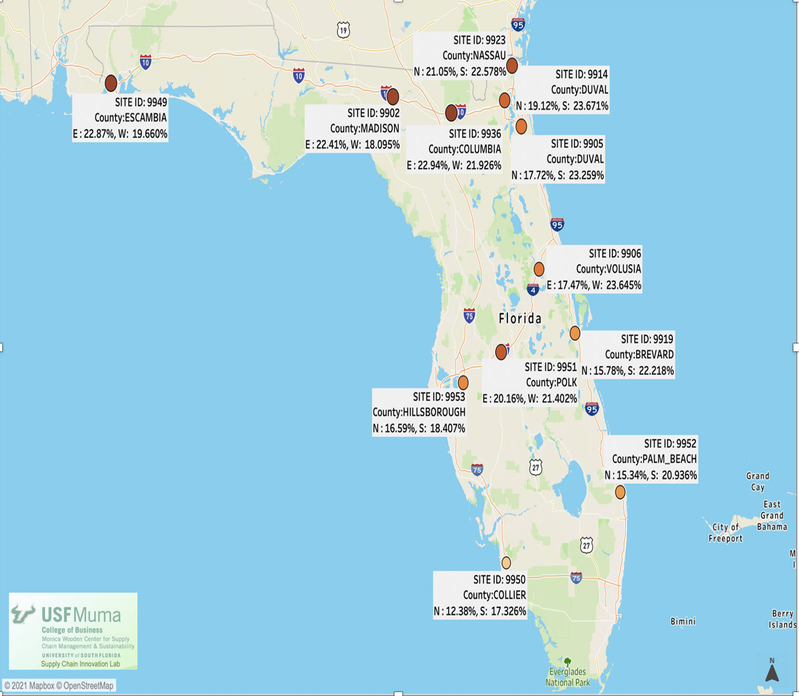
Figure 27. Cubed Out Truck Percentages by Direction on WIM Sites Located on
Interstate Highways

Since the data included a time variable, the research team also analyzed it with respect to time, to check whether there is any seasonality in it. For this analysis, data were split into months and average empty backhauling percentages were plotted for every month of 2018 and 2019. As shown in Figure 28 of all the empty trucks through the site id 9923 which belongs to Nassau County on I-95, approximately 70% of them were traveling in the north direction i.e., leaving Florida and approximately 30% of them were traveling in the south direction, i.e., entering Florida in January. We can observe the seasonality in the data by looking at all the other charts for all the site ids. This tells us that empty backhauling is usually high during the beginning of the year and the onset of summer. Appendix E includes figures showing similar trends for all other counties/WIM sites located on interstate highways.
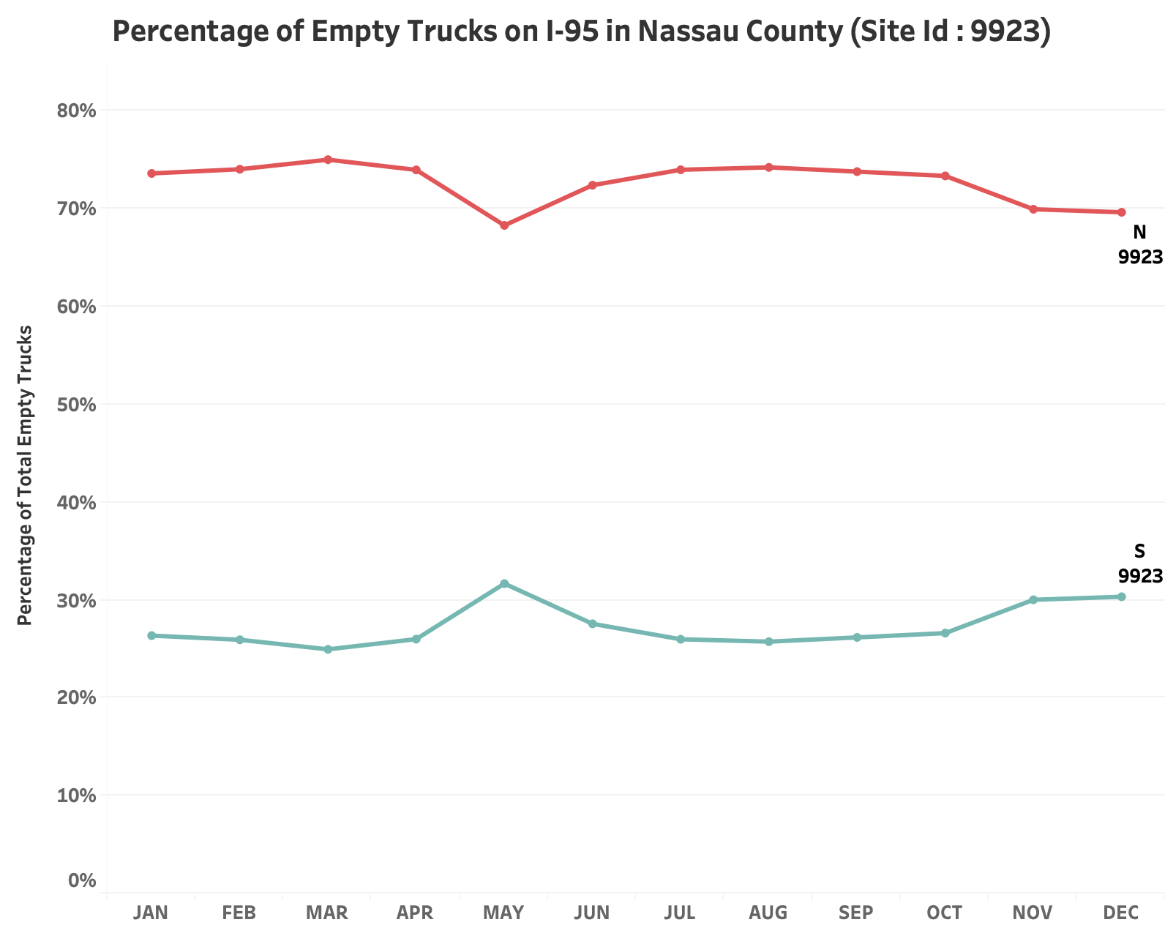
Figure 28. Percentage of Empty Trucks by Month and Direction in Nassau County
(WIM Site Id 9923) on I-95
We can observe the same trend in Figure 29 for Madison County for FHWA Class 8 and 9 trucks on I-10. About 65% of the empty trucks through the site id 9902 are traveling West, i.e., leaving the state, and about 35% of the empty trucks are traveling East, i.e., entering the state. The research team also observed that empty backhauling percentages are usually high during the beginning of the year.
To note, the chart for Hillsborough County, on I-75, shows a contradictory trend. We can see from Figure E12 in Appendix E that the percentage of empty trucks going in the South direction are higher than the ones going in the North direction. This is attributed to the high freight generators in that region such as Port Tampa Bay and intermodal rail yards. The freight received through these generators, needs to be distributed to both north and south Florida regions.
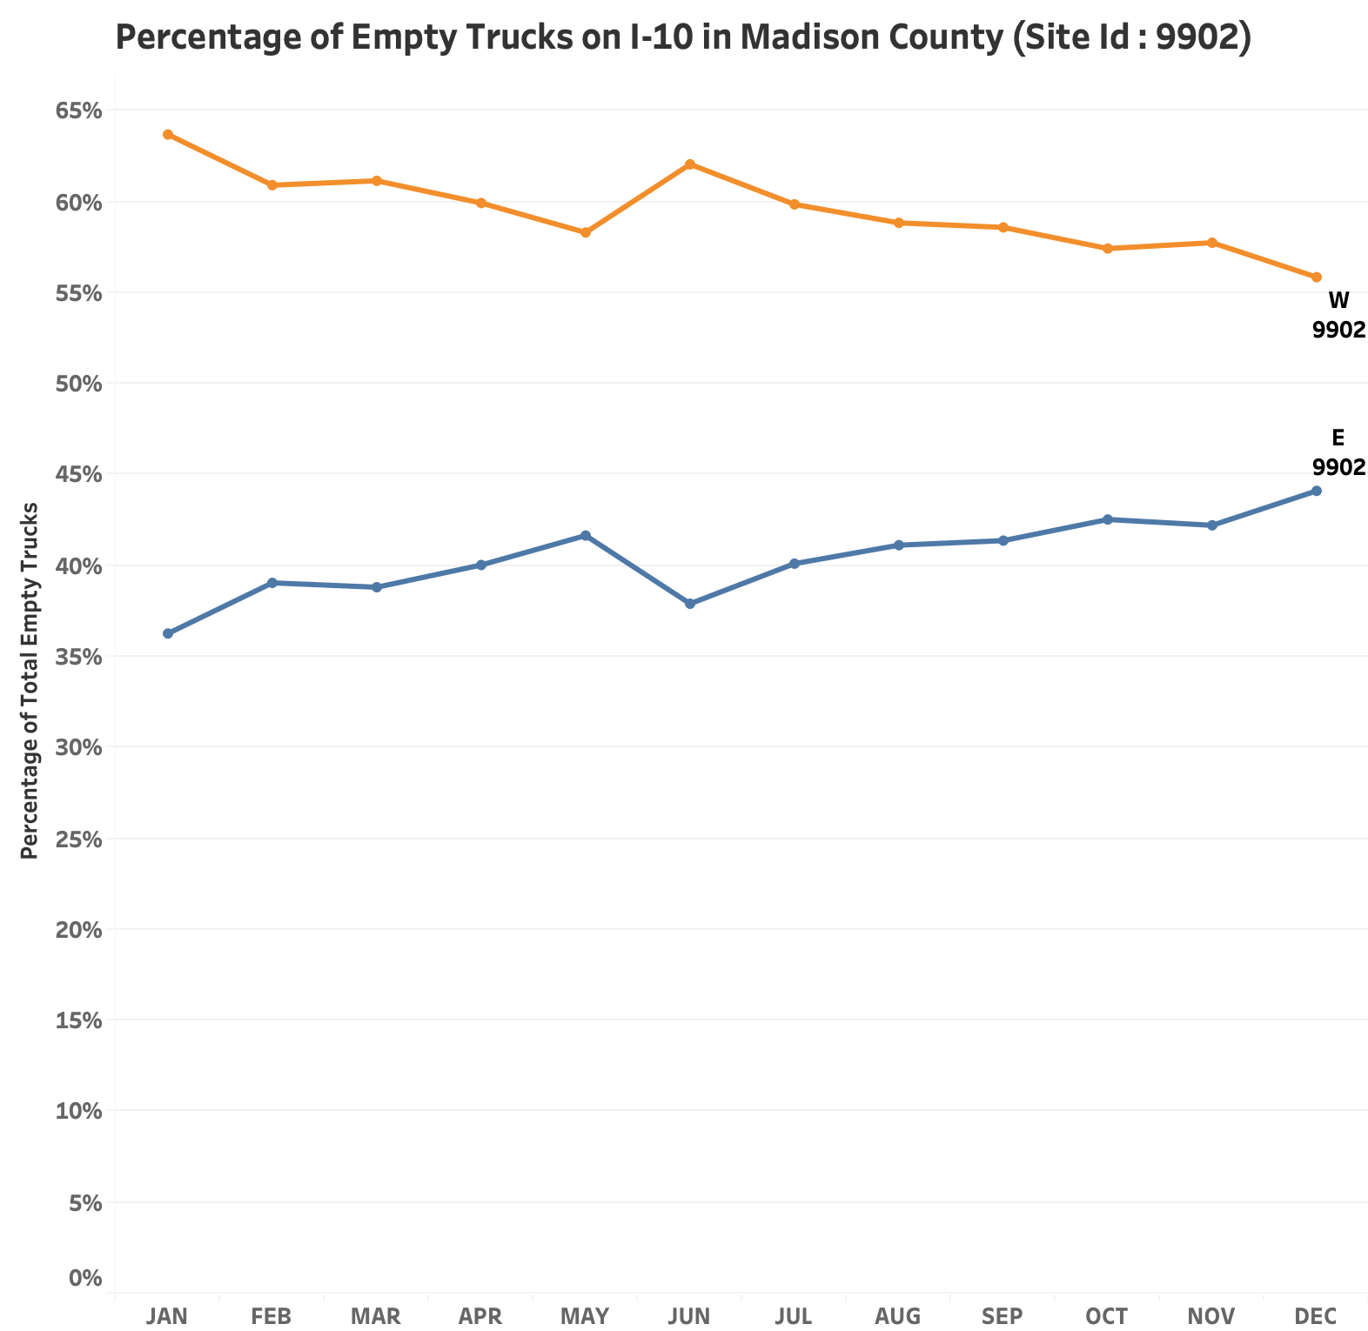
Figure 29. Percentage of Empty trucks by Month and Direction in Madison County
(WIM Site Id 9902) on I-10
The percentage of empty trucks were also analyzed by time of the day. The primary intention of this analysis was to determine which hour of the day had higher percentages of empty trucks flowing through Florida. Figures 30 through 32 depict the 2-year (2018 and 2019) average percentage of empty trucks by the hour of the day as observed on the three sites near the state line, on I-10 in Madison County, on I-75 in Collier County, and I-95 in Nassau County, respectively. It was observed that the percentage of empty trucks increases during the middle of the day as compared to hours in the night. This finding is consistent with the industry knowledge and empty backhaul movements in other parts of the country. Appendix F includes these time-of-day figures for all other sites.
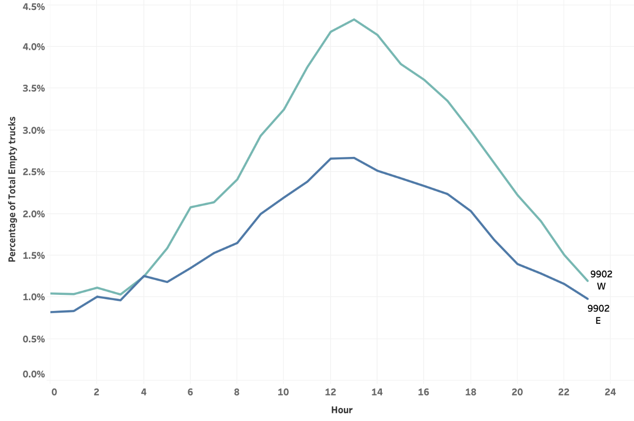
Figure 30. Percentage of Empty Trucks by the Hour of the Day and Direction in Madison County (WIM Site Id 9902) on I-10
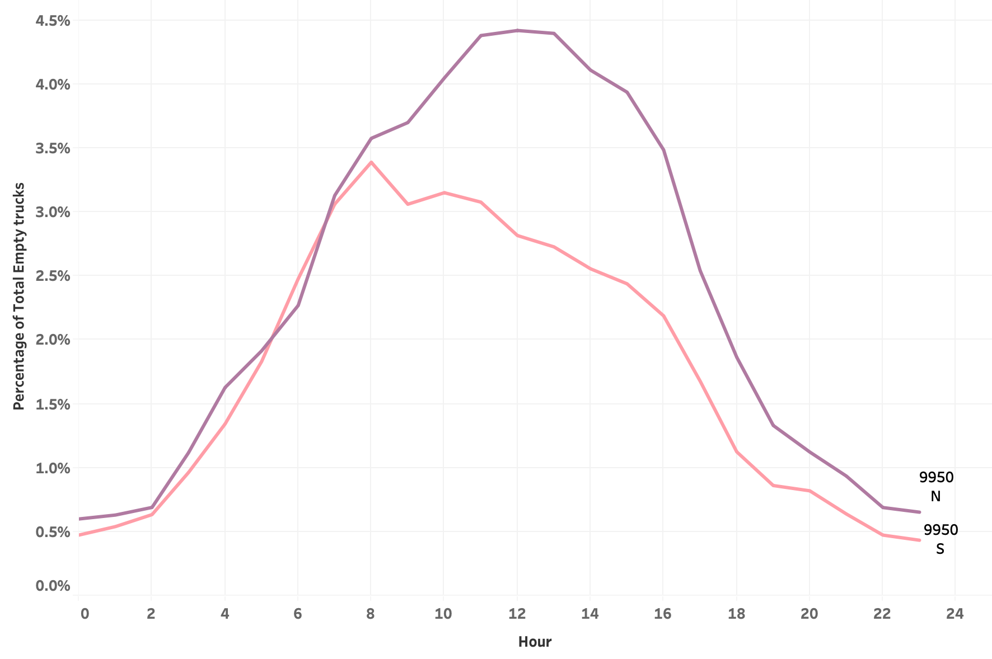
Figure 31. Percentage of Empty Trucks by the Hour of the Day and Direction in Collier County (WIM Site Id 9950) on I-75
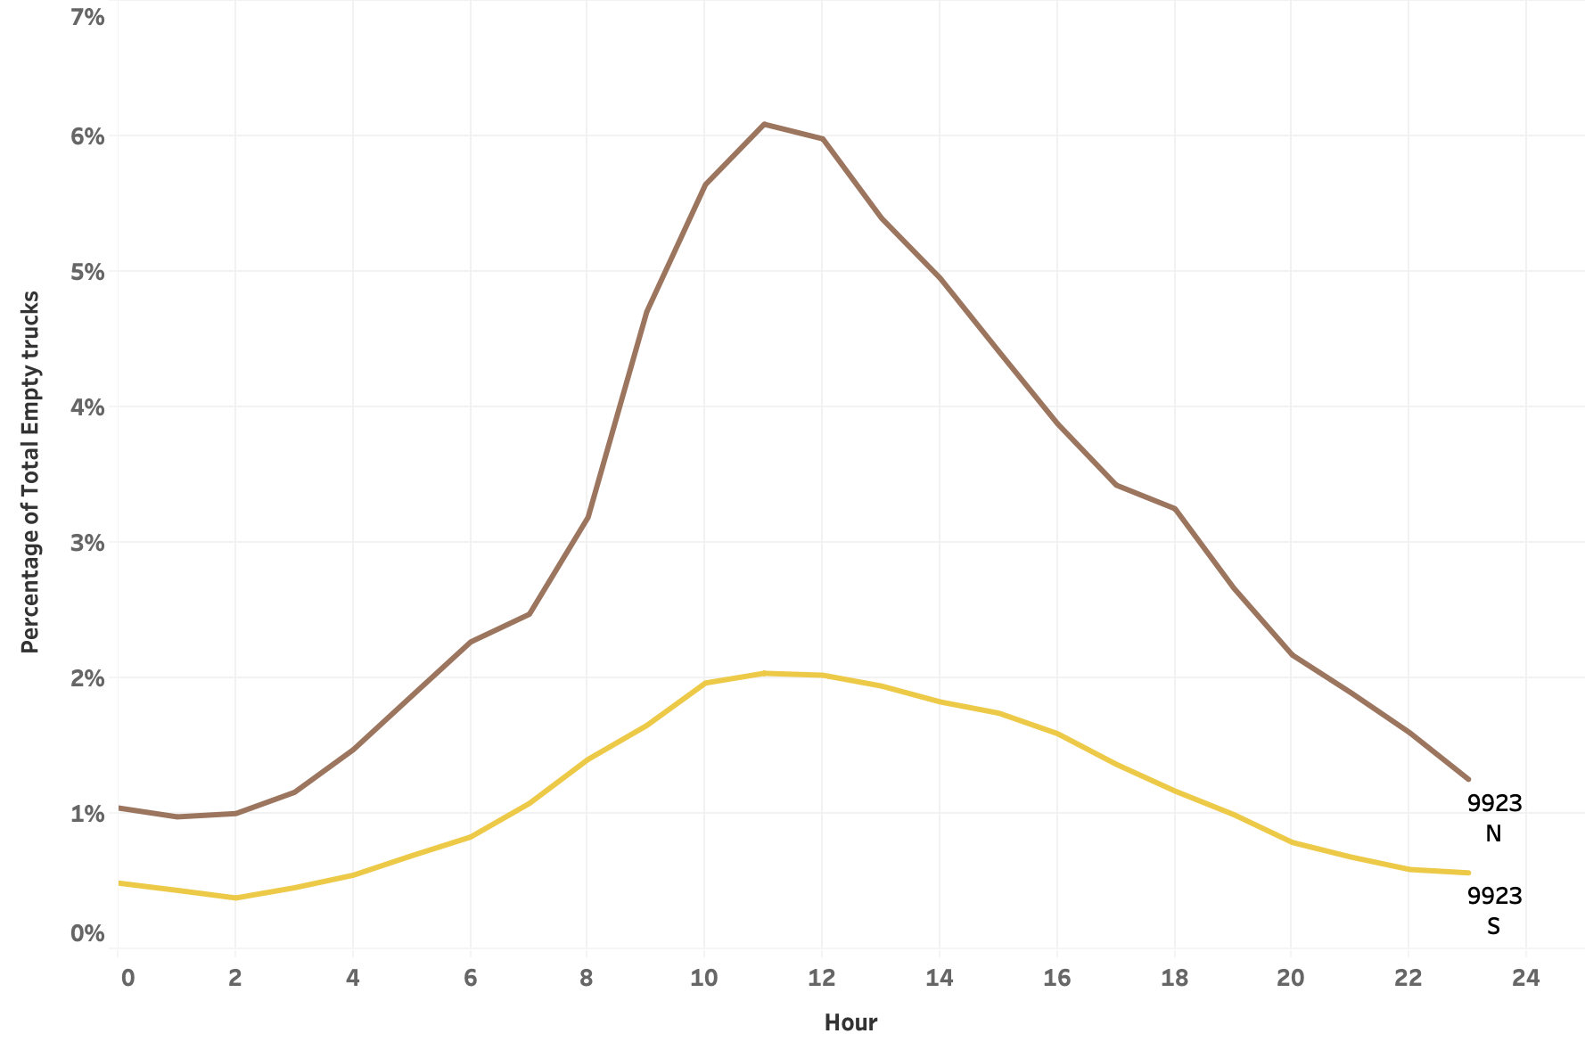
Figure 32. Percentage of Empty Trucks by the Hour of the Day and Direction in Nassau County (WIM Site Id 9923) on I-95

3.3.2 Empty Backhauling Percentages by Selected Counties
The research team analyzed data for 12 major site ids on three interstate highways as previously described. These site ids were located in various counties across Florida. Using this information, we checked which counties, using these 12 locations, had the highest backhauling percentages. The results can be used to get a fair idea as these WIM stations are located on the interstate highways and major long-haul freight transportation happen through these highways. We can see from Figure 33 (the darker the marker color, the higher the empty backhauling percentage) that Collier, Hillsborough, and Palm Beach have comparatively higher percentages of empty backhauling with respect to counties Madison, Columbia, and Nassau, which lie near the border.
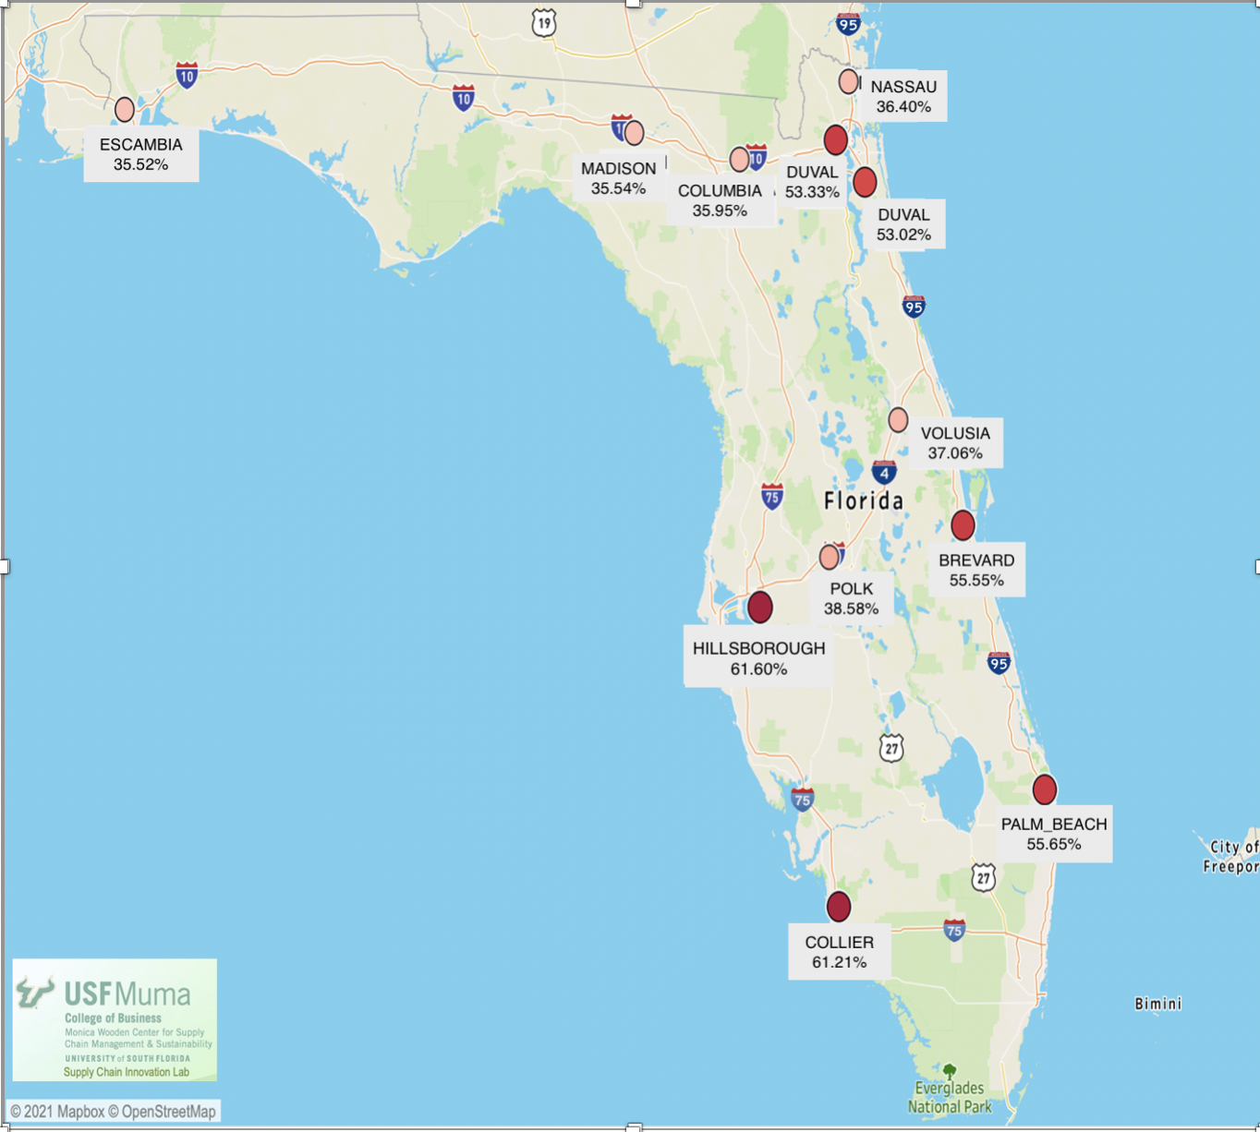
Figure 33. Empty Backhauling Percentages in Various Counties in Florida

4. Future Potential Manufacturing Impact on Empty Backhauling Percentage

The research team analyzed the skilled work force data corresponding to the major industries and counties by Enterprise Florida for the years 2018-2019 (some additional data for 2020 and 2021 were also used upon availability) and also determined the future manufacturing potential through skilled work force availability and potential to compare future significance of change to empty backhauls balance.

4.1 Data Collection and Cleaning for Skilled Work Force and Manufacturing in Florida

The skilled work force dataset contains the record of skilled workforce in Florida for counties with highest empty backhauling and counties with high freight activity. The dataset includes total labor force, total employment, unemployment, and the average annual wages with respect to individual counties. In this analytical study, the research team used the latest available skilled work force data from the years 2019 through 2021, from the Florida Department of Economic Opportunity (Figure 34).

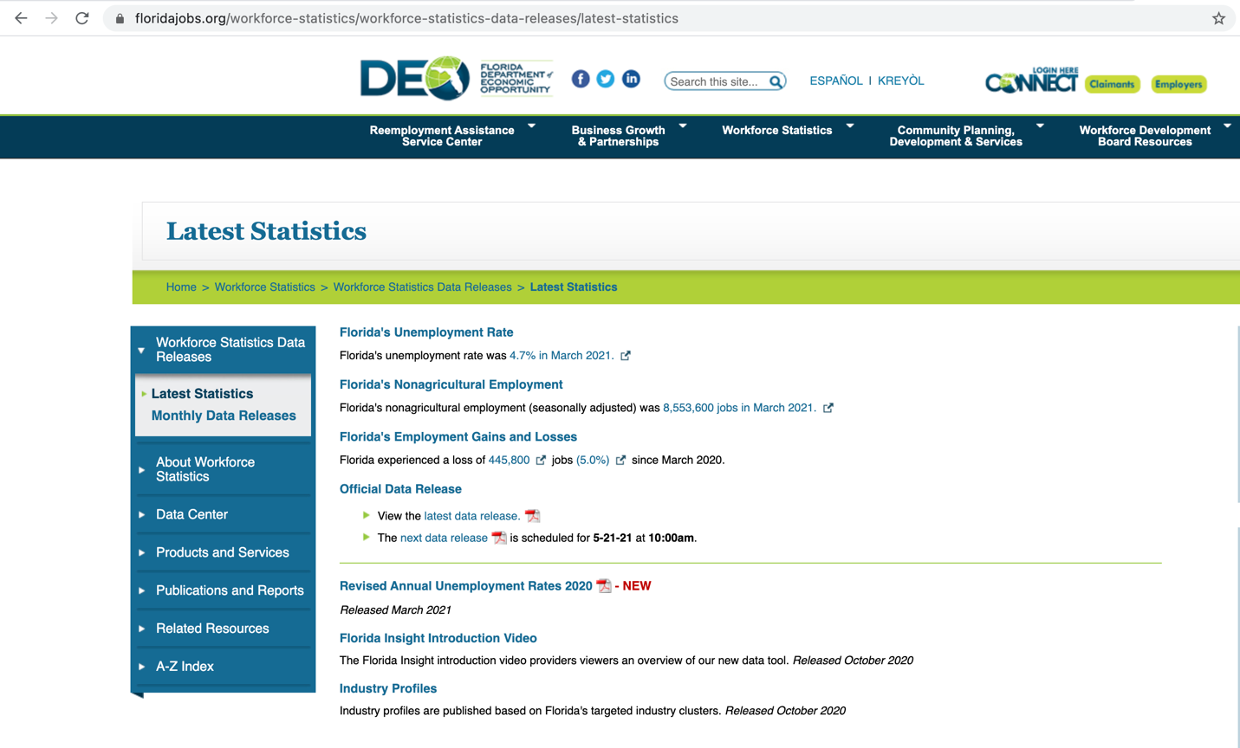
Figure 34. Screenshot of Florida Department of Economic Opportunity Website

Granularity and Quality of the Skilled Work Force Dataset: Granularity is the level of detail at which data are stored in a database. The skilled work force dataset has the count of skilled workforce at the county level with employment and unemployment count. The wage per county raw data was supplied as average wage per week, which was used to calculate the annual average wage with respect to each county.

Also, we performed validation and cross-references to ensure that data are valid and reasonable. This helped ensure the research team achieve accurate results and conclusions.

The research team also worked on collecting the data of manufacturing industries for the counties with highest empty backhauling percentage and high freight activities. The data collected was by geographic region including the counties with highest empty backhauling. This data was used to determine the emerging and existing manufacturing subsectors in these 14 counties mapped to the geographic regions that could have a positive impact on the reduction of empty backhauling. The research team referred to the Florida-Makes website for manufacturing industries data (Appendix G). Table 2 shows the mapping of selected counties to the respective geographic region. Following are the eight Florida specific geographic regions used in this study:

- Central Florida Manufacturing Sector
- First Coast Manufacturing Sector
- Gainesville Manufacturing Sector
- Northwest Florida and Capital Region Manufacturing Sector
- South Florida Manufacturing Sector
- Southwest Regional Manufacturing Sector
- Volusia Manufacturing Sector
- West Central Gulf Coast Manufacturing Sector
Table 2. Selected Florida Counties Mapping to Respective Geographic Manufacturing Sectors
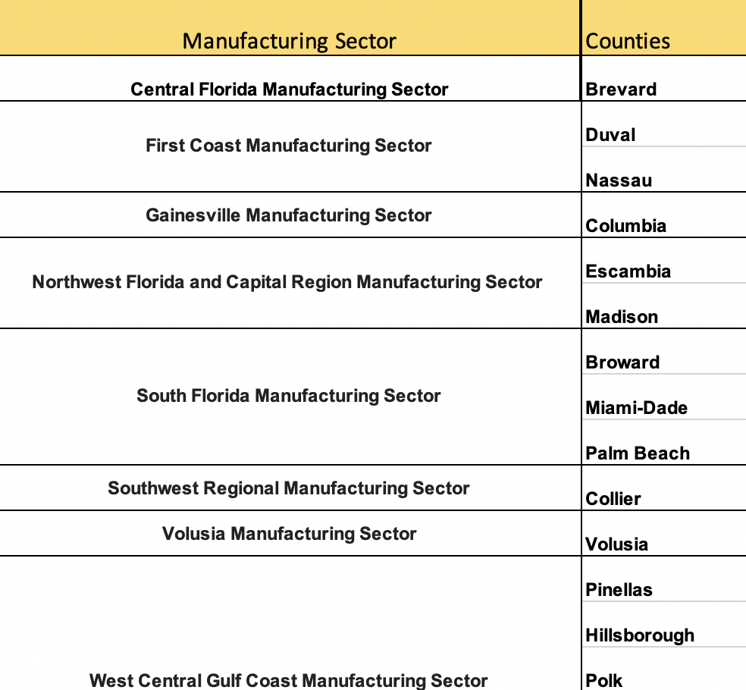

4.2 Analysis Methodology for Skilled Work Force and Manufacturing in Florida

This subsection describes the methodologies adopted for the data analysis. For analysis we used three datasets.
- Skilled work force data collection by selected counties
- Skilled work force data collection by manufacturing industries
- Florida manufacturing industries data collection by geographic region and selected counties and its overview

The first data set was used to analyze the skilled work force by the select counties with highest empty backhauling percentage. The second data set was used to analyze the skilled work force for different manufacturing sectors and using the findings from these two datasets along with the third dataset the research team analyzed different manufacturing industries in the before mentioned 14 counties. The team analyzed the top high-performing manufacturing sectors in Florida that outperformed the United States and represented an above-average share of the region’s economy along with high performing emerging manufacturing sectors, which performed better as compared with national employment growth in those sectors. We also considered the traditionally important legacy manufacturing industries, which has above-average shares of economic activity in the region.

Figure 35 depicts the methodology for the categorization of manufacturing sectors. Two main factors that were used to identify the type of manufacturing subsectors are Location Quotient (LQ) and Compound Annual Growth Rate (CARG). If the subsector employment LQ value is greater than 1.0, and the employment CAGR was greater than the subsector’s employment CAGR for the United States in the same period then the subsector belongs to “High- Performing” subsector. “Emerging” subsectors are the ones which have LQ values less than 1.0, but their employment CAGR was greater than the subsector’s employment CAGR for the United States during the same period. Lastly the “Legacy” subsectors have LQ values greater than 1.0, but their employment CAGR less than the subsector’s employment CAGR for the United States in the same period.
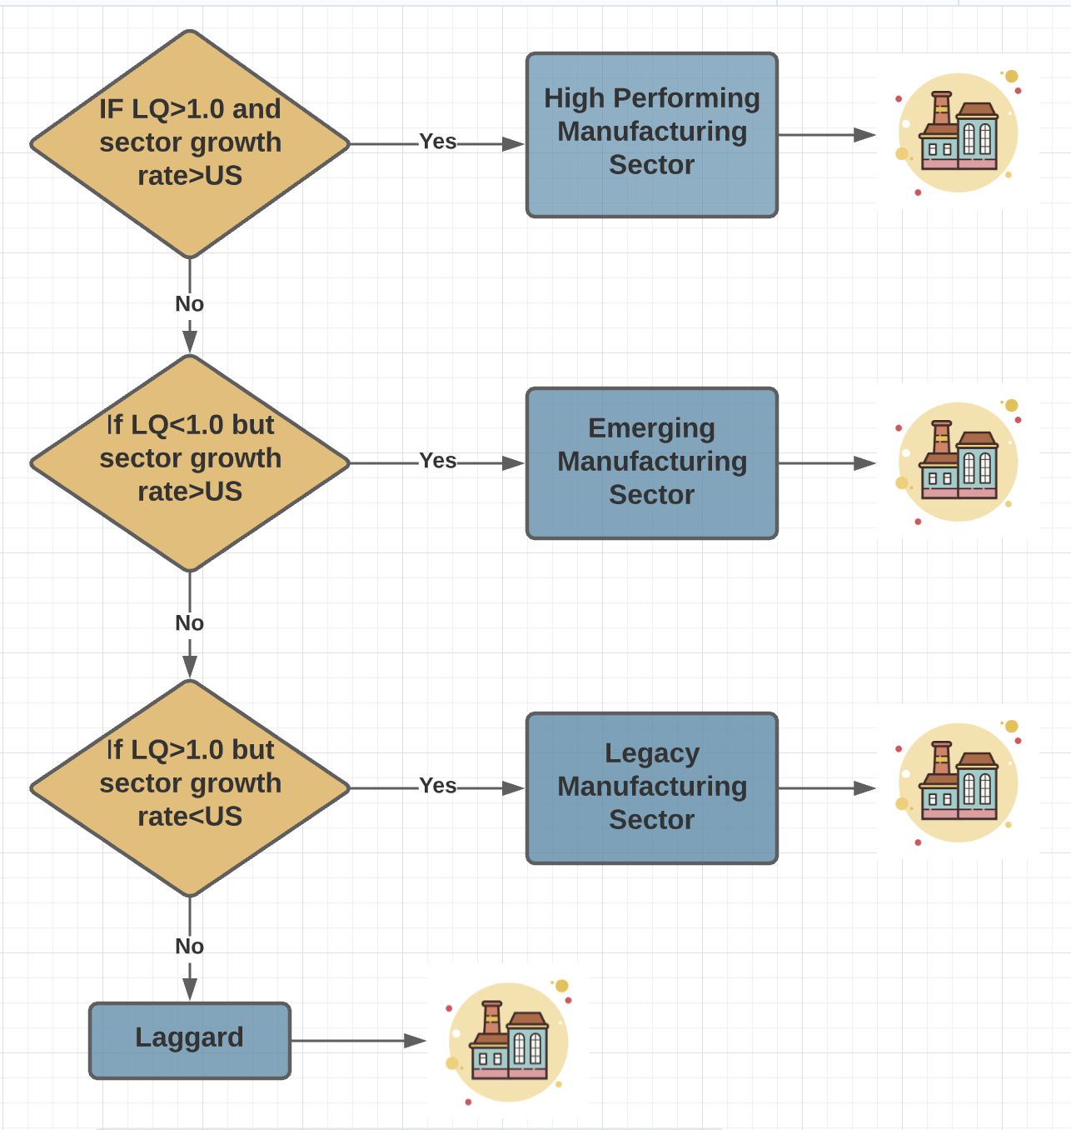
Figure 35. Manufacturing Sector Categorization Flowchart

where,

- LQ– Location Quotient
- Sector growth rate- It is the sector’s compound annual Growth rate

4.3 Skilled Work Force and Manufacturing Results and Findings

This subsection includes the results obtained from the analysis, such as potential manufacturing industries for various counties in Florida.

4.3.1 Findings and Maps

From Section 2 of this research project, we analyzed the counties with the highest empty backhauling percentage. The counties such as Collier, Hillsborough, and Palm Beach has the highest percentages of empty backhauling compared to other counties in Florida. It is important to determine the future manufacturing potential through skilled work force availability to reduce the empty backhauling and maintain the balance. According to the information provided by Enterprise Florida, the state is home to over 20,200 manufacturing companies that employ more than 371,000 workers with average annual manufacturing sector wages of $63,870. Florida has advanced manufacturing industries, which are diverse and include sectors producing intermediate and finished products ranging from plastics to motor vehicles. Miami-Dade manufacturing employment totaled over 41,000 jobs. Orange, and Pinellas counties contributed over 30,000 jobs each, while Hillsborough, Broward, Brevard, Duval, and Palm Beach counties contributed over 20,000 jobs each. Together, these seven counties accounted for 63.9% of Florida manufacturing jobs. Manufacturers including Jabil, Siemens and Nucor, choose Florida for their pro-business policies, strong workforce and access to domestic and global markets. These strong industry assets have great potential and help manufacturing businesses develop in Florida. Figure 36 shows the manufacturing sectors in Florida.
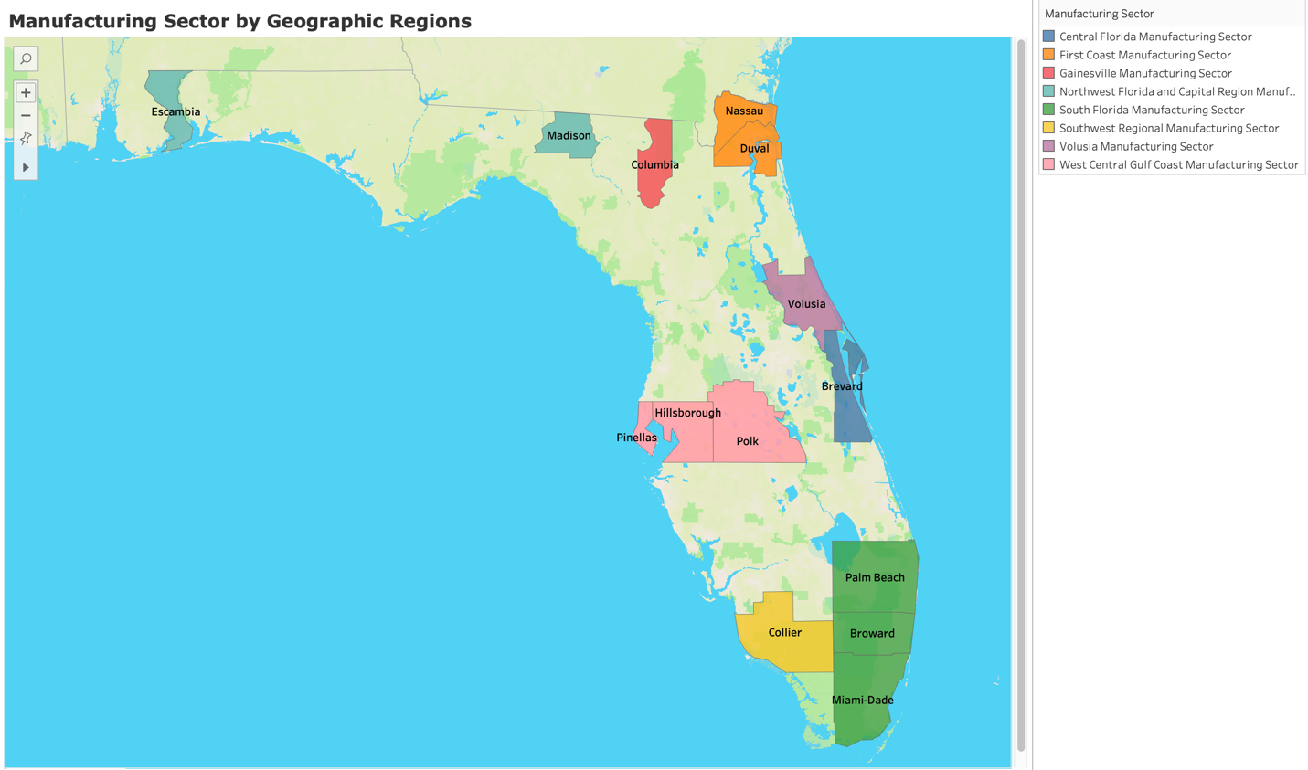
Figure 36. Manufacturing Sectors in Florida by Geographic Region and Counties
The three major reasons why Florida is an ideal location for manufacturing businesses, were determined to be skilled workforce, tax advantages, and robust infrastructure.

Skilled workforce: Florida is home to more than 10 million overall workers statewide, including 371,000 professional workers, who are employed in various manufacturing sectors. The availability of this exceptional labor force enhances Florida’s attractiveness as one of the best locations for manufacturing businesses. Florida also provides low unionization rates for private sector manufacturing. Figures 37 and 38 show total workforce numbers by the 14 Florida counties with highest empty backhauling and high freight activity. It should be noted that both Miami-Dade and Broward Counties have more than a 1 million worker work force. There has been an overall increase in the labor force since April 2020 for all of the previously mentioned 14 counties in the last few years since 2019. That said, initially COVID-19 had its impact on Labor force and lead to reduction of skilled labor force from December 2019 to April 2020. Figure 37 and Appendix H show the graphical representation of variation in labor force for all of the 14 counties.

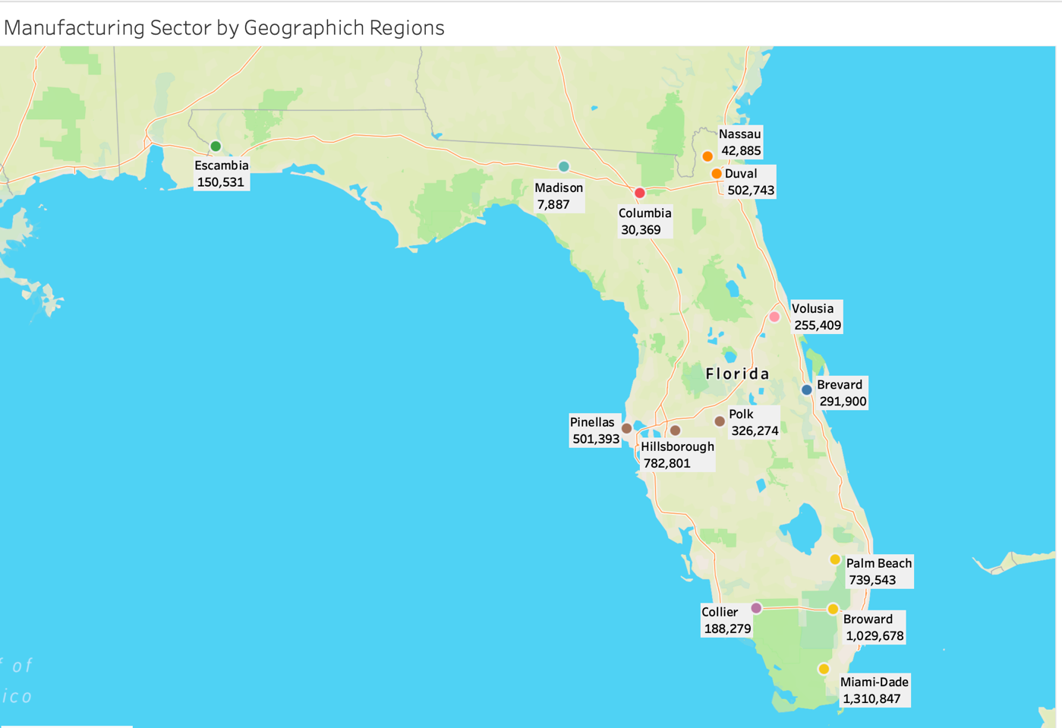
Figure 37. Total Work Force in Selected 14 Countries in Florida

Figure 38. Total Workforce with Respect to Selected 14 Counties in Florida

Robust Infrastructure: Florida has an extensive multi-modal transportation system supplying great accessibility to move goods anywhere across the state and into other parts of the United States. Florida has more than 100 airports, 3,000 miles of rail tracks, 15 deep-water seaports within 90 miles of any business in Florida and over 122,000 miles of highways.

Tax Advantages: Known for its industry-specific tax advantages, as well as no personal state income tax, Florida ranks as the No. 4 best state business tax climate according to the Tax Foundation. Specific to manufacturing, Florida offers special sales and use tax exemptions for the aviation and aerospace industry, including commercial space activity, manufacturing equipment and aircraft parts, modification, maintenance, and repair.

Quality of Life: There are countless reasons why Florida provides one of the highest qualities of life compared to other states. With great weather, recreation, and culture along with affordable cost of living, Florida is an ideal location. This makes it clear why Florida’s quality of life is an attractive asset. Florida is one of the most desirable and affordable places to live because of low tax environment, plentiful modern amenities, and quality public services.

4.3.2 Major Manufacturing Sector by Selected Geographic Region and Counties

The research team analyzed the future manufacturing potential that will create more outbound freight and thus reduce empty backhaul movements in the 14 counties with highest empty backhauling. These counties are divided into the previously mentioned geographical regions as highlighted in this subsection.

West Central Gulf Coast Manufacturing Sector

The counties with highest empty backhauling that are the part of West Central Gulf Coast region are Hillsborough, Pinellas, and Polk. The major city in the WCGC regional economy is Tampa. The labor market in the West Central Gulf Coast region is considerably tighter than at either the state or the national level. Hillsborough has a total labor force of 745,455 and Pinellas and Polk have the labor force of 488,857 and 308,560, respectively (as of December 2020).

The WCGC region has a diverse economy for a metropolitan region of its size, with its level of industrial diversity just above that of the statewide economy overall. With almost 50% of its manufacturing industry employment in advanced manufacturing subsectors, (a share greater than is seen in the United States overall), the WCGC region has significant opportunities for manufacturing sector innovation (i.e., creation of new patents) and productivity growth. It can also expect these sectors to employ more highly skilled workers and pay higher wages than other manufacturing sectors. The average annual wage per labor is $60,049 in Hillsborough County, $53,583 and $46,163 in Pinellas and Polk, respectively.

Half of the WCGC region’s manufacturing industry is composed of high-performing and emerging sectors. Table 3 shows potential manufacturing subsectors, which can have a positive impact on the reduction of empty backhauling.

Table 3. West Central Gulf Coast Region Manufacturing Subsectors
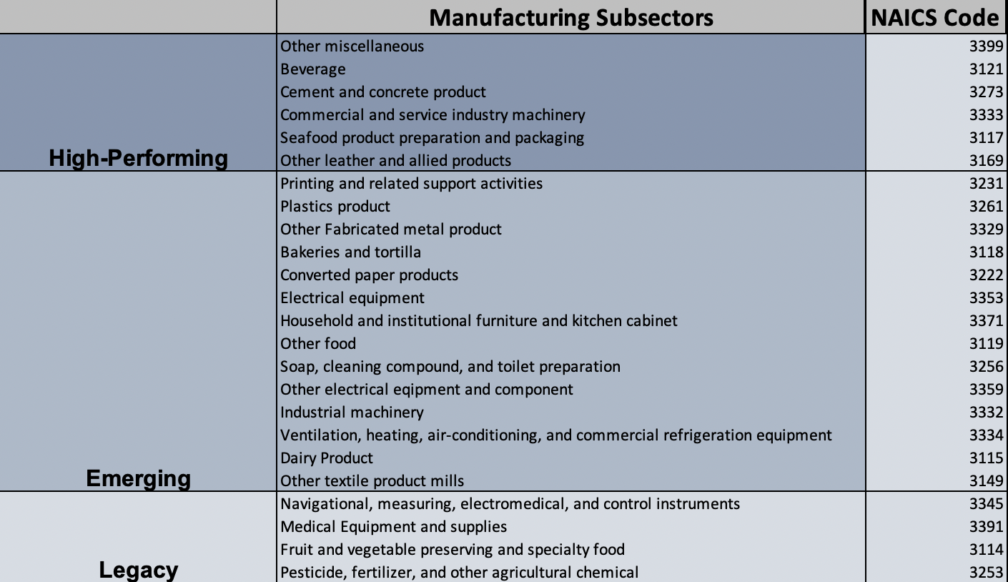
The six high-performing manufacturing subsectors currently contribute to 14.8% of total manufacturing employment in the West Central Gulf Coast region. The emerging manufacturing sectors indicate positive employment growth potential, as well as the potential to reduce empty backhauling in future. The legacy subsectors provide more than 17,800 jobs in manufacturing.

Central Florida Manufacturing Sector

Brevard County with 55.55% of empty backhauling percentage is part of the Central Florida region. With more than 290,000 work force and 278,878 current manufacturing jobs, it is a county with a much higher employment rate and annual average wages. The average annual wage is $53,901 for Brevard County. Computer and electronic products manufacturing sector are more concentrated in the Central Florida region with a high LQ value of 2.0.
Based on the Compound Annual Growth Rates (CAGRs) and Location Quotient (LQ) there are six high-performing manufacturing subsectors which performed much better than the United States and had LQ values greater than 1.
Table 4 shows the potential manufacturing subsectors in Central Florida region, which can have a positive impact on the reduction of empty backhauling.
Table 4. Central Florida Region Manufacturing Subsectors
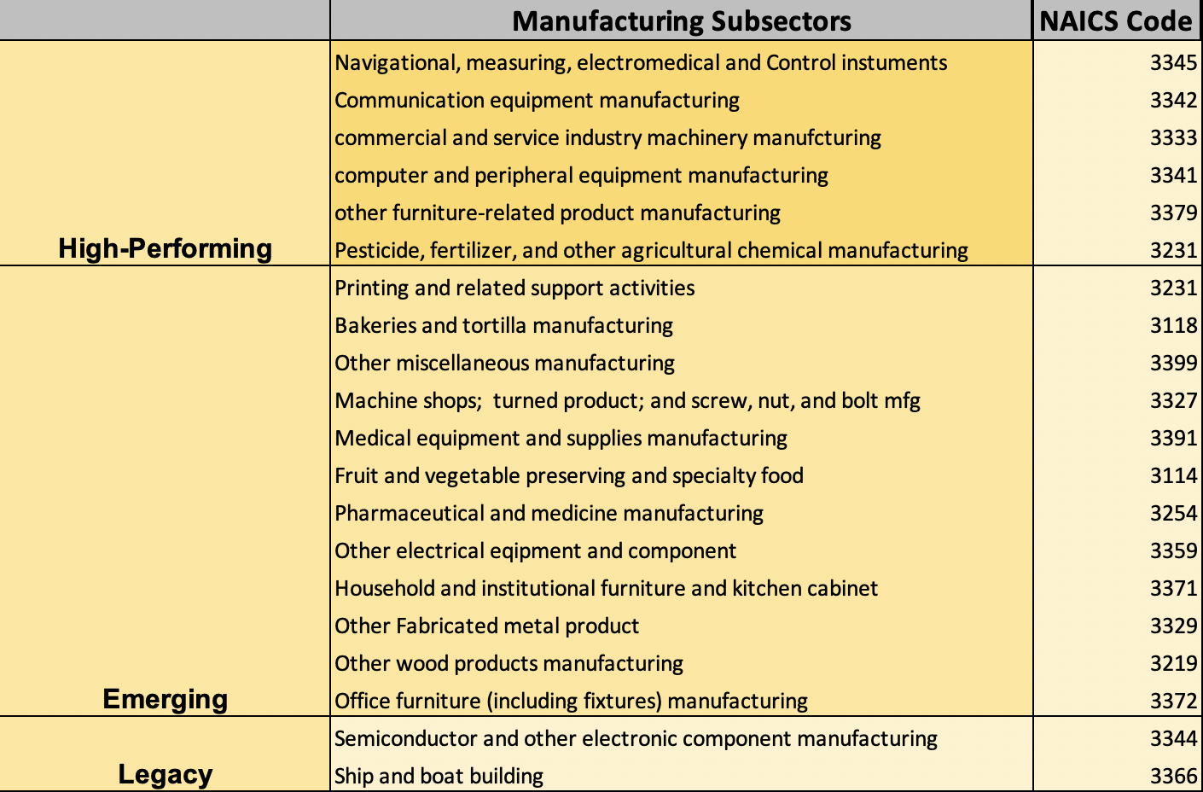

First Coast Manufacturing Sector
The First Coast region is comprised of Duval and Nassau counties. Duval has 55.33% and 53.01% empty backhauling for the WIM sites 9914 and 9905 respectively, and Nassau has 36.40% of empty backhauling. Jacksonville is the major city in the regional economy, situated within Duval County, a part of the Jacksonville, Florida, metropolitan statistical area (MSA).
Duval and Nassau have 4.8% and 3.8% unemployment rates respectively, therefore the labor market in the First Coast RMA is tighter as of April 2021 than at the national and state levels, where the unemployment rates were 6.1% and 4.8%, respectively as of April 2021. The average annual wage is $ 56,869 and $43,884 for Duval and Nassau Counties, respectively.
Table 5 shows potential manufacturing subsectors, which can have a positive impact on the reduction of empty backhauling. These potential industries include high-performing manufacturing sectors that outperformed the United States and represented an above-average share of the region’s economy (i.e., LQs values above 1.0).
Table 5. First Coast Region Manufacturing Subsectors
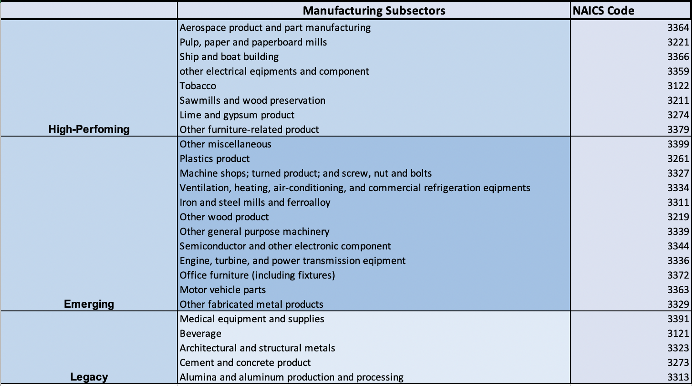

Gainesville Manufacturing Sector
The county with highest empty backhauling percentage that is part of the Gainesville region is Columbia with 35.95%. Columbia is in the Lake City, Florida micropolitan statistical area.
Columbia has an unemployment rate of 4.9%, which is a tighter labor market compared to the US level. It has a labor force of 30,369 and average annual wage of $40,810 as of April 2021, which is lower than the other counties considered for this study. This region has a relatively small portion of the region’s manufacturing sector. Miscellaneous, wood product, and machinery manufacturing currently offer the greatest number of manufacturing jobs in the region
The miscellaneous manufacturing sector, which includes the manufacture of medical equipment and supplies, office equipment, and sporting goods, grew 5.9% between 2000 and 2015 and had more than 1,850 employees in the Gainesville region in 2015. The Gainesville region hosts the global headquarters of medical equipment manufacturer Exactech, Inc. and a few manufacturing facilities.
Table 6 shows potential manufacturing subsectors which can have a positive impact on the reduction of empty backhauling. These potential industries include high-performing manufacturing sectors that outperformed the United States and represented an above-average share of the region’s economy (i.e., LQs values above 1.0).
Table 6. Gainesville Region Manufacturing Subsectors
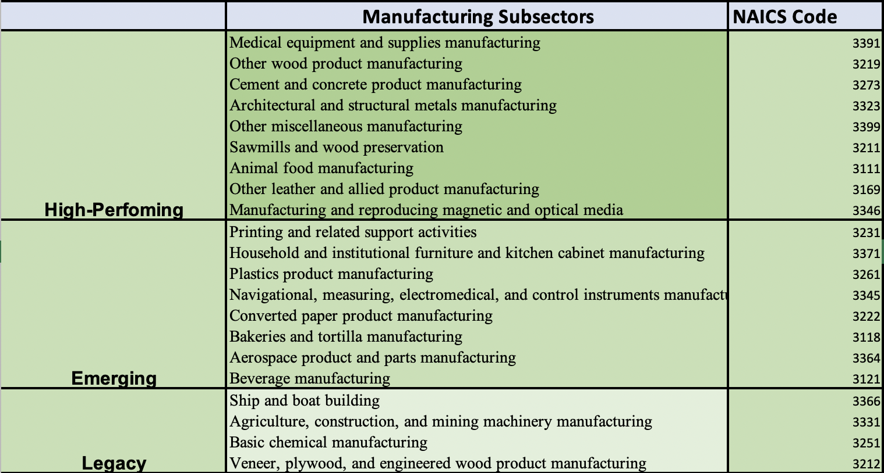ξ
The nine high-performing sectors highlighted above currently account for 61.2% of total manufacturing employment in the Gainesville region. The emerging sectors should receive special attention because while they currently account for below-average shares of economic activity, this is where growth opportunities are likely to be found and this could create more outbound freight and thus reduce empty backhaul movements.

Northwest Florida and Capital Region Manufacturing Sector
The counties with highest empty backhauling percentage representing Northwest Florida and Capital Region are Escambia and Madison with 35.52% and 35.53% of empty backhauling. Escambia has more than 150,000 labor force on the contrary Madison has a labor force of 7,887, which is the lowest among all of the 14 Florida counties with highest empty backhauling.
Escambia and Madison have unemployment rates of 4.9% and 5.6%, respectively. The transportation equipment, machinery, chemical, wood product, fabricated metal products, and nonmetallic mineral manufacturing sectors each offered more than 1,000 jobs in the region and together represent 72% of regional manufacturing industry employment as of 2016.
Table 7 represents potential manufacturing subsectors which can have a positive impact on the reduction of empty backhauling. These potential industries include high-performing manufacturing sectors that outperformed the United States and represented an above-average share of the region’s economy (i.e., had employment LQs above 1.0) and Emerging manufacturing industries along with the legacy industries.
Table 7. Northwest Florida and Capital Region Manufacturing Subsectors
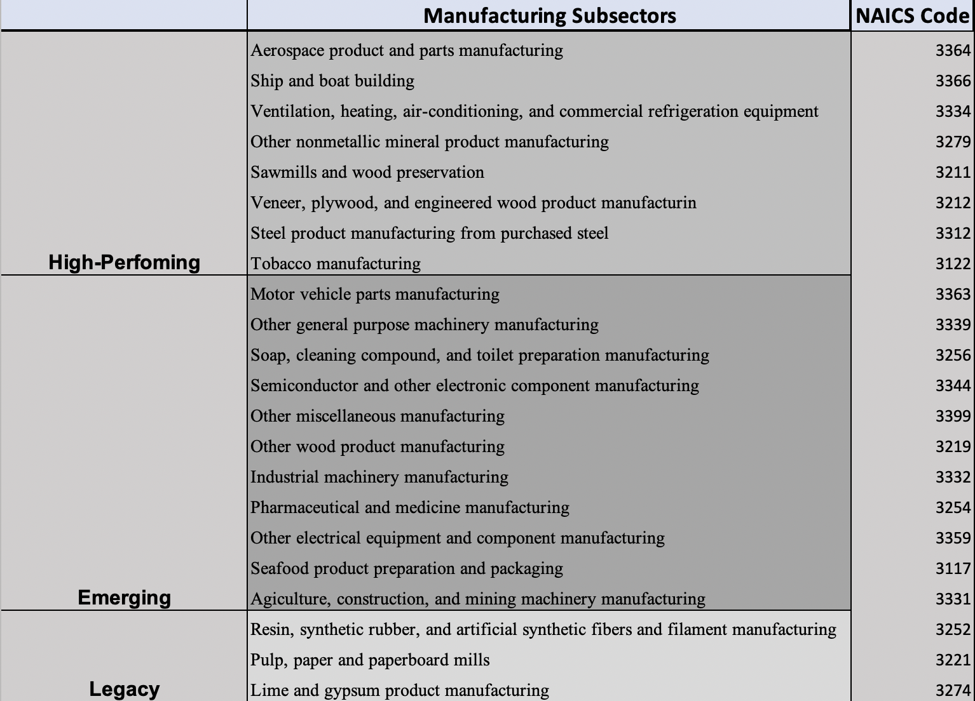
The eight high-performing sectors currently account more than 40% of total manufacturing employment in the Northwest Florida and Capital Region. The high-performing and emerging sectors represent nearly two-thirds of regional manufacturing employment. Supporting these high performing and emerging sectors would be very critical towards the goal of reducing the empty backhaul problem.

South Florida Manufacturing Sector
The South Florida Region counties with highest empty backhauling percentage and high freight activity include Palm Beach, Miami-Dade and Broward County. Palm Beach has 55.65% of empty backhauling. With more than 1.3 million total labor force, Miami-Dade manufacturing employment totaled over 41,000 in 2019. Palm Beach has 739,543 total labor force and Broward has more than 1 million labor force with high freight movements. The average annual unemployment rate in the South Florida region has been on par with the statewide rate and less than a third of a percentage point higher than the national unemployment rate.
Manufacturing sector comprises just over 100,000 jobs. The Transportation equipment, Miscellaneous, Food, Fabricated metal products, Computer and electronic product, Nonmetallic mineral, Machinery, Chemical, and Furniture and related products manufacturing sectors each provide employment to more than 5,000 workers in the South Florida region.
Table 8 represents potential manufacturing subsectors, which can have a positive impact on the reduction of empty backhauling.
Table 8. South Florida Region Manufacturing Subsectors
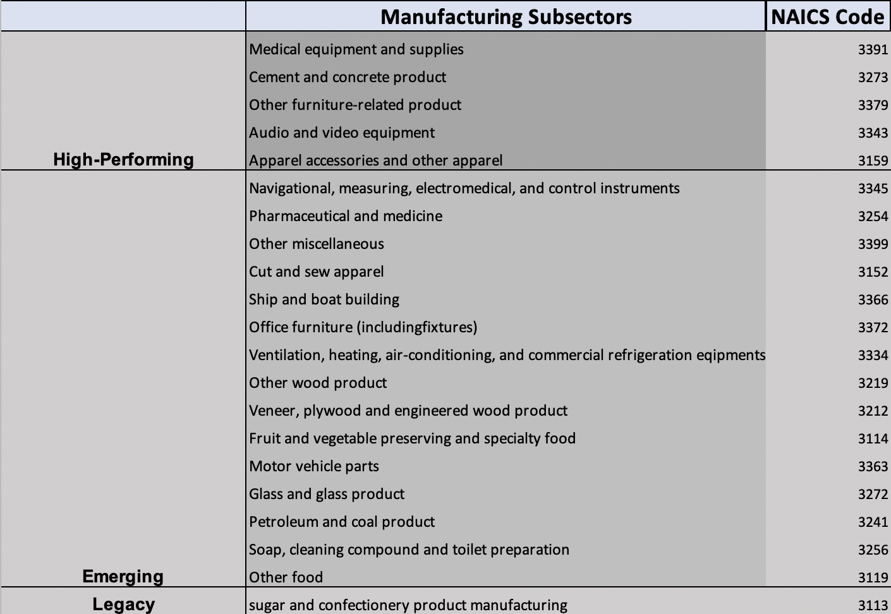

Southwest Regional Manufacturing Sector
The Southwest Florida Region count with highest empty backhauling percentage and high freight activity is Collier with 61.21% of empty backhauling. Collier recorded a 188,279-labor force and 3.8 % unemployment rate in April 2021.
The manufacturing sector provides employment to 11,000 workers and miscellaneous, nonmetallic mineral, machinery, and transportation equipment manufacturing sectors offered more than 1,000 jobs each.
There are three high-performing manufacturing sectors and many emerging manufacturing sectors in this region. Table 9 represents potential manufacturing subsectors, which can have a positive impact on the reduction of empty backhauling.
Table 9. Southern West Region Manufacturing Subsectors
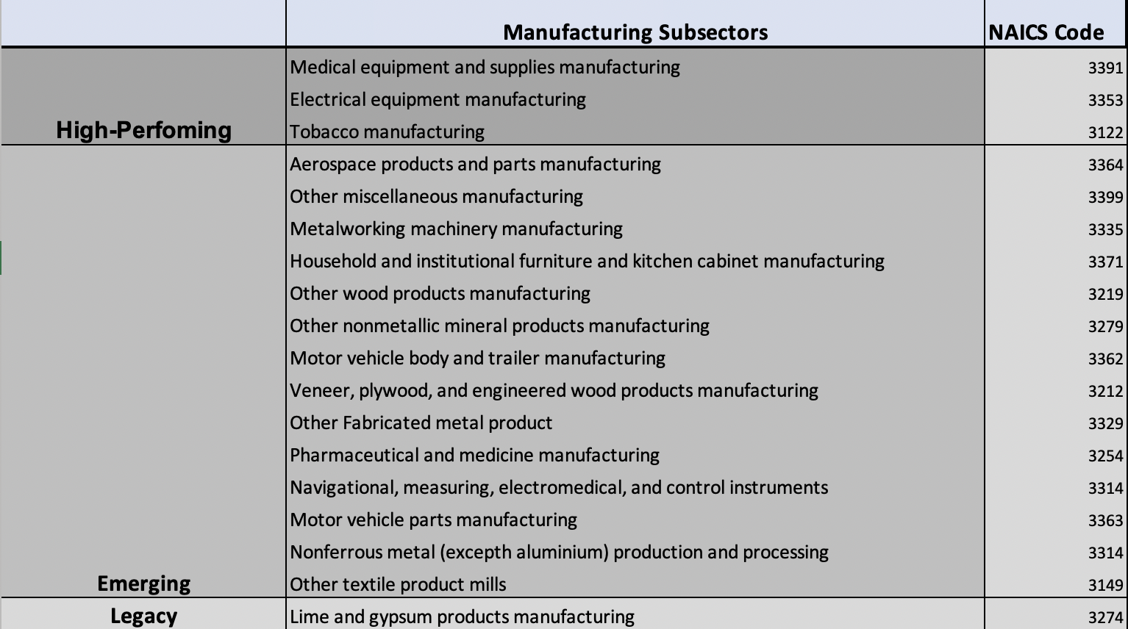

Volusia Manufacturing Sector
The Volusia region comprises Volusia County, which is situated within the Deltona-Daytona Beach-Ormond Beach, Florida metropolitan statistical area (MSA). With 255,409 labor force and 5.2 % unemployment rate, the average annual unemployment rate in the Volusia region has been higher than both the statewide and the national unemployment rates. The Volusia manufacturing sector provides employment to more than 10,000 workers.
Textile product mills have a positive employment growth rate, a higher-than-average concentration of employment, and relatively large number of jobs. More than 70% of the Volusia’s manufacturing industry is comprised of high-performing and emerging sectors.
Table 10 illustrates Volusia’s potential manufacturing subsectors, which can have a positive impact on the reduction of empty backhauling.
Table 10. Volusia Region Manufacturing Subsectors
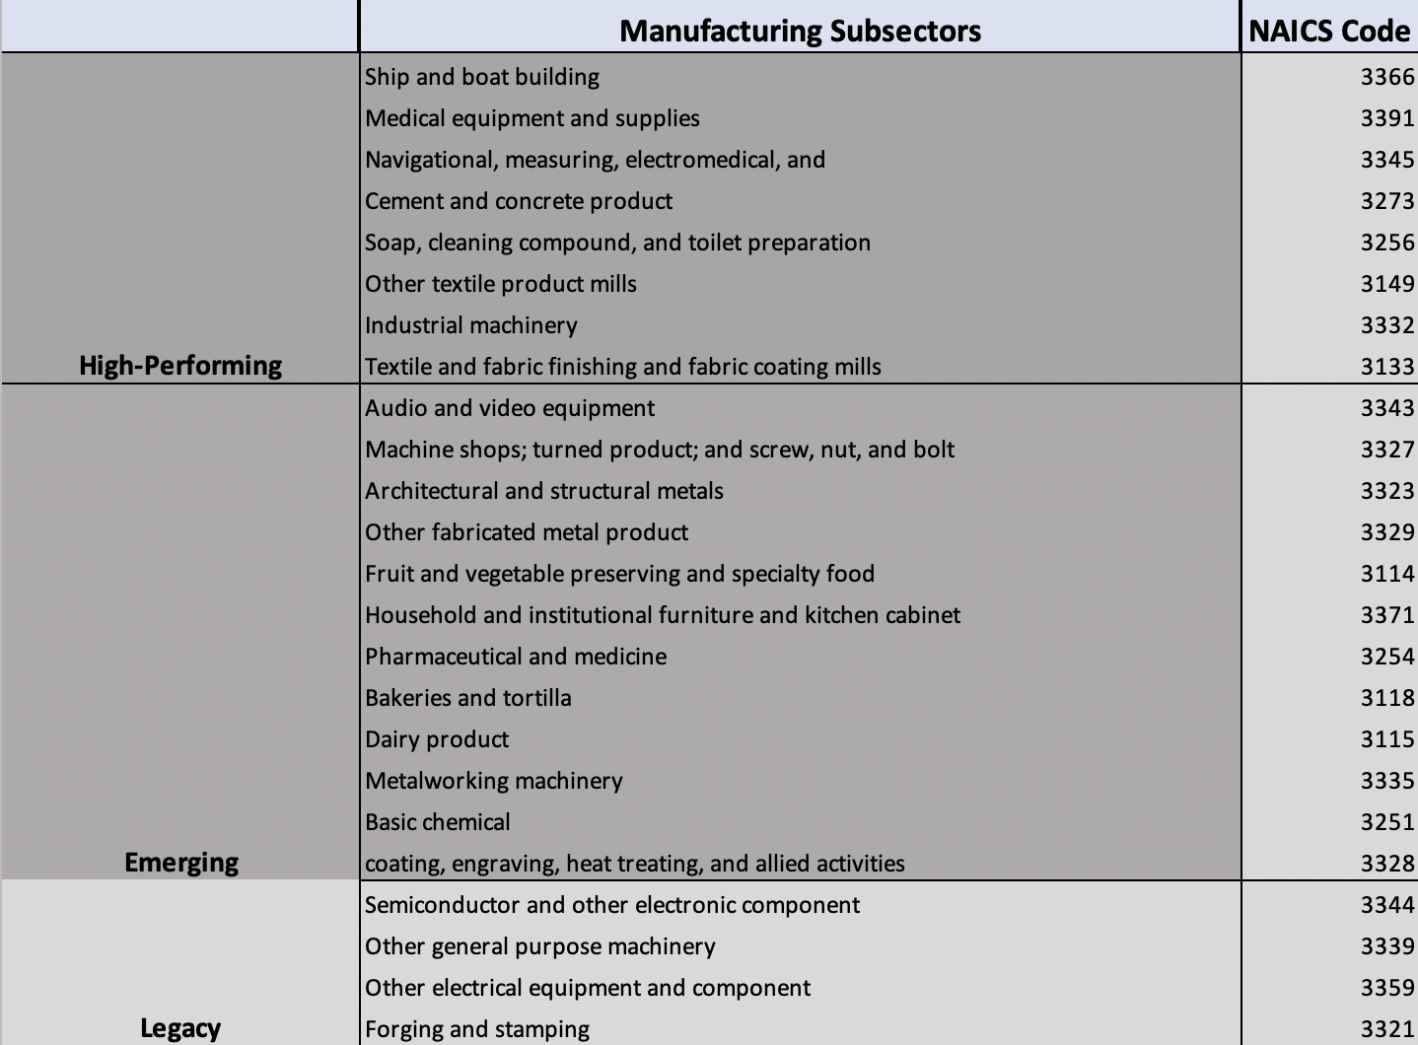

4.3.3 Future Manufacturing Impact on Truck Empty Backhauling

Tables 11 through 16 show all of the manufacturing commodities and their total weight and the estimated count of trucks carrying those commodities. The data used in the tables are from FAF Version 4 [6]. Data was available for the base year of 2012, and from 2020 through 2045. The data is forecast in 5-year intervals.

In these tables, columns 2, 4 and 6 show the weight of the manufacturing commodity carried by trucks in thousands of tons. Columns 3, 5 and 7 illustrate the estimated number of trucks carrying those manufacturing commodities. The research team calculated the truck count using the maximum weight that can be carried in a 40-ft container (2 TEUs). The research team converted the container size information into weight information to calculate the number of trucks.

- Dimensions of a (twenty-foot equivalent unit) TEU are approx. 20 ft (length) × 8 ft (width) × 9 ft (height).
- Maximum gross mass for dry cargo TEU is approx. 52,910 lb: 47,770 lb (net load) + 5,140 lb (empty container weight).
- 47,770 lb equals to 23.885 tons.
- Thus, the net weight of a 40-ft container equals 23.885 times 2, which equals 47.6 tons.

As an example, if the total weight of a commodity X is 500 ktons, then the total count of trucks was calculated as 500*1000/(2*(0.0005*(47770+5140)))),0), which is 9,451.

Table 11 and 12 describe the manufacturing commodities carried by trucks within Florida. Table 13 and 14 shows the manufacturing commodities carried by trucks from Florida to other states within United States. Table 14 and 15 shows the manufacturing commodities carried by trucks from Other States to Florida. FAF data and forecasts were reported in these tables for years 2020 through 2045

Table 11: Estimate for Trucks Carrying Various Manufacturing Commodities Within Florida – 2020 Through 2030
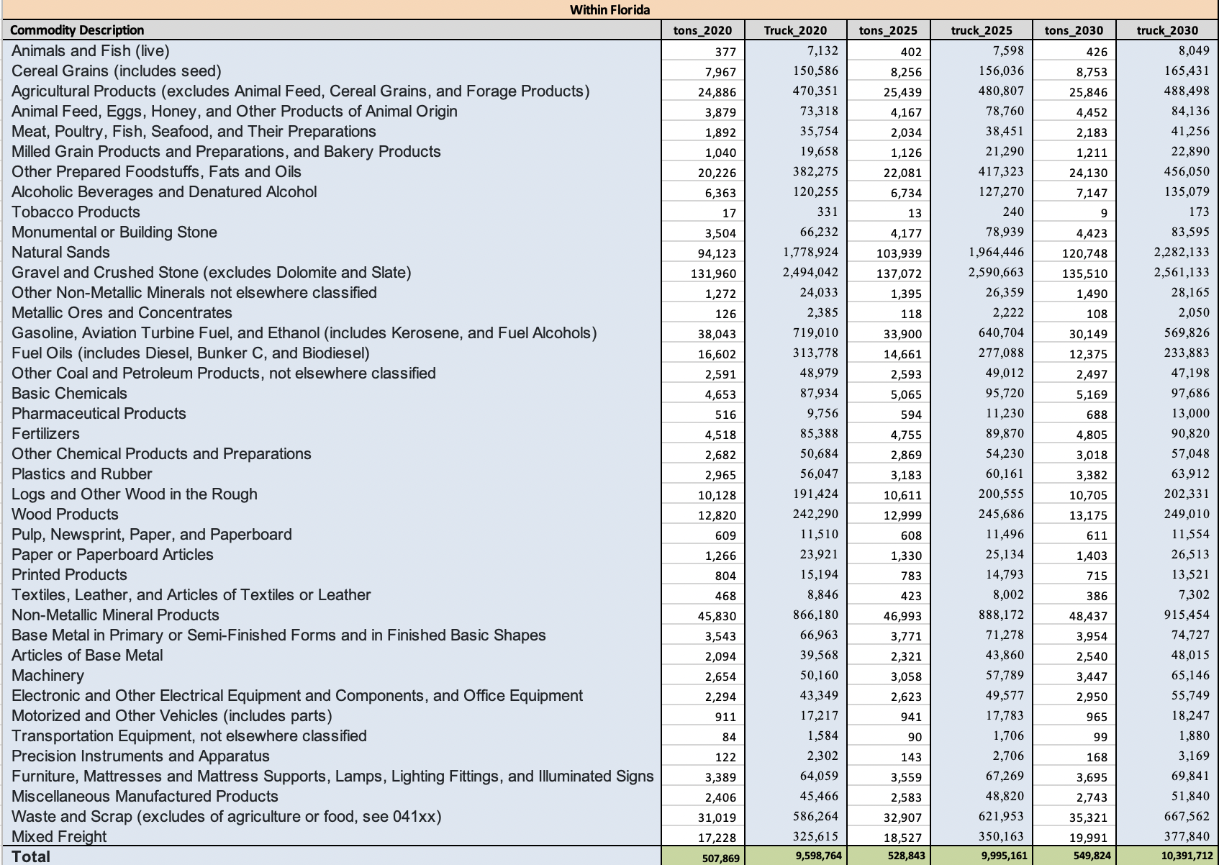
Table 12: Estimate for Trucks Carrying Various Manufacturing Commodities Within Florida – 2035 Through 2045
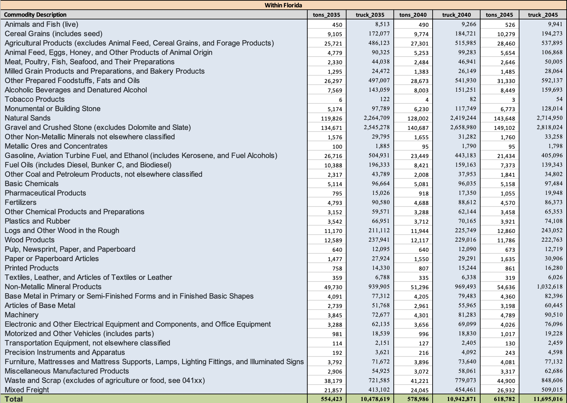

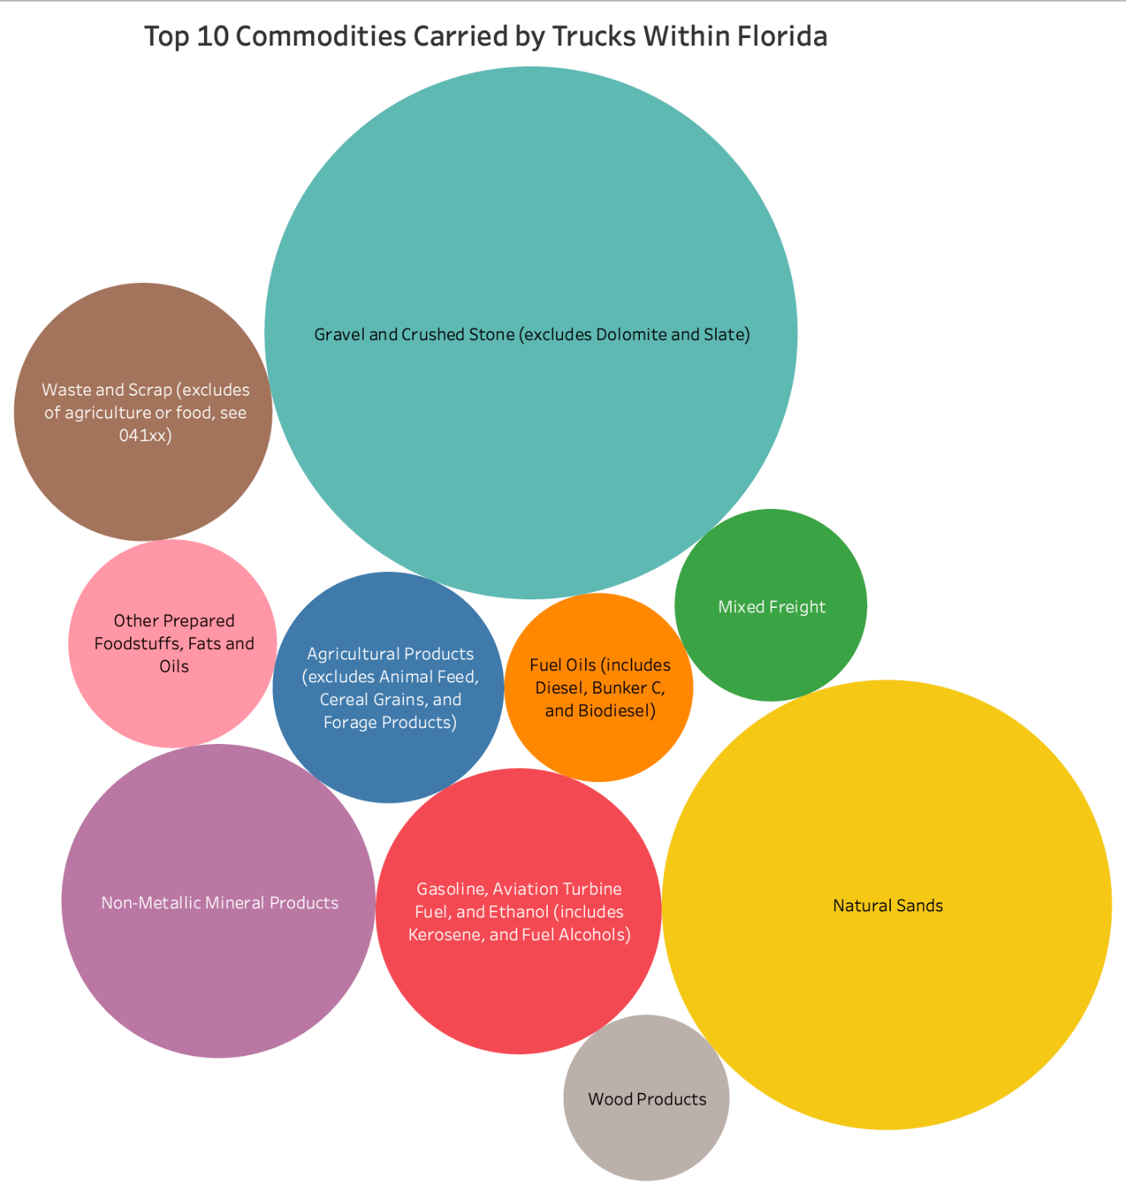
Figure 39: Top 10 Commodities Carried by Trucks Within Florida
Table 13: Estimate for Trucks Carrying Various Manufacturing Commodities from
Florida to Other States – 2020 Through 2030
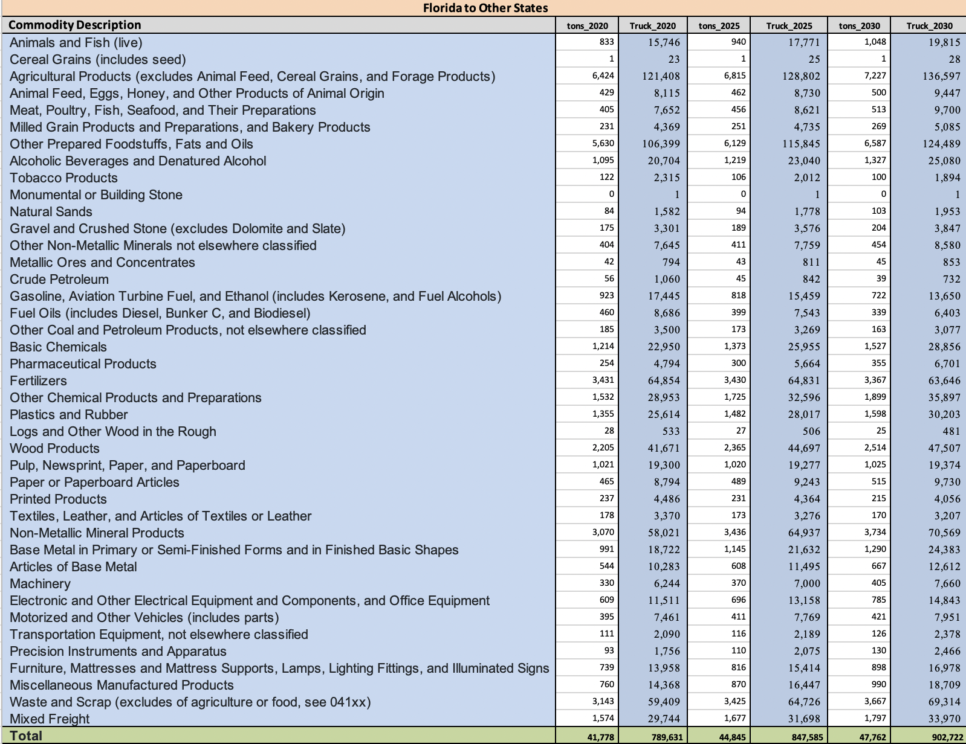
Table 14: Estimate for Trucks Carrying Various Manufacturing Commodities from Florida to Other States – 2035 Through 2045
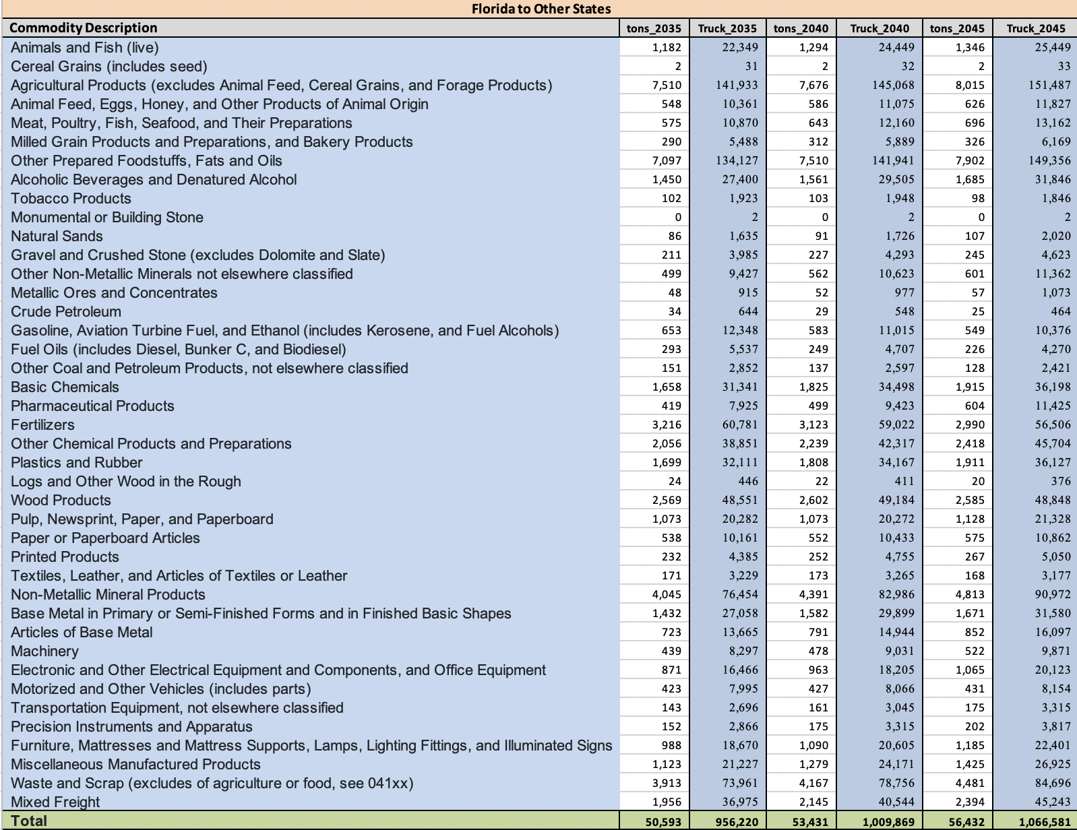

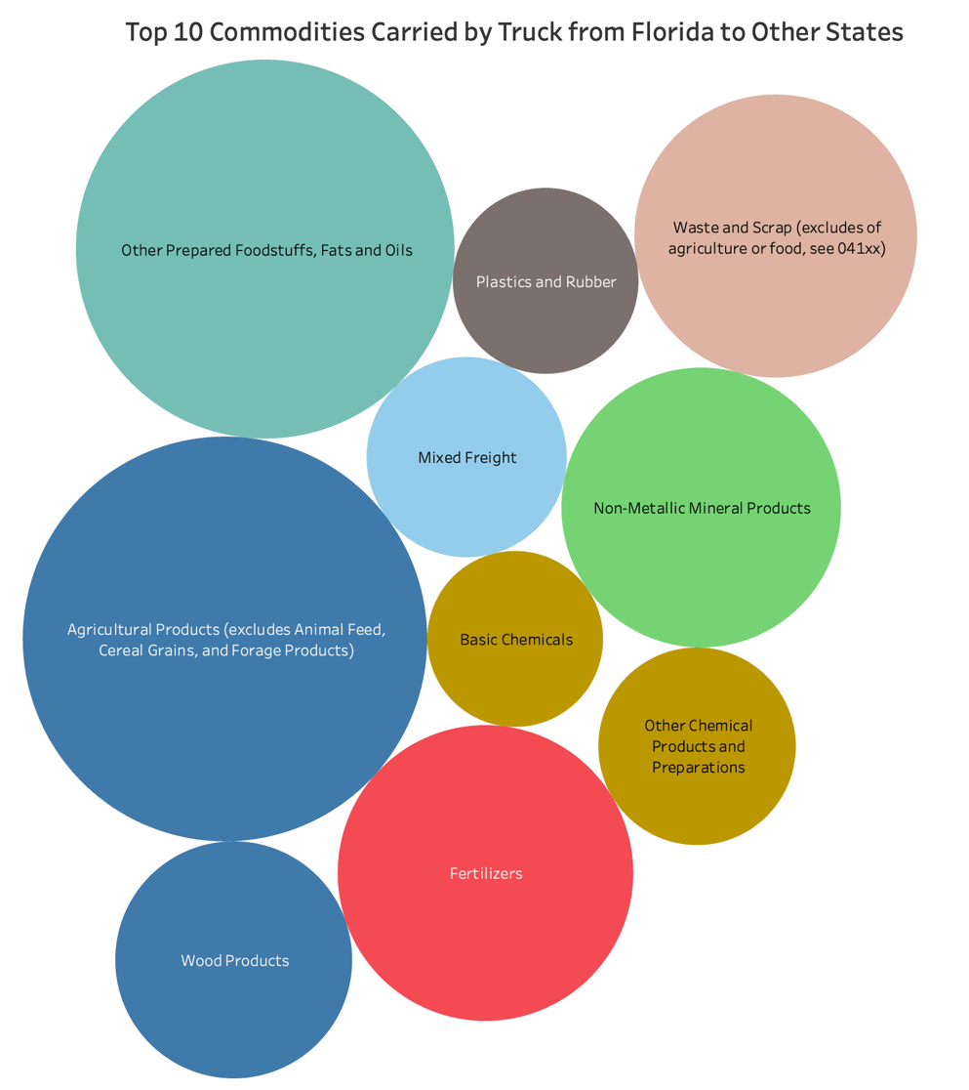
Figure 40: Top 10 Commodities Carried by Trucks from Florida to Other State
Table 15: Estimate for Trucks Carrying Various Manufacturing Commodities from
Other States to Florida – 2020 Through 2030
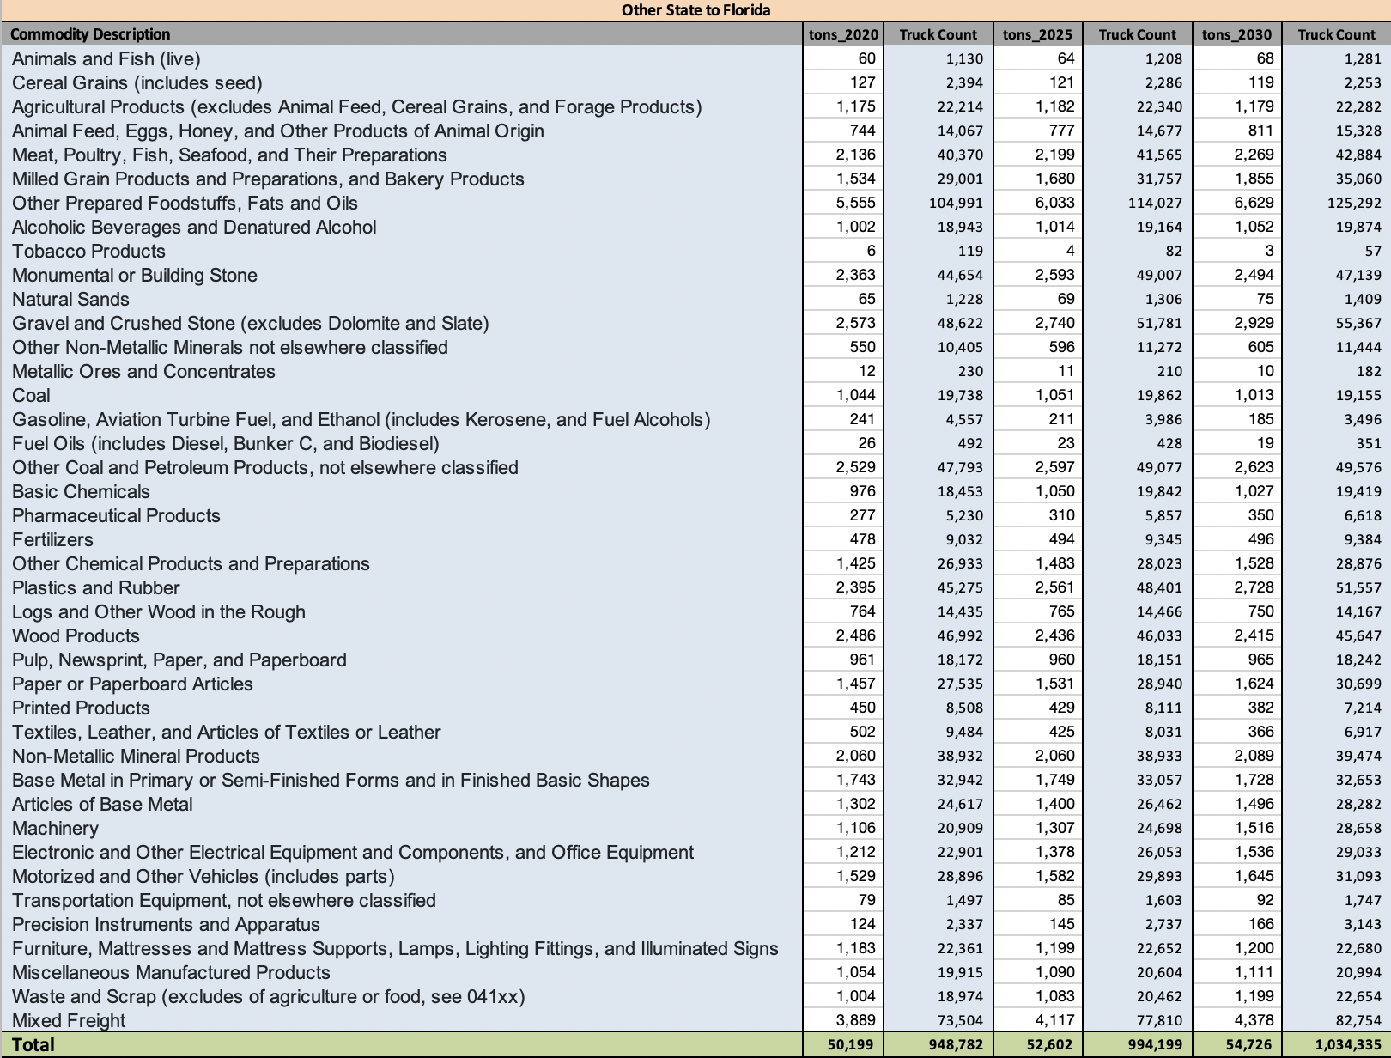
Table 16: Estimate for Trucks Carrying Various Manufacturing Commodities from
Other States to Florida – 2035 Through 2045
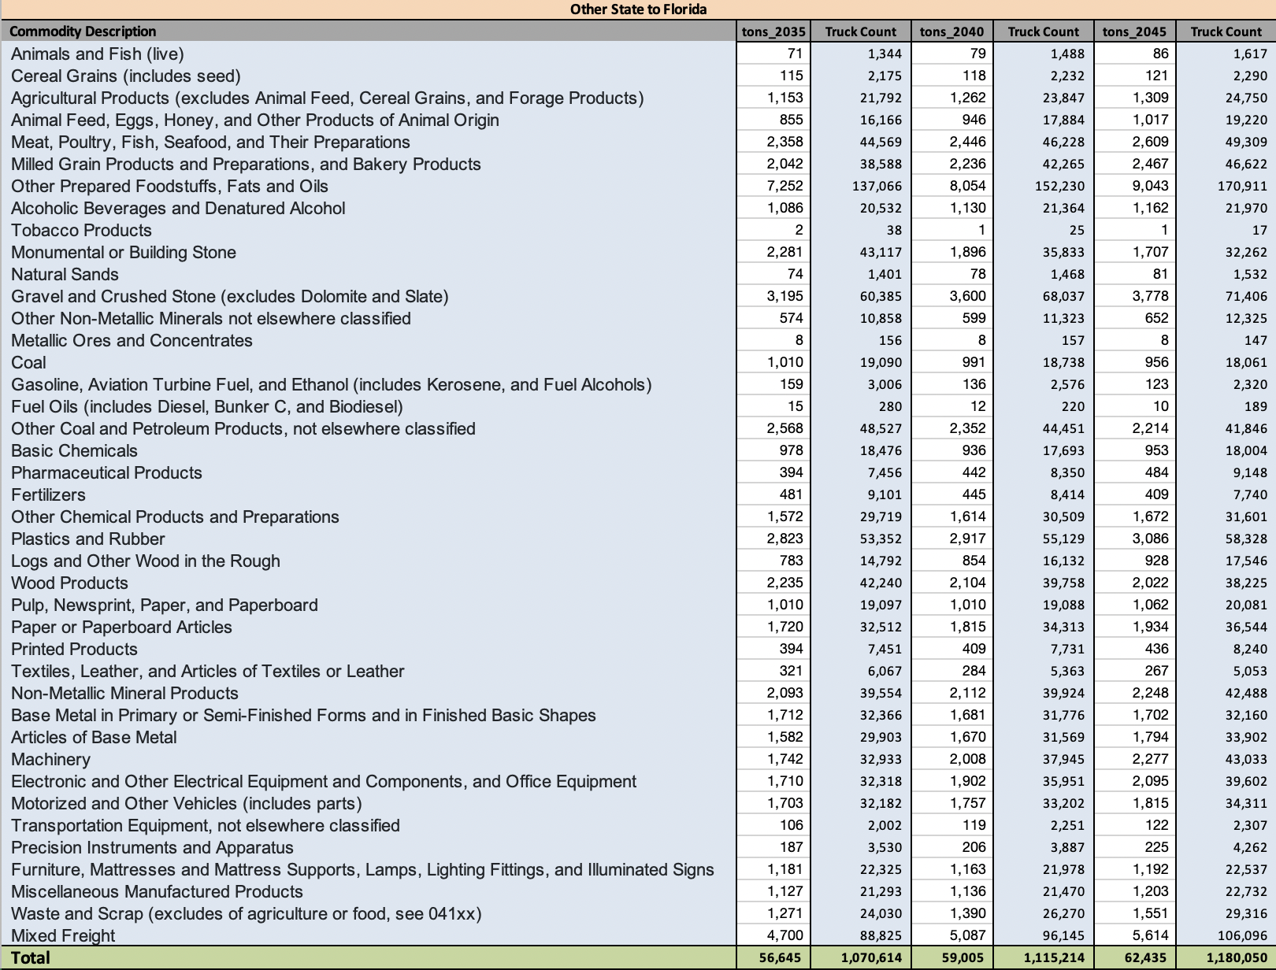

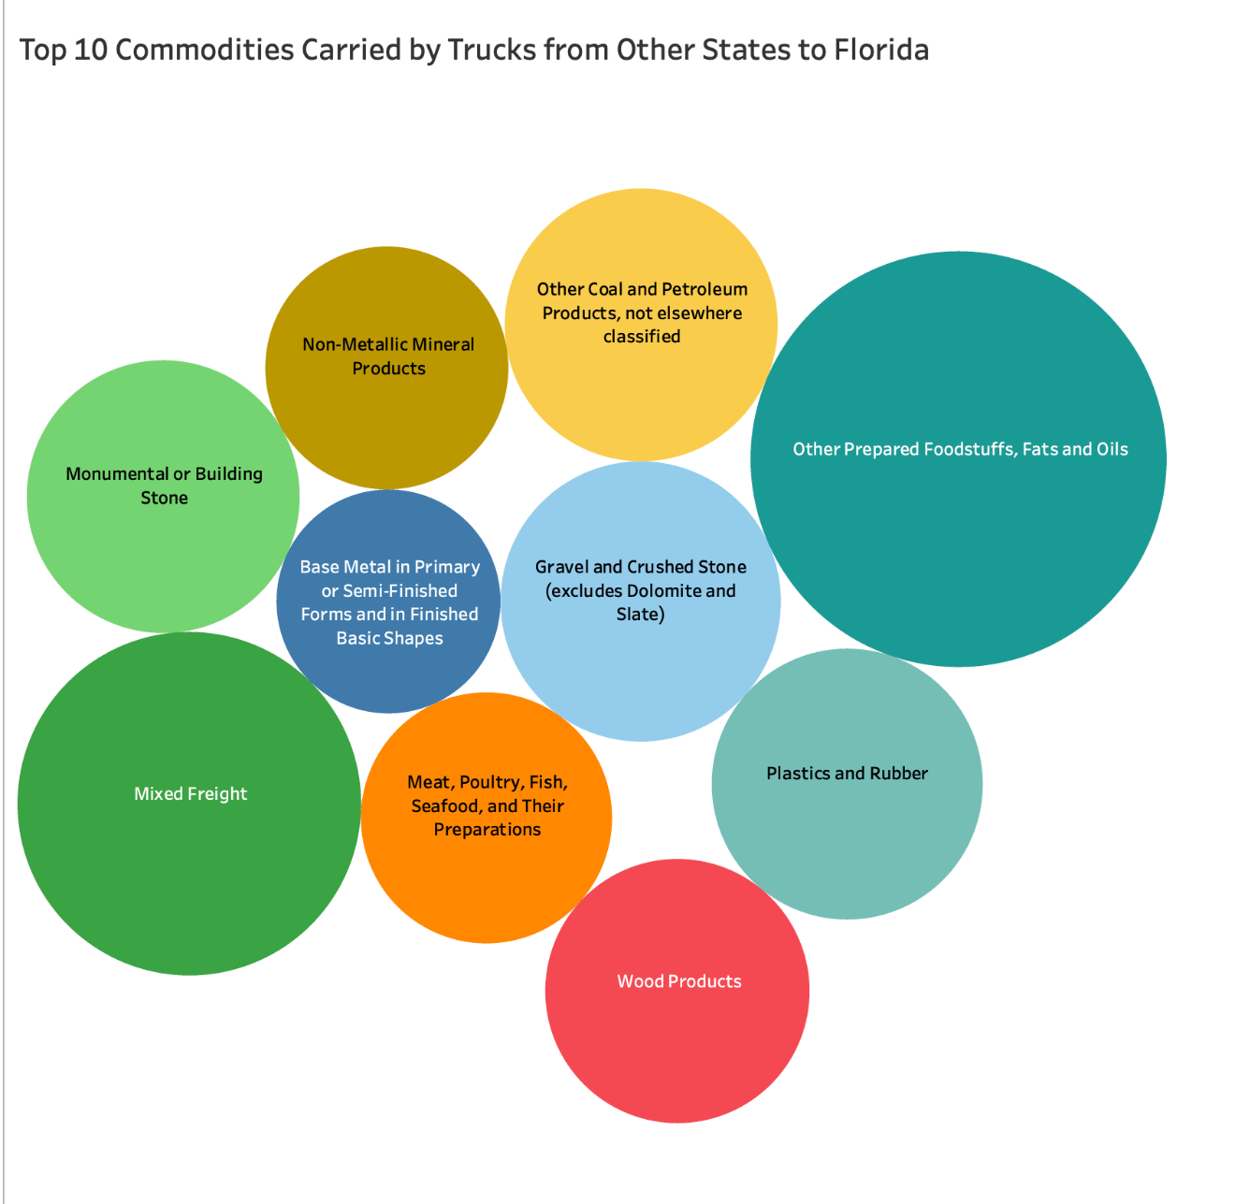
Figure 41: Top 10 Commodities Carried by Trucks from Other States to Florida

Figures 39, 40 and 41 describe the top 10 commodities carried by truck within Florida, Florida to Other States and Other States to Florida, respectively.

High Performing and Emerging Manufacturing Commodities: Tables 17 through 22 depict the commodities from high-performing and emerging manufacturing industries and the total weight and the estimated count of trucks carrying those commodities. Tables 17 and 18 describe the manufacturing commodities carried by trucks within Florida. Tables 19 and 20 show the manufacturing commodities carried by trucks from Florida to other states within United States. Table 21 and 22 shows the manufacturing commodities carried by trucks from Other States to Florida. FAF data and forecasts were reported in these tables for years 2020 through 2045.

Table 17: High Performing and Emerging Manufacturing Industry’s Commodities Carried by Trucks Within Florida – 2020 to 2030
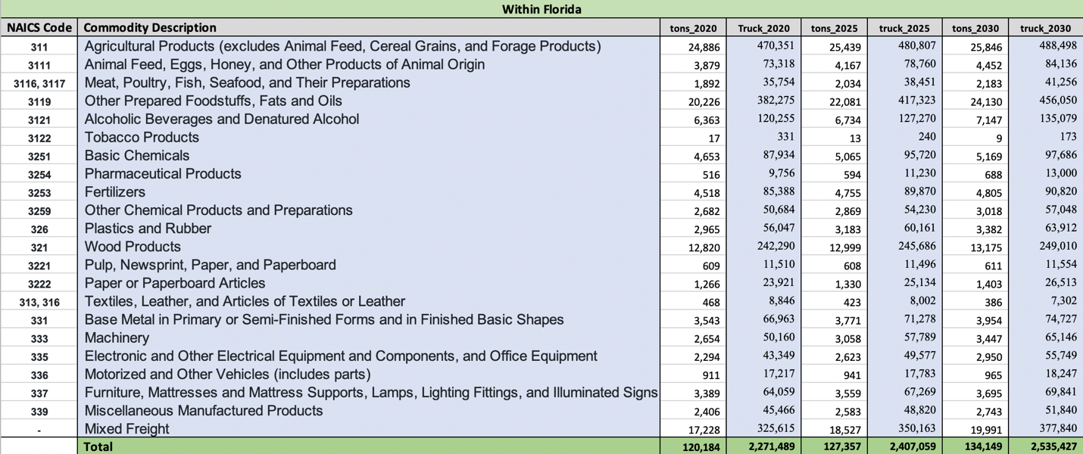

Table 18: High Performing and Emerging Manufacturing Industry’s Commodities Carried by Trucks
Within Florida – 2035 to 2045
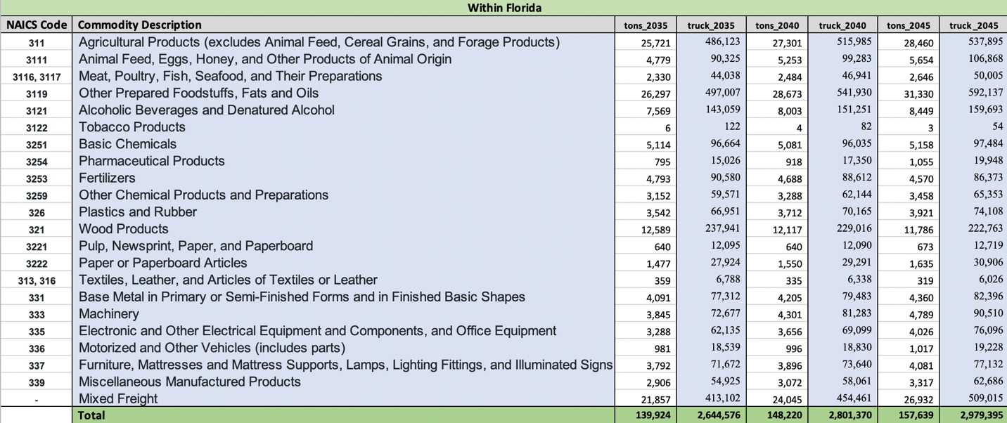

Table 19: High Performing and Emerging Manufacturing Industry’s Commodities Carried by Trucks from
Florida to Other States – 2020 to 2030
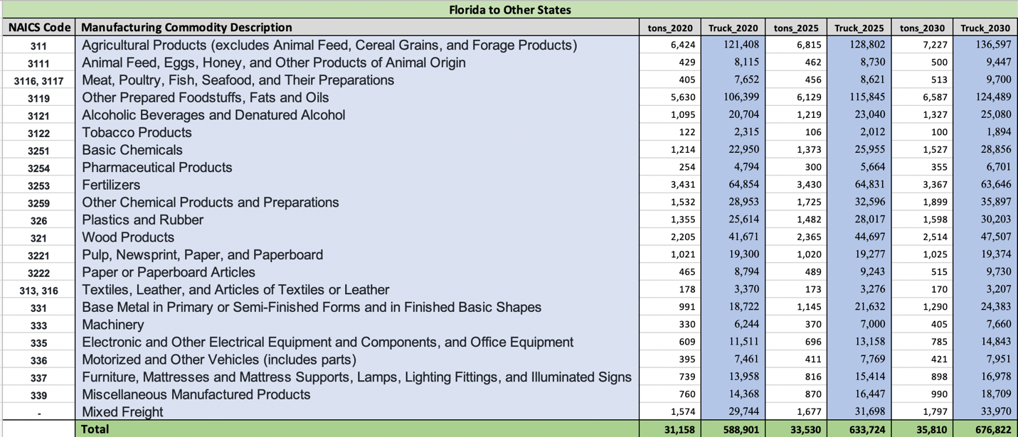

Table 20: High Performing and Emerging Manufacturing Industry’s Commodities Carried by Trucks from
Florida to Other States – 2035 to 2045
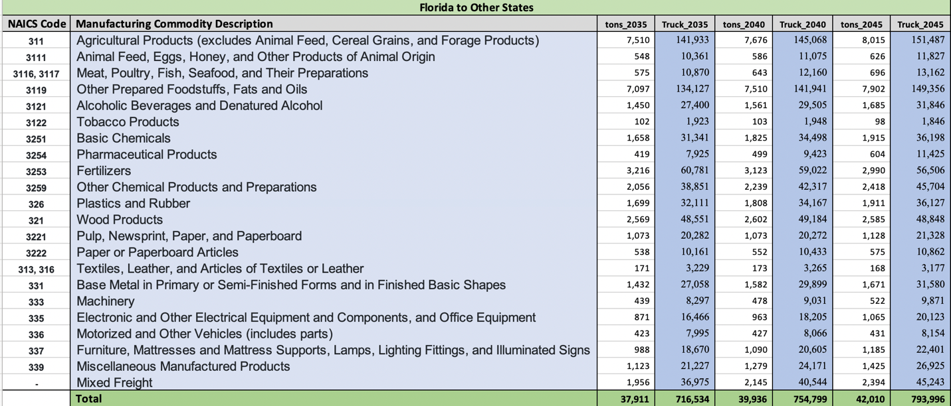

Table 21: High Performing and Emerging Manufacturing Industry’s Commodities Carried by Trucks
from Other States to Florida – 2020 to 2030
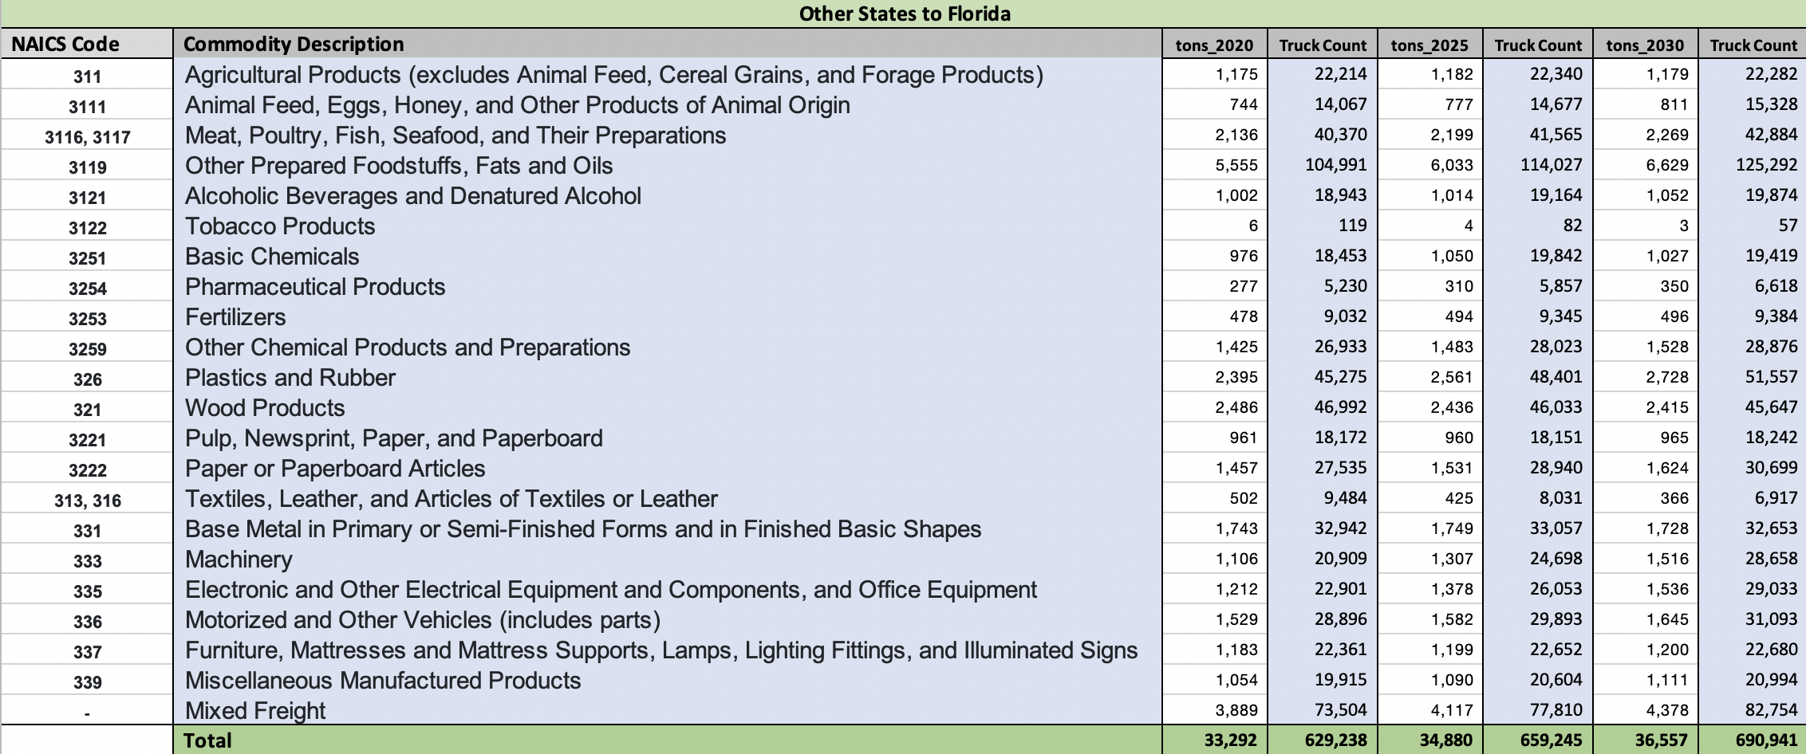

Table 22: High Performing and Emerging Manufacturing Industry’s Commodities Carried by Trucks from
Other States to Florida – 2035 to 2045
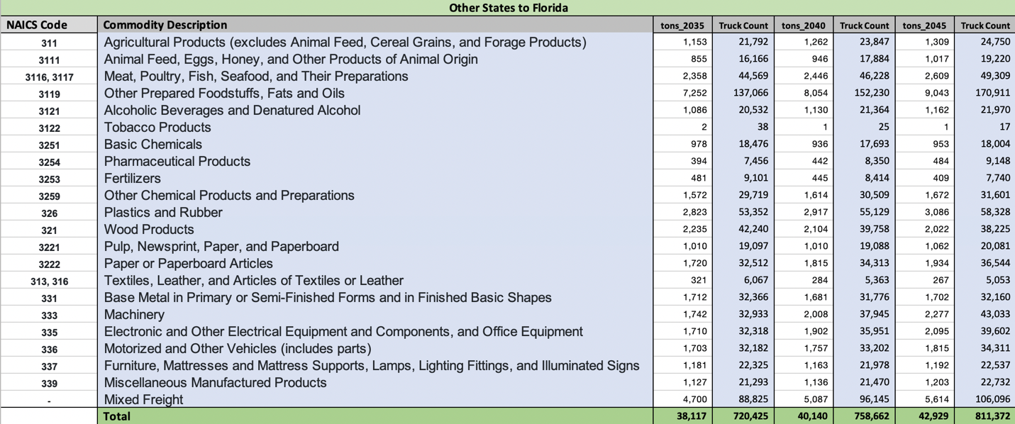

An evaluation of data from Tables 17 to 22 indicates evidence of growth in manufacturing production and rise in the estimated number of trucks carrying these commodities from Florida to Other States. Continued growth could result in the reduction of the difference between inbound and outbound freight, thus helping in reducing empty backhauling in Florida. The truck count column in above tables describes the number of trucks carrying the commodities in the specified year from 2020 through 2045. The numbers show the potential rise in truck count carrying the manufacturing commodities from 2020 to 2045.
Table 23 and 24 describe the trucks carrying forecasted manufacturing commodities from and to Florida for the years 2020 to 2045 and the difference between the total number of incoming and outgoing trucks. It can be observed that there is a substantial decrease in the difference in incoming and outgoing trucks from 2020 to 2045. In 2020 the difference in number of trucks carrying manufacturing commodities from other states to Florida (i.e., import) and Florida to other states (e.g., export) was approximately 40,337. With the increase manufacturing the difference in trucks, is forecasted and would likely reduce to 17,376 and the empty backhauling percentage will reduce significantly by 57%. Therefore, with additional manufacturing of goods in Florida, there can be an alleviation of empty truck backhauling in the 57% range, which is highly significant.
Table 23: 2020 Florida Incoming Trucks vs. Outgoing Trucks
Carrying Manufacturing Commodities
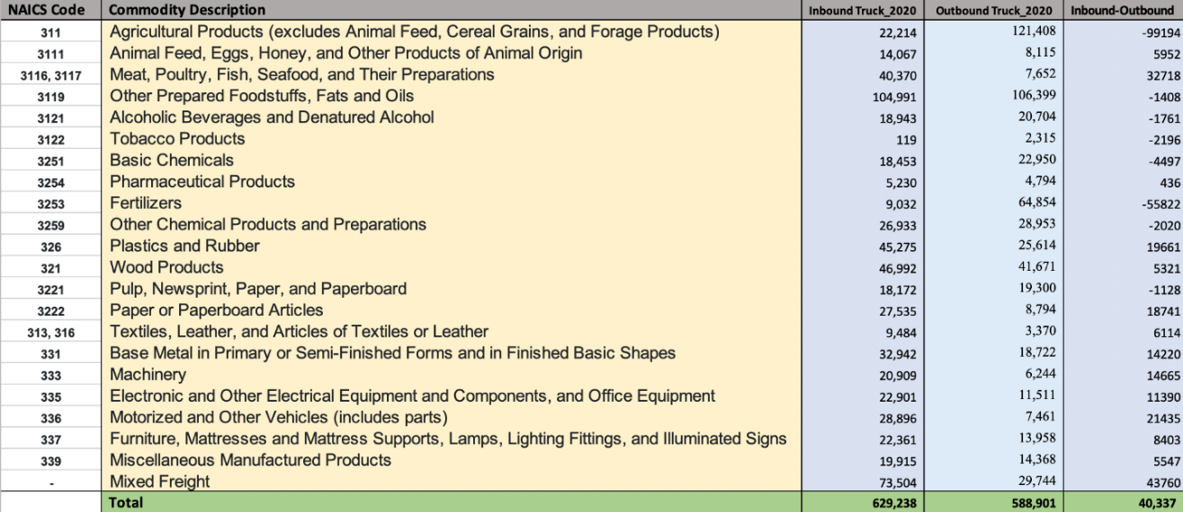

Table 24: 2045 Florida Incoming Trucks vs. Outgoing Trucks
Carrying Manufacturing Commodities
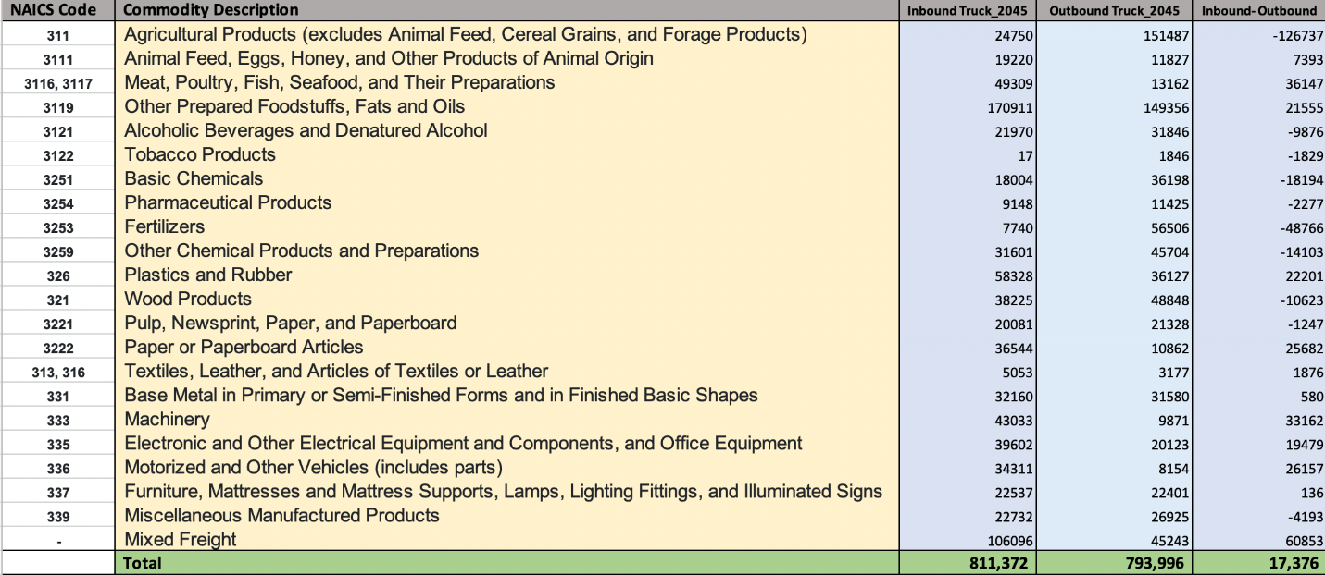

4.3.4 Potential Manufacturing Sector’s Impact on Empty Backhaul

Tables 25 through 28 show a comparative analysis performed by altering differing percentages for increasing manufacturing production in Duval County for assessing the potential impacts these may have on the empty backhaul issue. The manufacturing subsectors are shown in first column. The second column shows the weight of the manufacturing goods carried by these trucks. The research team used the empty backhaul data from Task 2 to get the empty truck count and calculated the maximum weight that can be carried in a 40 ft. container. This was rounded up to the ceiling to get an approximate number of trucks multiplied by the number of empty trucks and resulting in the total weight per manufacturing goods. The third column represents the percentages of the empty truck count when there is “0% increase in manufacturing”. For example, “10% increase in manufacturing” is 90% of total backhauling trucks. Similarly, the remaining columns represent the empty truck percentage reduction by altering the specific amount of manufacturing goods transported from Duval by increasing the manufacturing of the commodities. The percentage of truck reduction was calculated using the actual number of empty trucks for that county carrying different manufacturing goods. Tables 27 and 28 show the reduction in the truck count when the manufacturing is increased.

For example, agricultural products transported from Duval has 8.48% of empty backhauling trucks. If there is an increase in manufacturing of agricultural products by 10% the empty backhauling trucks will be reduced to 7.63% and backhaul truck count reduces from 127,067 to 114,360. Similarly, if manufacturing increases by 100%, empty backhauling trucks will be reduced to 0. Therefore, if the manufacturing is increased there will be significant reduction in empty backhauling.

It should be noted that this analysis was performed to depict how empty backhauling could potentially be decreased with an offsetting increase in manufacturing. However, actual numbers could look similar. As manufacturing is increased, and empty backhauling trucks can be filled up before they depart Florida.

Table 25. Backhaul Percentage Reductions for Duval County on Increase of
Manufacturing Production- 0-40% Increase
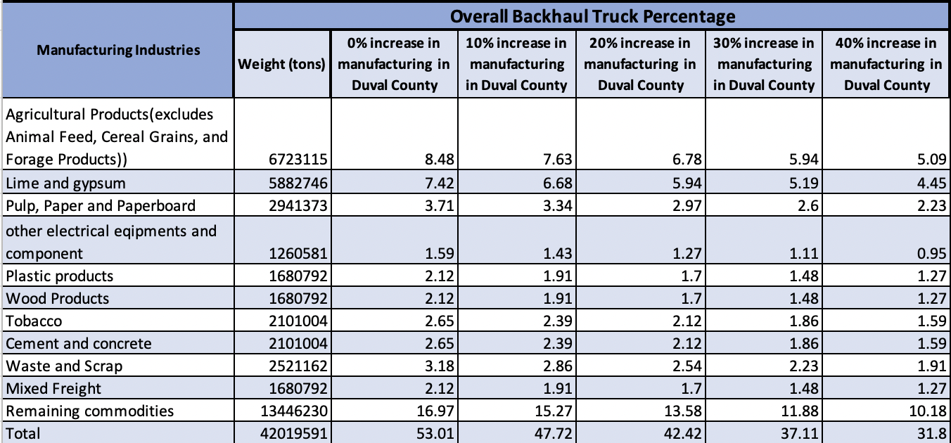

Table 26. Backhaul Percentage Reductions for Duval County on Increase of
Manufacturing Production- 50-100% Increase
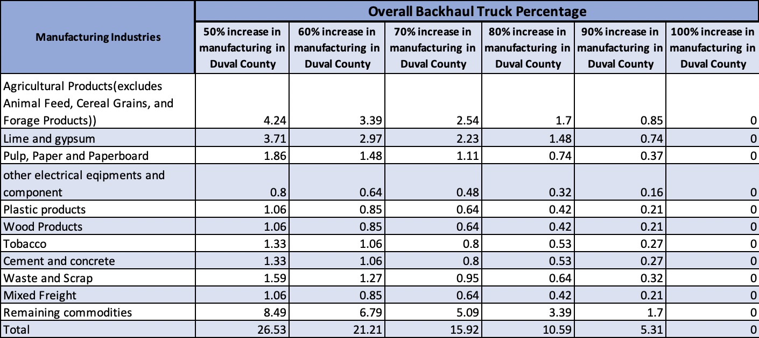

Table 27. Backhauling Truck Reductions for Duval County on Increase of
Manufacturing Production- 0-40% Increase
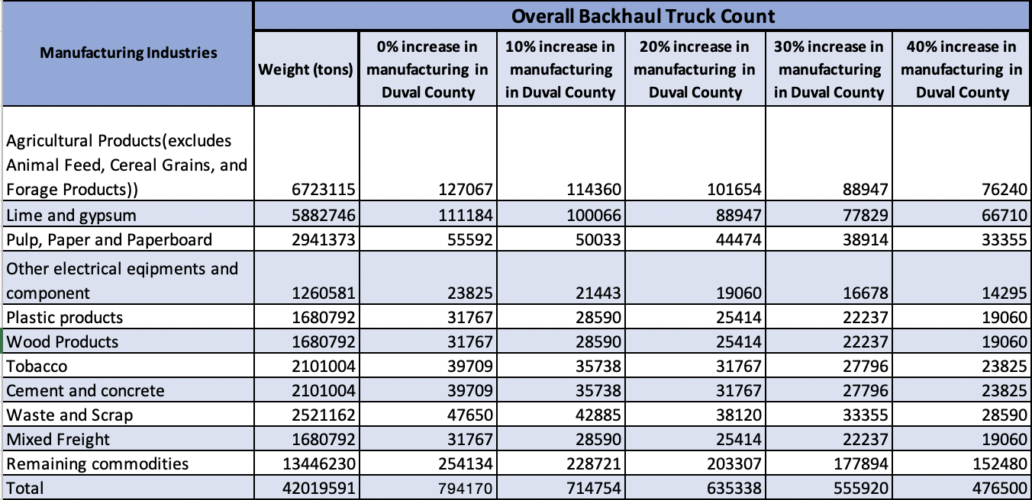

Table 28. Backhauling Truck Reductions for Duval County on Increase of
Manufacturing Production- 50-100% Increase
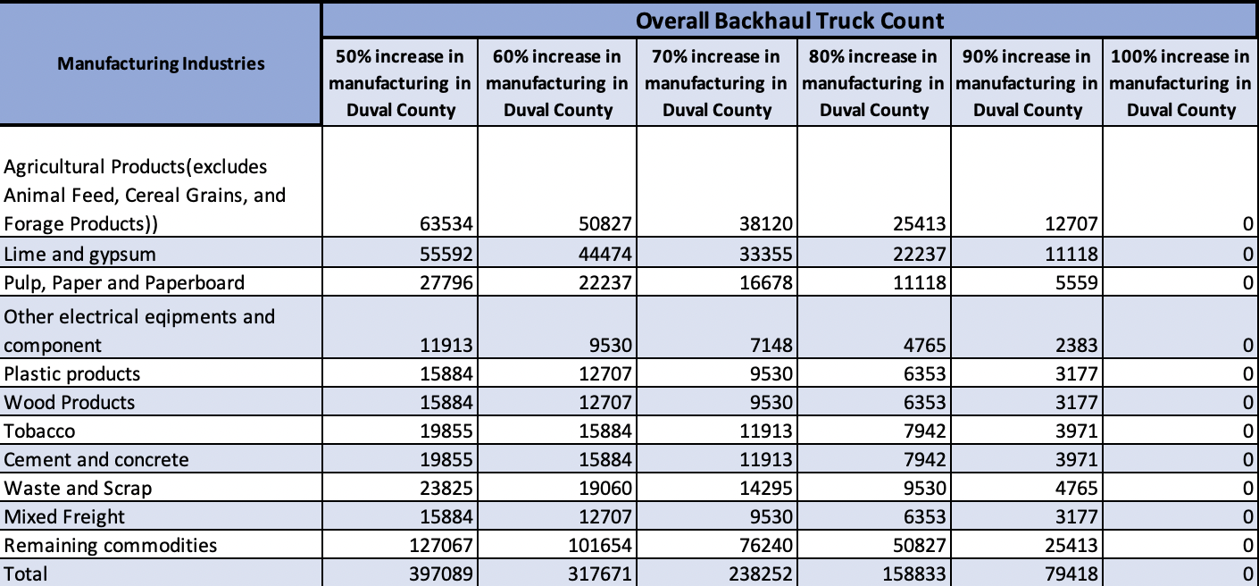

5. Key Factor Identification for Current Shipping Practices to/from Florida

This section summarizes the interviews and identifies the key factors for current shipping practices and choosing alternative transportation modes, which could potentially alleviate empty backhauling problem in Florida.

5.1 Expert Interviews to Determine Key Factors

To develop a deeper understanding of the shipping practices and factors affected the shipping mode choice, we conducted a series of interviews with experts from industry partners, such as manufacturers, major shippers and freight forwarders, that operate both in and out of Florida. These interviews helped in understanding/analyzing the decision-making criteria by the industry for current shipping practices and choosing alternative transportation modes such as seaborne, rail, etc. These interviews provided an overall understanding of the major factors affecting the mode choice and key factors that have an impact on decision-making process.

Due to safety measures adopted during the COVID-19 outbreak, all interviews were conducted remotely via Microsoft Teams. The interviews were performed with experts from a wide range of industries, including manufacturing, freight forwarding, and major shipping/transportation companies, among others. The purpose was to understand the shipping practices and factors affecting the shipping mode choice. In whole five expert interviews were conducted by the research team.

5.2 Summary of Interviews

This subsection documents the summaries of all five expert interviews conducted by the research team. The interviews were performed with experts from a wide range of industries, including manufacturing, freight forwarding, and major shipping/transportation companies, among others. The purpose was to understand the shipping practices and factors affecting the shipping mode choice.

Interview 1

Interview #1 was conducted on September 9, 2021. The interviewee is an expert from one of the largest multinational shipping & receiving companies in the United States. The interview supplied us with an overall idea about the commodities manufactured/ shipped by the firm, logistics facilities location and modes of transportation used by the company and factors affecting the shipping mode choice of the company. Lastly, Empty Backhauling concerns were also mentioned by the interviewee.

Factors affecting mode choice were cited during the conversation. The most important factor was cost. The real cost versus a driver cost (i.e., the per mile cost to the driver transporting the freight) was one of the most important factors mentioned by the interviewee. Time commitment factors were the second most mentioned, while the importance of the truck being fully loaded both ways was the third factor. i.e., the trucks coming to Florida should not go back empty, and this focuses on empty backhauling issues in Florida.

In addition to factors already mentioned, the interviewee also offered additional perspectives on the topic at hand. Of these, service was seen as the most important factor influencing the mode choice considering the timeliness of the delivery of commodities. Therefore, fulfilling the commitment is the topmost priority for the firm. Additionally, alternate modes of transportation might be considered if incentives were provided by the state. These could include transportation of products via seaborne, barge or rail, as opposed to over the road trucking.

Interview 2

Interview #2 was conducted on September 13, 2021, with a senior operations manager at one of the largest distribution facilities in the U.S. and operating within the state of Florida. The interview provided an overview of the commodities manufactured/ shipped by the firm, logistics facilities location, modes of transportation used by the company, and factors affecting the shipping mode choice of the company. The factors affecting the mode choice were cited during the conversation and included cost, but the company also looks at other factors like flexibility of the movement, and the speed to market. The latter factor impacts on-time delivery of their products. Achieving on-time delivery is a factor for which the company is willing to pay extra. Order fulfillment on time is the topmost priority for the firm therefore, speed is one of the most important factors for the company.

The firm predominantly uses truck as a preferred mode of transportation, in addition to some intermodal transportation also involving rail. The interviewee discussed cost savings realized through the use of rail. However, due to delays involving train movement, the company switched back to trucks, in order to reduce the risk of not achieving on-time delivery. Additionally, air freight shipping was utilized for more urgent delivery of certain products and therefore additional cost is justified for the need.

Interview 3

Interview #3 was conducted on September 15, 2021. The interviewee is an expert leading the North American logistic efforts for one of the world's largest plastics distribution companies. The most frequently cited factors reveled by the interviewee affecting the mode choice were demand weight (i.e., how much weight is needed by the customer), lead time, cost effectiveness, and types of commodities being shipped). Regarding the mode of transportation used by the company, it uses all modes of transportation however it uses rail the most. Out of all the experts interviewed for Task 4, this was the only firm that used rail as the primary mode of transportation.

In addition, the interviewee contributed other perspectives that may be pertinent to decision-makers. These include rolling inventory, lead time through ports, meeting the customer needs, and having a big warehouse and sourcing which impact their mode choice decision. Sourcing process includes activities involving identifying and assessing potential suppliers as well as selecting and engaging with an appropriate supplier who offers the best value. Customer satisfaction being the topmost priority, the company focus more on on-time delivery of commodities along with having a large space for storing the commodities and sourcing.

Interview 4

Interview #4 was conducted on September 16, 2021. The interviewee is an operations manager for a major third-party logistics company based in Florida, with operations throughout the U.S. The company provides packaging, transportation, and other services for bottlers, international producers of baked goods, cosmetic companies, Amazon, and many other customers. The most frequently cited factors affecting the mode choice were capacity, customarily service, and type or nature of goods i.e., depending on type of goods the mode of transportation is selected (e.g., coal is generally shipped by rails). Regarding the mode of transportation used by the company, it primarily uses truck transportation, but also uses some rail for shipping and receiving products. Additionally, the interviewee mentioned incentives for drivers and autonomous trucking as possible factors to improve logistics and to help mitigate driver shortages.

Interview 5

Interview #5 was conducted on October 11, 2021. Among the two interviewees, one is the director of transportation, and the other is the category manager of dedicated fleets and logistics officer at an residential door manufacturing company. While the interviewees were based outside of Florida in another US state, the company has major manufacturing operations within Florida, as well as facilities throughout the U.S. and Canada. The most frequently cited factors affecting the mode choice for this company were lead time, cost, and location. The company primarily uses over the road trucking as its primary mode of transportation along with some intermodal. However, rail is utilized when the costs benefitted the company. In addition, the interviewees discussed environmental impacts as being a factor of consideration when determining a mode of transportation (e.g., truck vs rail).

5.3 NVivo Analysis on Interviews
After the interviews were conducted, a transcript of each interview was developed. NVivo software was then utilized to analyze the transcripts to better understand and analyze the interviewees’ decision-making criteria. Criteria included transportation in and out of Florida, identifying critical factors for their potential choice of transportation mode. The transcripts were coded individually into NVivo, and the main results were compared and summarized.
The qualitative analysis of the interview transcripts began by loading the theory-driven factors from interview protocol to the NVivo software following the structure shown below. In this section, we focus on theory-driven factors and introduce those that emerged from the analysis itself.
Modes of transportation used – companies use different transportation modes to ship their commodities within Florida, Florida to other states and other states to Florida. From all five interviews we can conclude that all these companies mainly use truck transportation for their shipment with some rail shipments as well. And besides those modes, a few of these companies use intermodal and seaborne modes of transportation.
Factors affecting mode choice – different factors affecting mode choice was mentioned during the interviews. Most of the interviewees talked about cost, service and time as some of the major factors affecting their mode choice. Besides these factors, interviewees also mentioned some other interesting factors that can impact their decision like flexibility of movement, market, and reliability of transportation modes.

Commodities shipped to Florida – Interviewees mentioned about the commodities shipped by their companies to Florida. Commodities like door products, business to business items, different types of wood components, pelletized plastics, etc.

Commodities shipped from Florida– Almost all of the interviewees mentioned that they do not export any commodities from Florida except basic business to business items.
Incentives impact on mode choice – according to interviewed experts, to some extent, the incentives given by the government and local authorities can impact their mode choice decision. One of these incentives could be incentives for drivers, tax exemption, etc.
Commodities manufactured by the company – The interviewees talked about a wide rage of various commodities manufactured by their respective companies.

Deal breaker for alternate transportation mode – the interviewee talked about the various deal breakers for the company to choose alternate mode of transportation. These dealbreakers include autonomous trucking considering the driver shortages, shortage of drivers and infrastructure with big warehouse and sourcing to meet the customers need
play an important role in mode choice.
Logistic Location – the business or logistics distribution center location is something which plays a critical role in deciding the transportation mode choice. For businesses, the proximity to final customers is essential, to which they pay extra attention to.
Type of incentives – prospective incentives given by the government and local authorities can impact the mode choice decision of a company. The interviewee mentioned about the different types of incentives that can be given by government or local authorities like environmental impact, incentives for drivers, as well as tax exemption incentives for the companies.

5.4 Results and Findings for Key Factor Identification for Current Shipping Practices

The first analysis performed by the research team was to assess the frequency that each factor was cited during the interviews. For this type of analysis, NVivo presents two levels of frequency summarizations: codes and references. The file's frequency refers to the number of codes or topic in each document. In our case, a document is an interview (transcript files). The second type of frequency refers to how many times the topic was referenced in each document. In this work, as the level of analysis were the sentences, the number of references refers to the number of sentences in which the topic was mentioned during the interviews.

Although the number of references is not exactly a direct measure of the factor's importance, it is expected that key factors be more frequently mentioned during the interviews, and so, higher, or lower frequencies carry importance in this type of analysis. This analysis is shown in this section, where we first present the results for theory-driven factors clustered by factor groups and later the data-driven factors.

First, we present the modes of transportation used by the company factors frequencies sorted by the number of times the topics were cited in all interviews (references).

Table 29 shows that, among this group of factors, truck, and rail, as a mode of transportation are the most frequently observed during the expert interviews, with 15 and 8 references, respectively. On the other hand, Intermodal has been cited 7 times in all the interviews and Air Freight was sited in only two interviews. Only one company used all modes of transportation, including Seaborne.

Table 29. Interview Results of Modes of Transportation Used
Factors | Number of Interviews factor is mentioned in | Frequency
Truck | 5 | 15
Rails | 3 | 8
Intermodal | 3 | 7
Air Freight | 2 | 2
Seaborne | 1 | 1
All modes | 1 | 1

Regarding the factors affecting mode choice, three factors were more frequently cited than others: time (21 occurrences), cost (18 occurrences), and services (14 occurrences). It is noteworthy that these factors were also referenced during all interviews. Nevertheless, Empty Backhauling was mentioned 5 times in 2 interviews, and type of product shipped by the company was mentioned three times during 2 interviews, and reliability of transportation mode was cited 3 times. Market/flexibility to the market was cited only once in one interview. A summary of factors affecting mode choice is shown in Table 30.

Table 30. Interview Results of Factors Affecting Mode Choice
Factors | Number of Interviews factor is mentioned in | Frequency
Time | 5 | 19
Cost | 5 | 15
Service | 5 | 13
Empty Backhauling | 2 | 5
Type of Product | 2 | 4
Reliability of Transportation Mode | 2 | 2
Market | 1 | 1
Flexibility to the Market | 1 | 1

Types of incentives that can impact mode choice were comparatively less cited compared to the above-mentioned factors. The only factor “additional tax incentives” and “incentives for drivers” was mentioned seven and three times, respectively during five interviews. Environment impact was cited only once in one of the interviews. A summary of types of incentives that can impact mode choice is shown in Table 31. Incentives for drivers include extra pay and bonus. Environmental impact of transportation mode is the impact of the mode choice on the environment and ecosystem. The transportation mode should be eco-friendly and shouldn’t harm the environment (e.g., transportation mode that emits lot of carbons should be avoided).

Table 31. Interview Result of Incentives Impacting Mode Choice
Factors | Number of Interviews factor is mentioned in | References
Additional Tax Incentives | 5 | 7
Incentives for Drivers | 2 | 3
Environmental Impact | 1 | 1

Dealbreakers for mode choice factors were the less cited group of factors overall. The only factor cited more than once was driver shortage, mentioned 4 times during two out of the five interviews. Autonomous Driving was cited only once during an interview. A summary of dealbreakers for alternative mode choice is shown in Table 32. The driver’s shortage is one of the biggest problems faced by the shipping companies. Status of infrastructure includes infrastructure availability like having attractive warehousing space like having a big warehouse and sourcing. Autonomous Driving refers to self-driving vehicles or transport system that move without intervention of human solving the driver shortage problem.

Table 32. Interview Result of Dealbreakers for Mode Choice
Factors | Number of Interviews factor is mentioned in | References
Drivers Shortage | 2 | 4
Status of Infrastructure | 1 | 2
Autonomous Driving | 1 | 1

To summarize the frequency analysis, the research team developed a set of hierarchy charts which serve as a type of data visualization since the size of the box is proportional to how many times the topic was mentioned during the interview. Different levels of aggregations are also taken into consideration in this type of chart. The lower levels (most granular) are represented in a lighter color, while higher levels are represented with a darker color. For instance, the most granular level in this analysis is the factor itself (e.g., cost, time, empty backhauling, or service), so they are colored in light gray. The groups of factors (e.g., factors affecting mode choice) are represented in a darker color and contain all the "boxes “of factors that belong to each respective group. Besides the size of the rectangles, the larger groups are also placed in the left corner of the chart, while the smaller is on the bottom right side.

Afterwards, we analyzed the frequency that the factors appeared during each interview separately. For example, Figure 42 shows the hierarchy chart of the first interviewee, an expert from one of the largest multinational shippings & receiving and supply chain management companies in Florida, in which most of the topics were related to factors like cost, time, service and empty backhauling that impact shipping choice. We also notice that many different factors were mentioned during the interview, covering all groups of factors present in this study.

In this type of hierarchy chart, it is also possible to visually compare factors that belong to different groups. For instance, in Figure 42, it is evident that factors affecting mode choice, mode of transportation used by the company was more frequently cited. Because of the high number of factors and the discrepancy in frequency, some factors are not visible in Figure 42.

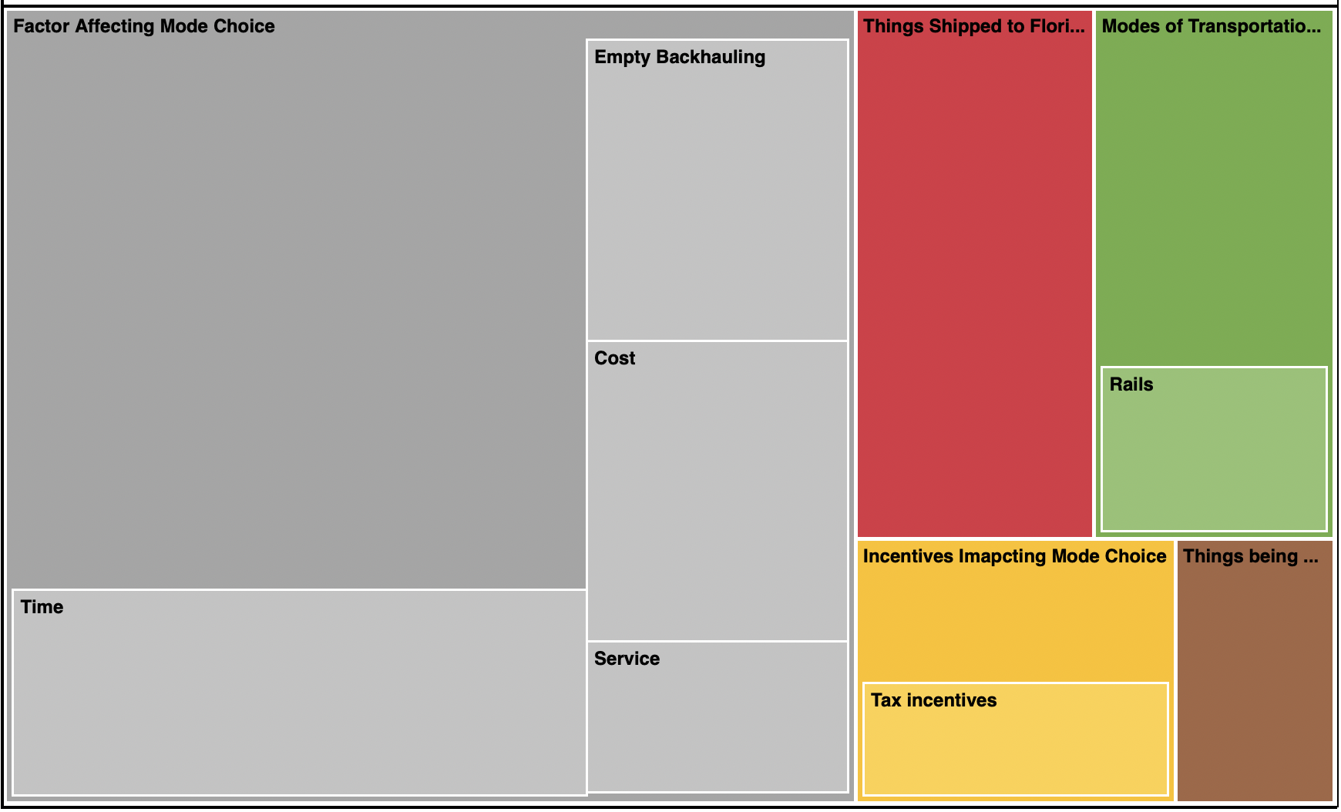
Figure 42. NVivo Hierarchy Chart of the First Interview

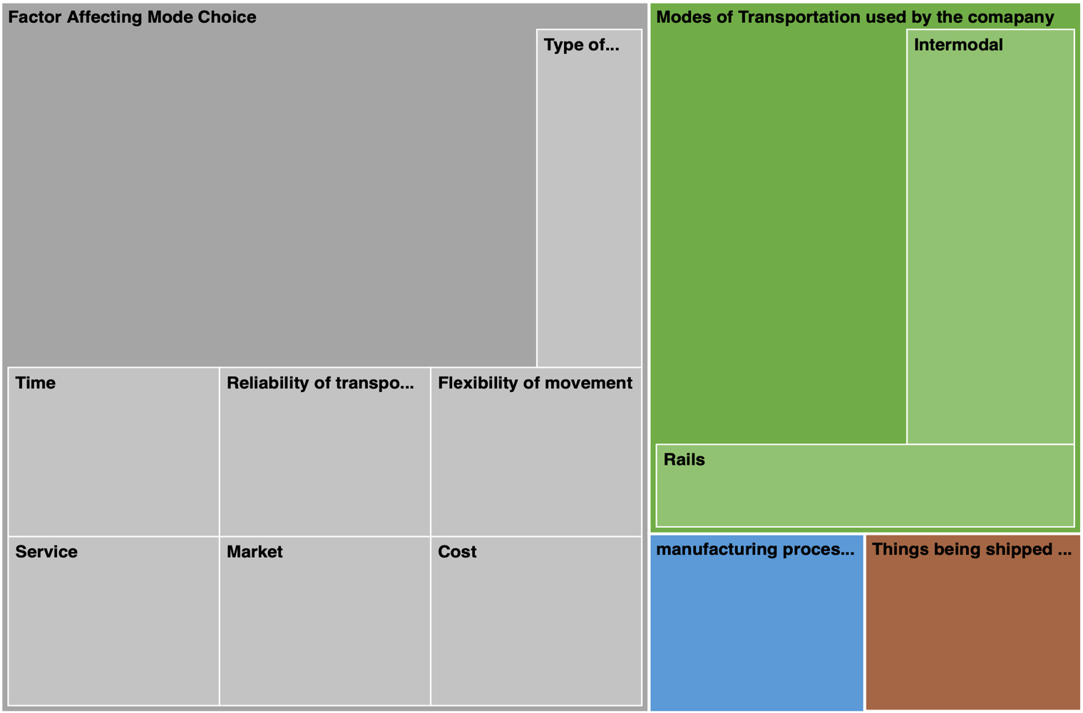
Figure 43. NVivo Hierarchy Chart of the Second Interview

In Figure 43, it is evident that factors affecting the mode choice, mode of transportation used by the company was more frequently cited than manufacturing, processing and logistic location factor. Because of the high number of factors and the discrepancy in frequency, some factors are not visible in Figure 43. Factor affecting mode choice included time, cost, service, market, reliability of transportation and flexibility of movement. Whereas in the modes of transportation used, the company uses rail and intermodal.

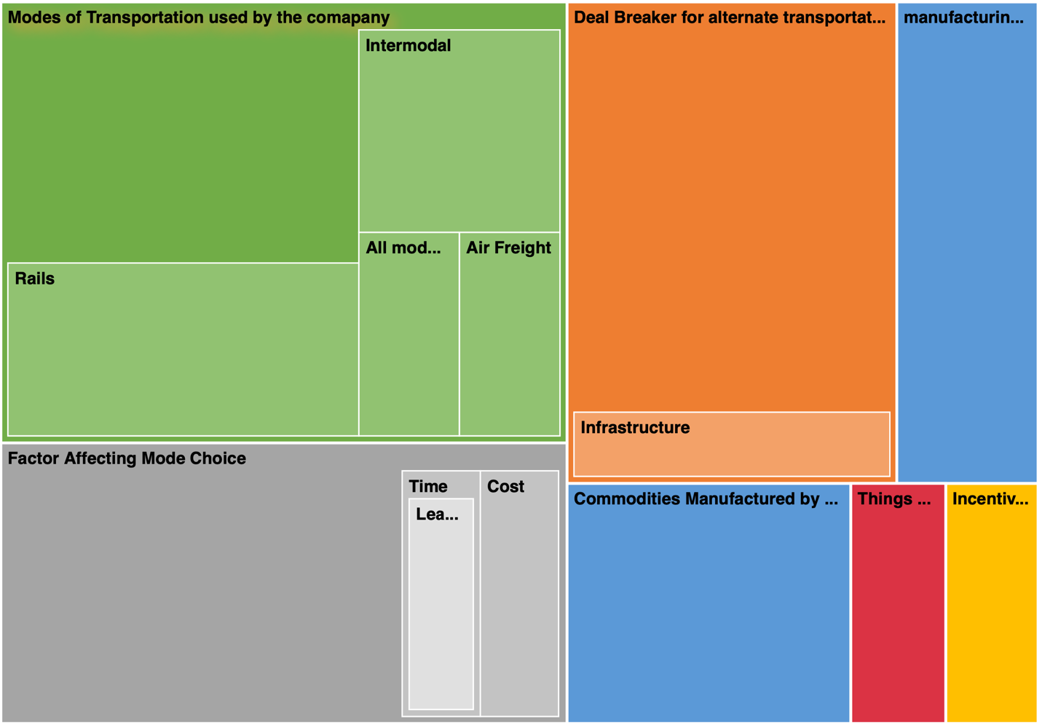
Figure 44. NVivo Hierarchy Chart of the Third Interview

In Figure 44, it is evident that factors affecting the mode choice, mode of transportation used, and dealbreakers for alternative transportation modes were cited more than other factors. Because of the high number of factors and the discrepancy in frequency, some factors are not visible in Figure 44. Factors affecting mode choice included time and cost whereas in the modes of transportation used, the company uses all modes of transportation.
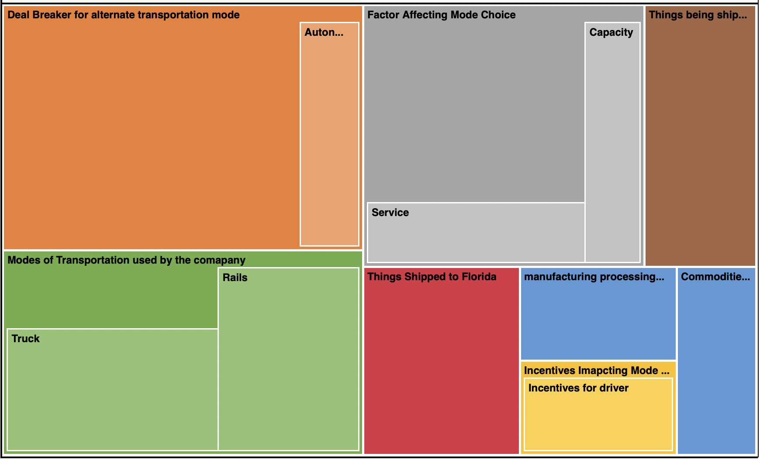
Figure 45. NVivo Hierarchy Chart of the Fourth Interview

In Figure 45, it is evident that dealbreaker for alternative transportation mode, mode of transportation used and factor affecting the mode choice were cited more than other factors. Factor affecting mode choice included service and capacity, whereas in the modes of transportation used, the company uses truck and rail. In addition, autonomous driving is a dealbreaker for the company.
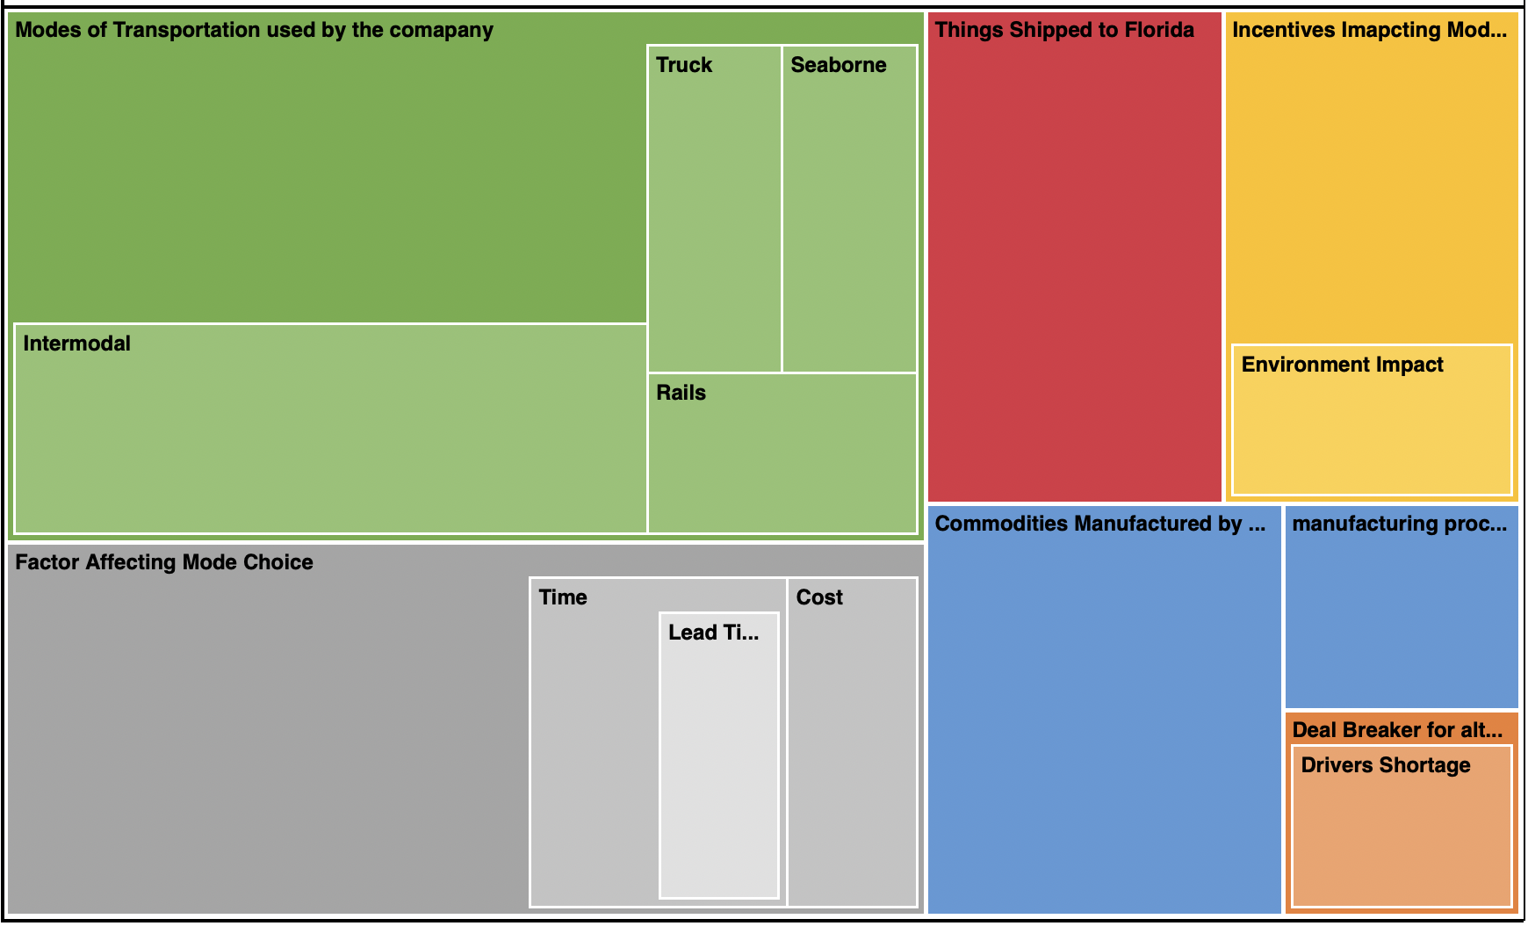
Figure 46. NVivo Hierarchy Chart of the Fifth Interview

In Figure 46, it is evident that mode of transportation used and factor affecting the mode choice were cited more than other factors. Factors affecting mode choice included time and cost, whereas in the modes of transportation used, the company uses truck, rail, seaborne and intermodal.

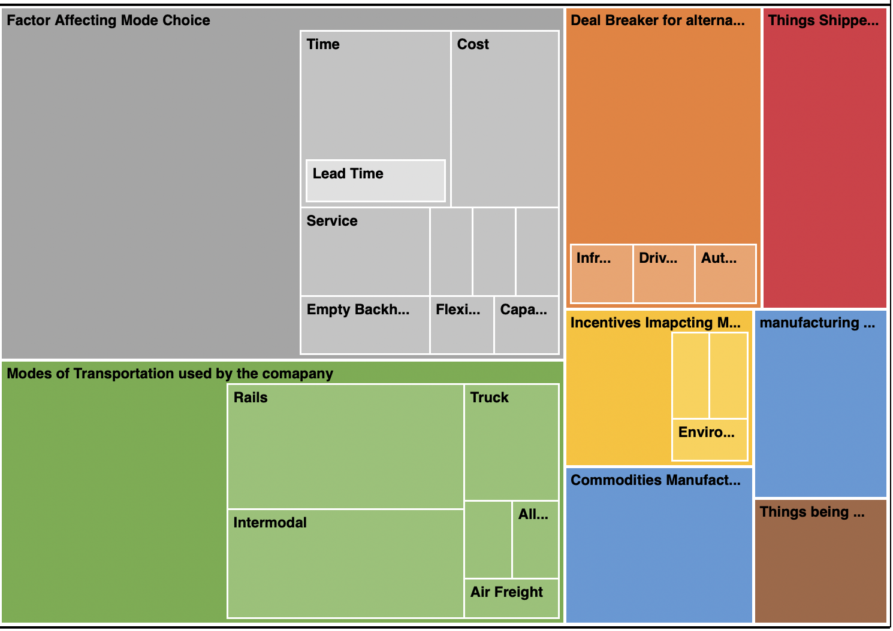
Figure 47. NVivo Hierarchy Chart of All Five Interviews Combined

In Figure 47, NVivo hierarchy of all five interviews combined, it is evident that factors affecting mode choice and mode of transportation used were cited more than all other factors.

In addition, we also analyzed the frequency of words in each interview transcript. This type of analysis can help unveil meaningful information from the transcripts beyond the NVivo factors. To help with this kind of evaluation, NVivo features a word cloud visualization, in which the font size represents the frequency of words. In word cloud visualization, the more frequent the words, the bigger they are shown. Also, to focus the analysis on potentially more meaningful words, this type of visualization usually excludes stop words–ubiquitous words that add very little value to the sentence, such as ”the”, “a”, “an”, and “which”.

First and second interview’s word clouds (Figure 48 and Figure 49) have highlighted words related to modes of transportation used, like for instance: “Rail”, “Truck”, “Train”, and “Intermodal”. Also, words that denote factors affecting the mode choice, such as “Cost”, “Time”,” Service”.
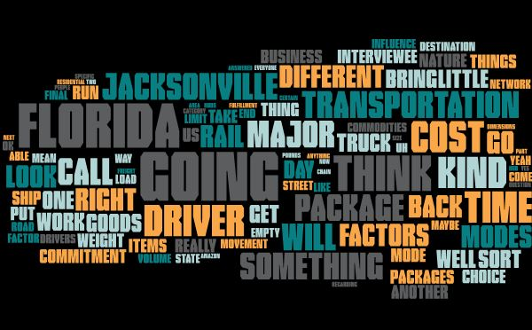
Figure 48. Word Cloud of the First Interview

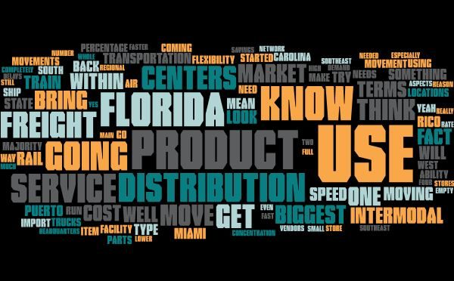
Figure 49. Word Cloud of the Second Interview

Nevertheless, the third interview word cloud highlights factors related to commodities shipped by the firm, such as "Material", “Plastic”, “Ship”, “Chemicals”, “Supply”. Also, factors affecting mode choice like “Cost”, “Time”, and “Market,” as shown in Figure 50.

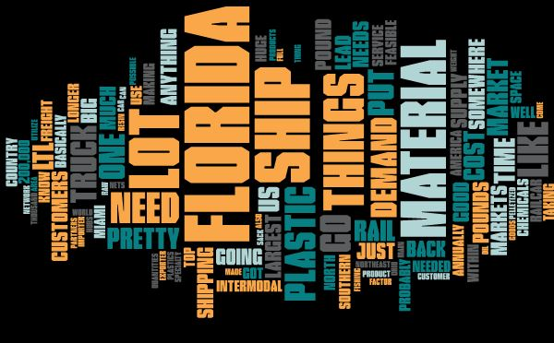
Figure 50. Word Cloud of the Third Interview

The word cloud of fourth interview, shown in Figure 51, highlighted factors like “Drivers”, “Capacity”, “Customers”, “Incentives”, “Service”, etc. that denote all major points covered in the interview.

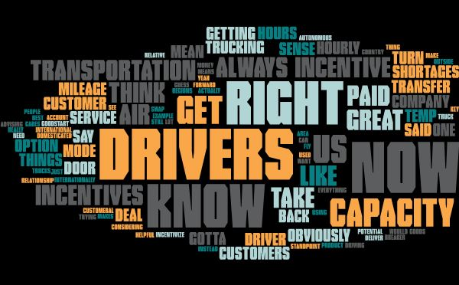
Figure 51. Word Could of the Fourth Interview

The word cloud in the fifth interview, shown in Figure 52, highlighted factors related to transportation like “Intermodal”, “Truck”, “Customers”, “Drivers”, “Shipments”, “Ocean”, and focuses on commodities manufactured and shipped by the firm like “Door”.

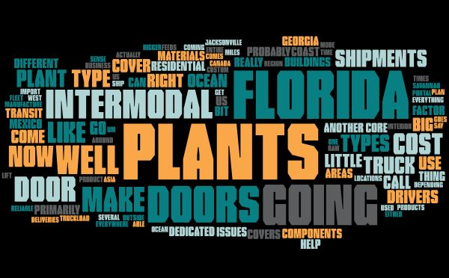
Figure 52. Word Cloud of the Fifth Interview

6. Recommended Backhaul Opportunities for Truck Drivers in Florida to Alleviate Empty Truck Backhauling

This section highlights the backhaul work opportunities data to provide recommendations on decreasing empty backhauling through these prospective backhaul work opportunities for truckers.

The work opportunities dataset contains the various alternate work opportunities available for the truck drivers in Florida and United States. The dataset contains the list of companies or platforms that provides various backhaul opportunities to truck drivers bringing goods to Florida. The research team investigated various available backhaul opportunities in United States, discover and access the best fitted opportunities for the State of Florida, which can lead to a reduction in empty backhauling towards its alleviation.

6.1 Available Online Platform for Trucking Backhauls Load Fulfillment
Based on extensive online research, the research team was able to find the online platforms that can be used to have truck drivers coming into Florida look for backloads as they are planning to drive into Florida to deliver goods. This way the empty backhauls could prospectively be eliminated and truckers bringing goods to Florida could prospectively align a load to be picked up from Florida for the backhaul. The below platforms are not in any specific order and are for informational purposes only.

6.1.1 Uber Freight
Uber Freight is a commercially available online platform/application that helps carriers and truck drivers to find loads within the continental United States. The truck drivers coming to Florida can prospectively take advantage of this and similar platforms and find backloads for their return trip and avoid empty backhauling. These types of platforms are one of the convenient ways for finding work opportunities for truck drivers in Florida, as Florida looks to alleviate empty backhauling.

Before, starting to use this app, the truck driver needs to sign up. Once their account is approved and authorized, they will be able to access their loads and book them through the app. Figure 53 shows the sign-up page for truck drivers.

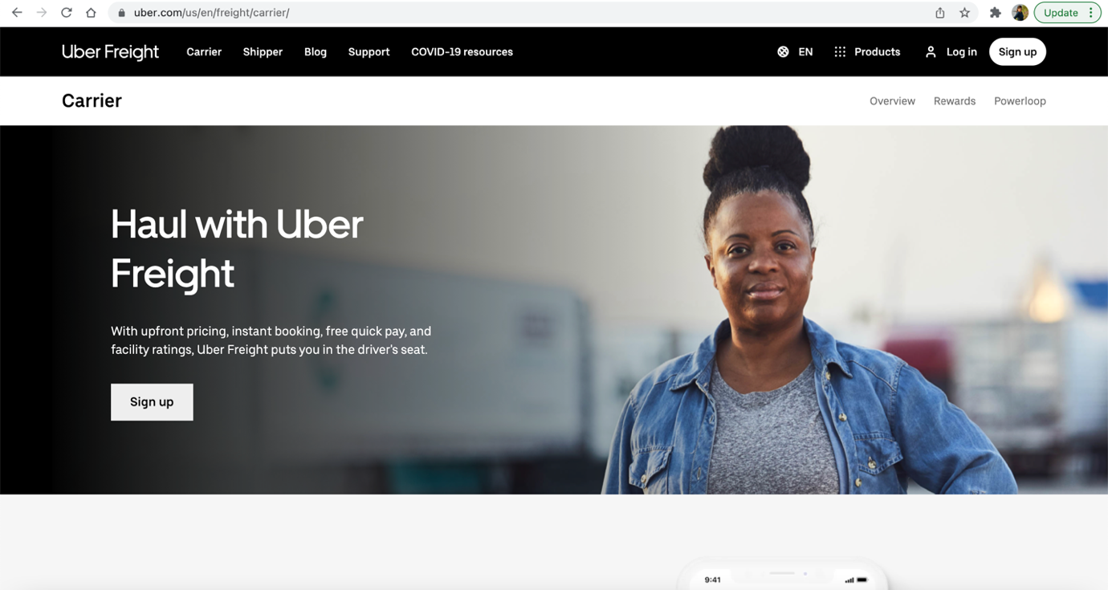
Figure 53. Uber Freight Landing Page

Once the truck drivers click on sign-up link, they are redirected to the registration page where they can provide their details to register on the App. Figure 54 shows the registration page that appears once the truck driver clicks on Sign up link.

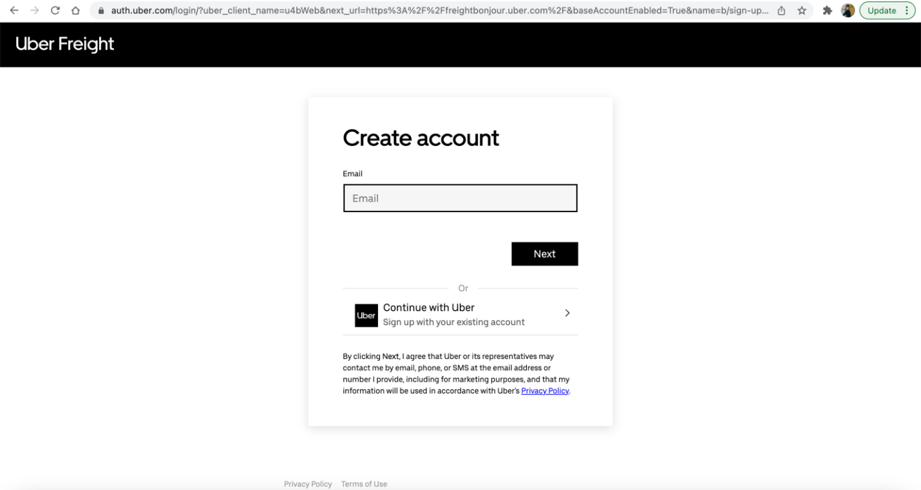
Figure 54. Uber Freight Carrier/Trucks Driver Registration Page
Uber Freight seems to have a user-friendly GUI. The driver needs to log in to their account, enter the pickup and drop-off location, and then get a quote.
The shipper who wants to ship their goods have a separate registration page. Figure 55 display the shipper’s registration page.

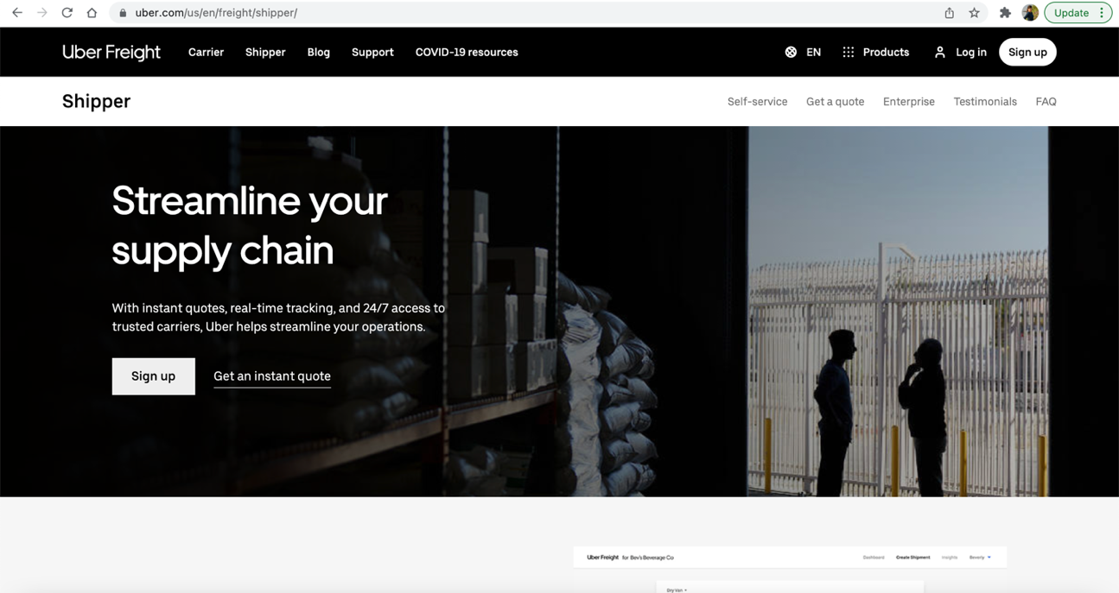
Figure 55. Uber Freight Shippers Driver Registration Page
Once the shipper clicks on the signup link, they are redirected to the below page (i.e., Figure 56)

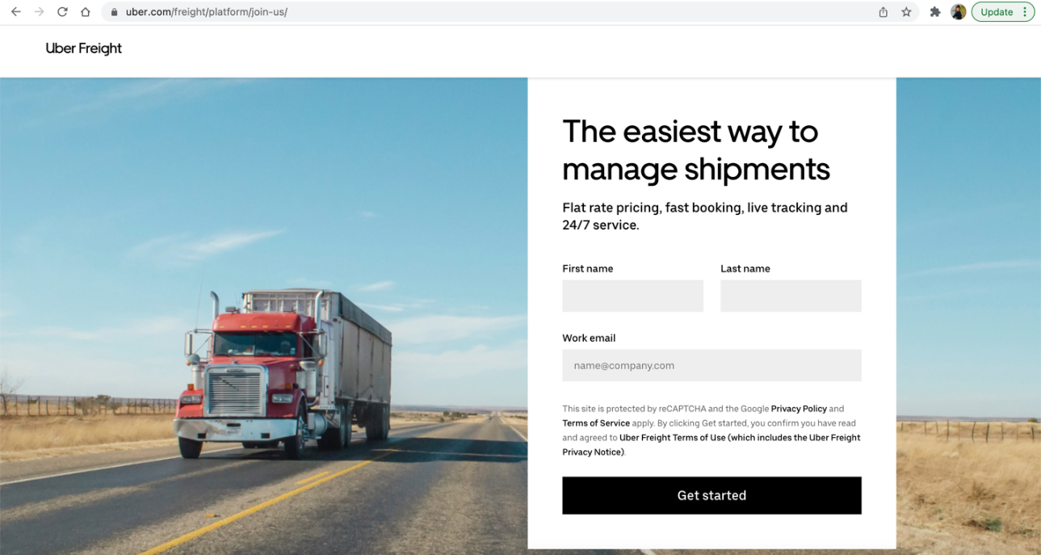
Figure 56. Uber Freight Shipper Account Creation Page
Uber Freight is one of the platforms available to find backhaul opportunities for the truck drivers bringing goods to Florida as this will allow them to carry shipments and goods on their return trip and therefore not going back empty towards the alleviation of empty backhauling.

6.1.2 Amazon Freight
Similar to Uber Freight, Amazon Freight is an online service that matches truck drivers with shippers. Like Uber Freight, the truck drivers can also take advantage of the online Amazon Freight platform (i.e., Figure 57) to find backhaul loads on their return trip from Florida.

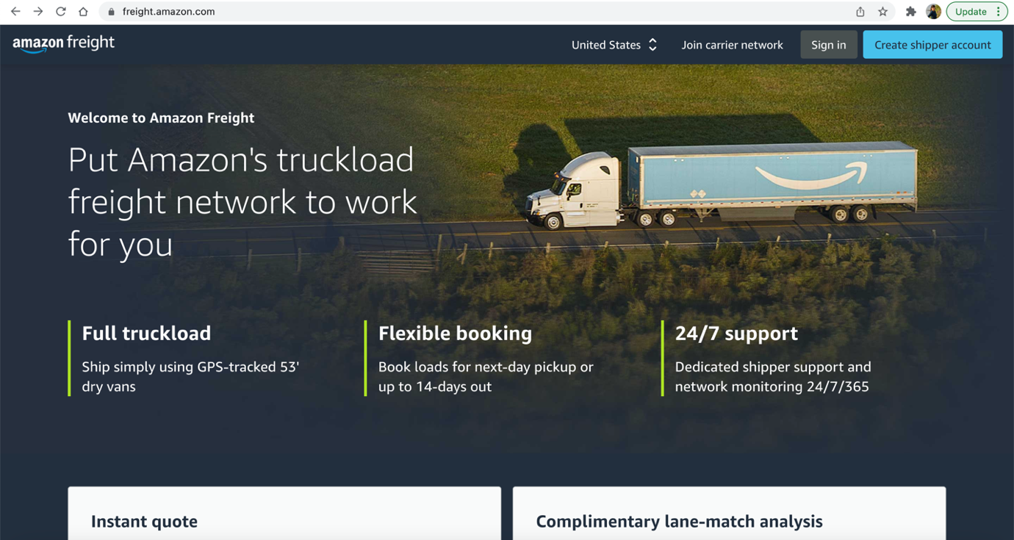Figure 57. Amazon Freight Website
Amazon Relay enables carriers/truck drivers to tap into their network, technology, and safety-first culture to build and grow their transportation businesses. Amazon Short-Term Contracts secures full workweeks for the truck drivers and the shipment company and guarantees revenue for provided trucks with single or multi-week contracts several weeks in advance.

The truck drivers/carriers can register by creating an account based on some pre -defined requirements. Figure 58 shows the requirements and the registration link. Once the user clicks on the create an amazon account link, he/she is directed to the registration page.
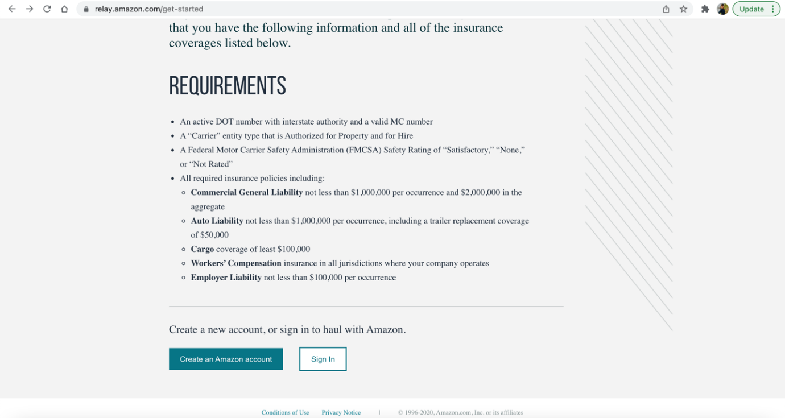
Figure 58. Amazon Freight Carrier/Truck Drivers Registration Requirements and Link
Below are some of the components of using Amazon Freight for the truck drivers and the carriers:
Short-Term Contracts: Amazon Freight suggests that this helps the carriers and the truck drivers to secure full workweeks and grow their fleet by locking in guaranteed revenue for provided trucks with single or multi-week contracts several weeks in advance.
Post A Truck: Amazon Freight suggests that this helps reduce empty miles and idle time by sharing when and where your trucks are available. Relay will automatically book loads matching the shippers’ criteria with the carrier and therefore focusing the small and large shipment companies to grow their business.
Load Board: Amazon Freight suggests that this helps choose a wide selection of exclusive work across Amazon's entire freight network with transparent, all-in pricing, and instantly book work.
Therefore, Amazon Freight was also reported by the research team as one of the online platform solutions for the backhaul opportunities to the truck drivers and thus helping in alleviating empty backhauling issues in Florida.

6.1.3 C.H. Robinson
C.H. Robinson states that they solve logistics problems for companies across the globe and across industries, from the simple to the most complex. Their global suite of services is advertised by the company to accelerate trade to deliver the products and goods that drive the world’s economy. Truck drivers can take advantage of multimodal transportation management system and expertise of C.H. Robinson and find loads for themselves. Figure 59 shows the C.H. Robinson website screenshot.
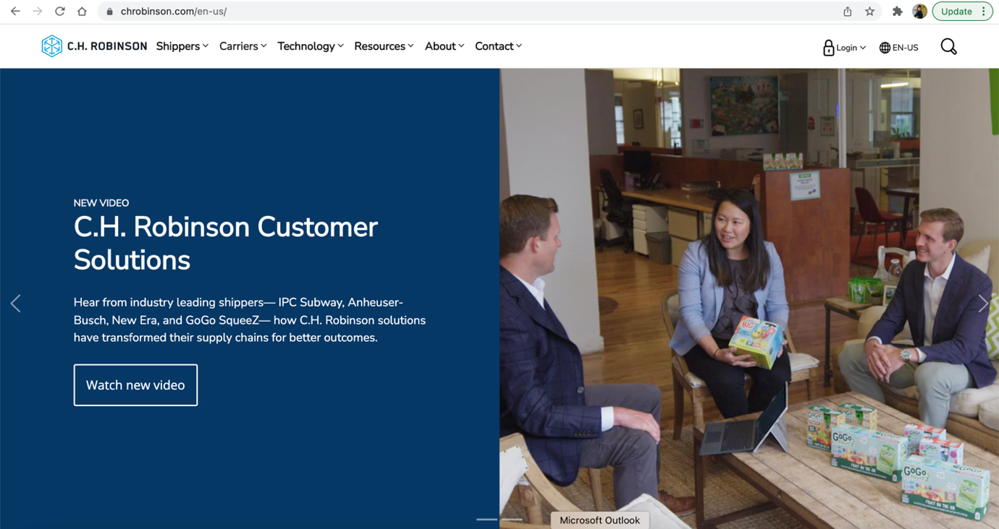
Figure 59. C.H. Robinson Website

The carriers tab (i.e., Figure 60) shows the different services provided by C.H. Robinson to the Carriers/truck drivers. The carriers can create their account by registering on their website and can take advantage of different work opportunities from their services.

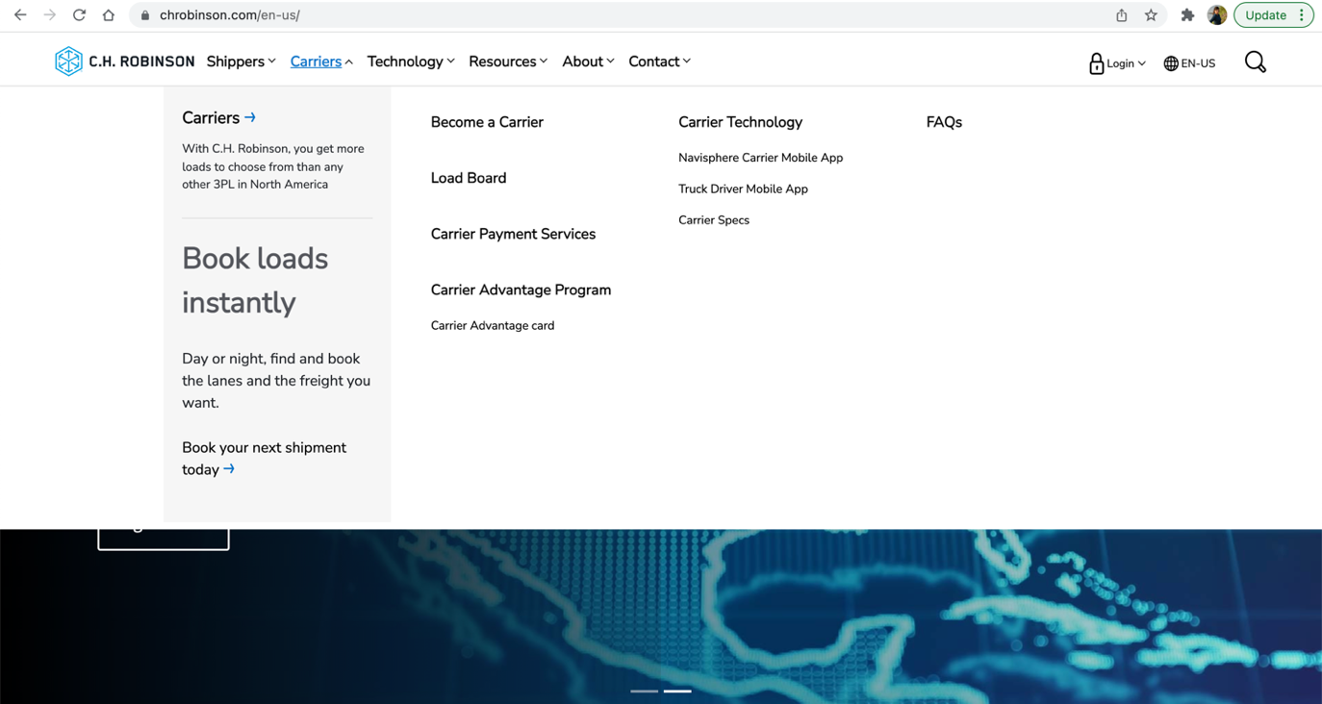
Figure 60. C.H. Robinson Carriers Service Page
Figure 61 shows how a truck driver can register on their website by clicking on the “get started” link, which redirects them to the registration steps (Figure 62). These include the fulfillment of certain requirements such as providing MC/MX number or DOT number, submit electronic W-9, providing certificate of insurance, read & accept Motor Carrier Agreement, etc.

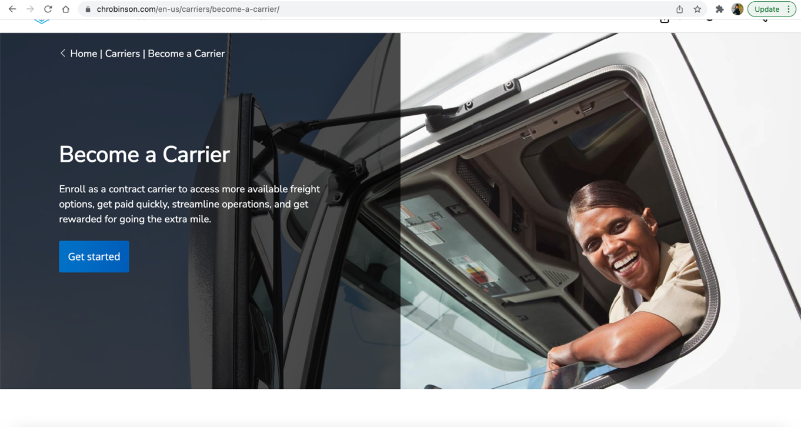
Figure 61. C.H. Robinson Carrier/Truck Drivers Registration Link Page

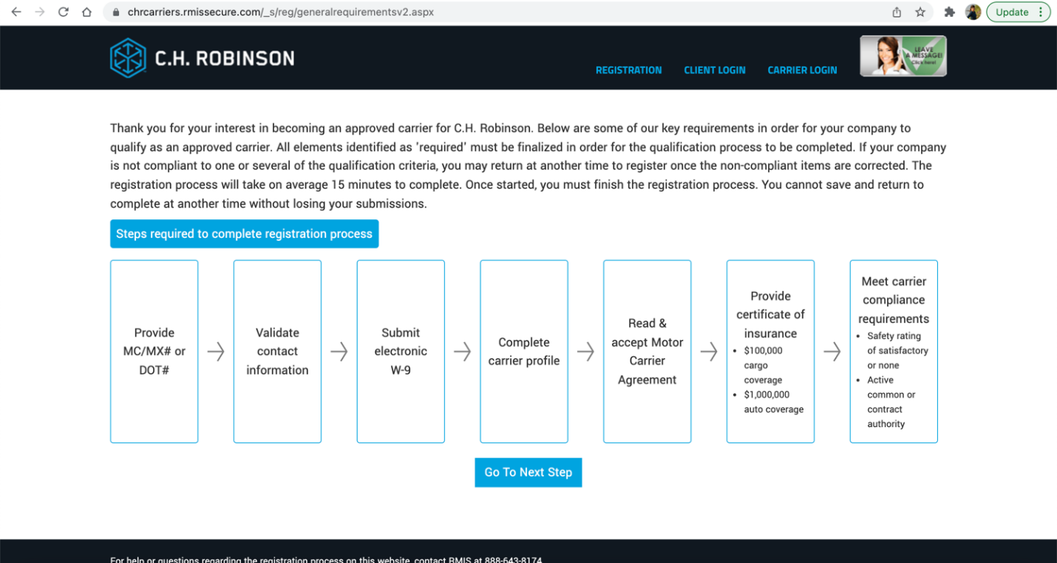
Figure 62. C.H. Robinson Carrier/ Truck Drivers Registration Steps

Therefore, C.H. Robinson’s services were also reported by the research team as another opportunity for the truck drivers to find backhaul opportunities.

6.1.4 Freightview
Freightview uses freight software to compare, book, track and analyze shipments with their carriers or truck drivers. Florida truck drivers can also take the advantage of the Freightview service to find backhaul loads for their return trips from Florida.
If a trucker is transporting LTL freight or parcels, Freightview can consolidate the negotiated LTL and parcel prices in one place. It also allows shippers to schedule pickups, creates bills of lading, print shipping labels, and shippers’ tracking from start to finish.
It is highlighted by Freightview that it has an easy-to-use shipping management software that consolidates the negotiated freight and parcel rates into one place so customers can compare rates and book their shipments accordingly. Figure 63 show the website of Freightview and how a truck driver can register on it.
Therefore, the Freightview platform was also reported by the research team as another opportunity for truck drivers to find backhaul opportunities for their trip back from Florida.
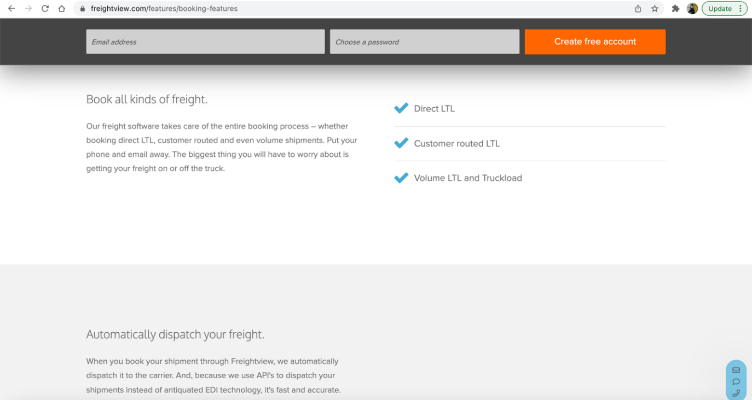
Figure 63. Freightview Website

6.1.5 Truckstop.com Load Board
Truck drivers coming in Florida can also take advantage of Truckstop.com application to find backhaul opportunities towards the alleviation of empty backhauling in Florida. The Truckstop.com Load Board gives logistics companies access to approved users and allows to search for trucks and routes. Its load board offers real-time load updates as well as additional features such as precise rate data by equipment type, rate trends, and rate levels.
Truckstop.com suggests that they deliver software solutions to support the entire freight-moving lifecycle, from matching to payment, to anything in between. Figure 64 shows the truckstop.com website.
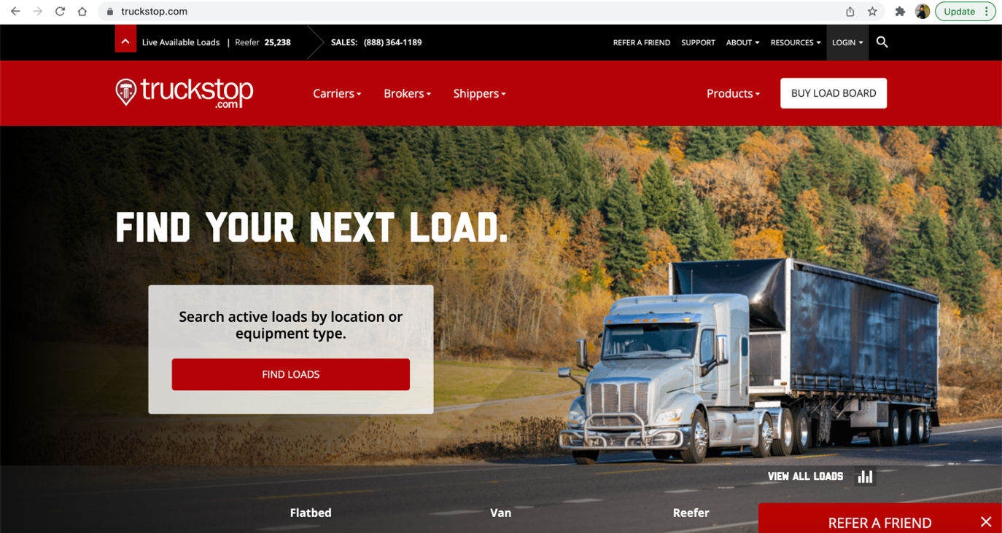
Figure 64. Truckstop.com Website
Similar to the above-mentioned other platforms, with truckstop.com the carrier or truck driver can register and based on their requirements, they are matched with the load that they can pick up for their backhaul trip from Florida.

6.1.6 Convoy
Convoy is another available platform that can help truck drivers to find backhaul opportunities from Florida. Convoy is a technology to identify better methods to link forwarders and carriers. It enables the transport of millions of truckloads via linked network of carriers. Convoy suggests that they focus on three important aspects i.e., maximize earnings, reduce hassle for the driver and shipper, and being able to see all the loads. Convoy’s digital freight network suggests that it gives the truck drivers the opportunity to maximize their earnings. In addition, it is suggested that the Convoy system reduces hassle as it allows finding and managing work from a smart phone or computer and the user can see shipper and facility names, addresses, and ratings on every load. The shippers can track their fleet’s locations and arrival times with GPS along with getting automatic alerts when loads are available on their preferred lanes. Figure 65 shows the Convey website.

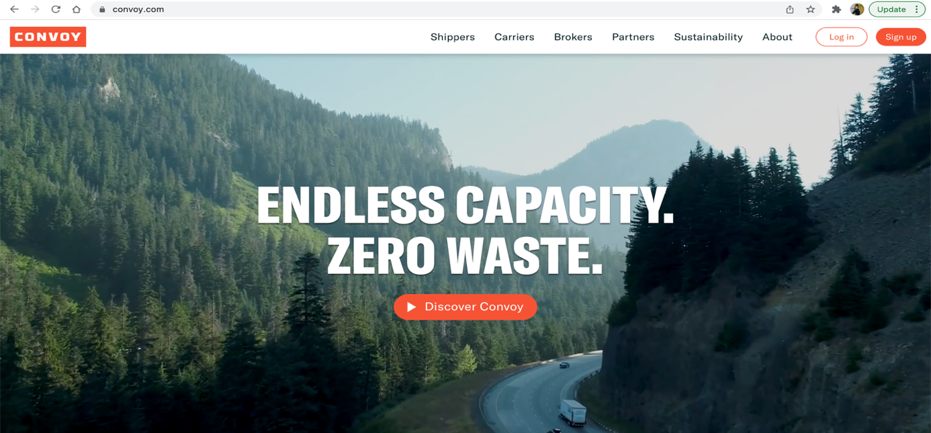
Figure 65. Convoy Website
The Truck drivers can register on the website or app by going in the Carrier Tab and creating their account. Once the truck drivers have register themselves, they can use Convoy’s service and can be matched with the backhaul load they can take from Florida. Figure 66 shows the Carriers registration page for truck driver registration.
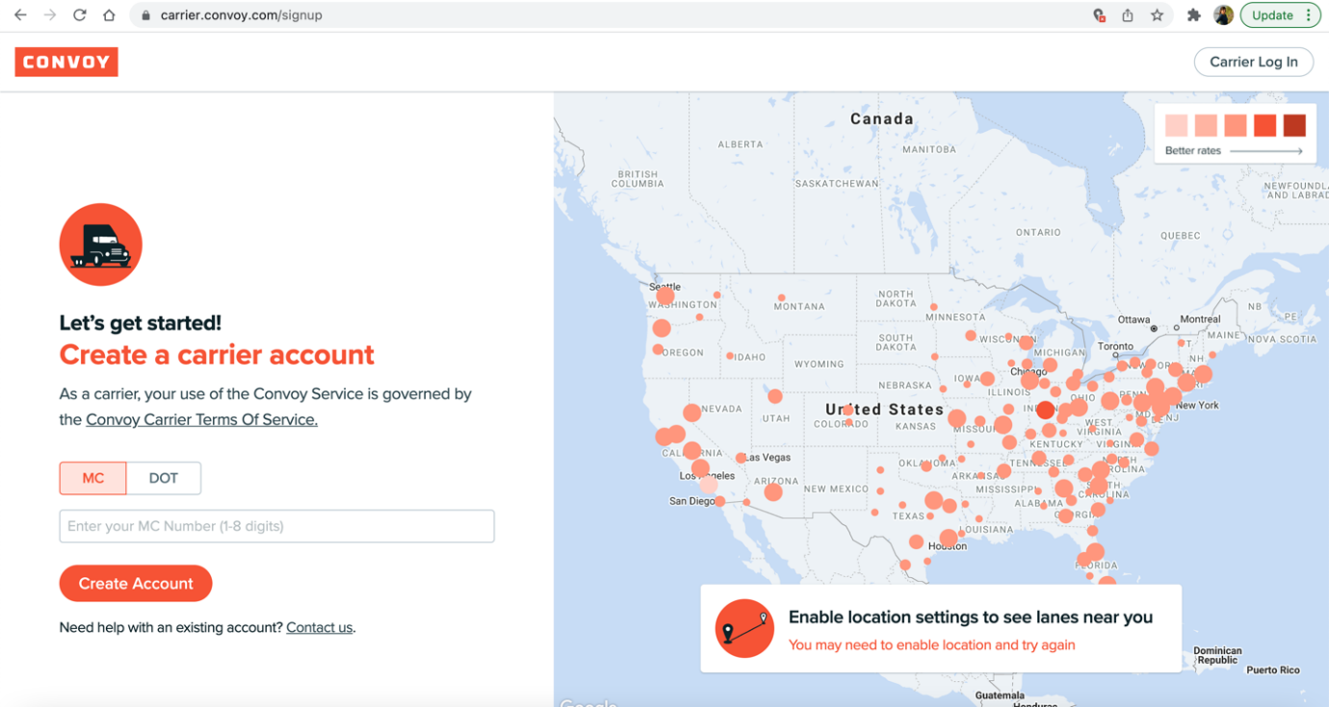
Figure 66. Convey Carrier/Truck Drivers Account Creation Page

6.1.7 Shipwell

Just like the aforementioned commercial platforms, the truck drivers coming in Florida can also take advantage of the Shipwell platform to search for backhaul opportunities. Shipwell is a centralized freight TMS that allows shippers, 3PLs, and freight forwarding companies to collaborate in one location. Shipwell suggests that it helps to discover broken connections in the supply chain by using analytics and reliable data. Its automation and machine learning algorithms, as advertised by the company, are said to have been designed to save time and money for users. Figure 67 shows the Shipwell website.
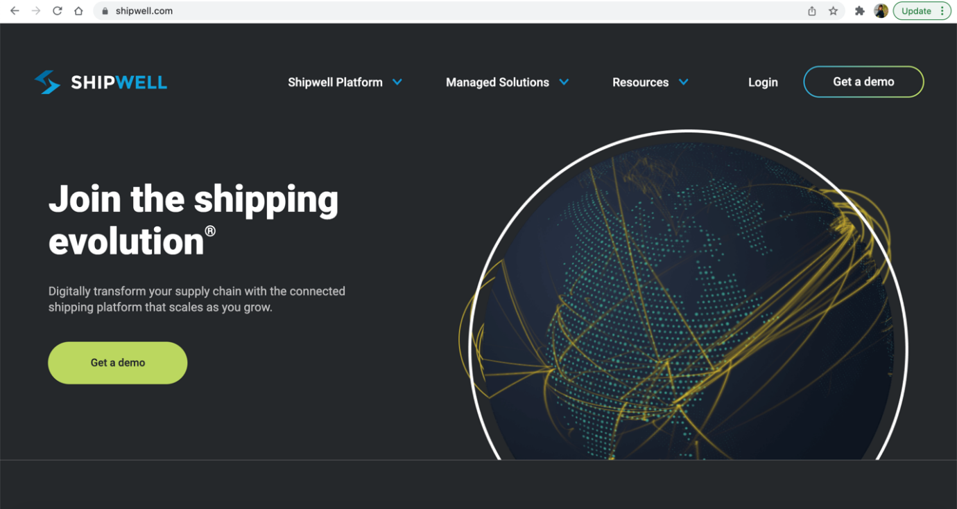
Figure 67. Shipwell website

Truck drivers can register on this website through the Carrier sign up page. Figure 68 shows the Carrier sign up page where the truck drivers can provide all the required details and can receive access to the Shipwell Load Board.
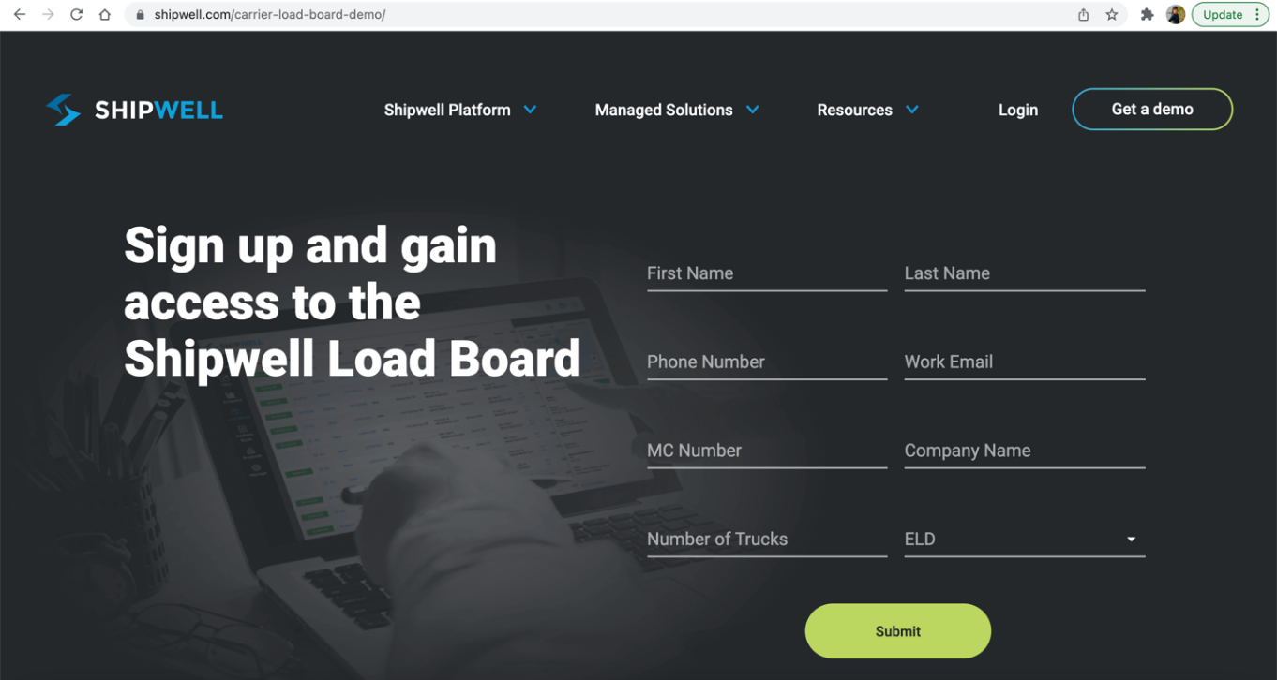
Figure 68. Shipwell Carrier/Truck Driver Sign-up Page

The above-mentioned platforms and companies can be used to educate the truck driver population bringing goods to Florida, as well as the shipper population to/from Florida, so that they prospectively utilize these services to be able to find backhaul loads to pick up from Florida towards the alleviation of empty backhauling. The above mentioned platforms/services were not intended to be an all-inclusive list, and were determined by research and expert interview responses as some of the available resources for truck resources to help them find backhaul loads.

6.2 Manufacturing Impact on Backhaul Opportunities for Truck Drivers

Increasing manufacturing in Florida would also have a great impact on the alleviation of truck empty backhauling, since an increase in manufacturing would prospectively lead to more goods production. And this in return would prospectively result in having more goods to ship from Florida to other states.
The high performing, emerging, and legacy manufacturing sectors listed in the above sections would play an important role in alleviating Florida’s empty backhauling problem through the creation of more outbound freight and filling up the trucks with goods on the return trip.
As also highlighted in Section 4 of this report, the research team analyzed the future manufacturing potential that will create more outbound freight and thus reduce empty backhaul movements in the top 14 counties with highest empty backhauling. Please refer to Section 4 for details.

West Central Gulf Coast Manufacturing Sector

The counties with highest empty backhauling that are the part of West Central Gulf Coast (WCGC) region are Hillsborough, Pinellas, and Polk. The major city in the WCGC regional economy is Tampa. The labor market in the West Central Gulf Coast region is considerably tighter than at either the state or the national level. Hillsborough has a total labor force of 745,455 and Pinellas and Polk have the labor force of 488,857 and 308,560, respectively (as of December 2020).

The WCGC region has a diverse economy for a metropolitan region of its size, with its level of industrial diversity just above that of the statewide economy overall. With almost 50% of its manufacturing industry employment in advanced manufacturing subsectors, (a share greater than is seen in the United States overall), the WCGC region has significant opportunities for manufacturing sector innovation (i.e., creation of new patents) and productivity growth. It can also expect these sectors to employ more highly skilled workers and pay higher wages than other manufacturing sectors. The average annual wage per labor is $60,049 in Hillsborough County, $53,583 and $46,163 in Pinellas and Polk, respectively.

Half of the WCGC region’s manufacturing industry is composed of high-performing and emerging sectors. Table 3 in Section 4 shows potential manufacturing subsectors, which can have a positive impact on the reduction of empty backhauling.
The six high-performing manufacturing subsectors currently contribute to 14.8% of total manufacturing employment in the West Central Gulf Coast region. The emerging manufacturing sectors indicate positive employment growth potential, as well as the potential to reduce empty backhauling in future. The legacy subsectors provide more than 17,800 jobs in manufacturing.
Central Florida Manufacturing Sector

Brevard County with 55.55% of empty backhauling percentage is part of the Central Florida region. With more than 290,000 work force and 278,878 current manufacturing jobs, it is a county with a much higher employment rate and annual average wages. The average annual wage is $53,901 for Brevard County. Computer and electronic products manufacturing sector are more concentrated in the Central Florida region with a high LQ value of 2.0.
Based on the Compound Annual Growth Rates (CAGRs) and Location Quotient (LQ) there are six high-performing manufacturing subsectors which performed much better than the United States and had LQ values greater than 1.
Table 4 in Section 4 shows the potential manufacturing subsectors in Central Florida region, which can have a positive impact on the reduction of empty backhauling.

First Coast Manufacturing Sector
The First Coast region is comprised of Duval and Nassau counties. Duval has 55.33% and 53.01% empty backhauling for the WIM sites 9914 and 9905 respectively, and Nassau has 36.40% of empty backhauling. Jacksonville is the major city in the regional economy, situated within Duval County, a part of the Jacksonville, Florida, metropolitan statistical area (MSA).
Duval and Nassau have 4.8% and 3.8% unemployment rates respectively, therefore the labor market in the First Coast RMA is tighter as of April 2021 than at the national and state levels, where the unemployment rates were 6.1% and 4.8%, respectively as of April 2021. The average annual wage is $ 56,869 and $43,884 for Duval and Nassau Counties, respectively.
Table 5 in Section 4 shows potential manufacturing subsectors, which can have a positive impact on the reduction of empty backhauling. These potential industries include high-performing manufacturing sectors that outperformed the United States and represented an above-average share of the region’s economy (i.e., LQs values above 1.0).
Gainesville Manufacturing Sector
The county with highest empty backhauling percentage that is part of the Gainesville region is Columbia with 35.95%. Columbia is in the Lake City, Florida micropolitan statistical area.
Columbia has an unemployment rate of 4.9%, which is a tighter labor market compared to the US level. It has a labor force of 30,369 and average annual wage of $40,810 as of April 2021, which is lower than the other counties considered for this study. This region has a relatively small portion of the region’s manufacturing sector. Miscellaneous, wood product, and machinery manufacturing currently offer the greatest number of manufacturing jobs in the region
The miscellaneous manufacturing sector, which includes the manufacture of medical equipment and supplies, office equipment, and sporting goods, grew 5.9% between 2000 and 2015 and had more than 1,850 employees in the Gainesville region in 2015. The Gainesville region hosts the global headquarters of medical equipment manufacturer Exactech, Inc. and a few manufacturing facilities.
Table 6 in section 4 shows potential manufacturing subsectors which can have a positive impact on the reduction of empty backhauling. These potential industries include high-performing manufacturing sectors that outperformed the United States and represented an above-average share of the region’s economy (i.e., LQs values above 1.0).
The nine high-performing sectors highlighted above currently account for 61.2% of total manufacturing employment in the Gainesville region. The emerging sectors should receive special attention because while they currently account for below-average shares of economic activity, this is where growth opportunities are likely to be found and this could create more outbound freight and thus reduce empty backhaul movements.
Northwest Florida and Capital Region Manufacturing Sector
The counties with highest empty backhauling percentage representing Northwest Florida and Capital Region are Escambia and Madison with 35.52% and 35.53% of empty backhauling. Escambia has more than 150,000 labor force on the contrary Madison has a labor force of 7,887, which is the lowest among all the 14 Florida counties with highest empty backhauling.
Escambia and Madison have unemployment rates of 4.9% and 5.6%, respectively. The transportation equipment, machinery, chemical, wood product, fabricated metal products, and nonmetallic mineral manufacturing sectors each offered more than 1,000 jobs in the region and together represent 72% of regional manufacturing industry employment as of 2016.
Table 7 in Section 4 represents potential manufacturing subsectors which can have a positive impact on the reduction of empty backhauling. These potential industries include high-performing manufacturing sectors that outperformed the United States and represented an above-average share of the region’s economy (i.e., had employment LQs above 1.0) and emerging manufacturing industries along with the legacy industries.
The eight high-performing sectors currently account more than 40% of total manufacturing employment in the Northwest Florida and Capital Region. The high-performing and emerging sectors represent nearly two-thirds of regional manufacturing employment. Supporting these high performing and emerging sectors would be very critical towards the goal of reducing the empty backhaul problem.
South Florida Manufacturing Sector
The South Florida Region counties with highest empty backhauling percentage and high freight activity include Palm Beach, Miami-Dade and Broward County. Palm Beach has 55.65% of empty backhauling. With more than 1.3 million total labor force, Miami-Dade manufacturing employment totaled over 41,000 in 2019. Palm Beach has 739,543 total labor force and Broward has more than 1 million labor force with high freight movements. The average annual unemployment rate in the South Florida region has been on par with the statewide rate and less than a third of a percentage point higher than the national unemployment rate.
Manufacturing sector comprises just over 100,000 jobs. The Transportation equipment, Miscellaneous, Food, Fabricated metal products, Computer and electronic product, Nonmetallic mineral, Machinery, Chemical, and Furniture and related products manufacturing sectors each provide employment to more than 5,000 workers in the South Florida region. Table 8 in section 4 represents potential manufacturing subsectors, which can have a positive impact on the reduction of empty backhauling.

Southwest Regional Manufacturing Sector
The Southwest Florida Region count with highest empty backhauling percentage and high freight activity is Collier with 61.21% of empty backhauling. Collier recorded a 188,279 labor force and 3.8 % unemployment rate in April 2021.
The manufacturing sector provides employment to 11,000 workers and miscellaneous, nonmetallic mineral, machinery, and transportation equipment manufacturing sectors offered more than 1,000 jobs each.
There are three high-performing manufacturing sectors and many emerging manufacturing sectors in this region. Table 9 in Section 4 represents potential manufacturing subsectors, which can have a positive impact on the reduction of empty backhauling.
Volusia Manufacturing Sector
The Volusia region comprises Volusia County, which is situated within the Deltona-Daytona Beach-Ormond Beach, Florida metropolitan statistical area (MSA). With 255,409 labor force and 5.2 % unemployment rate, the average annual unemployment rate in the Volusia region has been higher than both the statewide and the national unemployment rates. The Volusia manufacturing sector provides employment to more than 10,000 workers.
Textile product mills have a positive employment growth rate, a higher-than-average concentration of employment, and relatively large number of jobs. More than 70% of the Volusia’s manufacturing industry is comprised of high-performing and emerging sectors.
Table 10 in Section 4 illustrates Volusia’s potential manufacturing subsectors, which can have a positive impact on the reduction of empty backhauling.
The three major reasons why Florida is an ideal location for manufacturing businesses, were determined to be robust infrastructure, tax advantages and the availability of skilled work force as highlighted in this subsection.

6.3 Unified Online Platform for Incoming Truck Drivers for Backhaul Opportunities

An additional idea includes the prospective creation of a unified online platform for load fulfillment specific to the State of Florida, where truck drivers coming to Florida can register on the application and can have access to various small-scale and large-scale loads that they can pick up on their backhaul trip from Florida to other states. This application or online platform can be created, implemented, and managed by a third party and would require a champion to ensure its success. Along with the truck drivers, small shipping companies can register on this platform and can access to large number of truck drivers, which can carry their goods from Florida to other states at a reasonable price. This would be prospective win-win for both the truck drivers and the shippers. Figure 69 and Figure 70 show prototype landing pages for a unified incoming truck drivers’ platform for load fulfillment in Florida, if deemed feasible at the state level.

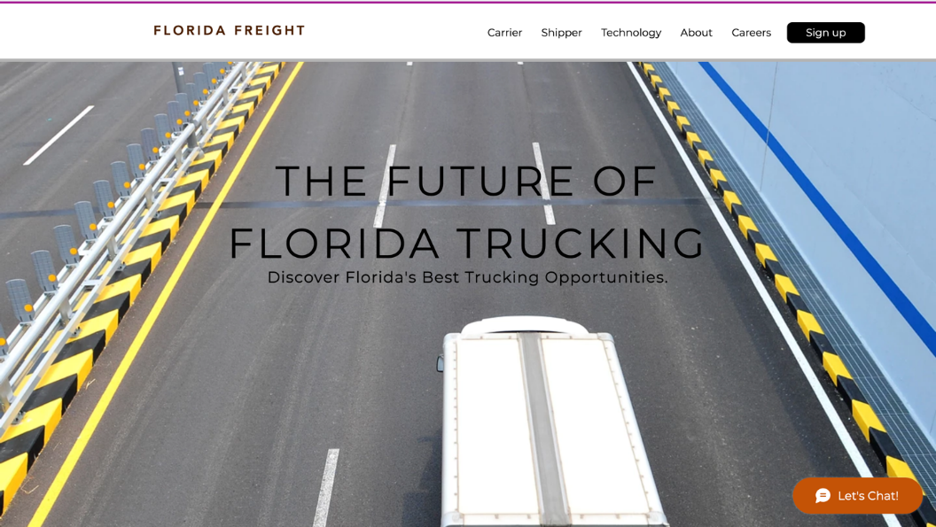
Figure 69. Unified Platform Prototype

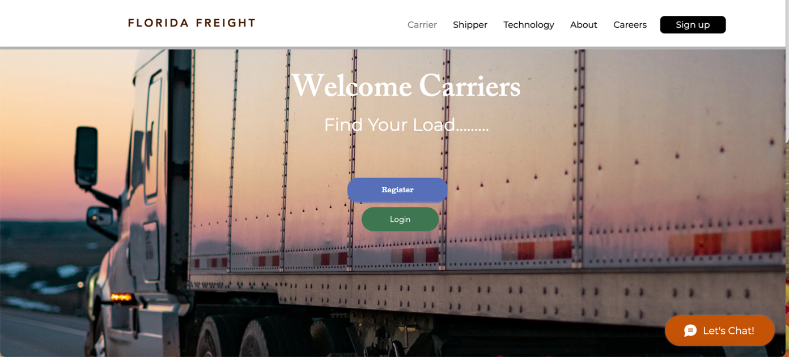
Figure 70. Carriers/Truck Drivers Page Prototype

7. Conclusions, Recommendations and Future Research

After reviewing the available literature on empty backhauling in Section 2, it was observed that Florida is not the only state/region, which has empty backhauling problems. Through this literature review, we have identified other states as well as the other countries with similar problems. This literature review also looked at the solutions implemented by various transportation departments to alleviate empty backhauling and we have a clear picture on percentages of backhauling and different solutions countries have adopted to alleviate empty backhauling.
Per the literature review in Section 2, it can be concluded that empty backhauling is an important problem, which affects a state’s economy. Some of the important techniques discussed in this literature review to alleviate empty backhauling were using collapsible containers, horizontal co-operation, and container sharing and substitution between different industries.
In Section 3 of this report, the research team analyzed the available Weigh-in-Motion (WIM) data for the years 2018 and 2019 for each truck passing through major WIM stations across the state of Florida. The research team obtained the empty backhauling truck percentages using this data and based on that determined the sites/locations/counties which required the highest level of empty backhaul alleviation. The research team examined empty backhauling percentages for various counties that have interstate highways passing through them for previous years. This gave a clear picture of the top counties which needed more attention and focus to alleviate this empty backhauling problem.
In Section 4, the research team analyzed the high performing, emerging and legacy manufacturing sectors in these top 14 counties which could play an important role in alleviating Florida’s empty backhauling problem through the creation of more outbound freight and filling up the trucks with commodities on their backhaul trip.

In Section 5 of this report, the research team interviewed the industry partners, such as manufacturers, major shippers, and freight forwarders, that operate both in and out of Florida in order to fully understand/analyze their decision-making criteria for their current shipping practices and choosing alternative transportation modes such as barge, rail, etc. The research team systematically interviewed executives from five companies in manufacturing, shipping and freight forwarding, which operate both in and out of Florida to assess the factors that impact the decision-making process of each firm.

A list of key factors for current shipping practices and for selecting alternative transportation modes were developed. These factors include time, cost, service, and empty backhauling related issues. Through the interviews, the research team also discovered additional factors such as reliability of transportation, capacity of goods being shipped, market and flexibility of movement that impact their mode choice.

The researchers discovered that majority of companies utilize trucking for shipment of products, however, might be persuaded by local and/or state government incentives to consider alternate transportation modes for shipping their commodities. Among the interviewees that participated, the alternate modes are most likely to be rail and seaborne modalities.

In Section 6 of this report, the research team provided recommendations on how truck drivers coming into Florida, bringing goods that are destined for Florida, can find work to leave the state with less-than-truckload (LTL) or truckload (TL) rather than empty backhauling out of the state.

The various work opportunities highlighted in Section 6 as available for truck drivers would prospectively help them find backhaul load opportunities for their return trip from Florida. Different online platforms and companies highlighted in this report could provide the truck drivers with backhaul load opportunities, which not only helps them earn additional wages, but also alleviates empty truck backhauling.
In addition, the high performing, emerging, and legacy manufacturing sectors highlighted in this report would play an important role in alleviating Florida’s empty backhauling problem through the creation of more outbound freight and filling up the trucks with goods on the backhaul trip.
Also, if a prospective unified incoming truck driver’s platform for load fulfillment purposes could be set up by a third party, specifically for the State of Florida, this may help in the alleviation of empty truck backhauling. However, this idea needs a strong champion to ensure its success if this is deemed feasible by the state.

The above-mentioned conclusions and recommendations have the potential to help Florida alleviate the truck empty backhauling problem as discussed throughout this report.

As the future research direction, items to understand the manufacturing industries and help foster initiatives needed to increase manufacturing productivity are necessary and highlighted as follows:

- What initiatives should be taken by the State of Florida for the emerging manufacturing sectors so that they can develop into high performing sectors

- Identify individual firms in each of the high performing and emerging sectors and identify and analyze formative success factors for the enhancement of manufacturing growth throughout Florida

- Further analysis of the legacy industries to identify the factors that comprise their historical success and competitiveness in Florida

- Identify regional competitive advantages that apply across all the manufacturing subsectors and those that are uniquely important to a few specialized subsectors

- Identify specific factors where firm level and regional/local measures can make a substantial difference
  - Firm-level factors such as effective management, efficient operations, competitive prices, superior product quality, etc.
  - Regional competitive advantages such as lower cost of doing business; high quality of labor; proximity to markets, suppliers, or both; lower tax rates; excellent transportation networks; favorable regulatory environment; etc.

References

American Transportation Research Institute. (2018). An Analysis of the Operational Costs of Trucking: 2018 Update. Retrieved from https://truckingresearch.org/wp-content/uploads/2018/10/ATRI-Operational-Costs-of-Trucking-2018.pdf
Arizona Department of Transportation. (2014). Arizona State Freight Plan: Economic Context of Freight Movement in Arizona. Retrieved from https://www.azdot.gov/docs/default-source/planning/State-Freight-Plan/14325-arizona-state-freight-plan-phase-3-economic-context-report.pdf?sfvrsn=2
Angel Juan, Javier Faulin, Elena Pérez-Bernabeu and Nicolas Jozefowiez. (2014). Horizontal Cooperation in Vehicle Routing Problems with Backhauling and Environmental Criteria. Procedia - Social and Behavioral Sciences, Elsevier, 111, pp.1133 - 1141. ff10.1016/j.sbspro.2014.01.148ff. ffhal-01913511f
Behrens, K., and Picard, P. M. (2011). Transportation, freight fates, and economic geography. Journal of International Economics, 85(2), 280-291.
De Oliveira G.F. (2014). Determinants of European freight rates: The role of market power and trade imbalance. Transportation Research Part E: Logistics and Transportation Review, 62, pp. 23-33
Department for Transport (2004), Transport of Goods by Road in Great Britain, Department for Transport, London. https://books.google.com/books?id=-K66PApWb3YC&pg=PP2&lpg=PP2&dq=Department+for+Transport+(2004),+Transport+of+Goods+by+Road+in+Great+Britain,+Department&source=bl&ots=dwvM6y_mF1&sig=CrWy8Xa7rwEhH6SY4vS650jrNCQ&hl=en&sa=X&ved=0ahUKEwjDqoGD3eHNAhUFVh4KHV4pATQQ6AEIMjAD#v=onepage&q=Department%20for%20Transport%20(2004)%2C%20Transport%20of%20Goods%20by%20Road%20in%20Great%20Britain%2C%20Department&f=false.
Department for Transport. United Kingdom. (2018). International Road Freight Statistics. Retrieved from https://assets.publishing.service.gov.uk/government/uploads/system/uploads/attachment_data/file/815840/international-road-freight-statistics-2018.pdf
Enterprise Florida. (2019). Industry excellence. Retrieved from https://www.enterpriseflorida.com/industries/manufacturing/
Florida Department of Transportation, Florida Chamber Foundation. (2013). Florida: Made for trade. Florida Trade and Logistics Study 2.0. Retrieved from http://www.flchamber.com/wp-content/uploads/MadeForTrade-FINAL-Single-1.pdf.
Florida Department of Transportation. (2018). Freight Data Fusion from Multiple Data Sources for Freight Planning Applications in Florida. Retrieved from https://www.fsutmsonline.net/images/uploads/reports/BDV24_977-18_FinalReport.pdf
Florida Department of Transportation, Office of Freight, Logistics and Passenger Operations. (June 2013). Florida Freight Mobility and Trade Plan: Policy Element. Retrieved from http://www.freightmovesflorida.com/docs/default-source/fmtp-freight-information/freight-mobility-and-trade-plan-policy-element_2013-06-19-web-%282%29.pdf?sfvrsn=0
Florida department of transportation, Transportation Data and Analytics Office. (2018). Truck empty backhaul. Retrieved from https://fdotwww.blob.core.windows.net/sitefinity/docs/default-source/statistics/docs/truck-empty-back-haul-final-report-2018.pdf?sfvrsn=8efaa9c_0
Florida Seaport Transportation and Economic Development Council. (December 2014). Analysis of global opportunities and challenges for Florida seaports. Retrieved from http://static.flaports.org/GlobalOppsAnalysis2015web.pdf
Freight Analysis Framework Version 4. (2015). FAF4 Summary Statistics: State Profile Tables. Retrieved from http://faf.ornl.gov/fafweb/FUT.aspx
Kuzmicz, K.A. and Pesch, E. (2019). Approaches to empty container repositioning problems in the context of eurasian intermodal transportation. Omega, 85, pp. 194-213
Lea, R. (1998). The empty running of road goods vehicles. Report 395/1998, Institute of Transport Economics, Oslo.
McKinnon, A. C. (1996). The empty running and return loading of road goods vehicles. Transport Logistics, 1(1), 1-19.
McKinnon, A. C., and Ge, Y. (2006). The potential for reducing empty running by trucks: A retrospective analysis. International Journal of Physical Distribution & Logistics Management, 36(5), 391-410.
Metroplan Orlando. Central Florida Regional Freight Mobility Study. (2013). Retrieved from https://metroplanorlando.org/wp-content/uploads/regional-freight-study-2013-final-report.pdf
Nevada Department of Transportation. (2013). Nevada Freight Program Assessment Statewide. Retrieved from https://www.nevadadot.com/home/showdocument?id=16426
Office of the United States Trade Representative states. (2018). Export and Import percentages from US to Mexico. Retrieved from https://ustr.gov/countries-regions/americas/mexico
State of Hawaii Department of Transportation Highways Division. (2018). Hawaii Statewide Freight Plan. Retrieved from https://hidot.hawaii.gov/highways/files/2019/03/HDOT_FreightPlan_FINAL.pdf
The PIERS Industry Blog: Imbalance in Trade prompts clever solution for empty containers. (n.d) https://pierstransportation.wordpress.com/2011/10/20/imbalance-in-trade-prompts-clever-solution-for-empty-containers-2/
Tong, J., Wen, H., Fan, X., and Kummer, S. (2010). Designing and decision making of transport chains between China and Germany. International Journal of Intelligent Systems and Applications, 2(2), 1.
United States Department of Transportation, Office of the Assistant Secretary for Research and Technology Bureau of Transportation Statistics. (2018). Freight Facts and Figures. Retrieved from http://www.rita.dot.gov/bts/sites/rita.dot.gov.bts/files/FF%26F_complete.pdf.
University of South Florida, Tampa, Center for Urban Transportation Research. (2013). Evaluation of Florida’s Inbound and Outbound Freight Imbalance.
Wang, L., Su, S. I. I., and Ruamsook, K. (2011). Analysis of the round-trip cost of road container transportation in China. Transportation Journal, 50(2), 204-217.
Wilmsmeier, Gordon & Hoffmann, Jan. (2008). Liner Shipping Connectivity and Port Infrastructure as Determinants of Freight Rates in the Caribbean. Maritime Economics and Logistics. 10. 130-151. 10.1057/palgrave.mel.9100195.
Figliozzi, M., Harrison, R., & McCray, J. (2000). Using weigh-in-motion data to calibrate trade-derived estimates of Mexican trade truck volumes in Texas. Transportation Research Record: Journal of the Transportation Research Board, (1719), 129-135.

Florida department of transportation, Transportation Data, and Analytics Office. (2018). Truck empty backhaul. Retrieved from https://fdotwww.blob.core.windows.net/sitefinity/docs/default-source/statistics/docs/truck-empty-back-haul-final-report-2018.pdf?sfvrsn=8efaa9c_0

Florida Traffic Online. (2019). Retrieved from https://tdaappsprod.dot.state.fl.us/fto/

FloridaMakes, Manufacts, Manufacturing sector profile by region. Retrieved from
https://www.floridamakes.com/manufacts.stml
Florida Department of Economic Opportunity, Bureau of Workforce Statistics and Economic Research, Florida’s April Employment Figures Released. Retrieved from http://lmsresources.labormarketinfo.com/library/press/release.pdf
Enterprise Florida, Manufacturing. Retrieved from https://www.enterpriseflorida.com/industries/manufacturing/
County Employment and Wages in Florida. Retrieved from https://www.bls.gov/regions/southeast/news-release/countyemploymentandwages_florida.htm

Annual Survey of Manufactures: Geographic Area Statistics: Summary Statistics for Industry Groups and Industries in the U.S. and States: 2019 and 2018. Retrieved from
https://data.census.gov/cedsci/table?q=AM1831BASIC&tid=ASMAREA2017.AM1831BASIC02&hidePreview=true

Bureau of Transportation Statistics: FAF Version 4
https://www.bts.gov/faf/faf4

Gibbs, G.R.: Analyzing Qualitative Data. Sage, Thousand Oaks, CA (2007).

NVivo qualitative data analysis software; QSR International Pty Ltd. Release 1.4.1, 2021.

Amazon Freight, Retrieved from
https://freight.amazon.com/

Annual Survey of Manufactures: Geographic Area Statistics: Summary Statistics for Industry Groups and Industries in the U.S. and States: 2019 and 2018. Retrieved from
https://data.census.gov/cedsci/table?q=AM1831BASIC&tid=ASMAREA2017.AM1831BASIC02&hidePreview=true

Bureau of Transportation Statistics: FAF Version
https://www.bts.gov/faf/faf4

C.H.Robinson, Retrieved from
https://www.chrobinson.com/en-us/

Convoy, Retrieved from
https://convoy.com/

FAF Version 4 Forecasting Method, Retrieved from
https://www.bts.gov/faf/faf4-faqs

FloridaMakes, Manufacts, Manufacturing sector profile by region. Retrieved from
https://www.floridamakes.com/manufacts.stml

Freightview, Retrieved from
https://www.freightview.com/

Shipwell, Retrieved from
https://shipwell.com/

Truckstop.com, Retrieved from
https://truckstop.com/carriers/

Uber Freight, Retrieved from
https://www.uber.com/us/en/freight/

APPENDIX A – Weigh-in-Motion (WIM) Data Attributes
Table A1. Weigh-in-motion (WIM) Data Attributes
Field | Description | Data Type
FILETYPE | Record Type | VARCHAR2 (3 Byte)
COUNTY | Federal Information Processing Standards (FIPS) Code for County | Number (2)
SITE | Site ID | Number (4)
UNITNO | Unit Number - 1 for single-unit site, 2 for dual-unit site (multiple units required at one location because of number of lanes or logistics for running conduit/cabling) | Number (1)
DIR | Direction of Travel | VARCHAR2 (1 Byte)
LANE | Lane number of travel – Lane 1 begins in the outside lane when heading North or East and increment from there. | Number (2)
BEGDATE | Date stamp (mm/dd/yyyy) | VARCHAR2 (10 Byte)
TIME_INTERVAL | Time stamp | Number (6)
VEHNO | Vehicle Number – generated by the system beginning at midnight with 1, up to approximately 65,500 and it resets to 1 again until midnight and it resets again | Number (5)
SCHEME F_CODE | Vehicle Class (Scheme “F”) Code | Number (2)
VEHTYP | Vehicle Type (Please Refer Table 2 for definitions) | Number (2)
VOL_CODE | Violation Code - Speed, Overweight, etc. | Number (1)
SPD | Speed of Vehicle (in mph) | Number (2)
VEH_LENGTH | Length of Vehicle (in feet) From Bumper to Bumper (format 99.99 decimal implied) | Number (5)
GROSS_WT | Gross Weight of Vehicle (in lbs.) | Number (6)
LEFTWGT1 | Left Axle 1 Weight (in lbs.) | Number (5)
RIGHTWGT1 | Right Axle 1 Weight (in lbs.) | Number (5)
AXLEWGT1 | Axle Weight 1 (in lbs.) | Number (5)
LEFTWGT2 | Left Axle 2 Weight (in lbs.) | Number (5)
RIGHTWGT2 | Right Axle 2 Weight (in lbs.) | Number (5)
AXLEWGT2 | Axle Weight 2 (in lbs.) | Number (5)
… | … | …
LEFTWGT9 | Left Axle 9 Weight (in lbs.) | Number (5)
RIGHTWGT9 | Right Axle 9 Weight (in lbs.) | Number (5)
AXLEWGT9 | Axle Weight 9 (in lbs.) | Number (5)
NUM_AXLE_SP | Number of Axle Spaces | Number (5)
NUM_AXLES | Number of Axles | Number (5)
WHEELBASE | Wheelbase (in feet) – distance from first to last axle (format 99.99 decimal implied) | Number (5)
SPACING1 | Axle 1-2 Spacing (in feet) (format 99.99 decimal implied) | Number (5)
SPACING2 | Axle 2-3 Spacing (in feet) (format 99.99 decimal implied) | Number (5)
… | … | …
SPACING6 | Axle 6-7 Spacing (in feet) (format 99.99 decimal implied) | Number (5)
SPACING7 | Axle 7-8 Spacing (in feet) (format 99.99 decimal implied) | Number (5)
SPACING8 | Axle 8-9 Spacing (in feet) (format 99.99 decimal implied) | Number (5)
TYPE | E = Error and N= Normal | VARCHAR (1)
ERRMSG | Error Message | VARCHAR (80)

APPENDIX B – FHWA Vehicle Classification
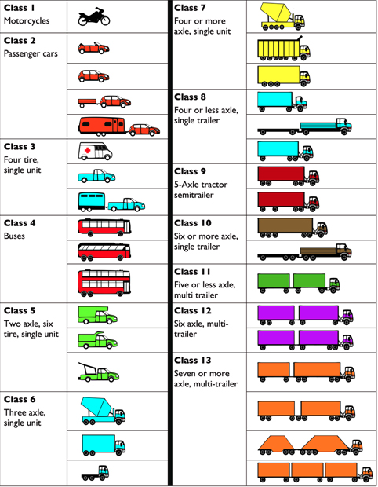
Source: https://www.fhwa.dot.gov/policyinformation/tmguide/tmg_2013/vehicle-types.cfm
Figure B1. FHWA Vehicle Classification

APPENDIX C – Truck Percentages by Vehicle Class for All Sites
Table C1. Truck Percentages by Vehicle Class for All Sites
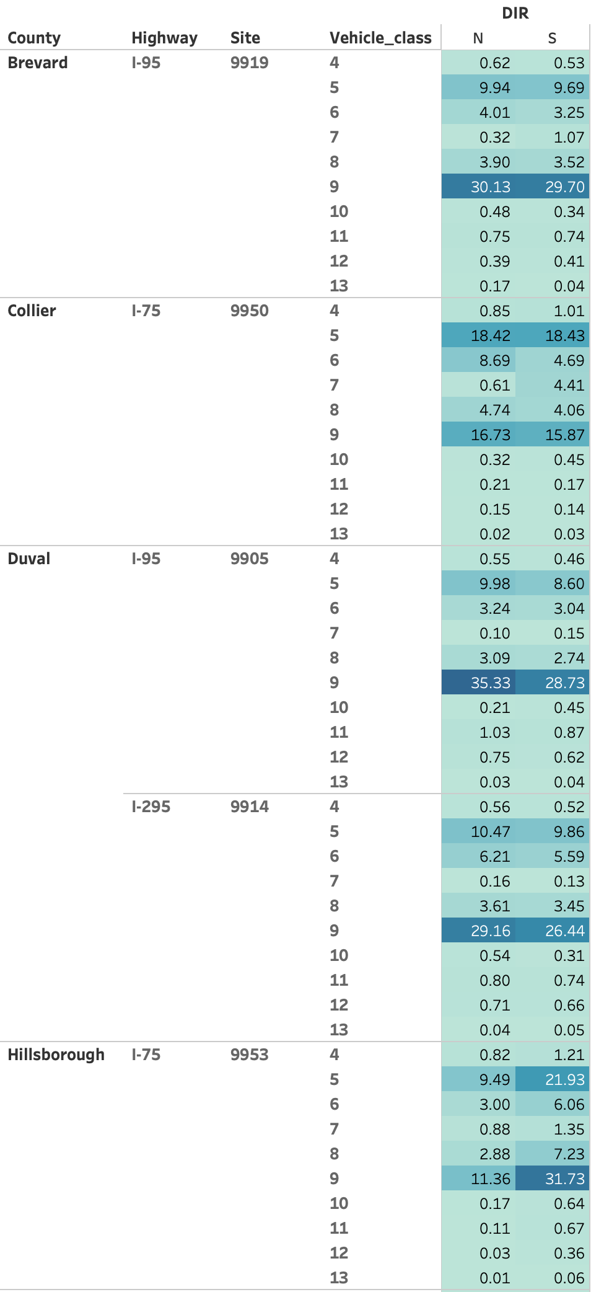

Table C2. Truck Percentages by Vehicle Class for All Sites Continued
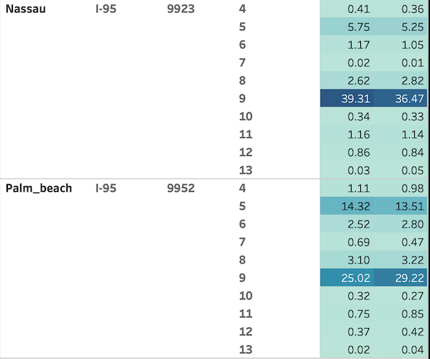

Table C3. Truck Percentages by Vehicle Class for All Sites Continued
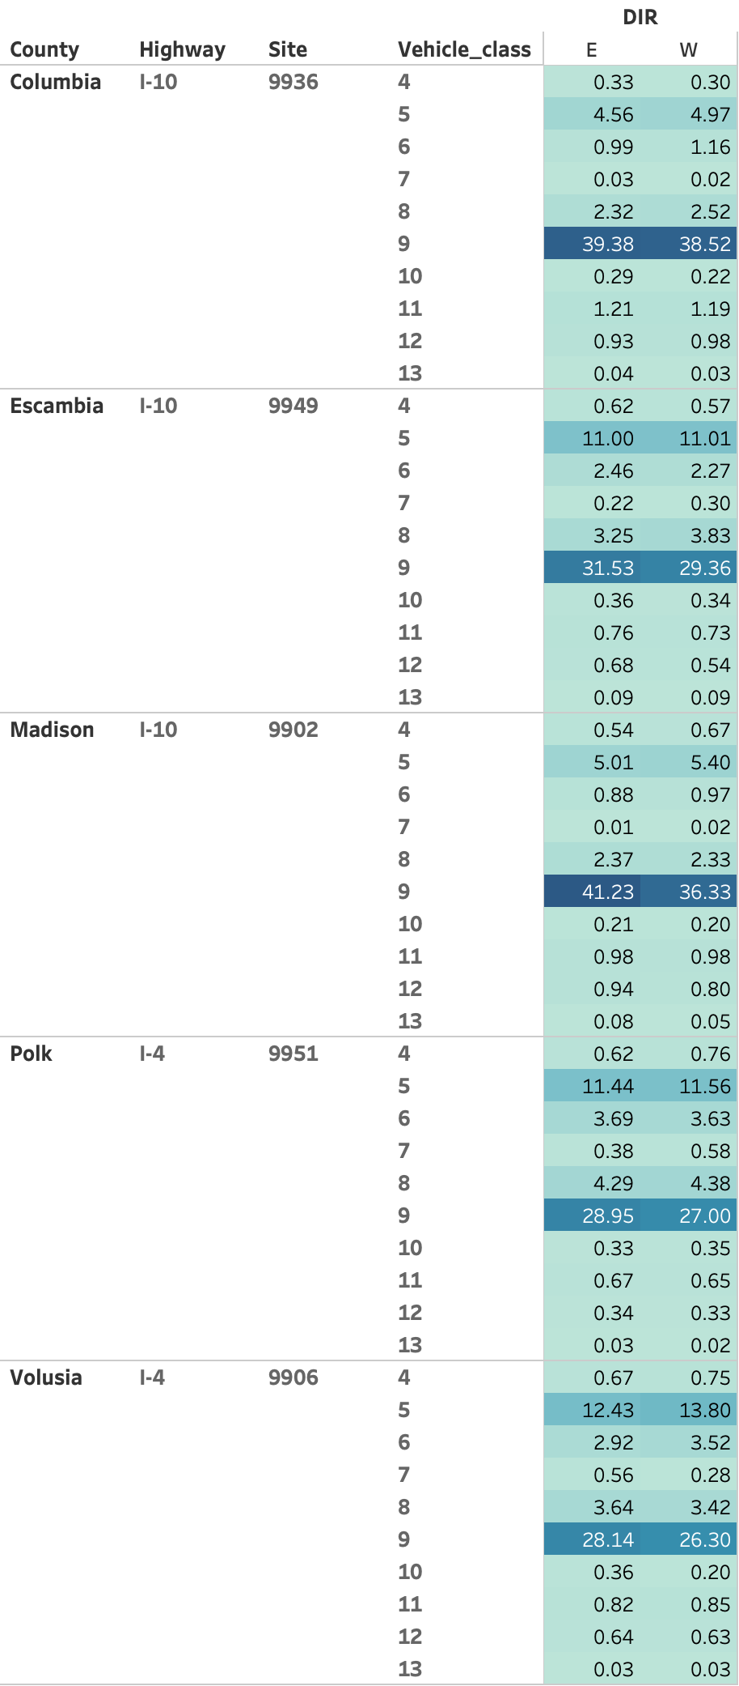

APPENDIX D – Empty and Full Truck Percentages by Direction of Travel

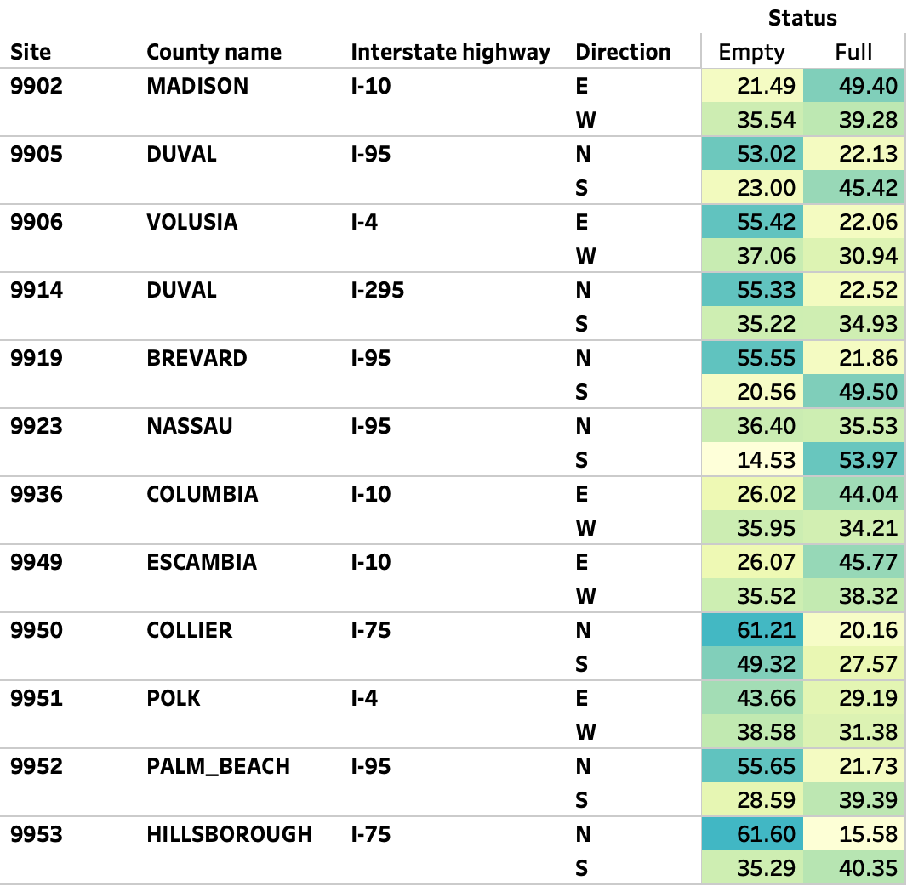
Figure D1. Empty and Full Truck Percentages by Direction of Travel

APPENDIX E – Empty Truck Percentages by Month
Figure E1. Percentage of Empty Trucks by Direction on I-10 in Madison County
(Site Id:9902)

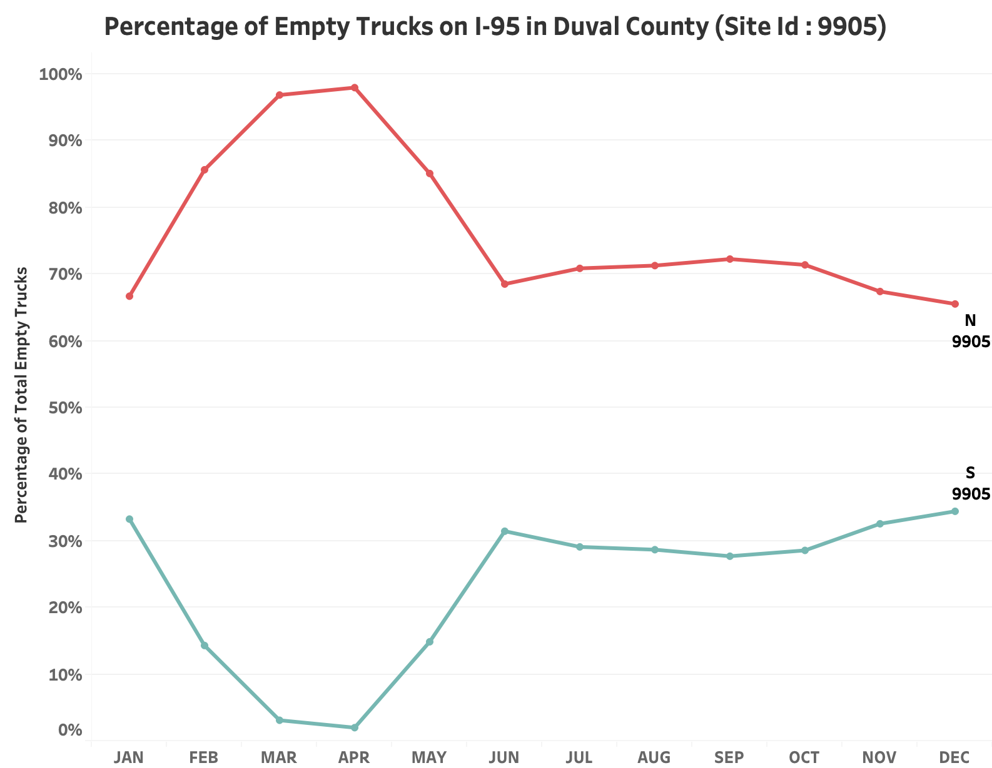

Figure E2. Percentage of Empty Trucks by Direction on I-95 in Duval County (Site Id:9905)
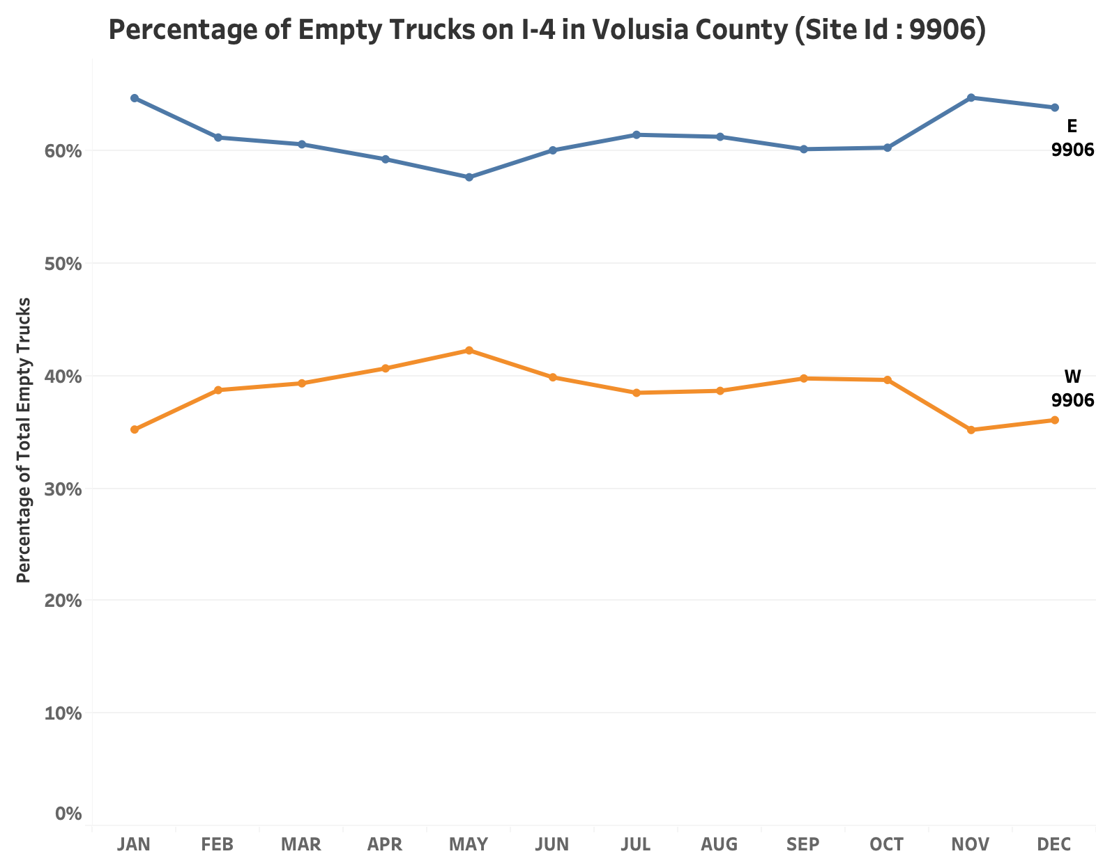

Figure E3. Percentage of Empty Trucks by Direction on I-4 in Volusia County (Site Id:9906)
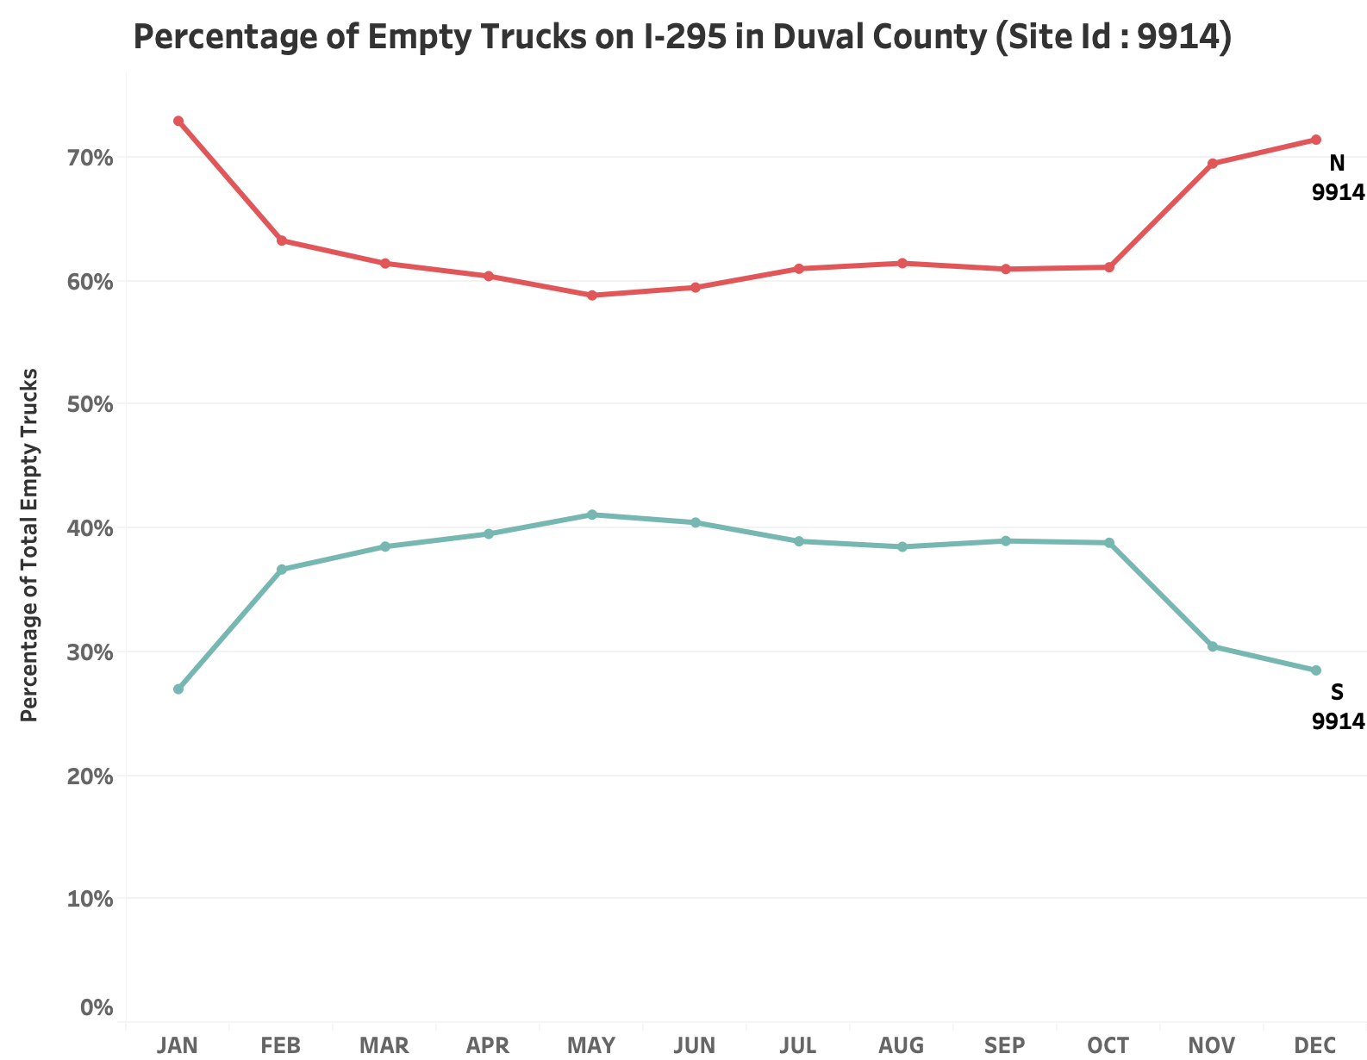

Figure E4. Percentage of Empty Trucks by Direction on I-295 in Duval County (Site Id:9914)
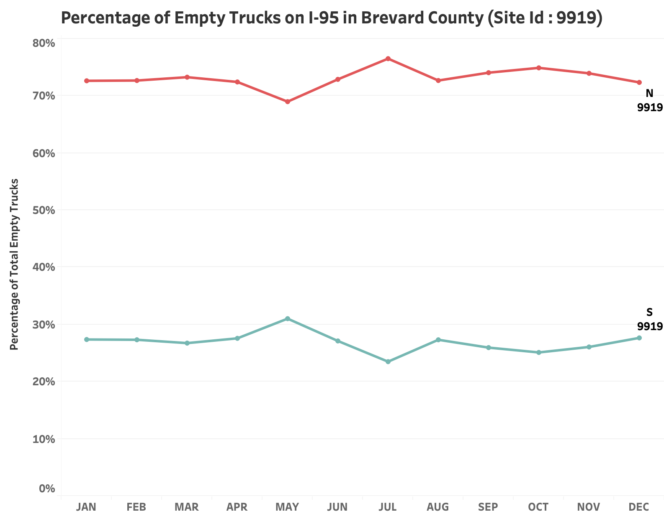

Figure E5. Percentage of Empty Trucks by Direction on I-95 in Brevard County (Site Id:9919)

Figure E6. Percentage of Empty Trucks by Direction on I-95 in Nassau County (Site Id:9923)
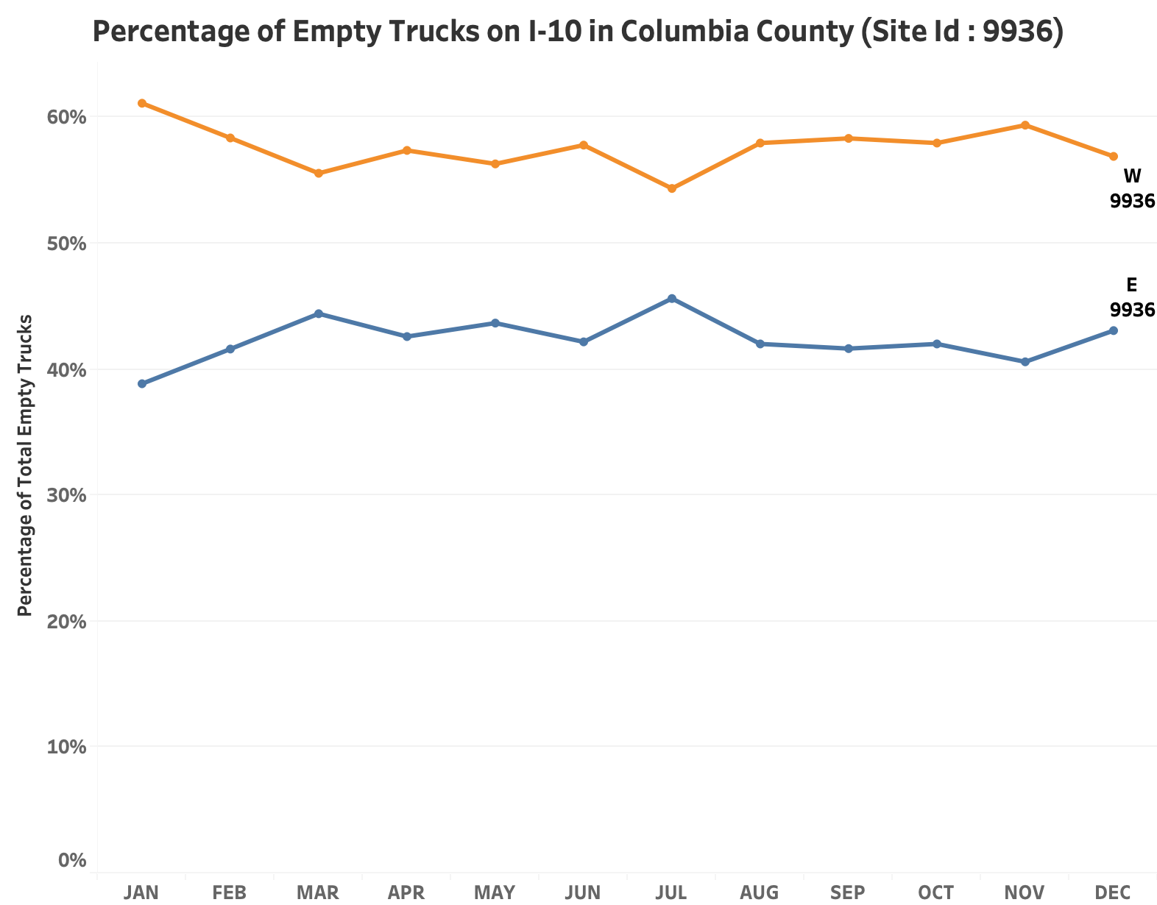

Figure E7. Percentage of Empty Trucks by Direction on I-10 in Columbia County
(Site Id:9936)
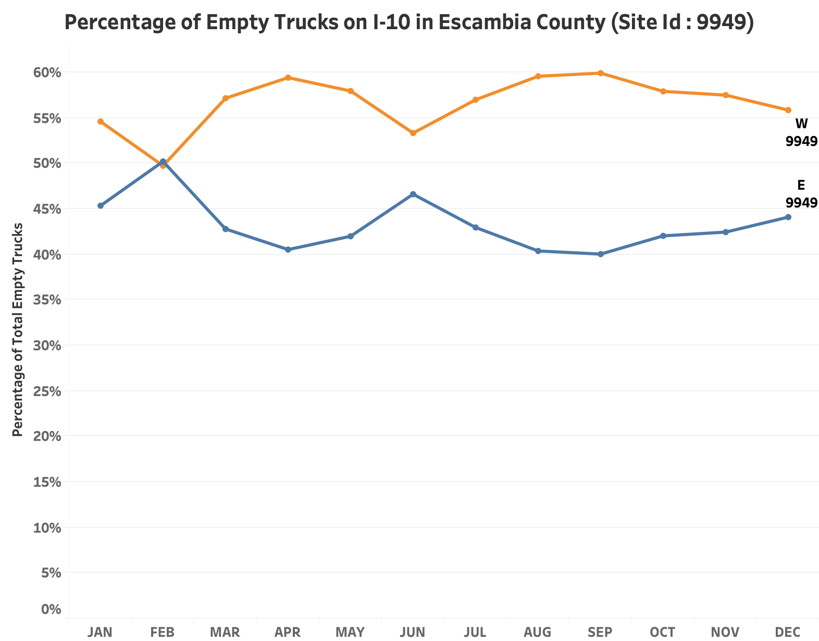

Figure E8. Percentage of Empty Trucks by Direction on I-10 in Escambia County
(Site Id:9949)
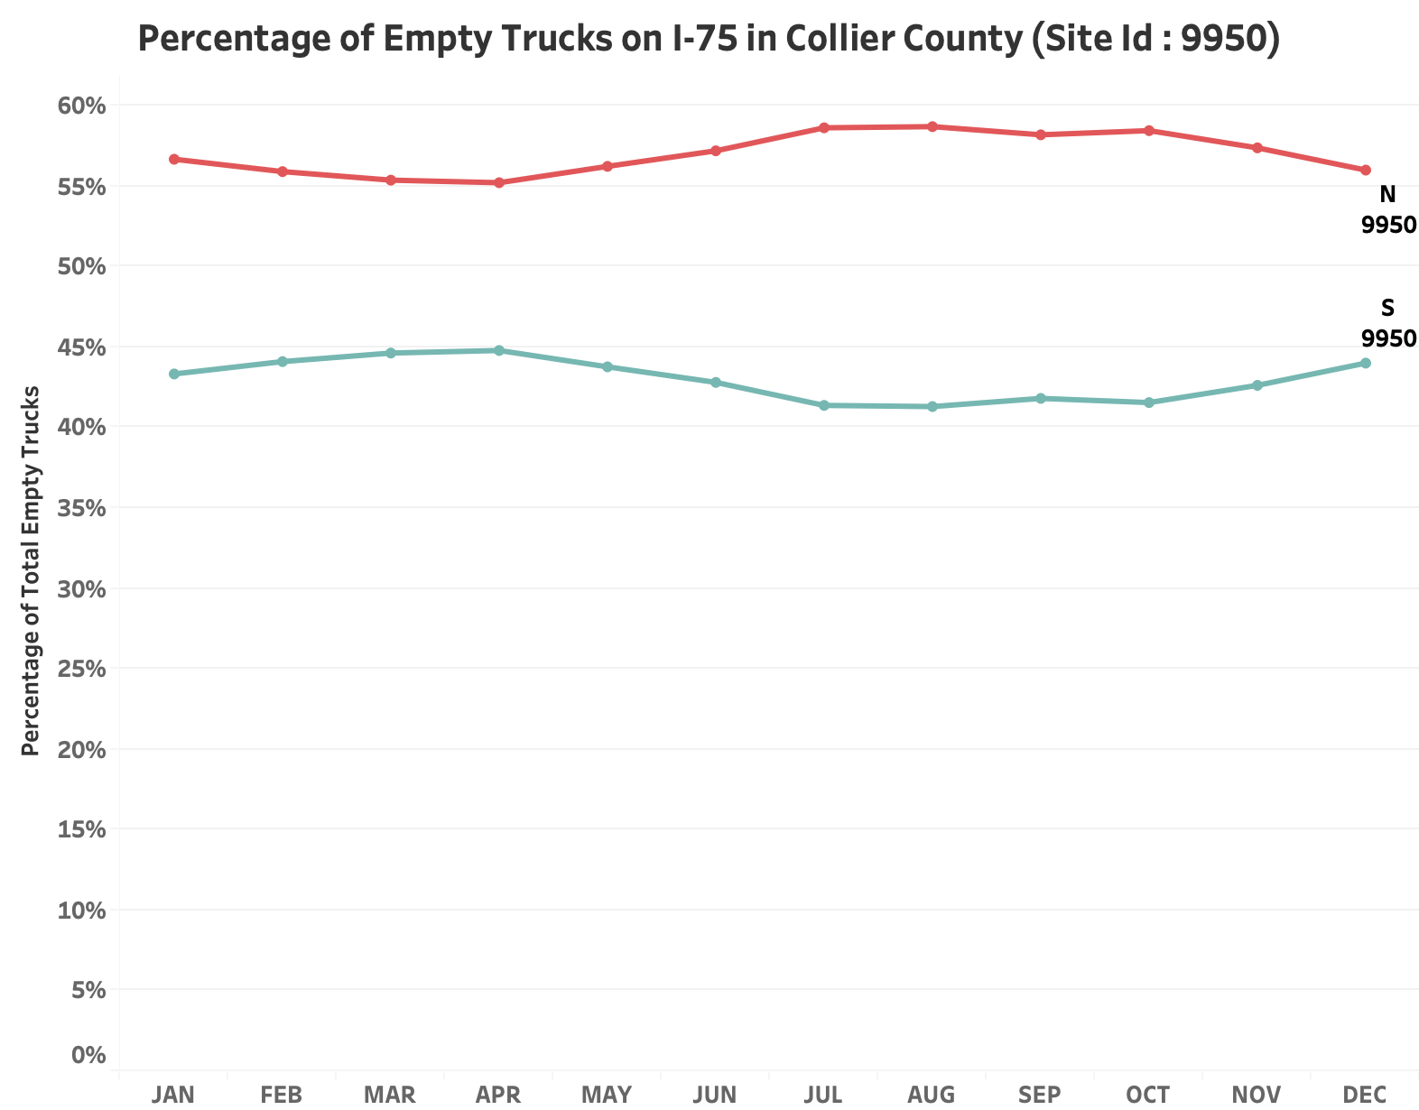

Figure E9. Percentage of Empty Trucks by Direction on I-75 in Collier County (Site Id:9950)
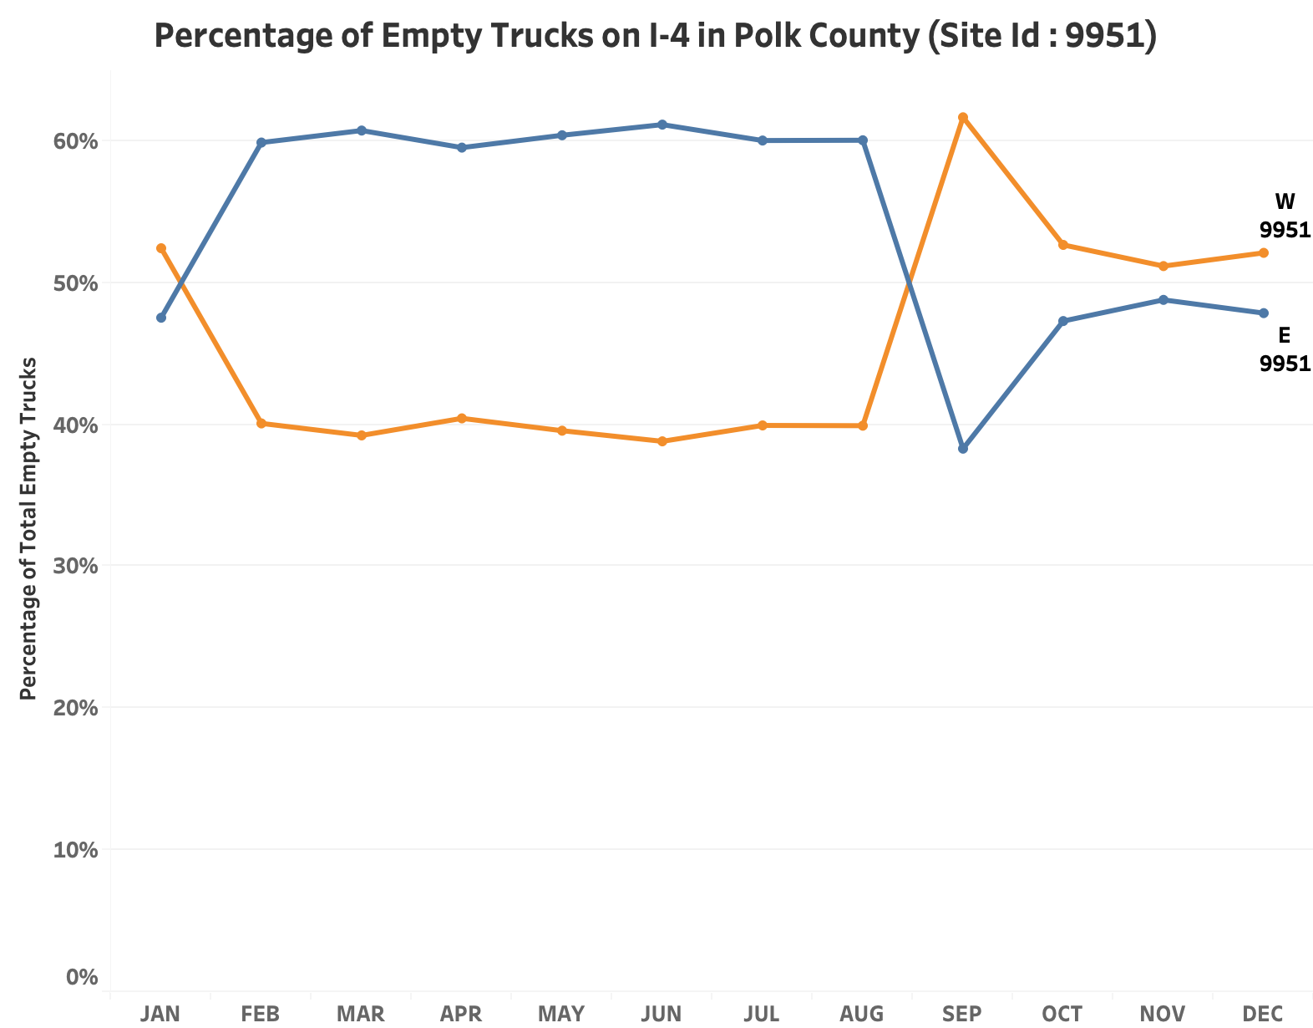

Figure E10. Percentage of Empty Trucks by Direction on I-4 in Polk County (Site Id:9951)
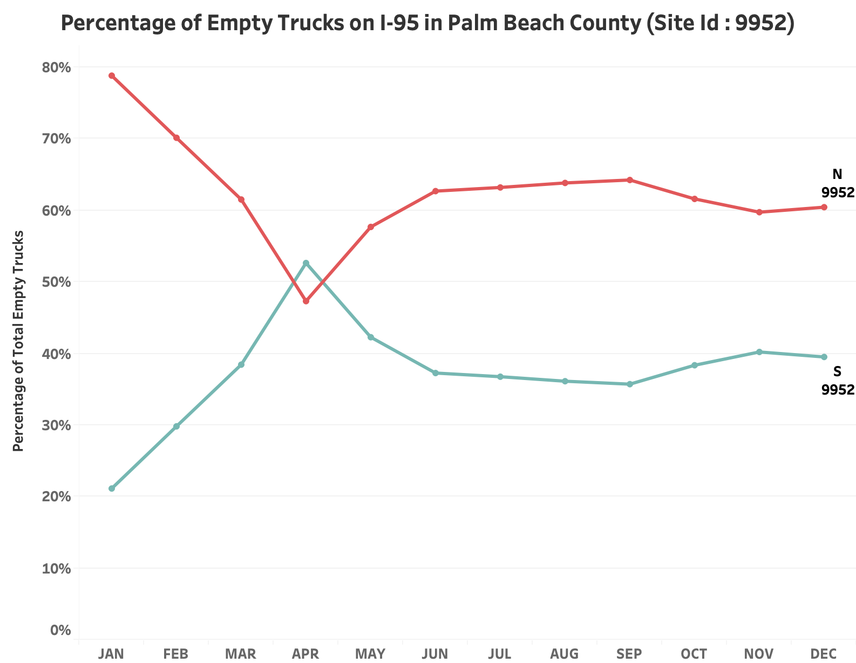

Figure E11. Percentage of Empty Trucks by Direction on I-95 in Palm Beach County
(Site Id:9952)
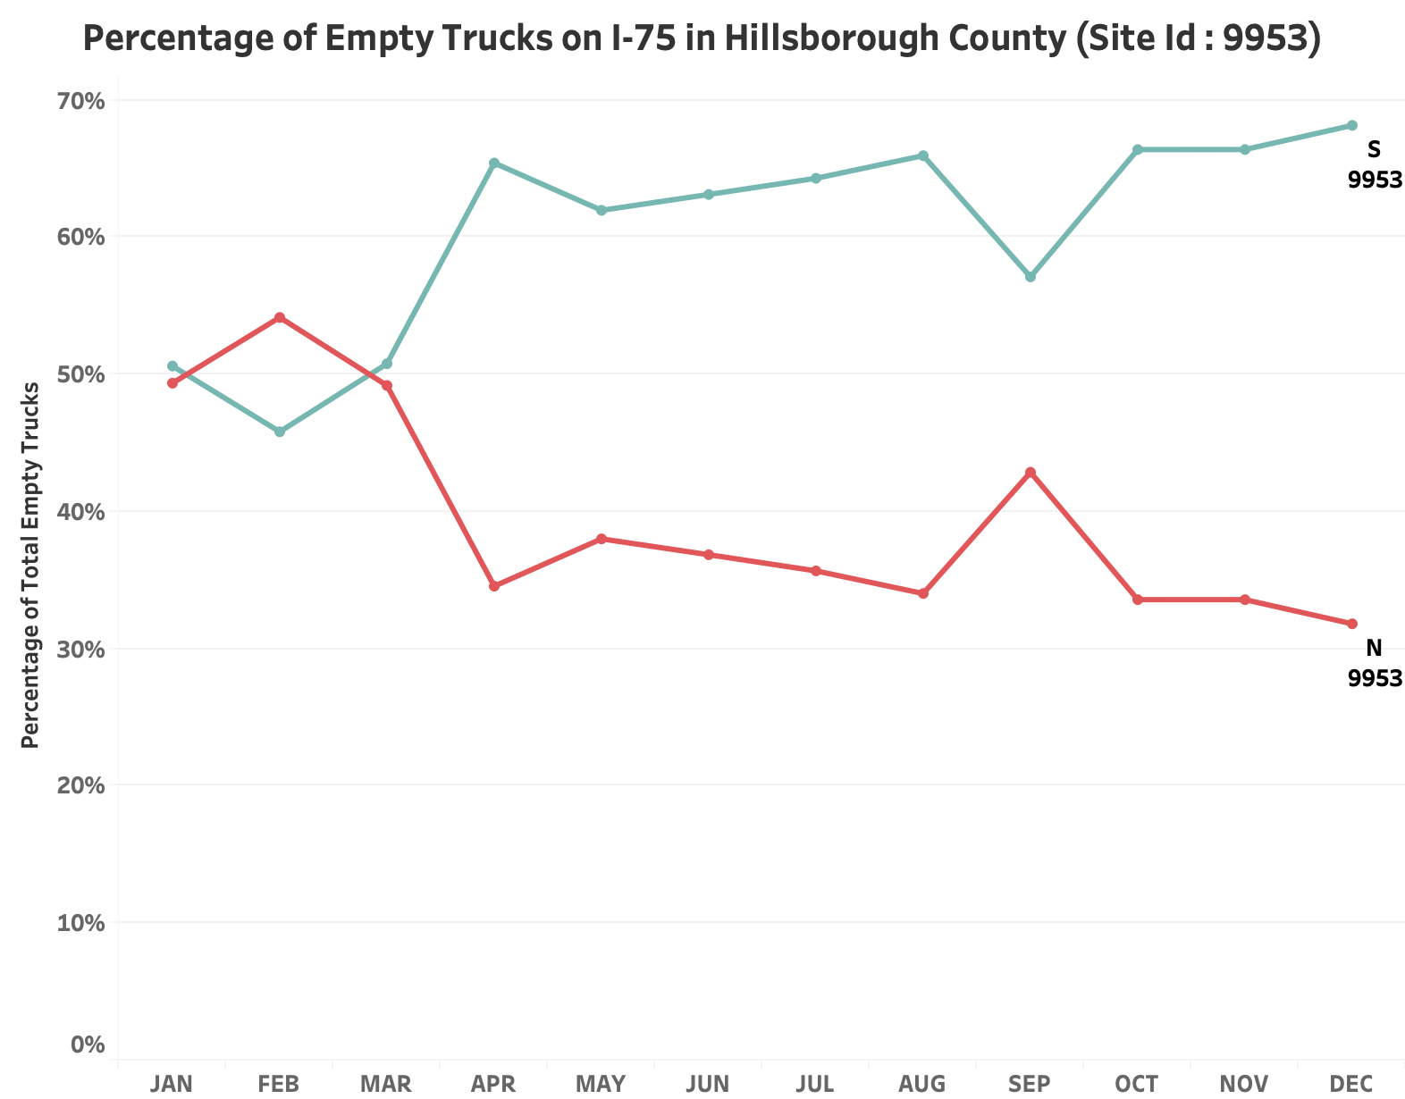

Figure E12. Percentage of Empty Trucks by Direction on I-75 in Hillsborough County
(Site Id:9953)

APPENDIX F – Empty Truck Percentages by Time of Day
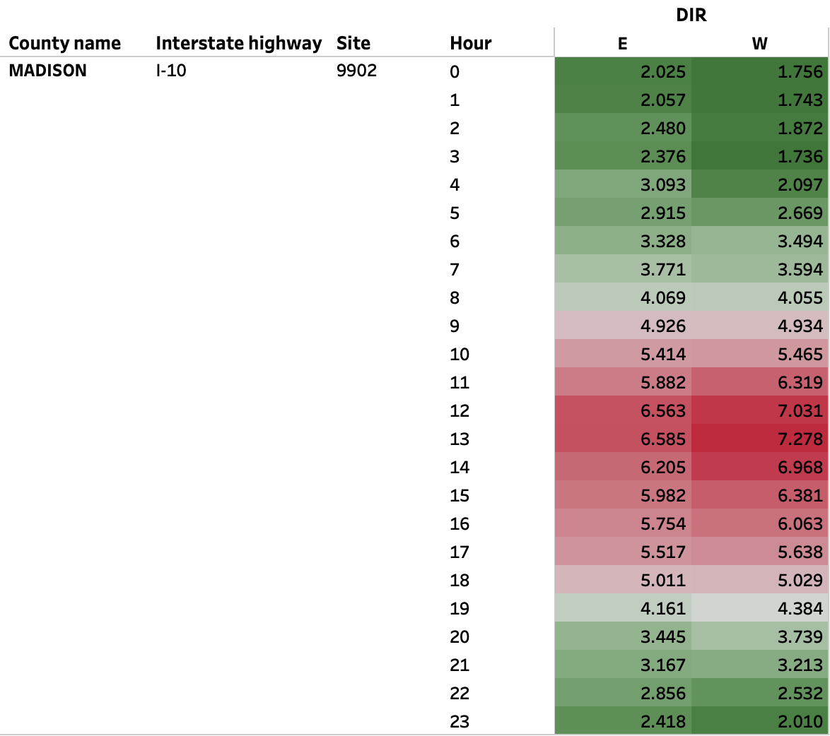

Figure F1. Percentage of Empty Trucks by the Time of the Day and Direction on I-10 in Madison County (Site Id:9902)

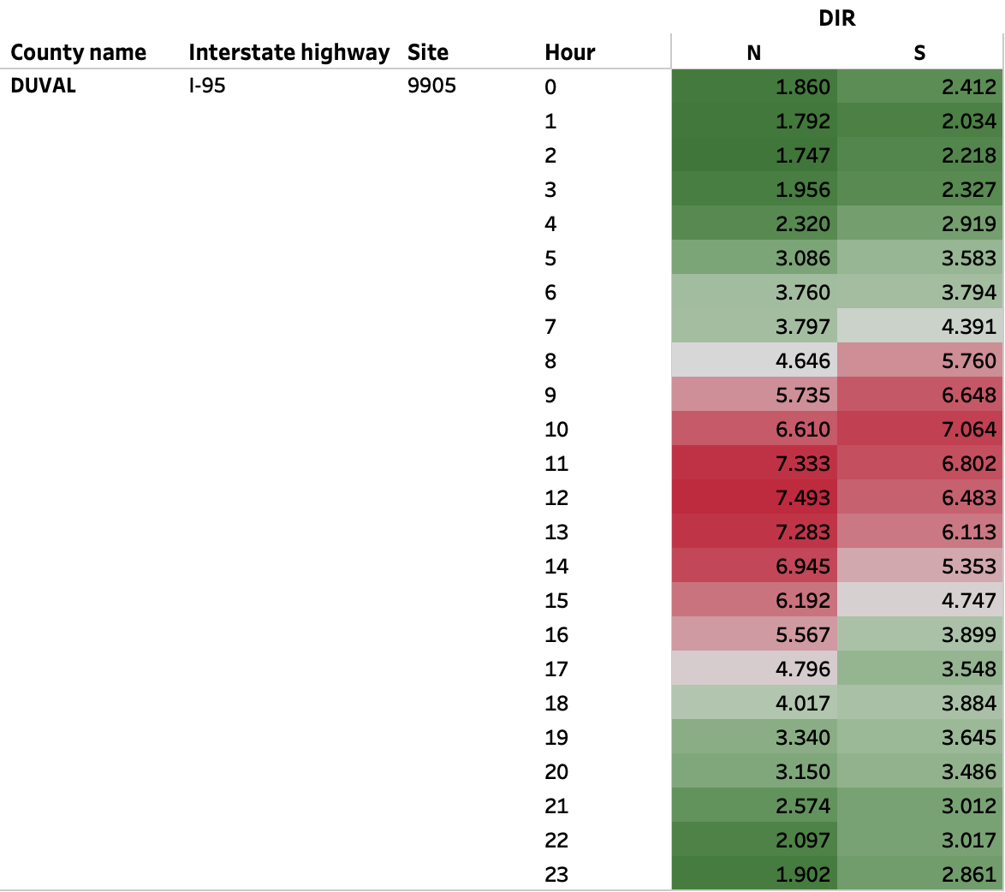

Figure F2. Percentage of Empty Trucks by the Time of the Day and Direction on I-95 in
Duval County (Site Id:9905)

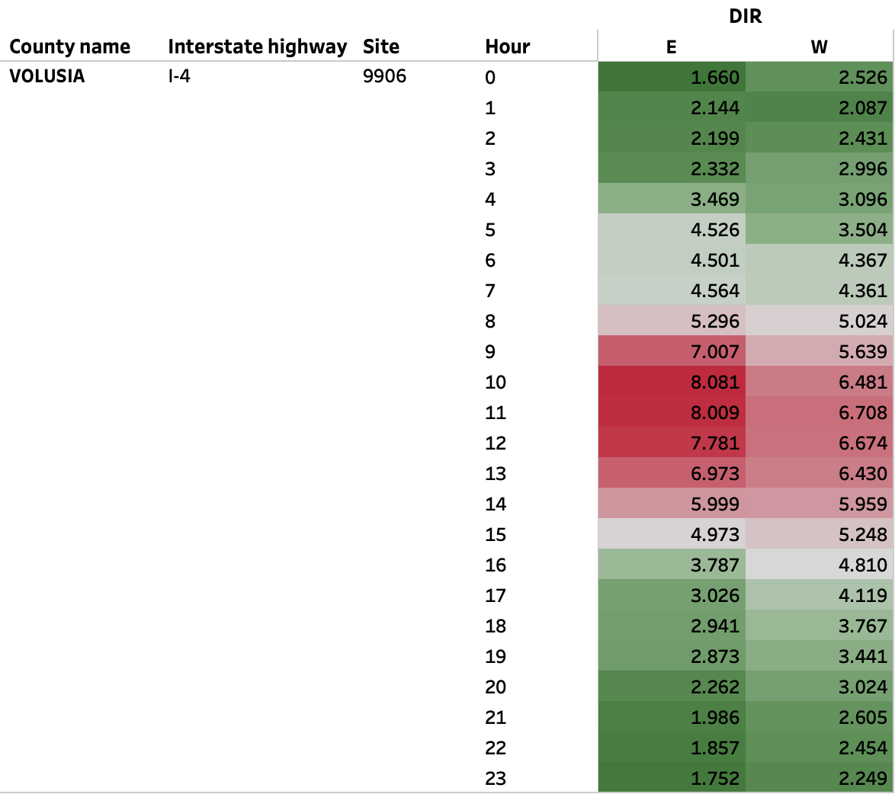

Figure F3. Percentage of Empty Trucks by the Time of the Day and Direction on I-4 in
Volusia County (Site Id:9906)

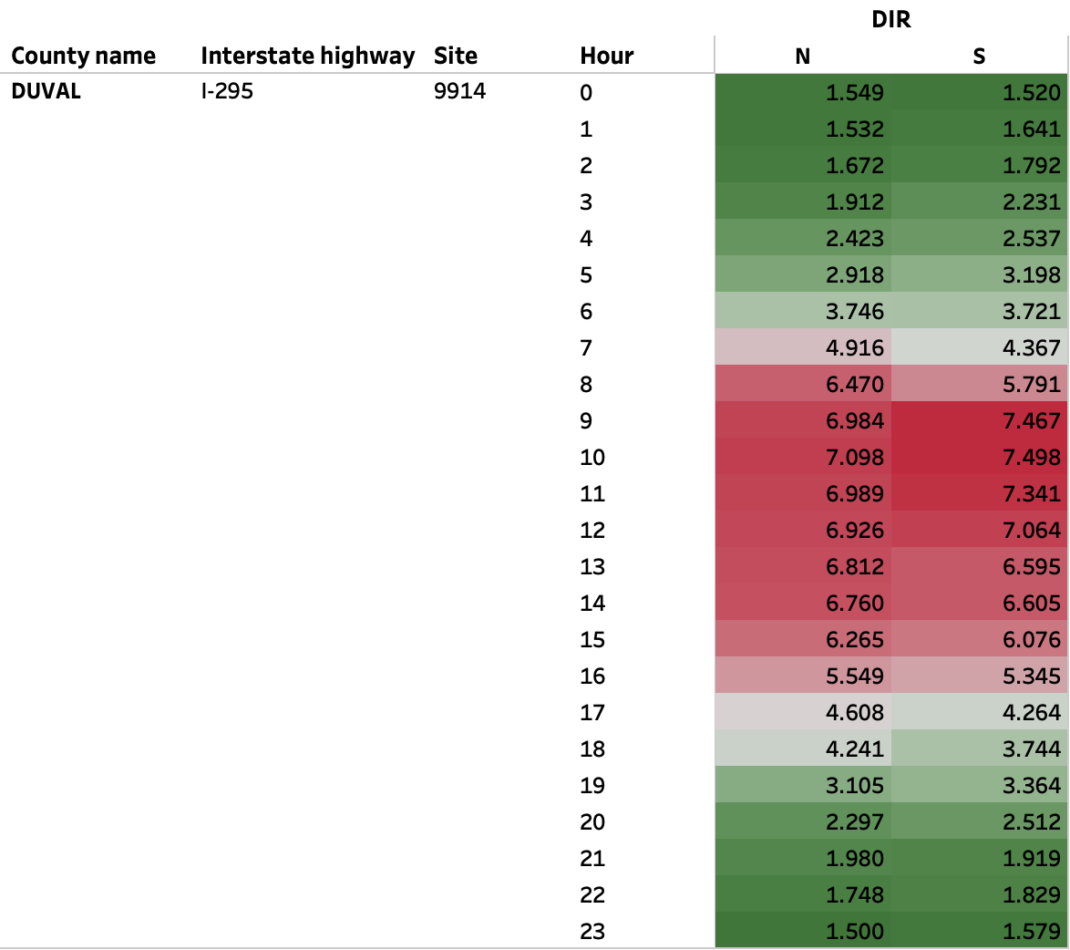

Figure F4. Percentage of Empty Trucks by the Time of the Day and Direction on I-295 in Duval County (Site Id:9914)

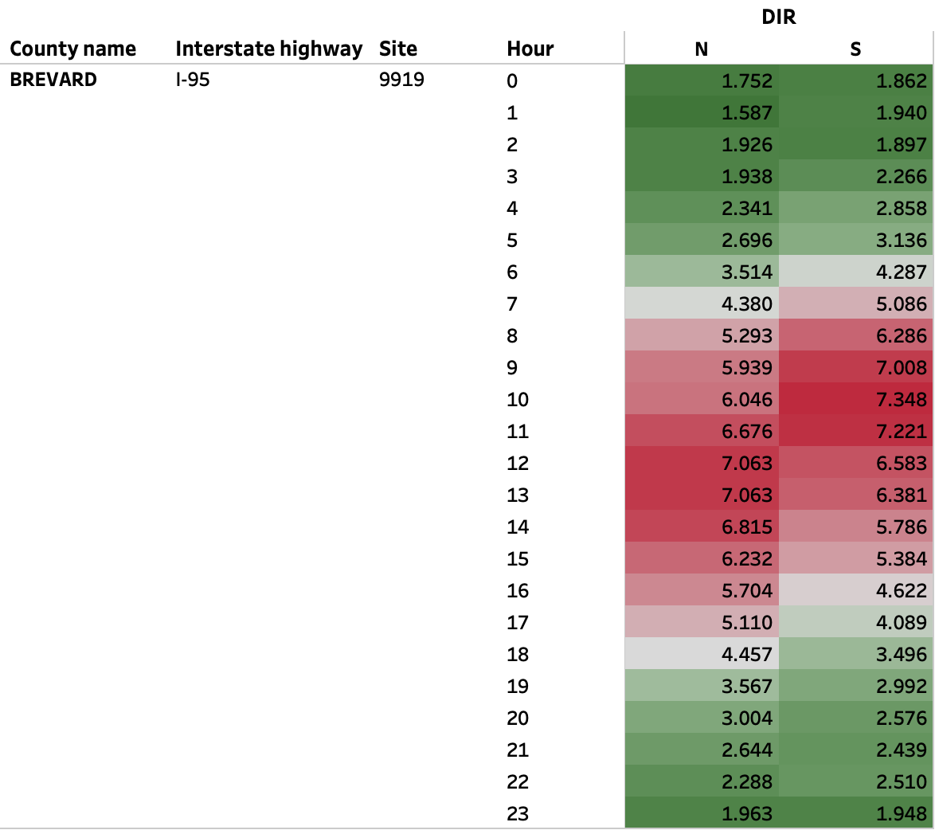

Figure F5. Percentage of Empty Trucks by the Time of the Day and Direction on I-95 in Brevard County (Site Id:9919)

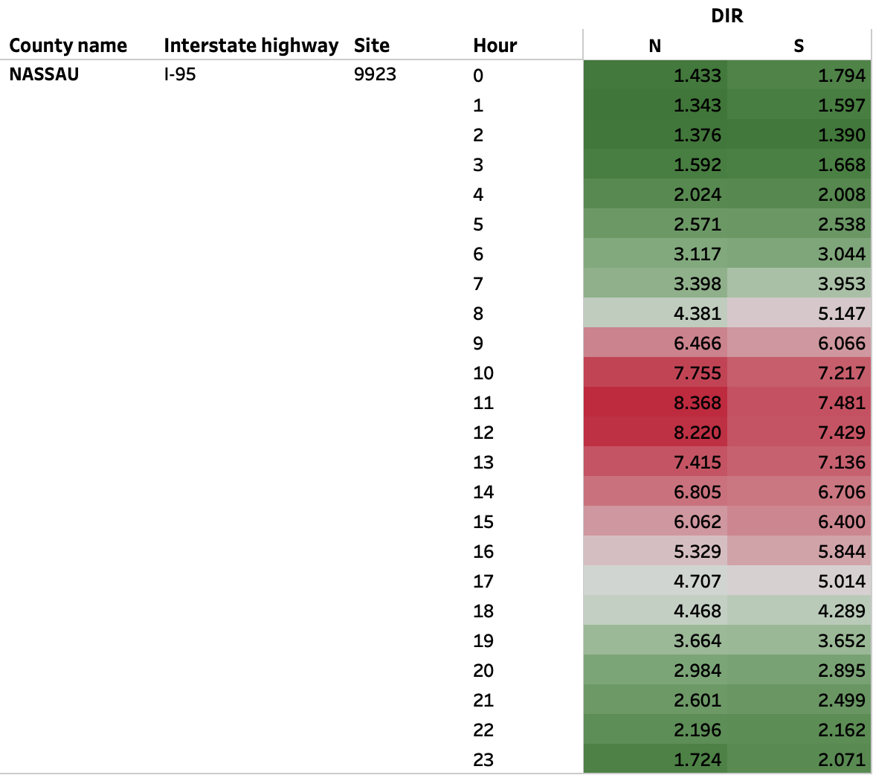

Figure F6. Percentage of Empty Trucks by the Time of the Day and Direction on I-95 in Nassau County (Site Id:9923)

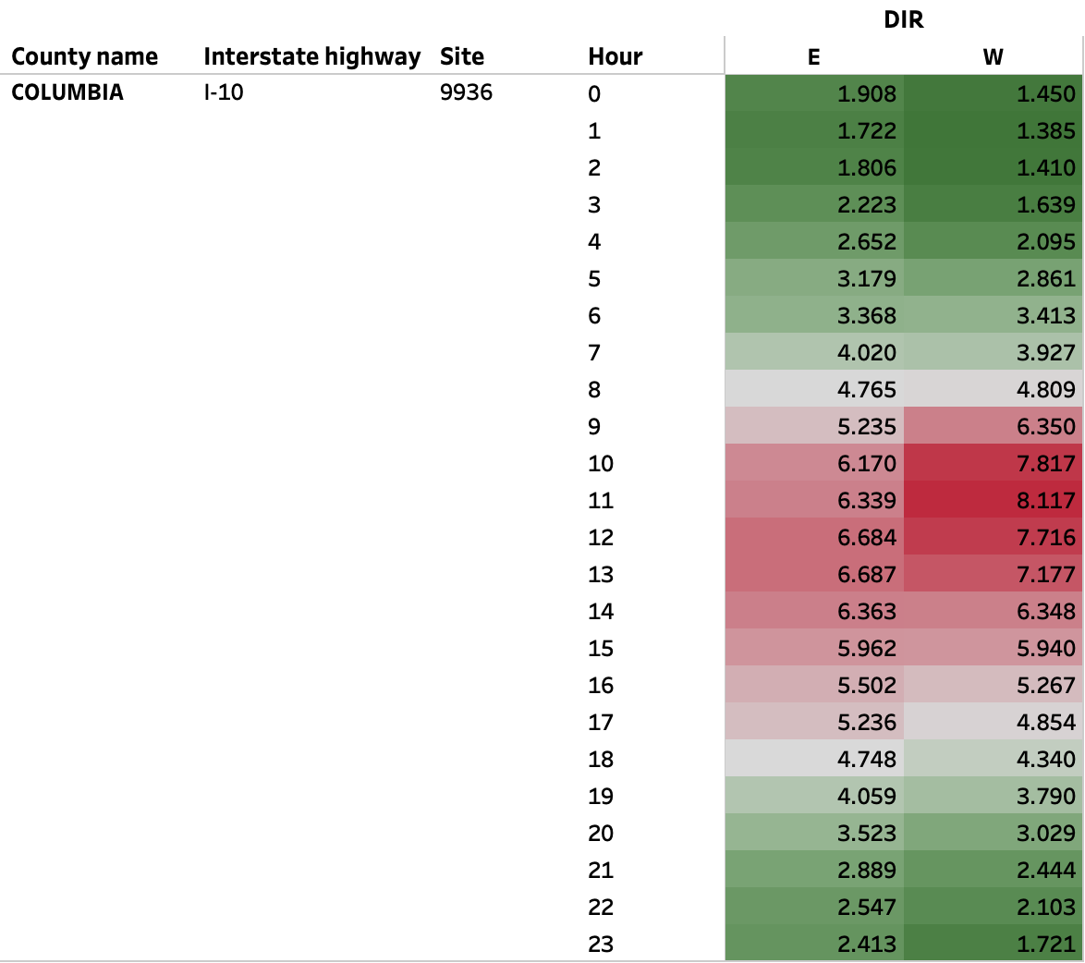

Figure F7. Percentage of Empty Trucks by the Time of the Day and Direction on I-10 in Columbia County (Site Id:9936)

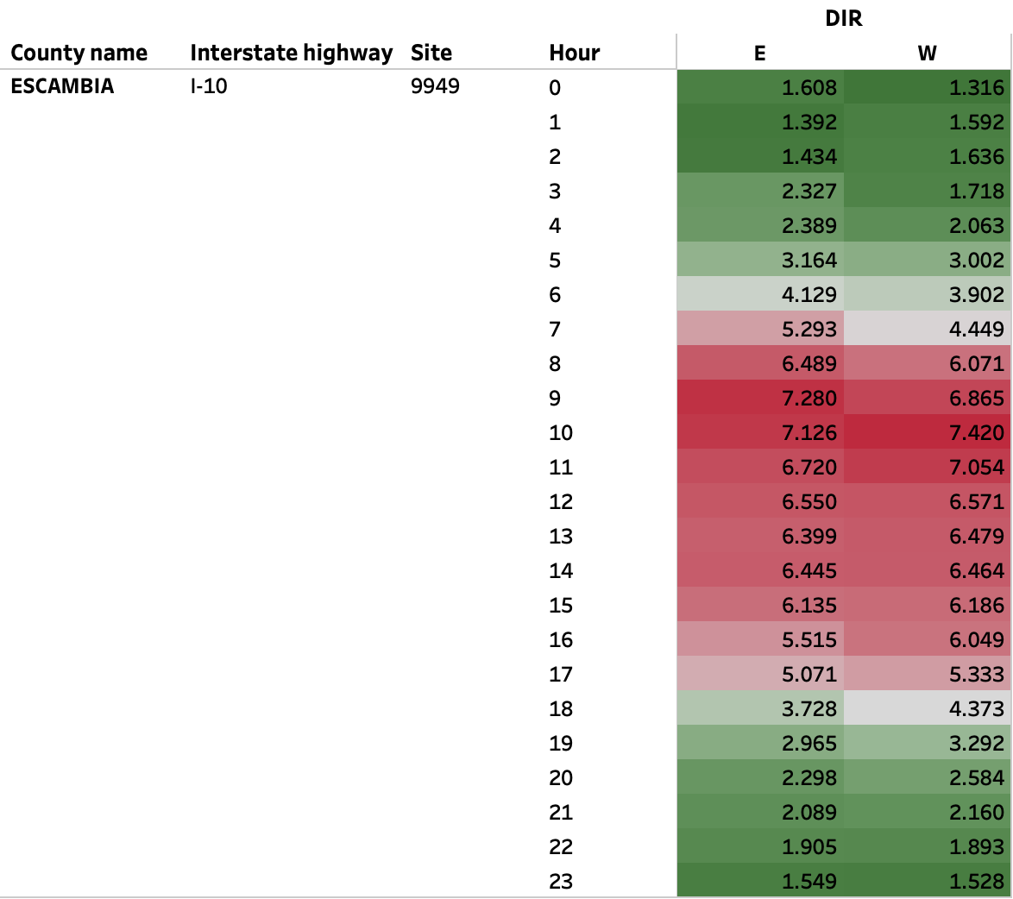

Figure F8. Percentage of Empty Trucks by the Time of the Day and Direction on I-10 in Escambia County (Site Id:9949)
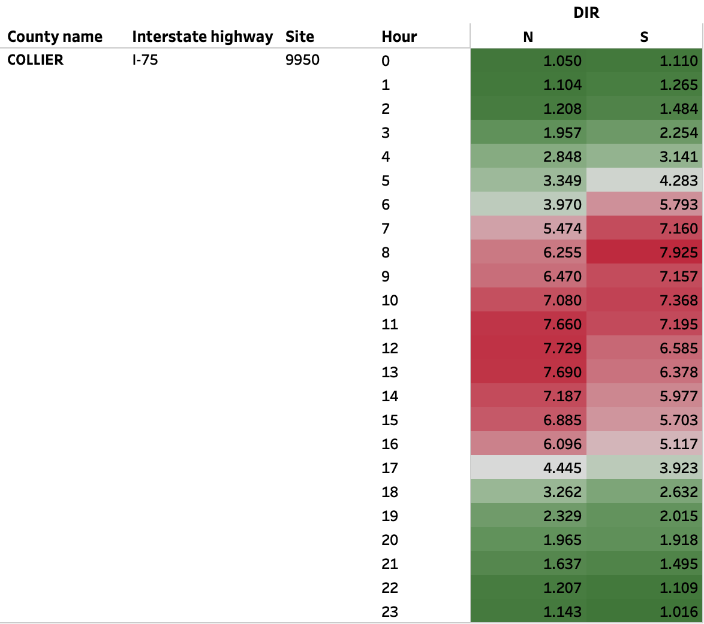

Figure F9. Percentage of Empty Trucks by the Time of the Day and Direction on I-75 in
Collier County (Site Id:9950)

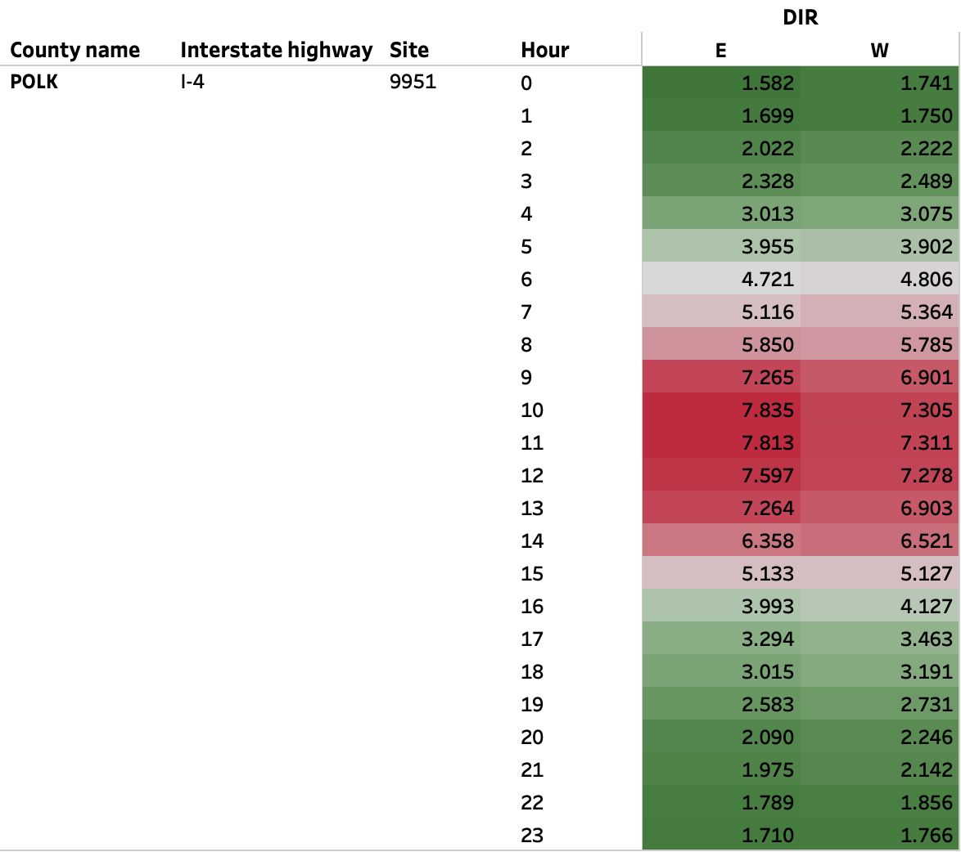

Figure F10. Percentage of Empty Trucks by the Time of the Day and Direction on I-4 in
Polk County (Site Id:9951)

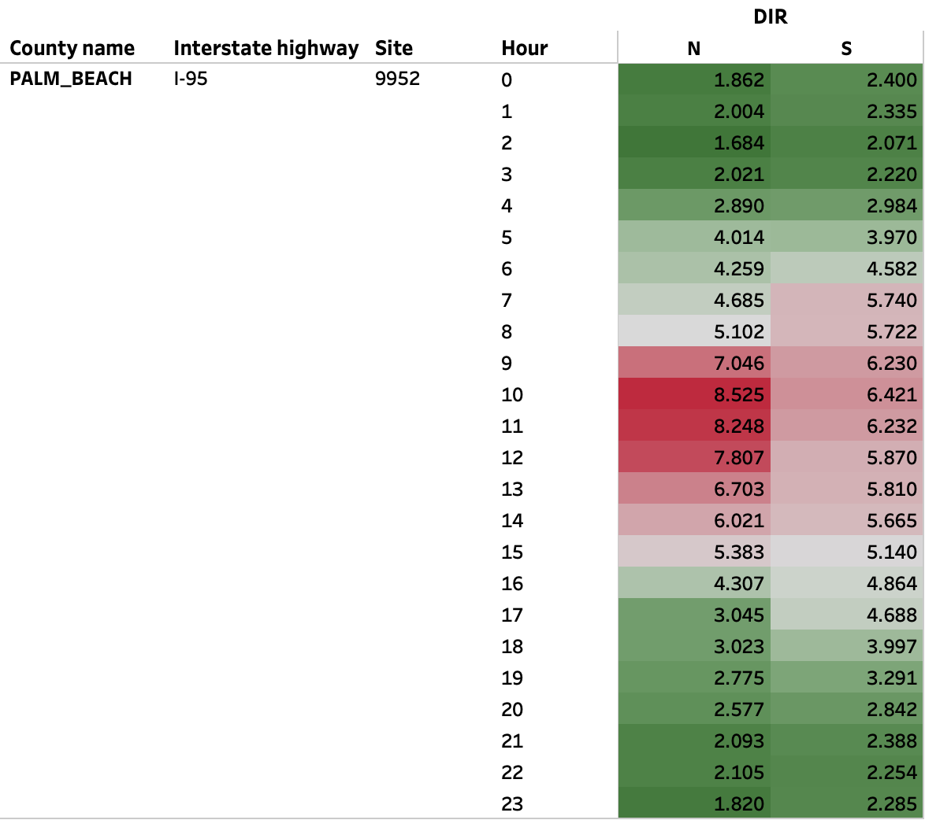

Figure F11. Percentage of Empty Trucks by the Time of the Day and Direction on I-95 in
Palm Beach County (Site Id:9952)

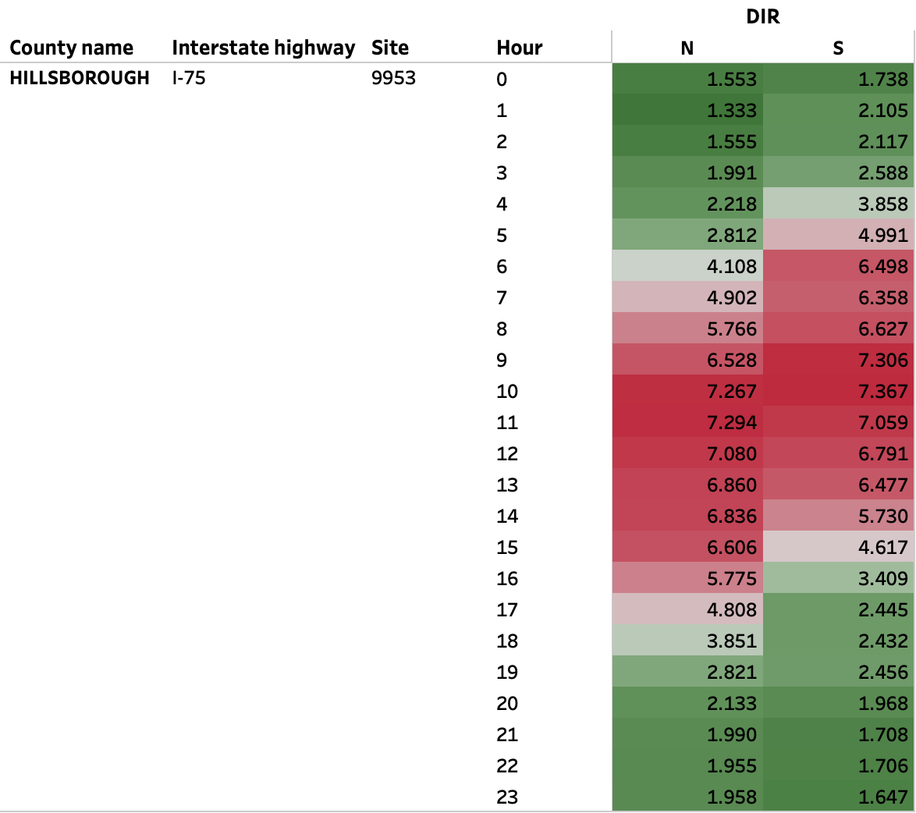

Figure F12. Percentage of Empty Trucks by the Time of the Day and Direction on I-75 in Hillsborough County (Site Id:9953)

APPENDIX G - Florida Labor Force and Manufacturing

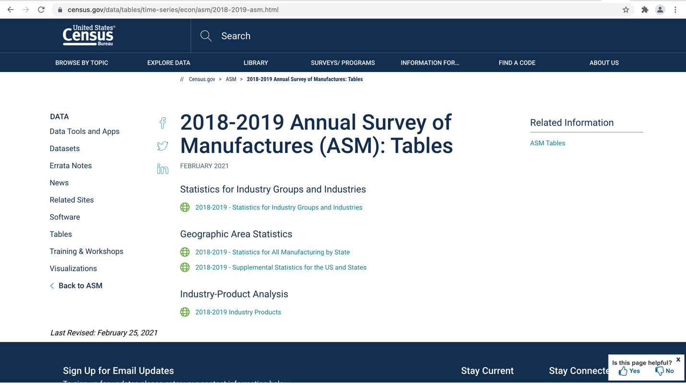
Figure G1. Screenshot of United States Census Bureau Website

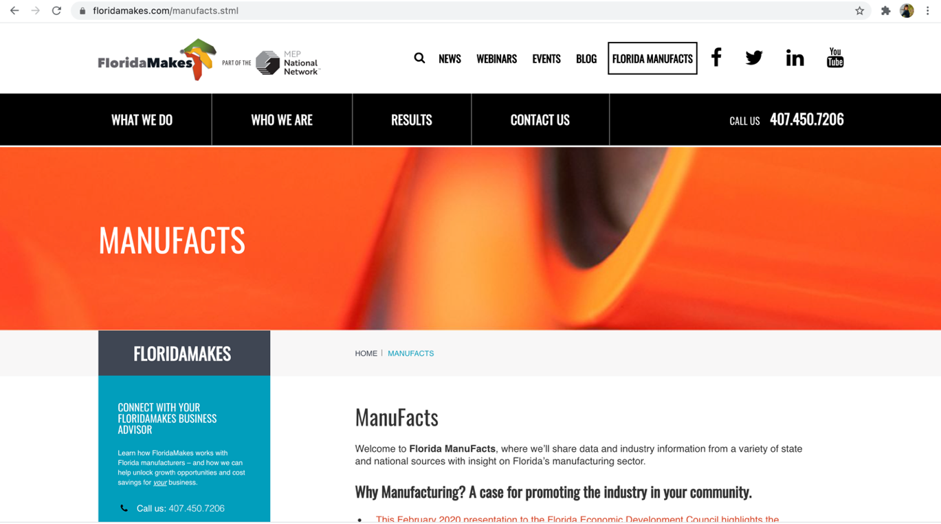Figure G2. Screenshot of Florida-Makes Website

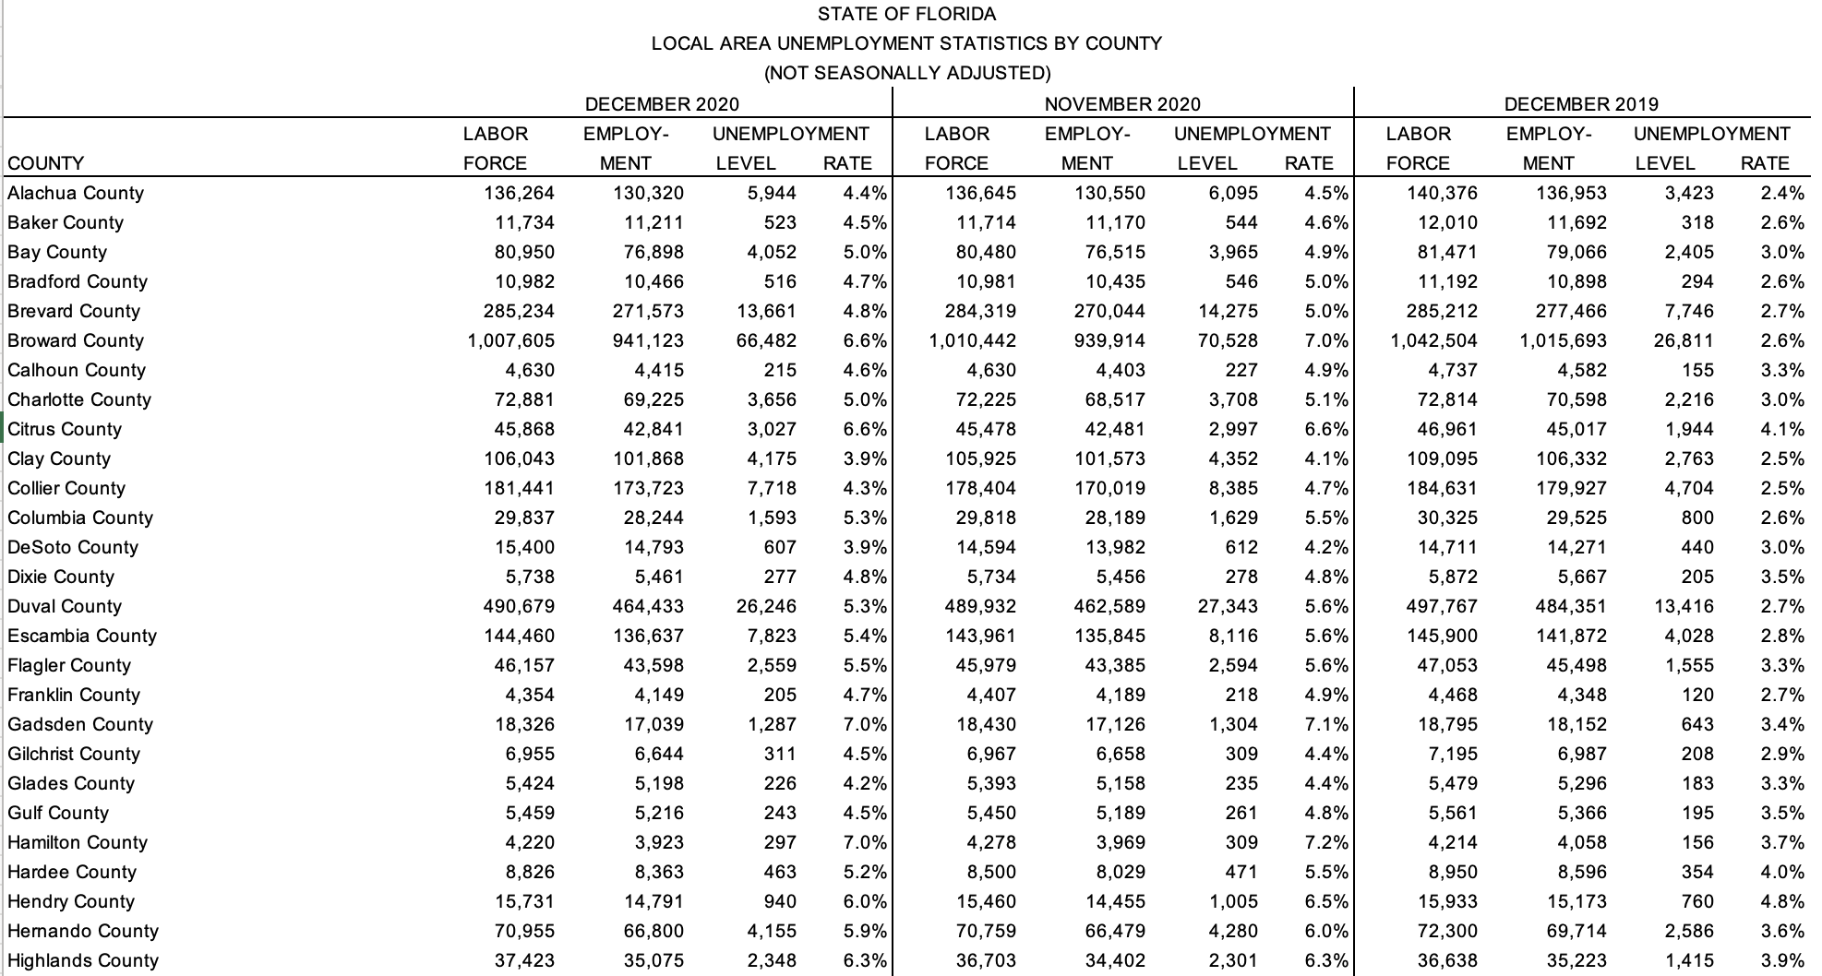
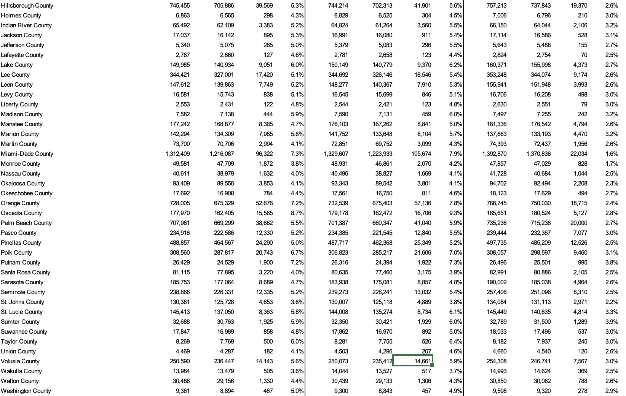
Figure G3. Labor Force with respect to County Data from the Year December 2019 to December 2020

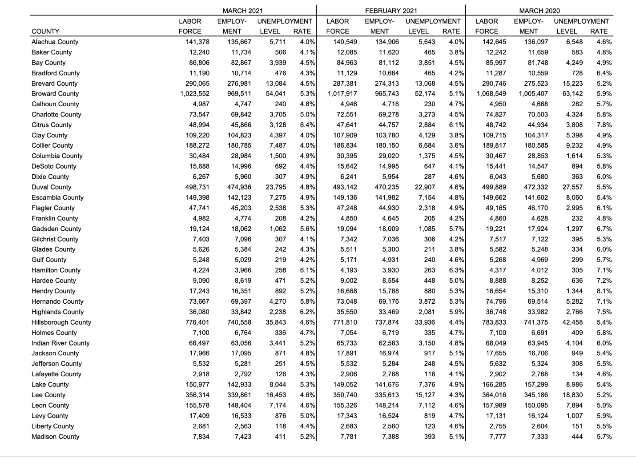
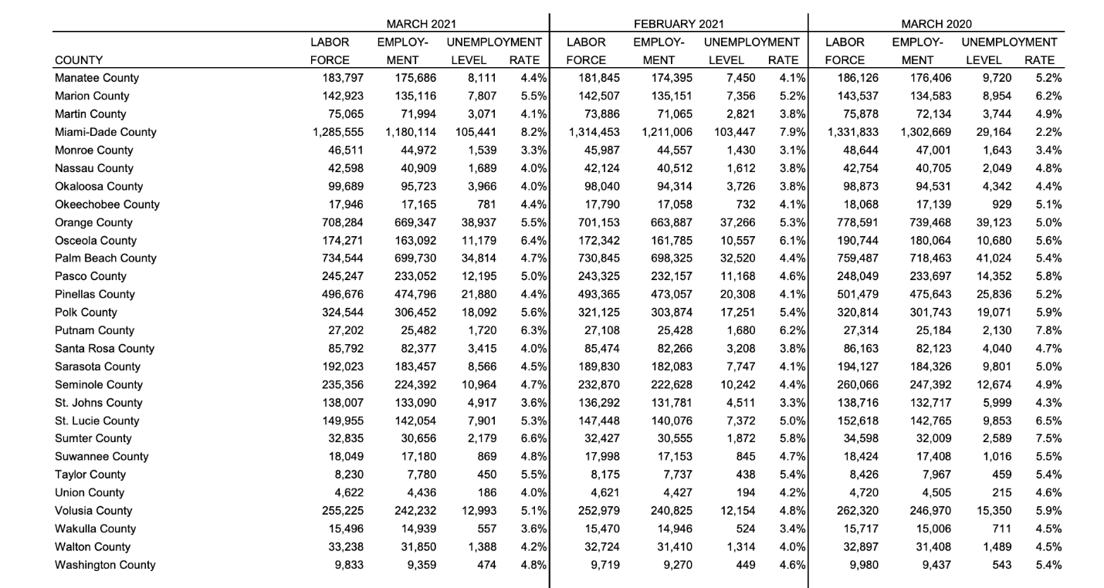
Figure G4. Labor Force with respect to County Data from the year March 2020 to March 2021

Table G1. NAICS Mapping to Manufacturing Subsector from 31-33 to 3149
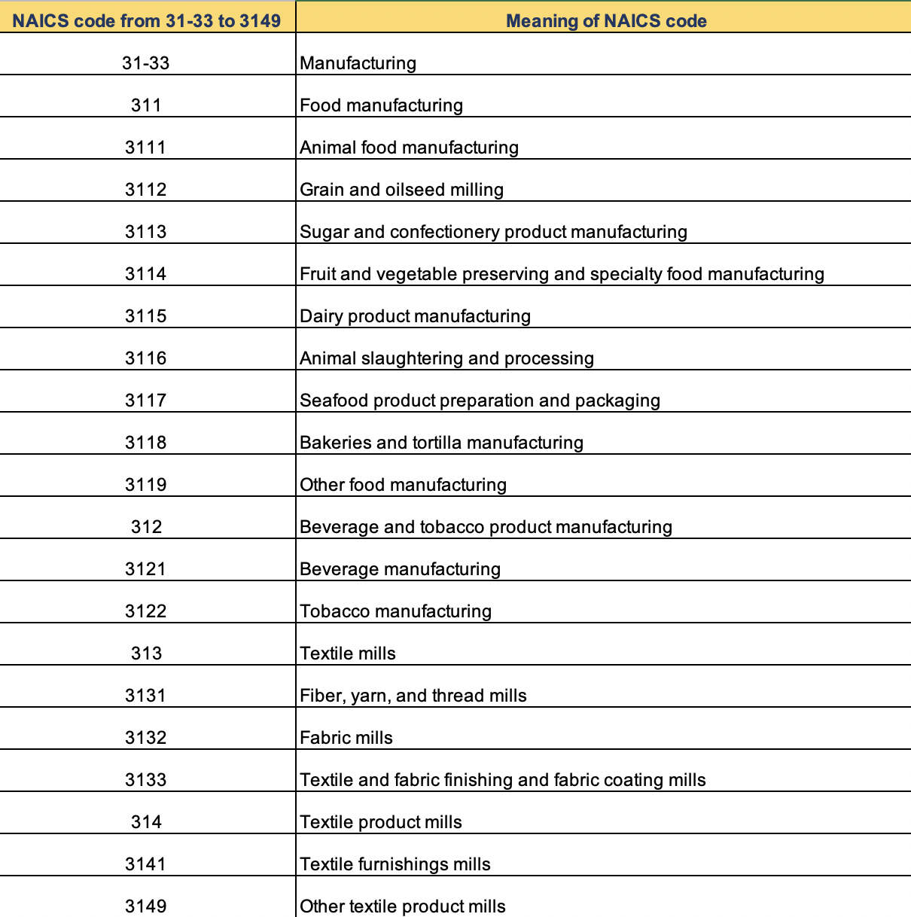

Table G2. NAICS Mapping to Manufacturing Subsector from 315 to 3251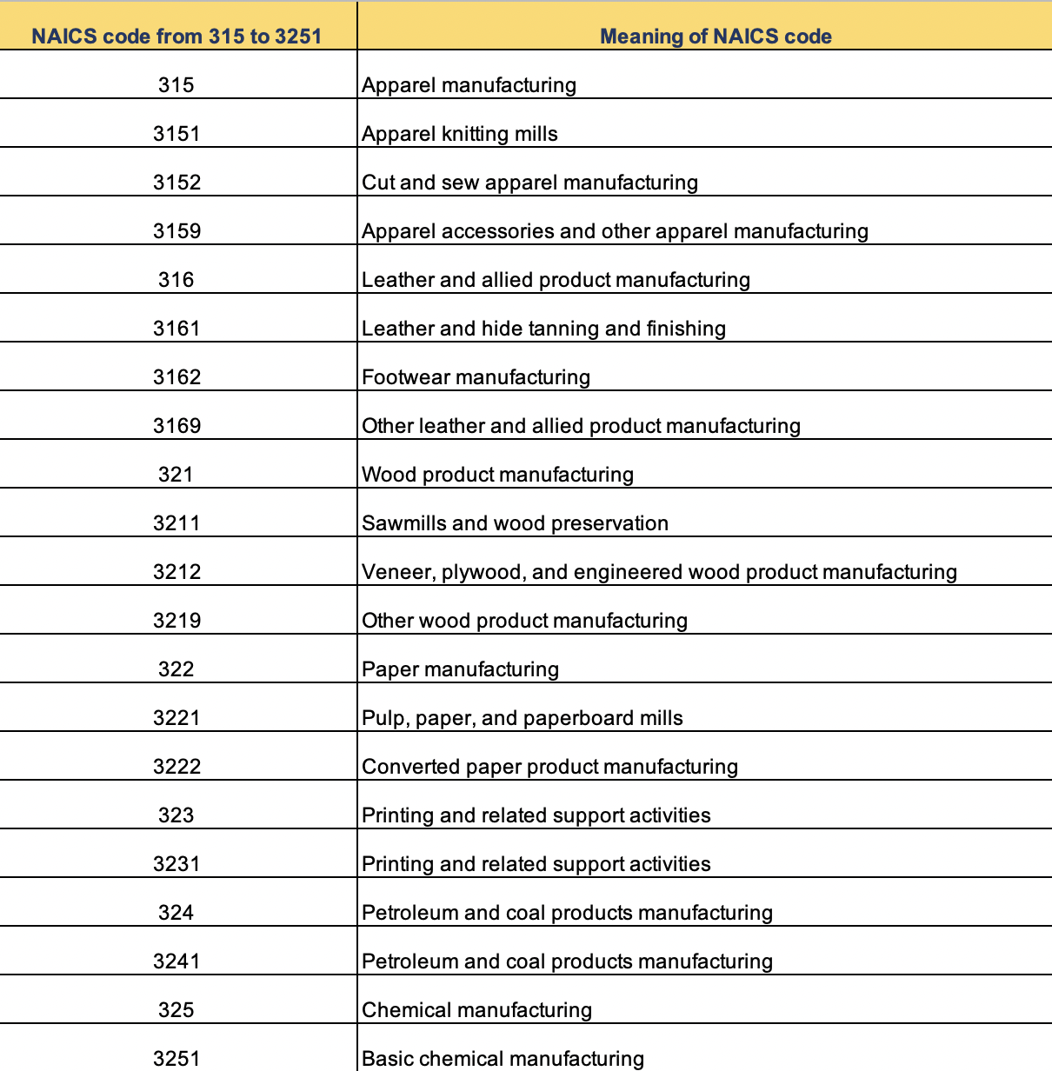

Table G3. NAICS Mapping to Manufacturing Subsector from 3252 to 3315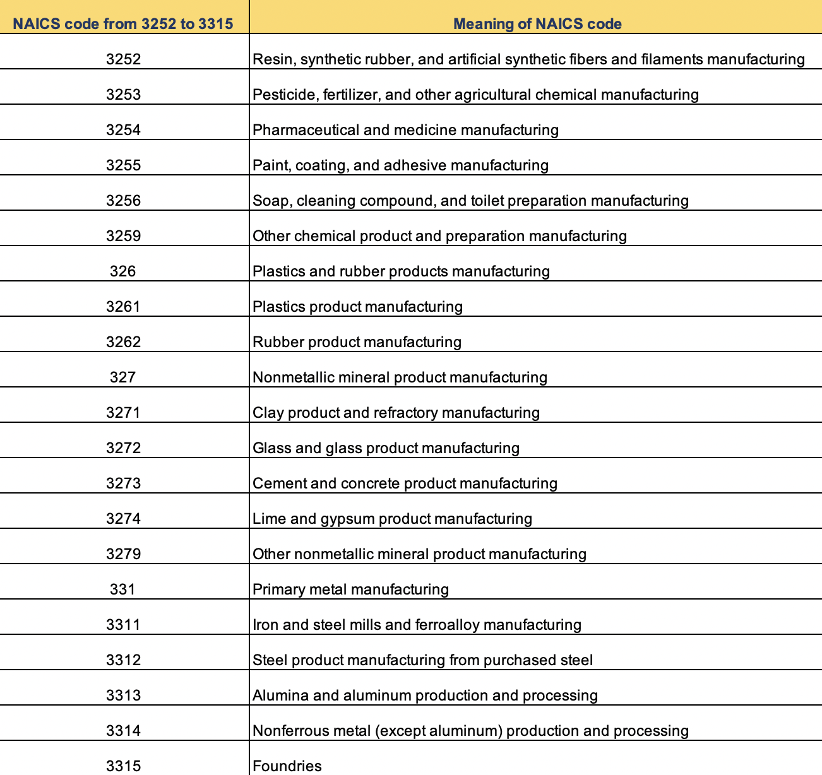

Table G4. NAICS Mapping to Manufacturing Subsector from 332 to 3342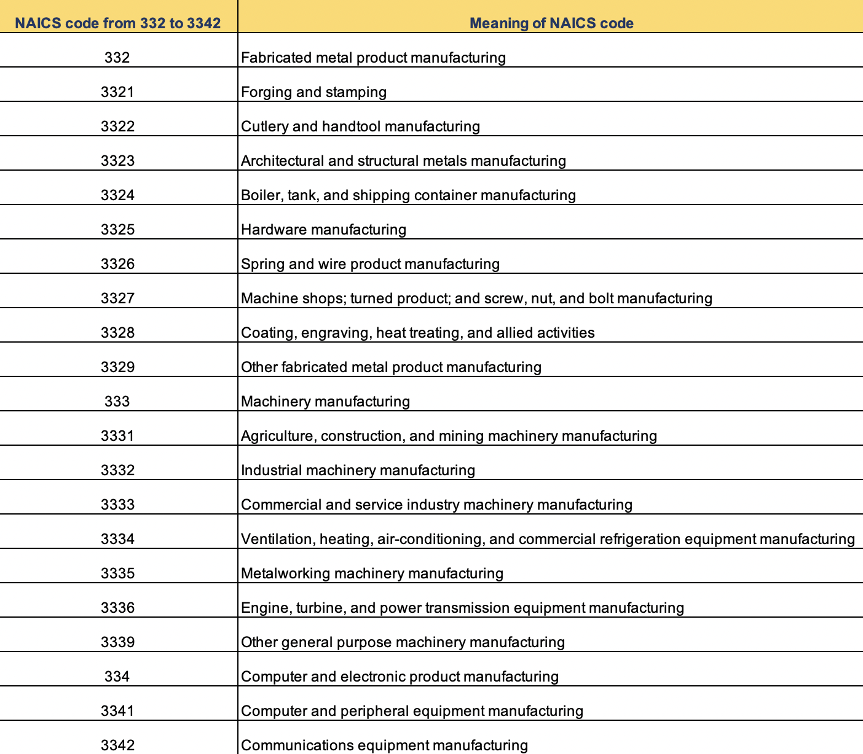

Table G5. NAICS Mapping to Manufacturing Subsector from 3343 to 3399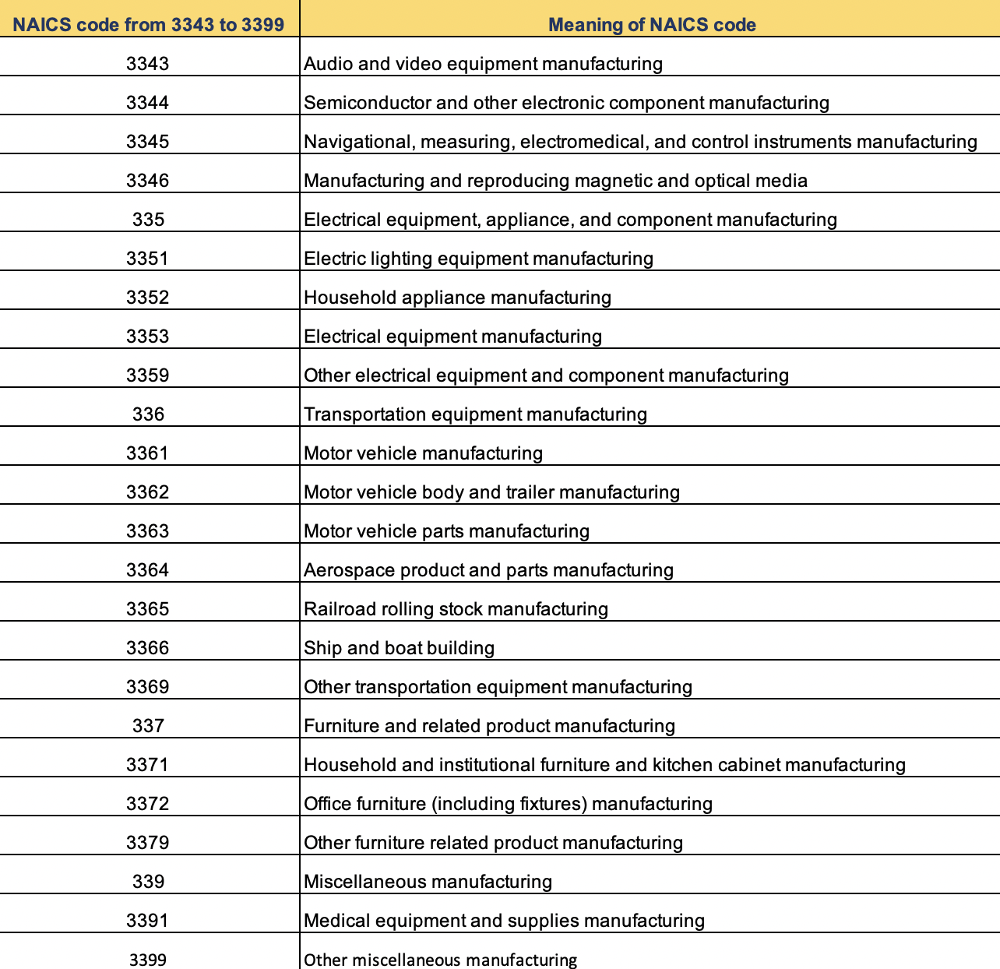

APPENDIX H - Variation in Labor Force by County for 2019-2021

Figure H1. Variation in the Labor Force of Hillsborough County from the Year 2019 to 2021

Figure H2. Variation in the Labor Force of Collier County from the Year 2019 to 2021

Figure H3. Variation in the Labor Force of Palm Beach County from the Year 2019 to 2021

Figure H4. Variation in the Labor Force of Brevard County from the Year 2019 to 2021

Figure H5. Variation in the Labor Force of Duval County from the Year 2019 to 2021

Figure H6. Variation in the Labor Force of Polk County from the Year 2019 to 2021

Figure H7. Variation in the Labor Force of Volusia County from the Year 2019 to 2021

Figure H8. Variation in the Labor Force of Nassau County from the Year 2019 to 2021

Figure H9. Variation in the Labor Force of Columbia County from the Year 2019 to 2021

Figure H10. Variation in the Labor Force of Madison County From the Year 2019 to 2021

Figure H11. Variation in the Labor Force of Escambia County from the Year 2019 to 2021

Figure H12. Variation in the Labor Force of Broward County from the Year 2019 to 2021

Figure H13. Variation in the Labor Force of Miami-Dade County from the Year 2019 to 2021

Figure H14. Variation in the Labor Force of Pinellas County from the Year 2019 to 2021

