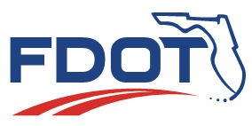
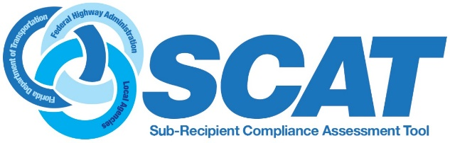

23 Code of Federal Regulations (CFR) Part 200 requires that the Florida Department of Transportation (FDOT) conduct periodic reviews of cities, counties, planning agencies and other recipients of Federal-Aid Highway Program funds to ensure they are complying with Title VI of the Civil Rights Act of 1964 and other nondiscrimination authorities. See Chapter 8 of the LAP Manual and the LAP Title VI and Nondiscrimination webpage for complete information on the history, definitions, and detailed requirements of the FDOT Subrecipient Compliance Assessment (SCAT) process.
Please complete the Assessment and upload it to GAP. Contact your District Local Program Administrator or the Statewide Local Program Administrator with questions, or refer to the LAP Nondiscrimination Handbook for Local Agencies.

Name of Agency: Click here to enter text. Number of Employees: Choose an item.

- Complete and upload a FDOT Title VI/Nondiscrimination Assurance to GAP. A copy of the document may be obtained here: Attachment B.
Assurance Execution Date: Click here to enter text.
Check the box provided when you have completed upload to GAP. ☐

- Post your agency’s written Title VI/Nondiscrimination Plan to your website that includes:
- Title VI/Nondiscrimination policy notice to the public.
- Filing procedures for discrimination complaints based on race, color, national origin, sex, age, disability, religion, or family status. (Note, this request does not include your agency’s employment discrimination policies/procedures.)
Best practice is to post or link Nondiscrimination Plan and related procedures directly from the home page of your website to ensure the public understands the documents are applicable to all programs within the agency.
Provide website location of posted document: Click here to enter text.

- Does your agency construct/improve curb ramps pursuant to the DOJ/DOT Technical Assistance Memo, including installation of truncated domes? http://www.fhwa.dot.gov/civilrights/programs/doj_fhwa_ta.cfm

Choose an item.

If no, briefly explain:
Click here to enter text.

- Subrecipients of Federal-Aid Highway Program funds must comply with the ADA in all aspects of design and construction. Florida laws and rules require use of the Florida Greenbook design standards when planning, designing, and constructing transportation facilities for projects located on local roadways. Federal-Aid Highway Program funded projects require use of the FDOT Design Manual (FDM) when designing and constructing projects located on the State or National Highway Systems. Both the Florida Greenbook and the FDM meet or exceed the 2010/2006 ADA Standards for Transportation Facilities and/or the Public Rights of Way Accessibility Guidelines (PROWAG).

Check the box to confirm your agency meets minimum design standards as required by Florida laws and rules: ☐ Yes

Check the box to confirm your agency complies with the design exception and/or variation process in instances of technical infeasibility: ☐ Yes

- Has your agency completed and publicly posted an ADA Transition Plan for the accessibility of pedestrian facilities within your public rights of way? (Note, this is a requirement of all government agencies with 50 or more employees, regardless of funding source. See 28 CFR 35.105 and 150(d)).

Choose an item.

- Enter (or verify) the name(s), title and contact information of your agency’s Title VI/Nondiscrimination and ADA Coordinator(s) in GAP.

Check the box provided when you have completed this item ☐
- Has your agency been the subject of discrimination complaints (race, national origin, color, sex, age, disability, religion or family status) during the past three years? (Note, this excludes employment discrimination complaints).
Choose an item.
If yes, briefly explain or attach documentation of complaint, dates and disposition, if any:
Click here to enter text.

- How does your agency advise the public of nondiscrimination policies or other similar information? Electronic or web-based posting alone is insufficient.

Check a minimum of two that apply to your agency:

☐ Web Page
☐ Social Media
☐ Postings in Public Buildings
☐ Public Meetings
☐ Publications/Media

- Recipients of federal funding are required to collect and analyze demographic data to ensure nondiscrimination and equity in recipient programs, services and activities. Identify your agency’s sources for collection and review of demographic data (race, national origin, age, etc.) on those affected your organizational decisions?
Check all that apply:

☐ US Census
☐ American Community Survey – Table s1601
☐ Department of Education
☐ School Board
☐ Community Development Offices
☐ Other sources Click here to enter text.

- Has your agency completed a written plan for providing language services to those who do not speak English proficiently, based upon analysis of the four factors described in Executive Order 13166 and related directives? (For more information or resources visit www.lep.gov).

Choose an item.

- A cornerstone of nondiscrimination is robust public involvement in recipient decision making regarding its programs, services and activities. Indicate how your agency provides outreach to and solicits input from minority, low income, elderly and disabled populations within your jurisdictional boundaries?
Check all that apply:

☐ Targeted public involvement of these communities

☐ Committees or advisory groups representing these communities (may include religious or social organizations).

☐ Community Development Department within the agency serving these communities
☐ Other Click here to enter text.

- My agency is completing this SCAT form to:

☐ Certify as a LAP agency
☐ Re-Certify as a LAP agency

☐ Qualify as a subrecipient of Federal-Aid Highway Program funds
☐ Comply with a request by FDOT and/or FHWA
Last updated 08/01/2022

