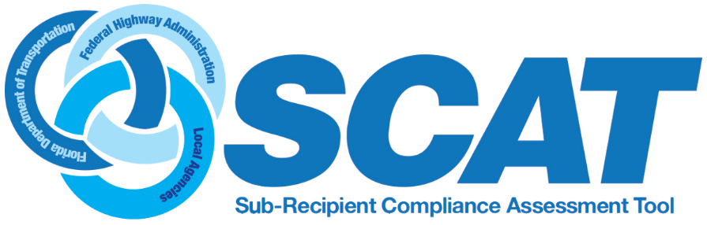

LAP Title VI and ADA Sub-Recipient Compliance Assessment Training (SCAT)

TBD |  | FDOT District near you!
8:30 AM | Registration: NONDISCRIMINATION PROGRAM TRAINING FOR LOCAL AGENCIES 2020
9:00 AM | Welcome |  | Federal Highway Administration  (FHWA FL Division)  Florida Department of Transportation (FDOT)
9:30 AM | History and Importance of Title VI and other Nondiscrimination Authorities |  | Carey Shepherd
10:30 AM | Tools for Title VI and ADA Compliance – SCAT |  | Jacqueline Paramore  Lorraine Moyle
11:30 PM | LUNCH on your own |  | ALL
1:00 PM | ADA Requirements for Local Governments and Tech Tools for Compliance |  | Brad Bradley
2:00 PM | ADA Standards – For Engineers . . and the rest of us |  | TBD
3:00 PM | Field Exercises (weather permitting) |  | ALL
4:00 PM | Q&A and Wrap – up |  | ALL
