For access to the public hearing upload, email CO-OWPBSupport@dot.state.fl.us requesting access

Go to: https://owpb.fdot.gov/WAP:
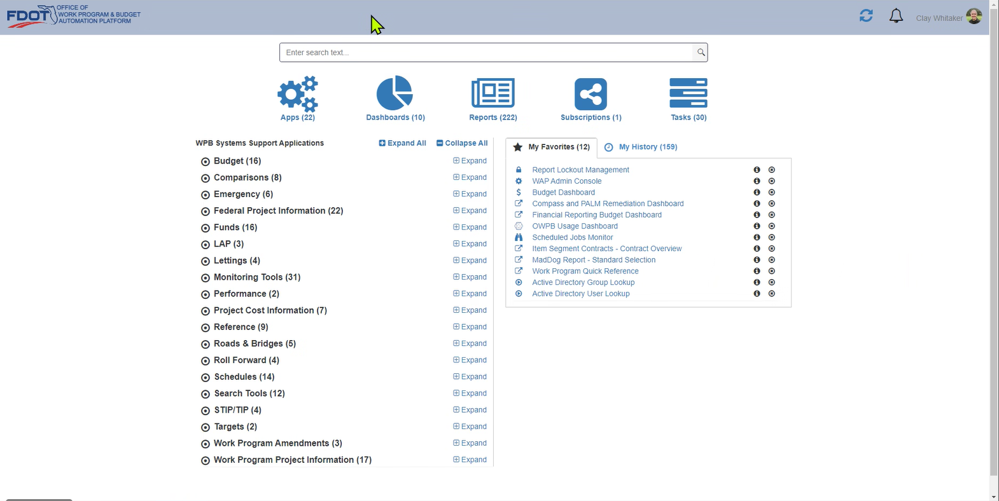

Search for public hearing, then Click public hearing report
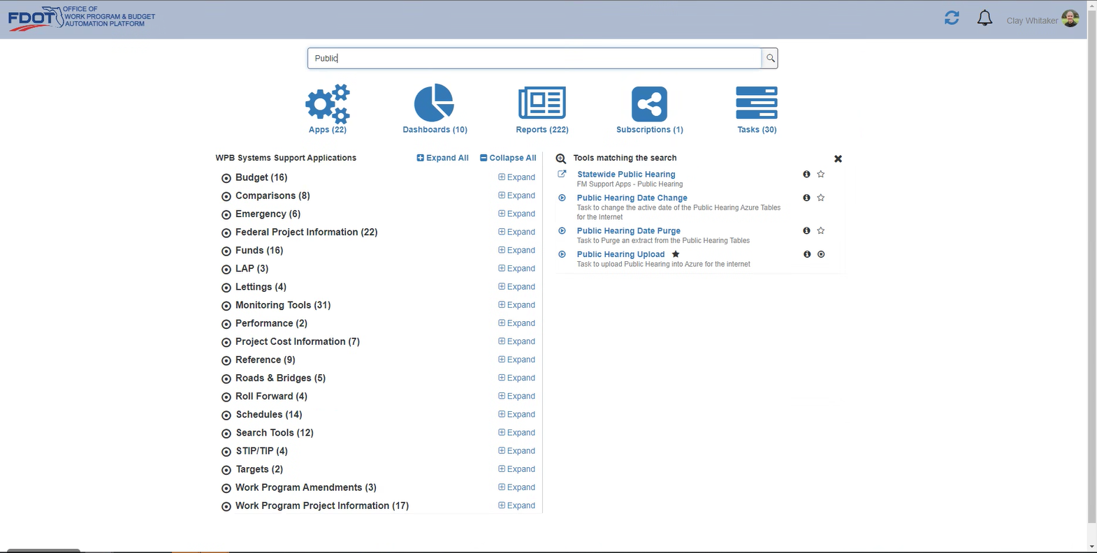

Select District
As of: pick “Live”
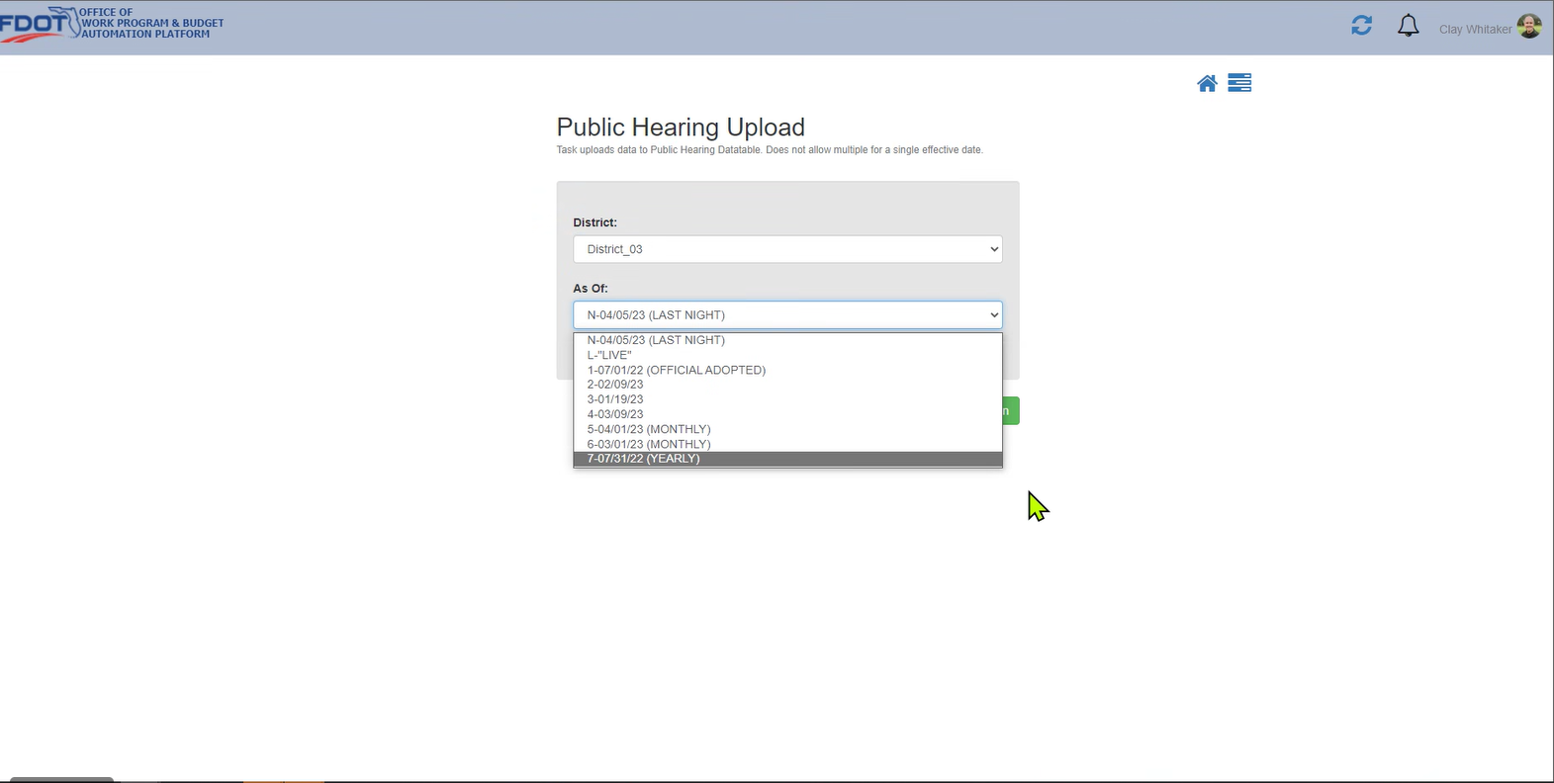
Hit run:
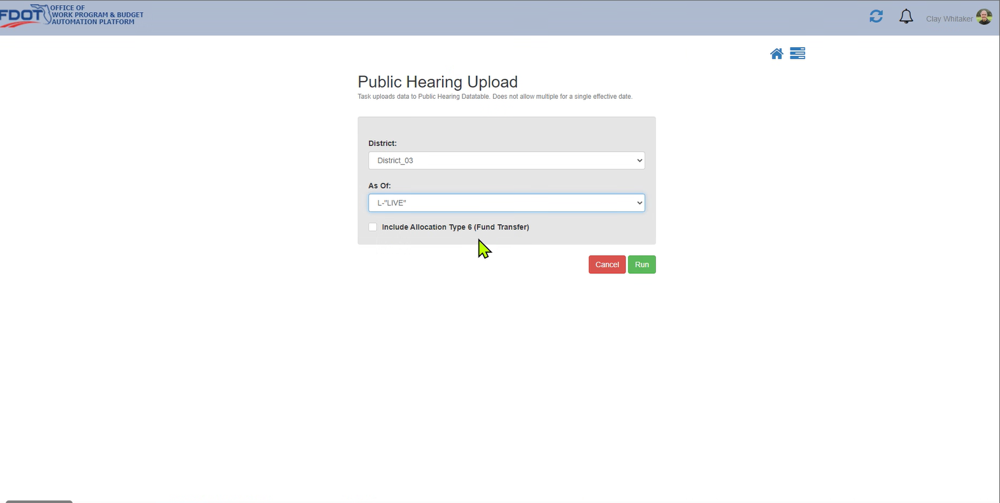

Click hyperlink
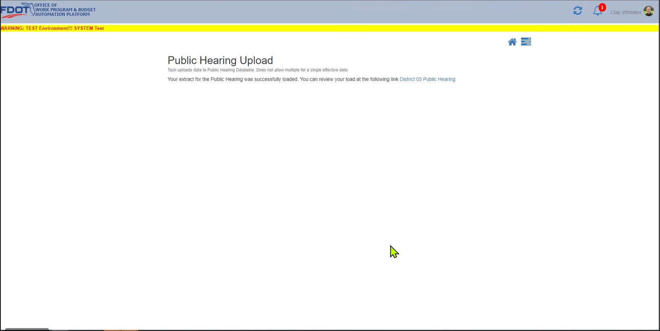

Data is now available for generating report
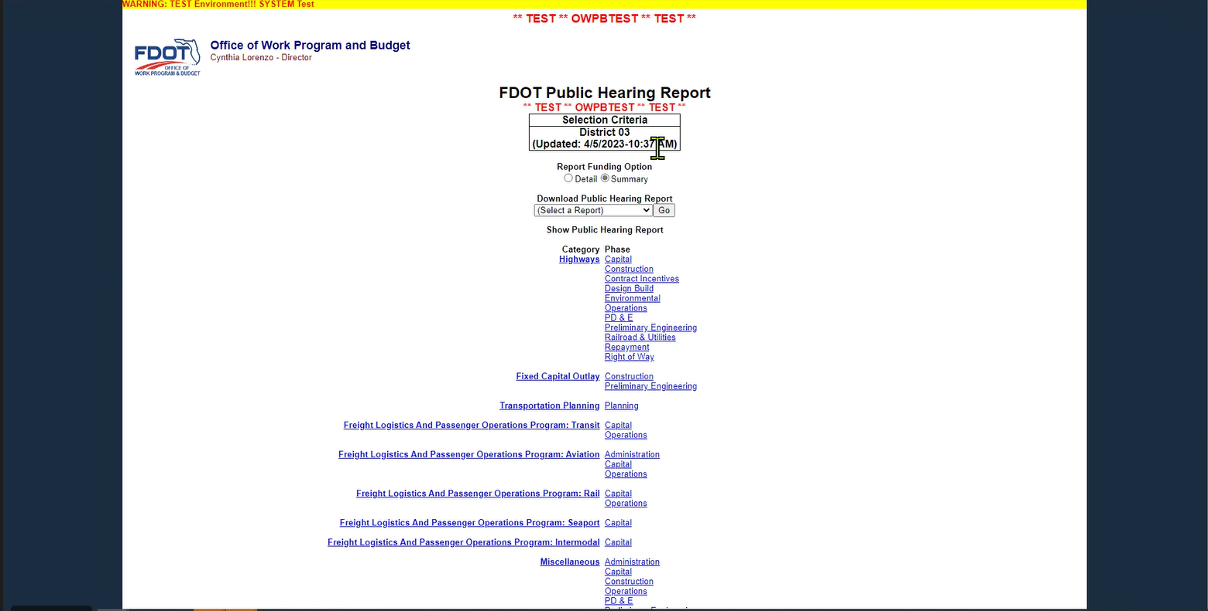

Select Detail or Summary
Detail – gives you fund codes for each FPID
Summary – does not give fund codes, gives you funding source (i.e. local, state, federal)

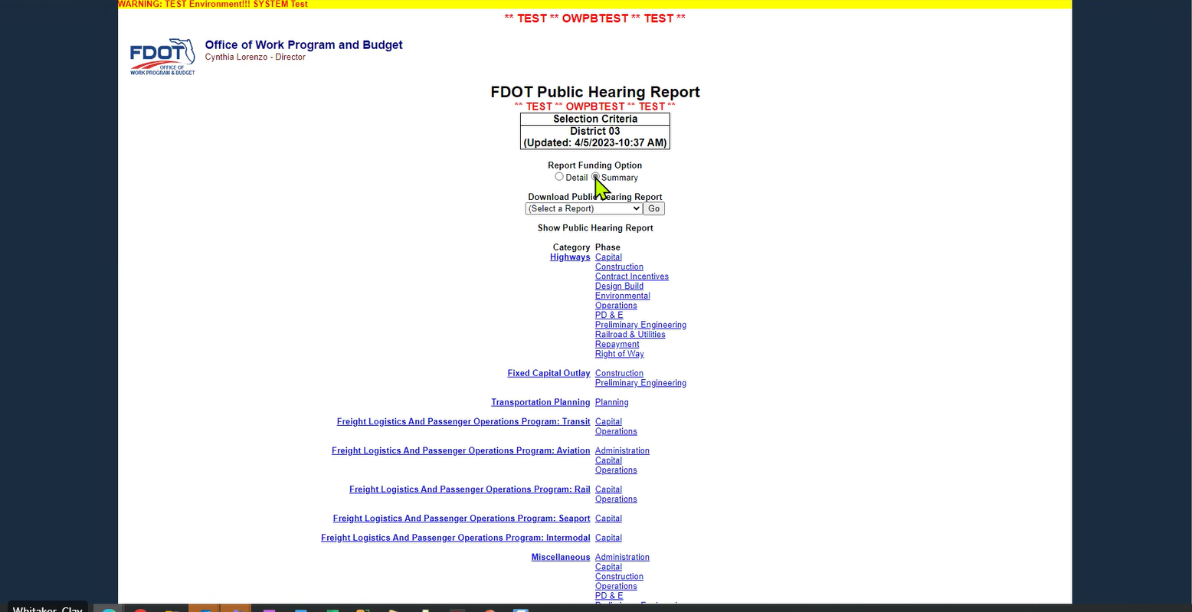

Pick ZIP (with PDFs by County) – generates a Zip file with individual reports by County.
