The Florida Freight Advisory Committee (FLFAC) was created in 2016 and serves the mission of the Florida Department of Transportation (FDOT) to provide a safe statewide transportation system that promotes the efficient movement of people and goods, supports the state’s economic competitiveness, prioritizes Florida’s environment and natural resources, and preserves the quality of life and connectedness of the state’s communities.

Consistent with federal guidance, the FLFAC will consist of a representative cross-section of public and private sector freight stakeholders.

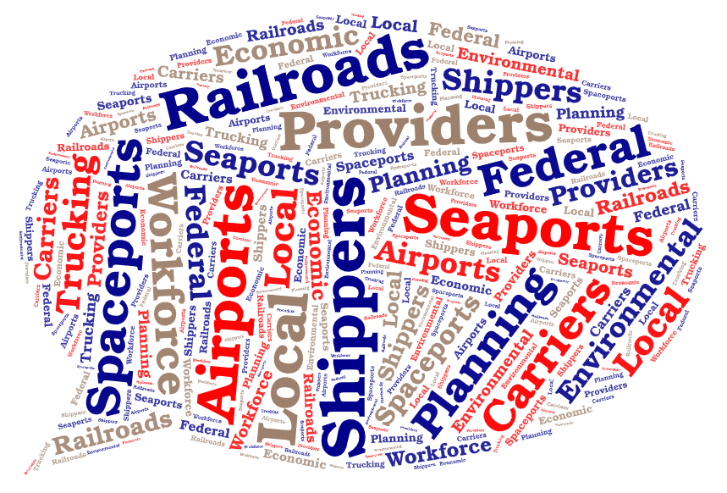

The FLFAC meets up to 4 times a year as needed, and is charged with:

* Advising the State on freight-related priorities, issues, projects, and funding needs;
* Serving as a forum for discussion of State decisions affecting freight transportation;
* Communicating and coordinating regional priorities with other organizations;
* Promoting the sharing of information between the private and public sectors on freight issues; and
* Participating in the development of the State's Freight Plan.

|  |  |  |  |  |
| --- | --- | --- | --- | --- |
| **Applicant Information** | | | | |
|  | | | | |
| Full Name: |  | | |
| Employer: | |  | | |
| Job Title: | |  | | |
| Mailing Address: | |  | | |
| City, State Zip Code: |  | | |
| Primary Phone: |  | | | |
| E-mail: |  | | | |
|  | | | | |
| **Are you a current member of the Florida Freight Advisory Committee wishing to continue to serve for another 1.5 years?** | | | | |
| Yes | | | No | |
| **Prior to the current half-cycle (1.5 years), have you served on the Florida Freight Advisory Committee before?** | | | | |
| Yes | | | No | |
| **Are you willing to commit to attending at least half of the yearly meetings?**  *(If a member is consistently failing to attend meetings and misses more than half of the yearly meetings with no notice, he or she will be asked to step down and a replacement will be found.)* | | | | |
| Yes | | | No | |

|  |  |  |  |
| --- | --- | --- | --- |
|  | | |  |
| **Are you willing to commit to leading at least one agenda item in the upcoming half-cycle (1.5 years)?** | | | |
| Yes | | No | |
| **What agenda item(s) would you be willing to lead?**  **Leading an agenda item can include:**   * **Speaking on a topic alone or as a group and preparing associated presentation materials or** * **Identifying willing non-FLFAC member participants and facilitating the topic.**   *(Your description may be as long as necessary. The field will expand as you type.)* | | | |
|  | | | |
|  |  | | |
|  | | | |
| **What are your current or past freight, trade, and logistics responsibilities and expertise?** *(Your description may be as long as necessary. The field will expand as you type.)* | | | |
|  | | | |
|  |  | | |
|  | | | |
| **Please disclose any potential conflicts of interest as it relates to providing recommendations on publicly funded transportation or logistics projects.** *(Your answer may be as long as necessary. The field will expand as you type.)* | | | |
|  | | | |
|  |  | | |