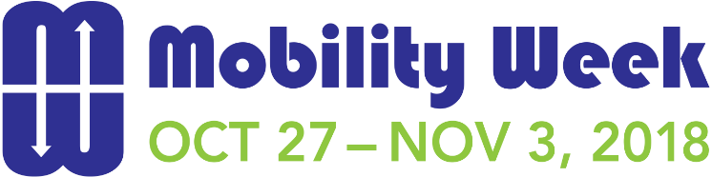



# 2018 Social Media Communication Plan – For Central Florida Partners

**PREPARED ESPECIALLY FOR OUR PARTNERS**

Mobility Week Tips and Social Media Posts

**Increase engagement during Mobility Week by using these suggested social media posts that you can use across your preferred platforms. Be sure to use #mobilityweekfl so we can follow your teams.**

* Like FDOT’s Facebook page and check for Mobility Week updates.
* Follow FDOT on Twitter page and check for Mobility Week updates.
* Encourage staff, family and friends to join the Mix-It-Up 2018 Challenge <http://fdot.gov/projects/mobilityweek/Mix_It_Up_Challenge.shtm>
* Mention Mobility Week in your agency newsletter.
* Share the event calendar and information on the Mix-It-Up Challenge in your agency break room.
* Coordinate a car pool for employees during Mobility Week.
* Host a Mobility Week event to spread awareness on safe multimodal travel options.
* Share your Mobility Week activities, pictures, videos and posts on your social media pages.
* Use the Mobility Week hashtag, [**#mobilityweekfl**](http://fdot.gov/projects/mobilityweek) in your posts
* Retweet Mobility Week events on your Twitter page.
* Share exciting posts highlighting your involvement in Mobility Week and encourage others to get involved too.
* Invite your followers to attend a Mobility Week event.
* Follow the [Mobility Week partners](http://fdot.gov/projects/mobilityweek/Partners.shtm) and share or retweet relevant posts.

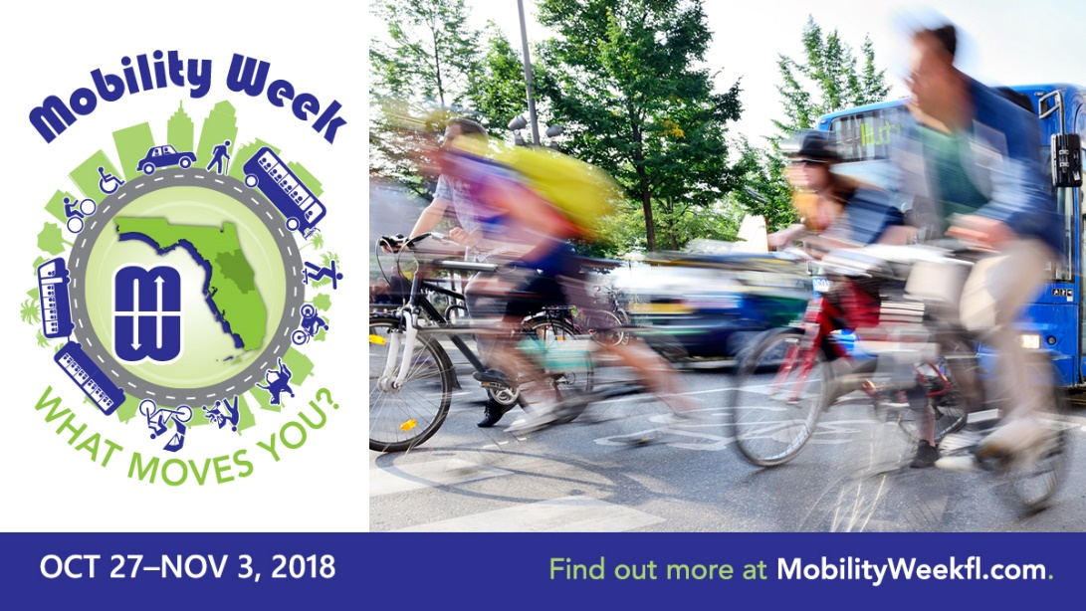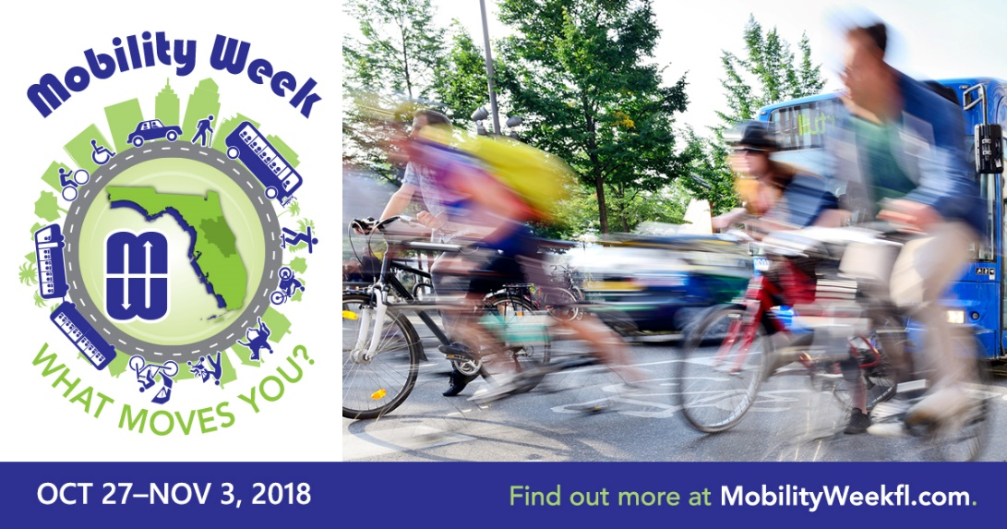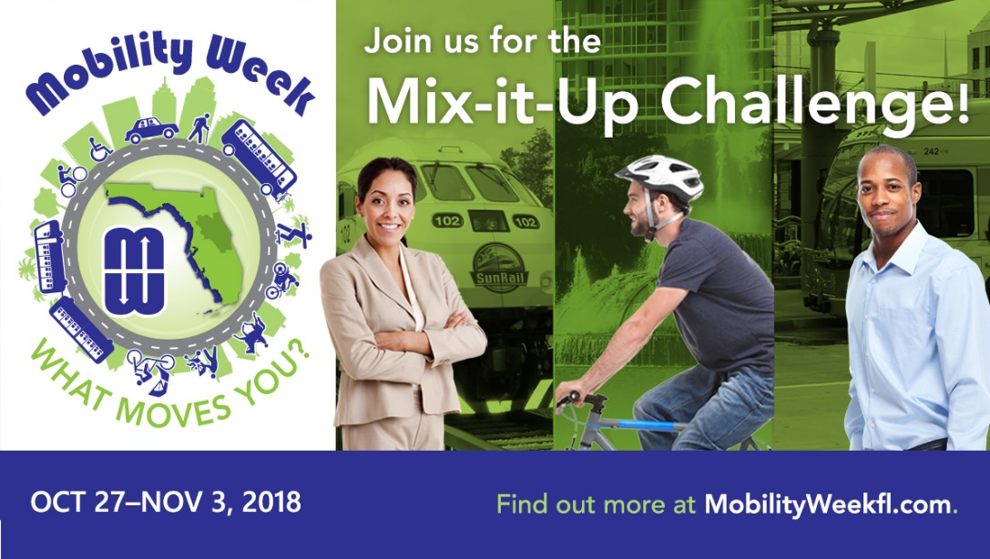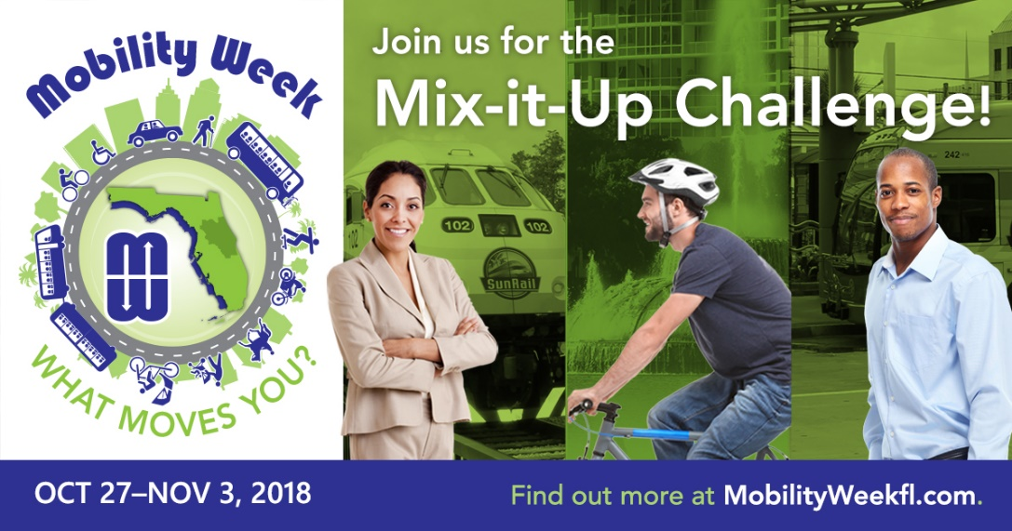

**Suggested Post Date:** Week of Oct. 15, 2018

|  |  |
| --- | --- |
| **Platform** | **Copy** |
| https://image.freepik.com/free-icon/facebook-logo-with-rounded-corners_318-9850.jpg | Mobility Week 2018 is around the corner! We are proud to join FDOT and its partner agencies to promote awareness of safe multimodal transportation choices. Florida residents can participate in a variety of activities from Saturday, October 27 through Saturday, November 3. For more information about Mobility Week, including a [calendar of events](http://fdot.gov/projects/mobilityweek/Find_Your_District_Events.shtm), [travel services available](http://fdot.gov/projects/mobilityweek/Find_Your_District_Transportation_Choices.shtm) in your area, and where to register for the [Mix-It-Up Challenge](http://fdot.gov/projects/mobilityweek/Mix_It_Up_Challenge.shtm), visit [FDOT Mobility Week](http://fdot.gov/projects/mobilityweek/). **#mobilityweekfl** |
| https://marketplace.canva.com/MAB0g7ZqQow/1/thumbnail/canva-twitter-social-media-icon-MAB0g7ZqQow.png | We are excited to be a part of Florida Mobility Week! Learn more at [FDOT Mobility Week](http://fdot.gov/projects/mobilityweek/). **#mobilityweekfl** |

**FaceBook Image** *(Sized 1200 x 628 px)*

**Twitter Image** *(Sized 1200 x 675 px)*

**Twitter Image** *(Sized 1200 x 675 px)*

**FaceBook Image** *(Sized 1200 x 628 px)*

**Suggested Post Date:** Second Post for Week of Oct. 15, 2018

|  |  |
| --- | --- |
| **Platform** | **Copy** |
| https://image.freepik.com/free-icon/facebook-logo-with-rounded-corners_318-9850.jpg | Join us for the Mix-It-Up Challenge! This fun, free online challenge takes place from October 27 through November 3, 2018. It is your opportunity to explore riding transit, biking, walking or carpooling rather than driving alone. All Florida residents are invited to participate. Take the challenge to try a new transportation choice that makes a positive impact on our transportation system and win prizes. To learn more, visit FDOT Mobility Week [Mix-It-Up Challenge](http://fdot.gov/projects/mobilityweek/Mix_It_Up_Challenge.shtm) website.  **#mobilityweekfl** |
| https://marketplace.canva.com/MAB0g7ZqQow/1/thumbnail/canva-twitter-social-media-icon-MAB0g7ZqQow.png | Take the fun, free, online Mix-It-Up Challenge to try a new transportation choice that makes a positive impact on our transportation system and win prizes. To enter, visit [mixitupchallenge.com](http://fdot.gov/projects/mobilityweek/Mix_It_Up_Challenge.shtm).  **#mobilityweekfl** |

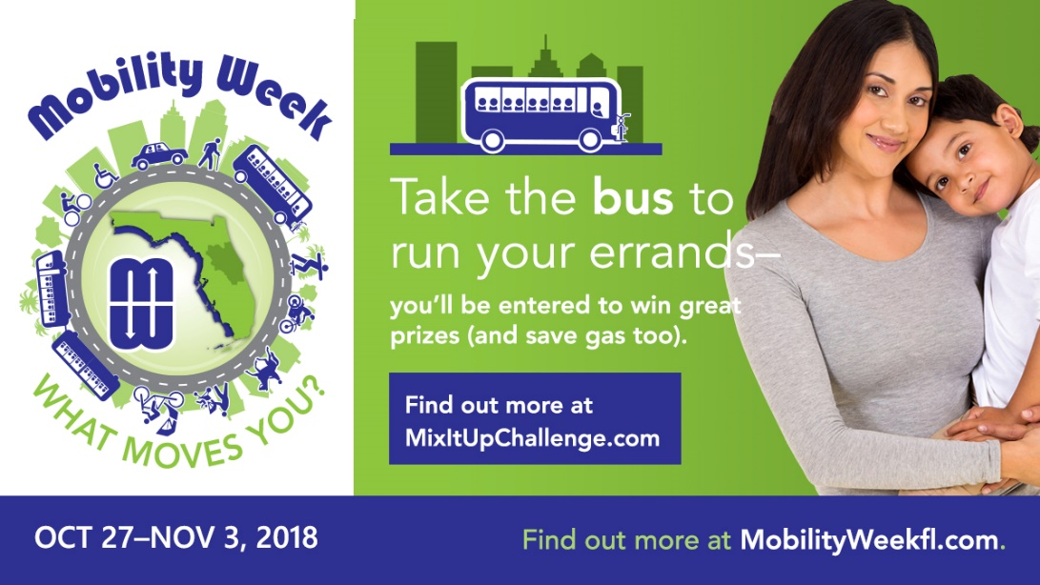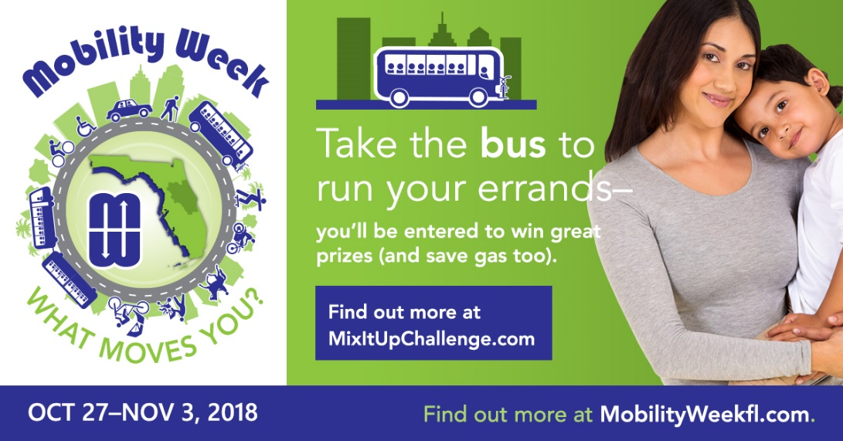

**Twitter Image** *(Sized 1200 x 675 px)*

**FaceBook Image** *(Sized 1200 x 628 px)*

**Suggested Post Date:** Week of Oct. 22, 2018

|  |  |
| --- | --- |
| **Platform** | **Copy** |
| https://image.freepik.com/free-icon/facebook-logo-with-rounded-corners_318-9850.jpg | During Mobility Week, cities, counties, and transportation agencies host events to promote transportation choices and offer information on how to safely bike, walk and ride transit. [Click here](http://fdot.gov/projects/mobilityweek/Find_Your_District_Events.shtm) to find out what events are happening in your area of the state.[**#mobilityweekfl**](http://fdot.gov/projects/mobilityweek/) |
| https://marketplace.canva.com/MAB0g7ZqQow/1/thumbnail/canva-twitter-social-media-icon-MAB0g7ZqQow.png | Interested in attending Mobility Week events in your area? [Click here](http://fdot.gov/projects/mobilityweek/Find_Your_District_Events.shtm) to find more. **#mobilityweekfl** |

**Suggested Post Date:** Oct. 26, 2018

|  |  |
| --- | --- |
| **Platform** | **Copy** |
| https://image.freepik.com/free-icon/facebook-logo-with-rounded-corners_318-9850.jpg | Are you a Florida resident? By taking the pledge to try a new transportation choice, you can make a positive impact on our transportation system. Pledge to replace your short trips with walking. You may get some great ideas while reliving stress! Join us at [mixitupchallenge.com](https://orlando.commuter-challenge.org/). [**#mobilityweekfl**](http://fdot.gov/projects/mobilityweek/)  “I love walking because it clears your mind, enriches the soul, takes away stress and opens up your eyes to a whole new world.” – Claudette Dudley |
| https://marketplace.canva.com/MAB0g7ZqQow/1/thumbnail/canva-twitter-social-media-icon-MAB0g7ZqQow.png | Take a pledge by riding transit, biking and walking and enter to win the grand prize and daily prizes. **#mobilityweekfl** |

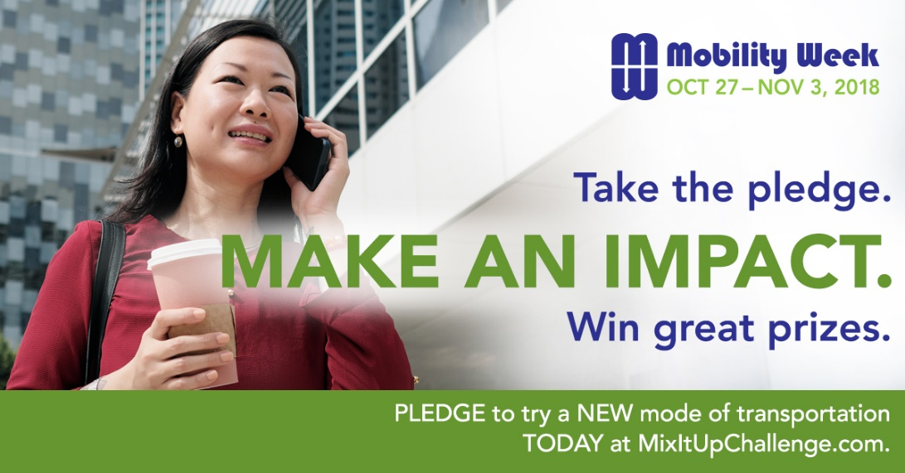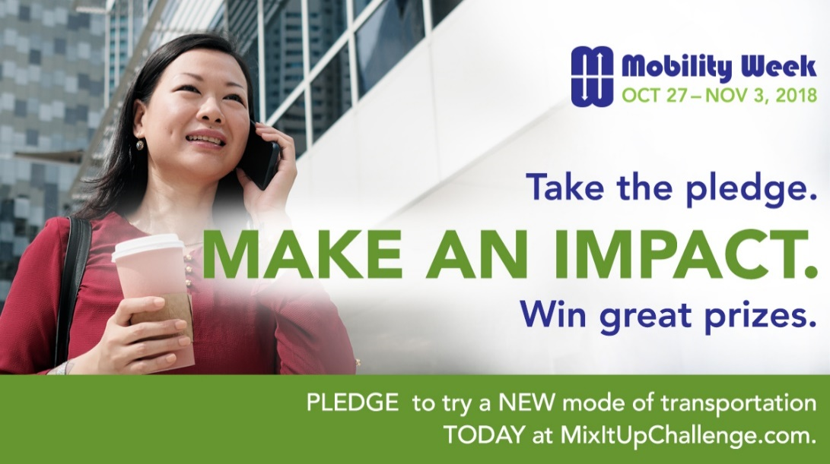

**Twitter Image** *(Sized 1200 x 675 px)*

**Twitter Image** *(Sized 1024 x 512 px)*

**FaceBook Image** *(Sized 1200 x 628 px)*

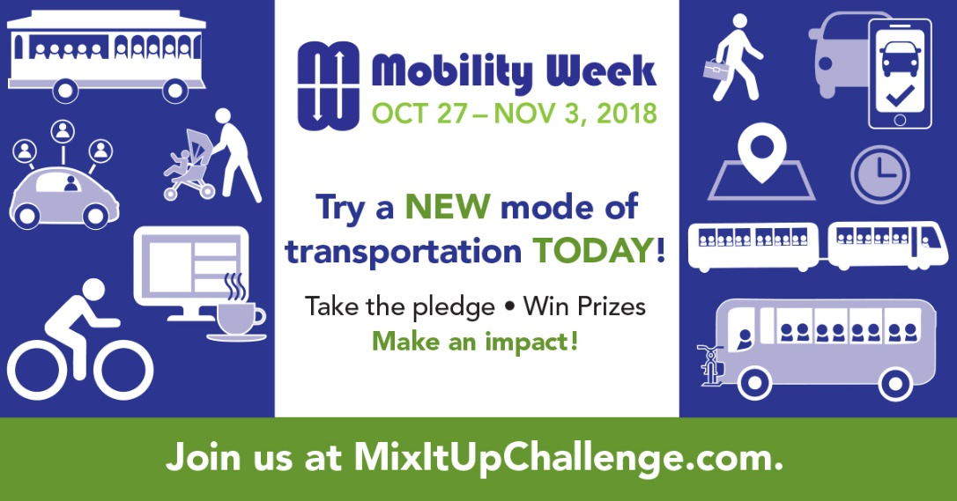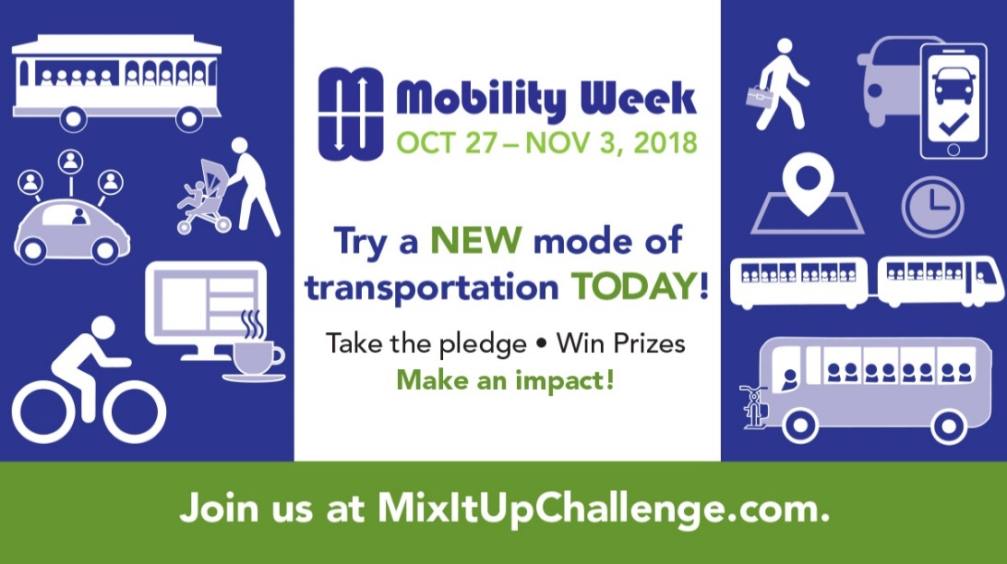

**Twitter Image** *(Sized 1200 x 675 px)*

**FaceBook Image** *(Sized 1200 x 628 px)*

**Suggested Post Date:** Oct. 27, 2018

|  |  |
| --- | --- |
| **Platform** | **Copy** |
| https://image.freepik.com/free-icon/facebook-logo-with-rounded-corners_318-9850.jpg | Florida’s Mobility Week officially begins today. It is an annual collection of events to promote safe multimodal travel choices and how those choices can build stronger communities, reduce traffic congestion and improve community health. Agencies, employers and individuals can all participate and contribute in their own way. Find out more at [www.mobilityweekfl.com](http://www.mobilityweekfl.com). [**#mobilityweekfl**](http://fdot.gov/projects/mobilityweek/) |
| https://marketplace.canva.com/MAB0g7ZqQow/1/thumbnail/canva-twitter-social-media-icon-MAB0g7ZqQow.png | Florida’s Mobility Week officially begins today. Find out how you can get involved at [www.mobilityweekfl.com](http://www.mobilityweekfl.com). **#mobilityweekfl** |

**FaceBook Image** *(Sized 1200 x 628 px)*

**Twitter Image** *(Sized 1200 x 675 px)*

**Suggested Post Date:** Oct. 29, 2017

|  |  |
| --- | --- |
| **Platform** | **Copy** |
| https://image.freepik.com/free-icon/facebook-logo-with-rounded-corners_318-9850.jpg | During Mobility Week, why not try a new mode of transportation for your commute, shopping and recreation? You might discover that you enjoy the extra exercise, meeting new people and saving money on fuel while you avoid sitting behind the wheel. Join us at [mixitupchallenge.com](http://fdot.gov/projects/mobilityweek/Mix_It_Up_Challenge.shtm).  [Click here](http://fdot.gov/projects/mobilityweek/Find_Your_District_Transportation_Choices.shtm) to see the transportation choices available in your area. [**#mobilityweekfl**](http://fdot.gov/projects/mobilityweek/) |
| https://marketplace.canva.com/MAB0g7ZqQow/1/thumbnail/canva-twitter-social-media-icon-MAB0g7ZqQow.png | Join the Mobility Week [Mix-It-Up Challenge](http://fdot.gov/projects/mobilityweek/Mix_It_Up_Challenge.shtm) for a chance to try a new transportation choice and win prizes while doing so. [Click here](http://fdot.gov/projects/mobilityweek/Find_Your_District_Transportation_Choices.shtm) to see the transportation choices available in your area. [**#mobilityweekfl**](http://fdot.gov/projects/mobilityweek/) |

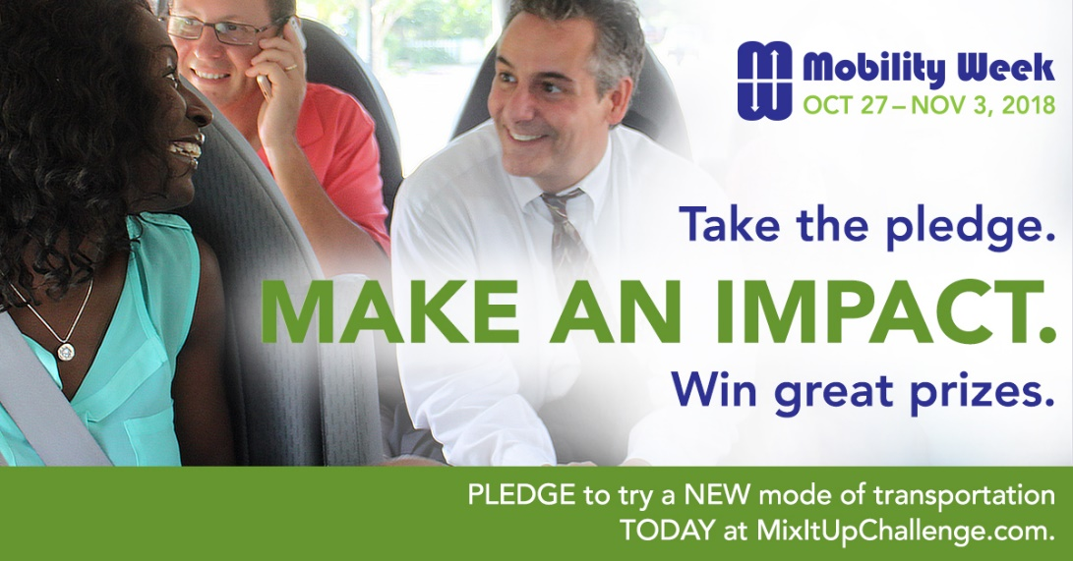

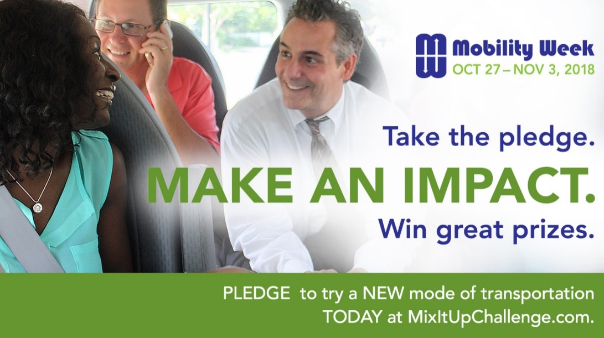

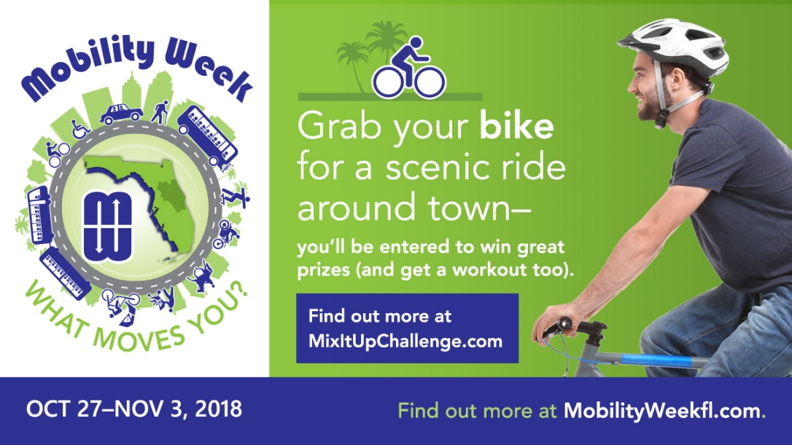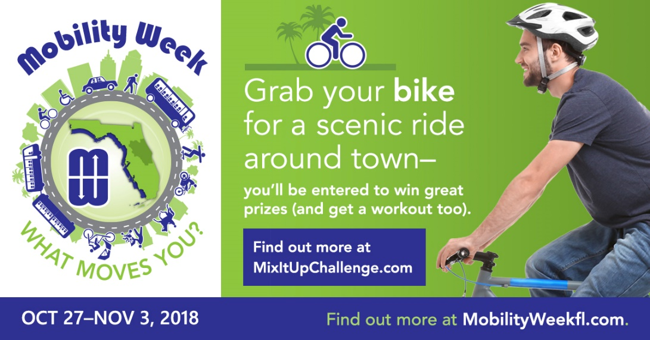

**Twitter Image** *(Sized 1200 x 675 px)*

**FaceBook Image** *(Sized 1200 x 628 px)*

**Suggested Post Date:** Oct. 30, 2018

|  |  |
| --- | --- |
| **Platform** | **Copy** |
| https://image.freepik.com/free-icon/facebook-logo-with-rounded-corners_318-9850.jpg | Make the switch from driving alone to using  other modes of transportation and win prizes. Take the [Mix-It-Up Challenge](http://fdot.gov/projects/mobilityweek/Mix_It_Up_Challenge.shtm). Pledge to bike during Mobility Week while enjoying the benefits of exercise, fresh air, stress relief while positively impacting our transportation system. [**#mobilityweekfl**](http://fdot.gov/projects/mobilityweek/)  As H.G. Wells said “Whenever I see an adult on a bicycle, I do not despair for the human race.” |
| https://marketplace.canva.com/MAB0g7ZqQow/1/thumbnail/canva-twitter-social-media-icon-MAB0g7ZqQow.png | Pledge to bike during Mobility Week. Join the [Mix-It-Up Challenge](http://fdot.gov/projects/mobilityweek/Mix_It_Up_Challenge.shtm) and win exciting prizes. [**#mobilityweekfl**](http://fdot.gov/projects/mobilityweek/) |

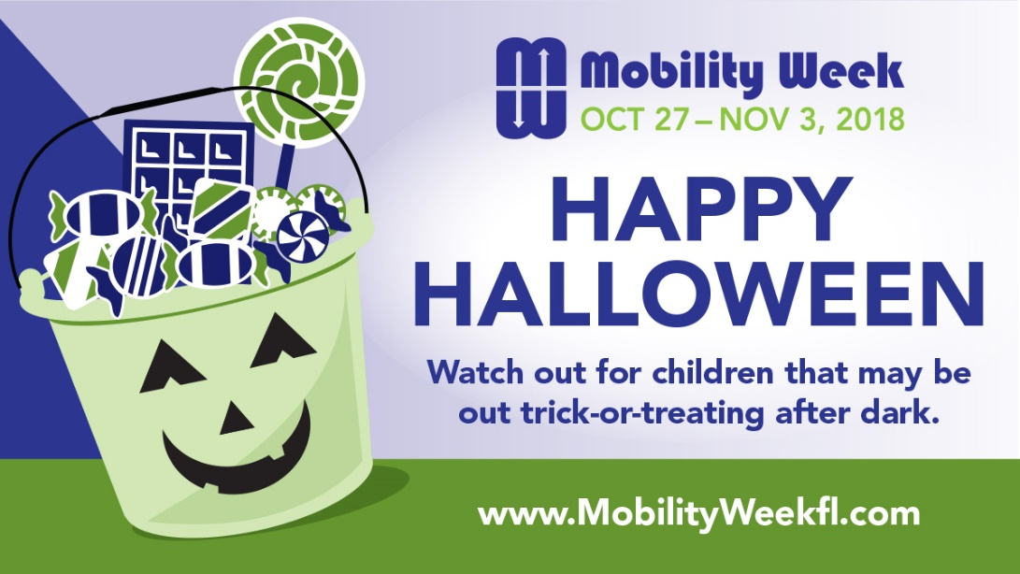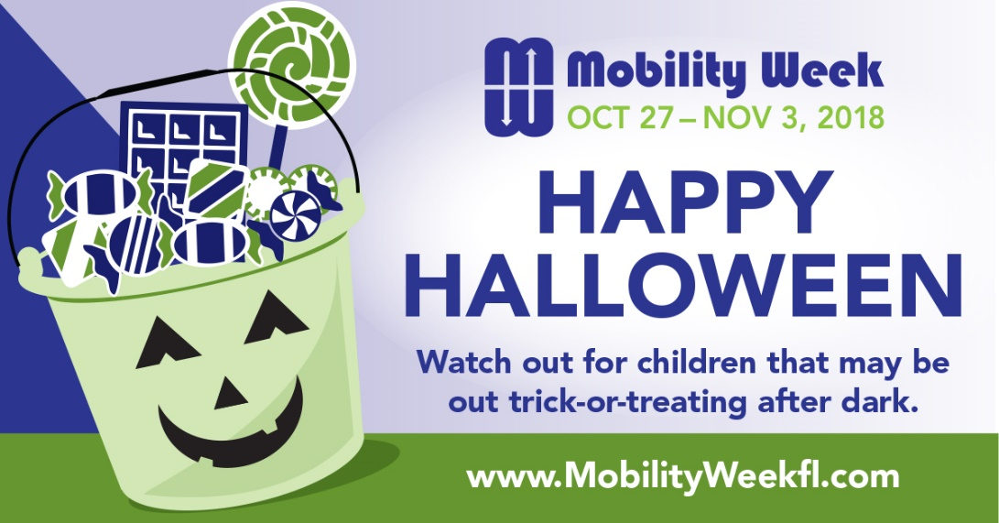

**Twitter Image** *(Sized 1200 x 675 px)*

**FaceBook Image** *(Sized 1200 x 628 px)*

**Suggested Post Date:** Oct. 31, 2018

|  |  |
| --- | --- |
| **Platform** | **Copy** |
| https://image.freepik.com/free-icon/facebook-logo-with-rounded-corners_318-9850.jpg | Happy Halloween! You can contribute to pedestrian safety by choosing not to drive today and if you do, watch out for children that may be out trick-or-treating after dark.  If you are walking after dark, make yourself visible to motorists, by carrying a flashlight, wearing a small flashing strobe light, or wearing reflective clothing. [Click here](http://fdot.gov/projects/mobilityweek/Find_Your_District_Events.shtm) to find out about events happening in your area this week. [**#mobilityweekfl**](http://fdot.gov/projects/mobilityweek/) |
| https://marketplace.canva.com/MAB0g7ZqQow/1/thumbnail/canva-twitter-social-media-icon-MAB0g7ZqQow.png | We can all have a safe Halloween by making sure motorists watch out for people walking and by pedestrians following safe walking practices, such as wearing reflective clothing. **#mobilityweekfl** |

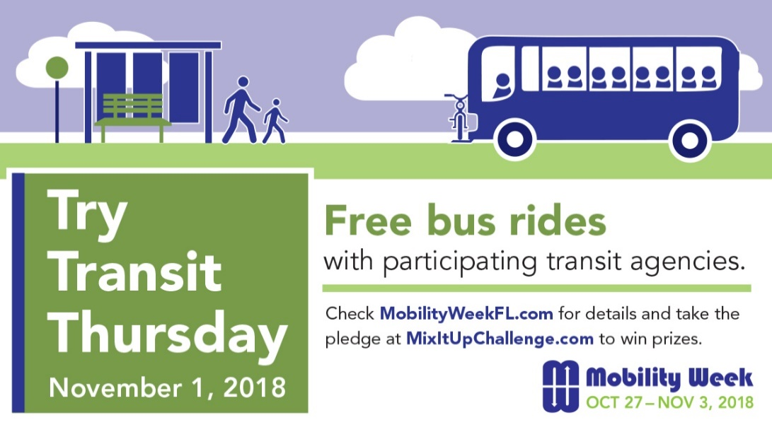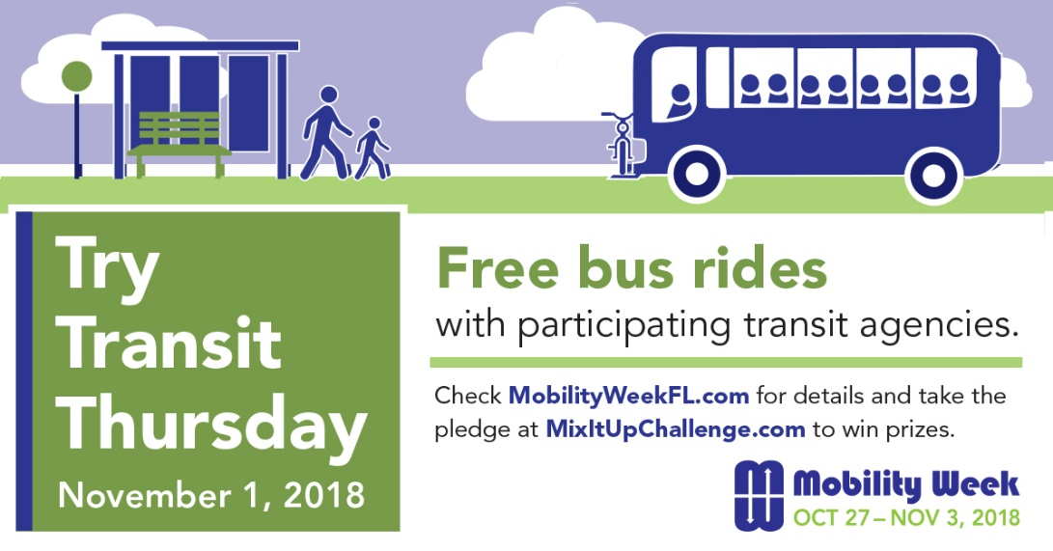

**Customize to your area or events.**

**Twitter Image** *(Sized 1200 x 675 px)*

**FaceBook Image** *(Sized 1200 x 628 px)*

**Suggested Post Date:** Nov 1, 2018

|  |  |
| --- | --- |
| **Platform** | **Copy** |
| https://image.freepik.com/free-icon/facebook-logo-with-rounded-corners_318-9850.jpg | Today is Try Transit Thursday. Participating transit agencies are offering free rides all day on their regularly scheduled routes. Use this as an opportunity to travel by bus at no cost. Take the pledge at [www.mixitupchallenge.com](http://www.mixitupchallenge.com) for a chance to win prizes. [**#mobilityweekfl**](http://fdot.gov/projects/mobilityweek/)  “On a bus, your eyes, ears, and pores are open absorbing in the variety, the wonder, and the magic of the city.” – George Takei. |
| https://marketplace.canva.com/MAB0g7ZqQow/1/thumbnail/canva-twitter-social-media-icon-MAB0g7ZqQow.png | Ride the bus for free or receive passenger appreciation giveaways at participating transit agencies. [Click here](http://fdot.gov/projects/mobilityweek/Find_Your_District_Events.shtm) to see if your transit agency is participating. **#mobilityweekfl** |

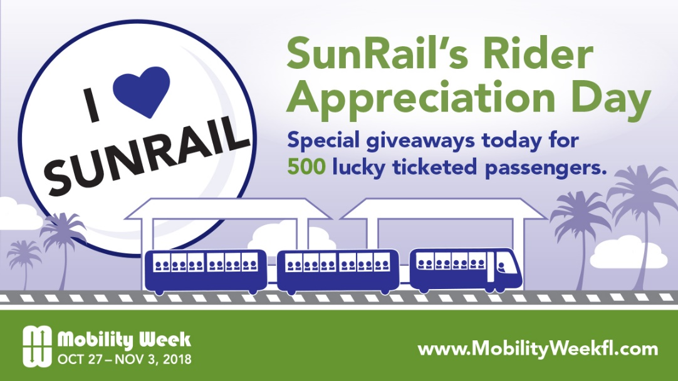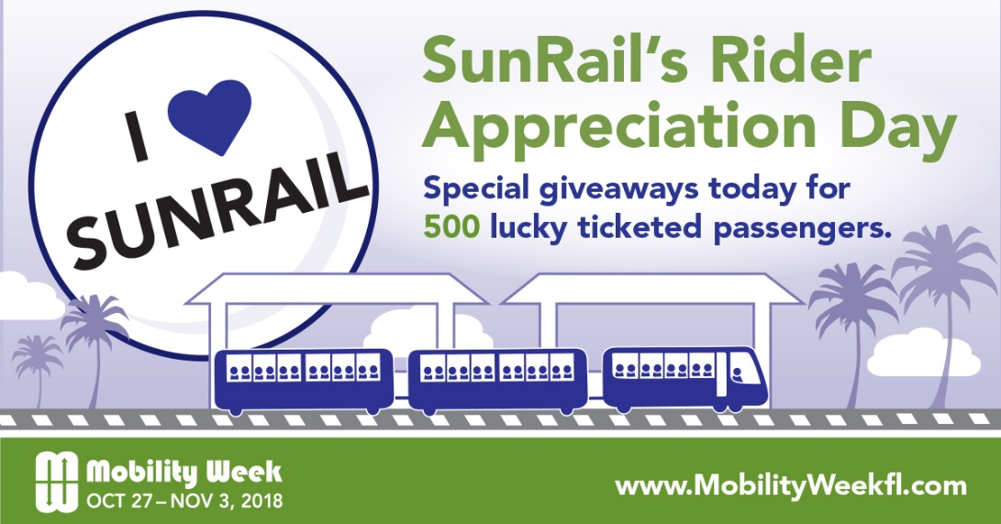

**Customize to your area or events.**

**Twitter Image** *(Sized 1200 x 675 px)*

**FaceBook Image** *(Sized 1200 x 628 px)*

**Suggested Post Date:** Nov. 2, 2018

|  |  |
| --- | --- |
| **Platform** | **Copy** |
| https://image.freepik.com/free-icon/facebook-logo-with-rounded-corners_318-9850.jpg | Join us aboard SunRail on Friday, November 2, as we celebrate SunRail’s Rider Appreciation Day with special giveaways for 500 lucky ticketed passengers. For train times and fare information, visit [SunRail.com](http://www.sunrail.com).  Take the pledge to ride the train instead of driving a car at [www.mixitupchallenge.com](http://www.mixitupchallenge.com). [**#mobilityweekfl**](http://fdot.gov/projects/mobilityweek/) |
| https://marketplace.canva.com/MAB0g7ZqQow/1/thumbnail/canva-twitter-social-media-icon-MAB0g7ZqQow.png | Join us aboard SunRail on Friday, November 2, as we celebrate SunRail’s Rider Appreciation Day with special giveaways for 500 lucky ticketed passengers. For train times and fare information, visit [SunRail.com](http://www.sunrail.com). [**#mobilityweekfl**](http://fdot.gov/projects/mobilityweek/) |

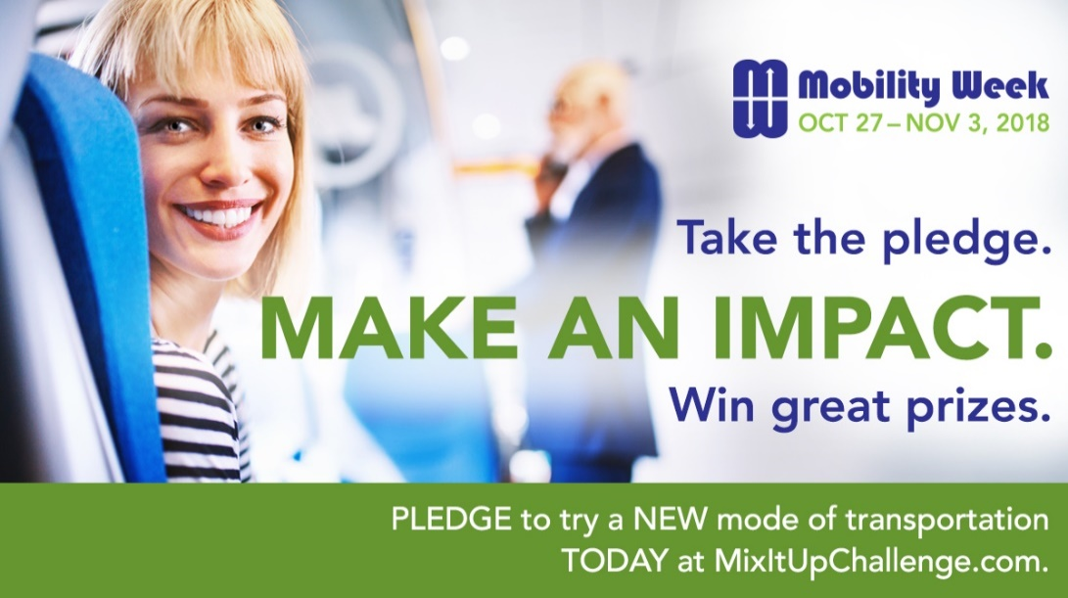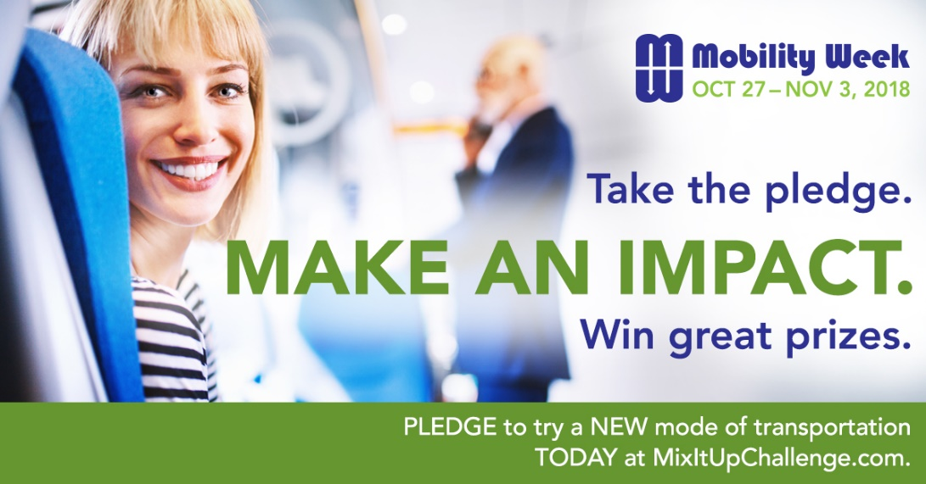

**FaceBook Image** *(Sized 1200 x 628 px)*

**Twitter Image** *(Sized 1200 x 675 px)*

**Suggested Post Date:** Nov. 3, 2018

|  |  |
| --- | --- |
| **Platform** | **Copy** |
| https://image.freepik.com/free-icon/facebook-logo-with-rounded-corners_318-9850.jpg | Today is the last day of Mobility Week and your last chance for taking the pledge to try a new transportation choice to win prizes. Take the pledge at [www.mixitupchallenge.com](http://www.mixitupchallenge.com) to finish Mobility Week strong. [**#mobilityweekfl**](http://fdot.gov/projects/mobilityweek/) |
| https://marketplace.canva.com/MAB0g7ZqQow/1/thumbnail/canva-twitter-social-media-icon-MAB0g7ZqQow.png | Today is the last day of Mobility Week and your last chance for taking the pledge to try a new transportation choice and win prizes. Take the pledge at [www.mixitupchallenge.com](http://www.mixitupchallenge.com) to finish Mobility Week strong. [**#mobilityweekfl**](http://fdot.gov/projects/mobilityweek/) |

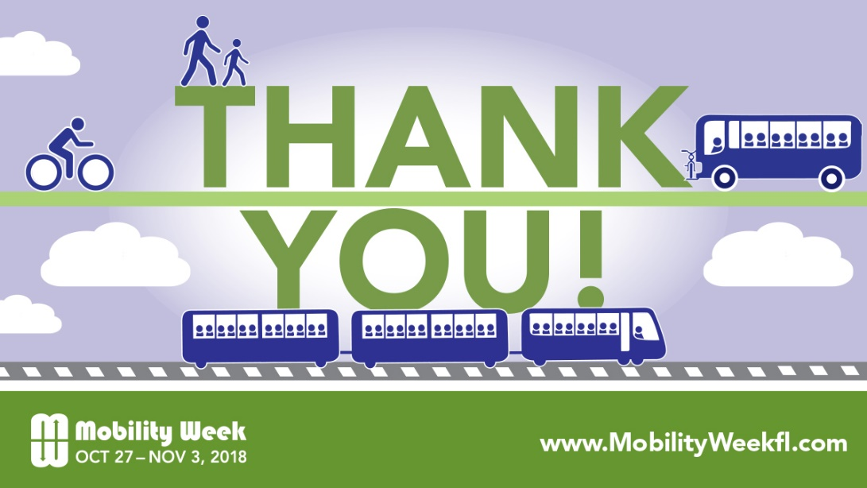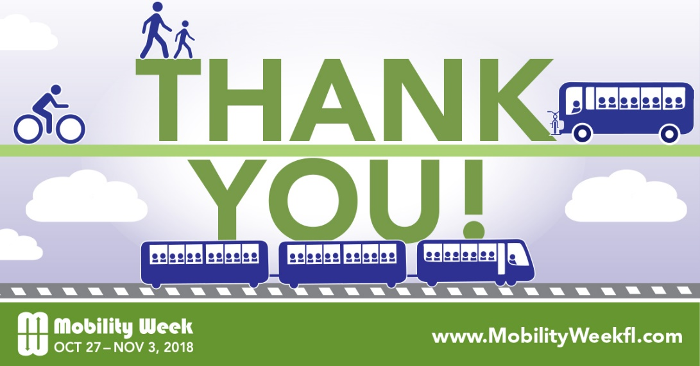

**Twitter Image** *(Sized 1200 x 675 px)*

**FaceBook Image** *(Sized 1200 x 628 px)*

**Suggested Post Date:** Nov. 5, 2018

|  |  |
| --- | --- |
| **Platform** | **Copy** |
| https://image.freepik.com/free-icon/facebook-logo-with-rounded-corners_318-9850.jpg | Thank you to everyone for making the third annual Mobility Week a success. From the partner agencies who organized events, to the elected officials who attended events, to the individuals who took the pledge to try a new transportation choice, you are the reason we had a successful Mobility Week 2018. [**#mobilityweekfl**](http://fdot.gov/projects/mobilityweek/) |
| https://marketplace.canva.com/MAB0g7ZqQow/1/thumbnail/canva-twitter-social-media-icon-MAB0g7ZqQow.png | Thank you to everyone for making the third annual Mobility Week a success. Thank you to our partners, elected officials, and residents, you are the reason we had a successful Mobility Week 2018. [**#mobilityweekfl**](http://fdot.gov/projects/mobilityweek/) |