MSI Report for AM Contract Managers

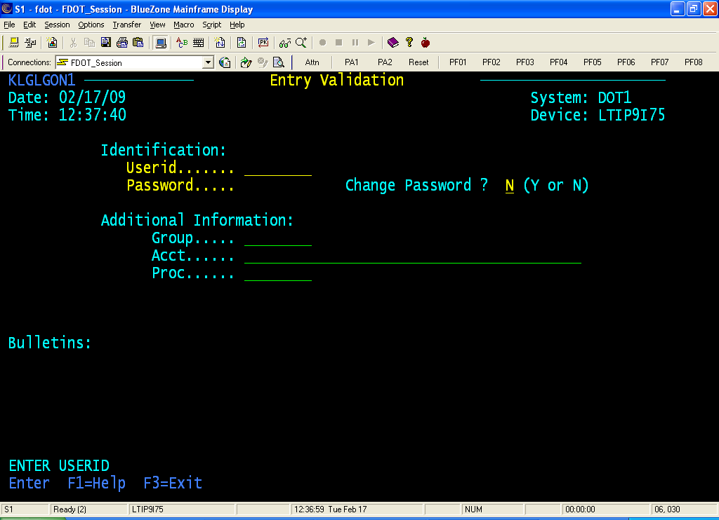
First you must type in your userid & password and then press the enter key.
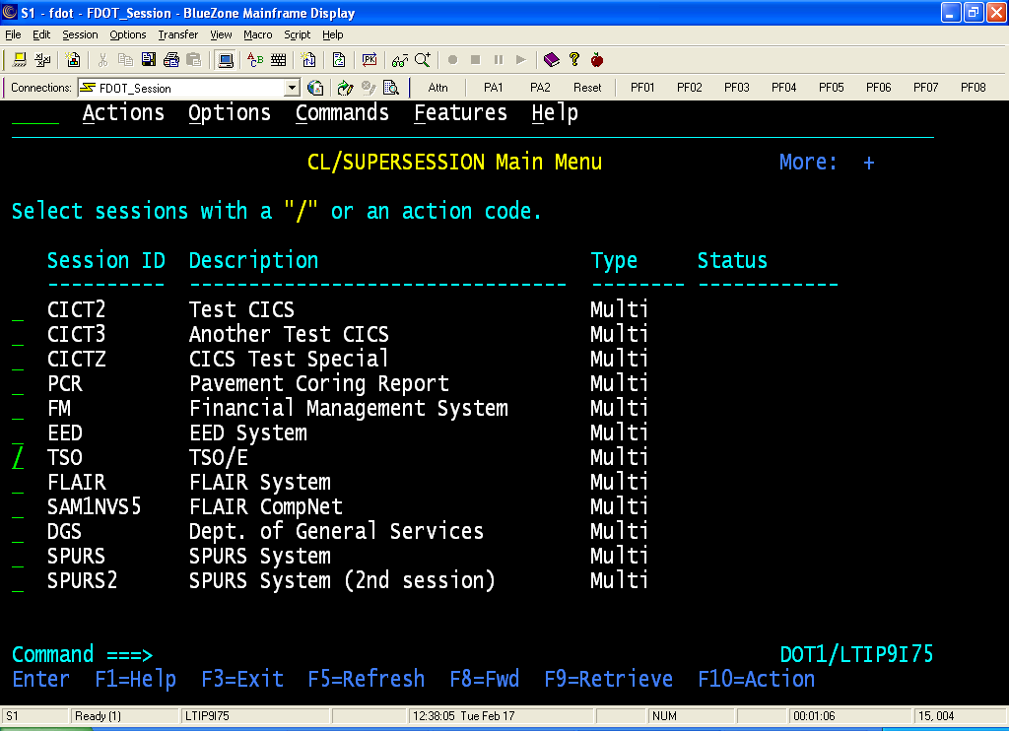
Select TSO, then press the enter key.

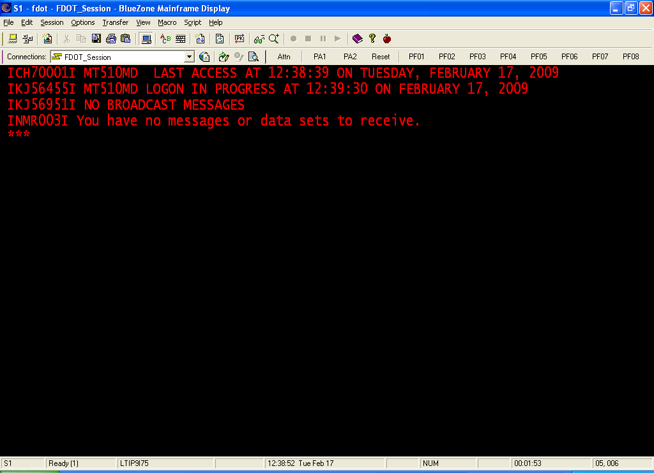
At this screen, press the enter key.
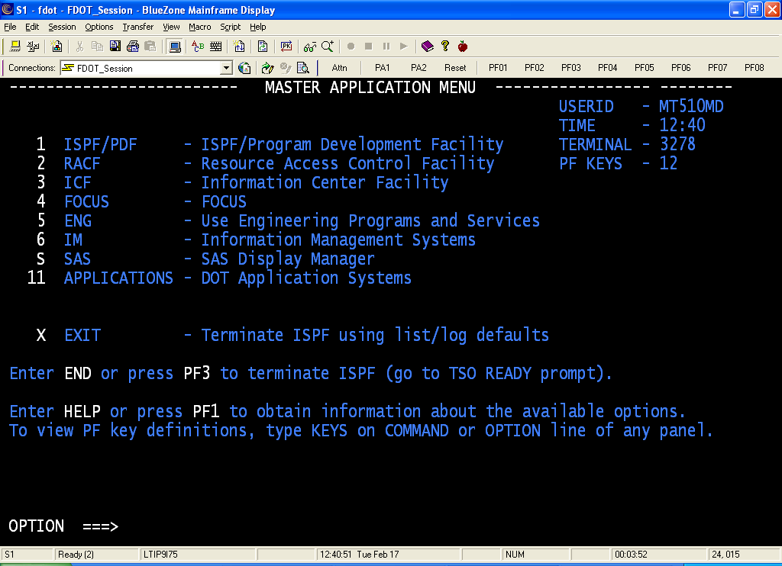
At this screen, press your F3 key or type the word “End” on the option line and then press the enter key.
If a Disposition Request Screen comes up, type in the # 2, then press the enter key.
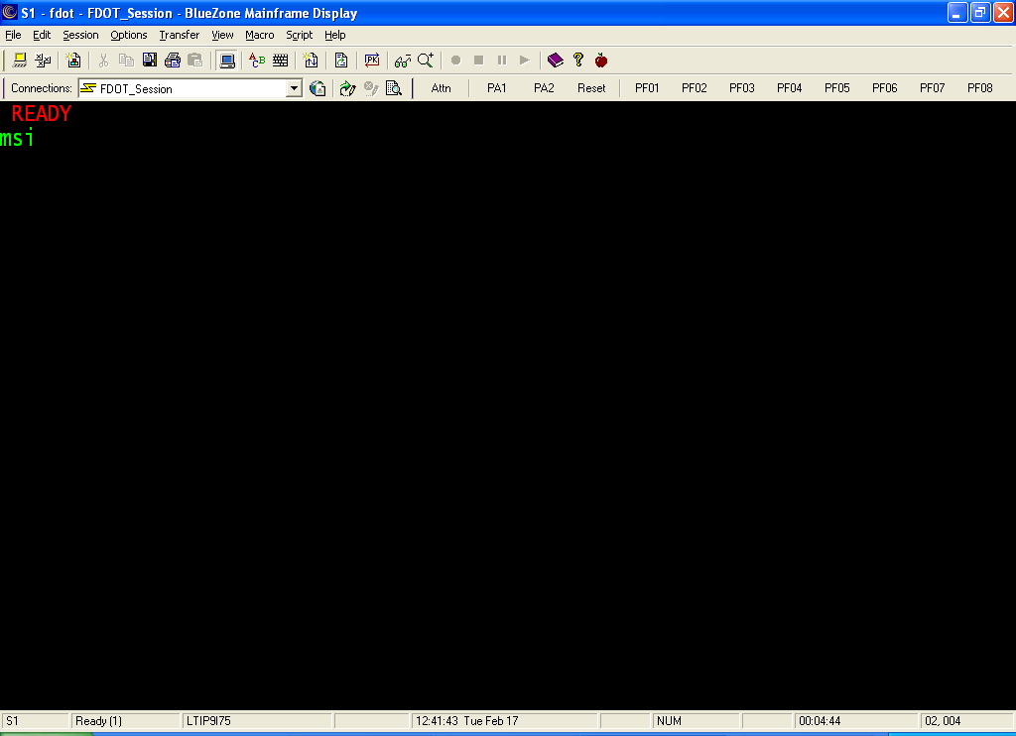
At the ready prompt type in the word “MSI”, then press the enter key.
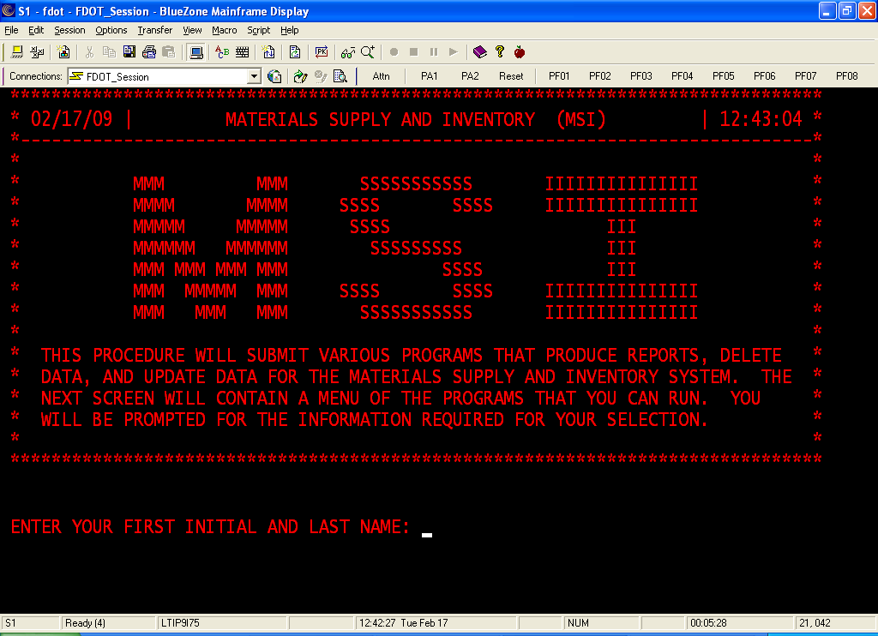
You may type in your information as asked for here or just press the enter key. The reason for you to type in you information, is so when you are printing any report from this program, your information will show on the cover page.
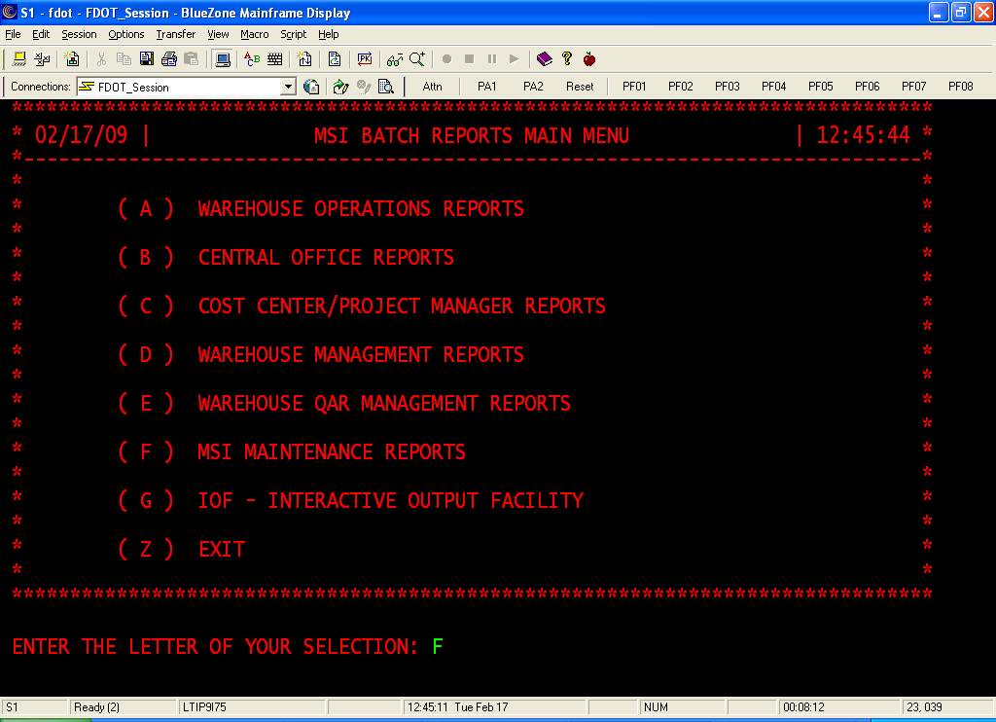
Next, you want to select letter “F”. This will bring your to the report options.
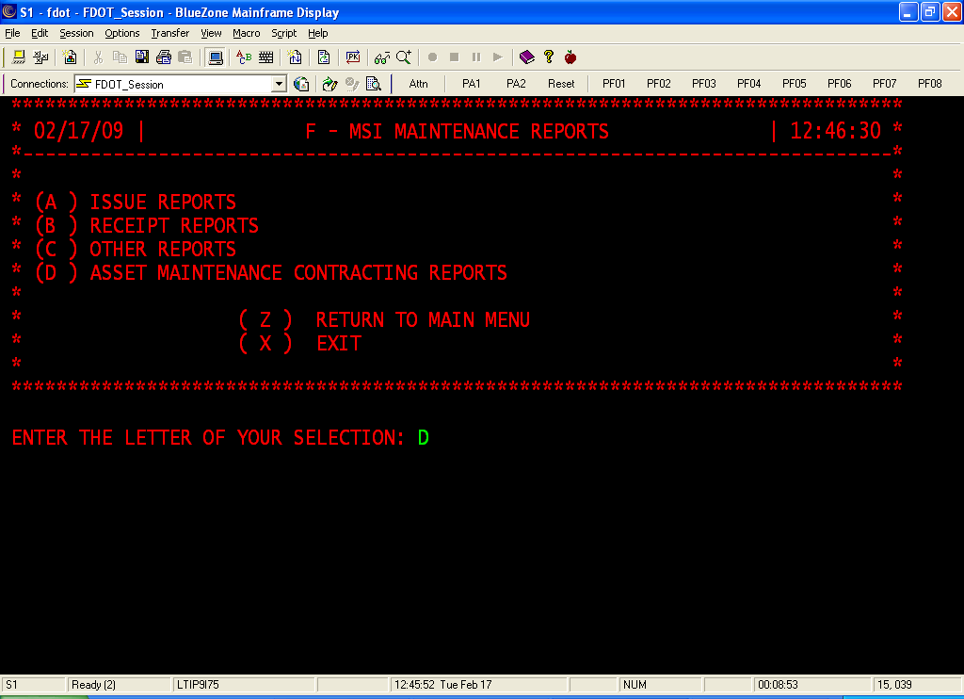
Next you will want to select letter “D”, then press the enter key.
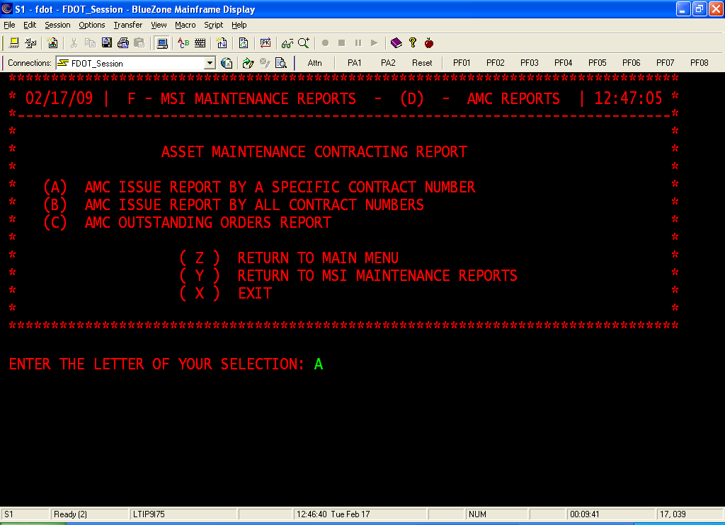
Here you can choose to see the orders sorted by: specific contract, all, or outstanding orders. For this class we will look for the information by specific contract, so select letter “A”, then press the enter key.
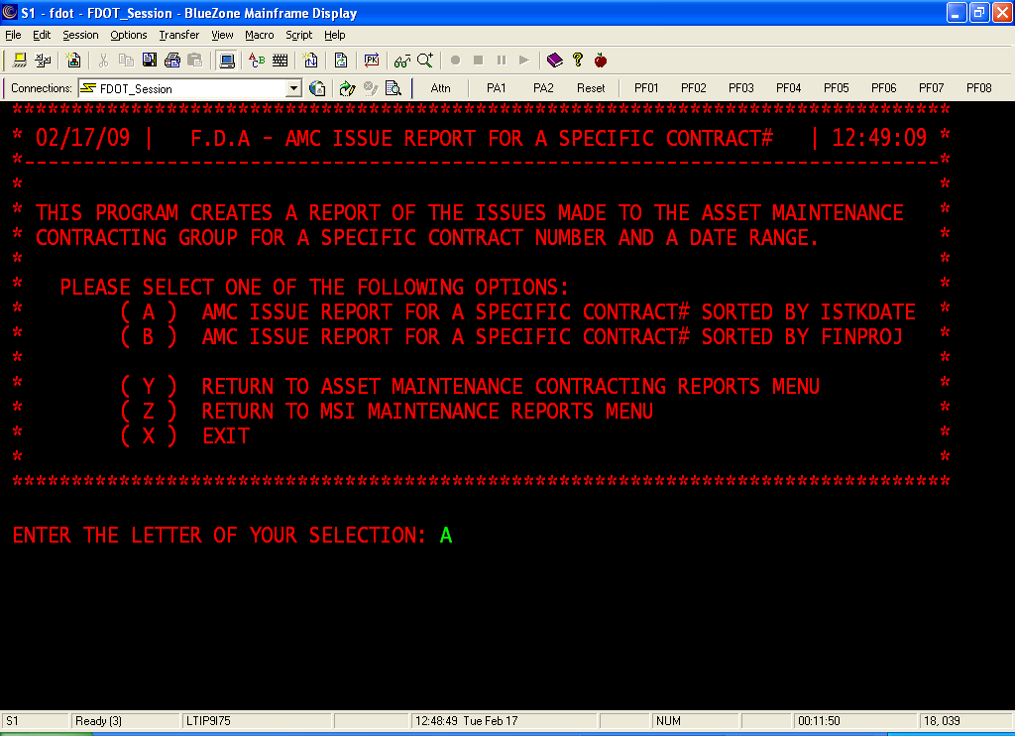
On this screen, you have a choice as to how you wish to have this report sorted. For this training, select letter “A”, then press the enter key.
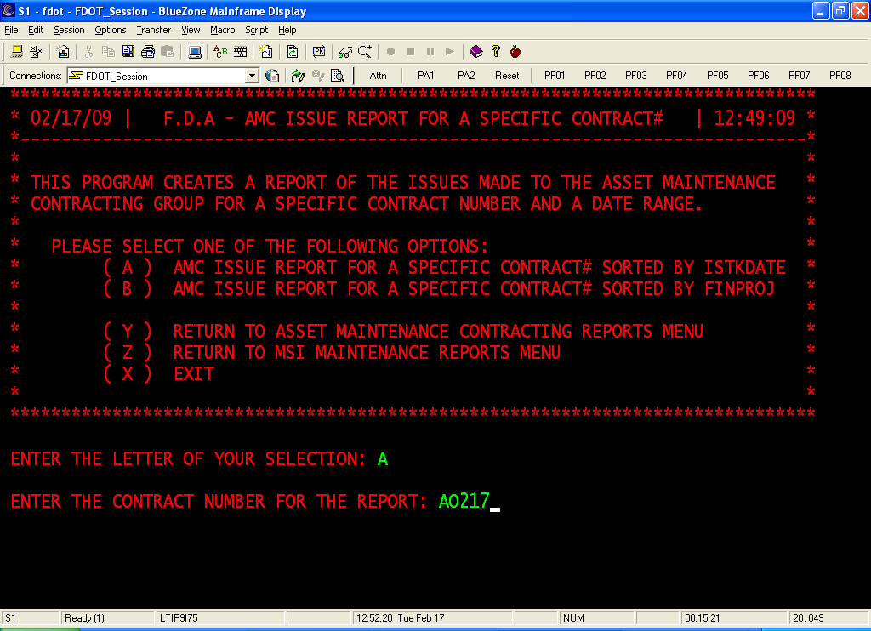
Next type in your contract number, then press the enter key.
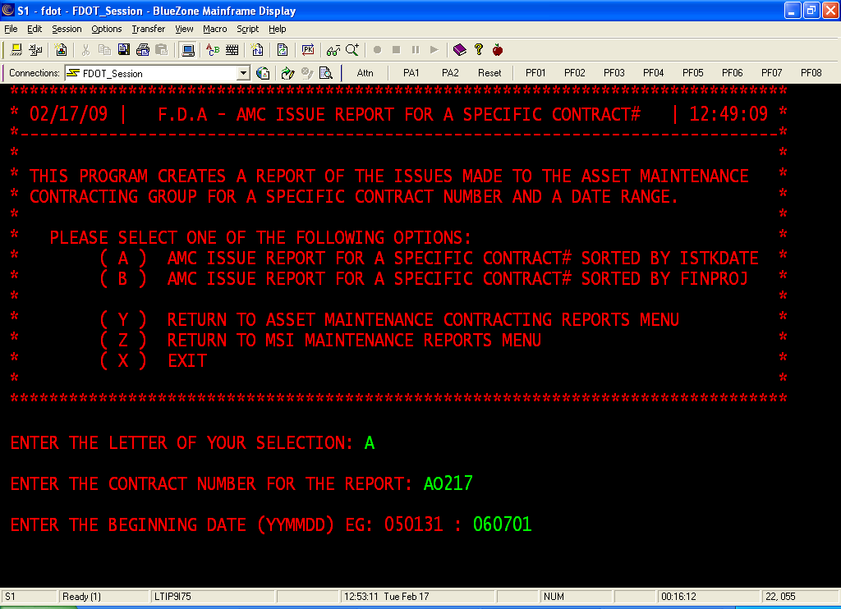
Type in the beginning date of the requested report period (this could be the date of the renewal or if you want this monthly, then do this monthly), then press the enter key.
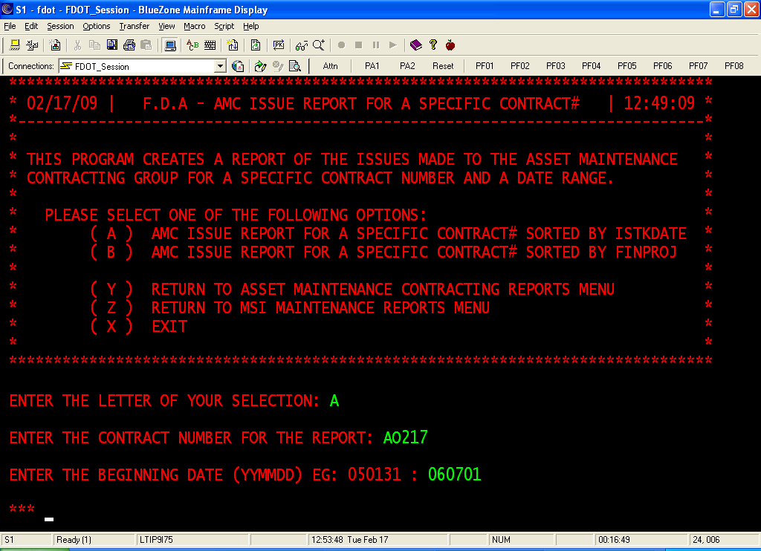
Remember, anytime you see three asterisk (***), press the enter key.
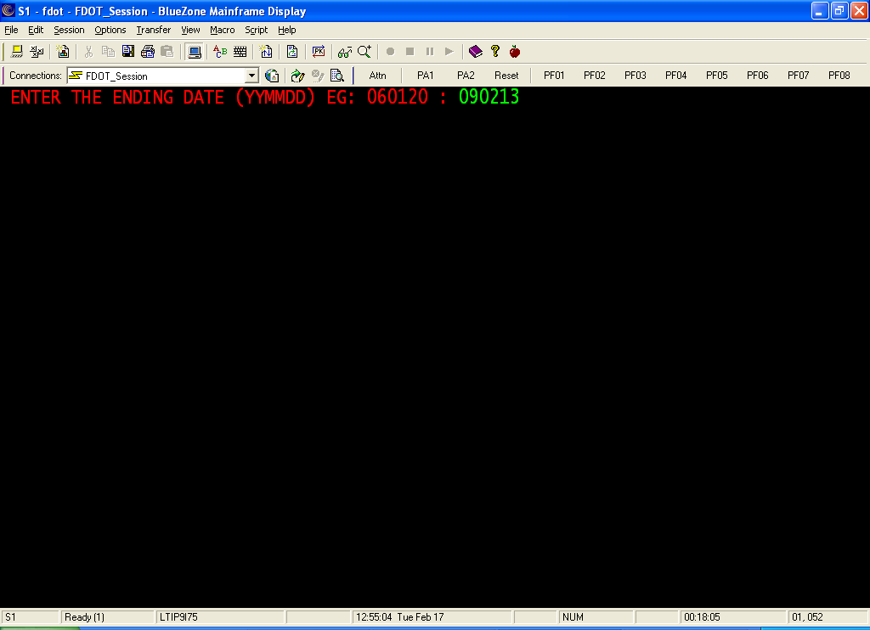
Type in the ending date of the requested report period, then press the enter key.
By doing this, the report will give you the total amount.

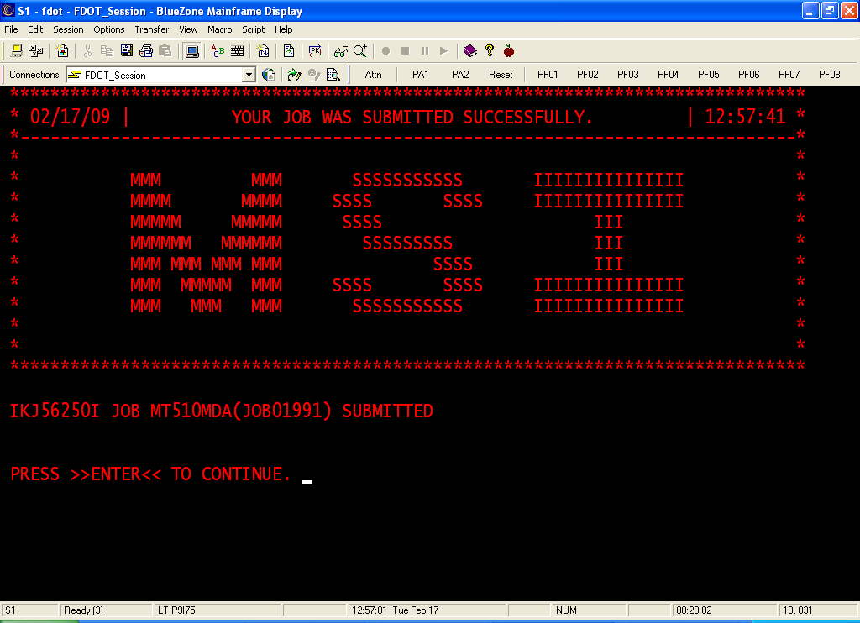
This screen gives you the job number (JOB01991). Please write it down and then press the enter key.
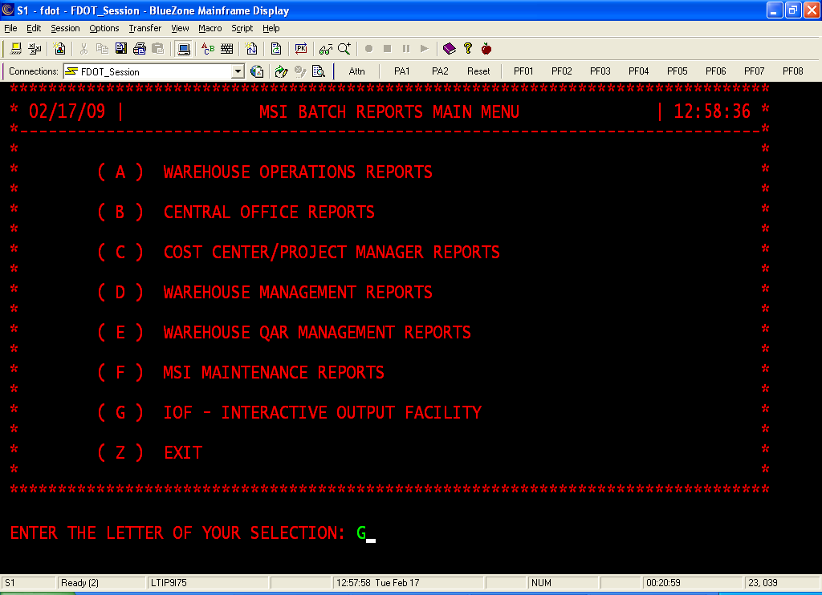
To print the report, you must go to the IOF. Type in option “G”, then press the enter key.
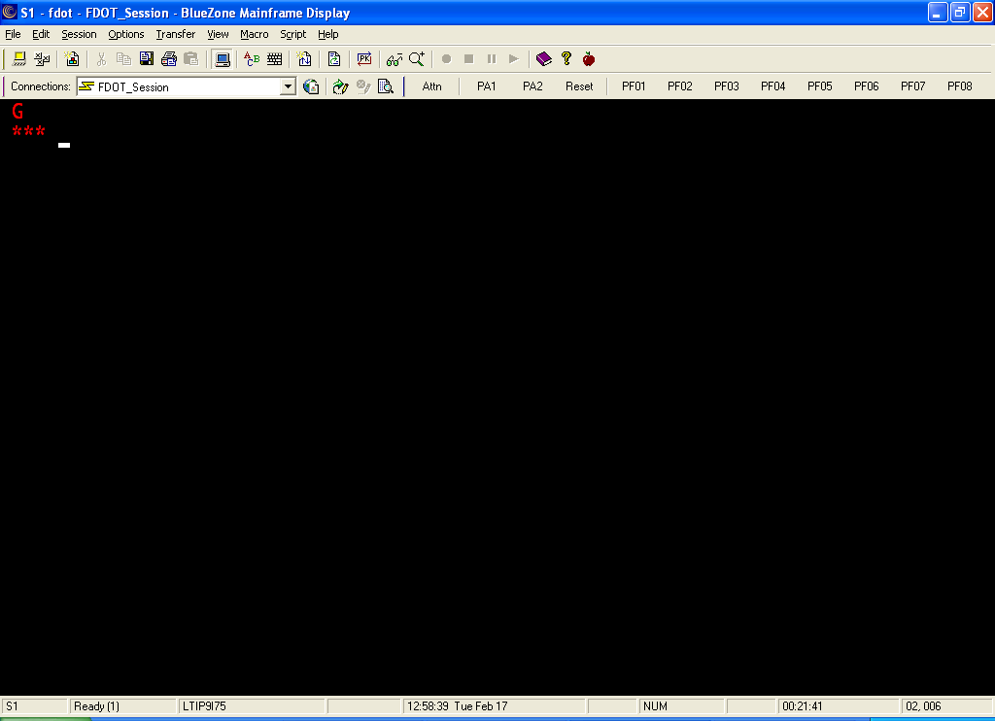
Remember, anytime you see three asterisk (***), press the enter key.
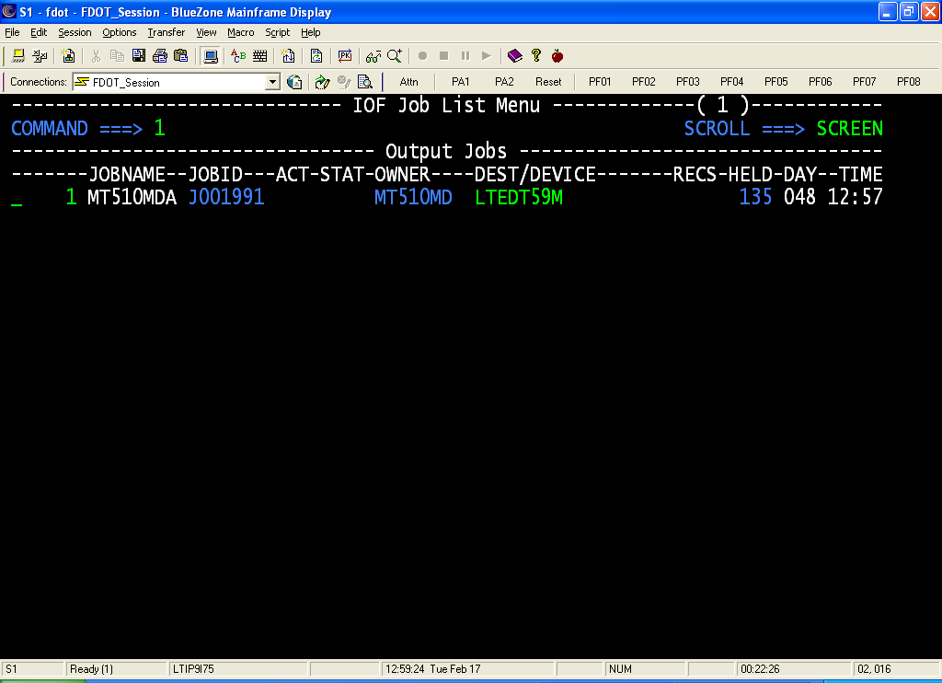
To be able to print the report, the job must be in the Output Jobs status. If you see your job number anywhere else, then that means it has not run yet. In this case, the report has already run. Type the number that is next to your job number (highlighted in green) at the command line then press the enter key.
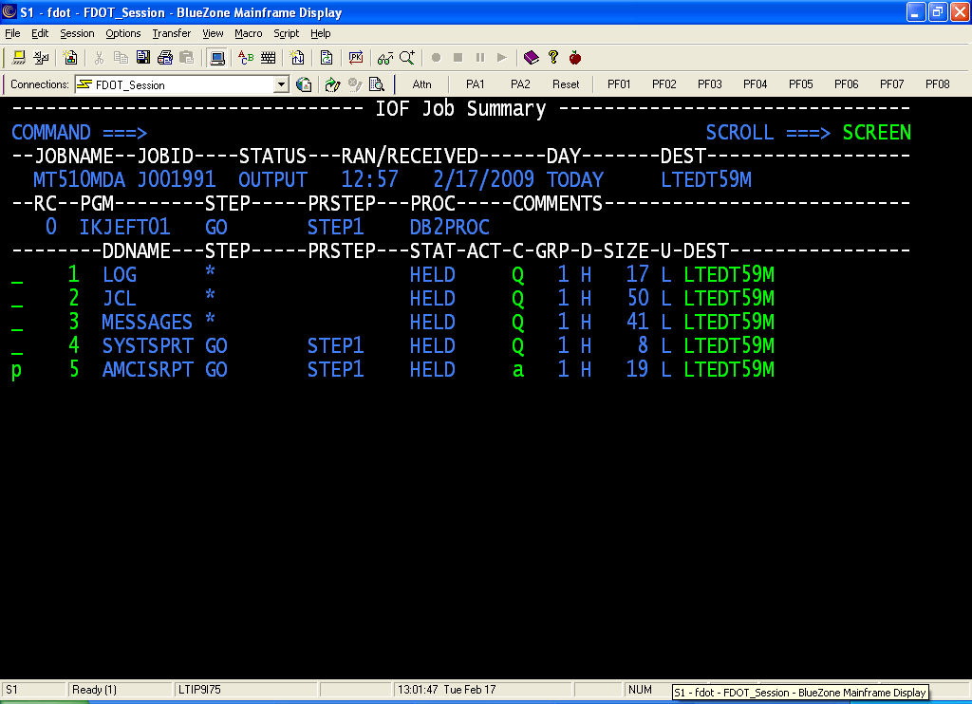
After you do that, this is the next screen you will see. The report is in option #5 (AMCISRPT). TO print it, you will put a letter “P” on the line next to number 5, then press you tab key. This will take you to the next field to change. You will overwrite the “Q” with an “A” then press the tab key again. This brings you to the Dest option. This is your printer name. If it says DOT, you must overwrite it with your printer destination. Then you will press the enter key.
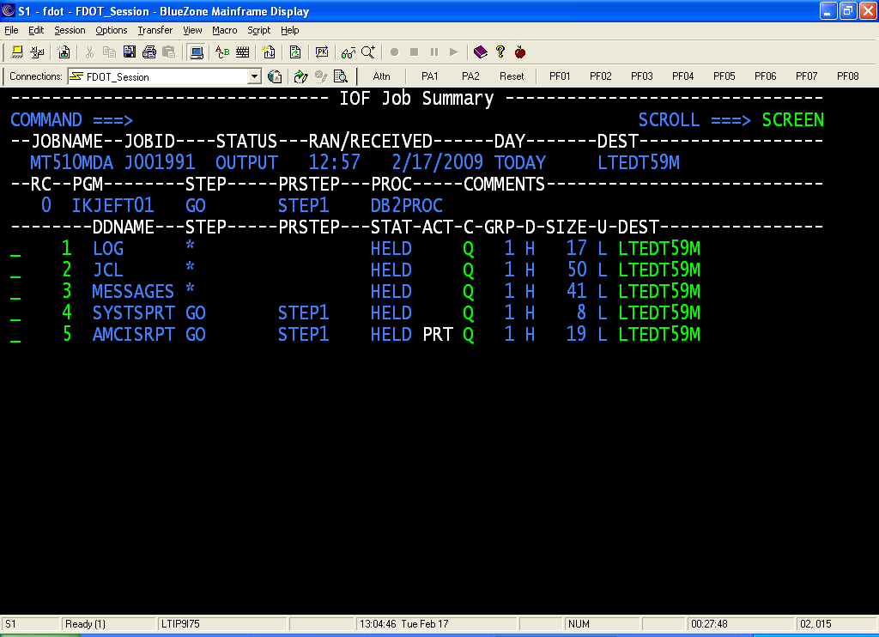
You will see this screen next. You will notice that the “P” and the ”A” have dropped off and now you have in white letters “PRT”. This shows you that you have correctly submitted this job for printing.
To get out of this screen, will need to press the F3 key.
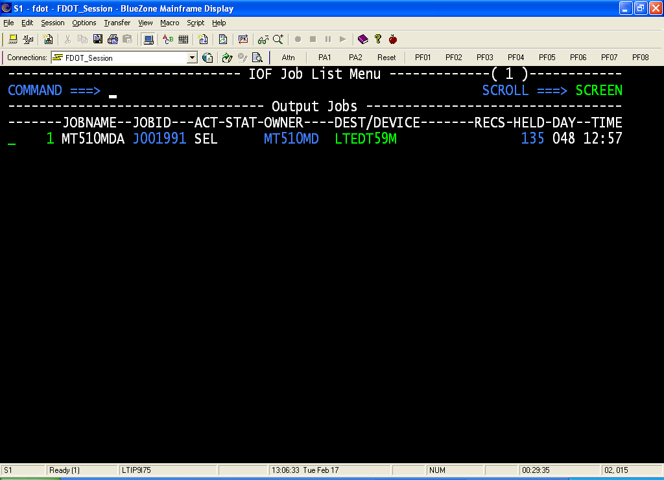
To get out of this screen, will need to press the F3 key.
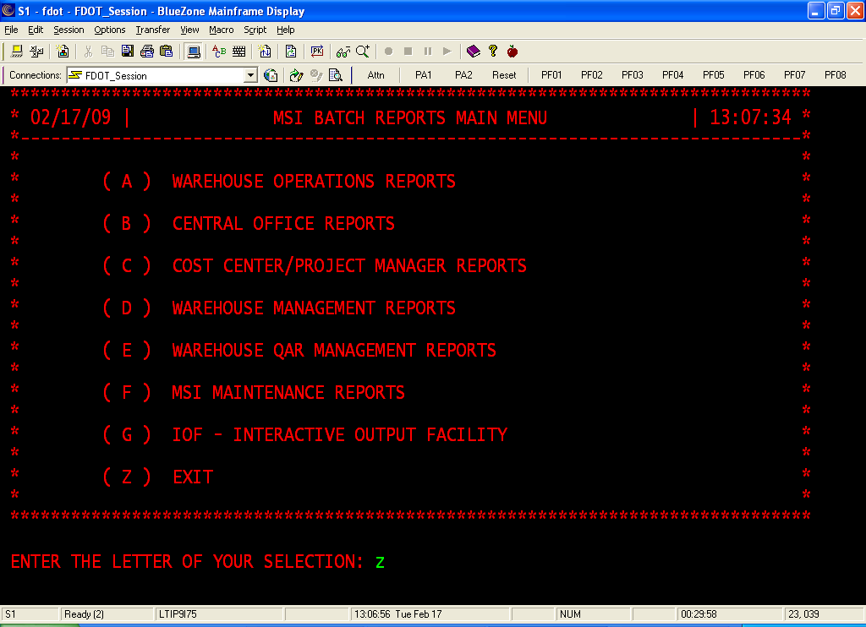
To get out of this menu, you will need to type the letter “Z”, then press the enter key.
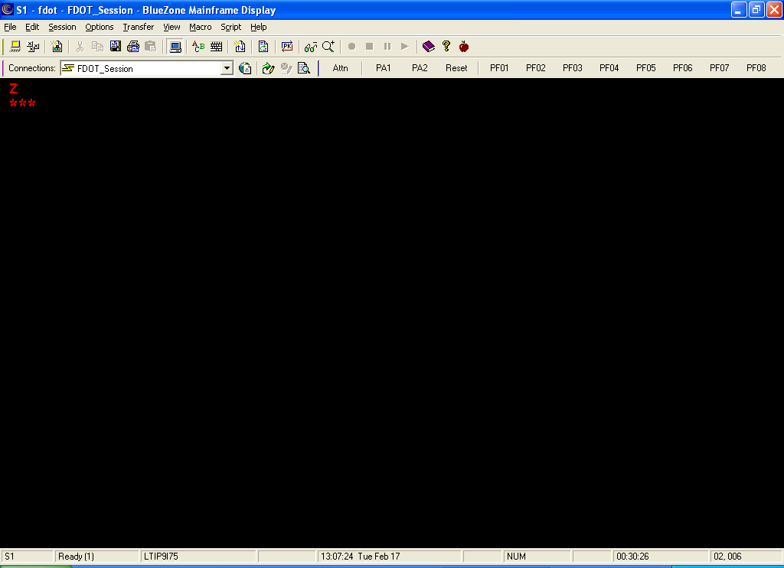
Remember, anytime you see three asterisk (***), press the enter key.
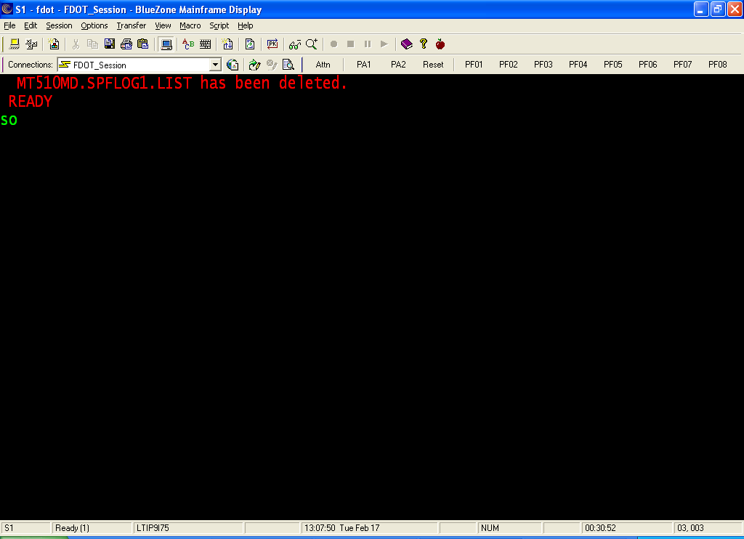
To get out of TSO, at the ready prompt, type in “SO”, then press the enter key.
After this action, close DOTNET like you normally would.

