Continuing Professional Education Credits for Reporting Purposes

Melinda Miguel, Chief Inspector General
“CIG Priorities for Florida’s IG Community”
February 12, 2019
This is to certify that _____________ attended “CIG Priorities for Florida’s IG Community” and has received CPE credits sponsored by the Association of Inspectors General as noted below.

Event Title | Start Date | End Date | CPE Credit
“CIG Priorities for Florida’s IG Community” | 02/12/19 | 02/12/19 | 1 Hour

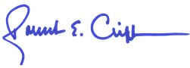

_________________________________________________________
Robert E. Clift, President
Florida Chapter - Association of Inspectors General

The Association of Inspectors General is registered with the National Association of State Boards of Accountancy (NASBA) as a sponsor of continuing professional education on the National Registry of CPE Sponsors. State boards of accountancy have final authority on the acceptance of individual courses for CPE credit. Complaints regarding sponsors may be addressed to:

National Registry of CPE Sponsors, 150 Fourth Avenue North, Suite 700 Nashville, TN 37219-2417 ID Number 107732
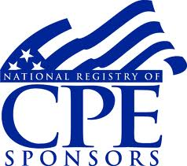
Program Level: Overview
Field of Study: Auditing (Governmental)- 1 hour
Delivery Method: Group Live
Location: Sheraton Four Points, Tallahassee, FL
Prerequisites: None
Advanced Preparation: None

