FLORIDA DEPARTMENT OF TRANSPORTATION LIMITED ENGLISH PROFICIENCY (LEP) GUIDANCE
Title VI of the Civil Rights Act of 1964, The Civil Rights Restoration Act of 1987; 42 USC 2000(d) to 2000-4; and Executive Order 13166 prohibit recipients of federal financial assistance from discriminating against individuals based on race, color and national origin. Other federal and state nondiscrimination regulations prohibit discrimination against individuals based on age, sex, disability, religion, and family or income status. The Florida Department of Transportation (FDOT), as a recipient of federal financial assistance, takes reasonable steps to ensure meaningful access to its programs, services and activities for all citizens including those individuals with limited English proficiency. Individuals who do not speak English as their primary language and who have a limited ability to read, speak, write, or understand English may be considered Limited English Proficient (LEP).
The FDOT interacts with persons who may be LEP in the administration of its programs, services and activities. This guidance ensures that LEP individuals are provided meaningful access to the FDOT’s programs, services and activities.
LEP services can be provided in two ways: verbal interpretation and written translation of vital documents. Florida is a richly diverse state with residents and visitors from all over the world. FDOT’s own staff is representative of that diversity and has competent language speakers of a variety of languages. FDOT does provide verbal interpretation with reasonable notice, regardless of the LEP language. FDOT’s public advertisements clearly state that language services are available with specified notice. These advertisements are also routinely translated and posted both in minority publications and at public forums. FDOT also utilizes ‘I Speak’ cards to help identify language needs and match them to LEP services. Finally, most of FDOT’s public meetings have staff members available who are competent speakers of the most frequently encountered languages in the FDOT district where the meeting is being held.
Written translation of vital documents is handled somewhat differently. The
Department of Justice (DOJ) LEP Guidance requires that four (4) factors be considered when deciding whether written LEP services are required:
- The number or proportion of LEP persons in the eligible service population;
- The frequency with which LEP individuals come into contact with the program or activity;
- The importance of the service provided by the program; and • The resources available.
Florida’s population and diversity varies vastly from region to region, making a single
LEP approach difficult. For example, the recent American Community Survey (ACS) (an office of the U. S. Census Bureau) from 2009 indicated an LEP population (percent of people 5 years old and over who speak English less than very well) at an estimated 11.6% statewide compared to 8.6% nationwide. However, this percentage is not evenly represented throughout the State. Further, frequency of contact with FDOT by LEP individuals also varies greatly. The Miami area sees a much higher proportion of Spanish and Creole speakers than does its more rural partners in the northern area of the state. Similarly, based on transportation needs, availability of public transit and long/short term transportation planning, the importance of the services also varies depending on the area of the State.
Generally, the FDOT offers written language services in Spanish and Haitian-Creole. Public information documents such as project flyers, public safety brochures, public transit information, and nondiscrimination processes are translated into these languages. Moreover, the FDOT also has guidelines in place through its Right of Way Office (ROW) to equitably address the language needs of individuals and families being displaced.
More specifically, FDOT is divided into seven (7) districts and Florida’s Turnpike Enterprise. Each district serves a different region of the State, including the population centers of Miami, Tampa, Orlando and Jacksonville. Each district has a Title VI Coordinator responsible for disseminating Title VI and LEP information throughout the district with the assistance of Program Area Officers (PAOs) in the following programs:
planning, environmental, design, right-of-way, construction, maintenance, public transportation, professional services, contractual services and public information (Procedure #275-010-010-e). In order to properly gauge the quantity, quality and type of LEP service for each region, the FDOT districts will each analyze their programs, services and activities using the four factor test.
1. The number or proportion of LEP persons eligible to be served. The 2009 American Community Survey shows that the four (4) most prevalent languages spoken by individuals who are LEP in Florida (among the population 5 and over who speak English less than very well) are: Spanish (8.92%); French Creole (1.03%); Portuguese (.106%); and Vietnamese (.107%). The following table is representative of Florida’s overall LEP demographics:

ANALYSIS OF TOP FOUR LANGUAGES STATEWIDE
DISTRICT SPANISH FRENCH CREOLE VIETNAMESE PORTUGUESE
1 | 175,549 | 15,549 | 2,104 | 2,110
2 | 33,625 | 3,737
3 | 17,969 | 1,695 | 1,737
4 | 265,871 | 81,233 |  | 5,205
5 | 187,291 | 16,920 | 6,839 | 6,397
6 | 718,521 | 53,970 |  | 4,427
7 | 125,431 | 3,981 | 7,761
TOTAL | 1,524,257 | 177,085 | 18,441 | 18,139
PERCENT | 8.92% | 1.03% | 0.107% | 0.106%

In addition, each District analyzed its census data and reported Spanish as the highest population of LEP individuals. However, the Districts found that their regional areas had other unique LEP populations, as represented by the following tables showing an analysis of the top four (4) languages spoken by LEP individuals in each district:

ANALYSIS OF TOP FOUR LANGUAGES IN

DISTRICT 1
Population  5 years and older | Number of LEP  Persons | Percentage of LEP  Persons | LEP Persons who Speak Spanish |  | LEP Persons who Speak  French Creole |  | LEP Persons who Speak  Portuguese |  | LEP Persons who Speak  Vietnamese
Total | Total | Percent | Total | Percent | Total | Percent | Total | Percent | Total | Percent
2,389,201 220,824 9.24% 175,549 7.34% 15,549 0.65% 2,110 0.08% 2,104 0.08%

ANALYSIS OF TOP FOUR LANGUAGES IN

DISTRICT 2
Population  5 years and older | Number of LEP  Persons | Percentage of LEP  Persons | LEP Persons who Speak  Spanish |  | LEP Persons who Speak  French Creole |  | LEP Persons who Speak  Tagalog |  | LEP Persons who Speak  Serbo-Croatian
Total | Total | Percent | Total | Percent | Total | Percent | Total | Percent | Total | Percent
1,762,539 63,797 3.61% 33,625 1.90% 3,737 0.21% 3,090 0.17% 2,069 0.11% ANALYSIS OF TOP FOUR LANGUAGES IN

DISTRICT 3
Population  5 years and older | Number of LEP  Persons | Percentage of LEP  Persons | LEP Persons who Speak  Spanish |  | LEP Persons who Speak  Vietnamese |  | LEP Persons who Speak  Tagalog |  | LEP Persons who Speak  French Creole
Total | Total | Percent | Total | Percent | Total | Percent | Total | Percent | Total | Percent
1,253,205 34,074 2.71% 17,969 1.43% 1,737 0.13% 1,709 0.13% 1,695 0.13%

ANALYSIS OF TOP FOUR LANGUAGES IN

DISTRICT 4
Population  5 years and older | Number of LEP  Persons | Percentage of LEP  Persons | LEP Persons who Speak Spanish |  | LEP Persons who Speak  French Creole |  | LEP Persons who Speak  Chinese |  | LEP Persons who Speak  Portuguese
Total | Total | Percent | Total | Percent | Total | Percent | Total | Percent | Total | Percent
3,332,712 423,794 12.71% 265,871 7.97% 81,233 2.43% 6,361 0.19% 5,205 0.15%

ANALYSIS OF TOP FOUR LANGUAGES IN

DISTRICT 5
Population  5 years and older | Number of LEP  Persons | Percentage of LEP  Persons | LEP Persons who Speak Spanish |  | LEP Persons who Speak  French Creole |  | LEP Persons who Speak  Vietnamese |  | LEP Persons who Speak  Portuguese
Total | Total | Percent | Total | Percent | Total | Percent | Total | Percent | Total | Percent
3,309,395 259,078 7.82% 187,291 5.65% 16,920 0.51% 6,839 0.20% 6,397 0.19%

ANALYSIS OF TOP FOUR LANGUAGES IN

DISTRICT 6
Population  5 years and older | Number of LEP  Persons | Percentage of LEP  Persons | LEP Persons who Speak Spanish |  | LEP Persons who Speak  French Creole |  | LEP Persons who Speak  Portuguese |  | LEP Persons who Speak  Chinese
Total | Total | Percent | Total | Percent | Total | Percent | Total | Percent | Total | Percent
2,358,564 800,348 33.93% 718,521 30.46% 53,970 2.28% 4,427 0.18% 3,568 0.15% ANALYSIS OF TOP FOUR LANGUAGES IN DISTRICT

7
Population  5 years and older | Number of LEP  Persons | Percentage of LEP  Persons | LEP Persons who Speak Spanish |  | LEP Persons who Speak  Vietnamese |  | LEP Persons who Speak  French Creole |  | LEP Persons who Speak  Serbo-Croatian
Total | Total | Percent | Total | Percent | Total | Percent | Total | Percent | Total | Percent
2,671,137 178,012 6.66% 125,431 4.69% 7,761 0.29% 3,981 0.14% 2,263 0.08%

Note: For a breakdown by county within each District, see Appendix A.
FDOT used other sources to verify this data, including the environmental screening tool within the Efficient Transportation Decision Making (ETDM) Process. Another resource used to verify the LEP populations identified by the ACS was the U. S. Department of
Education’s Annual Consolidated State Performance Report (CSPR) for school year 2008-2009. The CSPR includes a section on LEP students in grades K-12 and identifies the most commonly spoken languages by those students. The CSPR identifies Spanish, Creole, Portuguese and Vietnamese as the most commonly spoken languages among Florida’s LEP students (Appendix B).
The results of the analysis are that Spanish and French Creole are the largest representative populations statewide with lesser representation of Vietnamese, Portuguese and Chinese. In addition some Districts have varying LEP populations of Italian, German, Tagalog and Greek.
- Frequency of contact with LEP persons. In order to validate the census information and determine which of the LEP populations most frequently have contact with FDOT programs, services and activities, FDOT conducted a field review of each of its District nondiscrimination programs. Data was collected on the frequency of telephone, mail and in-person contact with LEP individuals. The FDOT also required the Districts to report frequency of contact with LEP individuals on its Quarterly District Title VI Report (Report Number 275-010-11). The results indicate that Spanish is by far the most frequently encountered LEP language in all Florida’s Districts, though the regions of central and south Florida have more frequency of contact. Creole was also a commonly encountered language, though generally only in the southeast portion of the state.
- Nature or importance of the program. All of the FDOT’s programs are important; however, those related to safety, public transit, ROW, environment, nondiscrimination and public involvement are among the most important. As such, publications and other material disseminated regarding these programs are routinely available in both Spanish and French Creole. Nevertheless, the FDOT is committed to providing meaningful access and will provide written translation for any of its documents, when reasonable, effective and within the available resources. In other cases, the FDOT will strive to provide alternative but meaningful accessibility. Moreover, the FDOT continually evaluates its programs, services and activities to ensure that persons who may be LEP are always provided with meaningful access. For a list of publications/documents in Spanish and French Creole, see Appendix C.
- Resources available. The FDOT understands that it is a large entity serving a potentially large number of Spanish and French Creole speaking individuals. The FDOT makes every effort to make its programs, services and activities accessible to LEP individuals. In addition to documents that are routinely published in the most frequently encountered languages, the FDOT will use available resources, both internal and external, to accommodate reasonable requests for translation. Further, the FDOT’s policies require free oral interpretation services, regardless of the language, with seven (7) days notice.

In addition, the FDOT has identified, developed and uses the following:

- District lists of staff who volunteers to assist as interpreters and/or translators if needed. Lists are verified and updated annually by the District Title VI Coordinators and provided to the Statewide Title VI Coordinator.
- Individuals who have contact with the public are provided with “I Speak” language cards to identify language needs in order to match them with available services. Language cards are verified and distributed annually by the District Title VI Coordinators.
- The FDOT through the District Offices have developed partnerships with local agencies, organizations, law enforcement, colleges/universities, local school districts and social service agencies that are available to assist with its LEP responsibilities.
- A list of web based translation services for use, when required.
- A list of telephone translation services for use, when required.
Safe Harbor Stipulation
Federal law provides a “Safe Harbor” stipulation so that recipients such as FDOT can ensure with greater certainty that they comply with their obligations to provide written translations in languages other than English. A “safe harbor” means that if a recipient (FDOT) provides written translations in certain circumstances; such action will be considered strong evidence of compliance with the FDOT’s written-translation obligations under Title VI.
The failure to provide written translations under the circumstances does not mean there is noncompliance, but rather provides a guide for recipients that would like greater certainty of compliance that can be provided by a fact-intensive, four factor analysis. For example, even if a safe harbor is not used, if written translation of a certain document(s) would be so burdensome as to defeat the legitimate objectives of its program, it is not necessary. Other ways of providing meaningful access, such as effective oral interpretation of certain vital documents, might be acceptable under such circumstances.
Strong evidence of compliance with the recipient’s written-translation obligations under
‘safe harbor’ includes providing written translations of vital documents for each eligible LEP language group that constitutes 5% or 1,000, whichever is less, of the population of person’s eligible to be served or likely to be affected or encountered. FDOT’s translation of other documents, if needed, can be provided orally.
This safe harbor provision applies to the translation of written documents only. It does not affect the requirement to provide meaningful access to LEP individuals through competent oral interpreters where oral language services are needed and are reasonable.
CONCLUSION:
FDOT recognizes that language needs will change as Florida’s population changes. Further, FDOT is required to assess its programs and services each year to determine compliance with various nondiscrimination regulations. As such, FDOT will revisit the LEP plan each year and make appropriate changes, as needed. For questions or concerns regarding the FDOT’s commitment to nondiscrimination or to request LEP services, contact Michael Klump, Interim FDOT Statewide Title VI Coordinator at (850) 414-4764 or by email michael.klump@dot.state.fl.us .

APPENDIX A
DISTRICTS BY COUNTY

FRENCH
COUNTY SPANISH CREOLE PORTUGUESE ITALIAN VIETNAMESE CHINESE POLISH
Charlotte | 2,384 | 777 | 139 | 181
Collier | 37,317 | 4,861 | 174 | 538
Desoto | 6,933
Glades | 1,062
Hardee | 5,725
Hendry | 9,352 | 130
Highlands | 6,845 | 271
Lee | 39,994 | 4,186 | 1,246 | 595
Manatee | 15,548 | 1,939 |  |  | 630 | 579
Okeechobee | 4,395
Polk | 35,171 | 2,687 | 551 |  | 599
Sarasota | 10,823 | 1,095 |  |  | 875 |  | 931
D-1 TOTALS | 175,549 | 15,945 | 2,110 | 1,314 | 2,104 | 579 | 931

COUNTY SPANISH FRENCH CREOLE CHINESE KOREAN VIETNAMESE TAGALOG ARABIC OTH SLAVIC LANG SERBO CROATIAN
Alachua | 4,397 | 634 | 841 | 548
Baker | 142
Bradford | 166
Clay | 3,082 | 669 | 385 |  |  | 305
Columbia | 759
Dixie | 0
Duval | 15,793 | 2,070 |  |  |  | 2,785 |  |  | 2,069
Gilchrist | 232
Hamilton | 468
Lafayette | 96
Levy | 937
Madison | 400
Nassau | 529
Putnam | 2,476
St. Johns | 1,912 |  | 287 |  |  |  | 261 | 237
Suwannee | 1,590
Taylor | 68
Union | 578 |  |  |  | 94
D-2 TOTALS | 33,625 | 3,373 | 1,513 | 548 | 94 | 3,090 | 261 | 237 | 2,069

COUNTY SPANISH FRENCH CREOLE CHINESE KOREAN VIETNAMESE TAGALOG THAI OTH ASIAN GERMAN HINDI
Bay | 1,973 | 264 |  |  | 451 |  |  | 311
Calhoun | 236 | 116 |  |  |  |  |  |  | 102
Escambia | 3,107 | 564 |  |  | 593 | 820
Franklin | 148
Gadsden | 2,000 | 79
Gulf | 351 | 32
Holmes | 149 | 10
Jackson | 746 | 68 |  |  | 57
Jefferson | 71 |  |  |  |  |  |  |  | 100 | 235
Leon | 2,984 | 539 | 512 |  | 326
Liberty | 63
Okaloosa | 3,126 |  |  | 445 |  | 473 | 309
Santa Rosa | 1,685 |  |  | 154 | 310 | 294
Wakulla | 102 | 23 | 25 |  |  | 51
Walton | 959 |  |  |  |  | 71 | 91
Washington | 269 |  |  |  |  |  |  |  | 61
D-3 TOTALS | 17,969 | 1,695 | 537 | 599 | 1,737 | 1,709 | 400 | 311 | 263 | 235

COUNTY SPANISH FRENCH CREOLE PORTUGUESE ITALIAN CHINESE VIETNAMESE TAGALOG POLISH
Broward | 143,523 | 45,925 |  |  | 4,049 | 2,744
Indian River | 6,098 | 347 |  | 144 |  | 227
Martin | 6,676 | 779 |  | 174 |  |  |  | 237
Palm Beach | 94,698 | 30,530 | 4,406 |  | 2,312
St. Lucie | 14,876 | 3,652 | 799 |  |  |  | 278
D-4 Totals | 265,871 | 81,233 | 5,205 | 318 | 6,361 | 2,971 | 278 | 237

COUNTY SPANISH FRENCH GERMAN RUSSIAN PORTUGUESE VIETNAMESE CHINESE ARABIC OTH SLAVIC ITALIAN OTH INDIC
Brevard | 8,180 | 1,264 |  |  |  | 647 |  | 959
Flagler | 1,673 |  |  | 678 | 524 |  |  |  | 494
Lake | 9,891 | 662 | 198 |  |  |  | 316 |  |  | 198
Marion | 9,508 | 380 | 265 |  |  |  |  |  |  |  | 199
Orange | 87,455 | 11,484 |  |  | 5,251 | 5,232
Osceola | 37,895 | 1,678 |  |  | 622 |  |  | 587
Seminole | 16,037 |  |  |  |  | 780 | 711 | 355
Sumter | 2,792 | 71 |  |  |  | 180
Volusia | 13,860 | 1,381 |  |  |  |  | 498 | 503
D-5 TOTALS | 187,291 | 16,920 | 463 | 678 | 6,397 | 6,839 | 1,525 | 2,404 | 494 | 198 | 199

FRENCH
COUNTY SPANISH CREOLE PORTUGUESE CHINESE RUSSIAN OTH SLAVIC
Miami-Dade | 714,117 | 53,349 | 4,427 | 3,568
Monroe | 4,404 | 621 |  |  | 290 | 143
D-6 TOTALS | 718,521 | 53,970 | 4,427 | 3,568 | 290 | 143

COUNTY SPANISH FRENCH CREOLE GERMAN ITALIAN CHINESE VIETNAMESE KOREAN GREEK SERBO-CROATIAN
Citrus | 1,637 | 206 |  | 212 | 385
Hernando | 3,240 | 242 | 285 | 390
Hillsborough | 86,596 | 2,997 |  |  |  | 3,435 | 1,341
Pasco | 12,813 | 536 |  |  | 561 |  |  | 767
Pinellas | 21,145 |  |  |  |  | 4,326 |  | 1,810 | 2,263
D-7 TOTALS | 125,431 | 3,981 | 285 | 602 | 946 | 7,761 | 1,341 | 2,577 | 2,263

APPENDIX B
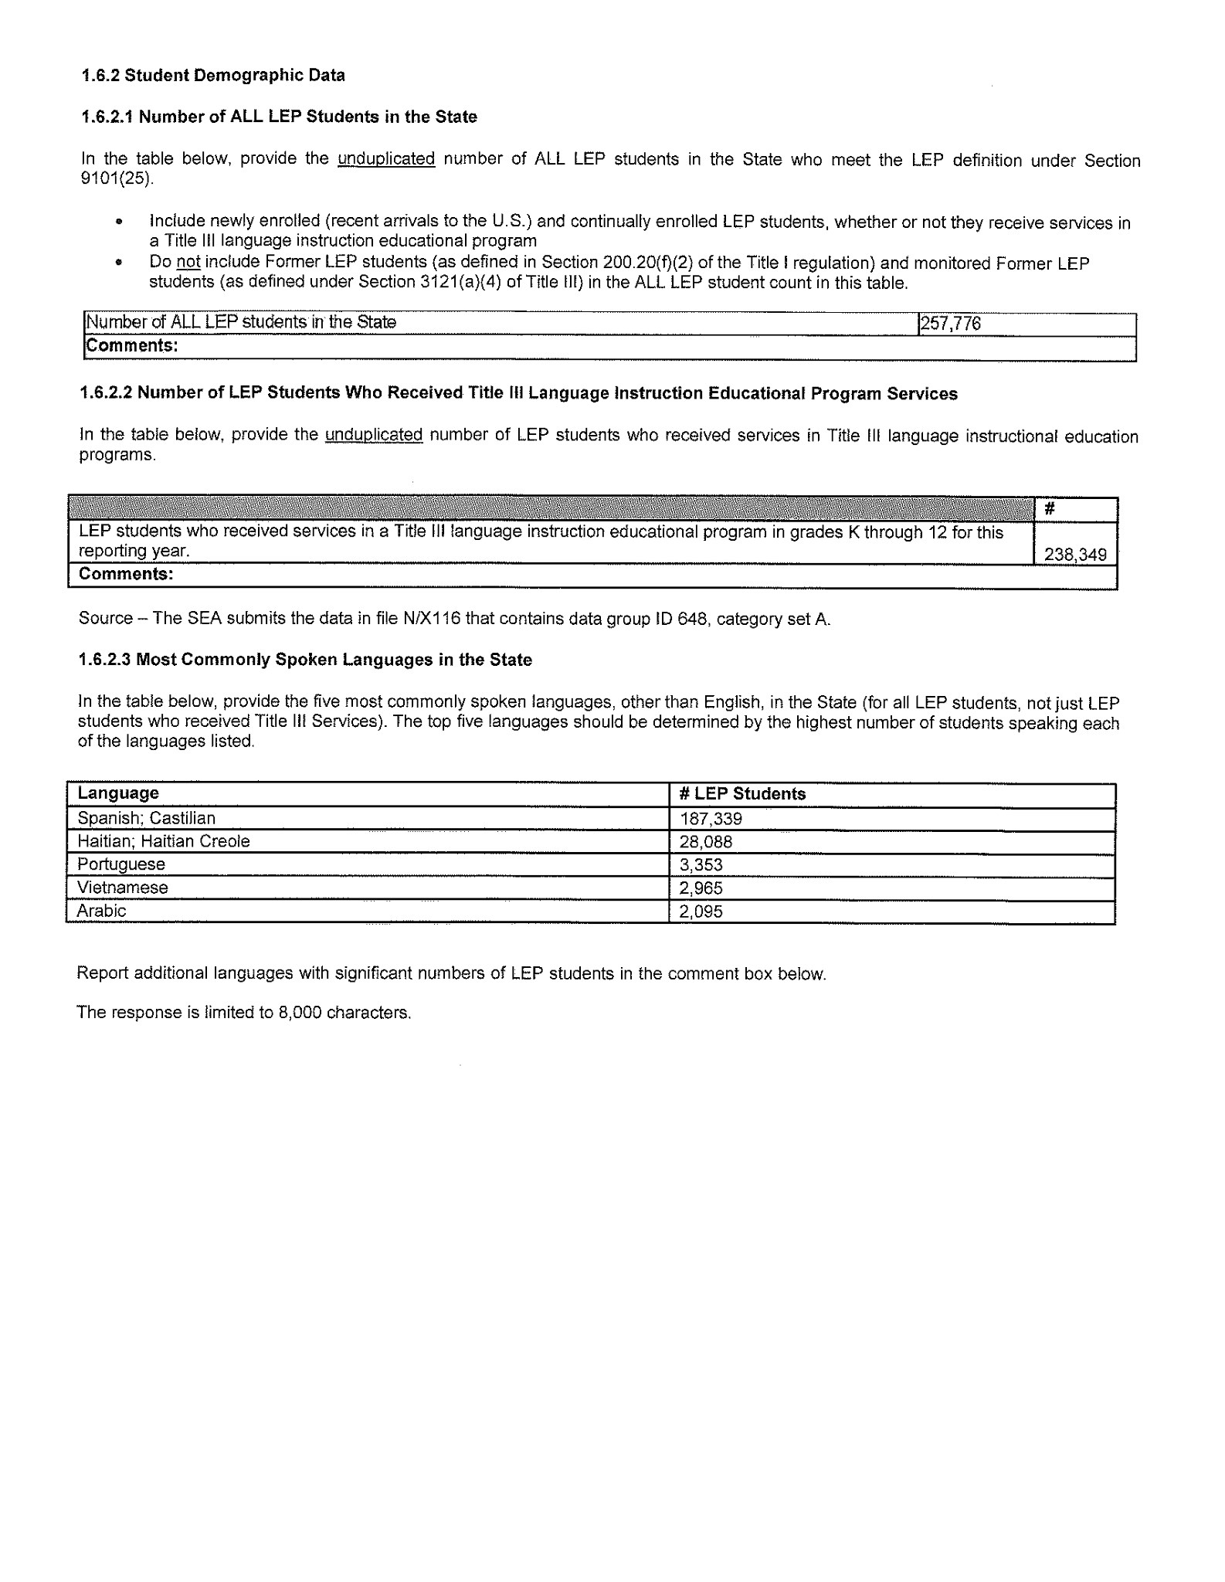
APPENDIX C

FDOT DOCUMENTS THAT HAVE BEEN TRANSLATED INTO OTHER LANGUAGES

- Title VI Policy (Spanish and Haitian Creole)
- Title VI Complaint Form (Spanish and Haitian Creole)
- Essential Right of Way Documents (Forms Library)

