FLORIDA DEPARTMENT OF TRANSPORTATION
LANGUAGE ASSISTANCE PLAN
INTRODUCTION:
The Florida Department of Transportation (FDOT) believes that early, extensive and sustained public involvement is critical to providing safe and equitable transportation facilities for everyone in Florida, including those who are limited English proficient (LEP), either because English is not their native language, or they have low literacy in general. Providing meaningful access to essential FDOT services for LEP individuals not only ensures a balance in public interaction, but also complies with key civil rights authorities, including Title VI of the Civil Rights Act of 1964 (which in part prohibits national origin discrimination) and regulations issued subsequent to Executive Order 13166, Improving Access to Services for Persons with Limited English Proficiency. To ensure LEP access, FDOT developed a Limited English Proficiency (LEP) Guidance to evaluate the number or proportion of LEP persons; the frequency with which these persons contact FDOT; nature and importance of FDOT services; and the resources available to FDOT. FDOT revisits and updates the guidance, as necessary, at least every three (3) years. To view the LEP Guidance, click the link above or contact the FDOT Equal Opportunity Office at 850-414-4750 (711 Florida Relay).
This Language Assistance Plan (Plan) was developed to address interpretation and translation needs identified by the FDOT LEP Guidance. FDOT is a state agency comprised of a Central Office in Tallahassee and eight (8) districts. This Plan provides FDOT’s overall language assistance resources but does not preclude the districts from offering more extensive or tailored LEP services, depending on their various needs. For more information on additional services available in particular areas, visit the FDOT Public Information Office or call the Central Office Communication Director at 850-414-4590 (711 Florida Relay).
FDOT has divided the Plan into three (3) parts addressing the training, verbal interpretation, and written translation resources used to assist those who are LEP, as well as measuring compliance and effectiveness. As with the LEP Guidance, this Plan will be regularly reviewed for accuracy and updated no less than once every three (3) years. For additional information, contact the plan administrator, Aldrin T. Sanders at 850-414-4764, Aldrin.Sanders@dot.state.fl.us.
- Staff Training
FDOT has more than 6,000 employees statewide, all of whom receive nondiscrimination training every three (3) years, tracked by the FDOT Equal Opportunity Office. In addition, FDOT has a robust, ongoing civil rights training initiative that includes staff in its districts, as well as those in the Local Agency Program (LAP) and Florida Metropolitan Planning Organizations (MPOs). For public involvement, FDOT offers several intensive training sessions each year and comprehensive guidance providing attendees with the most effective way of reaching vulnerable populations. Regardless of the topic or audience, FDOT always incorporates LEP information, including a description of the four-factor analysis and tips for providing LEP services in an effective but resource-conscious manner. Finally, FDOT ensures that all staff participating in direct or phone contact with the public receive annual refresher training specifically on providing language services.
Beyond staff training, FDOT offers a number of resources to employees and sub-recipients on effective communication with LEP individuals. Both the Planning and LPA handbooks have sections dedicated to LEP provisions, as do the FDOT Project Development & Environmental Manual and Public Involvement Handbook. These resources are regularly distributed in the field and easily accessible on the Internet. Further, FDOT believes that FHWA’s publication How to Engage Low-Literacy and LEP Populations in Transportation Decision-making is still the best resource of its kind. FDOT provides links to this document and promotes its use among employees, sub-recipients and the industry. FDOT annually updates and publishes a nondiscrimination Resources for Practitioners document, available in hard copy or via the web. The list includes several resources that are specifically for LEP services, including links to the popular I Speak cards. Other resources on the list also provide LEP information, ancillary to more general civil rights topics.
- Verbal Interpretation
Florida is culturally rich, with residents and visitors from all over the world. FDOT is proud of this diversity, including the many different languages spoken. Therefore, FDOT requires that its districts and various departments provide verbal interpretation to LEP individuals regardless of the language, given reasonable notice. FDOT includes the following statements on all public notices and project information documents:
“Public participation is solicited without regard to race, color, national origin, age, sex, religion, disability or family status. Persons who require special accommodations under the American with Disabilities Act (ADA) or persons who require translation services (free of charge) are asked to contact the [person listed in the notice] at least [up to but no longer than ten (10)] days before the meeting.”
FDOT refers to its LEP Guidance when providing this statement in areas with high numbers of persons speaking Florida’s identified LEP languages, Spanish and Haitian Creole. In these areas, FDOT uses Spanish and Creole language media sources to advise communities in their primary language of available language services:
La participación del público es solicitado sin distinción de raza, color, origen nacional, edad, sexo, religión, discapacidad o estado civil. Las personas que requieran acomodaciones especiales bajo la Ley para las Personas con Impedimentos (Americans with Disabilities Act), conocida por sus siglas en inglés ADA, o las personas que requieran servicios de traducción (de forma gratuita) deben comunicarse con [la persona que aparece en el aviso] al menos [hasta, pero no más de diez (10) ] días antes de la reunión.
Nou mande patisipasyon tout moun nenpòt ras, koulè, peyi ou soti, laj, gason ou fanm, relijyon, andikape ou pa, ak nenpòt sitiyasyon fanmiw. Andikape American with Disabilities Act (ADA) rekonèt yo ki bezwen sipò espesyal oswa moun ki bezwen tradiksyon pap peye anyen, Selman rele nan nimero telefòn sa xxxxxxx pou pi piti xxxx jou avan reyinion an.
FDOT’s workforce is an almost exact demographic reflection of the state it serves. As such, many FDOT employees and consultants are fluent in languages other than English. Each FDOT district and the Turnpike Enterprise maintains a list of employees who are 1) competent foreign language speakers and 2) who are fluent with transportation industry terms and concepts in their additional language(s). As not all bilingual speakers are equally capable of reading and writing at a level equivalent to speaking, the list is annotated for those who can provide both verbal interpretation and written translation. Again, though not assessed, language mastery is required, up to and including the ability to discuss/translate industry terms-of-art and concepts in the foreign language. FDOT Districts update the lists every three (3) years.
Employee Interpretation Lists are not public documents and FDOT does not encourage public contact of its employees based on language ability. Rather, all staff that assists the public has access to the list, along with other tools to identify the language and refer the LEP individual to a representative who can competently assist.
FDOT recognizes that it may not be able to provide all verbal interpretation using in-house resources. Therefore, each district has the authority to purchase professional interpretation services, either on contract or via minutes of use. Each district has identified one or more interpretation service providers and either executed a suitable contract or otherwise arranged for service on hand when/if need arises. FDOT also recommends that each district have regular contact with institutions of higher education (IHE) in their areas, as schools are often able to provide language resources with short notice.
- Written Translation
In its LEP Guidance, FDOT determined that while transportation is of critical importance to the lives and wellbeing of those living or visiting Florida, many of its documents lack essential information necessitating translation to Spanish or Haitian Creole, the two (2) representative populations whose languages were identified as LEP service-eligible based on the four-factor analysis. FDOT believes that information regarding civil rights, safety, and property appraisal/acquisition/relocation (realty) are of vital importance and require translation. Therefore, general distribution information for these programs has been translated into the two (2) prevalent languages. Moreover, 511, FDOT’s telephone number for advising the public of transportation and traffic related incidents, is accessible in Spanish both by telephone and by web.
However, due to the demographic diversity among FDOT’s districts, the decision to translate project documents is made case by case, based on the language(s) represented in the project area. Further, FDOT carefully evaluates project documents to determine whether translation is the best method of reaching the public. FDOT is committed to providing meaningful access, and will provide translation of any document when reasonable, effective and within available resources. FDOT Districts routinely provide vital information by developing Fact Sheets in English, Spanish and Creole (as needed) for major Design/Construction projects. The Districts also provide translation of plan and project documents for common occurrences such as lane closures, new sidewalk and pedestrian ramp additions, and new lighting, traffic signals and pavement marking.

Similarly, all of FDOT significant transportation projects use websites to provide information to the public. These sites are available in English and Spanish and, as needed, Haitian Creole.
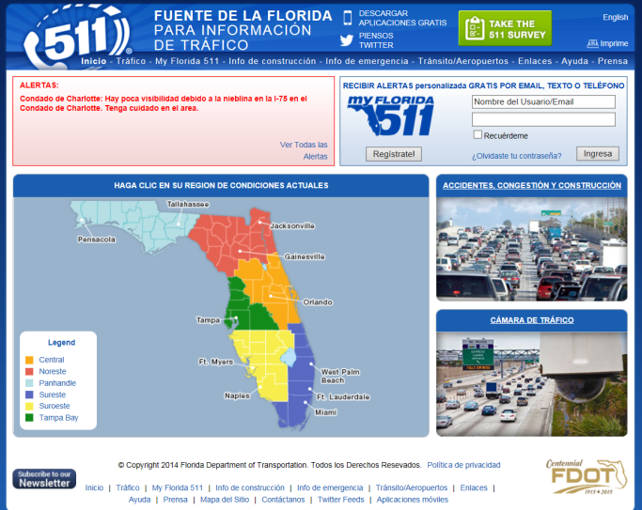
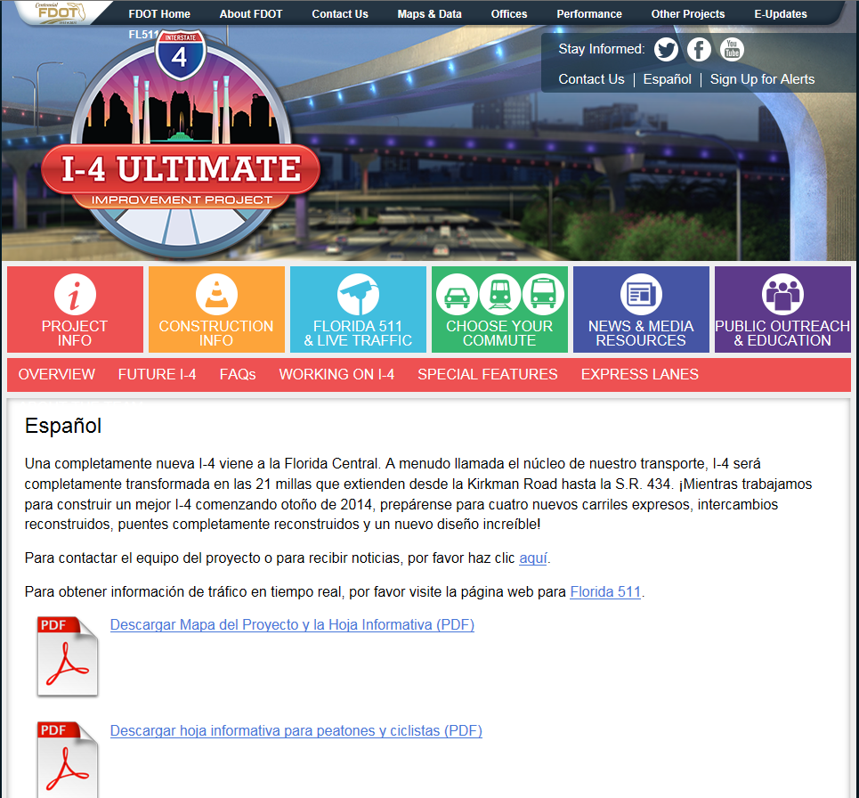
In districts with much higher proportions of Spanish and Haitian-Creole speakers than the more northern areas of the state, when warranted, FDOT will incorporate Spanish and Haitian-Creole translation capacities to major project websites to meet LEP needs. http://www.95express.com/ .
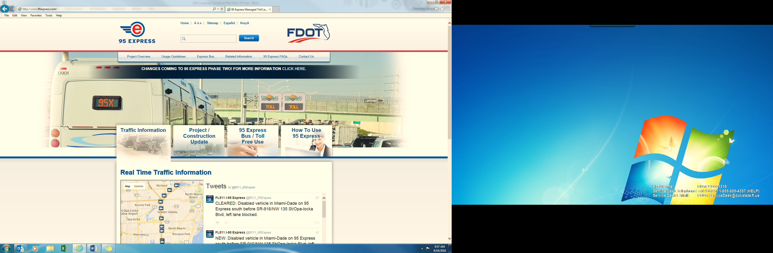
- Measuring Effectiveness
To ensure that civil rights programs, including LEP, are substantially compliant and meaningfully delivered, FDOT annually reviews all of its federal program areas. As part of these Quality Assurance Reviews (QARs), the State Title VI/Nondiscrimination Coordinator collects alternative language publications and media sources in each district and then compares them to area demographics. The Coordinator also tests the accuracy of the district interpreter/translator list to ensure that it is up to date and that employees remain willing to provide their services.
In addition, FDOT quarterly collects field information on the number of instances verbal interpretation and written translation is requested and provided. This data is loosely compared to American Community Survey (ACS) demographics for the various districts showing English spoken “less than very well.” If a disparity exists between the figures, the Coordinator schedules a special emphasis review to further assess compliance. The Coordinator also maintains this data for annual reporting to federal funding authorities.
Title VI | FY 20XX
# of Title VI complaints filed with the STA
# of completed investigations conducted by the STA
# of STA completed investigations with findings
# of planned STA reviews
# of completed STA reviews
# of current STA Subrecipients
# of planned STA Subrecipient reviews
# of completed STA Subrecipient reviews
# of planned training sessions
# of completed training sessions
Limited English Proficiency (LEP)
% of population that does not speak English proficiently
# of languages (other than English) used by the population
# of translation services provided by STA
# of interpreter services provided by STA
Cost of translation and interpreter services provided

- Conclusion
FDOT believes that its alternative language services meet or exceed LEP requirements by focusing on customer service rather than exclusively on legal compliance. To date, FDOT has no record of unmet language service needs and, though it regularly processes Title VI and other complaints, none have been related to LEP. For more information on FDOT’s LEP responsibilities, contact the Language Assistance Plan Administrator, Aldrin T. Sanders at 850-414-4764 or Aldrin.Sanders@dot.state.fl.us. For additional information on LEP requirements or resources, visit www.lep.gov.

