INSTRUCTIONS
[THIS PAGE TO BE REMOVED UPON COMPLETION OF THE REPORT]
This PD&E Noise Study Report (NSR) template may be used to create Florida Department of Transportation (FDOT) Noise Study Reports. The following “user-inputs” are used in this document to guide the author on writing the report, listed in Table Ex.-1.
Table Ex.-1 – User Inputs
Text Input Object | How does Writer/Author Respond?
Blue italicized text | This instructional text guides the writer on how to compile the document. This temporary text should be removed before the report is finalized.
[BLOCK ENTRIES] | These are items that need to be replaced by the parameter indicated inside the block (i.e., “[ROADWAY NAME]” would be replaced by “U.S. 27”).
Dropdown boxes (e.g., “is/is not”, “would/would not”) | The appropriate item should be chosen from the drop-down list using the down arrow.
If/Then paragraphs | The appropriate paragraph should be used. These If/Then statements are listed directly in the text as well as in tables. Any unused/inapplicable paragraphs should be removed.

Project Development and Environment
Noise Study Report
Florida Department of Transportation
District [NUMBER]
[PROJECT TITLE]
[LIMITS OF THE PROJECT]
[COUNTY NAME], Florida
Financial Management Number: [FM NUMBER]
ETDM Number: [ETDM NUMBER]
[DATE]
The environmental review, consultation, and other actions required by applicable federal environmental laws for this project are being, or have been, carried out by the Florida Department of Transportation (FDOT) pursuant to 23 U.S.C. § 327 and a Memorandum of Understanding dated May 26, 2022, and executed by the Federal Highway Administration and FDOT.

EXECUTIVE SUMMARY
The Florida Department of Transportation (FDOT) District [NUMBER] is preparing a Project Development and Environment (PD&E) Study evaluating proposed improvements to [ROADWAY NAME] from [ROADWAY NAME] to [ROADWAY NAME], in [COUNTY NAMES] County, a distance of approximately [NUMBER OF MILES] miles. The proposed improvements consist of [PROPOSED IMPROVEMENTS DECRIPTIONS]. The project improvements qualify for a Type I noise project due to [LIST QUALIFYING PROJECT ACTIVITIES FROM THE TYPE I PROJECT LIST].
This PD&E Noise Study Report (NSR) presents the methodology and results of the highway traffic noise evaluation for [PROJECT NAME] (Financial Management Number [FM NUMBER]). The purpose of this noise study is to identify noise sensitive sites that would be impacted by the preferred alternative, evaluate abatement measures at impacted noise sensitive sites, and determine where noise abatement (i.e., noise barriers) should be included with the project and re-evaluated in the design phase.
If there are no impacted receptors within the project, the following statement (or variation thereof) should be used (otherwise, remove the following statement):
The Federal Highway Administration (FHWA) Traffic Noise Model (TNM), version 2.5, was utilized to predict noise levels at [NUMBER] receptor points representing [NUMBER] residences and [NUMBER] special land uses (SLUs). For the year [YEAR] Build condition, noise levels are not predicted to approach, meet, or exceed the Noise Abatement Criteria (NAC) at any residence or SLUs within the project limits. Additionally, a substantial increase of 15 dB(A) is not predicted to occur at any residence or SLU. Based on the noise analyses performed to date, there appear to be no impacted areas within the project that require abatement consideration.
If there are impacted receptors within the project, the following statement (or variation thereof) should be used (otherwise, remove the following statement):
The Federal Highway Administration (FHWA) Traffic Noise Model (TNM), version 2.5, was utilized to predict noise levels at [NUMBER] receptor points representing [NUMBER] residences and [NUMBER] special land uses (SLUs). For the year [YEAR] Build condition, noise levels are predicted to approach, meet, or exceed the Noise Abatement Criteria (NAC) at [NUMBER] residences and [NUMBER] SLUs within the project limits. These impacted noise sensitive sites were evaluated to determine the feasibility and reasonableness of providing barriers to reduce traffic noise. Additionally, a substantial increase of 15 dB(A) is/is not predicted to occur at any residence or SLU.
If impacts were identified and noise barriers were evaluated but unable to meet feasible and reasonable requirements, the following statement (or variation thereof) should be used (otherwise, remove the following statement):
The noise barrier evaluation process identified that a noise barrier/noise barriers would/would not provide at least a 5 decibel (dB[A]) reduction to [NUMBER] impacted residences and [NUMBER] impacted SLUs. However/Additionally, the noise barriers would/would not meet the Noise Reduction Design Goal (NRDG). However/Therefore, the noise barriers do not meet the criteria of feasibility and/or reasonableness to warrant the construction of a noise barrier. Based on the noise analyses performed to date, there are no feasible solutions available to mitigate the noise impacts at the locations identified in Section 3.2.
If noise barriers were able to meet feasible and reasonable requirements, the following statement (or variation thereof) should be used (otherwise, remove the following statement):
The noise barrier evaluation process identified that noise barriers are a feasible and reasonable form of abatement and could potentially provide at least a 5 dB(A) reduction at [NUMBER] of the [NUMBER] impacted residences ([NOISE ANALYSIS AREA NAMES]), and at [NUMBER] of the [NUMBER] impacted SLUs ([SLU NAMES/DESCRIPTIONS]) at a cost below the reasonable limit. Additionally, the noise barrier achieves the Noise Reduction Design Goal (NRDG). Noise barriers were found to be potentially feasible and reasonable at the following Noise Analysis Areas (NAA):
- [NAA # AND DESCRIPTION OF RESIDENTIAL AREAS AND/OR SLUS]
- [NAA # AND DESCRIPTION OF RESIDENTIAL AREAS AND/OR SLUS]
- [NAA # AND DESCRIPTION OF RESIDENTIAL AREAS AND/OR SLUS]
Noise barriers cannot provide at least a 5 dB(A) reduction to [NUMBER] impacted residences and [NUMBER] impacted SLUs because they do not meet the criteria of feasibility and/or reasonableness to warrant the construction of a noise barrier.

Table of Contents
To update Table of Contents, right-click and select “Update Field” and then “Update entire table”.
SECTION 1 Introduction 1
1.1 Project Description 1
1.2 Purpose and Need 3
1.3 Existing Facility 3
1.4 Proposed Improvements 3
SECTION 2 Methodology 6
2.1 Noise Metrics 6
2.2 Traffic Data 6
2.3 Noise Abatement Criteria 7
2.4 Noise Abatement Measures 9
2.4.1 Traffic Management 9
2.4.2 Alignment Modifications 10
2.4.3 Buffer Zones 10
2.4.4 Noise Barriers 10
2.4.5 Noise Barriers for Special Land Uses (Non-residential) 11
2.4.6 Existing Noise Barriers 12
2.5 Noise Model 14
2.5.1 Model Validation 14
2.6 Noise Sensitive Sites 15
2.6.1 Common Noise Environments and Noise Analysis Areas 16
SECTION 3 Traffic Noise Analysis Results 20
3.1 Existing Noise Levels 20
3.2 Substantial Increase in Noise 23
3.3 Noise Abatement Criteria Evaluation 23
3.3.1 NAA #1 23
SECTION 4 Conclusions 29
4.1 Impacted Noise Sensitive Sites 29
4.2 Recommended Noise Barriers 29
4.3 Statement of Likelihood 30
SECTION 5 Construction Noise and Vibration 32
SECTION 6 Community Coordination 33
6.1 Public Involvement 33
6.2 Contours 33
REFERENCES 35
APPENDIX A Traffic Data A-1
APPENDIX B Project Aerials B-1
APPENDIX C Predicted Noise Levels C-1
APPENDIX D Model Validation Field Sheets D-1
APPENDIX E SLU Equivalent Residence Calculation Worksheets E-1

Note: modify the list of appendices based on the project. Not every project will require all the currently listed appendices.
List of Figures
Figure 1-1: Project Location Map [EXAMPLE] 2
Figure 1-2: Existing Typical Sections [EXAMPLE] 4
Figure 1-3: Proposed Typical Sections [EXAMPLE] 5

List of Tables
Table 2-1 Noise Abatement Criteria 8
Table 2-2 Typical Noise Levels 9
Table 2-3 Feasible and Reasonable Requirements for a Noise Barrier 11
Table 2-4 Existing Noise Barriers (EXAMPLE) 12
Table 2-5 Noise Model Validation 14
Table 3-1 Ambient Noise Monitoring (EXAMPLE) 22
Table 3-2 Noise Barrier Analysis – NAA #1 (Residential-only) 27
Table 3-3 Noise Barrier Analysis – NAA #2 (SLU and Residential) 28
Table 4-1 Potentially Feasible and Reasonable Noise Barriers 31
Table 6-1 Noise Abatement Criteria Contours 34

ACRONYMS
Acronyms may be added or removed based on use in this document.
BER Benefited Equivalent Residence
CFR Code of Federal Regulations
CNE Common Noise Environment
dB Decibels
dB(A) A-weighted decibels
DPK Date of Public Knowledge
ER Equivalent Residence
ETDM Efficient Transportation Decision Making
FDOT Florida Department of Transportation
FHWA Federal Highway Administration
FM No. Financial Management Number
ft. Feet
Leq(h) Hourly equivalent noise levels
LOS Level of Service
mph Miles per hour
MSE Mechanically-Stabilized Earth
NAA Noise Analysis Area
NAC Noise Abatement Criteria
NEPA National Environmental Policy Act
NRDG Noise Reduction Design Goal
NSR Noise Study Report
PER Preliminary Engineering Report
PD&E Project Development and Environment
ROW Right-of-way
SLM Sound Level Meter
SLU Special Land Use
sq. ft. Square Feet
TER Total Equivalent Residence
TNM Traffic Noise Model

Introduction
The Florida Department of Transportation (FDOT) District [NUMBER] is preparing a Project Development and Environment (PD&E) Study evaluating proposed improvements to [ROAD NAME] from [ROAD NAME] to [ROAD NAME], in [COUNTY NAMES] County, a distance of about [NUMBER] miles. The project limits are shown in Figure 1-1.
This PD&E Noise Study Report (NSR) presents the methodology and results of the highway traffic noise evaluation for [PROJECT NAME] (Financial Management Number [FM NUMBER]). [Phase II/Phase III] Plan sets dated [INSERT DATE] were utilized as a basis for this evaluation.
The purpose of this noise study is to identify noise sensitive sites that would be impacted by the preferred alternative, evaluate abatement measures at impacted noise sensitive sites, and determine where noise abatement (i.e., noise barriers) should be included with the project and re-evaluated in the design phase.
Secondary objectives of this study include the consideration of construction noise and vibration impacts as well as the development of noise contours, that can be used in the future by local municipal and county government agencies to identify compatible land uses along the project roadways.
This report also provides technical documentation for the findings described in the project’s Preliminary Engineering Report (PER) and the [TYPE OF ENVIRONMENTAL DOCUMENT].

Project Description
[STANDARDIZED PROJECT DESCRIPTION]

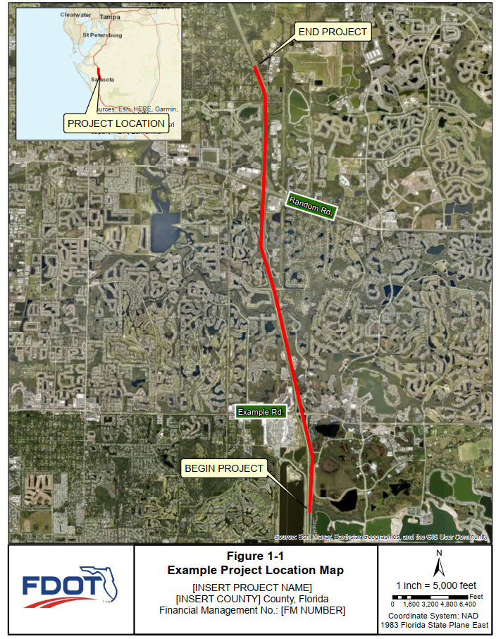
Figure 1-1: Project Location Map [EXAMPLE]

Purpose and Need
The Purpose and Need Section should be verbatim to the environmental document. However, if doing so would cause this section to become too lengthy, coordinate with the District Noise Specialist on what information to include.
The purpose of this project is to [STANDARDIZED PURPOSE AND NEED STATEMENT FOR PROJECT]

Existing Facility
As shown in the existing typical sections in Figure 1-2, the existing facility consists of [EXISTING FACILITY DECRIPTION]

Proposed Improvements
The proposed improvements consist of [PROPOSED IMPROVEMENTS DECRIPTION].
As shown in Figure 1-3, the typical section consists of [PROPOSED TYPICAL SECTION DECRIPTION].The concept plans for the Build Alternative(s) is/are included in the PER.
If more than two typical sections need to be included, it is recommended to put all typical section graphics into an Appendix.

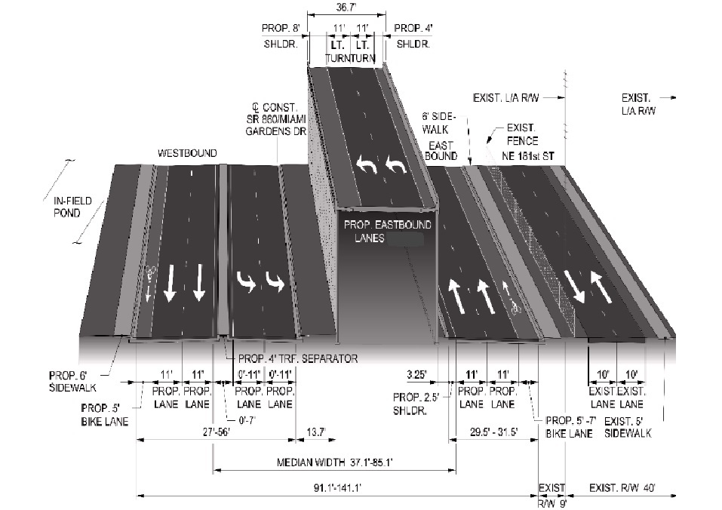
Figure 1-2: Existing Typical Sections [EXAMPLE]
Figure 1-3: Proposed Typical Sections [EXAMPLE]

Methodology
This highway traffic noise study was completed in accordance with Title 23, Code of Federal Regulations, Part 772 (23 CFR 772), Procedures for Abatement of Highway Traffic Noise and Construction Noise following methodology and procedures established by the FDOT in the PD&E Manual, Part 2, Chapter 18, Highway Traffic Noise, and the FDOT Traffic Noise Modeling and Analysis Practitioners’ Handbook .
The FHWA’s Traffic Noise Model (TNM), version 2.5, was used to predict existing and future traffic noise levels and to analyze the effectiveness of noise barriers, where warranted. This model estimates the acoustic intensity at noise sensitive receptor sites from a series of roadway segments (the source).
Representative receptor sites were used as inputs to the TNM to estimate noise levels associated with existing and future conditions within the project limits. These sites were chosen based on noise sensitivity, roadway proximity, anticipated impacts from the proposed project, and homogeneity (e.g., the site is representative of other nearby sites). For single-family residences, traffic noise levels were predicted at the edge of the dwelling unit closest to the nearest primary roadway. For other noise sensitive sites that may be impacted (e.g., non-residential land uses), traffic noise levels were predicted where the exterior use/activity occurs. The next two sentences should be removed if interior analysis was not warranted. For the prediction of interior noise levels, the receptor site was placed inside the building at the corner of the façade closest to the roadway or in the interior area determined to be the area of frequent use. Building noise reduction factors and window conditions identified in Figure 18-3 in Part 2, Chapter 18 of the PD&E Manual were used to determine the potential for interior noise impacts.

Noise Metrics
Noise levels developed for this traffic noise study are expressed in decibels (dB) using an “A”-scale [dB(A)] weighting. This scale most closely approximates the response characteristics of the human ear to typical traffic noise levels. All reported noise levels are hourly equivalent noise levels [Leq(h)]. The Leq(h) is defined as the equivalent steady-state sound level that, in an hourly period, contains the same acoustic energy as the time-varying sound level for the same hourly period. Use of these metrics is consistent with the requirements of 23 CFR 772.

Traffic Data
Traffic data is of primary importance in a traffic noise prediction model. FDOT traffic data for the existing [YEAR], No-Build [YEAR] and [YEAR] design Build Alternatives were obtained from [SOURCE]. The traffic data were reviewed to identify forecasted traffic volumes that would yield the highest traffic noise impact. As required in the FDOT’s PD&E Manual, when the predicted design year peak hour directional demand traffic volumes equal or exceed Level of Service (LOS) C, LOS C hourly traffic volumes were utilized. For roadway segments where the predicted peak hour directional demand traffic volumes is less than LOS C, the peak hour demand volumes were utilized. For this evaluation, the [YEAR] Build condition was modeled with peak hour directional demand volumes for [ROAD NAMES], while LOS C volumes were modeled for [ROAD NAMES].
Traffic volumes and speeds used in the analysis are included in Appendix A.

Noise Abatement Criteria
Noise sensitive land uses are areas where there is frequent human use that may be impacted by traffic noise levels that approach, meet, or exceed the Noise Abatement Criteria (NAC) – levels established by the Federal Highway Administration (FHWA) at which abatement must be considered. Typical noise sensitive land uses include residences, schools, places of worship, commercial properties with outdoor areas of use, and recreational areas. As shown in Table 2-1, the NAC vary by activity category.
The FDOT NAC is defined as being within one dB(A) of the FHWA’s NAC to reflect values that “approach” the FHWA criteria. For perspective on the decibel values, Table 2-2 provides typical noise levels of common indoor and outdoor activities.
Noise abatement measures must also be considered when a substantial increase in traffic noise is predicted to occur as a direct result of a transportation project. FDOT defines a substantial increase as 15 dB(A) or more above existing conditions. A substantial increase typically occurs in areas where traffic noise is a minor component of the existing noise environment but would become a major component after the project is constructed. This occurs more frequently with new alignment projects.
Table 2-1
Noise Abatement Criteria
Activity  Category | Activity Leq(h) |  | Evaluation  Location | Description of Land Use Activity Category
Activity  Category | FHWA | FDOT | Evaluation  Location | Description of Land Use Activity Category
A | 57 | 56 | Exterior | Lands on which serenity and quiet are of extraordinary significance and serve an important public need and where the preservation of those qualities is essential if the area is to continue to serve its intended purpose.
B | 67 | 66 | Exterior | Residential.
C | 67 | 66 | Exterior | Active sports areas, amphitheaters, auditoriums, campgrounds, cemeteries, day care centers, hospitals, libraries, medical facilities, parks, picnic areas, places of worship, playgrounds, public meeting rooms, public or nonprofit institutional structures, radio studios, recording studios, recreation areas, Section 4(f) sites, schools, television studios, trails, and trail crossings.
D | 52 | 51 | Interior | Auditoriums, day care centers, hospitals, libraries, medical facilities, places of worship, public meeting rooms, public or nonprofit institutional structures, radio studios, recording studios, schools, and television studios.
E | 72 | 71 | Exterior | Hotels, motels, offices, restaurants/bars, and other developed lands, properties or activities not included in A – D or F.
F | ------ | ------ | ------ | Agriculture, airports, bus yards, emergency services, industrial, logging, maintenance facilities, manufacturing, mining, rail yards, retail facilities, shipyards, utilities (water resources, water treatment, electrical), and warehousing.
G | ------ | ------ | ------ | Undeveloped lands that are not permitted.
(Based on Table 1 of 23 CFR 772 and FDOT PD&E Manual Chapter 18)
¹ The Leq(h) Activity Criteria values are for impact determination only, and are not design standards for noise abatement measures.
² Includes undeveloped lands permitted for this activity category.
Note: FDOT defines that a substantial noise increase occurs when the existing noise level is predicted to be exceeded by 15 decibels or more as a result of the transportation improvement project. When this occurs, the requirement for abatement consideration will be followed.

Table 2-2
Typical Noise Levels
Common Outdoor Activities | Noise Level  dB(A) | Common Indoor Activities
Jet Fly-over at 1000 ft.  Gas Lawn Mower at 3 ft.  Diesel Truck at 50 ft., at 50 mph  Noise Urban Area (Daytime)  Gas Lawn Mower at 100 ft.  Commercial Area  Heavy Traffic at 300 ft.  Quiet Urban Daytime  Quiet Urban Nighttime  Quiet Suburban Nighttime  Quiet Rural Nighttime  Lowest Threshold of Human Hearing | ---110---  ---100---  ---90---  ---80---  ---70---  ---60---  ---50---  ---40---  ---30---  ---20---  ---10---  ---0--- | Rock Band  Food Blender at 3 ft.  Garbage Disposal at 3 ft.  Vacuum Cleaner at 10 ft.  Normal Speech at 3 ft.  Large Business Office  Dishwasher Next Room  Theater, Large Conference Room (Background)  Library  Bedroom at Night, Concert Hall (Background)  Lowest Threshold of Human Hearing
Source: California Dept. of Transportation Technical Noise Supplement, September 2013, Page 2-20.

Noise Abatement Measures
Noise abatement is considered at all noise sensitive sites predicted to meet or exceed the FDOT NACor which have a substantial increase in noise, as stipulated by 23 CFR 772, as stipulated by 23 CFR 772. Abatement measures considered include traffic management, alignment modifications, noise buffer zones through application of land use controls, and noise barriers. Each of these abatement measures are discussed further in the following sections.

Traffic Management
Traffic management techniques can be used to abate traffic noise. For example, the timing of traffic lights could be altered to eliminate frequent stopping, heavy trucks could be limited to certain hours of the day on specific roads, and speed limits could be reduced. [ROAD NAME] serves as a [NORTH/SOUTH OR EAST/WEST] route for the movement of freight. Limiting heavy truck operations would affect the movement of materials and goods over an extensive area. Therefore, prohibiting or limiting heavy truck traffic on [ROAD NAME] is not considered a reasonable abatement measure for this project. A substantial speed reduction on [ROAD NAME] would lower traffic noise levels. However, the capacity of the roadway to service traffic would also be reduced with a reduction of speed. Therefore, speed reduction is not a reasonable abatement measure for this project.

Alignment Modifications
If the proposed road is a new alignment, the following statement, or variation thereof, may be used (otherwise, remove the following statement):
Modifying the horizontal alignment and/or vertical profile of a roadway can influence highway traffic noise levels and can therefore be an effective abatement measure. However, the proposed vertical profile and horizontal alignment of [ROAD NAME] has been governed by minimizing other environmental impacts. Project costs and detrimental effects on land use and other environmental factors have been minimized using the proposed corridor. An alignment modification that could provide a substantial noise reduction is, therefore, not a feasible or reasonable abatement measure.
If the proposed project is making modifications to an existing roadway, the following statement, or variation thereof, may be used (otherwise, remove the following statement):
Modifying the horizontal alignment and/or vertical profile of a roadway can influence highway traffic noise levels and can therefore be an effective abatement measure. However, the existing alignment of [ROAD NAME] has already established the proposed horizontal and vertical alignment. Project costs and detrimental effects on land use are minimized by making use of the existing corridor. The cost of acquiring additional property for the sole purpose of abating highway traffic noise may exceed the cost reasonable limit of $64,000 per benefited receptor (defined as a noise sensitive site receiving at least a 5 dB(A) noise reduction from the abatement measure). Therefore, an alignment modification that could provide a substantial noise reduction is not a feasible or reasonable abatement measure.

Buffer Zones
Providing a buffer space (i.e., an area of undeveloped land) between a highway and future noise sensitive development can minimize or eliminate noise impacts.
Buffer zones can be implemented through local land use planning. The distances between the proposed highway and noise sensitive sites (where predicted traffic noise levels approach, meet or exceed the NAC for Activity Categories A, B, C and E) are determined to facilitate future land use planning that is compatible with the traffic noise environment. For the proposed conceptual design, the distance between the nearest edge of pavement of [ROAD NAME] and the location where traffic noise levels would approach a particular NAC is provided in SECTION 6. Local officials can use the information in Table 6-1 (or Figure 18-7 Noise Contours from PD&E Manual Chapter 18) to establish buffer zones for future projects, thereby minimizing or avoiding noise impacts at sensitive land uses. The distances do not account for any reduction in noise levels that may be provided by berms, privacy walls or intervening structures in the noise propagation path. These buffer zone contours also do not account for any increase in noise resulting from increased highway elevation (e.g., overpasses) or elevated noise sensitive sites (e.g., second floor patios).

Noise Barriers
Noise barriers reduce noise levels by interrupting the sound path between a highway and noise sensitive site. Barriers can cause sound waves to bend around and over the barrier (diffraction) which produces a “shadow zone” behind the barrier itself. To effectively reduce traffic noise, a barrier must be relatively long, continuous (with no intermittent gaps), and of sufficient height. A noise barrier must be considered a feasible and reasonable noise abatement measure to be suggested for inclusion into the project. Feasibility factors are related to the acoustical and engineering properties of an abatement measure. Reasonableness factors are related to the environmental, economic, and social properties. For a noise barrier to be considered feasible and cost reasonable, the following minimum conditions should be met (Table 2-3):
Table 2-3 Feasible and Reasonable Requirements for a Noise Barrier
Feasible | Reasonable
At least two impacted receptors must be provided a noise reduction of 5 dB(A). | A noise barrier must also attain the Noise Reduction Design Goal (NRDG), which states that a minimum noise reduction of 7 dB(A) for at least one benefited receptor must be achieved. This receptor may also have been previously identified as meeting the feasibility requirement of receiving a 5 dB(A) reduction.
Engineering factors (design/construction, safety, access, ROW, maintenance, drainage, and utility) must be considered, and all conflicts must be resolved. | The cost of the noise barriers should not exceed $64,000 per benefited receptor. This is the upper cost limit established by FDOT. A benefited receptor is defined as a recipient of an abatement measure that experiences at least a 5 dB(A) reduction as a result of providing a noise barrier. The current unit cost used to evaluate cost reasonableness is $40 per square foot (sq. ft.).
-- | The viewpoints of benefited receptors must be considered.
Within the project limits, noise barrier locations are evaluated as follows:
- Right-of-way (ROW) noise barriers located outside the clear zone, which is defined in the FDOT Design Manual as ‘the amount of recoverable area beyond the traveled way’ but within the ROW, are initially considered at heights ranging from 8 ft. to 22 ft. in 2 ft. increments. According to the FDOT Design Manual, noise barriers outside the clear zone shall not exceed a maximum height of 22 ft.
- If a ROW barrier cannot provide at least a 5 dB(A) reduction to an impacted receptor or the barrier is not feasible due to engineering and/or construction limitations, then a shoulder barrier is evaluated. According to the FDOT Design Manual, shoulder barriers shall not exceed 14 ft. in height when on embankment and 8 ft. in height when on structure or Mechanically Stabilized Earth (MSE).
The length and height of the noise barriers are optimized based on the benefit provided to noise sensitive sites with predicted noise levels that meet, or exceed the FDOT NAC.

Noise Barriers for Special Land Uses (Non-residential)
This section, or a variation thereof, can be used if barriers were evaluated for Special Land Uses (non-residential land uses) as part of the final design process. Otherwise, it should be removed.
The methodology used to evaluate noise barrier systems for non-residential sites differs from that used for residential locations. The standard procedure for determining the feasibility and reasonableness of a noise barrier for a special land use (SLU) site is documented in Methodology to Evaluate Traffic Noise at Special Land Uses (FDOT 2024). In this methodology, SLUs are assigned an Equivalent Residence (ER) based on the person-hours of use at the SLU in order to evaluate the reasonableness and feasibility of a noise barrier. This SLU evaluation is a multi-step process, as summarized below.
- If an impacted SLU receptor is not adjacent to impacted residences or other impacted SLUs such that a single noise barrier would not be a practical form of abatement for all impacted properties, it is considered isolated. An optional preliminary screening analysis may be applied to isolated impacted SLUs to determine if it has enough person-hour usage to equate to at least two residences to be found feasible for noise abatement. To meet the feasibility requirement, the isolated SLU must have at least 44,326 person-hours of use per year (equivalent to the number of person-hours per year for two single family residences) in the benefited area for a noise barrier to be found as a feasible form of noise abatement.
- A noise barrier is evaluated if the preliminary screening results indicate that a full analysis is warranted or if the impacted SLU is adjacent to other impacted SLUs or residences.
- A noise barrier is found feasible and reasonable if the requirements of Table 2-3 are met, which can be determined through the use of the FDOT SLU Worksheet. Once it is determined that impacted SLUs benefit from the analyzed noise barrier, the FDOT SLU Worksheet is utilized to assess whether a noise barrier is a reasonable form of abatement. The SLU Worksheet includes all residences and SLUs that would receive a benefit from the noise barrier. This methodology allows the combined evaluation of all impacted land use activity categories that would potentially benefit from a single noise barrier system.

Existing Noise Barriers
If existing noise barriers are present in the project limits, include this section with the following text or variation thereof (otherwise, remove this section and the following statement).
Of importance, [NUMBER] existing noise barrier is/barriers are present within the proposed project limits and are listed in Table 2-4.
Table 2-4
Existing Noise Barriers (EXAMPLE)
Existing Noise Barrier Number | NAAs | Location | Approx. Height (ft.) | Approx. Length (ft.) | Construction Year
1 | ABC, XYZ, and PQR Neighborhood | ROW | 22 | 2,500 | 2014
2 | Residences from ABC Street to XYZ Road | Shoulder | 14 | 1,700 | 2014
3 | Residences from ABC Street to XYZ Road | Shoulder/Structure | 14/8 | 1,000/500 | 2014
This section, or a variation thereof, can be used if existing barriers were evaluated as part of the final design process. Otherwise, it should be removed.
The standard procedure for determining traffic noise impacts for a project where there are existing FDOT noise barriers is documented in FDOT’s Methodology to Evaluate Existing Noise Barriers (FDOT 2025). This methodology is used to determine whether to replace, extend, or maintain the existing noise barrier if there are traffic noise impacts from the Build condition. The following summarizes the steps taken for the evaluation of the two existing noise barriers within the project corridor.
- Identify Impacts. Are receptors impacted under the Build condition with the existing noise barrier included in the analysis? If no, the analysis is complete and the existing noise barrier is maintained. If yes, the evaluation proceeds to Step 2.
- Determine if Existing Barrier Meets Current FDOT Requirements. The intent of Step 2 is to determine the abatement merits of the existing noise barrier and if it meets the FDOT acoustic feasibility and reasonableness requirements with the proposed project. If the existing barrier is proven to provide acoustically feasible abatement to all impacted receptors and meets the NRDG, the existing barrier is not a candidate for further abatement strategies.
A comparison is made between the predicted Build condition noise levels without the existing noise barrier and the predicted Build condition with the existing noise barrier. Does the existing noise barrier benefit two impacted receptors AND meet the NRDG? If no, the evaluation proceeds to Step 3. If yes, does the Build condition impact receptors that are not benefited by the existing noise barrier? If no, the analysis is complete and the existing noise barrier is maintained. If yes, the evaluation proceeds to Step 3.
- Compare Build Condition Noise Levels to Existing Noise Levels. The intent of Step 3 is to compare the future Build condition and existing noise levels to determine the extent of the proposed roadway design's noise increase. Is the change in noise levels from the existing condition to the Build Alternative greater than 3 dB(A) at any impacted receptor that is not benefited by the existing noise barrier with the Build Alternative? If not, the analysis is complete. If yes, the evaluation proceeds to Step 4.
- Evaluate Lengthening Existing Barrier. The intent of Step 4 is to determine if the existing noise barrier can be lengthened to provide effective noise reduction to the impacted, but not currently benefited, receptors identified in Step 2. To determine if the "lengthened noise barrier" scenario meets the feasibility and reasonableness criteria, a comparison is made between the lengthened noise barrier scenario and the "without noise barrier" from Step 2.
If the lengthened noise barrier segment(s) is not feasible and reasonable while maintaining the existing barrier's height, the evaluation proceeds to Step 5.
- Is the Barrier a Candidate for Replacement? Once it has been established that lengthening the existing barrier is not feasible or reasonable, it is suggested that replacement options be evaluated. However, it must be possible for a potential replacement noise barrier to be at least 6 ft. taller than the existing noise barrier. According to FHWA guidance, an additional 6 ft. in height equals an approximate 3 dB(A) decrease, assuming the line of sight is blocked. A 3 dB(A) decrease is the lowest perceptible difference in noise reduction unless a change in the line of sight from any receptor to the roadway occurs. If the existing noise barrier is located on a bridge structure or along the shoulder of the roadway, the existing noise barrier is not eligible for replacement unless a change in the line of sight is possible. If the existing barrier is ground-mounted and taller than 16 ft., it is not a candidate for replacement unless the line of sight is altered.
If the line of sight cannot be altered, the analysis is complete; no feasible and reasonable replacement or lengthening options exist, and the existing barrier is maintained. If the line of sight can be altered, the evaluation proceeds to Step 6.
- Evaluate Replacing the Existing Noise Barrier. Following the FDOT Traffic Noise Modeling & Analysis Practitioners' Handbook, the final step evaluates the optimum replacement barrier dimensions (length and height). To calculate a receptor's noise reduction from the replacement barrier, compare the "replacement noise barrier" scenario to a "no noise barrier" scenario (Step 2). This allows for a more achievable noise reduction, as the existing noise barrier already provides a reduction in noise levels. All newly benefitted receptors (those not benefited by the existing noise barrier) are included, as is the entire length/height of the replacement noise barrier in the cost-effectiveness calculation, excluding the cost of removing the existing noise barrier. Does the replacement noise barrier meet FDOT's feasible and reasonable criteria, excluding the cost of removing the existing noise barrier and only counting receptors not already benefited by the existing noise barrier? If not, no feasible and reasonable options exist, and the existing barrier is maintained.

Noise Model
Noise level predictions were produced using the FHWA’s TNM Version [VERSION NUMBER]. This model calculates estimated noise levels at noise sensitive receptor sites based on highway traffic parameters that are input to the model. Model-predicted noise levels are influenced by several factors including vehicle speed and types, the distance between the noise source and receptor, the effects of intervening, structures (buildings, barriers, etc.), ground surface type, and topography.

Model Validation
To validate the accuracy of the computer noise model for the project area, field measurements were taken following procedures documented in FHWA’s Noise Measurement Handbook. All monitoring events were a minimum of 30 minutes (3 repetitions of 10 minutes each) in duration, consistent with FDOT procedures. Noise monitoring was performed on [DATE] using a [MAKE/MODEL OF SOUND LEVEL METER] [Type I/Type II] sound level meter (SLM). Prior to taking noise measurements, the SLM was calibrated using a [MAKE/MODEL OF CALIBRATOR] calibrator. TNM model validation was performed at [NUMBER] sites along the project corridor. The validation sites were located along the ROW of the existing highway. Traffic volumes by vehicle classification were noted during each monitoring event. A [MODEL OF RADAR GUN] radar gun was used to obtain average operating speeds. Field notes for each monitoring event are provided in Appendix D. Locations of monitoring sites are depicted in aerials provided in Appendix B.

Model Validation Results
The results for each monitoring event are provided in Table 2-5. The FDOT PD&E manual states that the model is validated if the existing field measured highway traffic noise levels and predicted highway traffic noise levels for the existing condition are within +/- 3.0 dB(A). The variance between measured and predicted noise levels was less than 3 dB(A). Therefore, the noise model is predicting within the level of accuracy specified in FDOT’s PD&E Manual, Part 2, Chapter 18. If the noise measurements at the validation sites are outside the TNM predicted model limits of +/- 3.0 dB(A), additional measurements or project reconnaissance may be necessary to determine why noise measurements did not validate.
Table 2-5
Noise Model Validation
Location | Run  # | Date | Start  Time | Field  Measured  Level dB(A) | TNM  Predicted  dB(A) | Variance dB(A)
Validation Site #1  ~XX’ from Edge of Pavement | 1 | [XX/XX/XX] | XX:XX | XX.X | XX.X | XX.X
Validation Site #1  ~XX’ from Edge of Pavement | 2 | [XX/XX/XX] | XX:XX | XX.X | XX.X | XX.X
Validation Site #1  ~XX’ from Edge of Pavement | 3 | [XX/XX/XX] | XX:XX | XX.X | XX.X | XX.X
Validation Site #2  ~XX’ from Edge of Pavement | 1 | [XX/XX/XX] | XX:XX | XX.X | XX.X | XX.X
Validation Site #2  ~XX’ from Edge of Pavement | 2 | [XX/XX/XX] | XX:XX | XX.X | XX.X | XX.X
Validation Site #2  ~XX’ from Edge of Pavement | 3 | [XX/XX/XX] | XX:XX | XX.X | XX.X | XX.X
Validation Site #3  ~XX’ from Edge of Pavement | 1 | [XX/XX/XX] | XX:XX | XX.X | XX.X | XX.X
Validation Site #3  ~XX’ from Edge of Pavement | 2 | [XX/XX/XX] | XX:XX | XX.X | XX.X | XX.X
Validation Site #3  ~XX’ from Edge of Pavement | 3 | [XX/XX/XX] | XX:XX | XX.X | XX.X | XX.X

Noise Sensitive Sites
The receptors representing noise sensitive sites are located in accordance with 23 CFR 772, FDOT’s PD&E Manual, Part 2, Chapter 18 and the FDOT Traffic Noise Modeling & Analysis Practitioners Handbook as follows:
- Activity Category B and D receptors were located at the edge of the dwellings/buildings that is closest to [ROAD NAME].
- Activity Category E receptors were located in exterior areas where frequent human use may occur.
- Ground-floor receptor points were modeled at five ft. above the ground elevation. Each additional floor was modeled at an additional 10 ft. For example, second-story receptors were modeled at 15 ft., and third story receptors were modeled at 25 ft.
The locations of the receptors are depicted on aerials in Appendix B. The alphanumeric identification for each receptor point was formulated as follows:
- Receptor points representing residential land uses (Activity Category B) are specified with an “R”.
- Receptor points representing non-residential land uses (i.e., SLUs) are specified with an “N”.
- The numeric portion of the receptor identification identifies a specific receptor point and generally increase from [SOUTH/WEST] to [NORTH/EAST].
- Multi-story receptors are identified with “a” to represent ground-floor units; “b” to represent 2nd floor units; “c” to represent 3rd floor units, etc.
Highway traffic noise levels were predicted at [NUMBER] receptors representing [NUMBER] residences and [NUMBER] special land uses (SLUs; i.e., non-residential areas) potentially affected by highway traffic noise. Receptors representing noise sensitive land uses were established by a field review performed on [DATE], and verified using data from the County Property Appraiser. If desired, describe the types of noise sensitive sites identified. Optional sentence: Within the project limits, the noise sensitive land uses along [ROAD NAME] for which there is a NAC include:
- Activity Category B (residential areas) – [NUMBER] residences
- Activity Category C –
  - [PROPERTY TYPE]: [NUMBER]
  - [PROPERTY TYPE]: [NUMBER]
  - [PROPERTY TYPE]: [NUMBER]
- Activity Category D –
  - [PROPERTY TYPE]: [NUMBER]
  - [PROPERTY TYPE]: [NUMBER]
  - [PROPERTY TYPE]: [NUMBER]
- Activity Category E –
  - [PROPERTY TYPE]: [NUMBER]
  - [PROPERTY TYPE]: [NUMBER]
  - [PROPERTY TYPE]: [NUMBER]

Common Noise Environments and Noise Analysis Areas
Common Noise Environments (CNEs) are defined as a group of receptors representing noise sensitive sites within the same activity category that are exposed to similar noise sources and levels; traffic volumes, traffic mix, and speed; and topographic features, according to 23 CFR Part 772. Generally, CNEs occur between two secondary noise sources, such as interchanges, intersections, cross-roads.
The Noise Analysis Area (NAA) is the area within and beyond the project limits that has Type I project characteristics and that requires a noise analysis. The NAA completely encompasses the area where alterations and construction will occur and may include areas beyond the construction limits. The NAA is subdivided based on geographic, traffic, and other similar characteristics for grouping of CNEs. CNEs should be grouped into NAAs based on if a single noise barrier (or continuous noise barrier system) could be designed for all CNEs in the NAA based on reasonable assumptions. Each NAA is discussed separately in this report.

Traffic Noise Analysis Results
The following section provides the results of the traffic noise analysis, including the identification of existing noise levels, future noise levels, and the evaluation of abatement measures at impacted noise sensitive sites.

Existing Noise Levels
Existing noise level at each receptor can be determined by one of two ways, depending on if traffic noise is the dominant source of noise or not:
- Ambient Measurements – The Noise Analyst obtains ambient measurements near noise sensitive sites in the project area using a sound level meter (SLM) and assigns the resulting noise levels to appropriate nearby receptors. This methodology is used for receptors that are not near existing roadways where traffic noise is not the dominant source of noise (e.g., a new alignment); or
- TNM Modeling – The Noise Analyst models existing conditions using existing traffic values in TNM. Each receptor’s existing noise level is then predicted by TNM. This methodology is used for receptors that are found near existing roadways where traffic noise is the dominant source of noise.
Note that only one method may be used for each receptor, but the project as a whole may utilize both methods. If both methods are used, Appendix C should notate which receptors were modeled and which were measured.
The following should be used for receptors whose noise level were determined from ambient measurements (otherwise, remove the following statement).
Existing (i.e., ambient) noise monitoring was performed to establish present-day noise levels for some/all receptors, since the [ROAD NAME] is a new alignment and traffic noise is not a prevalent noise source at some NAAs along the entire Preferred Alternative. Because this project is a new alignment, TNM modeling was not performed for Existing and No-Build scenarios where traffic noise was not a dominant source of noise.
Noise monitoring followed the procedures documented in FHWA’s Noise Measurement Handbook, Ambient noise measurements were taken at [NUMBER OF MEASUREMENT SITES] sites using a [SOUND LEVEL METER NAME] SLM, which was calibrated using a [CALIBRATOR NAME] calibrator. Ambient noise monitoring field sheets and results are provided in Table 3-1. Non-highway-traffic noise sources during each monitoring event were noted to ensure a reasonable existing condition was captured (e.g., characteristics of vegetation, presence of wildlife, types of man-made noise sources, etc.). Common natural noise sources included [NOISE SOURCES SUCH AS BIRDS, OTHER WILDLIFE SUCH AS INSECTS, ETC.]. Common man-made noise sources included [MAN-MADE NOISE SOURCES SUCH AS AIRPLANES, DISTANT TRAFFIC, RESIDENTIAL EQUIPMENT SUCH AS AIR CONDITIONERS, ETC.]. Non-highway-traffic noise sources are listed in Table 3-1.
The locations of ambient noise monitoring sites are shown in the aerial sheets found in Appendix B. Each receptor was assigned an existing noise level based on the ambient noise level measured at the nearest monitoring location. An individual receptor’s existing noise level is listed in Appendix C.
The following should be used for receptors whose noise level were determined from TNM (otherwise, remove the following statement).
The FHWA’s TNM was used to predict existing noise levels for receptors located near roadways and where traffic noise is dominant. As noted in Section 2.2, existing traffic data for [YEAR] was obtained from [SOURCE]. Appendix C lists the existing noise level for each receptor.

Table 3-1
Ambient Noise Monitoring (EXAMPLE)
Monitoring Site | Event | Duration | Date | Time | Leq(h) | Average Leq(h)  dB(A) | Field Notes
M1 | 1 | 10 mins. | 7/6/2024 | 9:00 AM | 55.5 | 55.6 | Distant air conditioning equipment; birds chirping
M1 | 2 | 10 mins. | 7/6/2024 | 9:12 AM | 55.6 | 55.6 | Distant air conditioning equipment; birds chirping
M1 | 3 | 10 mins. | 7/6/2024 | 9:22 AM | 55.7 | 55.6 | Distant air conditioning equipment; birds chirping
M2 | 4 | 10 mins. | 7/6/2024 | 9:40 AM | 46.3 | 46.7 | Birds chirping
M2 | 5 | 10 mins. | 7/6/2024 | 9:51 AM | 46.7 | 46.7 | Birds chirping
M2 | 6 | 10 mins. | 7/6/2024 | 10:02 AM | 47.1 | 46.7 | Birds chirping
M3 | 7 | 10 mins. | 7/6/2024 | 10:35 AM | 57.2 | 58.0 | Sandhill cranes in distance
M3 | 8 | 10 mins. | 7/6/2024 | 10:45 AM | 58.0 | 58.0 | Sandhill cranes in distance
M3 | 9 | 10 mins. | 7/6/2024 | 10:55 AM | 58.8 | 58.0 | Sandhill cranes in distance
M4 | 10 | 10 mins. | 7/6/2024 | 11:06 AM | 52.2 | 49.9 | Plane overhead at 1 minute in; frogs in pond
M4 | 11 | 10 mins. | 7/6/2024 | 11:17 AM | 49.4 | 49.9 | Plane overhead at 5 minutes in; frogs in pond
M4 | 12 | 10 mins. | 7/6/2024 | 11:28 AM | 48.0 | 49.9 | Plane overhead at 8 minutes in; frogs in pond

Substantial Increase in Noise
An evaluation of substantial increases was performed for this PD&E phase analysis. Each noise sensitive site was assigned an existing noise level based on a representative monitoring station’s average Leq(h) (see Section 2.8)/ TNM predicted existing noise levels and is provided in Appendix C. As shown in Appendix C, substantial increases in traffic noise are/are not expected as a result of this project.
If substantial increases are predicted to occur, the following language should be included (otherwise, remove the following statement)
Receptors which were identified as having a substantial increase were evaluated for noise abatement and are discussed in Section 3.2.

Noise Abatement Criteria Evaluation
An evaluation of noise sensitive sites that may be impacted by traffic noise levels that meet or exceed the FDOT NAC was performed. Each noise sensitive site was modeled in TNM and a future noise level was predicted. Noise abatement was considered at all noise sensitive sites found to be impacted. Each NAA is discussed separately.

NAA #1
This NAA is located north/south/east/west of [ROAD NAME] (Appendix B, Aerial Sheet [NUMBER]) and is composed of [NUMBER] residences and [NUMBER] SLUs. Each residential area/SLU/residential area and SLU is discussed in the sections below.

COMMON NOISE ENVIRONMENTS
The following noise sensitive sites are found in this NAA.
Include the following statement (or variation thereof) for residential areas.

[RESIDENTIAL AREA/NEIGHBORHOOD NAME]
Residences from [ROAD NAME] to [ROAD NAME] in [SUBDIVISION AND NEIGHBORHOOD NAMES] (Appendix B, Aerial Sheet [NUMBER]) are represented by [NUMBER] receptor points representing [NUMBER] residences ([RECEPTOR IDs]). Exterior traffic noise levels are predicted to range from [NUMBER] to [NUMBER] dB(A) for the design year and do not approach, meet or exceed/approaches, meets or exceeds the FDOT NAC at the residences. Furthermore, the residences are/are not expected to have a substantial increase of 15 dB(A) over existing conditions (see Appendix C). Therefore, a noise barrier for these residences was/was not evaluated further.
Include the following statement (or variation thereof) for SLUs.

[SLU NAME]
[SLU NAME] (Appendix B, Aerial Sheet [NUMBER]) is located along [ROAD NAME] and was evaluated as an exterior use area/indoor use area, as no exterior area of frequent human use exists on the property. This [SLU TYPE] has a [NOISE SENSITIVE SITE TYPE; e.g, playground, active sports area, etc.] that was evaluated for traffic noise impacts as an Activity Category C/D/E and was represented by [NUMBER] receptors ([RECEPTOR IDs]). Predicted exterior/Including a 25 dB(A) insertion loss provided by the building, predicted interior highway traffic noise levels range from [NUMBER] to [NUMBER] dB(A) for the year [YEAR]. Build condition highway traffic noise levels do/do not meet or exceed the FDOT NAC at the [SLU TYPE] exterior/interior use area. Furthermore, the facility is/is not expected to have a substantial increase of 15 dB(A) over existing conditions (see Appendix C). Therefore, a noise barrier was/was not evaluated further.

NOISE BARRIER EVALUATION
Consult the following Table, Table Ex. 2, to identify the proper text to include in the report. Remove Table Ex. 2 upon completion of the Report.
Table Ex. 2 - Noise Barrier Evaluation Example Text (table to be deleted)
Scenario | Example Text
If there is an isolated impacted residence, include the following statement (or variation thereof) (otherwise, remove the following statement). | Although one residence is predicted to experience noise levels that approach, meet or exceed the NAC, because FDOT policy requires two impacted receptors to be benefited by a 5 dB(A) reduction in order for a barrier to be feasible, a barrier is not considered a feasible abatement measure for the isolated impacted residence. Therefore, a noise barrier for the isolated impacted residence was not evaluated.
If an SLU is present in the NAA and it did not pass the Preliminary Screening, the following statement (or variation thereof) should be used (otherwise, remove the following statement). | A noise barrier was evaluated following the FDOT SLU procedures outlined in Section 2.7. Following the FDOT SLU procedures, a preliminary screening was performed to identify if the person-hour usage of the [SLU TYPE] was high enough to proceed with a noise barrier analysis. The results of the preliminary screening identified that, based upon reasonable assumptions, the [SLU TYPE] does not have enough person-hours of use for a noise barrier to be considered a cost reasonable form of abatement. Therefore, a noise barrier was not evaluated further for the SLU.
If an SLU is present in the NAA, the following statement (or variation thereof) should be used to document the Benefited Equivalent Residence calculation for the SLU (otherwise, remove the following statement). | A noise barrier was evaluated following the FDOT SLU procedures outlined in Section 2.7. The property owner was contacted to obtain usage information and was/but was not able to provide usage information. Based on the information provided by the SLU owner(s)/coordination with the FDOT District Noise Specialist, daily usage of the [SLU TYPE] was assumed to be [NUMBER] people per day for [NUMBER] hours per day. Based on the methodology described in FDOT’s Methodology to Evaluate Highway Traffic Noise at Special Land Uses, the Benefited Equivalent Residences (BER) for this SLU is [NUMBER] residences (see Appendix E).
If an isolated SLU is present in the NAA and it has a Benefited Equivalent Residence of the SLU is less than 2, the following statement (or variation thereof) should be used (otherwise, remove the following statement). | Based on the methodology described in FDOT’s Methodology to Evaluate Highway Traffic Noise at Special Land Uses, an SLU is considered ineligible for a barrier if it is an isolated SLU (i.e., not adjacent to another impacted SLU or impacted residential area) with a BER of less than two. This is based upon the FDOT feasibility requirement that two impacted residents must receive a benefit for a noise barrier to be considered feasible. Based upon usage information provided by the SLU owner(s)/identified through coordination with the FDOT District Noise Specialist, this SLU is isolated and has a BER of [NUMBER]. Therefore, the SLU is ineligible for a noise barrier, and a noise barrier was not evaluated further.
If a ROW noise barrier was not evaluated, include the following statement (or variation thereof) (otherwise, remove the following statement). | A ROW noise barrier was not evaluated, due to [REASON(S) WHY A ROW MOUNTED NOISE BARRIER WAS NOT EVALUATED.].
If a ROW noise barrier was evaluated, include the following statement (or variation thereof) (otherwise, remove the following statement). | A ROW noise barrier was evaluated at a maximum height of 22 ft., stepping down in 2 ft. increments. The noise barrier evaluation, shown in Table 3-2 or Table 3-3 , found that ROW noise barriers ranging from [NUMBER] to [NUMBER] ft. in height would/would not provide a benefit to at least two impacted residences/ERs/residences and ERs, would/would not meet the NRDG, and it is/is not cost reasonable. The reason for not being considered cost reasonable is the low density of homes evaluated relative to the size and cost of a noise barrier./
If a shoulder and/or structure mounted barrier was evaluated, include the following statement (or variation thereof) (otherwise, remove the following statement). | A shoulder noise barrier was evaluated at a maximum height of 14 ft., stepping down in 2 ft. increments. (and limited to 8 ft. where on structure)/,. The noise barrier evaluation, shown in Table 3-2 or Table 3-3, found that a shoulder noise barrier ranging from [NUMBER] to [NUMBER] ft. in height would/would not provide a benefit to at least two impacted receptors, would/would not meet the NRDG, and it was/was not cost reasonable. The reason for not being considered cost reasonable is the low density of homes evaluated relative to the size and cost of a noise barrier./
If a combination ROW and Shoulder and/or structure mounted noise barrier was evaluated, include the following statement (or variation thereof) (otherwise, remove the following statement). | A combination ROW and shoulder-mounted/ROW, shoulder and structure-mounted/ROW and structure-mounted noise barrier was evaluated at heights ranging from [NUMBER] to [NUMBER] ft. in height. The noise barrier evaluation, shown in Table 3-2 or Table 3-3, found that a shoulder noise barrier ranging from [NUMBER] to [NUMBER] ft. in height would/would not provide a benefit to at least two impacted receptors and would/would not meet the NRDG, and it was/was not cost reasonable. The reason for not being considered cost reasonable is the low density of homes evaluated relative to the size and cost of a noise barrier./
The following statement (or variation thereof) should be included when a noise barrier is found to be not reasonable or feasible (otherwise, remove the following statement). | A feasible and reasonable noise barrier was not identified for this NAA. Therefore, a noise barrier for this NAA is not recommended.
The following statement (or variation thereof) should be included when a noise barrier is found to be reasonable but not feasible (otherwise remove the following statement) | Noise barriers were evaluated for feasibility and reasonableness in accordance with FDOT and FHWA criteria. While the proposed barriers were determined to be reasonable based off cost-effectiveness, they were found to be not feasible due to [REASONS WHY THE BARRIER WAS NOT FEASIBLE].
The following statement (or variation thereof) should be included when a noise barrier is found to be feasible but not reasonable (otherwise remove the following statement) | Noise barriers were evaluated for feasibility and reasonableness in accordance with FDOT and FHWA criteria. While the proposed barriers were determined to be feasible based off cost-effectiveness and public input, they were found to be not reasonable due to [REASONS WHY THE BARRIER WAS NOT REASONABLE].
The following statement (or variation thereof) should be included when a noise barrier is found feasible and reasonable (otherwise, remove the following statement). | As shown in Table 3-2 or Table 3-3, Barrier ID No. [NUMBER], a [NUMBER] ft. ROW-mounted/shoulder-mounted/ROW and shoulder-mounted noise barrier, is reasonable and feasible and provides the most benefit to the residences/SLU/residences and SLU/residences and SLUs. Therefore, a noise barrier for the residences/SLU/residences and SLU/residences and SLUs is recommended for further evaluation in the design phase.

Barrier ID | Barrier Location | Approximate Barrier XY/  Extent (Stationing) | Barrier Height¹ (ft.) | Barrier Length²  (ft.) | Number of Impacted Residences | Number of Impacted Residences Within a Noise Reduction Range |  |  | Number of Benefited Residences |  |  |  | Maximum Reduction  dB(A) | Total Estimated Cost⁵ ($) | Cost Per Benefited Residence ($) | Cost Reasonable?
 |  |  |  |  |  | 5-5.9 dB(A) | 6-6.9 dB(A) | > 7  dB(A) | Impacted³ | Other⁴ | Total | Average Reduction dB(A)
1
2
3
4
5
6
7
8
Table 3-2
Noise Barrier Analysis – NAA #1 (Residential-only)
¹ Full height is for the length indicated. If a shoulder noise barrier location is indicated, the length of vertical height tapers at the shoulder barrier’s terminus (See FDOT Standard Plans) would be in addition to the length indicated.
² Variation in the barrier length is a result of optimizing the length for a particular height.
³ Benefited residences with a predicted noise level that approaches or exceeds the NAC.
⁴ Benefited residences with a predicted noise level that does not approach the NAC.
⁵ Unit cost of $40 per square foot of noise barrier.

Table 3-3
Noise Barrier Analysis – NAA #2 (SLU and Residential)
Barrier Scenario | Barrier Location | Barrier Height (ft.) | Barrier Length¹ (ft.) | Barrier Total Cost² ($) | Approximate Barrier XY Extent (Stationing) | Residences* |  | Special Land Uses |  | Total Impacted and Benefited Residences and Equivalent Residences³* | Total Benefited Residences and Equivalent Residences* | Average Reduction [(dB(A)] | Maximum Reduction [(dB(A)]⁴ | Cost per Benefited Residence/  Equivalent Residence ($) | Cost Reasonable?
 |  |  |  |  |  | Impacted and Benefited | Benefited | Impacted and Benefited Equivalent Residences | Benefited Equivalent Residences
1
2
3
4
¹Barrier length refers to the total length at the ROW, Shoulder, or on Structure.
²Assumes $40 per square foot.
³If total Impacted BER is less than 2, the noise barrier is not considered feasible.
⁴Maximum Reduction refers to the maximum reduction at any receptor (residential or SLU) evaluated for the noise barrier. If 7 dB(A) or greater, the NRDG requirement is met.
*Columns can be removed if there are no residences included.
.

Conclusions

Impacted Noise Sensitive Sites
If there are no impacted receptors within the project, the following statement (or variation thereof) should be used (otherwise, remove the following statement):
Noise levels were predicted at [NUMBER] receptor points representing [NUMBER] residences and [NUMBER] SLUs. For the year [YEAR] Build condition, noise levels are not predicted to meet or exceed the FDOT NAC at any residence or SLUs within the project limits. Based on the noise analyses performed to date, there appear to be no impacted areas within the project that require abatement consideration.
If there are impacted receptors within the project, the following statement (or variation thereof) should be used (otherwise, remove the following statement):
Noise levels were predicted at [NUMBER] receptor points representing [NUMBER] residences and [NUMBER] SLUs. For the year [YEAR] Build condition, noise levels are predicted to meet or exceed the FDOT NAC at [NUMBER] residences and [NUMBER] SLUs within the project limits. These impacted sites were evaluated to determine the feasibility and t reasonableness of providing barriers to reduce traffic noise. Additionally, a substantial increase of 15 dB(A) is/is not predicted to occur at any residence or SLU (shown in Appendix C).

Recommended Noise Barriers
If no impacts were identified in the project, this section can be removed, or the following statement (or variation thereof) should be used (otherwise, remove the following statement):
No impacts were identified as a result of this project. Therefore, noise barrier consideration was not required.
If noise barriers were unable to meet feasible and reasonable requirements, the following statement (or variation thereof) should be used (otherwise, remove the following statement):
The noise barrier evaluation identified that noise barriers cannot meet FDOT's acoustic and/or reasonableness criteria for [NUMBER] impacted residences and [NUMBER] impacted SLUs. Based on the noise analyses performed to date, there are no feasible and reasonable solutions available to mitigate the noise impacts at the locations identified in Section 3.2.
If noise barriers were able to meet feasible and reasonable requirements, the following statement (or variation thereof) should be used (otherwise, remove the following statement):
The noise barrier evaluation identified that noise barriers are a feasible and reasonable form of abatement and could potentially meet FDOT’s acoustic and reasonableness criteria at [NUMBER] of the [NUMBER] impacted residences ([NAA NAMES]), and at [NUMBER] of the [NUMBER] impacted SLUs ([SLU NAMES/DESCRIPTIONS]). Noise barriers were found to be potentially feasible and reasonable at the NAAs listed in Table 4-1.

Statement of Likelihood
The following is the Statement of Likelihood that should be used if noise barriers were found to be reasonable and feasible in this document (otherwise, remove the following statement):
The Florida Department of Transportation is committed to the construction of feasible and reasonable noise abatement measures at the noise impacted locations identified in Section 4.2 and listed in Table 4-1 contingent upon the following conditions:
- Final recommendations on the construction of abatement measures are determined during the project’s final design and through the public involvement process;
- Detailed noise analyses during the final design process support the need, feasibility and reasonableness of providing abatement;
- Cost analysis indicates that the cost of the noise barrier(s) will not exceed the cost reasonable criterion;
- Community input supporting types, heights, and locations of the noise barrier(s) is provided to the District Office;
- Safety and engineering aspects as related to the roadway user and the adjacent property owner have been reviewed and any conflicts or issues are resolved.
If impacts are identified, but no feasible or reasonable abatement is identified, the following statement (or variation thereof) shall be used (otherwise, remove the following statement):
Based on the noise analyses performed to date, there are no feasible solutions available to mitigate the noise impacts at the locations identified in Section 3.2. Therefore, noise barriers are not recommended for further evaluation as part of this project at this time.
If no impacts are identified, the following statement (or variation thereof) shall be used (otherwise, remove the following statement):
Based on the noise analyses performed to date, traffic noise impacts are not predicted to occur as a result of the project’s current design. Therefore, noise barriers are not recommended for further evaluation as part of this project at this time.

Table 4-1
Potentially Feasible and Reasonable Noise Barriers
¹Barrier length refers to the total length at the ROW, Shoulder, or on Structure.
²Assumes $40 per square foot.
³If total Impacted BER is less than 2, the noise barrier is not considered feasible.
⁴Maximum Reduction refers to the maximum reduction at any receptor (residential or SLU) evaluated for the noise barrier. If 7 dB(A) or greater, the NRDG requirement is met.
Note: this table can be formatted to address the particular aspects of the project (i.e., adding more footnotes, more rows/sub-rows for segmented barriers, etc.)
Barrier ID | Common Noise Environments | Barrier Location | Barrier Height (ft.) | Barrier Length¹ (ft.) | Barrier Total Cost² ($) | Approximate Barrier XY Extent (Stationing) | Residences |  | SLUs |  | Total Impacted and Benefited Residences and Equivalent Residences³ | Total Benefited Residences and Equivalent Residences | Cost per Benefited Residence/  Equivalent Residence ($) | Cost Reasonable?
 |  |  |  |  |  |  | Impacted & Benefited Residences | Benefited Residences | Impacted & Benefited SLUs (ER) | Benefited SLUs (ER)
1
2
3
Totals | ------ | ------ | ------ | ------ |  | ------ |  |  |  |  |  |  | ------ | ------

Construction Noise and Vibration
Based on the existing land use within the limits of this project, construction of the proposed roadway improvements will/will not result in any noise or vibration impact. If noise sensitive land uses develop adjacent to the roadway prior to construction, additional impacts could result. It is anticipated that the application of the FDOT Standard Specifications for Road and Bridge Construction will minimize or eliminate most of the potential construction noise and vibration impacts. However, should unanticipated noise or vibration issues arise during the construction process, the Project Manager, in concert with the District Noise Specialist and the Contractor, will investigate additional methods of controlling these impacts.

Community Coordination

Public Involvement
Coordination with local agencies, officials and the general public is ongoing. The public will have/has had the opportunity to comment on the proposed project at public meetings and other outreach efforts. The following outreach efforts have occurred/will occur:
- [PUBLIC OUTREACH EVENT NAME, DATE, TIME AND PLACE]
  - Public comments: [NO COMMENTS RECEIVED/INSERT COMMENTS RECEIVED].
- [PUBLIC OUTREACH EVENT NAME, DATE, TIME AND PLACE]
  - Public comments: [NO COMMENTS RECEIVED/INSERT COMMENTS RECEIVED].
- [PUBLIC OUTREACH EVENT NAME, DATE, TIME AND PLACE]
  - Public comments: [NO COMMENTS RECEIVED/INSERT COMMENTS RECEIVED].
A copy of the final NSR will be circulated to the appropriate local planning/zoning officials for their use upon approval of the Environmental Document. Planning/zoning officials should reference Table 6-1 in Section 6.2 to plan appropriate noise buffer zones.

Contours
Land uses such as residences, schools, places of worship, and recreational areas are considered incompatible with highway traffic noise levels that exceed the NAC. To reduce the possibility of re-appearing traffic noise impacts, noise contours were developed for the future improved roadway corridor. These contours predict the distance from the improved roadways Edge of Pavement (EOP) for the Future Build condition to the location where the NAC for each Activity Category is expected to be approached in the design year [DESIGN YEAR].
Providing a buffer between a roadway and future noise sensitive land uses is an abatement measure that can minimize or eliminate noise impacts in areas of future development. To encourage the use of this abatement measure through local land use planning and zoning, copies of this report, once finalized, will be shared with local officials consistent with state requirements found in FDOT’s traffic noise policy, documented in FDOT’s PD&E Manual and federal requirements found in 23 CFR Part 772.17.
As shown in Table 6-1, within the project limits the extent of the noise level contour varies for each of the Activity Categories evaluated.
Table 6-1
Noise Abatement Criteria Contours
Roadway Segment | Distance (ft.)¹
Roadway Segment | Activity Category  A  [56 dB(A)] | Activity Category  B & C  [66 dB(A)] | Activity Category  E  [71 dB(A)]
Example: NB I-99 between 143rd Street and 150th street | 225 | 150 | 65
¹Distance references to the edge of pavement. Distance does not account for any reduction in noise levels that may be provided by berms, privacy walls or intervening structures.

REFERENCES
23 CFR Part 772, "Procedures for Abatement of Highway Traffic Noise and Construction Noise", Federal Register, Vol. 75, No. 133, Tuesday, July 13, 2010; pages 39834‐39839.
Florida Department of Transportation. "Highway Traffic Noise", Part 2, Chapter 18. Project Development and Environment Manual, Florida Department of Transportation, Tallahassee, July 31, 2024.
Florida Department of Transportation. "Methodology to Evaluate Existing Noise Barriers, Florida Department of Transportation, Tallahassee, February 2025.
Florida Department of Transportation. "Methodology to Evaluate Highway Traffic Noise at Special Land Use Locations, Florida Department of Transportation, Tallahassee, July 2025.
Florida Department of Transportation. "Traffic Noise Modeling and Analysis Practitioners’ Handbook, Florida Department of Transportation, Tallahassee, September 2025.
Florida Department of Transportation Design Manual Volume 1, Chapter 264, “Noise Walls and Perimeter Walls”, January 2025.
Florida Department of Transportation "Standard Specifications for Road and Bridge Construction", January 2025.
Florida Department of Transportation, “2023 FDOT Quality/Level of Service Handbook”; Tallahassee, Florida; January 2023.
Federal Highway Administration Report FHWA‐HEP‐10‐025, “Highway Traffic Noise: Analysis and Abatement Guidance”, June 2010 (revised December 2011); 76 pages.
Federal Highway Administration, “FHWA Traffic Noise Model User’s Guide (Version 2.5 Addendum)”, April 2004; 44 pages.
Federal Highway Administration Report Number FHWA‐HEP-18-065, “Noise Measurement Handbook”, June 2018; 205 pages.
Federal Highway Administration Report FHWA‐HEP‐06‐015, “FHWA Highway Construction Noise Handbook: Final Report”. August 2006; 185 pages.
Federal Highway Administration Report FHWA-HEP-18-065, “Noise Measurement Handbook”. June 1, 2018; 205 pages.
Federal Highway Administration. “Consideration of Existing Noise Barrier in a Type I Noise Analysis FHWA-HEP-12-051.” https://www.fhwa.dot.gov/ENVIRONMENT/noise/noise_barriers/abatement/existing.cfm

APPENDICES
APPENDIX A Traffic Data
APPENDIX B Project Aerials
APPENDIX C Predicted Noise Levels
APPENDIX D Model Validation Field Sheet
APPENDIX E SLU Equivalent Residence Calculation Worksheets

APPENDIX A Traffic Data

APPENDIX B Project Aerials

The following Appendix should contain Project Aerials of the corridor. The project aerials are suggested to depict noise-specific features, including but not limited to:
- Noise sensitive sites
  - Impact status
  - Benefit status (if applicable)
- SLU names (or CNE, NAA IDs/names)
- Validation measurement locations
- Ambient measurement locations (if applicable)
- Property acquisitions
- Outdoor advertising locations
- Neighborhood walls
- Existing noise barriers
- Parcel/property lines
- Proposed Design
  - Roadway
  - ROW
  - Stationing
Because noise barriers are not finalized during the PD&E Phase, consult the District Noise Specialist on whether to show proposed and/or evaluated (but not proposed) noise barriers in aerials.
Example graphics are shown on the following pages. Note that these examples may be changed according to project and District needs.
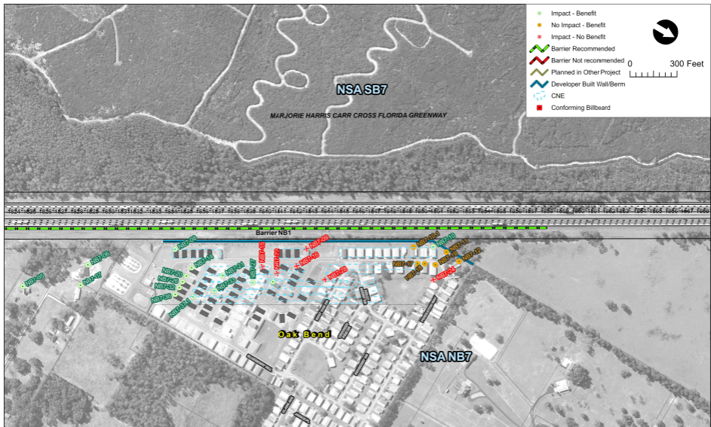
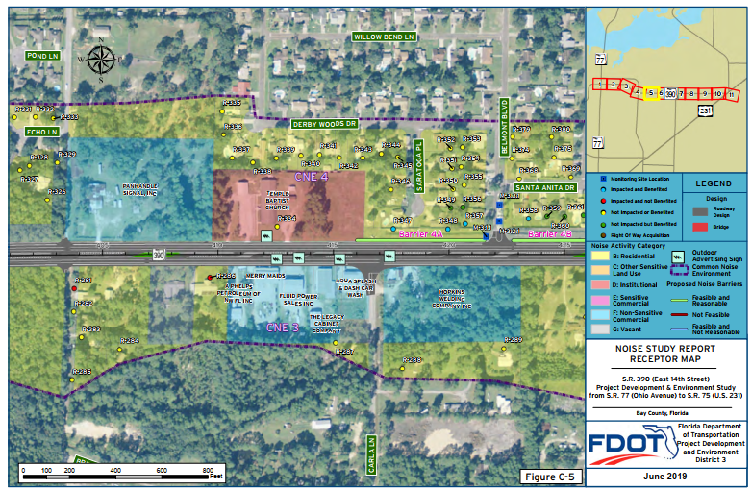
\

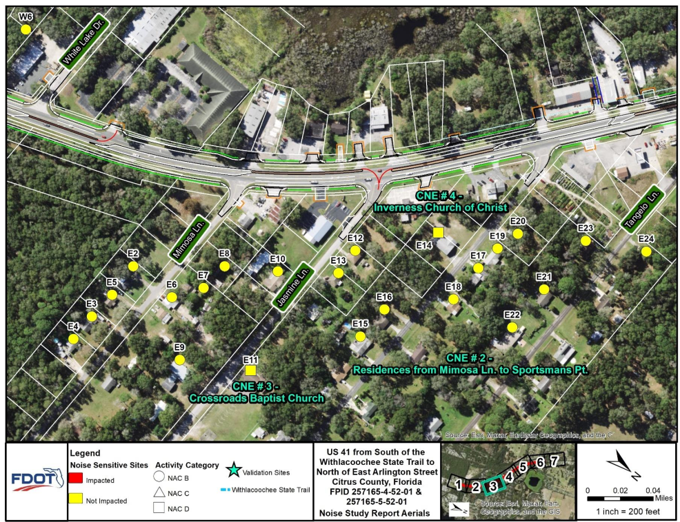
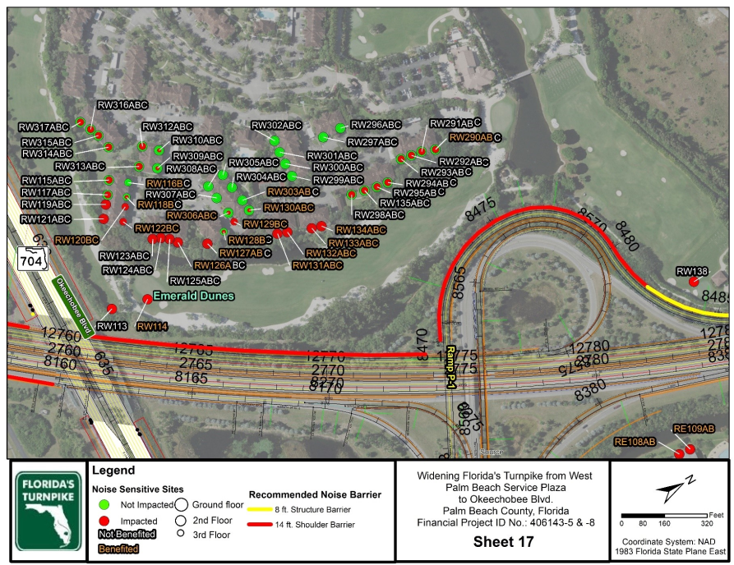
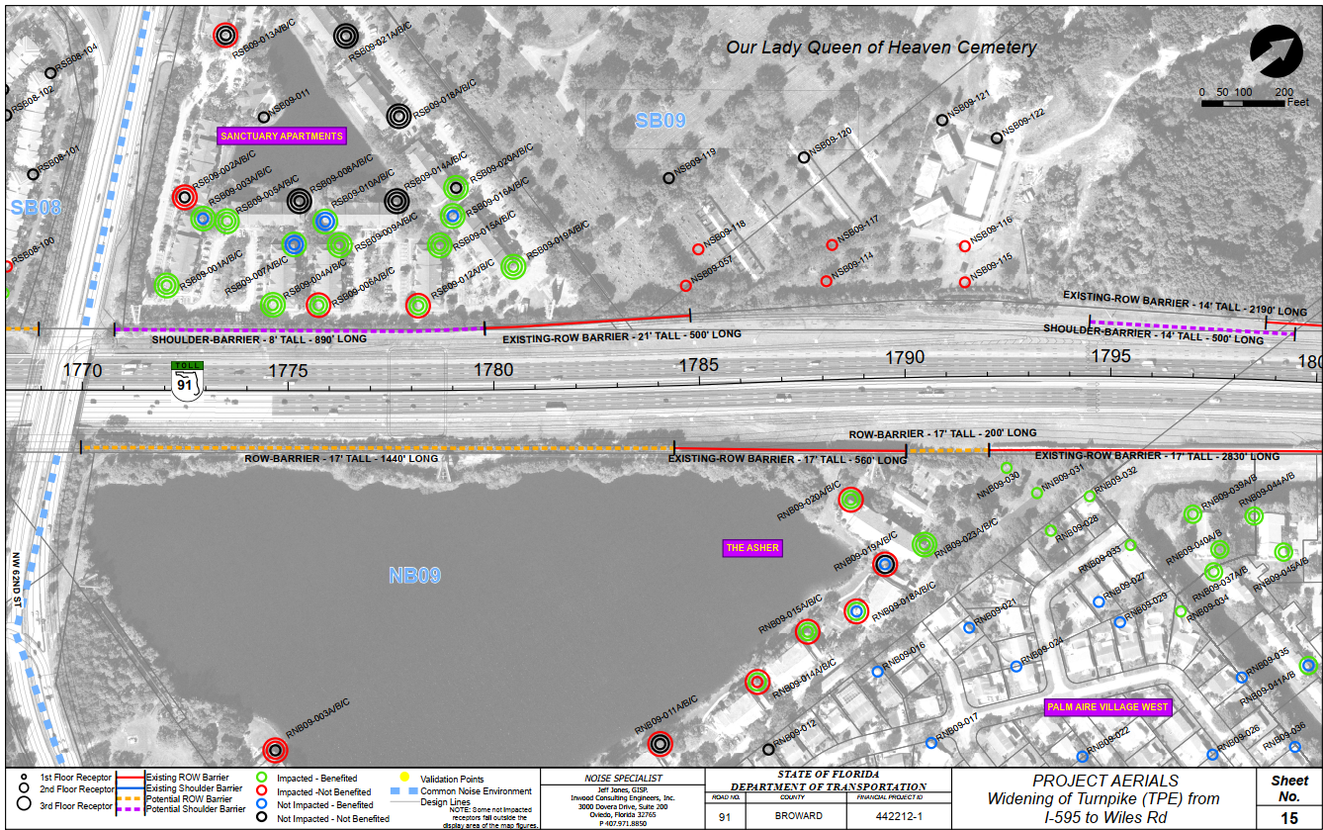

APPENDIX C Predicted Noise Levels
Common Noise Environment Name | Aerial Sheet Number  [OPTIONAL] | Receptor ID | Activity Category | Property Type  [OPTIONAL] | Number of Residents Represented | [YEAR]  Existing Condition  dB(A) | [YEAR]  No-Build Condition  dB(A) | [YEAR]  Build Condition  dB(A) | Difference  Between  Existing and  Build dB(A) | Impacted
 |  |  |  |  |  |  |  |  |  | Substantial Increase | NAC
Example: Residences from ABC Street to XYZ Road | 1 | EB1 | B | Residence | 1 | 62.5 | 64.2 | 66.5 | 4.0 | No | Yes
Example:  ABC School | 2 | R8 | C | School (exterior) | 0.5 | 63.8 | 64.9 | 68.8 | 5.0 | No | Yes

APPENDIX D Model Validation Field Sheets

Table D-1
Measured Noise Levels and Traffic Data for Validation [EXAMPLE]
Project
Date
Name of Observer(s)
Wind Speed
Temperature
Humidity
Cloud Cover
Feet from Edge of Pavement
X,Y, Z
Sound Level Meter Model/Serial #
Calibration Performed
Site #
Repetition | File Name | Start Time | Roadway Direction | Cars | Medium Trucks | Heavy Trucks | Motor-  cycles | Buses | Speed (mph) | Sound Level dB(A)
1
2
3
Repetition | Notes
1
2
3

APPENDIX E SLU Equivalent Residence Calculation Worksheets
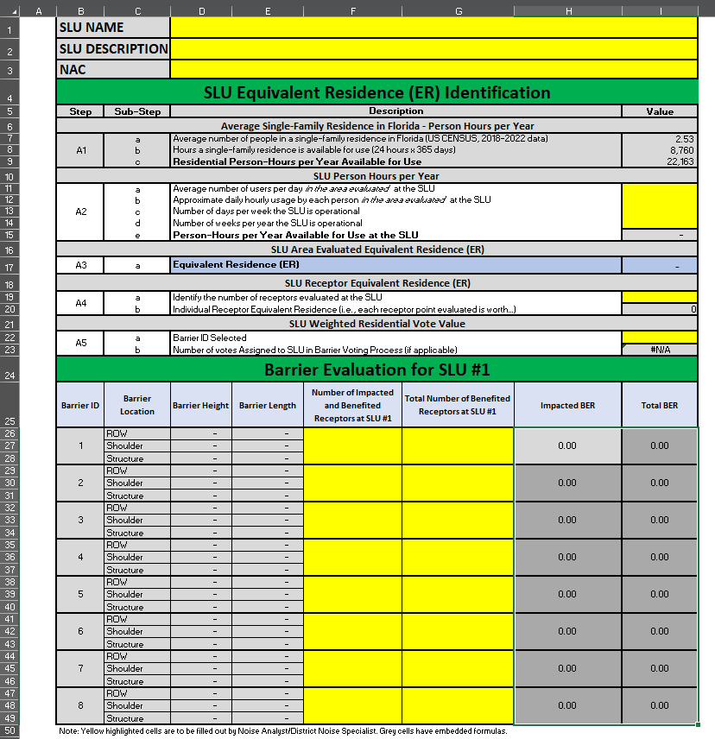

[INSERT COUNTY] Property Appraiser website: [INSERT WEBSITE]

