COPY | GRAPHIC
FACEBOOK/IG:  Thinking about an e-bike? Before you buy:  ✔️ Check local rules—e-bike laws vary by city and class  ✔️ Look for the label (class, top speed, motor wattage)  ✔️ Consider age & speed—kids ages 9–12 are advised to avoid bikes over 10 mph  #EBikeSafety  Twitter/X:  Thinking about an e-bike? Before you buy:  ✔️ Check local rules—e-bike laws vary by city and class  ✔️ Look for the label (class, top speed, motor wattage)  ✔️ Consider age & speed—kids ages 9–12 are advised to avoid bikes over 10 mph  #EBikeSafety | 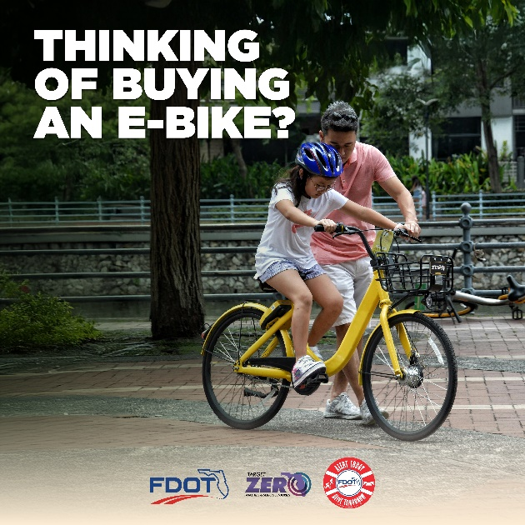
FACEBOOK/IG:  #DYK that in Florida, e-bikes have the same rights as regular bicycles?  They can ride on roads, bike lanes, and shared paths—basically anywhere bikes are allowed!  Always check local rules, as some areas may have restrictions.  Learn more about E-Bike Safety at https://bit.ly/48xbwvf  #TargetZeroFL #EBikeSafety  Twitter/X:  #DYK in Florida, e-bikes have the same rights as bicycles? 🚲⚡  Ride on roads, bike lanes & shared paths—wherever bikes are allowed.  Check local rules for restrictions.  Learn more: https://bit.ly/48xbwvf  #TargetZeroFL #EBikeSafety | 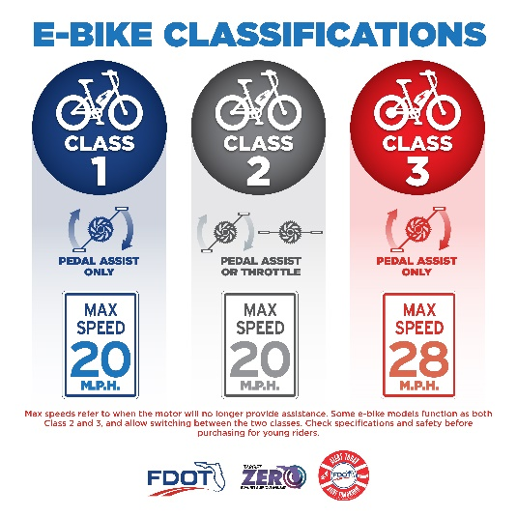  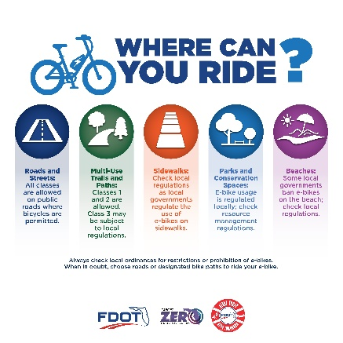
A few simple choices can make every e-bike trip safer, not only for you, but everyone else, too! Let’s ride smart and get everyone home safely. 💙  #EBikeSafety | 