FDOT VPN – DMS DocuSign PowerForm instructions (Revised 3/11/22)

https://na2.docusign.net/Member/PowerFormSigning.aspx?PowerFormId=6486c4f8-1a5e-48b1-b8b9-5f48bbc4873b&env=na2&acct=92e13a48-e8c0-406b-8826-71ea9f18b32c
IMPORTANT - The process will require that the Person completing this form knows who the Consultant’s FDOT Project Manager is and their email. They must also know who the Cost Center Manager is for the FDOT Project Manager and the Cost Center Manger’s email address. The Person submitting the form may be a different person from the Consultant or the same person. Each person identified on the DocuSign PowerForm will receive a copy of the final signed, completed document.
- The first person listed is the name of the Person completing this form requesting VPN via DMS access for a Consultant, along with their email address.
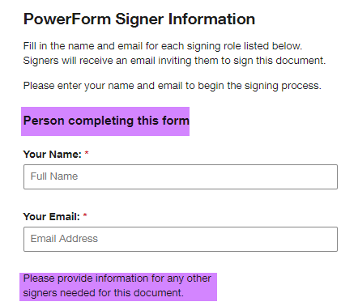

- The second person listed is the name of the Consultant and their email address.
- The third person listed is the name of the FDOT Project Manager and their email address.
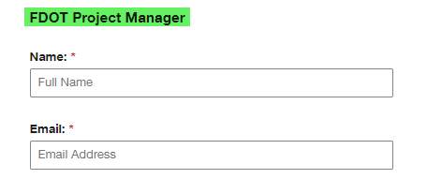
- The fourth person listed is the name of the Cost Center Manager and their email address.
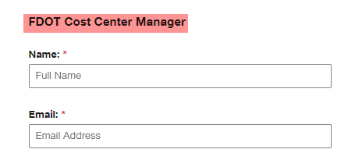

- The fifth and last person listed is the name of the person responsible for paying the bill for the VPN service. This may be the same as the consultant requesting the service or it may not be. We are calling this person the Company Billing Agent.
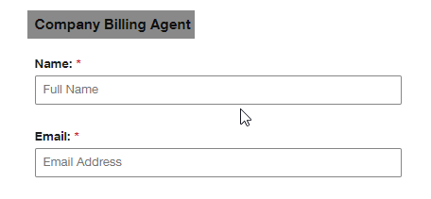
Note: there is a Backup Admin listed on the submission page. Please do not change that information.
As soon as the five users have been identified by name and email, you will click the Begin Filling Out Form button.
This begins the PowerForm process flow. Each user will be notified via email to complete their part. The email will look similar to this: 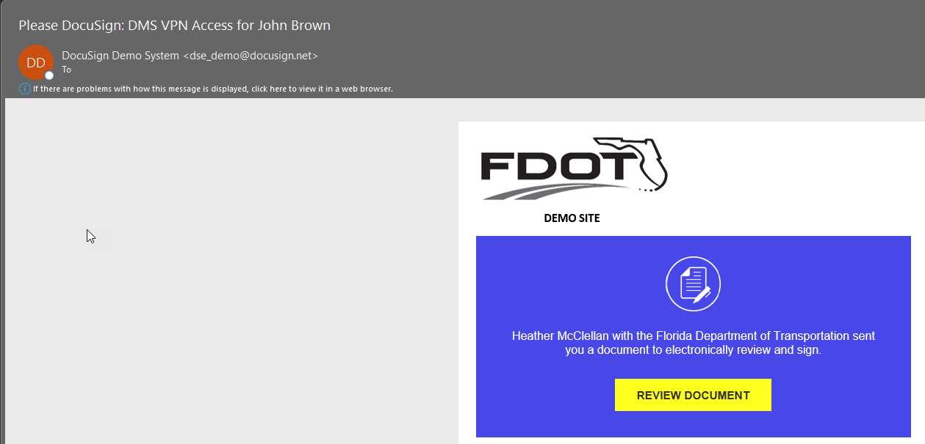
Simply click on the Review Document button. It will take the user directly to the PowerForm.
DocuSign will require that each user acknowledge they have read and agree to the Electronic Record and Signature Disclosure.
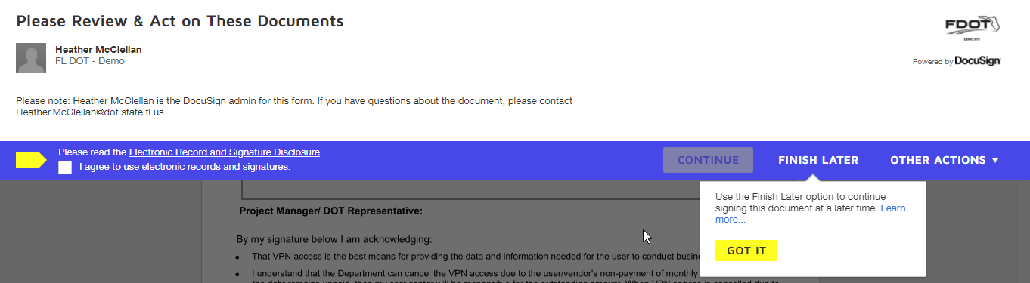
Once the user has marked that they “agree”, it will allow them to CONTINUE.
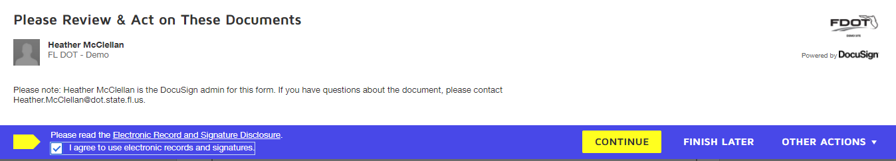
Note that after each stage of the process there is the option to Save a Copy of Your Document. There will be a final signed copy automatically provided via email for each person involved in the completion of the document.
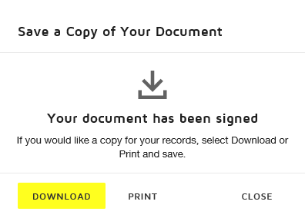

- The first action is for the Person completing this form. They may complete any of the available fields, but none are required for this step. Once they are ready, they will click the FINISH button.

- The second action is for the Consultant. They will be notified via email to complete their part.
If any fields have information entered by the Person completing this form, they will see the following message:
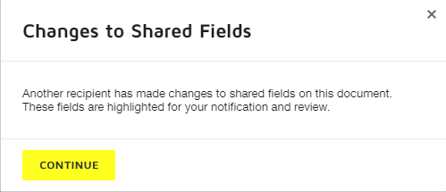
Click on CONTINE.
If updates are needed for any of the information entered by the Person completing this form, the Consultant can do so. The Consultant must complete the Reason for VPN access request.
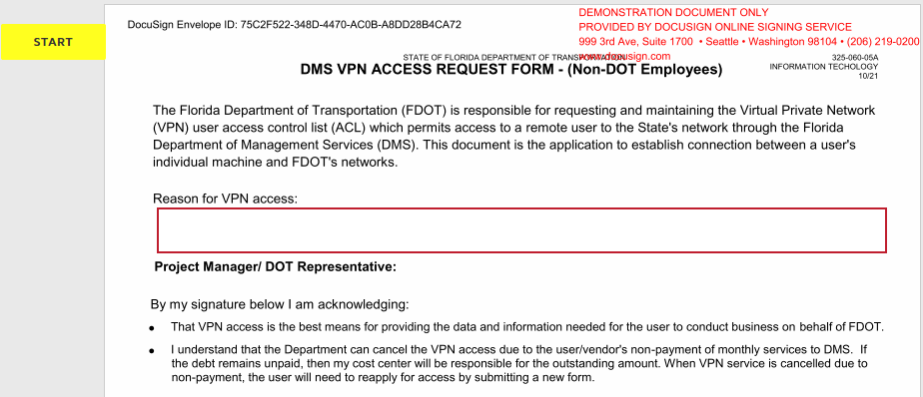
The next part will be the Company Billing Address information. This section is first since it is selected first when FDOT is ordering the service. Fill in the following mandatory fields:
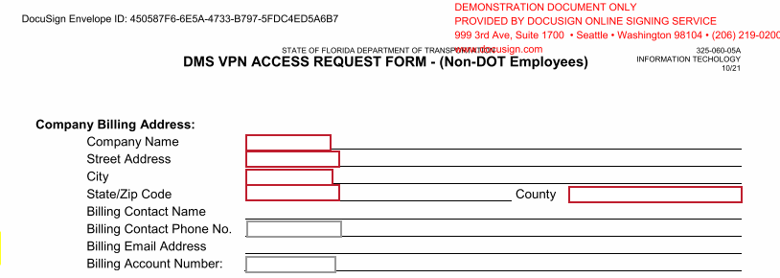
The next sections to complete are the optional Technical Support fields and the mandatory question regarding the Service Address.
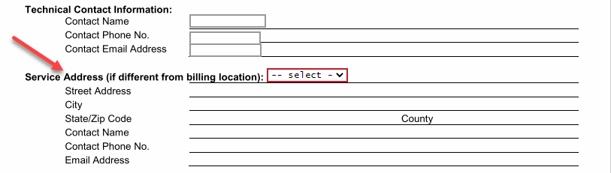
If the Service Address is the same as the Billing Address, you will answer No and move to the last section to complete.
If the Service Address is different than the Billing Address, you will answer Yes and complete the required fields.
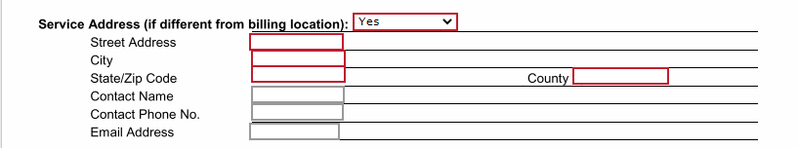
The last part the Consultant will complete is their User ID if they already have one (optional field) and their Phone number and Company email address (required).
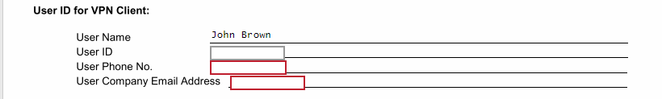
Once they have completed the last fields, the user will click on the FINISH button at the bottom of the page.
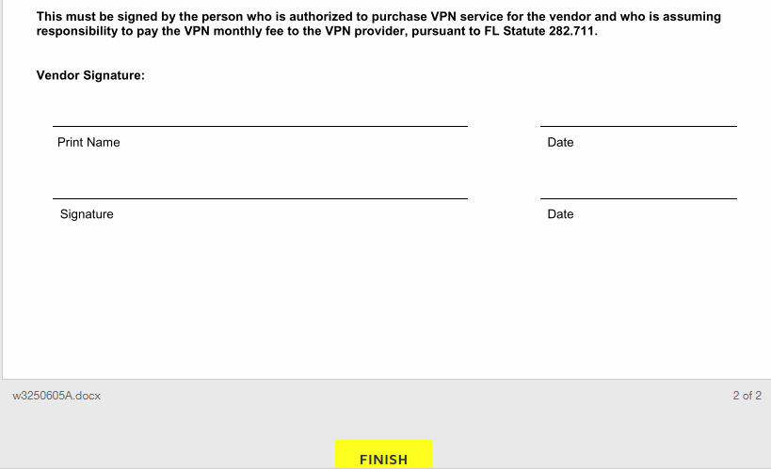
Here is an Example with the fields completed by the Consultant.
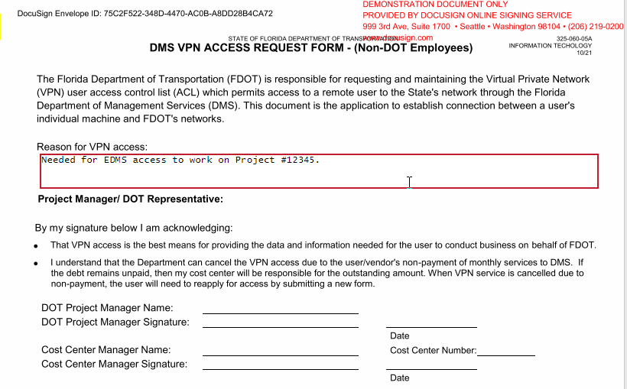
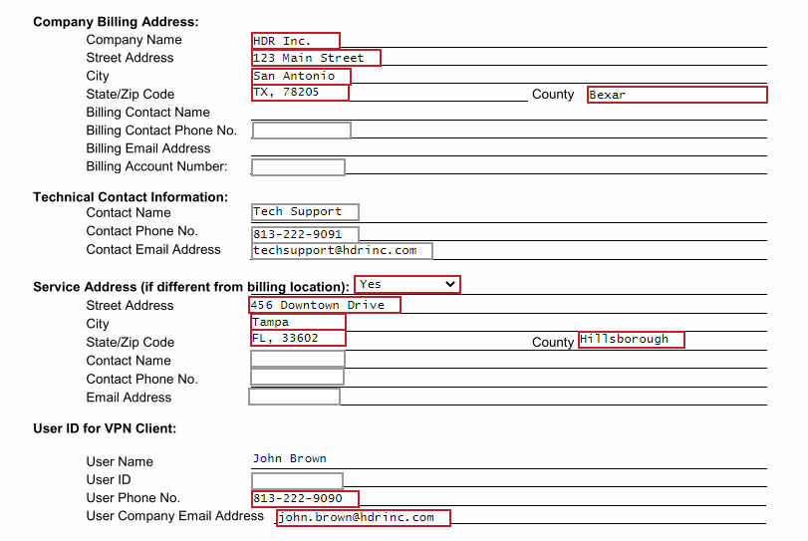
After the consultant has clicked on the FINISH button, it will take them out of the PowerForm.

- The third action is for the FDOT Project Manager.
All they will need to do is click on the Review Document button in the email they receive. It will take them to the PowerForm.
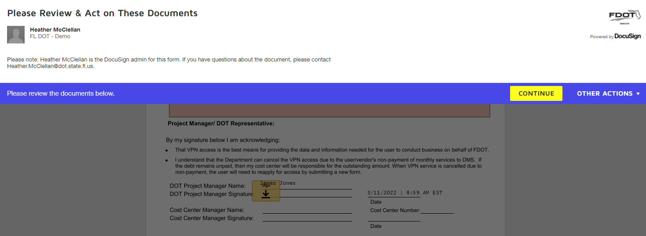
Once they click on CONTINUE, it will prompt the FDOT PM through signing the form. Once they have signed, they will click on the FINISH button.
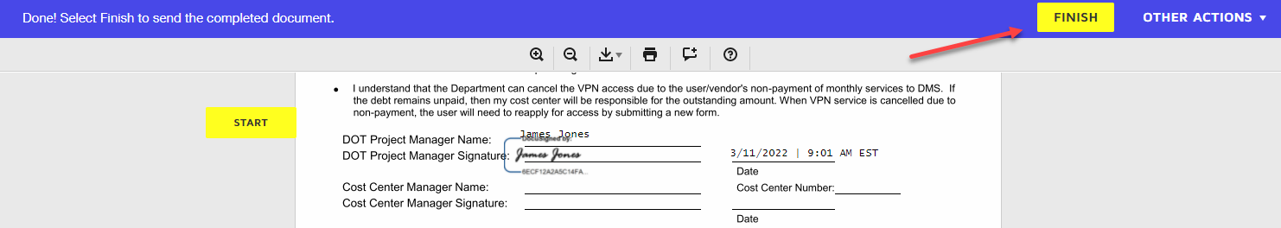
- The fourth person that will receive an email to complete the form will be the Cost Center Manager. The email will look the same, and all they will need to do is click on the Review Document button. It will take them to the PowerForm.
Once the CCM has signed the document and filled in their Cost Center Number, they will click the FINISH button.
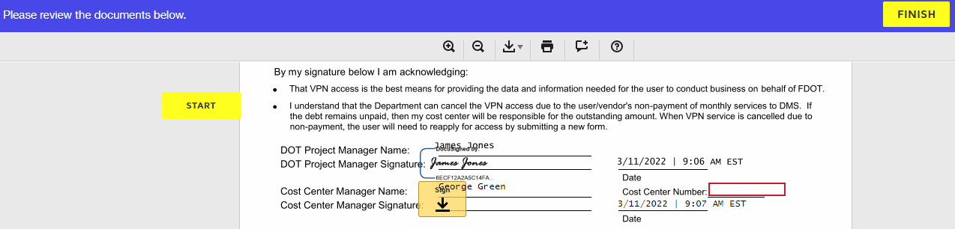
- The last user that will receive the email to complete the form will be the Company Billing Agent. This may be the same person as the Consultant if they are signing as paying for their bill. If there is a company agent, then it will be a different person entering the final signature.
In this example: The Consultant is not the same person as the Company Billing Agent.
The Company Billing Agent will need to enter their Billing Contact Phone number. There is also an optional field where the CSAB Billing ID number may be listed if it is known.
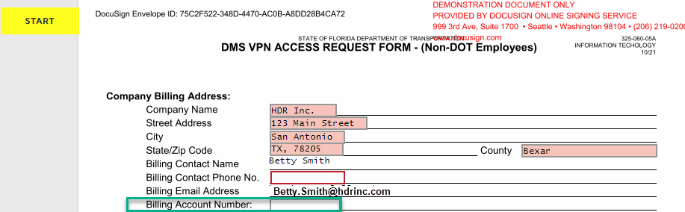

Once these fields are complete, the Company Billing Agent will be prompted to sign the form. Once they have signed the document, they will click the FINISH button.
This completes the DocuSign PowerForm for VPN-DMS access. The emails to each person in the process will be generated with the final version of the signed document.
The email will look similar to this:
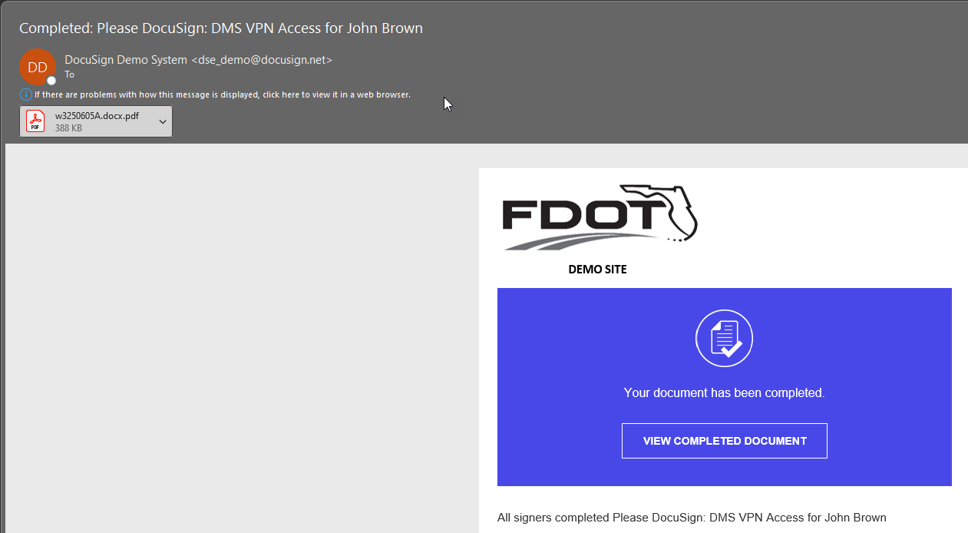

The completed Example screen shots:
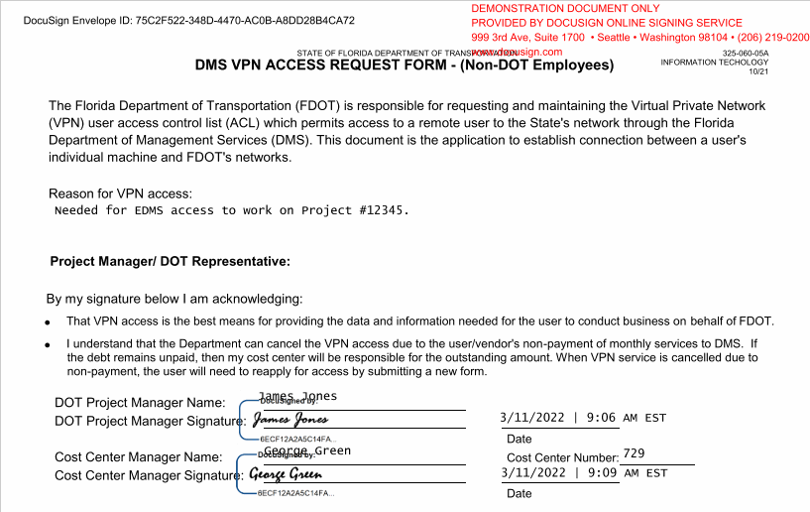
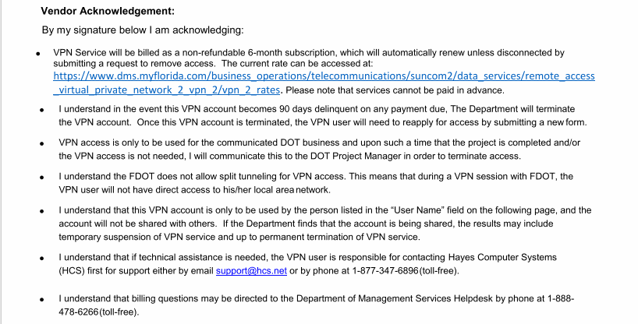
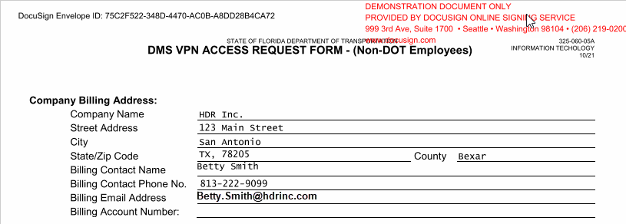

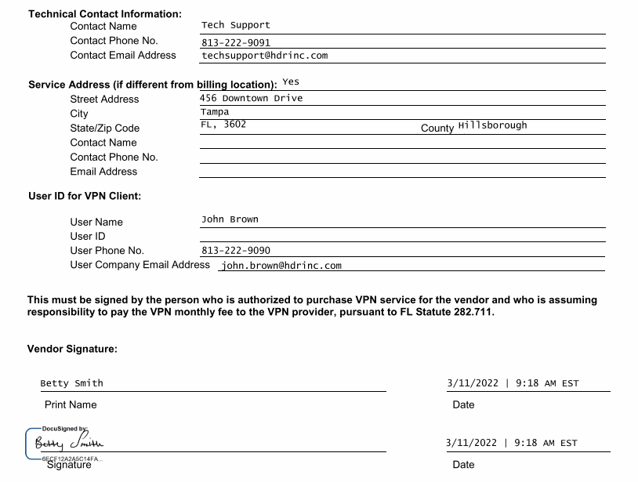
If you have any questions about this form, please contact your local Security Coordinator.

