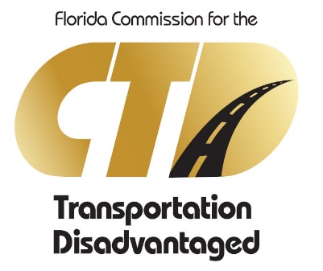
DATE: September 30, 2020
Commission for the Transportation Disadvantaged
PUBLIC COMMENT FORM

Instructions:
- Complete comment form, including your address. PLEASE TYPE OR PRINT
- Email comment card to David.Darm@dot.state.fl.us
- The meeting facilitator will first call on webinar speakers, followed by conference call speakers. Instructions will be provided on unmuting webinar audio and phone lines.
- Comments must be limited to five (5) minutes per speaker.

How will you be participating in the public workshop? Webinar Phone____

Name___________________________________________________________

E-Mail__________________________________________________________

Phone__________________________________________________________

Address_________________________________________________________

City____________________________________________________________

Zip Code_________________ County_____________________________

Representing____________________________________________________

Subject_________________________________________________________
_______________________________________________________________
_______________________________________________________________

Support____ _ Oppose___ __ Neutral___ __

