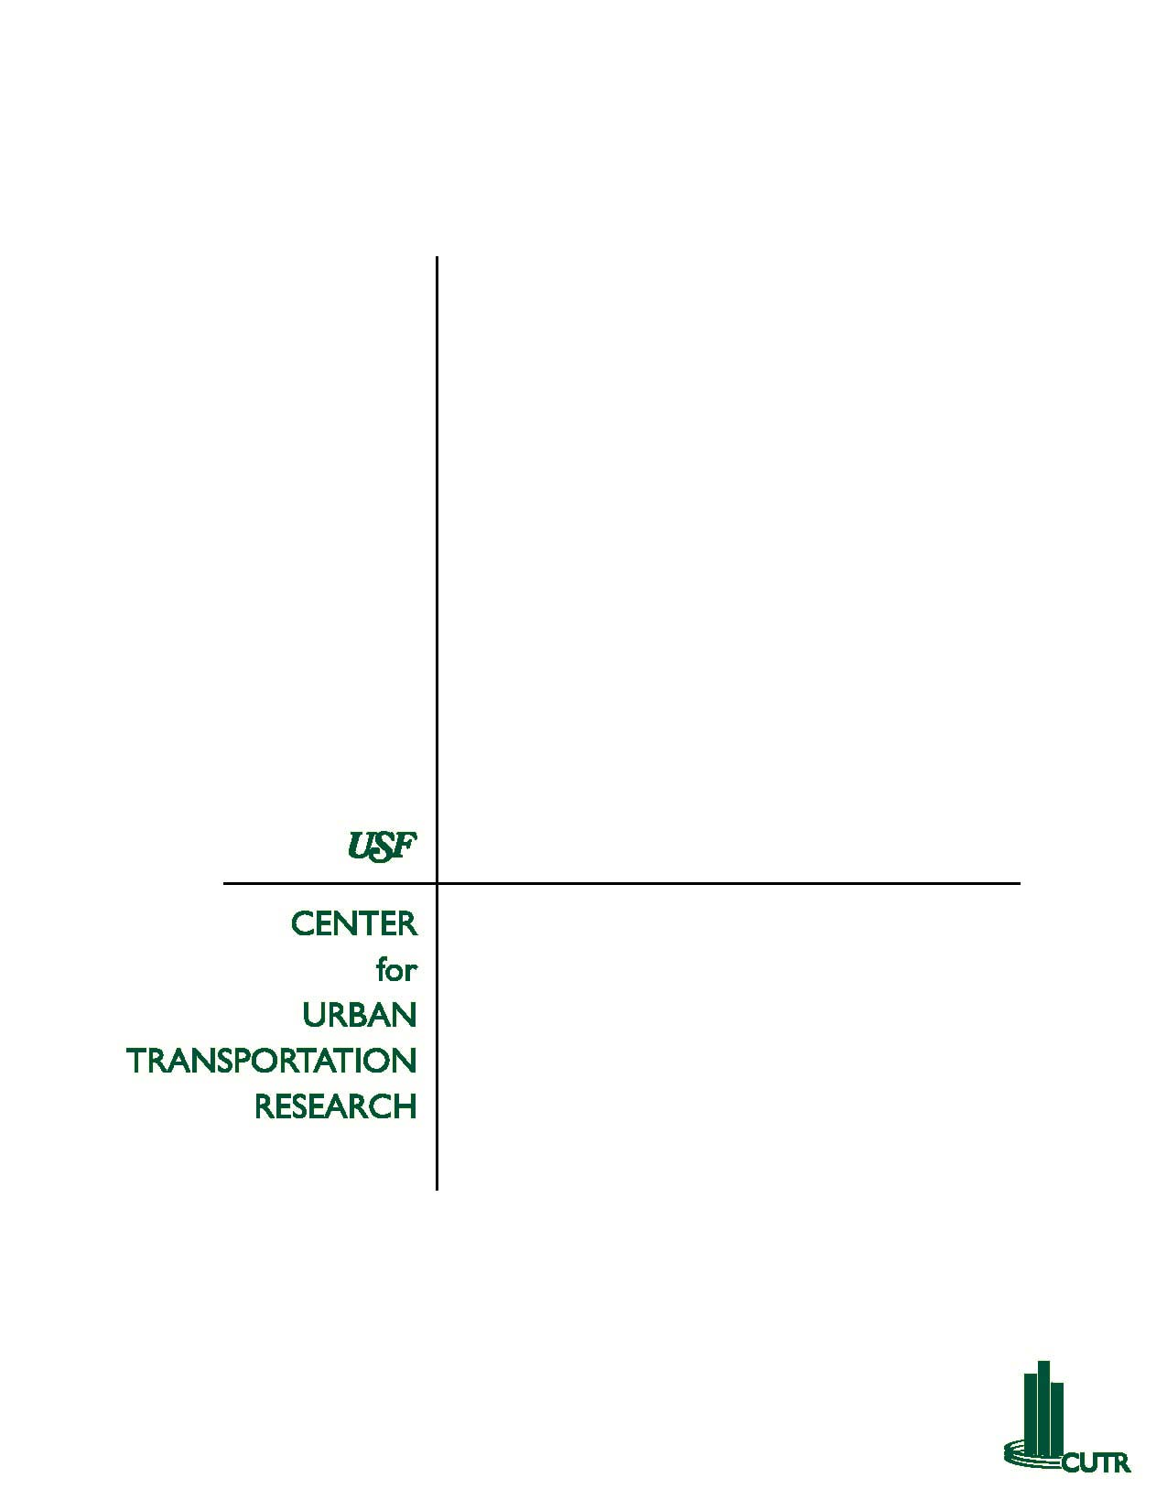

Technical Memorandum 6
Demand Forecasting Methodology
Florida Commission for the Transportation Disadvantaged

Introduction

This section describes a simple statistical model designed to provide estimates of supply of and demand for transportation disadvantaged (TD) services at the county level, using a minimal amount of readily-available data. This model requires no mathematical skills beyond addition and multiplication, can be used with population estimates or with actual head counts, and can be completed in less than five minutes.

To begin the estimation procedure described below, the following five data inputs are necessary:

- the number of county residents with incomes below the poverty line;
- the number of county residents age 65 or older;
- the number of county residents who exhibit a transportation-related disability (for purposes of this model, “transportation-related disability” is defined as a self-care disability or a go-outside disability—see Appendix.);
- funding data for both sponsored and non-sponsored trips within the coordinated system, preferably on a cost-per-trip basis; and
- a determination of whether the county is considered by the US Census to be part of a Metropolitan Statistical Area.

Most of this information is available from the US Census. However, one of the useful features of this model is that projections and estimates from virtually any reliable source can be used. Bear in mind that the results of the model are only as good as the data that goes into it. Inaccurate data cannot produce accurate estimates under even the best of circumstances.

It is recommended that any results generated with this model be verified before making irreversible decisions based on those results.

The Model

Step 1: Estimate County-Level TD Population.

Data requirements

You will require three data points to use this model:

- the number of people residing in your county with incomes below the poverty line;
- the number of elderly people residing in your county; and
- the number of people residing in your county who exhibit a transportation-related disability.

Once you have obtained these data points, drop them into the appropriate slots in this formula:

[(Elderly population) × 0.812] +
[(poverty population) × 0.77] +
[(transportation-disabled population) × 1.02] =
estimate of your county’s TD population.

This method accounts for overlapping between the three segments of the TD population, and eliminates the double-counting of those who belong to multiple segments.

The method used to calculate these multipliers is described in the Appendix.

Estimating the transportation-disabled population

It may not be possible to get a completely accurate count of individuals suffering from a transportation-related disability from US Census data. That is because, while the Census does track how many people report a self-care disability and how many report a go-outside disability, it does not count the number of people suffering from both types. This means that simply adding the self-care disabled population to the go-outside disabled population will overestimate the number of transportation-disabled people living in your county.

When this happens, use the following formula to correct for overlap between segments:

[(Elderly population) × 0.189] +
[(non-elderly population) × 0.055] =
estimate of the transportation-disabled population in your county.

The method used to calculate these multipliers is described in the Appendix.

Step 2: Estimating the Supply of Sponsored Trips

Data requirements

You will need to know the average cost of providing a sponsored trip in your county. Or, if you don’t have that data, you will need the total number of trips provided and the total amount of sponsored funding received (preferably from the most recent year for which data are available).

You will also need to know the amount of funding (for sponsored trip provision only) your county expects to receive for the year in question.

To determine the average cost of providing a sponsored trip in your county, divide the total amount of funding received by the total number of trips provided.

To estimate the supply of sponsored trips, divide the expected funding amount by the average cost per trip. This is the number of trips your county can expect to supply.

Step 3: Estimating the Supply of Non-Sponsored Trips

Data requirements

You will need to know the average cost of providing a non-sponsored trip in your county. Or, if you don’t have that data, you will need the total number of trips provided and the total amount of non-sponsored funding received (preferably from the most recent year for which data are available).

You will also need to know the amount of funding (for non-sponsored trip provision only) your county expects to receive for the year in question.

To determine the average cost of providing a non-sponsored trip in your county, divide the total amount of funding received by the total number of trips provided.

To estimate the supply of non-sponsored trips, divide the expected funding amount by the average cost per trip. This is the number of trips your county can expect to supply.

Step 4: Estimate the Demand for Non-Sponsored Trips

Data requirements

You will require an estimate of the TD population in your county (generated in Step 1 above), and you will need to know if your county is considered by the US Census to be part of a Metropolitan Statistical Area.

To estimate the demand for non-sponsored trips, simply multiply your estimated TD population by 1.2 if your county is not part of a MSA. If your county is included in a MSA, your estimated TD population is equal to the estimated demand for general trips.

The logic behind this methodology is discussed in the Florida Statewide Transportation Disadvantaged Plan: Population and Demand Forecasts, 1996 – 2015. We have seen fit to continue its use.

Step 5: Determine Demand for Sponsored Trips.

The demand for sponsored trips is assumed to be equal to the supply of sponsored trips.

The reason is that, since the provision of these trips falls under the purview of assorted social services agencies and is directly related to demand for the social services themselves, any attempt to estimate this demand would necessarily have to account for all the different health, economic and social factors that drive demand for social services. Clearly, that is beyond the scope of this model.

The logic behind this methodology is discussed in the Florida Statewide Transportation Disadvantaged Plan: Population and Demand Forecasts, 1996 – 2015. We have seen fit to continue its use.

Step 6: Estimating the Total Demand for TD Services

To estimate the total demand for TD services in your county, simply add the estimated demand for non-sponsored trips (determined in Step 4 above) to the estimated demand for sponsored trips (determined in Step 5 above).

Step 7: Estimating the Total Net Trip Supply

Data requirements

You will need the estimated supply of sponsored trips (calculated in step 2 above), the estimated supply of non-sponsored trips (calculated in step 3 above), and the total demand for TD services (calculated in step 6 above).

To estimate the total net trip supply expected for the year in question, simply plug the data into this formula:

(total sponsored trip supply) +
(total non-sponsored trip supply) –
(total demand for TD services) =
estimated surplus or shortfall

If this formula produces a positive result, your county can expect to have surplus trips for the year in question. If this formula produces a negative result, however, your county can anticipate facing a trip shortage.

The Model, at a Glance:

Step 1:

[(Elderly population) × 0.812] + [(poverty population) × 0.77] +
[(transportation-disabled population) × 1.02] = estimate of county TD population.
Step 2:

(Expected amount of sponsored trip funding) / (average cost per sponsored trip) = estimated supply of sponsored trips

Step 3:

(Expected amount of non-sponsored trip funding) / (average cost per non-sponsored trip) = estimated supply of non-sponsored trips

Step 4:

(Estimate of county TD population) × MSA Multiplier = estimated demand for non-sponsored trips

Step 5:

Estimated supply of sponsored trips = estimated demand for sponsored trips

Step 6:

Estimated demand for non-sponsored trips + estimated demand for non-sponsored trips = estimated total demand for trips

Step 7:

Estimated supply of sponsored trips + estimated supply of non-sponsored trips - estimated total demand for trips = estimated net total trip supply
Appendix

Multipliers used to estimate TD population

The multipliers for estimating total TD population for each Florida County were developed using an ordinary least squares regression technique. This technique “predicts” a dependent variable* (total TD population by county) by combining explanatory variables (elderly, transportation-disabled, and poverty-stricken populations). The multipliers attached to each explanatory variable describe the relationship of that variable to the total TD population—for example, if the multiplier for the elderly variable was 0.5, that would mean that every elderly person who moves into a county would increase the total TD population by 0.5 people.

Essentially, an ordinary least squares regression accomplishes this by averaging variables across many observations (in this case, the data for a single county is the same thing as an observation). Of course, this is a vast oversimplification; however, a more accurate and technical explanation of multiple regression techniques is beyond the scope of this document.

For this study, instead of determining a different formula for each of Florida’s 67 counties, the explanatory variables of elderly population, population with incomes below the poverty line, and population with transportation-related disabilities were identified for each Florida County. The regression technique then determined a single formula that best fits ALL counties throughout the state.

The dataset consisted of observations for each of Florida’s 67 counties in 2000 and 1990.

Multipliers used to estimate transportation-disabled population

The multipliers for this formula were generated using an ordinary least squares regression. No constant term was included in the regression. Explanatory variables used were total elderly population and total non-elderly population. The dependent variable was the number of people who exhibited at least one transportation-related disability (either go-outside or self-care).

Data used were from the 1990 US Census. Observations were taken from each of Florida’s 67 counties.

*This variable was calculated in accordance with the methodology described in Methodology Guidelines for Forecasting TD Transportation Demand at the County Level—combining the elderly, transportation-disabled, and poverty-stricken populations, and subtracting from that total all individuals who fall in two or more of those categories. Whenever possible, actual US Census data were used.

References:

Annual Performance Report, Florida Commission for the Transportation Disadvantaged, 2000.

Florida Statewide Transportation Disadvantaged Plan: Population and Demand Forecasts, 1996 – 2015, Center for Urban Transportation Research, 1996.

Methodology Guidelines for Forecasting TD Transportation Demand at the County Level, Center for Urban Transportation Research, 1993

US Census data, 1990.

US Census data, 2000.

Go-Outside The Home Disability - In Census 2000, a person 5 years old and over had a going-outside-the home disability if:
- they had a physical, mental, or emotional condition lasting 6 months or more that made it difficult to perform certain activities like (c) going outside the home alone to shop or visit a doctor's office (going outside the home disability)
- this data was derived from answers to long-form questionnaire item #17c
- Item #17c was asked of a sample of the population 5 years old and over.

Self-Care Disability - In Census 2000, a person 5 years old and over had a self-care disability if:
- they had a physical, mental, or emotional condition lasting 6 months or more that made it difficult to perform certain activities like (b) dressing, bathing, or getting around inside the home (self-care disability).
- this data was derived from answers to long-form questionnaire item #17b
- Item #17b was asked of a sample of the population 5 years old and over.

