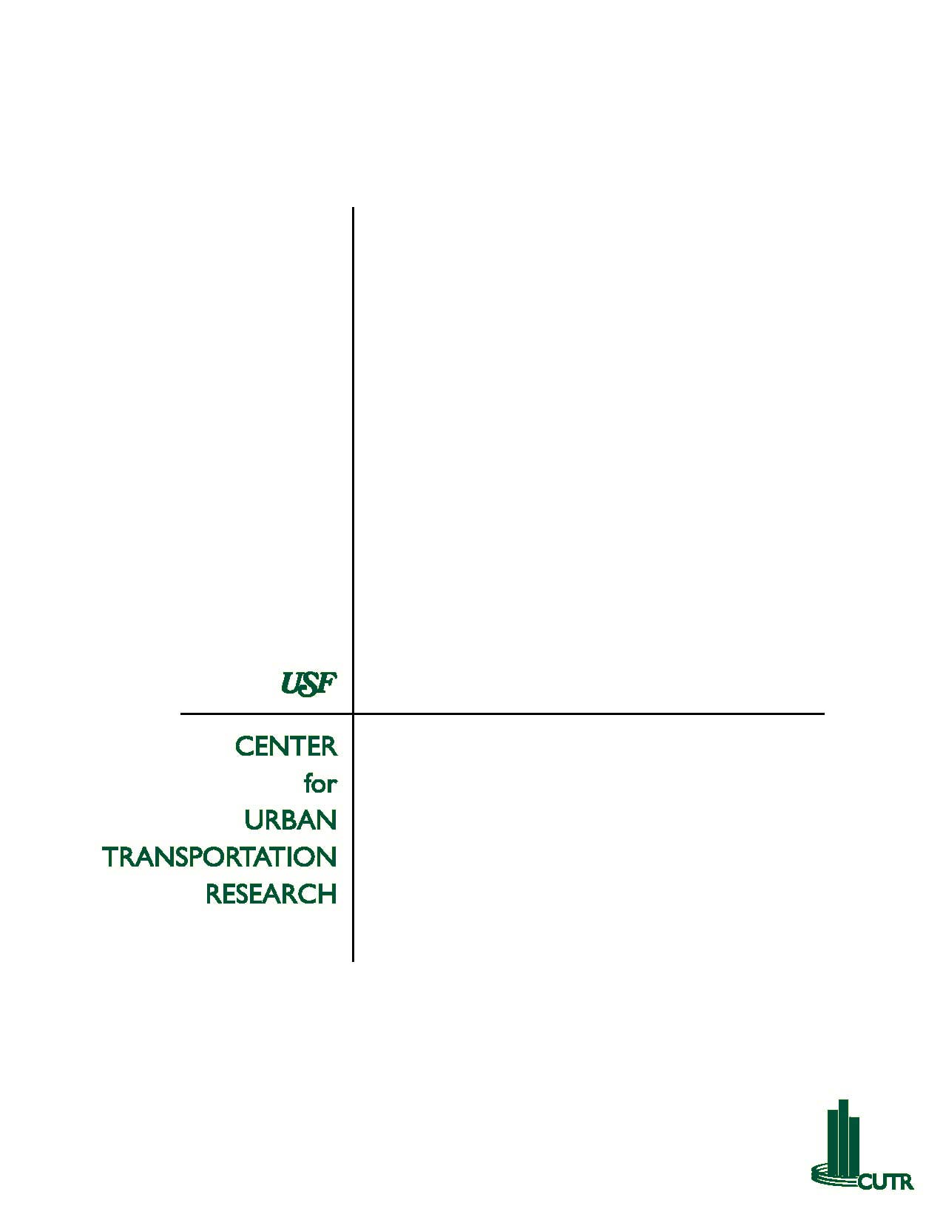

Technical Memorandum 5
Research Specialized Transportation
Florida Commission for the Transportation Disadvantaged

Introduction

Coordination among providers and agencies that offer transportation alternatives holds the potential to increase transportation availability and access, enhance service quality, eliminate duplicative services, and substantially improve cost effectiveness in the delivery of transportation to those most needy. While some states are just beginning, many others are continuing efforts to implement coordinated systems to maximize transportation options and minimize service costs.

This summary is not intended to be an exhaustive summary of every innovation in the world of specialized transportation but, rather, serve as an overview of the successes in other states that may be applicable to Florida.

Successful coordination is determined by 2 measures: either more service is provided for the same expense OR the same level of service is provided for less money. If neither outcome is realized then coordination is not an appropriate business strategy.

While the issue of coordinated human service transportation has been greatly emphasized during the last 5 to 10 years both in delivery of service and the level of research that surrounds how best to deliver the services needed, the concept of transportation coordination has been promoted for over 25 years. While there are barriers to coordination that have been identified throughout the research and practice of specialized transportation, great efforts have been made to provide these needed services to the transportation disadvantaged public. At all levels of government (federal, state and local), creative ideas about how to best serve the transportation disadvantaged population have been crafted in programs and policies.

The next section discusses some of the programs and policies that have been developed at all levels of government in hopes to disseminate and circulate best practices from around the Country.

Barriers to Coordination

Attempts to deliver coordinated transportation both efficiently and effectively is met with challenge in many aspects. Both in Florida and around the Country, barriers to coordination are identified as being the largest obstacle to overcome. Barriers to coordination observed within Florida’s coordinated system include:

- Financial considerations
- Geographical concerns
- Reporting requirements
- Agency cooperation
- Varying interpretations of rules and regulations

In reviewing reports and data from around the Country, these same barriers were identified by most officials as being detrimental to the success of programs. However, in areas that had both identified and worked to address issues related to these obstacles, successful outcomes had been recognized.

Federal Initiatives

On February 23, 2004, President Bush issued an executive order on Human Service Transportation. The order was directed, “to enhance access to transportation to improve mobility, employment opportunities, and access to community services for persons who are transportation disadvantaged.” Within the Executive Order was the establishment of the Interagency Transportation Coordinating Council on Access and Mobility (CCAM). The membership of the interagency council is comprised of the Secretaries of the Departments of Transportation, Health & Human Services, Education, Labor, Veterans Affairs, Agriculture, Housing and Urban Development, and the Interior; in addition to the Attorney General and the Commissioner of Social Security.

In the year since its inception, CCAM has established a national presence in the service and delivery of specialized transportation. Under its “United We Ride” program, it recognized five States for their commitment to provide specialized transportation services to those in need with 2004 Leadership Awards. The States of Florida, Maryland, North Carolina, Ohio and Washington State were identified for outstanding work to develop coordinated systems and for their roles as models for other states.

CCAM continues to develop a national action plan which seeks to develop outreach and education plans for coordinated human service transportation; to simplify access to transportation services; to reduce restrictive and duplicative laws, regulations and programs at the Federal level; to standardize the cost allocation processes; and to document successful strategies in the delivery of human service transportation at all levels of government.

Statewide Initiatives

The program administered by the Florida Commission for the Transportation Disadvantaged continues to be a national leader in the coordination of transportation services for disadvantaged populations.

In addition to the State of Florida and its establishment of the Commission for the Transportation Disadvantaged (CTD), there are a few other states that have established strong statewide transportation coordination programs that serve as successful models around the Country. They include Iowa, Kansas, Kentucky, Maine, North Carolina, Ohio, Pennsylvania and Washington. A brief background on some of the programs is provided below:

Iowa
Iowa has long been recognized as a leader in transit coordination. 1975 the Iowa General Assembly authorized three pilot projects to demonstrate the benefits of consolidating and coordinating the provision of human services transportation funded under various federal programs under a single administrative agency. That same year the Iowa Department of Transportation awarded federal capital funding to 17 private-non-profit corporations to assist in the provision of specialized transportation for elderly or developmentally disabled clients.
In 1976, provisions were added to the Iowa Code that required all public funds spent on transit to be expended in conformance with the state transit plan. That same year, state transit assistance grants were provided to fund both urban transit systems and multi-county regional transit systems.
In 1977 the Iowa DOT defined the concept of regional transit systems as being multi-county regions based on the governor's sub-state planning regions. The planning agency in each region was funded to prepare a regional transit development program, which inventoried existing transportation services and needs, and served as the basis for applications for state and federal transit assistance funding
Today, Iowa has a unique system of coordination that includes the use of local transit and school buses in cities throughout the State. At least eight cities have systems in place that either coordinate placing students on public transit buses, as well as transit systems contracting with local school boards to utilize school buses after school routes are completed. Another form of coordination uses small transit buses to carry rural children living in locations difficult to serve efficiently with large school buses to school.

Kentucky
In Kentucky, the Human Services Transportation Delivery (HSTD) program provides non-emergency, non-ambulatory medical transportation services throughout the State. Subregional transportation providers have contracted with the State Office of Transportation Delivery (OTD), which is responsible for coordinating and providing transportation for each of the State’s 15 transportation subregions.

Maine
A program entitled Independent Transportation Network (ITN) was created by the Southern Maine Area Agency on Aging (SMAAA) and the Federal Transit Administration (FTA). The goal of the program is to create a community based mobility solution, suitable for replication, which could be sustained by user fares and voluntary community support. ITN uses cars and paid and volunteer drivers to provide service 24 hours/day, 7 days/week.

North Carolina
Coordinated transportation efforts in North Carolina date back to a 1978 Executive Order requiring the coordination of human service transportation throughout the State. Presently there are over 50 coordinated systems operating in the State. Agencies representing the aging population, mentally challenged residents, vocational programs, and city and county programs all work together to provide transportation options that are more cost-effective and efficient than in the past.

Ohio
The Ohio Department of Transportation provides annual operating funding for the Ohio Transportation Coordination Program, which serves three goals: to improve and expand services in counties with no public transit system; to increase effective and efficient delivery of transportation services; to develop coordination models for use by other communities.

Rhode Island
In Rhode Island, the Department of Elder Affairs partners with the Departments of Mental Health, Retardation and Hospitals (MHRH), Human Affairs (DHS) and the Rhode Island Public Transit Authority (RIPTA) and local partners and contractors. This partnership, called RIde provides older persons and others needing transportation a seamless array of low-cost mobility services, including public fixed route and paratransit services, access to jobs, dialysis, adult day care, health care, vocational rehabilitation and other activities.

Washington
The public transit agency serving the City of Seattle and surrounding King County, Washington area, known as METRO, established the Community Partnerships Program (CPP) to facilitate the delivery of transportation services around the Seattle regional area. METRO provides retired paratransit vehicles, free maintenance and limited funding to regional area human service agencies providing services for ADA eligible riders.

Wisconsin
Two State Departments (Workforce Development and Transportation) jointly administer the Wisconsin Employment Transportation Assistance Program (WETAP), which integrates state and federal funding sources into one coordinated process. Using funding from FTA’s Job Access and Reserve Commute (JARC) Program, and the Wisconsin DOT’s Travel Demand Management (TDM) Program, WETAP provides funding for demonstration projects with the objective of long-term funding for low-income workers to access transportation and employment related activities including child care and job training.

Regional/Local/Organizational Initiatives

In addition to coordinated efforts at the Federal and State level, there have been creative programs conducted by local and regional governments, as well as through social service agencies, that are relevant to the Florida Commission for the Transportation Disadvantaged.

San Diego, California
The San Diego Council on Governments (SANDAG) in San Diego, California, established the Specialized Transportation Referral and Information for the Disabled and Elderly (STRIDE) program in 2001. STRIDE is a web based service that provides information on more than 190 specialized transportation programs available in the area. The mission of STRIDE is “to provide a referral service with comprehensive information of specialized transportation providers designed to improve access to transportation and to enhance the quality of life of seniors and persons with disabilities. To date, eleven social service agencies have joined in a Memorandum of Understanding indicating their support of the STRIDE project.

Licking County, Ohio
In Licking County, the coordinated transportation program consists of several County social service agencies that work together to provide transportation services for member agency clients. Member agencies make every effort to use vehicles and drivers operated by member agencies to transport clients in a more efficient and effective manner than could be achieved individually. A third party contractor is also available to provide trips that would otherwise go unmet by the current member agencies' transportation resources. Member agencies include the local Association of Retarded Citizens (ARC), Housing Authority, Department of Job and Family Services, Goodwill Industries, Senior Resident Centers and the YMCA.

Yakima &Moses Lake, Washington
First founded in 1965 as an employment and training program, People for People (PfP) now has a Transportation Program that provides elderly and disabled transportation services, Medicaid transportation services, job access and reverse commute program transportation, and rural intercity bus service. The stated mission of PfP is to strengthen communities by providing resources and opportunities that empower people to lead self sufficient and enriched lives. The State of Washington contracts with PfP using FTA Section 5311 rural transportation funding. In turn, PfP coordinates with several social service agencies around Yakima and Moses Lake to provide transportation options to residents who would have no other means of travel to work, school, medical appointments and shopping.

Stanly County, North Carolina
Stanly County Umbrella Services Agency (SCUSA) provides community transportation services responsive to the current and changing needs of Stanly County residents. Transportation includes trips to and from agencies, employment sites, businesses, medical centers (in and out of county), community college, Senior Center, nutrition sites, YMCA for the after school program, group trips, dialysis, nursing homes, county schools, daycare's, etc. Services are provided utilizing vans and buses through subscription and demand response routes. Vehicles are available to serve the disabled population as well.

US Agency on Aging
The Eldercare Locator, established by United States Administration on Aging (USAoG) in 1991, links those in need with state and local area agencies on aging and community-based organizations that serve older adults and their caregivers. Whether an older person needs help with services such as meals, home care or transportation, or a caregiver needs training and education or a well-deserved break from care giving responsibilities, the Eldercare Locator is there to point that person in the right direction. The Eldercare Locator is administered in partnership with the National Association of Area Agencies on Aging and the National Association of State Units on Aging.
Volunteers
A review of transportation programs around the country reveals that many use volunteers from a variety of organizations imperative to the success of their work. Most organizations reported using volunteers to serve in a number of different capacities, including as drivers, door to door escorts, administrative workers, reservationists, companions, and assistants. Many organizations reported reaching out to community organizations (churches, groups, seniors, out of work people); to get the bulk of the volunteers needed to run services effectively. Having a pool of volunteer organizations to be able to call upon when needed was also noted as being effective in handling the delivery of transportation services.

Implications for the State of Florida

As noted previously, Florida has been often cited as having a model coordinated transportation program for others to replicate. However, from the review of programs conducted throughout the Country, there are several ideas to which the Florida CTD could benefit in exploring. Those ideas include, but are not limited to, the use of volunteers in bolstering an already strong organized system, additional emphasis for the win-win situation public transit and school boards could recognize by further coordinating their transportation systems, the use of Job Access and Reverse Commute programs at a local level, and other state and federal programs.

Conclusion

The mission of the Florida Commission for the Transportation Disadvantaged is to, “insure the availability of efficient, cost-effective, and quality transportation services for transportation disadvantaged persons.” Throughout the process of reviewing programs and policies that deliver specialized transportation around the country, it was recognized in numerous publications and state programs that the process of coordinating transportation services needs to be further developed and enhanced. While Florida is at the forefront in the delivery of specialized transportation, the CTD should continue to develop methods to provide regional coordination across county boundaries. Often the closest and most convenient job center, hospital and shopping location may be across jurisdictional boundaries. Focusing on regional coordination could be the next step for the Florida CTD to consider in the near future.

The review of specialized transportation programs throughout the Country verifies that the CTD continues to provide outstanding services for the transportation disadvantaged public. The increase in the provision of service, while observing decreases in costs for providing trips can be clearly linked to the coordination of transportation providers throughout the State of Florida. While significant progress in satisfying the needs of Florida’s transportation disadvantaged population has been accomplished, the Commission can not afford to rest on its laurels. There is much yet to be accomplished and the Commission should consider embarking on new and innovative paths.

