Florida Department of Transportation
Office of Information Technology (OIT)

Requirements Deliverable Standards

Table of Contents
Document Revision History 4
About The Standards 5
Scope 5
Structure 5
Standards 5
1.0 Requirements Deliverable Standards 6
1.1 General Information 6
1.1.1 Introduction 6
1.1.2 Scope of the Project 6
1.1.3 Business Processes 6
1.1.4 Stakeholders 6
1.2 Requirements Table 6
1.2.1 Requirement ID 6
1.2.2 Requirement Type 6
1.2.3 Requirement Name 6
1.2.4 Requirement Description 6
1.2.5 Priority 7
1.3 Requirement Types 7
1.3.1 Scope Requirements (High-level) 7
1.3.2 Business Rules (Detail) 7
1.3.3 Functional Requirements (Detail) 7
1.3.4 Non-functional/Technical Requirements (Detail) 8
1.3.5 Interface Requirements (Detail) 8
1.3.6 Data Requirements (Detail) 8
1.3.7 Report Requirements (Detail) 8
1.3.8 Policy and Regulation Requirements (Detail) 8
1.3.9 Training Requirements (Detail) 8
1.4 Requirements Traceability 8
1.5 References 9
1.5.1 References 9
1.5.2 Appendices 9
1.5.3 Glossary 9
1.6 Document Revision History 9

Document Revision History
Version | Date | Name | Description
0.9 | 3/23/16 | Stephanie Taylor | Updated the standards
0.8 | 2/3/16 | Stephanie Taylor | Updated the standards
0.7 | 12/8/15 | Stephanie Taylor | Added a header, updated verbiage, changed sort order in the revision history.
0.6 | 11/24/15 | Stephanie Taylor | Made significant changes to the format and verbiage per feedback from Bill
0.5 | 11/20/15 | Stephanie Taylor | Updated the sections and format
0.4 | 11/18/15 | Stephanie Taylor | Updated verbiage
0.3 | 11/18/15 | Stephanie Taylor | Added numbering scheme to headings
0.2 | 11/18/15 | Stephanie Taylor | Made changes per feedback from Bill Lucas
0.1 | 11/18/15 | Stephanie Taylor | Created first draft

About The Standards

Scope
The following standards apply to requirements deliverables that are developed or maintained by vendors, staff, or consultants employed by, or contracted with, OIT.

Structure
Supporting details for each standard are included below. The supporting details provide standards that Applications Services staff have developed over the years. It also includes references, links, and techniques that can be used in conjunction with the referenced standards.

Standards
All projects that include a requirements deliverable are required to follow these standards. All projects that are subject to OIT oversight will be reviewed against these standards for compliance. All exceptions to these standards must be requested through the Standards & Technical Work Group (STWG), with final approval by the Application Services Manager. Please see the OIT Method & Practice entitled BSTWG Exception Request Process for detailed information regarding exception requests.

Requirements Deliverable Standards

General Information
All requirements deliverables must include a section that details general information and includes the following:

Introduction
The Introduction section shall provide an overview of the project. This section shall explain why it was conceived, what it will do once it is completed, and the types of people that are expected to use it.

Scope of the Project
The Scope of the Project section shall include a brief narrative explaining the project.

Business Processes
The Business Processes section shall include descriptions and diagrams (where applicable) to explain the processes that are defined during the requirements gathering phases.

Stakeholders
The Stakeholders section shall provide a list of all stakeholders for the project.

Requirements Table
All requirements deliverables must include a table of all requirements with the following columns:

Requirement ID
All requirements must be assigned a unique identifier.

Requirement Type
All requirements must have a requirement type. See section 1.3 for a list of requirement types.

Requirement Name
All Scope Requirements must be given a requirement name. The requirement name must be in plain English.
NOTE: A requirement name may be assigned to each detailed requirement, but it is only required for Scope Requirements.

Requirement Description
All requirements must be given a requirement description. The description must be written in plain English and shall describe a specific requirement.

Priority
` All requirements must be assigned a priority. The priority of the specific requirement shall be displayed with the following priority types:
      - Must Have – requirements labeled with this priority are critical to the final expected product and must be completed for the successful delivery of the project
      - Should Have – requirements labeled with this priority are useful but not necessary to the implementation of the final expected product
      - Could Have – requirements labeled with this priority are desirable but not necessary to the implementation of the final expected product
      - Out of Scope – requirements labeled with this priority are desirable but out of scope for the project

EXAMPLE:
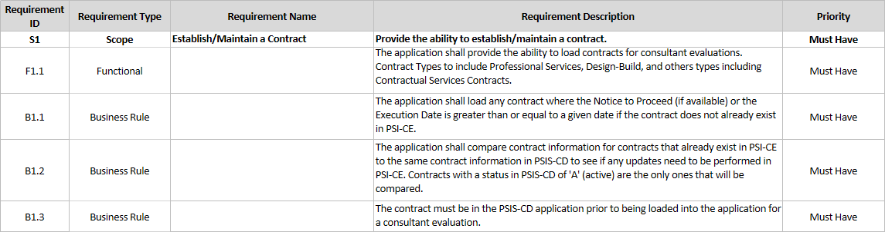

Requirement Types
All Requirements Deliverables must include all of the following requirement types unless otherwise specified in the procurement instrument or Project Plan:

Scope Requirements (High-level)
Scope Requirements shall provide specific details for the features and functions that characterize the product, service, or end result of the project.

Business Rules (Detail)
The Business Rules section shall provide specific details for all rules that define or constrain some aspect of business for the project.

Functional Requirements (Detail)
Functional Requirements shall provide specific details for what the user expects to be able to do.

Non-functional/Technical Requirements (Detail)
Non-functional/Technical Requirements shall specify the overall system requirements that will govern the development and implementation of the system. This requirement type shall establish usability, reliability, performance, and stability.

Interface Requirements (Detail)
Interface Requirements shall outline how databases and applications interact with each other.

Data Requirements (Detail)
Data Requirements shall describe the data entities and their relationships.

Report Requirements (Detail)
Report Requirements shall specify the reports that the system will be required to produce.

Policy and Regulation Requirements (Detail)
Policy and Regulation Requirements shall detail all relevant laws, regulations, policies, and standards that will affect the operation of the project. This requirement type shall also include any relevant external regulatory requirements or constraints imposed by normal business practices.

1.3.9 Training Requirements (Detail)
Training Requirements shall provide specific details for the training that will be necessary for the end users. This requirements type shall outline the training requirements that will be essential for the end users to complete in order to be able to effectively function in the system.

Requirements Traceability
All requirements deliverables must include a Requirements Traceability Matrix that clearly shows the traceability of all detail requirements to a corresponding scope requirement. All detail requirements must be able to trace to at least one scope requirement.

EXAMPLE:

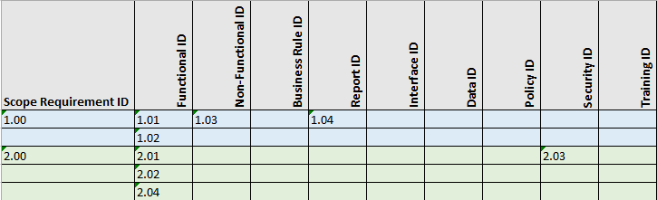

References
All requirements deliverables must include a section that documents all references, appendices, and glossary terms that were used when defining the requirements. The References section should include all of the following:

References
The References section shall provide a list of all sources of information that are referenced in the requirements document.

Appendices
The Appendices section shall be used to append any documents that were used when creating the requirements document for the project.

1.5.3 Glossary
The Glossary section shall be used to define all terms and acronyms required to properly interpret the requirements contained within the requirements document.

Document Revision History
All requirements deliverables must include a Document Revision History table. The Document Revision History table shall identify revisions to the document starting with the initial creation. This table shall be updated whenever a change or update is made to the requirements document.

