1. Right click on the signature in Adobe and select Validate Signature:
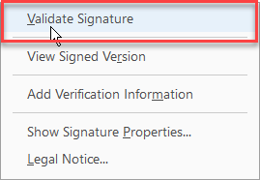

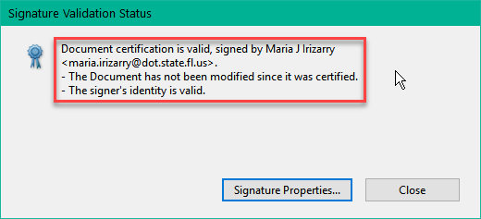
2. The signature should show up as valid. If it shows up as UNKNOWN, follow in the instructions the here.

Do not add an individual’s certificate to your trusted certificates by clicking Signature Properties, then Show Signer’s Certificate, then Trust and Add to Trusted Certificates:
