Signature Validation Status: UNKNOWN
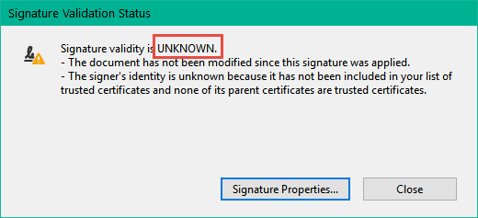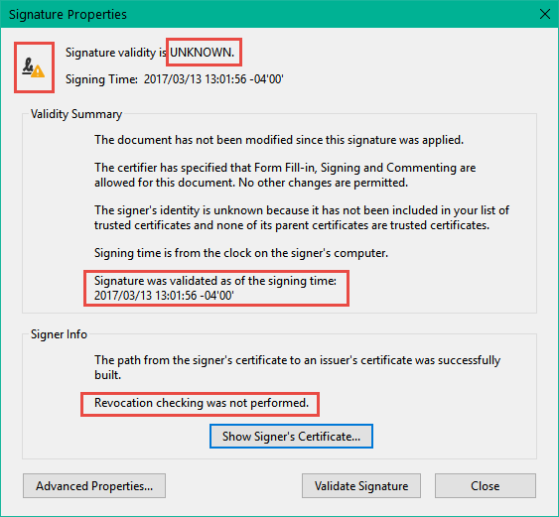

Steps to Fix:

1 – In Adobe Reader, select Edit, then Preferences:
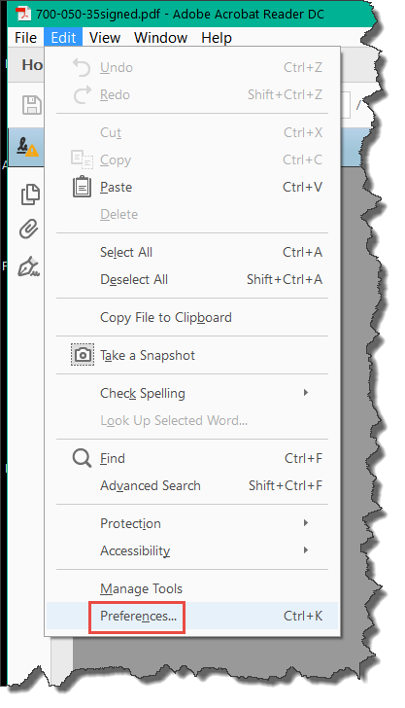
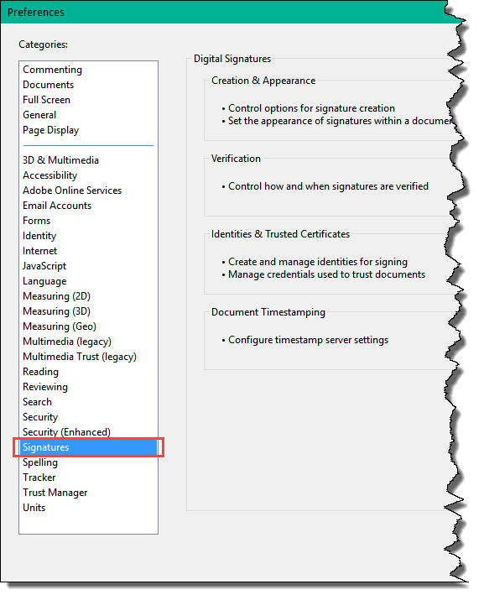
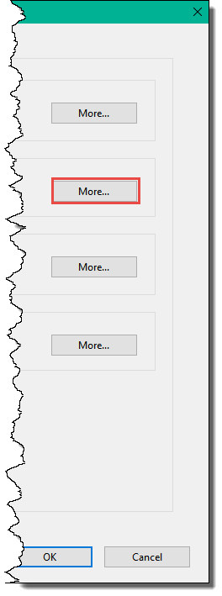
2 - Under Signatures and Verification, then More:

3 - On the “Signature Verification Preferences” screen, select both boxes under “Windows Integration, Trust ALL root certificates in the Windows Certificate Store for:”
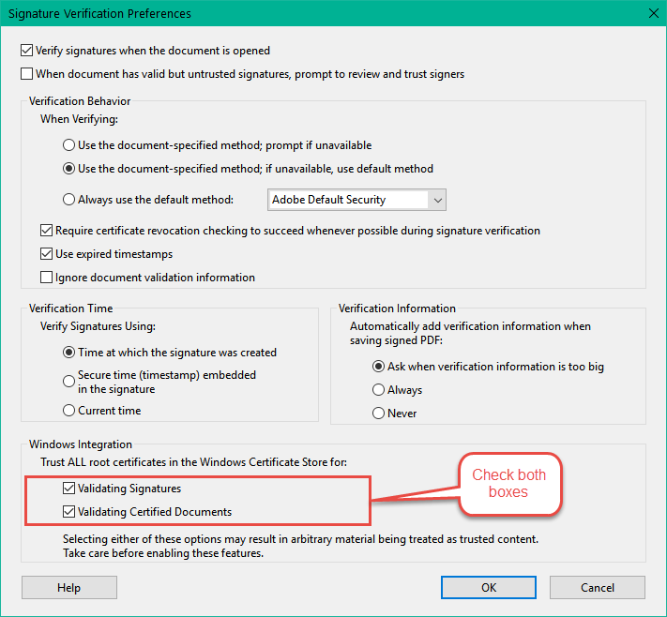
4 – Signatures will show VALID and will check for revocation, if the certificate is available in the Windows Certificate Store.

