Buy America Tracking
- Open PrC Production.
- Check the role. PrCRPA and PrCCSS roles can apply this agency view; no other district role has this authority.
- Select Contract Administration and enter the contract id:
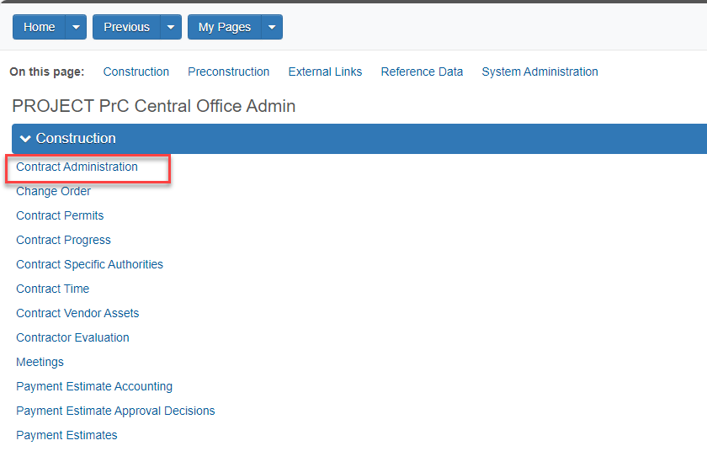
- Once the contract is in focus, click the drop-down to the right of the ‘Save’ button and select ‘Import DWR Agency View Reference Item Associations’:
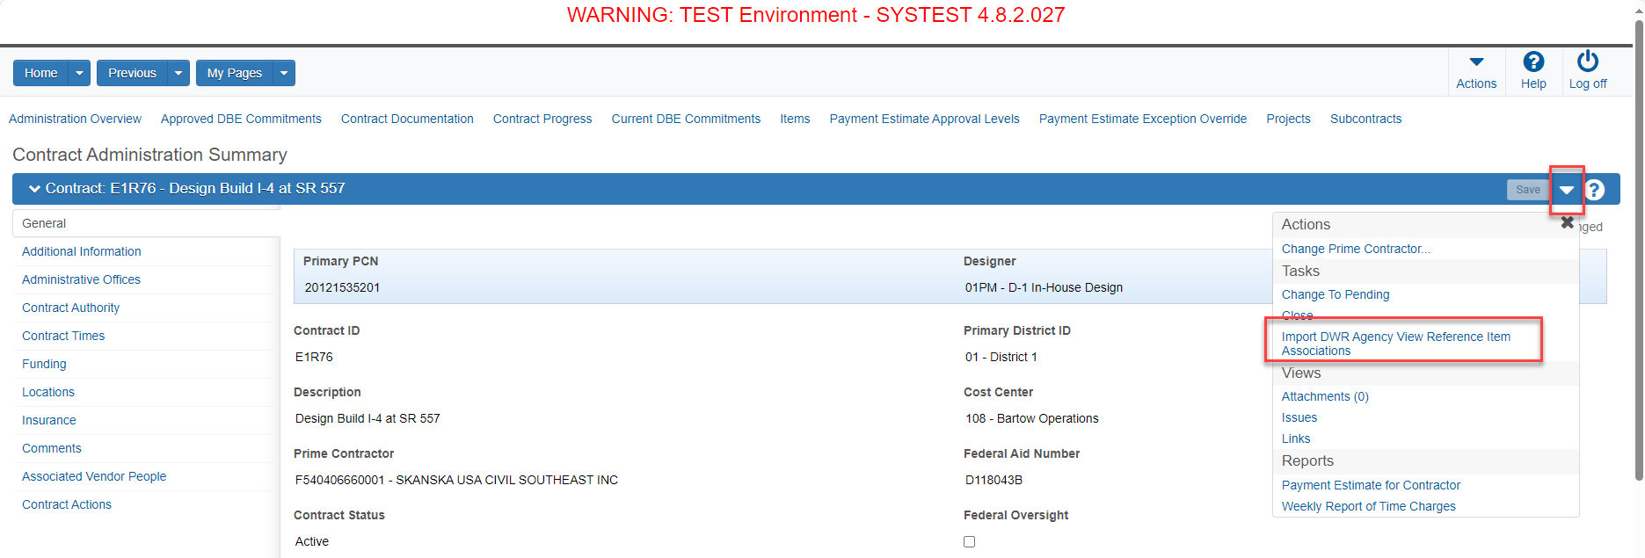

- A message that the import was complete/successful will show once the agency view is applied:
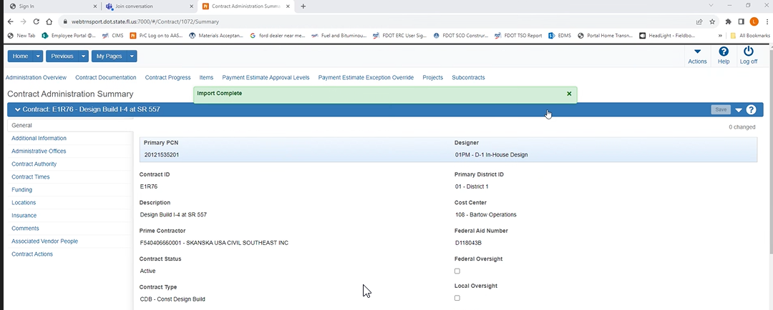
Additionally, the Contract Administration Summary > Additional Information > DWR Agency View Reference Item Associations Imported will indicate ‘YES’ when the agency view is applied:
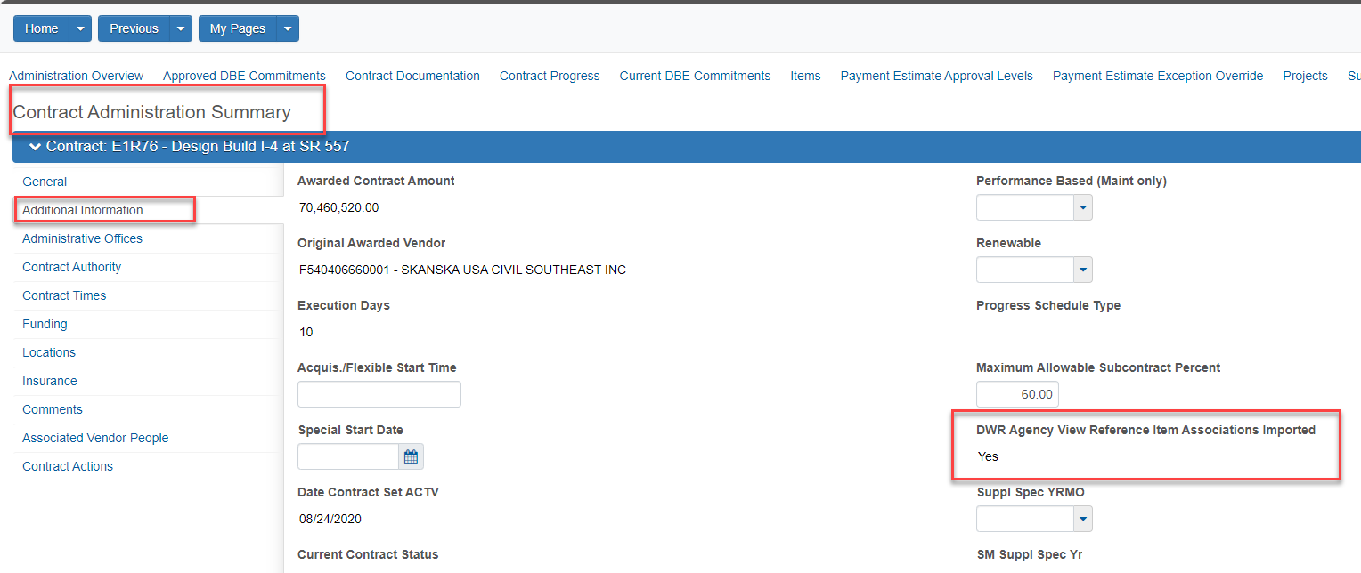

- Select ‘Contract Progress’ in the top ribbon of the page to navigate to Daily Work Reports:
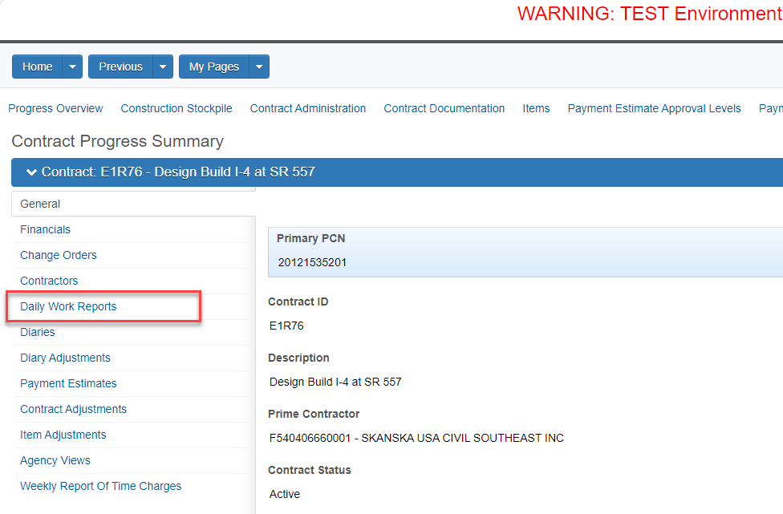

- Create a new DWR. Include the ‘Contractor on Site’ and then ‘Add Pay Items¹.’ Choose the pay item to associate with the Buy America Tracking. Post a -0- quantity, add location, and enter a comment “This posting is to record a Buy America tracking record.”. Once the DWR has been completed, ‘Save’:
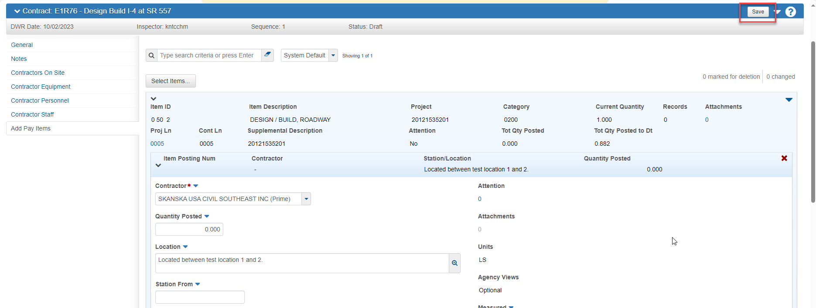
- After saving, expand the posting, click the drop-down arrow in the item posting (not the main item), scroll to the ‘Foreign Steel Tracking’, and click the link:
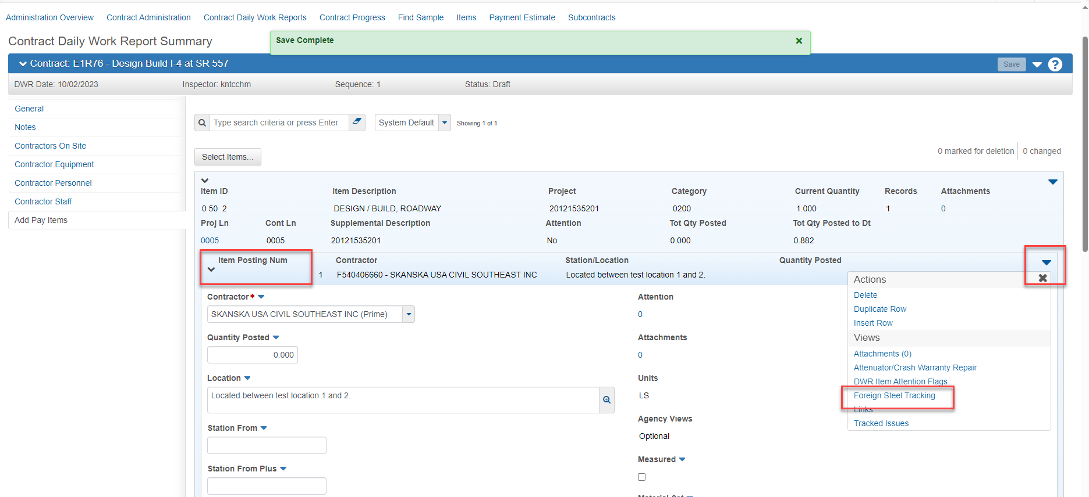

- The ‘Foreign Steel Tracking’ agency view summary will open and allow input of the steel that is being tracked.
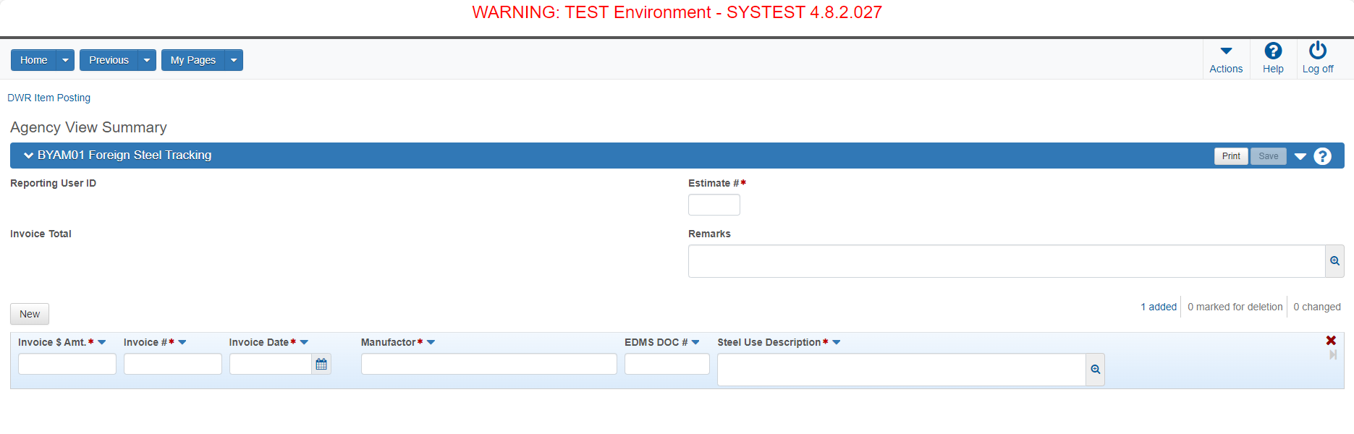
- The required fields for tracking are the estimate number you are making payment for steel stockpile or steel installation, the invoice number of the foreign steel, the amount of the foreign steel, and the manufacturer or supplier. You may enter any certificate numbers or other pertinent information in the ‘Steel Use Description’ field. This field also requires information to be input. There is a location for an EDMS number. If there is an EDMS number, please input it for reference. Once all data has been input, click ‘Save’ in the top right corner:
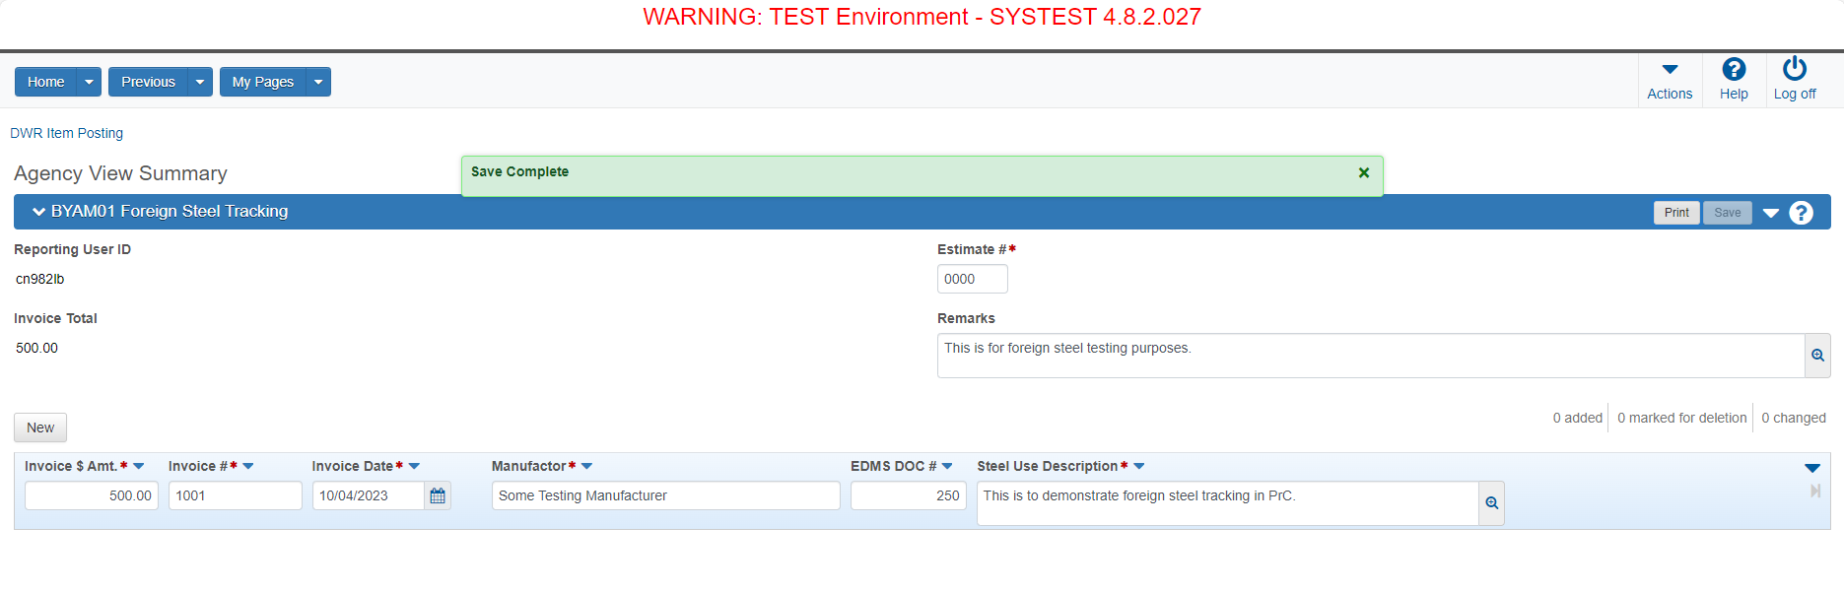
- The Buy America agency view has now been applied.

AddPayItems¹ – To check pay items eligible for Buy America Agency View application, follow these steps:

- From the Home page in PrC, click Agency Views:
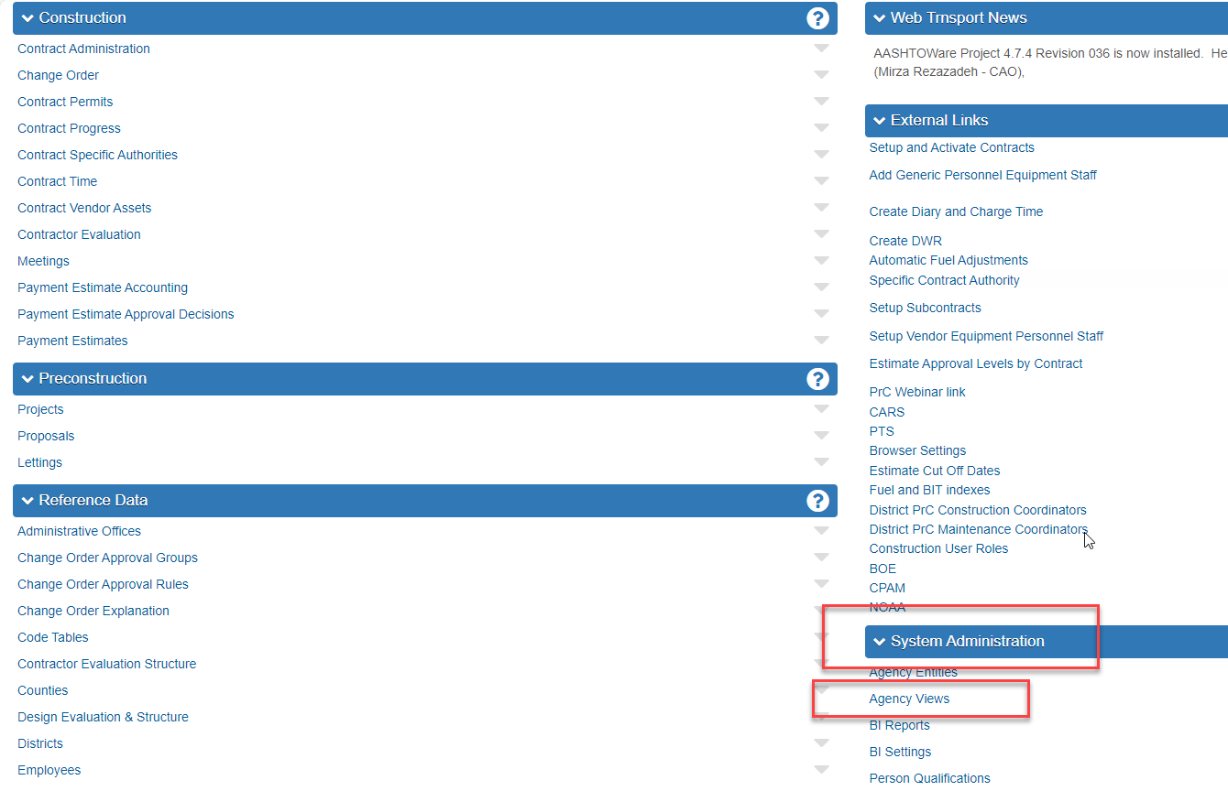

- Find BYAM01 (Buy America), click the dropdown arrow to the right of the agency view, and select ‘Agency View Associations’. This will then show a list of Pay Items that Buy America can be associated with:
