Asphalt Plant OPeration
  - Training Video
“HOW THE ASPHALT PLANT WORKS”
This video was produced by a private company not associated with FDOT. The link is provided with the express permission of Ajax.
It explains the process of how asphalt is produced.
The Training Development Team hopes you will find this information useful.

DISCLAIMER
This video is not an endorsement of any company or its affiliates.

This video is for informational purposes only
The following tutorial is for inspectors, maintenance and other plant and roadway personnel. It is intended to show how an asphalt plant operates.

CTQP QUALIFICATIONS
Plant and roadway inspectors are required to have qualifications through the FDOT Construction Training and Qualification Program (CTQP). Chapter 3 of the Construction Training and Qualification Manual (CTQM) provides details by job function as it relates to asphalt in FDOT projects. More information regarding paving, plant, and mix designer courses, prerequisites, requalifications, revocation, and responsibilities.

QUESTIONS
If you have any questions regarding asphalt, plant operations, or roadway operations, please contact:
Rich Hewitt, State Asphalt Engineer
Richard.Hewitt@dot.state.fl.us
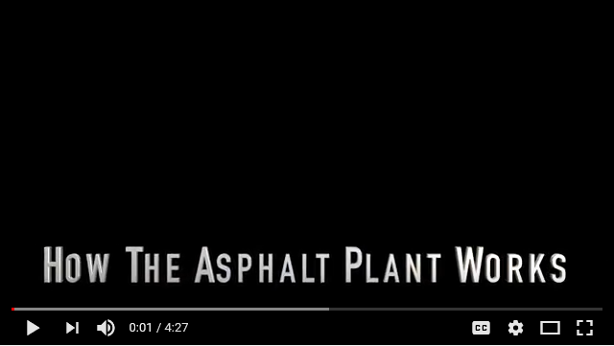

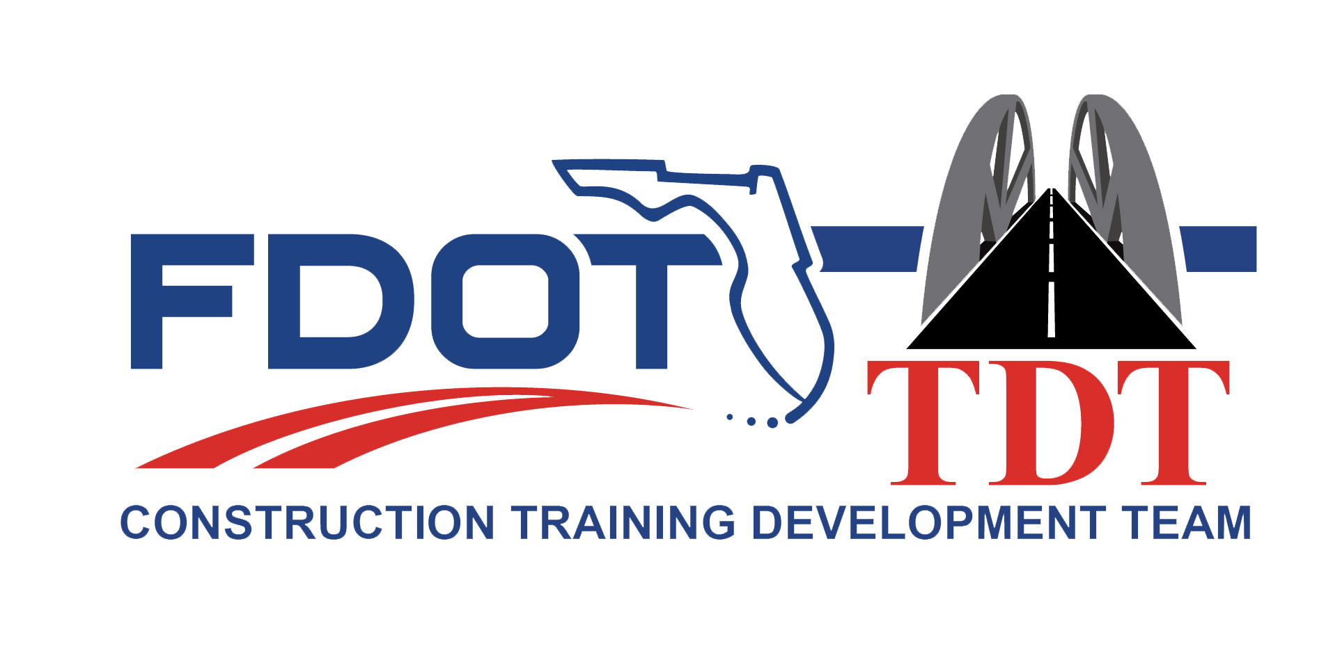

https://www.youtube.com/watch?v=C1UYusqSlsY&feature=youtu.be

