Production Rates Tool – notes regarding import to P6

This document will outline the process of importing activities and durations from the Excel tool into P6. Before beginning, you will need to have the standalone Excel file with the exported activities and durations. This file can be generated via Step 4 of the production rates tool. You will also need to have a P6 schedule created ahead of time so that you can select “Update Existing Project” as the import action.

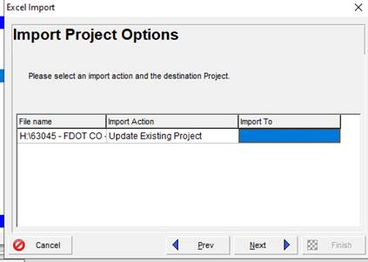

You may see the following comment pop up. If so, click “Yes” to continue.

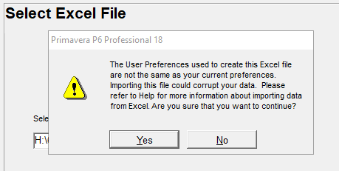

You will need to build out the WBS hierarchy in P6 as the Excel import will come in with all activities at the base level. You can utilize Activity IDs to assist with this as the tool will use a “P1” suffix for the first Phase worksheet found, “P2” for the second phase, and so on.

