SECTION 4

If you do not already have access to the Department’s Materials Acceptance and Certification System (MAC) you will need to create an account. Once you have and account, you will also need to create an Access Request within MAC to be able to access your project’s information.

The MAC application is located here:
https://mac.fdot.gov/default.aspx

Instructions for creating an account and requesting access are below.

Revised 11/26/2019
How to get to MAC and create an ISA (Internet Subscriber Account)………

http://www.mac.fdot.gov

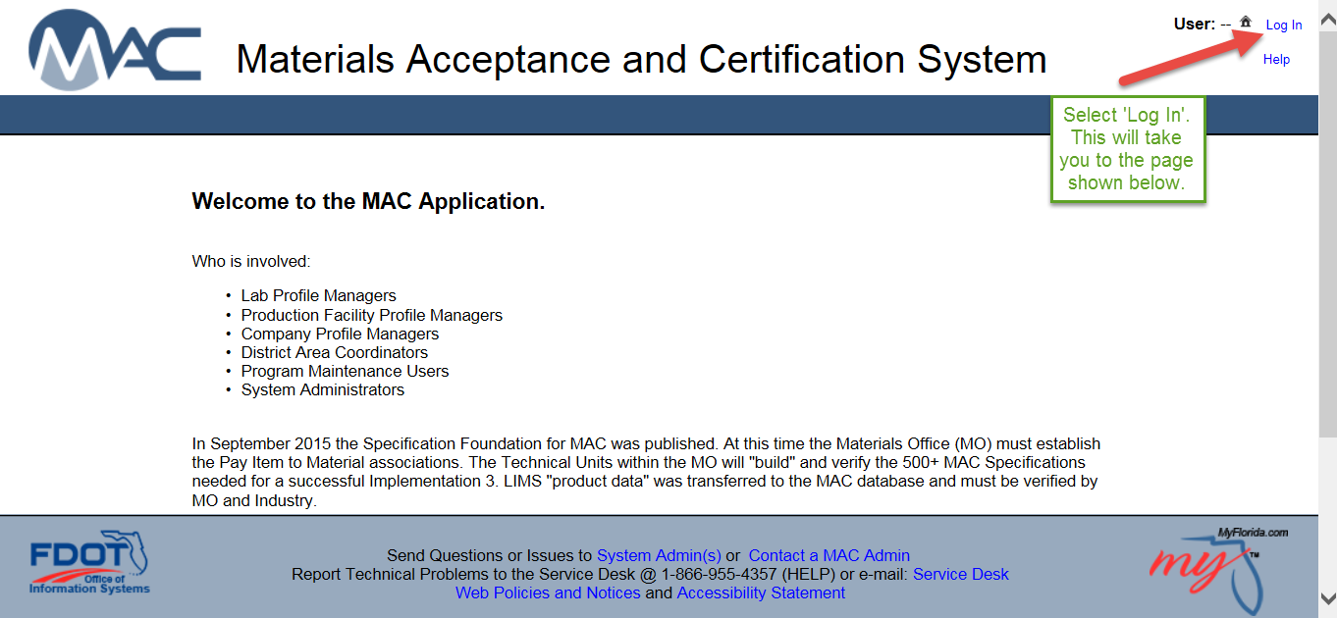
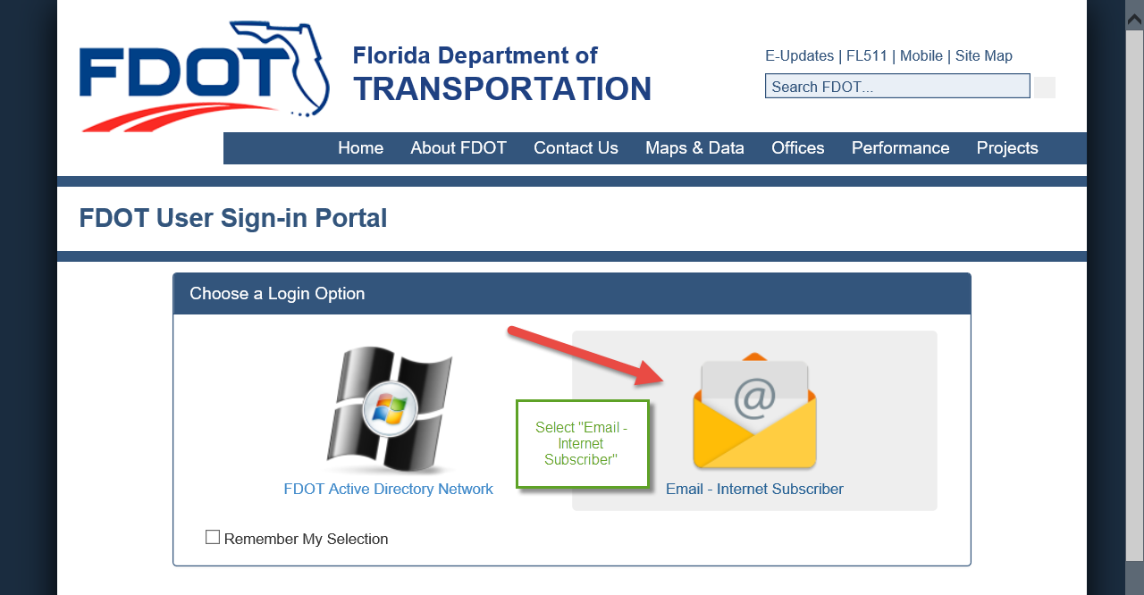
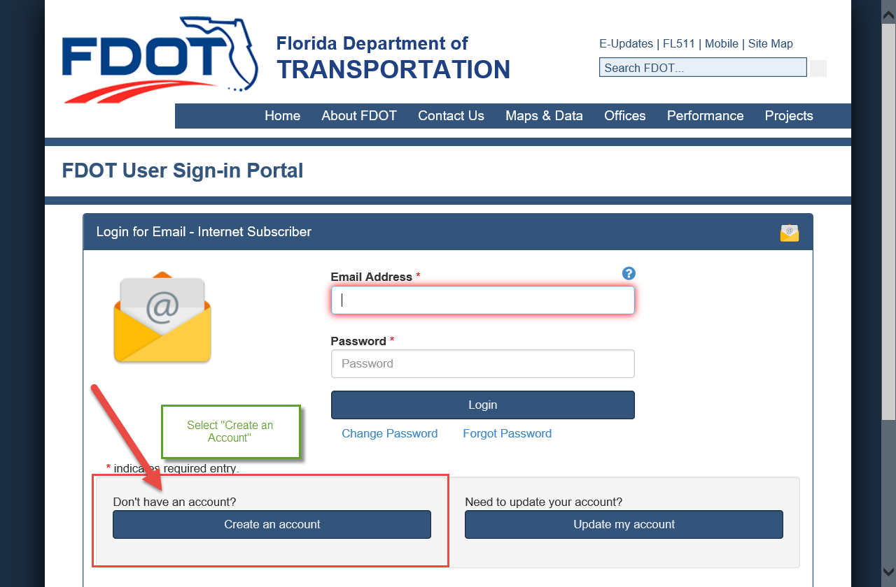

Complete all the information shown on the form (including terms of use) and select ‘Create Account’.
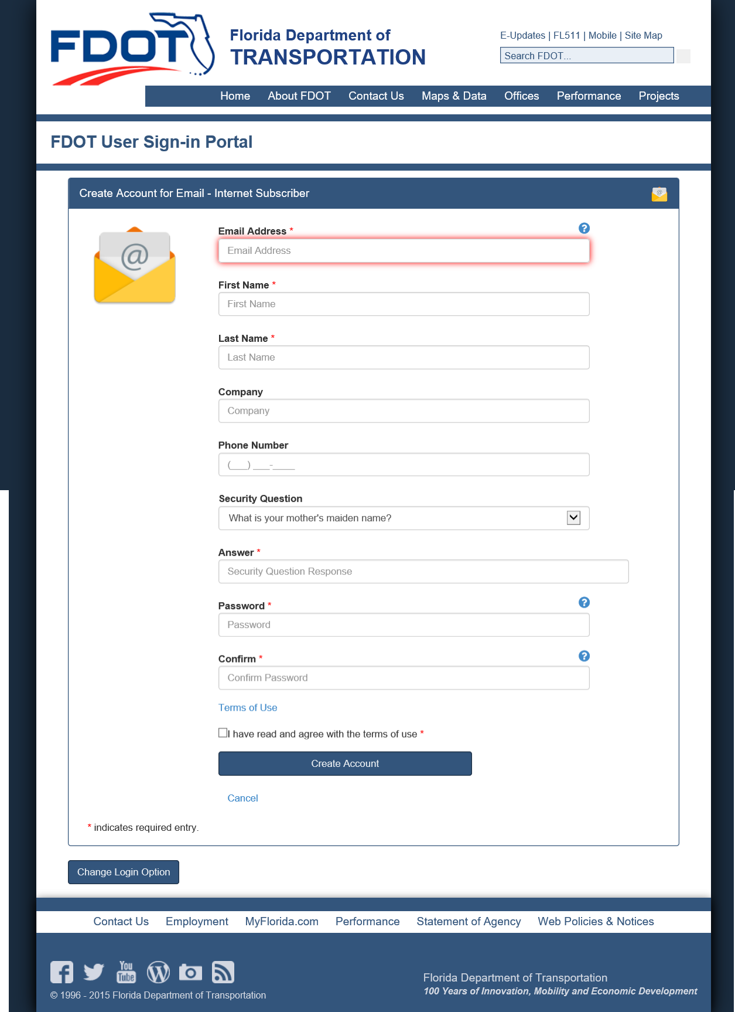
Once the account is created, you will receive an email to confirm the activation. Follow the blue link in the email. This link takes you to the ISA site to confirm the email that is tied to your ISA (internet subscriber account).
Once you have confirmed that all your information is correct, close out that site and log in to MAC. This is where you will create your Access Request for your company.
If you have any questions, please don’t hesitate to contact your District Application Coordinator Cassie Hammond @ 386-961-7728 or cassie.hammond@dot.state.fl.us

How to Select Your MAC Access………………………………

Once you have an account in MAC, you will need to log in to the Production Site (link shown below) and select your access if you haven’t already done so.

https://mac.fdot.gov/default.aspx

Select the “My Access” tab at the top of the page in the dark blue bar. This will show what access you currently have, if any. Select “Create Access Request” to open the request box.

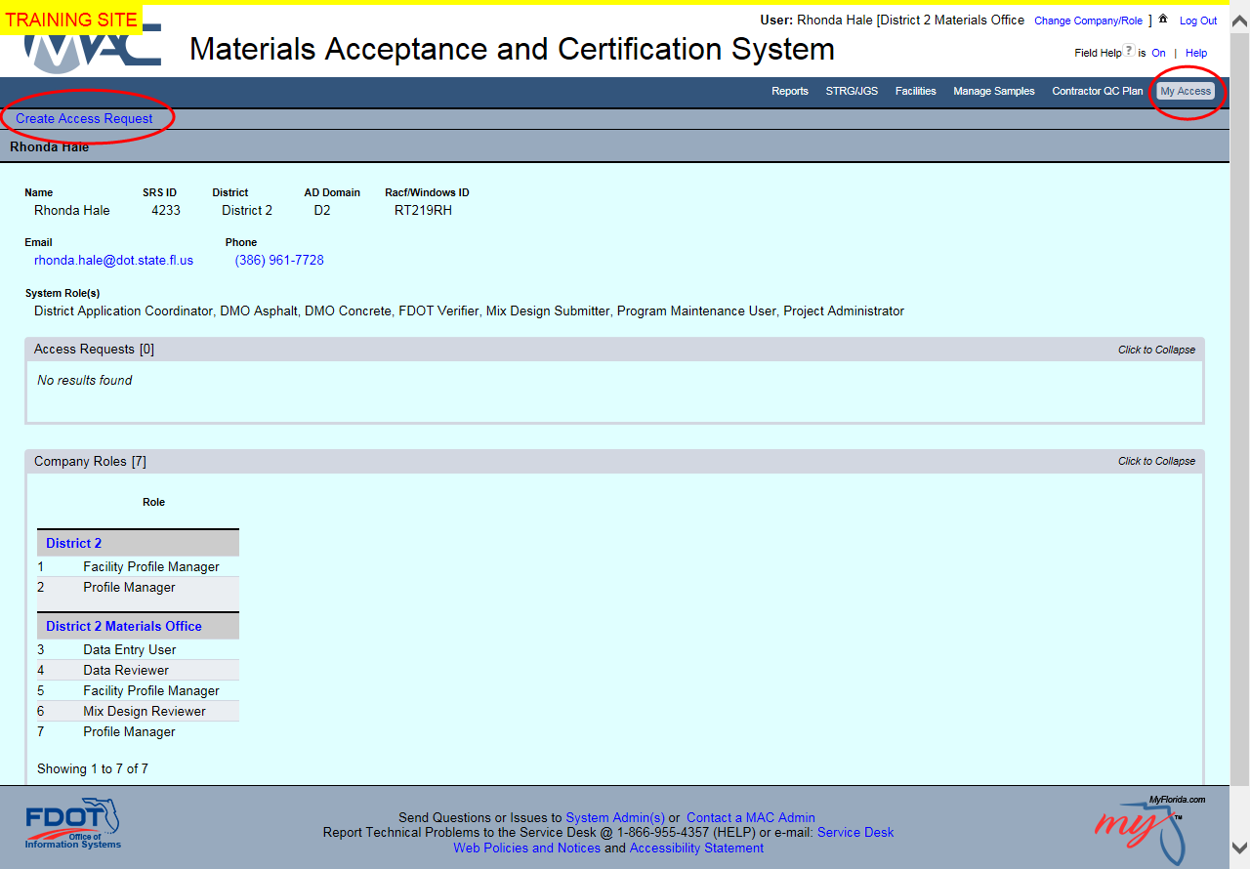
The request box looks like this. If your company is already in MAC (most all are), you will select I am a “User for a Company that currently exists in MAC”. If your company is not currently in MAC, then you will choose “User for a Company that does not yet exist in MAC”, then follow the prompts to add your company information. (2nd option)

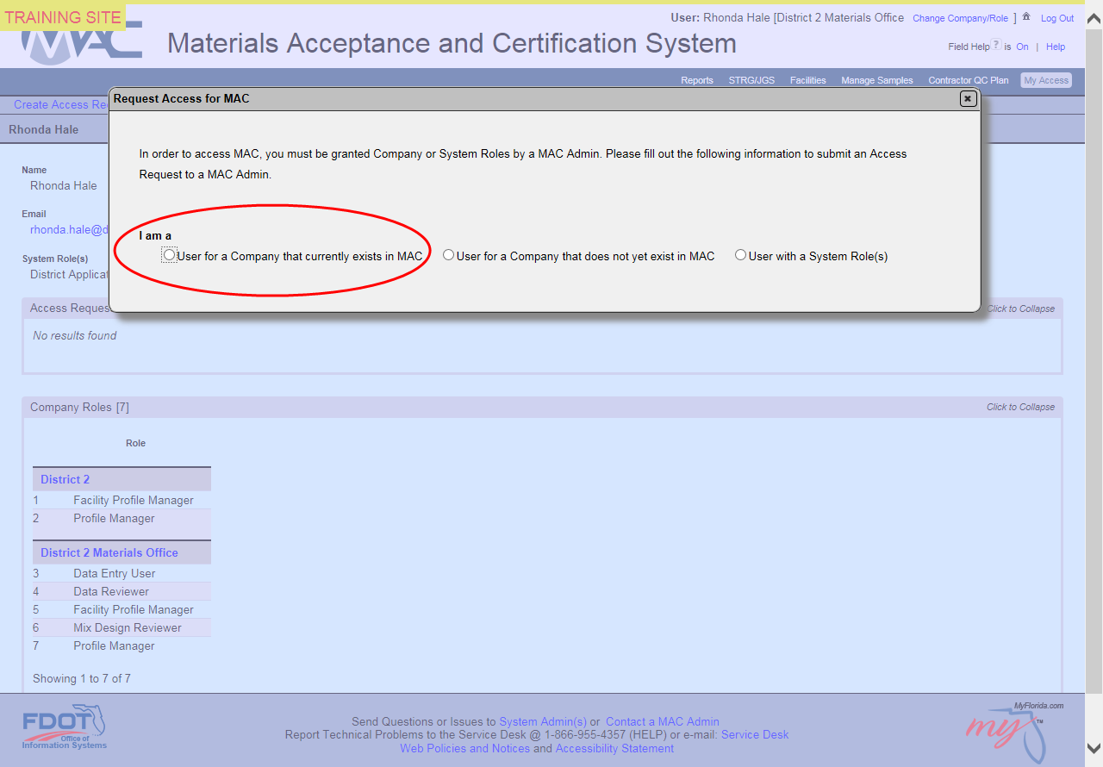

This selection will trigger the box to expand. In the “Existing Company” box, start typing your company name. After 3 characters the box will give you a listing of available companies. Select your company.

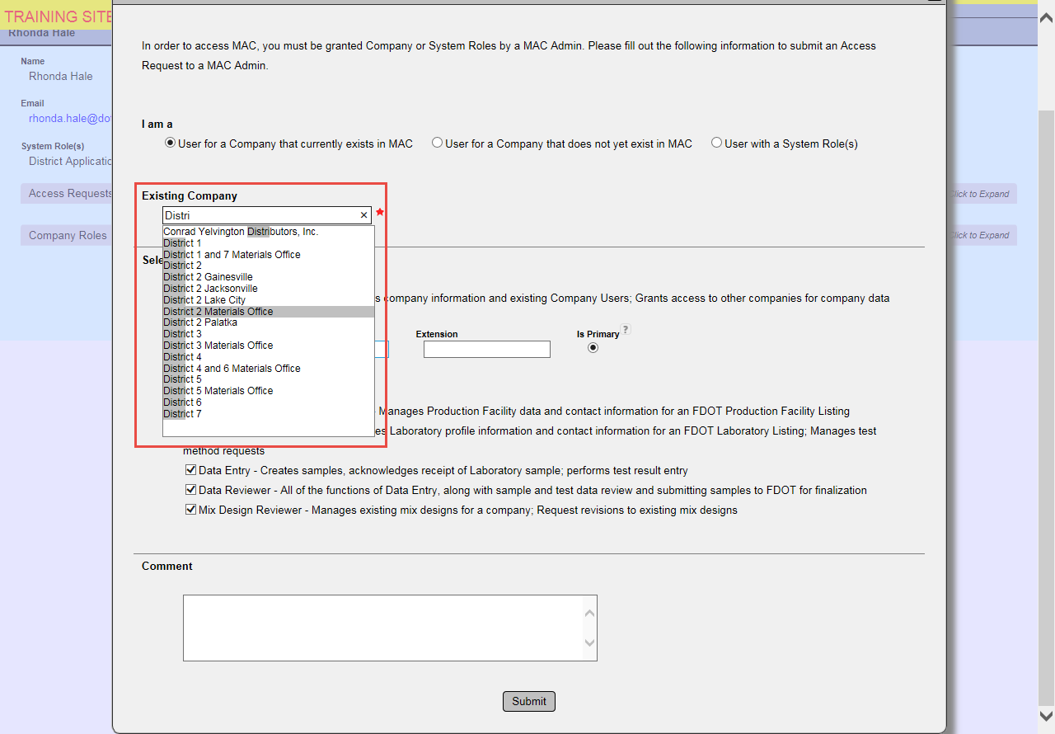

Once you have selected your company, you will then “Select Company Role(s)”. Click the box or boxes for the roles you require. In the comments box you can place a justification for specific roles, if needed.

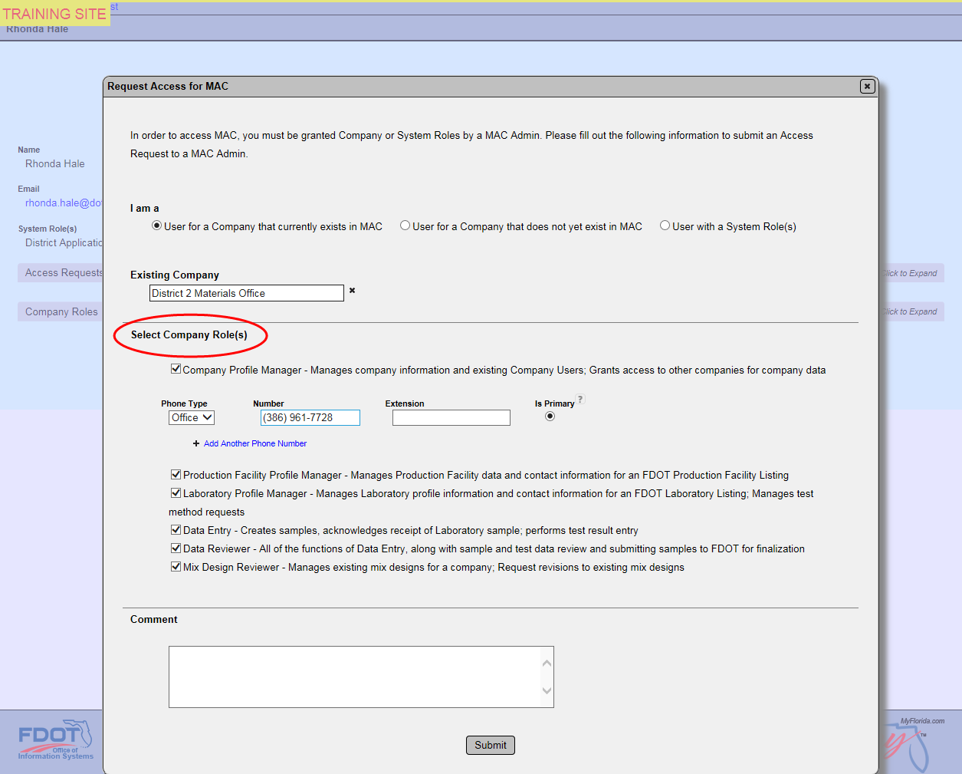

Click submit and a temporary green bar will flash at the top of your screen telling you the request was submitted successfully.

Your “Access Requests” bar will show the requests you have submitted.
Once submitted, the requests will go to the DAC in the District your company is in for processing.

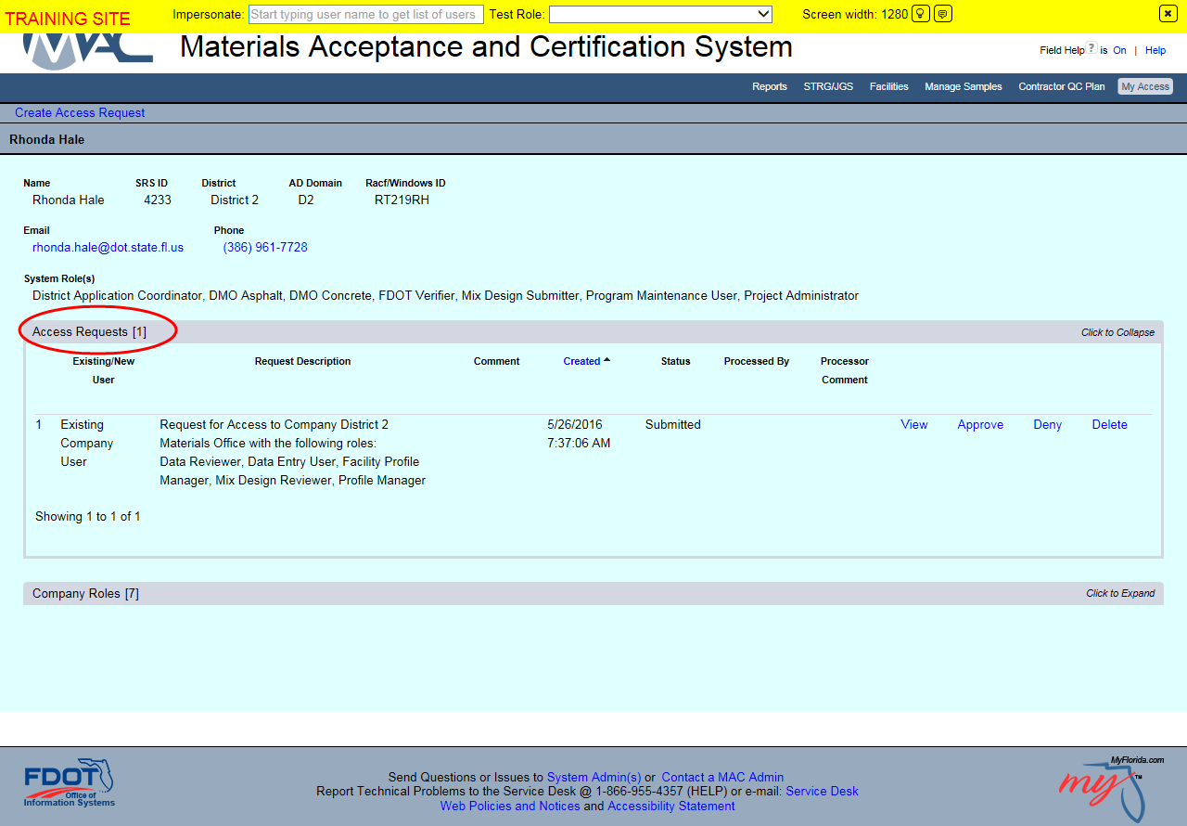

If you have any questions or need additional assistance, please contact your local DAC.

D2 DAC Cassie Hammond
386-961-7728
cassie.hammond@dot.state.fl.us

