SECTION 3b

EROSION CONTROL – DULY AUTHORIZED REPRESENTATIVE (DAR)

Revised as of 1/25/2023

For projects requiring the FDEP NPDES Construction Generic Permit, there are documents which require signatures from a Responsible Authority who meets the requirements of Rule 62-620.305(1), F.A.C. This requirement includes the Notice of Intent (NOI) and SWPPP Inspection Reports (FDOT 650-040-03). If other people have been delegated to sign the SWPPP Inspection Reports on behalf of the Responsible Authority, then a DAR form is required. The DAR can only start after the RA has obtained the FDEP NPDES Permit. Refer to the FDEP NPDES CGP Permit (Section 8.9).

The contractor can complete FDEP’s DAR form (link below) or use the DAR Example Letter (see page 3) as their DAR submittal to FDEP. The forms must be wet signed.

FDEP’s DAR Form:
https://floridadep.gov/sites/default/files/Delegation_Guidance_Doc_3.pdf

Contractor’s DAR letter must include this certification:
“I certify under penalty of law that this document and all attachments were prepared under my direction or supervision in accordance with a system designated to assure that qualified personnel properly gathered and evaluated the information submitted. Based on my inquiry of the person or persons who manage the system, or those persons directly responsible for gathering the information, the information submitted is, to the best of my knowledge and belief, true, accurate, and complete. I am aware that there are significant penalties for submitting false information, including the possibility of fine and imprisonment for knowing violations.”

Each DAR form must be emailed to FDEP (NPDES-stormwater@FloridaDEP.gov).

A copy of the email submittal and DAR must be submitted to the Construction CEI.

This process shall repeat each time the roles are changed for the life of the project.

Example of FDEP’s DAR Form:
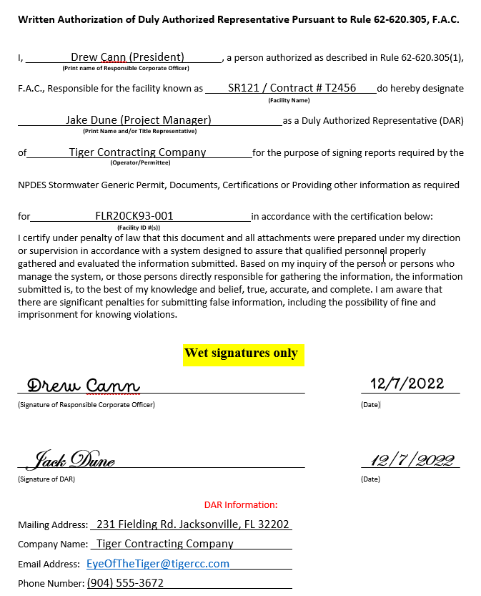
TIGER CONTRACTING COMPANY
3672 Jordan Lane Lake City, FL 32025
(386) 555-1923 FAX (386) 555-7478

December 7, 2022

Attention: FDEP NPDES Stormwater Program – Notices Center
NPDES-stormwater@FloridaDEP.gov

Subject: FDEP NPDES CGP – DULY AUTHORIZED REPRESENTATIVE NOTICE
Site Location: SR-121, From Larry Place to Cotton Picker Road
FIN #: 213256-1-52-01
Contract #: T2456
County: Baker
NPDES Permit#: FLR20CK93-001

Please accept this letter as my required written authorization of Duly Authorized Representative pursuant to Rule 62-620.305, F.A.C.

I, Drew Cann, President (RESPONSIBLE AUTHORITY, TITLE), a person authorized as described in Rule 62-620.305(1), F.A.C., Responsible for T2456 (CONTRACT NUMBER) located at SR 121 (SITE LOCATION), do hereby designate Jack Dune, Project Manager (REPRESENTATIVE) as a Duly Authorized Representative (DAR) of Tiger Contracting Company (COMPANY NAME) for the purpose of signing reports documents, certifications or providing other information as required NPDES Stormwater Generic Permit for the following facility FLR20CK93-001 (FDEP NPDES CGP PERMIT NUMBER) in accordance with the certification below:

“I certify under penalty of law that this document and all attachments were prepared under my direction or supervision in accordance with a system designated to assure that qualified personnel properly gathered and evaluated the information submitted. Based on my inquiry of the person or persons who manage the system, or those persons directly responsible for gathering the information, the information submitted is, to the best of my knowledge and belief, true, accurate, and complete. I am aware that there are significant penalties for submitting false information, including the possibility of fine and imprisonment for knowing violations.”

Respectfully,

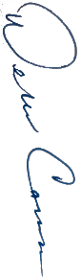
Dew Cann - President
Tiger Contracting Company
Cell: 386-365-0110
EyeOfTheTiger@tigercc.com

