SECTION 10a
Request for Endangered Species Inspection of the Proposed Borrow Pit Site

Please find attached a sample letter that is to be completed if the Contractor is going to open a new Borrow Pit.

EXAMPLE ATTACHMENTS

DHR Clearance
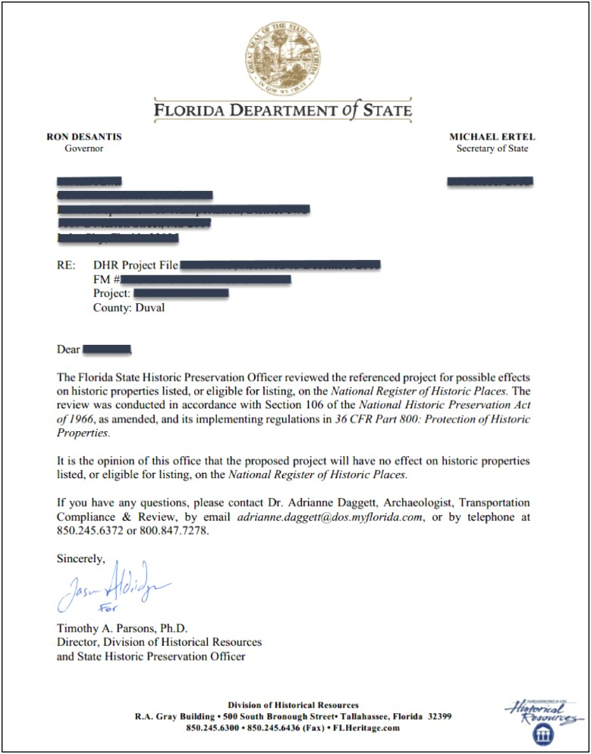

Site Map
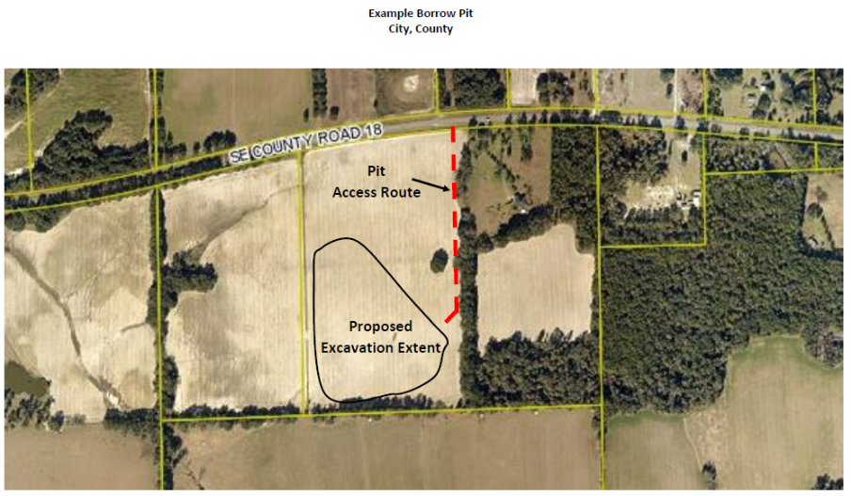

Revised as of 12/03/2019


TIGER CONTRACTING COMPANY
2435 Willow Lane Jacksonville, FL 35548
(904) 678-9642 FAX (904) 678-9645

May 8, 2019

FDOT District Construction Environmental
1109 S Marion Ave
Lake City, FL 32025-5874

Re: Request for Endangered Species Inspection of Proposed Borrow Pit
FINPROJ No:
FAP No.: (If applicable)
Contract No.:
County/Section:

To Whom it May Concern:

We propose in the very near future to open a new borrow pit and construct a haul road to furnish fill material to the above referenced Department of Transportation project.

Borrow Pit Name:
Site Contact (Name & Number):
Estimated Acreage and/or Cubic Yards:

The proposed site is owned by and is located as follows:

Parcel Number:
Section, Township, Range:
Lat/Long:
Physical Address:
County, City:
Description: See attached Site Location Map (ID access road(s) and limits of proposed excavation)

The DHR clearance is (underline one) still pending OR approved and attached

Per Spec 120-6, we are notifying you to please initiate a field review of this site to determine the possible impact of our operations on endangered and threatened species. The site is accessible along the outside boundaries of the pit by a standard vehicle. The vegetation of the center has not been cleared yet and is ready for your field review. The site contact listed above will ensure the property owner is notified prior to the scheduled inspection. We understand this is a supplemental inspection and all applicable environmental permits have been acquired. Please advise as to your findings at your earliest convenience.

If you have any questions in regard to this request, contact (Contractor’s Representative) at (Phone).

Sincerely,

Stephanie Michaels
Project Administrator

