About OpenText DM Webtop for EEDMS
Effective as of March 17th, 2021, the Department no longer supports OpenText DM Webtop for EEDMS and all users currently using DM Webtop must switch to using EEDMS Client Release 16.7 eDOCS.
EEDMS Icons
JAVA-based  OpenText DM Webtop  NO LONGER SUPPORTED | Release 16.7  eDOCS Web Client
 |   

Using This Guide
This guide is intended to provide the reader step-by-step instructions on how to switch from DM Webtop to EEDMS Client Release 16.7 eDOCS. Additionally, includes information about each of the District address links and updates required.

Step-by-Step Instructions
- Login using either the Windows OR Citrix credentials, e.g., UserID – CNxxxxx, KNxxxxx, etc.
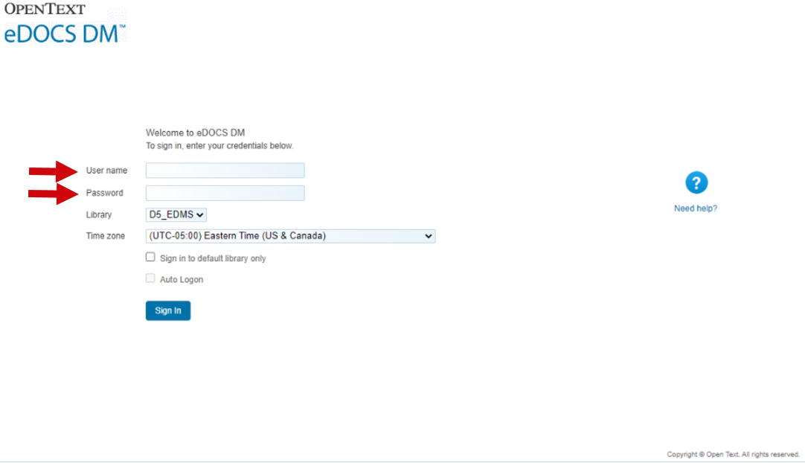

- On your First Login – Select Settings from the drop-down menu located in the upper right-hand corner.
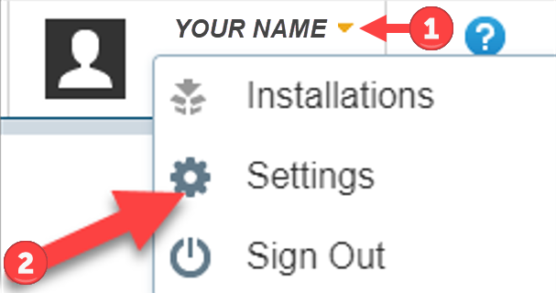

- Next, you will need to adjust (if necessary) the following User Settings:
 Set your Default Search Form
 Set your Default Profile Form for both the Folder and Primary Form
 Set your Default Landing Page/ Form Style to Classic
 Click OK this will Save the changes.
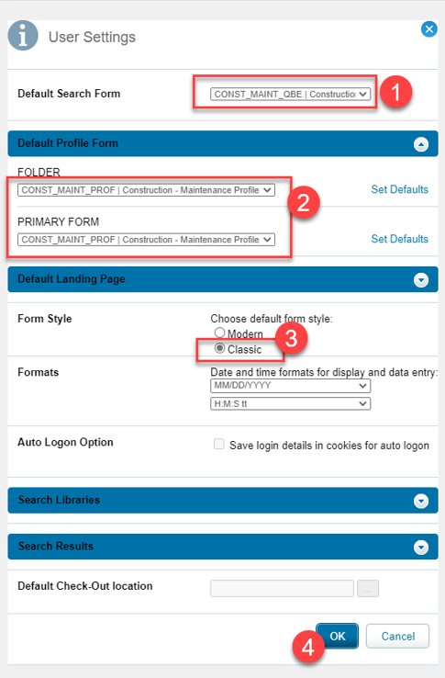

- How to use the New Interface.
To Add a new digital document Click Add New
Then, Select the Document from local/network drive

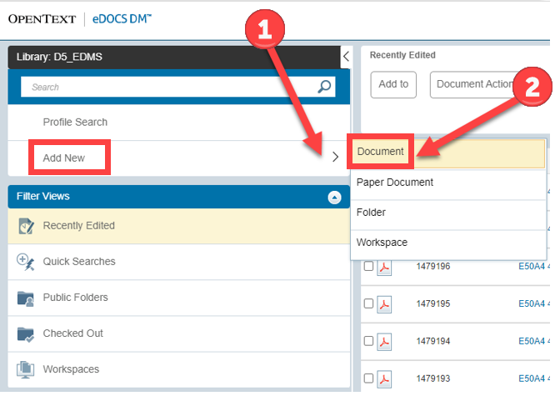

- Now you will be prompted to Populate the Profile Form. Populate as you normally would and Click OK.

- Edit the Profile by Hovering over Actions and Selecting Profile.
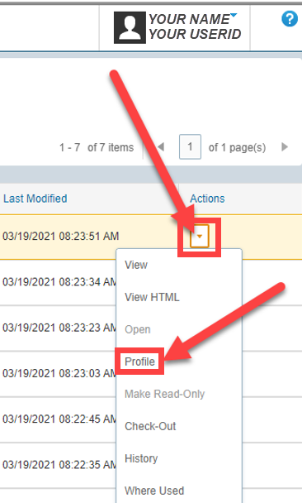

- To Locate documents,
Select Profile Search and add any Search Attributes necessary to locate your document(s) OR
Select the Search Bar to enter a Document Number
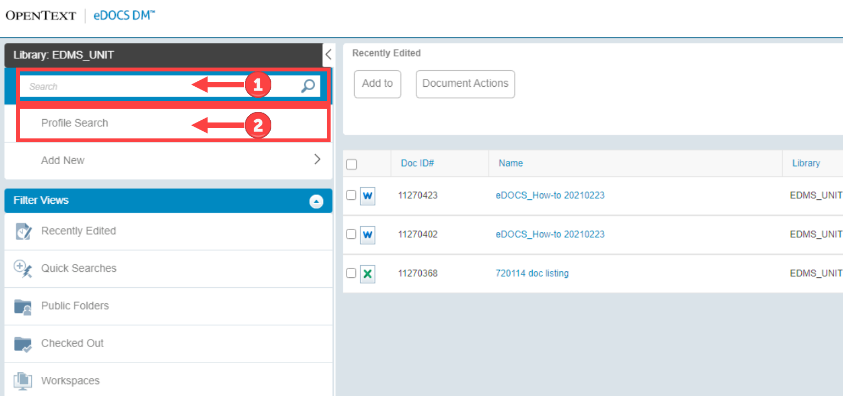

Update Your Bookmarks
If you have any bookmarks for District DM Webtop clients they will need to be updated to the new eDOCS Web client sites. Addresses are as follows:
District eDOCS Web Client Sites
District Name | District Number | Address
Central Office – Tallahassee | CO | https://coedmsweb.fdot.gov/edocs
Bartow | D1 | https://d1edmsweb.fdot.gov/edocs
Lake City | D2 | https://d2edmsweb.fdot.gov/edocs
Chipley | D3 | https://d3edmsweb.fdot.gov/edocs
Ft. Lauderdale | D4 | https://d4edmsweb.fdot.gov/edocs
Deland | D5 | https://d5edmsweb.fdot.gov/edocs
Miami | D6 | https://d6edmsweb.fdot.gov/edocs
Tampa | D7 | https://d7edmsweb.fdot.gov/edocs
Turnpike – Headquarters | TP | https://tphedmsweb.fdot.gov/edocs
Turnpike - Pompano | TP | https://tppedmsweb.fdot.gov/edocs

